AI ASSISTED CODING
ASSIGNMENT-8.3

Name: A.vishnu vardhan Reddy
HT NO.:2403A51253
Batch No.:11

TaskDescription#1
UseAItogeneratetestcasesforis_valid_email(email)andthenimplementthevalidatorfunction.

Requirements:

- Mustcontain@and.characters.
- Mustnotstartorendwithspecialcharacters.
- Shouldnotallowmultiple@.

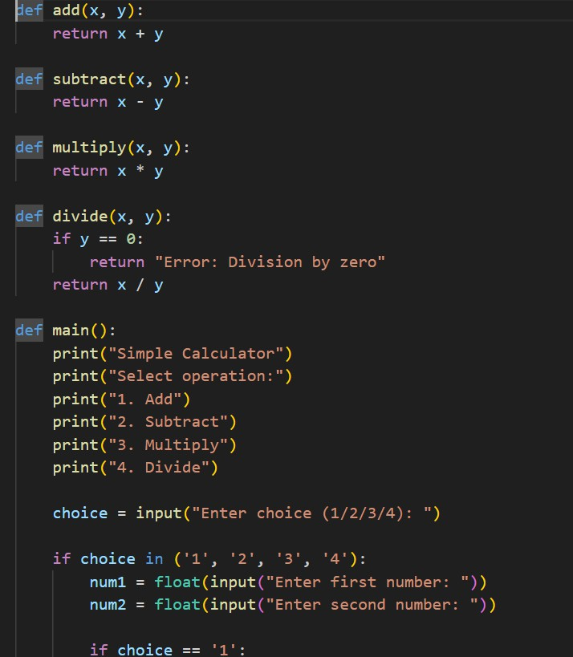

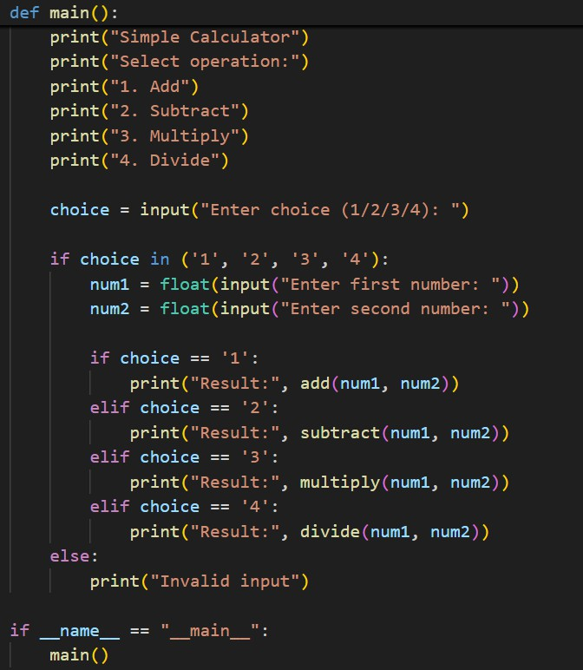

OUTPUT:

