AI ASSISTED CODING
ASSIGNMENT-9.2

Name: B. Praneeth
HT NO: 2403A51246
Batch No.: 11
Task – 1
Task: Use AI to add Google-style docstrings to all functions in a
given Python script.
• Instructions:
o Prompt AI to generate docstrings without providing any
input-output examples.
o Ensure each docstring includes:
▪ Function description
▪ Parameters with type hints
▪ Return values with type hints
▪ Example usage
o Review the generated docstrings for accuracy and
formatting.
Expected Output 1:
o A Python script with all functions documented using
correctly formatted Google-style docstrings.
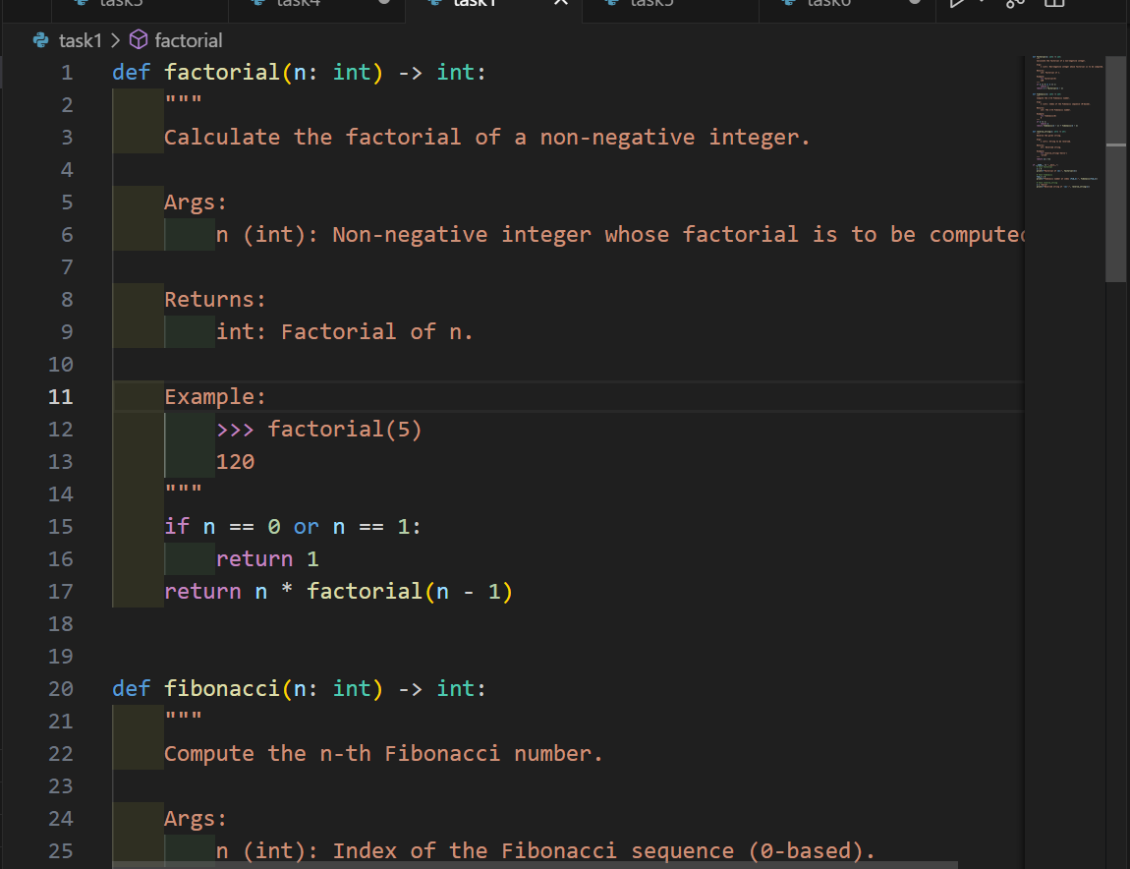
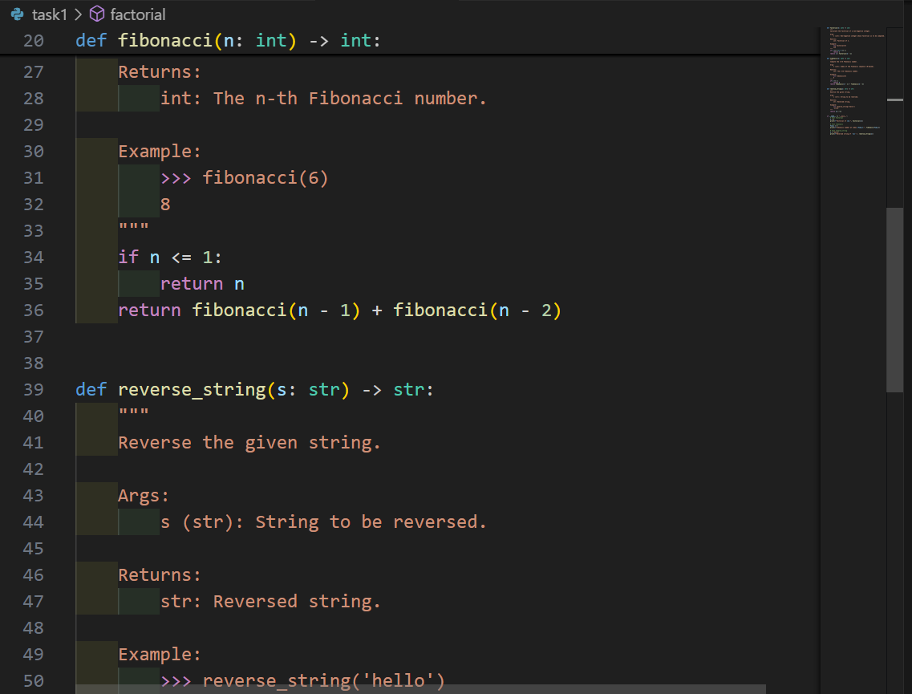

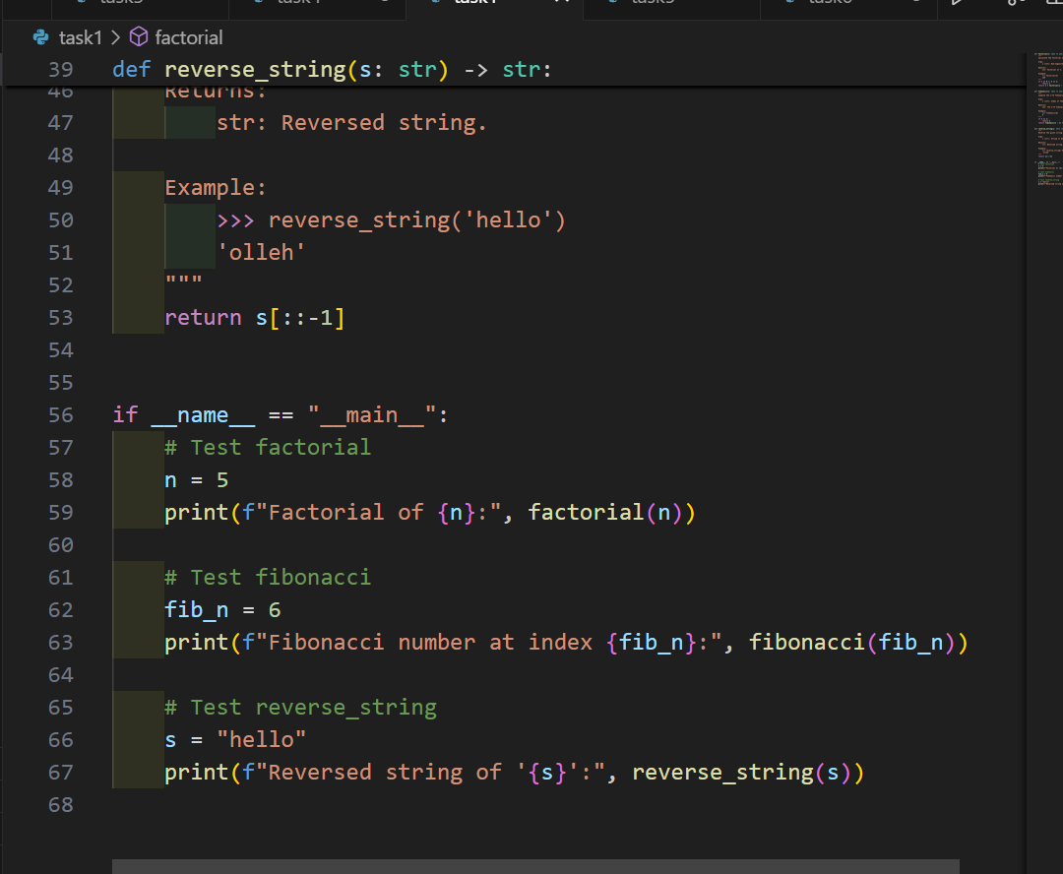
OUTPUT:
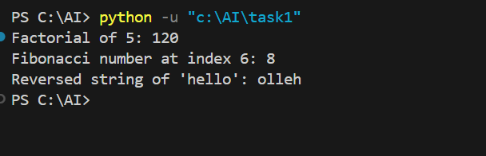
Task – 2
Task: Use AI to add meaningful inline comments to a Python
program explaining only complex logic parts.
• Instructions:
o Provide a Python script without comments to the AI.
o Instruct AI to skip obvious syntax explanations and focus
only on tricky or non-intuitive code sections.
o Verify that comments improve code readability and
maintainability.
Expected Output 2:
o Python code with concise, context-aware inline comments
for complex logic blocks.
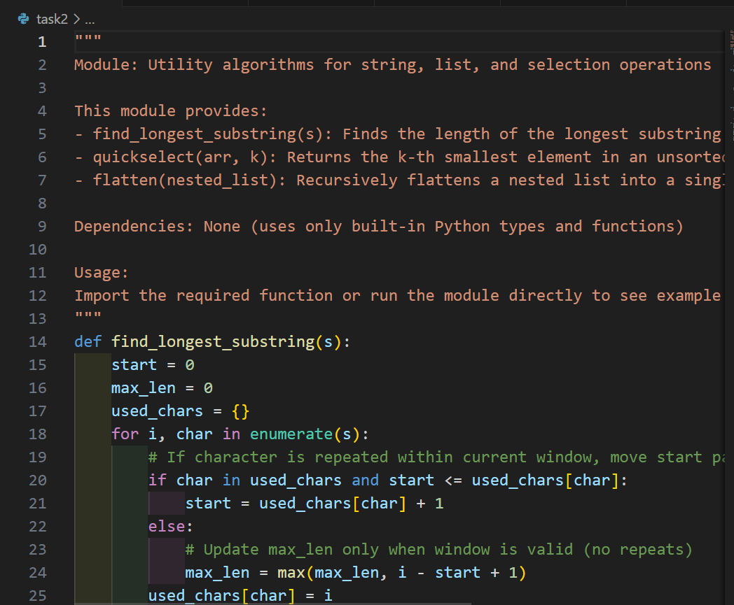
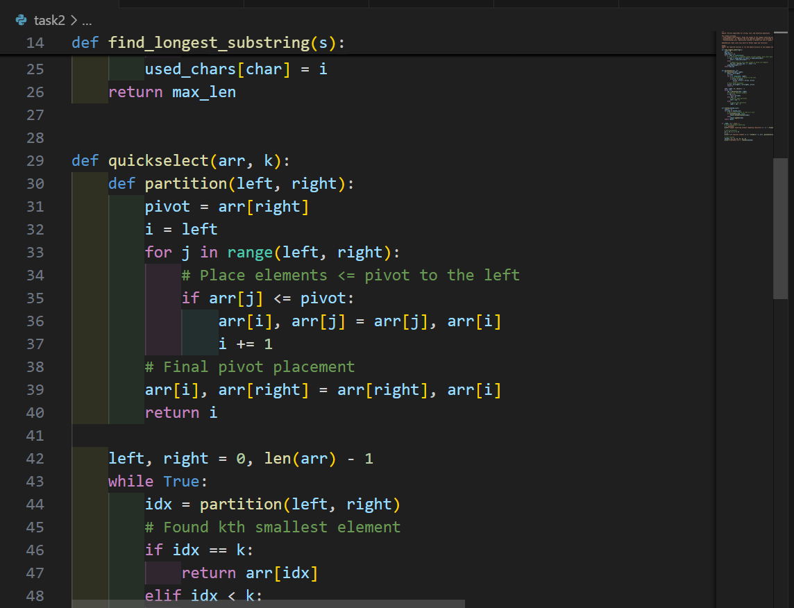
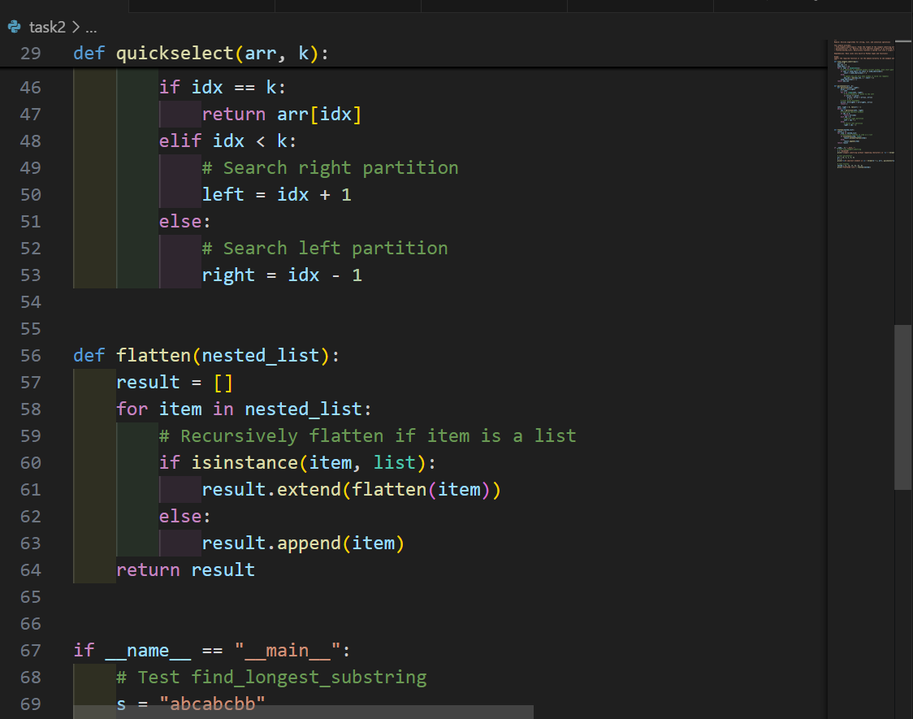
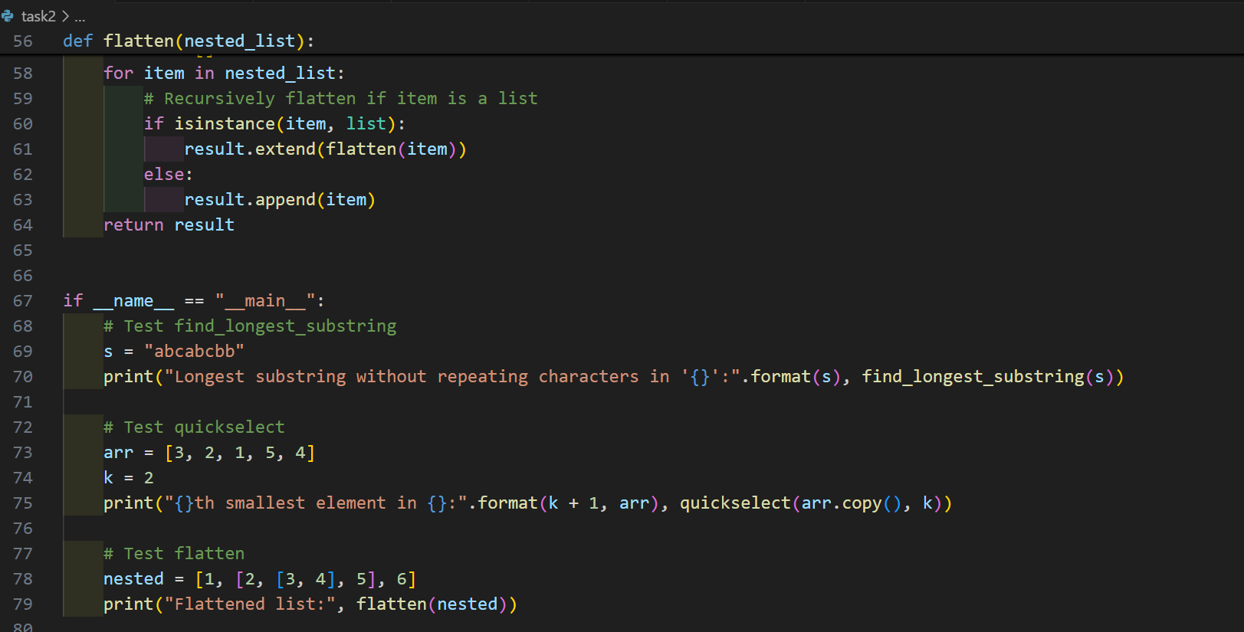

OUTPUT:
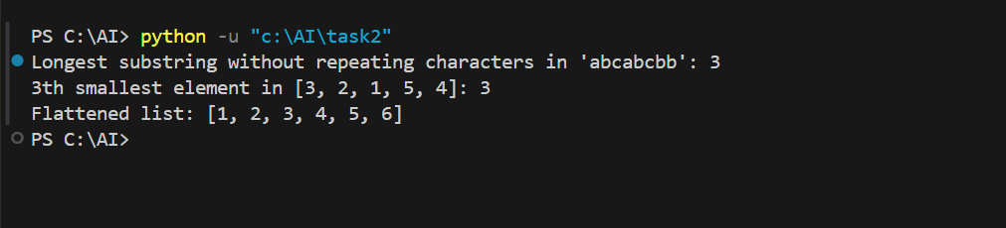
Task – 3
Task: Use AI to create a module-level docstring summarizing the
purpose, dependencies, and main functions/classes of a Python
file.
• Instructions:
o Supply the entire Python file to AI.
o Instruct AI to write a single multi-line docstring at the top
of the file.
o Ensure the docstring clearly describes functionality and
usage without rewriting the entire code.
Expected Output 3:
o A complete, clear, and concise module-level docstring at
the beginning of the file.
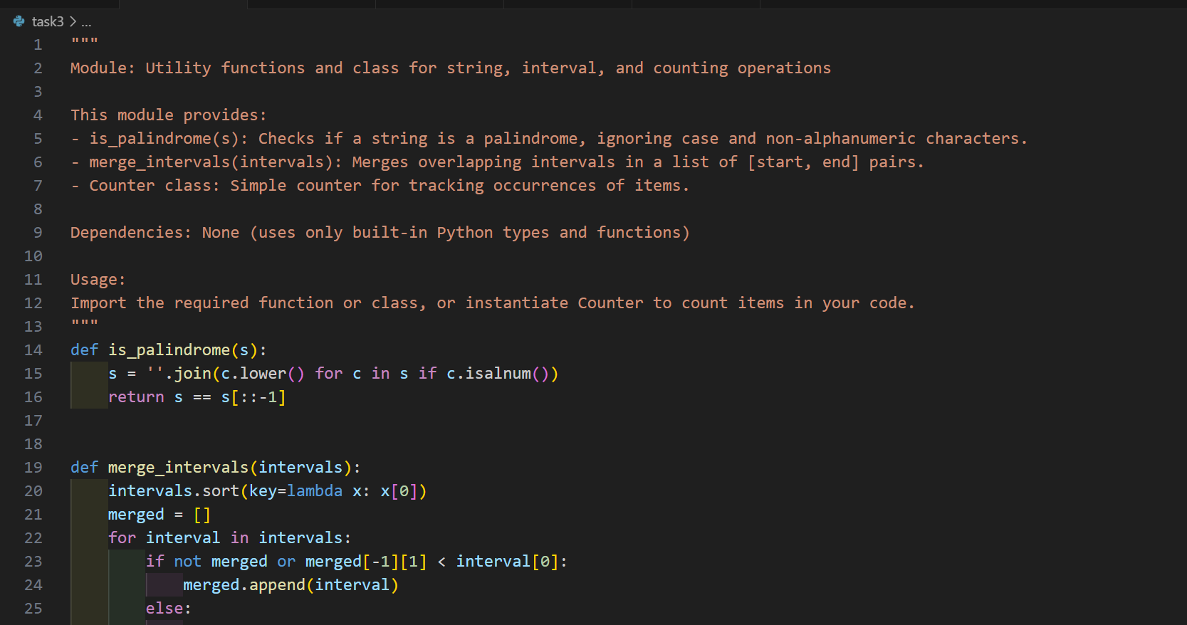
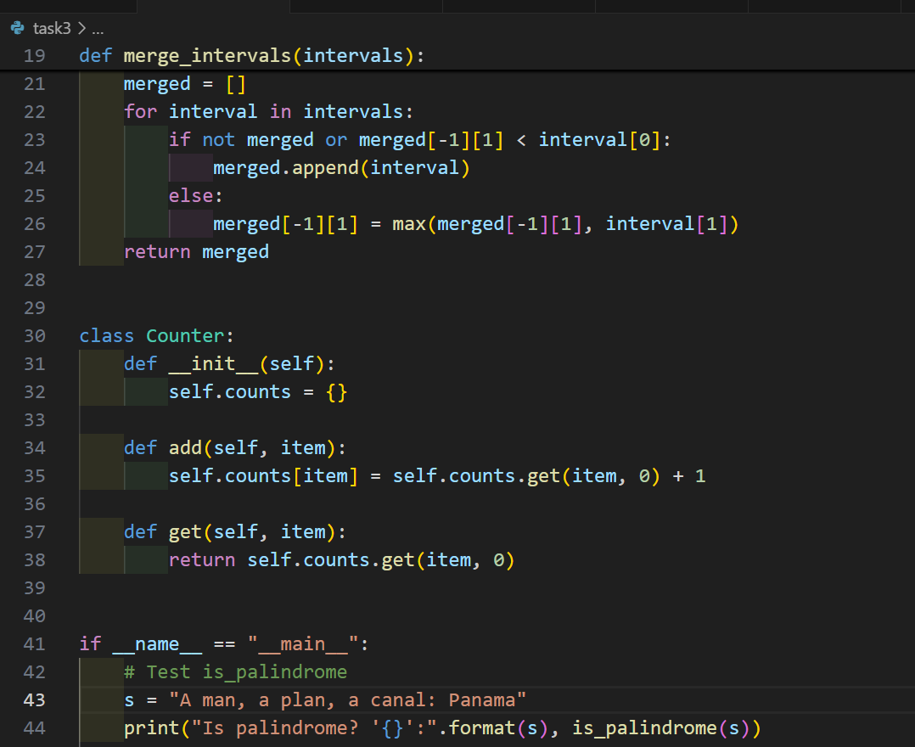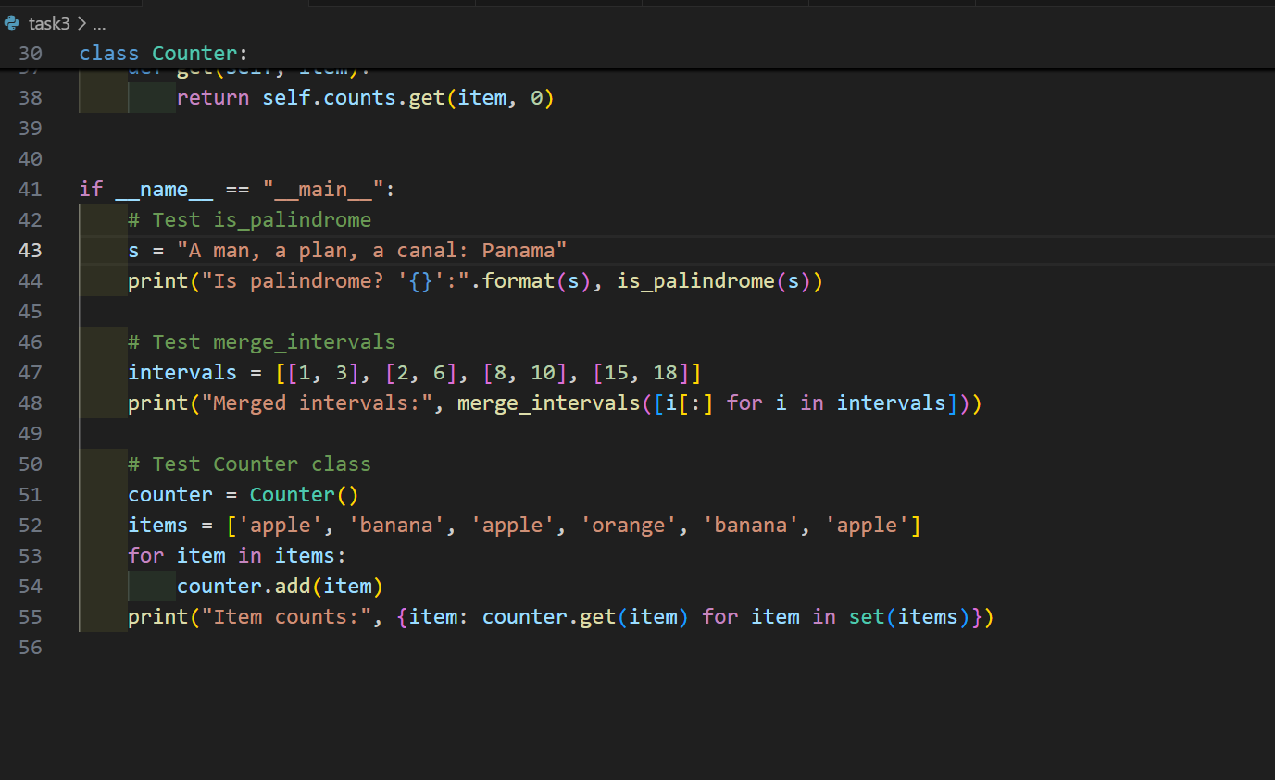

OUTPUT:

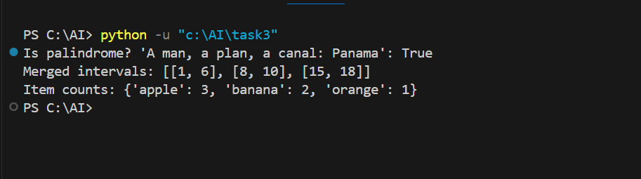

Task – 4
Task: Use AI to transform existing inline comments into
structured function docstrings following Google style.
• Instructions:
o Provide AI with Python code containing inline comments.
o Ask AI to move relevant details from comments into
function docstrings.
o Verify that the new docstrings keep the meaning intact
while improving structure.
Expected Output 4:
o Python code with comments replaced by clear,
standardized docstrings.
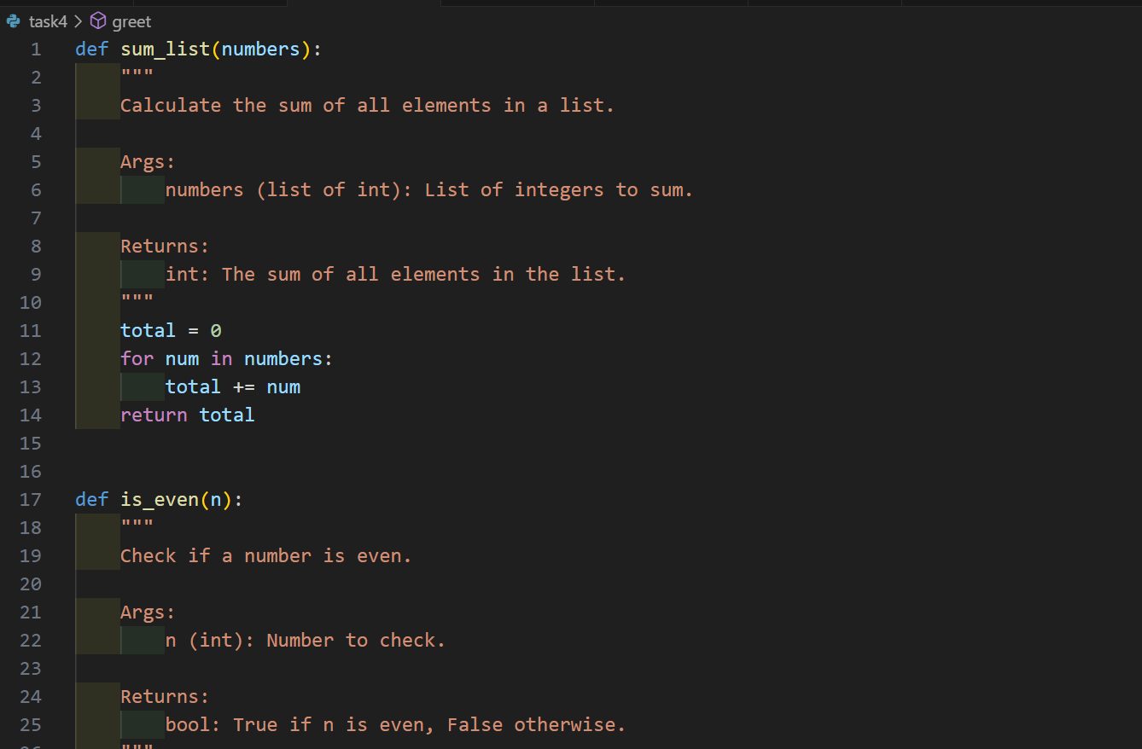
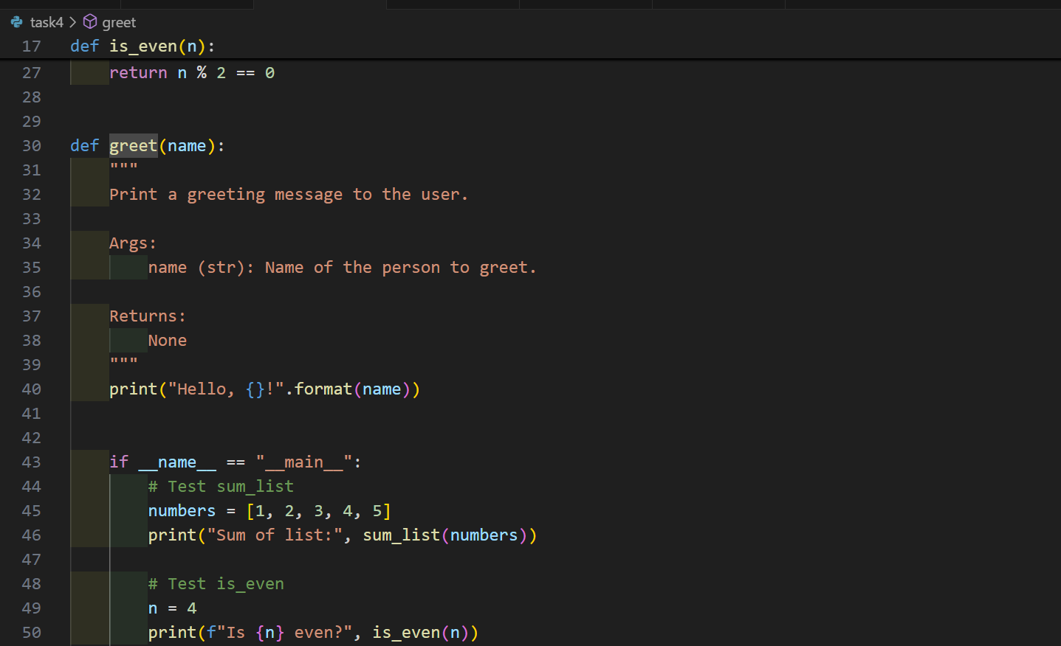
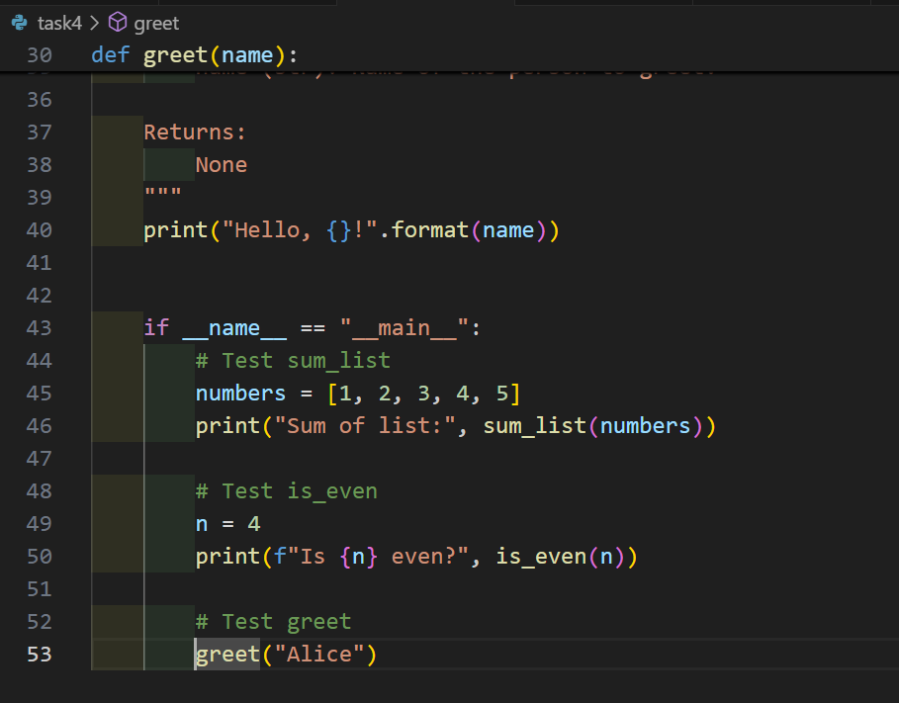
OUTPUT:
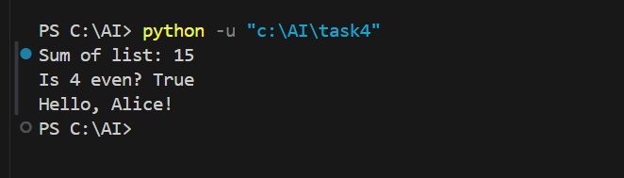
Task – 5
Task: Use AI to identify and correct inaccuracies in existing
docstrings.
• Instructions:
o Provide Python code with outdated or incorrect
docstrings.
o Instruct AI to rewrite each docstring to match the current
code behavior.
o Ensure corrections follow Google-style formatting.
Expected Output 5:
o Python file with updated, accurate, and standardized
docstrings.
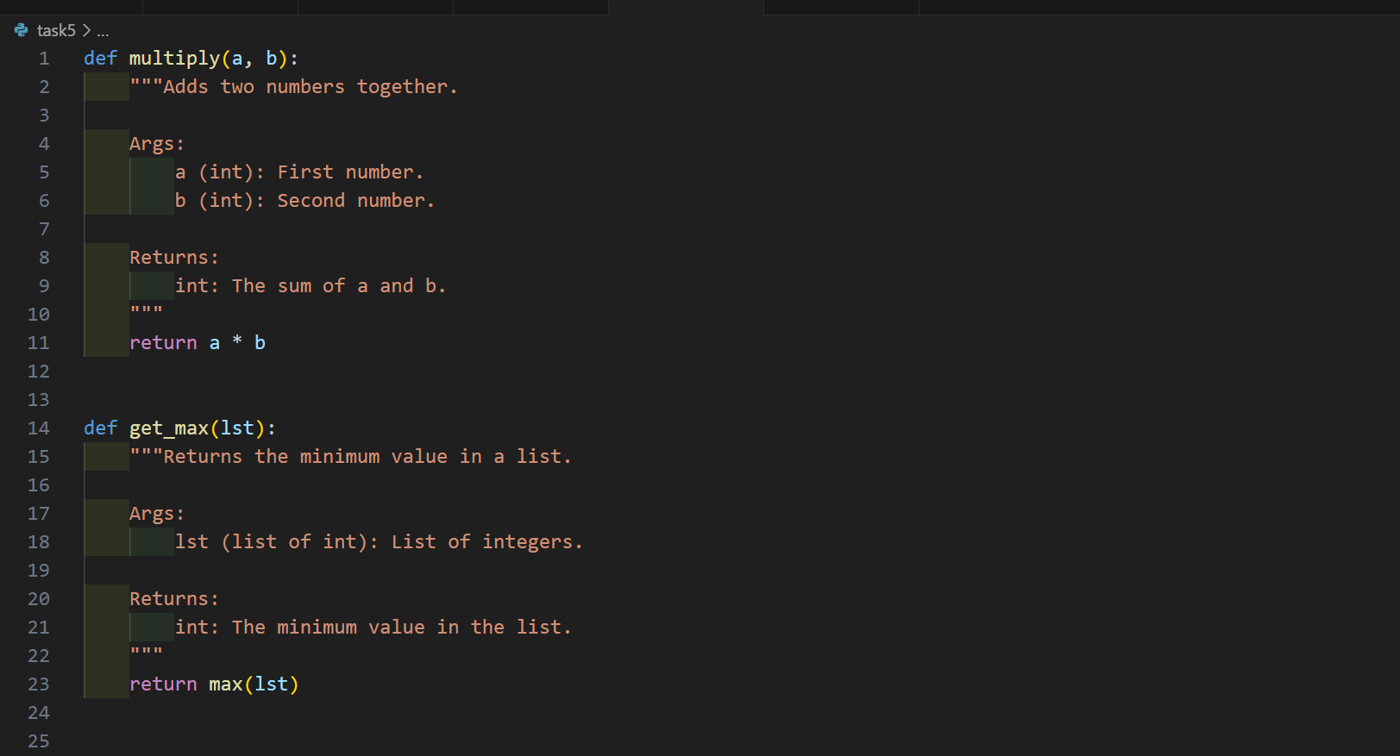
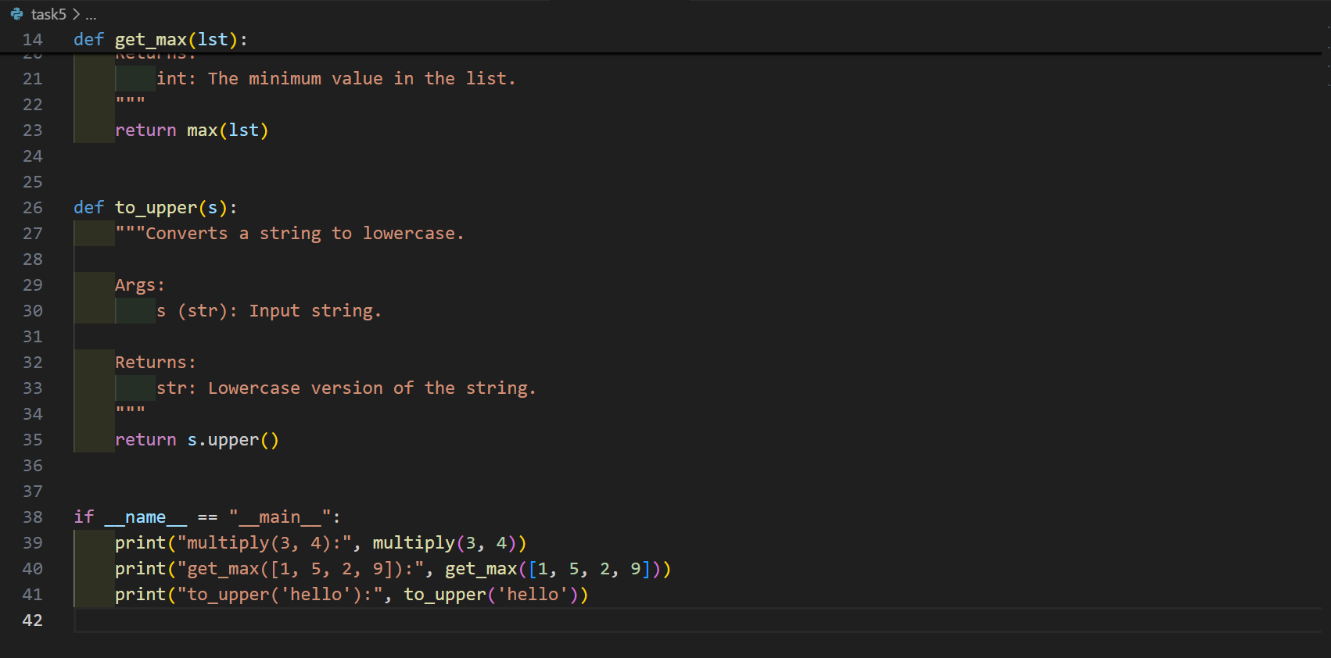

OUTPUT:
