AI ASSISTED CODING
ASSIGNMENT – 9.5
Name : B. Praneeth
HT NO.: 2403A51246
BATCH:11
Task-1: (Automatic Code Commenting)
Scenario: You have been given a Python function without comments.
def calculate_discount(price, discount_rate):
return price - (price * discount_rate / 100)
• Use an AI tool (or manually simulate it) to generate line-by-line
comments for the function.
• Modify the function so that it includes a docstring in Google-style
or NumPy-style format.
• Compare the auto-generated comments with your manually
written version
Prompt: Given this Python function:
def calculate_discount (price, discount_rate):
return price - (price * discount_rate / 100)
- Add line-by-line comments explaining each line.
- Rewrite the function with a Google-style docstring (include description, parameters, return, example).
- Compare AI-generated comments with your manually written comments.

Code:
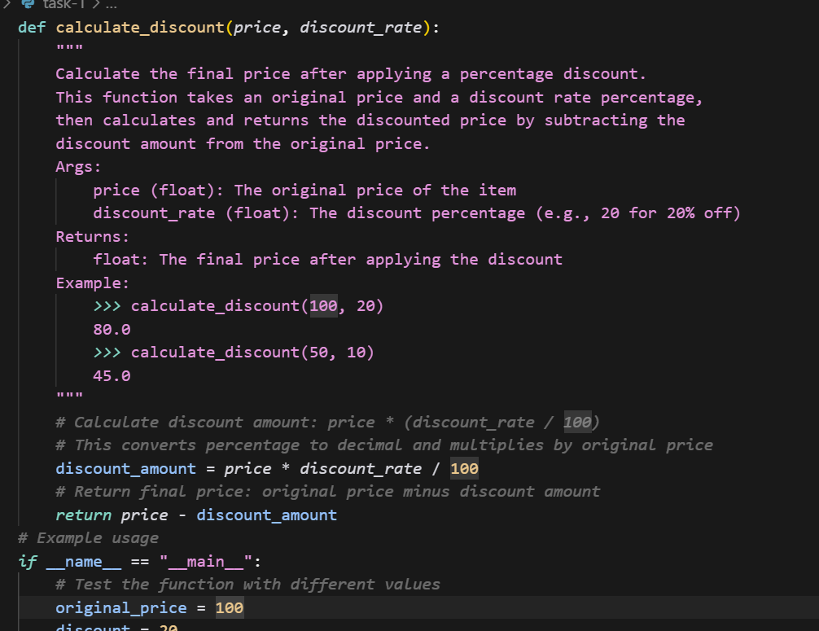
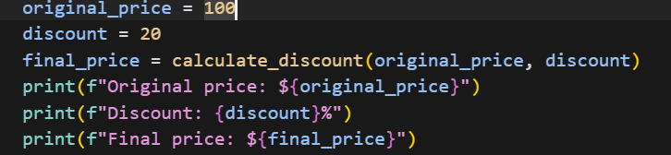
Output:
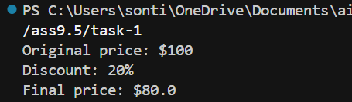

Task-2: (API Documentation Generator)
Scenario: A team is building a Library Management System with
multiple functions.
def add_book(title, author, year):
# code to add book
pass
def issue_book(book_id, user_id):
# code to issue book
Pass
• Write a Python script that uses docstrings for each function (with
input, output, and description).
• Use a documentation generator tool (like pdoc, Sphinx, or
MkDocs) to automatically create HTML documentation.
• Submit both the code and the generated documentation as output.
Prompt: Given these functions:
def add_book (title, author, year):
pass
def issue_book (book_id, user_id):
pass
- Add docstrings with description, inputs, outputs, and example.
- Generate HTML documentation using pdoc, Sphinx, or MkDocs.
- Submit the Python script and generated docs.

Code:
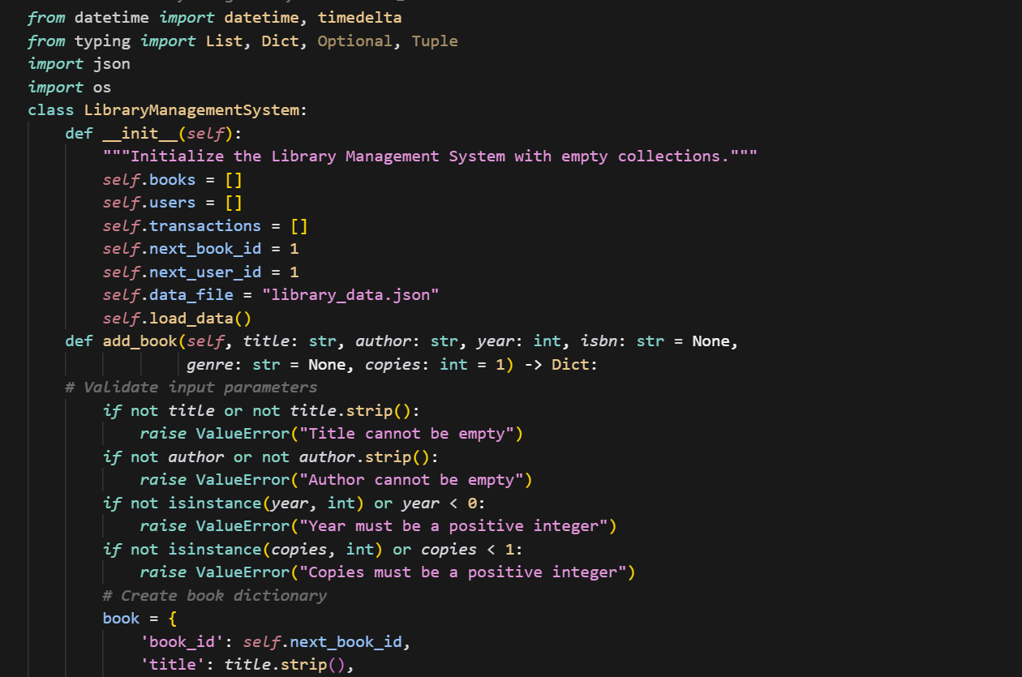
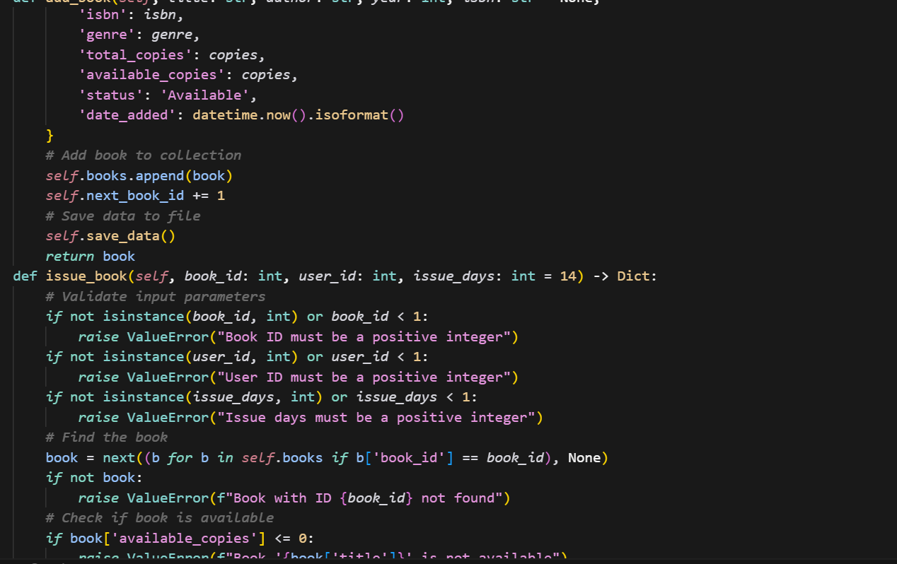
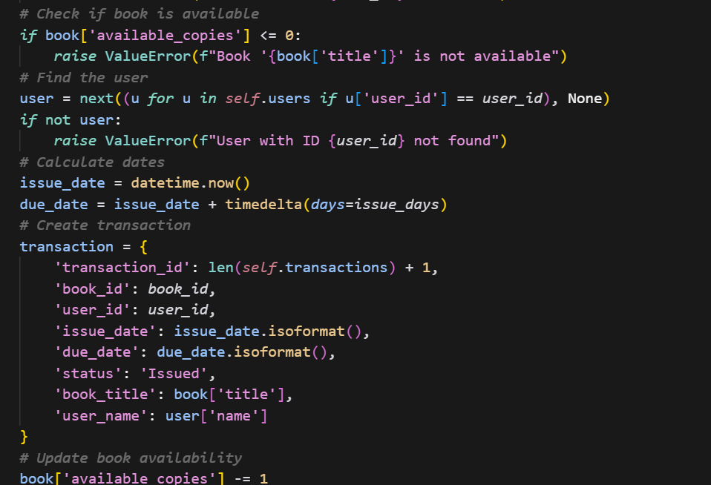
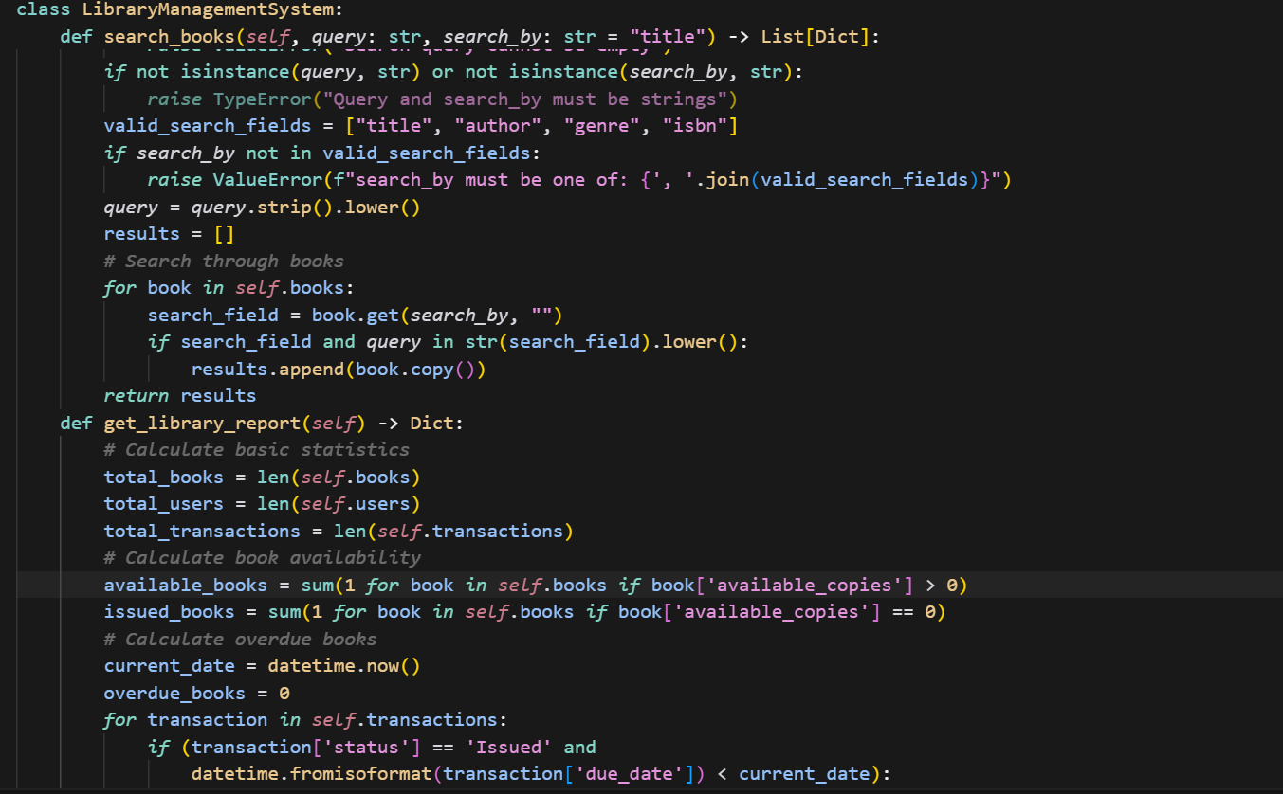
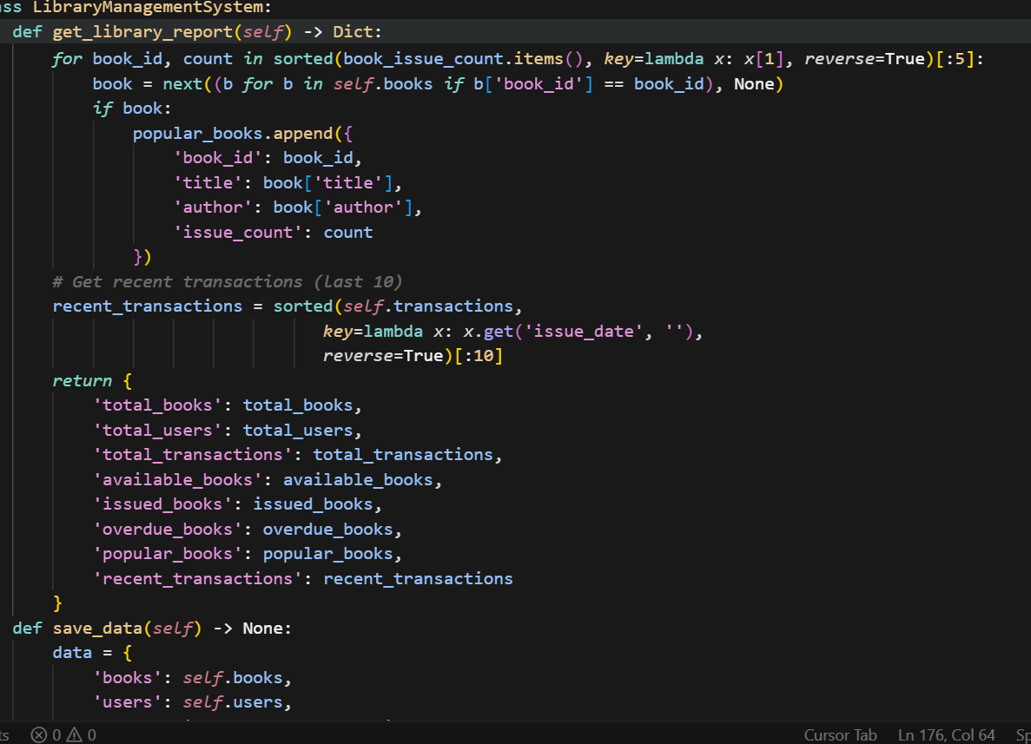
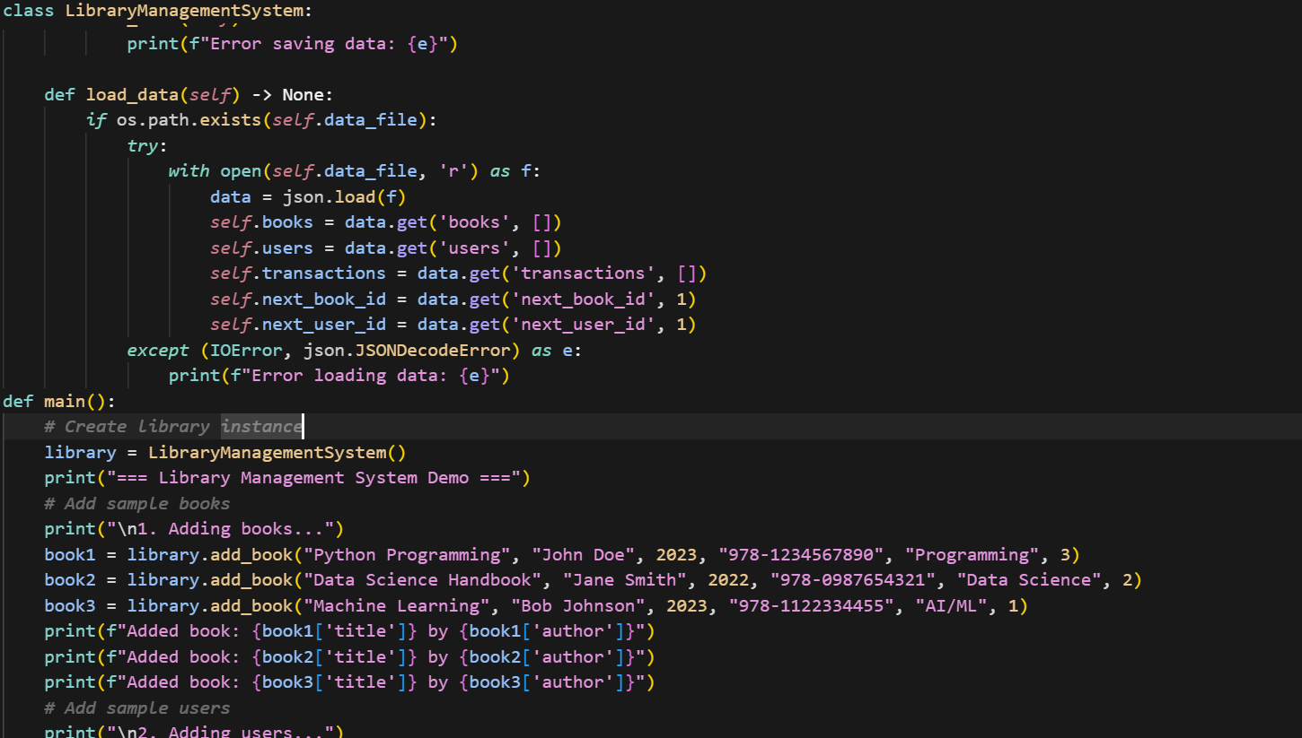
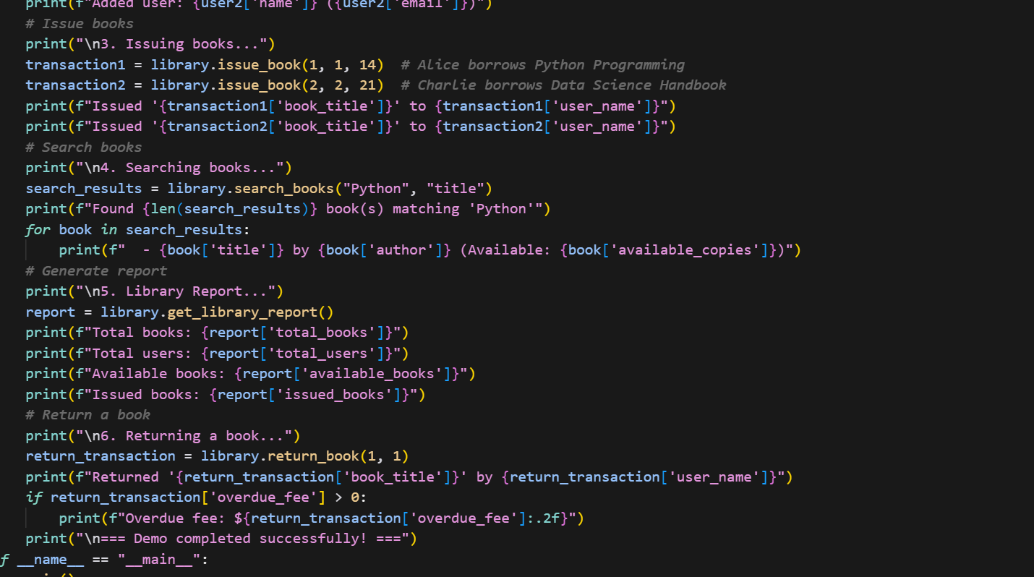
Output:
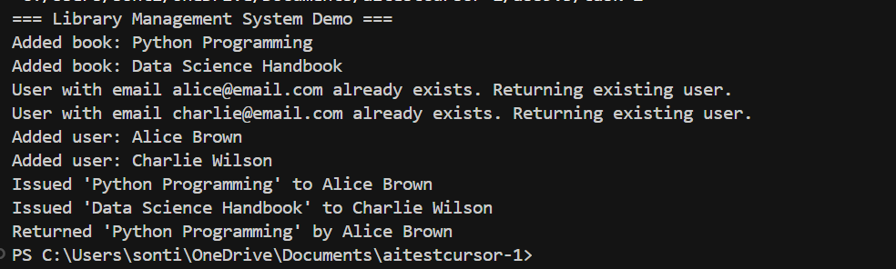
Task-3: (AI-Assisted Code Summarization)
Scenario: You are reviewing a colleague’s codebase containing long
functions.
def process_sensor_data(data):
cleaned = [x for x in data if x is not None]
avg = sum(cleaned)/len(cleaned)
anomalies = [x for x in cleaned if abs(x - avg) > 10]
return {"average": avg, "anomalies": anomalies}
• Generate a summary comment explaining the purpose of the
function in 2–3 lines.
• Create a flow-style comment (step-by-step explanation).
• Write a short paragraph of documentation describing possible use
cases of this function in real-world scenarios.
Prompt: Given this function:
def process_sensor_data(data):
cleaned = [x for x in data if x is not None]
avg = sum(cleaned)/len(cleaned)
anomalies = [x for x in cleaned if abs (x - avg) > 10]
return {"average": avg, "anomalies": anomalies}
Write:
1. A 2–3-line summary comment.
2. Step-by-step flow-style comments.
3. A short paragraph on real-world use cases.
Code:
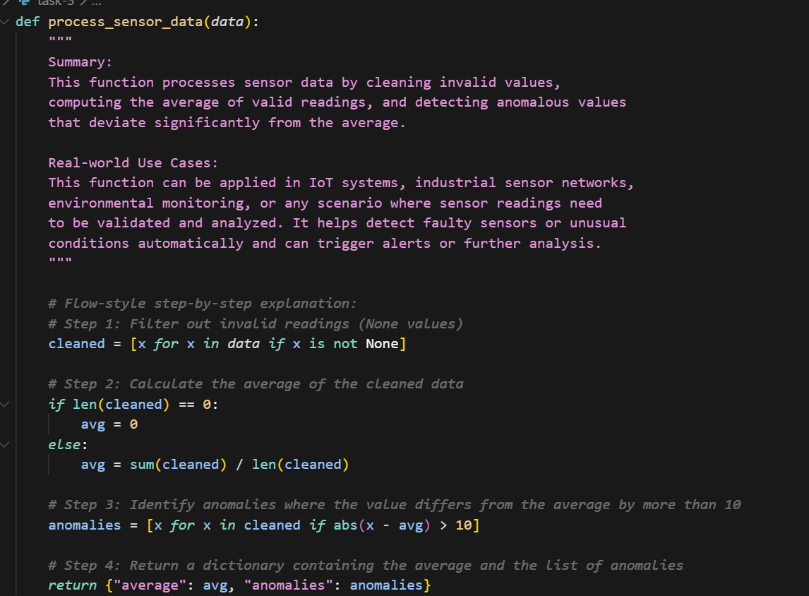
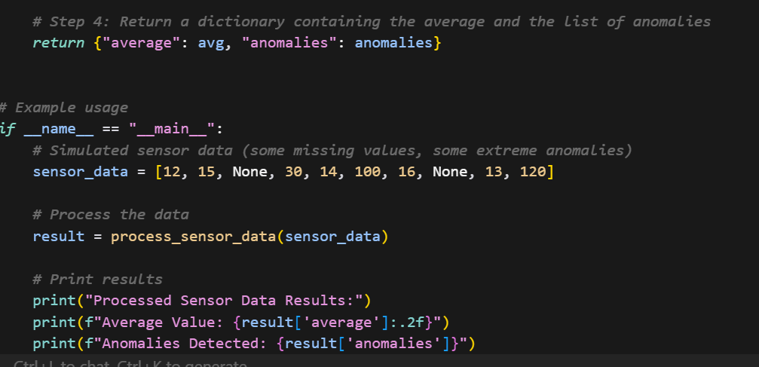
Output:
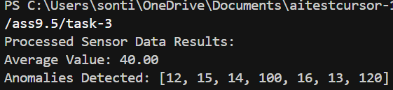
Task-4: (Real-Time Project Documentation)
Scenario: You are part of a project team that develops a Chatbot
Application. The team needs documentation for maintainability.
• Write a README.md file for the chatbot project (include project
description, installation steps, usage, and example).
• Add inline comments in the chatbot’s main Python script (focus
on explaining logic, not trivial code).
• Use an AI-assisted tool (or simulate it) to generate a usage guide
in plain English from your code comments.
• Reflect: How does automated documentation help in real-time
projects compared to manual documentation?
Prompt: You are an AI Python documentation assistant.
1. Add Google-style docstrings to all functions in this Python script.
2. Add inline comments explaining the logic.
3. Generate a simple plain-English usage guide.
Python Script:
<PASTE YOUR PYTHON CODE HERE>
Output:
- Python code with docstrings and comments.
- Plain-English usage guide.
Code:
Readme code:
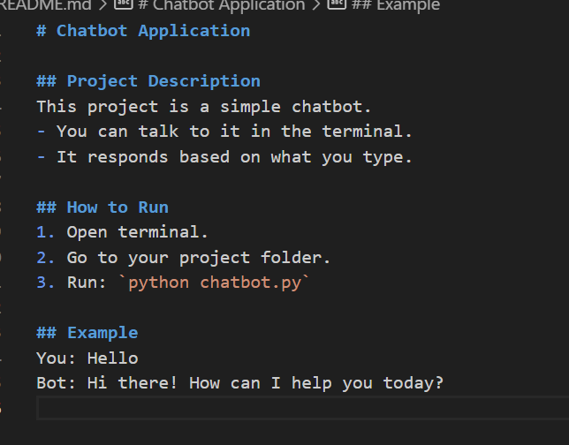

Chatbot code:
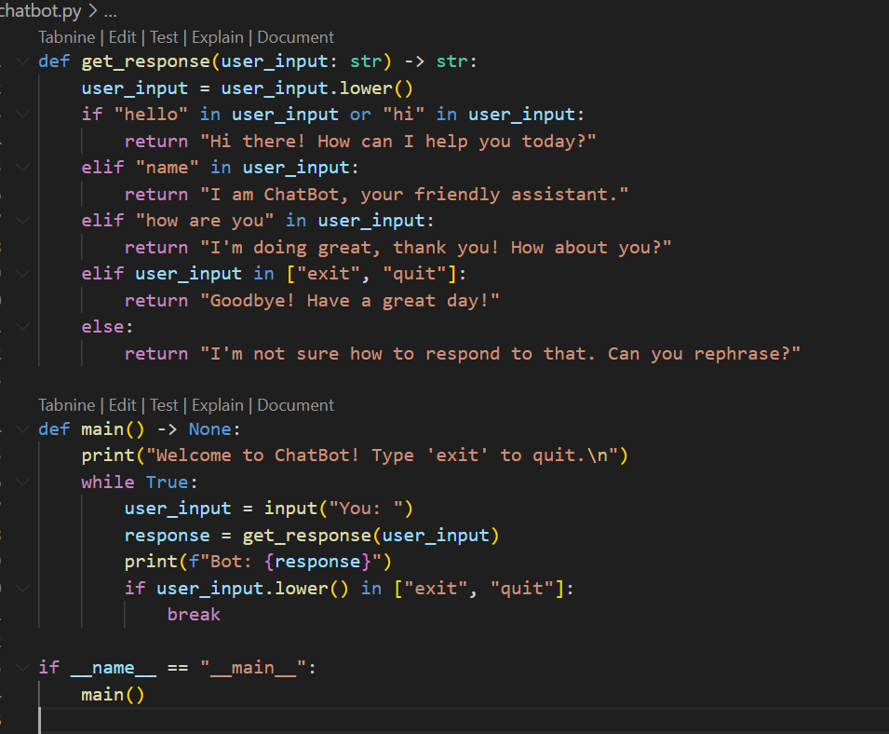
Output:
