AI ASSISTED CODING

ASSIGNMENT-10.1
Name: B. Praneeth
HT NO.:2403a51246
Batch No.:11
TASK 1
GIVEN CODE-

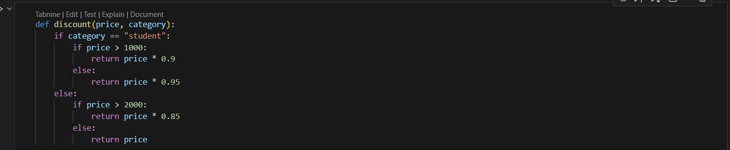
PROMPT-
For the above code simplify and refactor for readability.
AI GENERATED CODE-

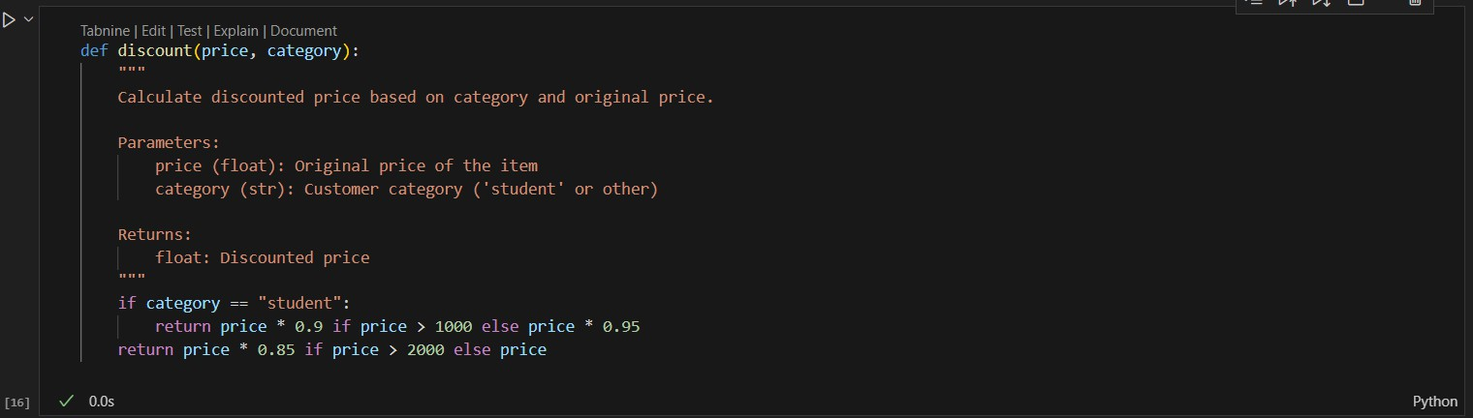

TASK 2

GIVEN CODE-
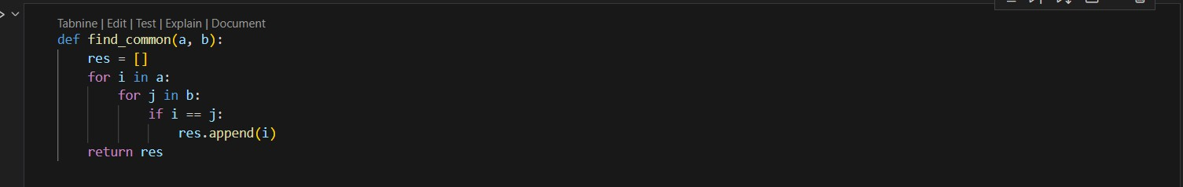
PROMPT-
Refactor and optimize the above code.
AI GENERATED CODE-
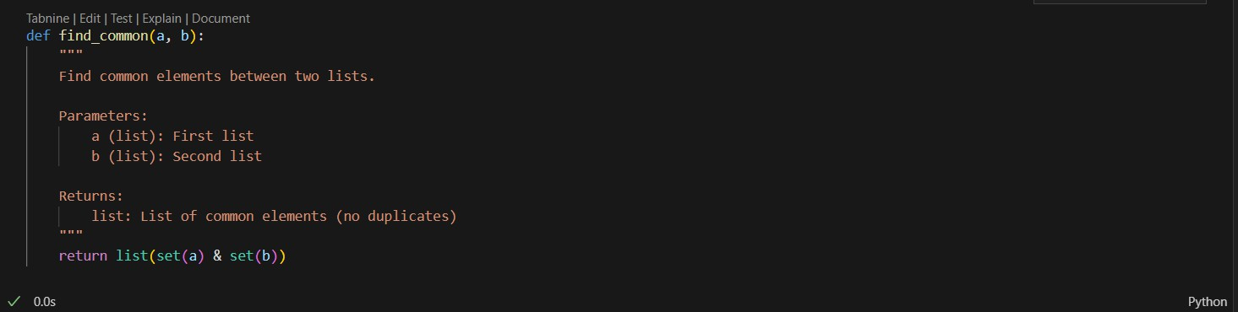

TASK 3
GIVEN CODE-

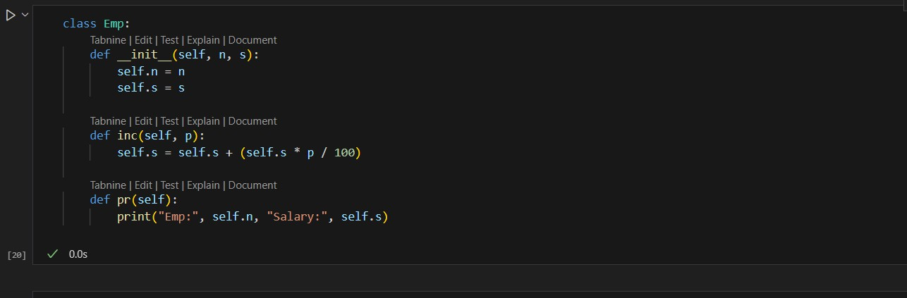
PROMPT-
For the above code improve Naming conventions, Encapsulation, Readability C maintainability.

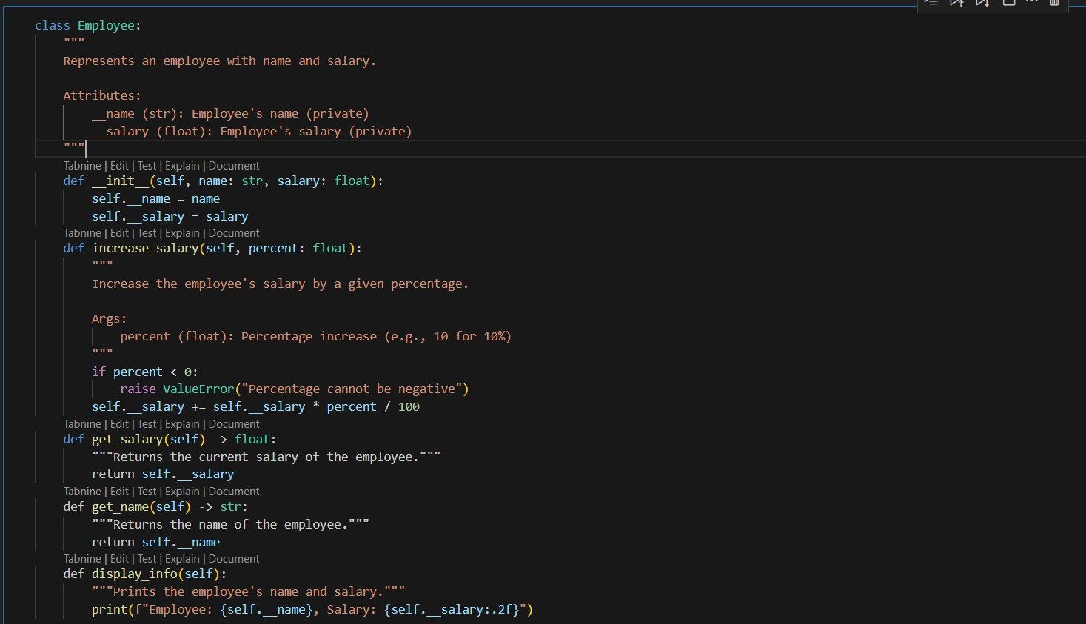
TASK 4
GIVEN CODE-
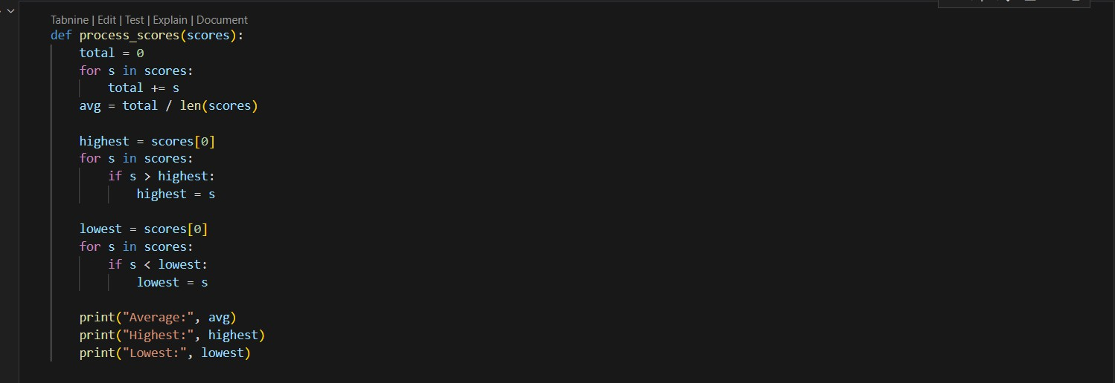
PROMPT-
Break the code into smaller helper functions.

AI GENERATED CODE-
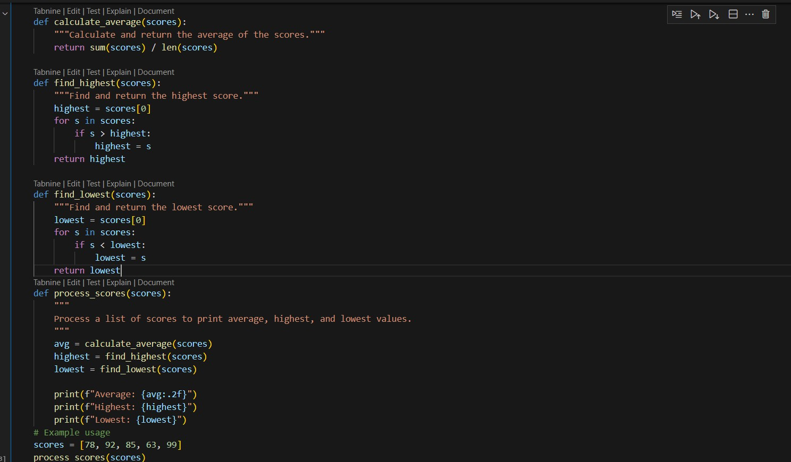
OUTPUT-
TASK 5
GIVEN CODE-

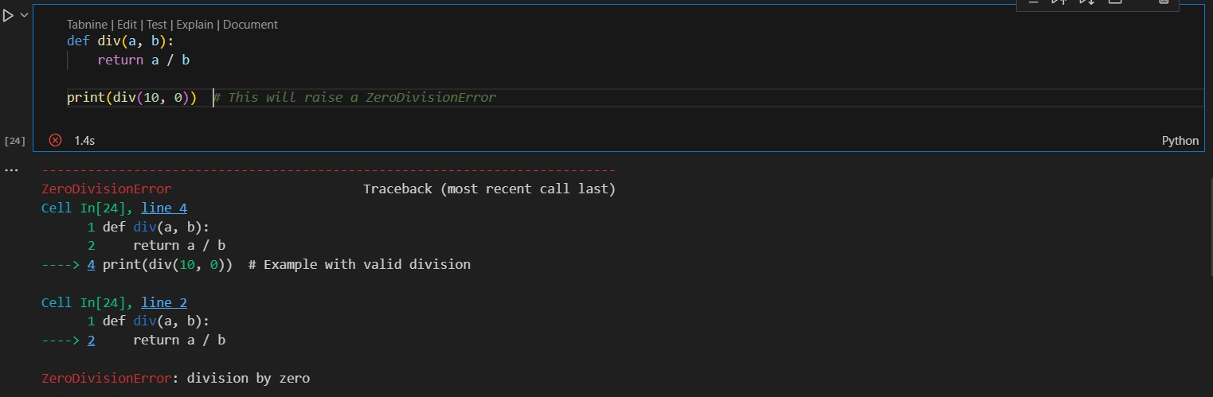
PROMPT-
For the above code improve error handling, naming, and readability.
AI GENERATED CODE-

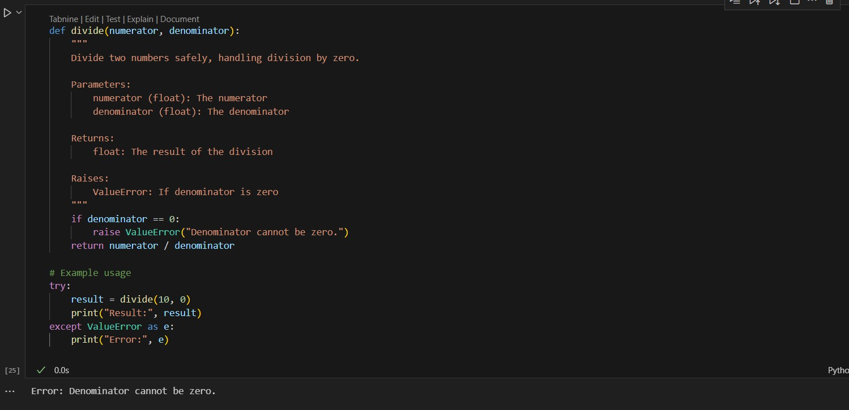
TASK 6
GIVEN CODE-

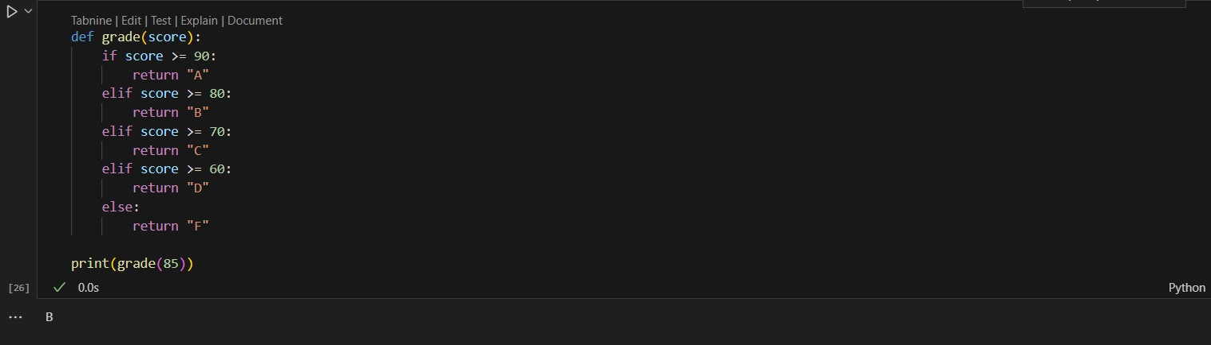
PROMPT-
Simplify overly complex logic.

AI GENERATED CODE-

