**BIG DATA ANALYSIS USING IBM CLOUD DATABASES**

**TEAM MEMBER: VISHNU** T (822721106048)

**PHASE 5:** PROJECT DOCUMENTATION & SUBMISSION

**Problem Title:** Big Data Analysis

**Problem Statement:** Dive into the world of big data analysis with IBM Cloud Databases. Uncover hidden insights from vast datasets, from climate trends to social patterns. Visualize your findings and derive valuable business intelligence. Embark on data-driven adventures, exploring the endless possibilities of big data!

**DESIGN THINKING:**

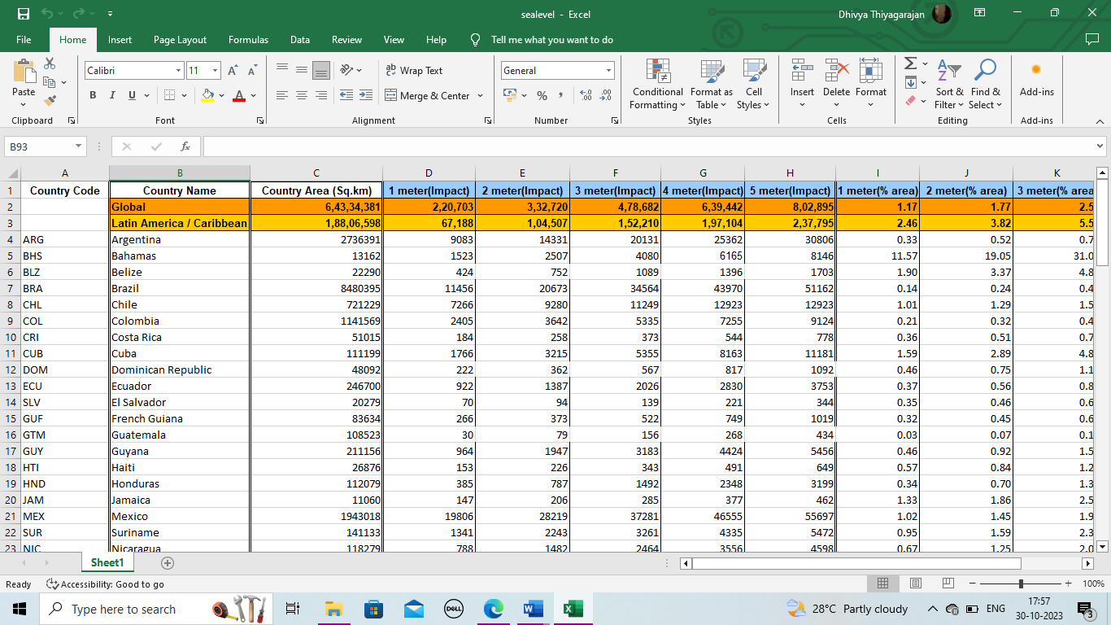**1.DATA SELECTION:** Sea level Data sets according to sea level rise and its impact.

**2.DATABASE SETUP:**

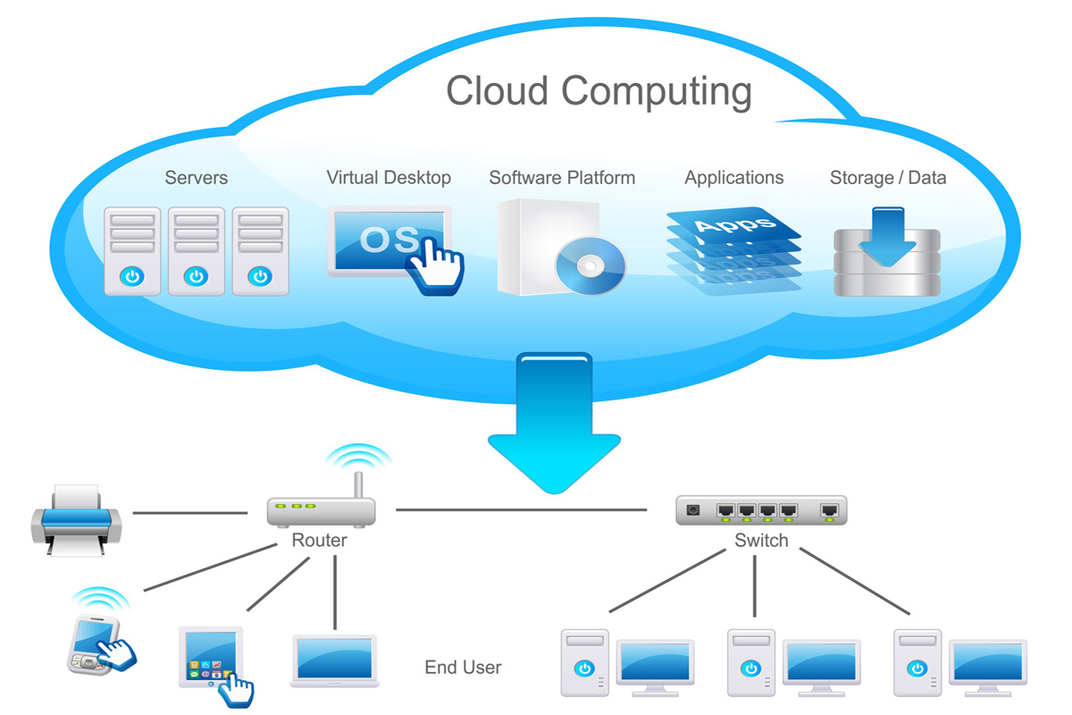

**DASHBOARD:**

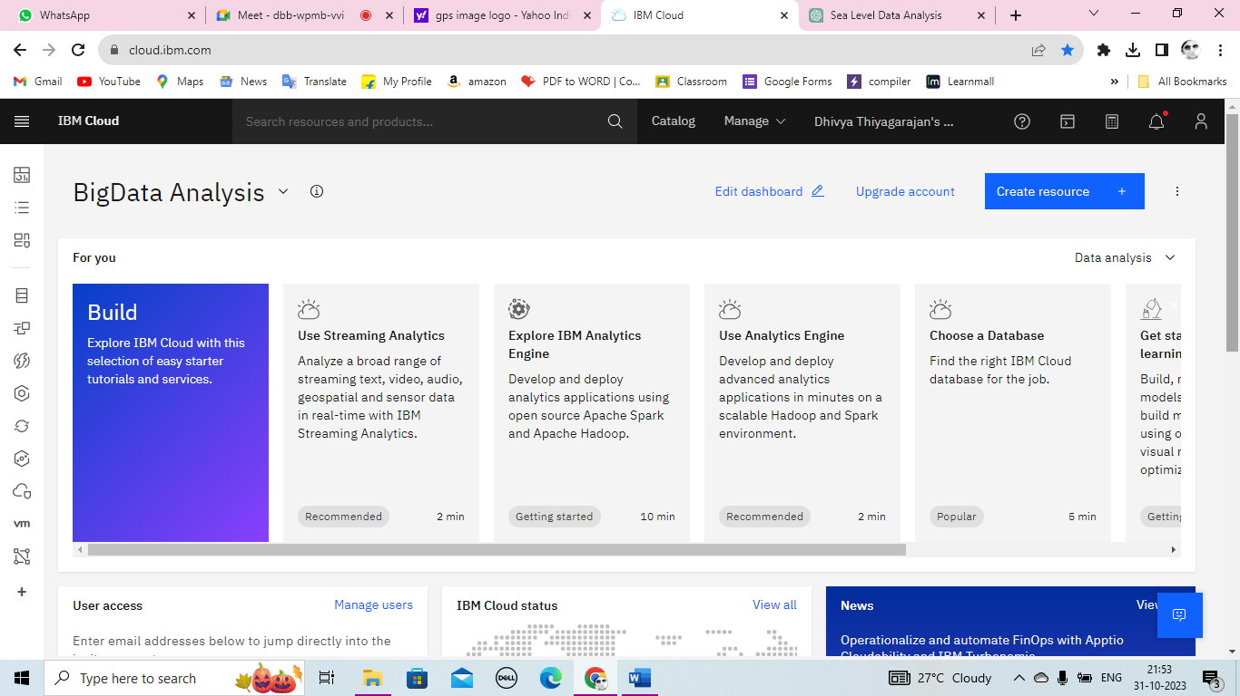

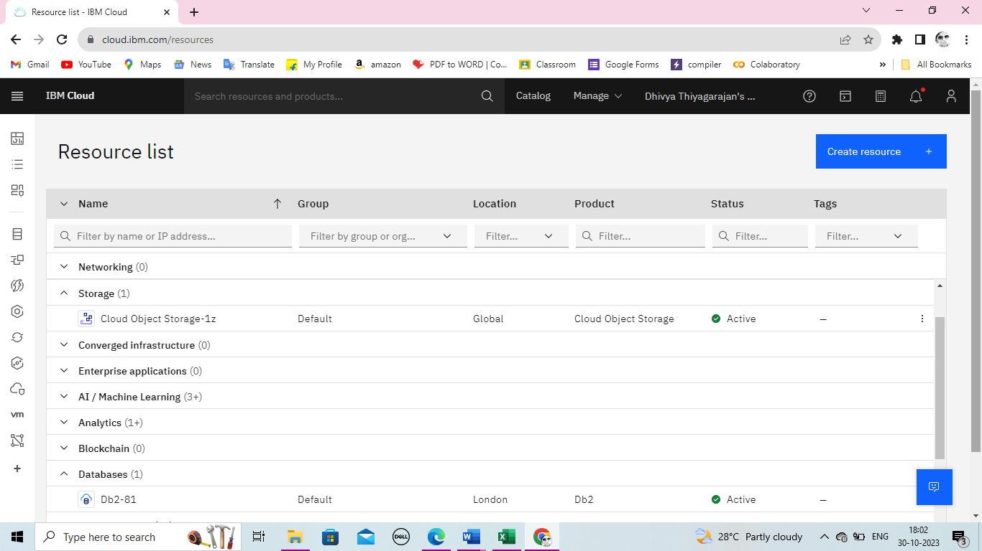

**3.DATA EXPLORATION:**

Data exploration is a broad process that is performed by business users and an increasing numbers of citizen data scientists with no formal training in data science or analytics, but whose jobs depend on understanding data trends and patterns. Exploration and preparation typically involve a great deal of interactive data analysis and visualization—usually using languages such as Python and R in interactive tools and environments that are specifically designed for this task.

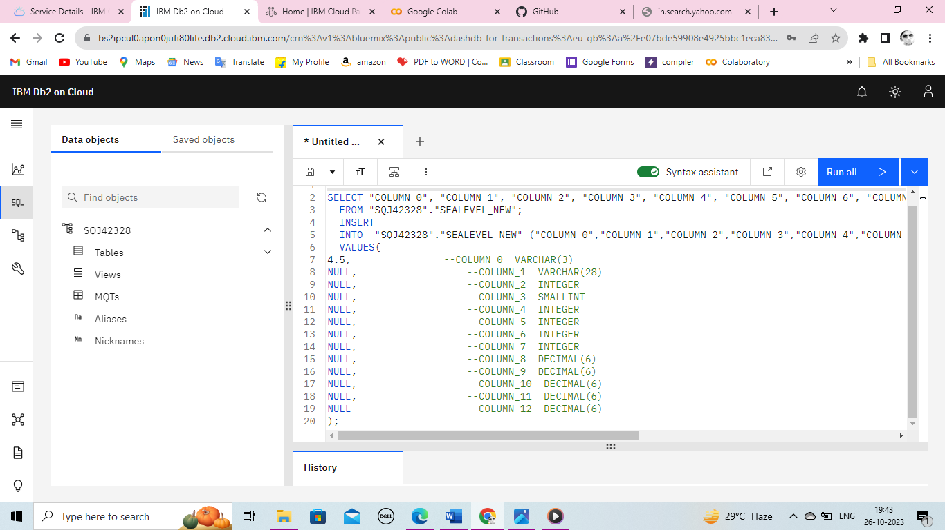**SQL OUERIES AND RESULT:**

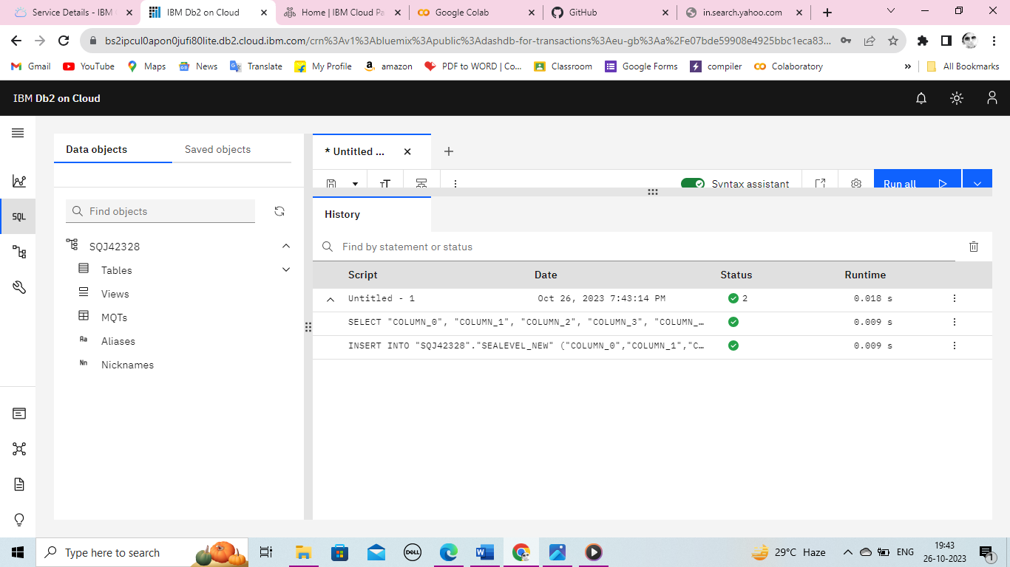

**4.ANALYSIS TECHNIQUES:**

**SENTIMENTAL ANALYSIS:** Sentiment analysis, also known as sentiment mining or emotional analysis, is a technique used in data analytics to determine and quantify the emotional tone or sentiment expressed in text data. It involves analyzing a piece of text, such as a social media post, review, comment, or any written content, to determine whether the expressed sentiment is positive, negative, or neutral.

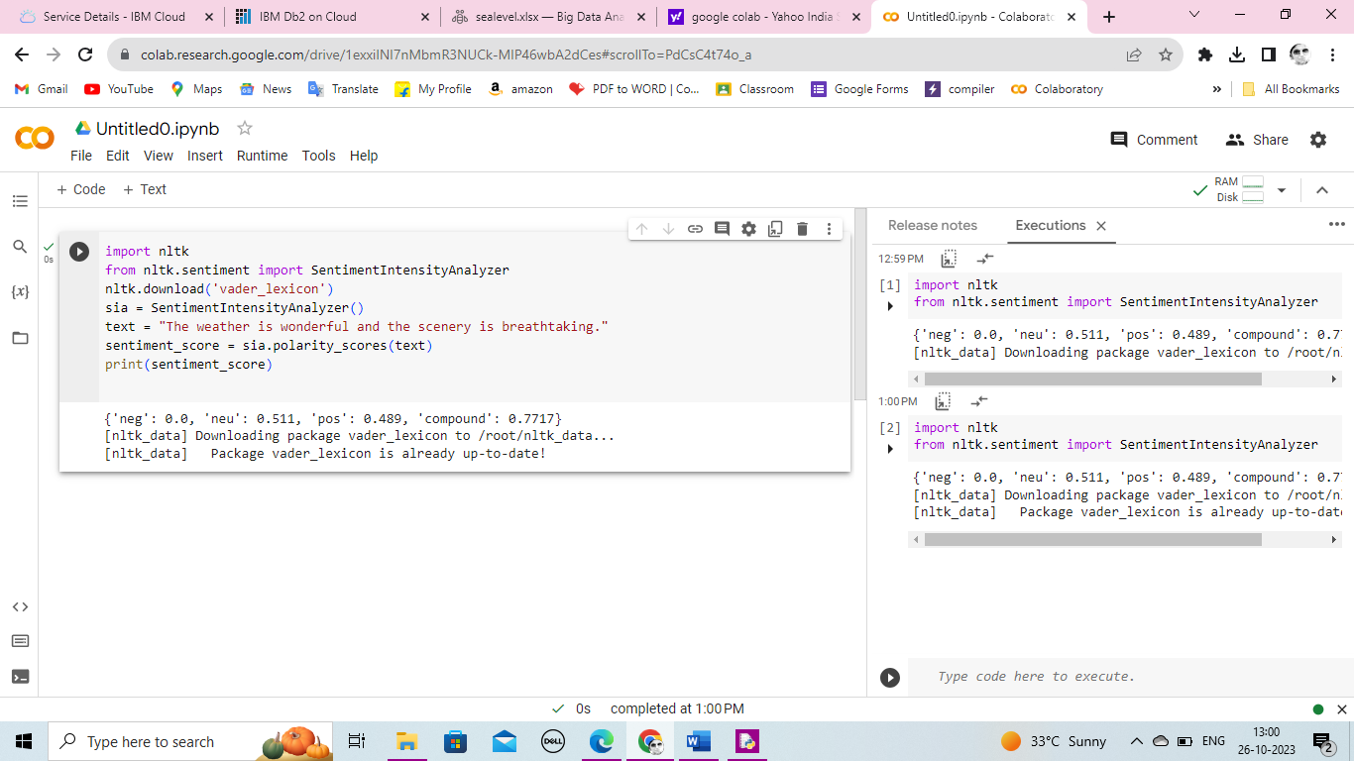

**5.VISUALIZATION:** visualizations to present the analysis results in an understandable and impactful manner.

**WORK-FLOW TO LOA D THE DATASETS:**

VISUALIZE THE RESULTS

LAUNCH IN

IBM WATSON STUDIO FOR CLOUD PAK OF DATA

PROJECT CREATION

CREATE ASSEST TO LOAD THE DATASETS

**IBM CLOUD PAK FOR DATA:**

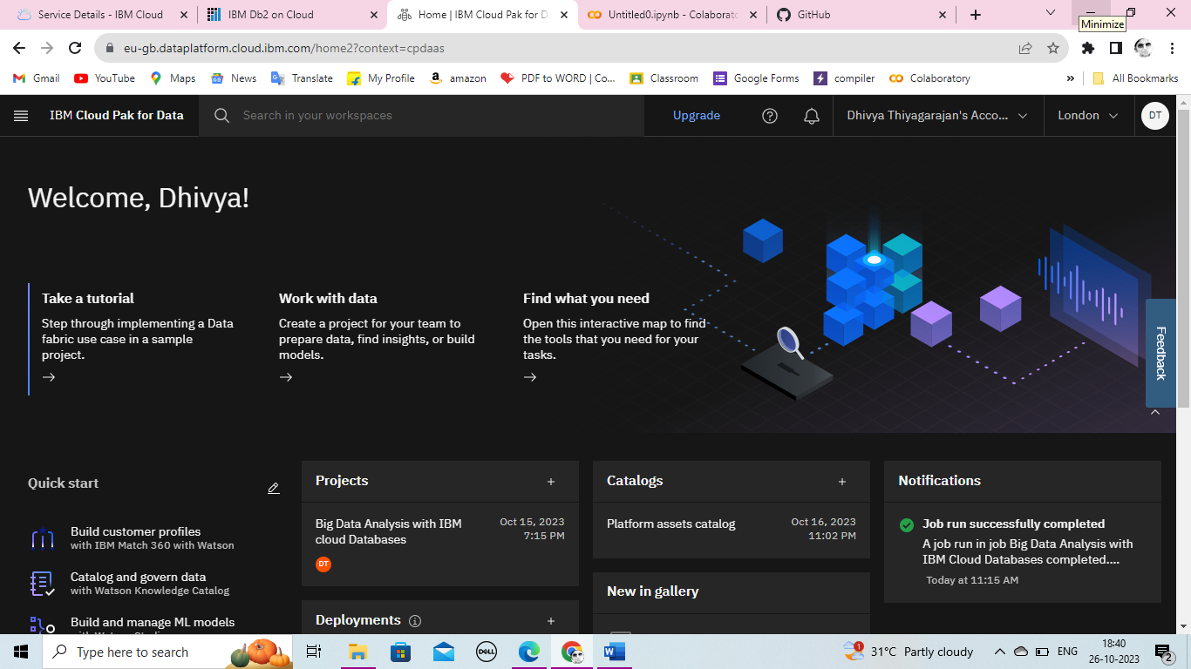

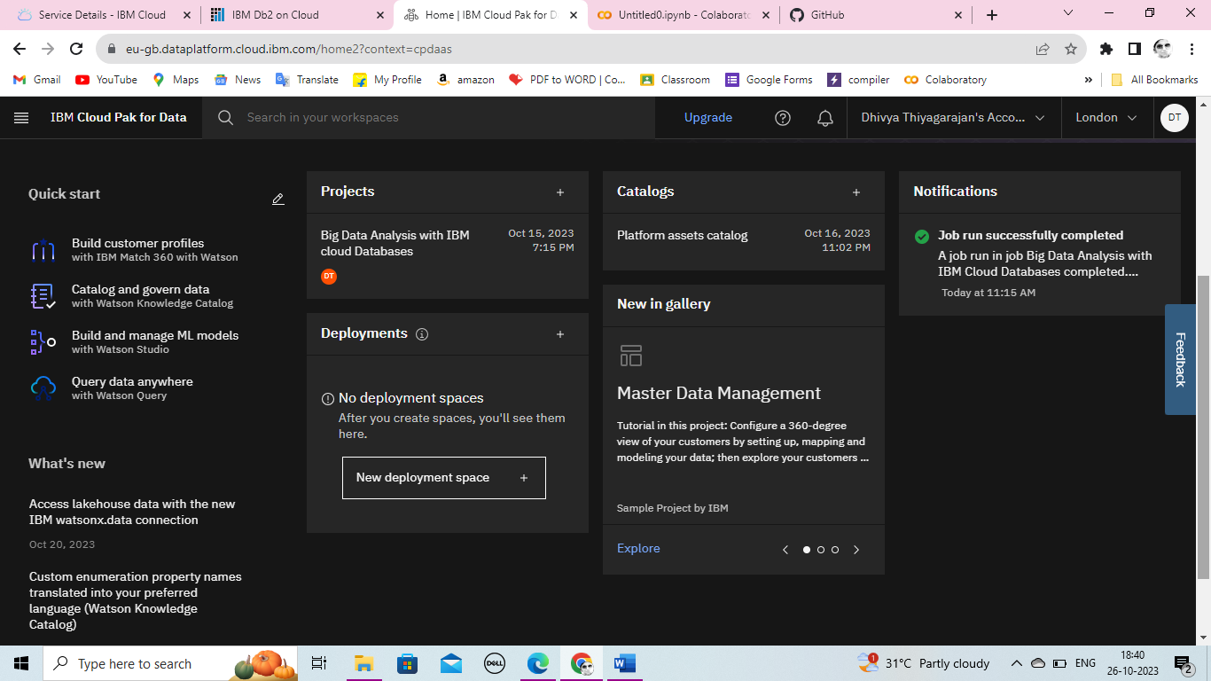

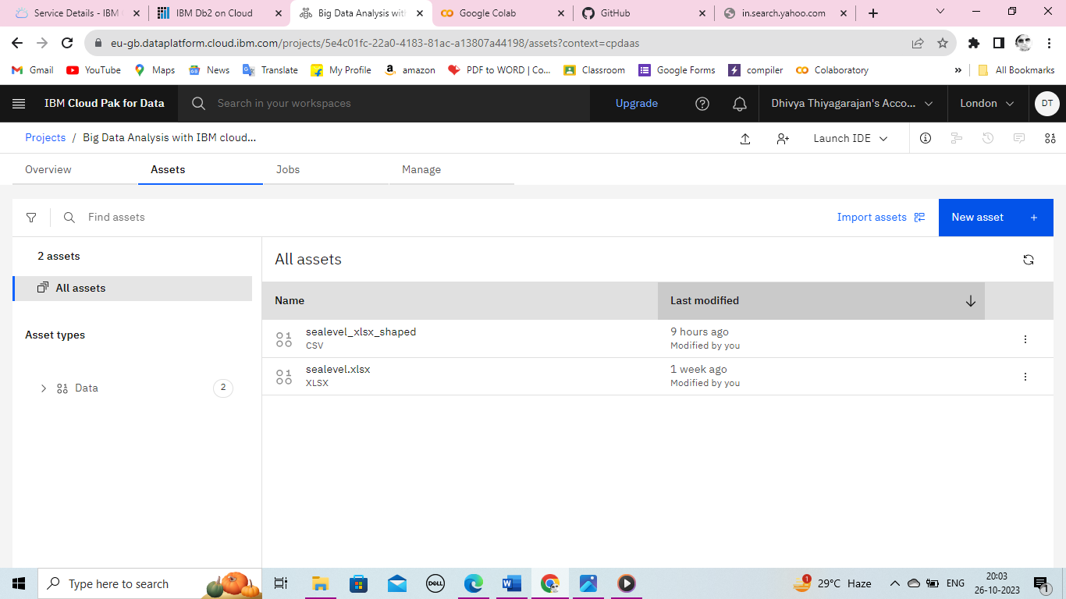

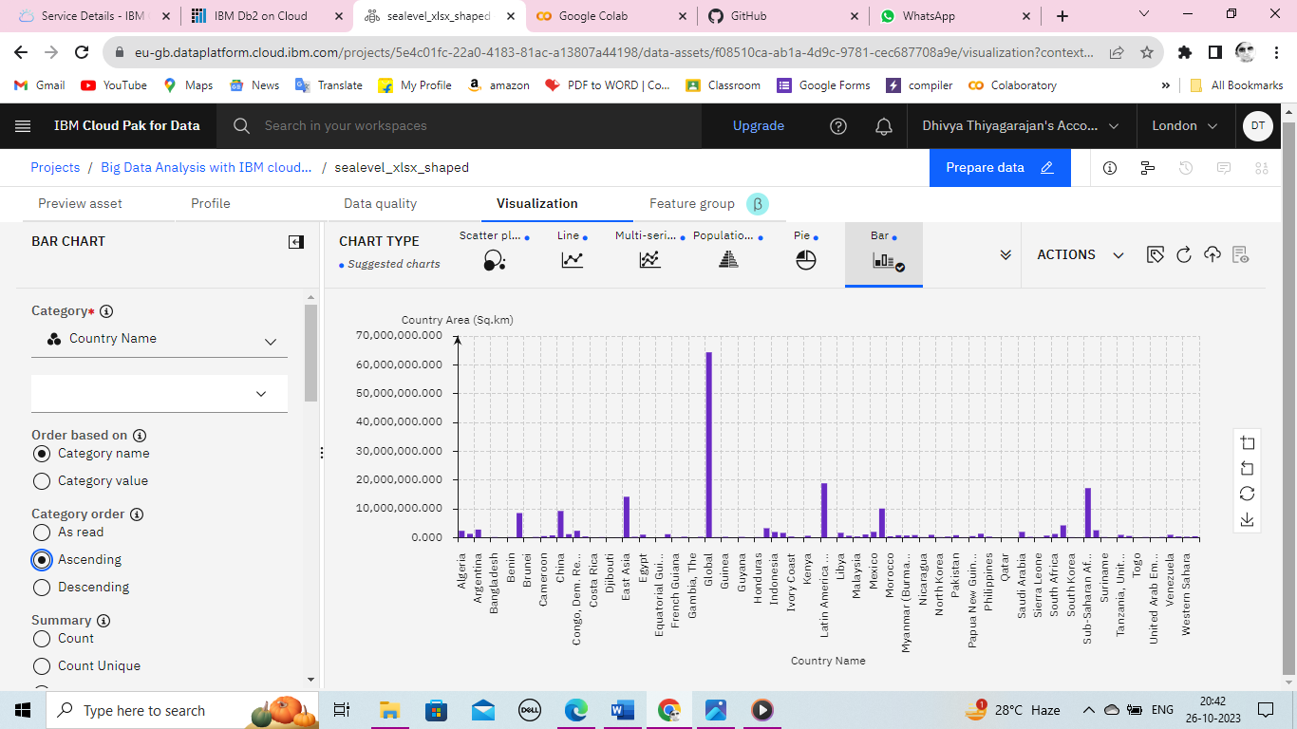**Visualized results between Country Name between Country Area(sq.km):**

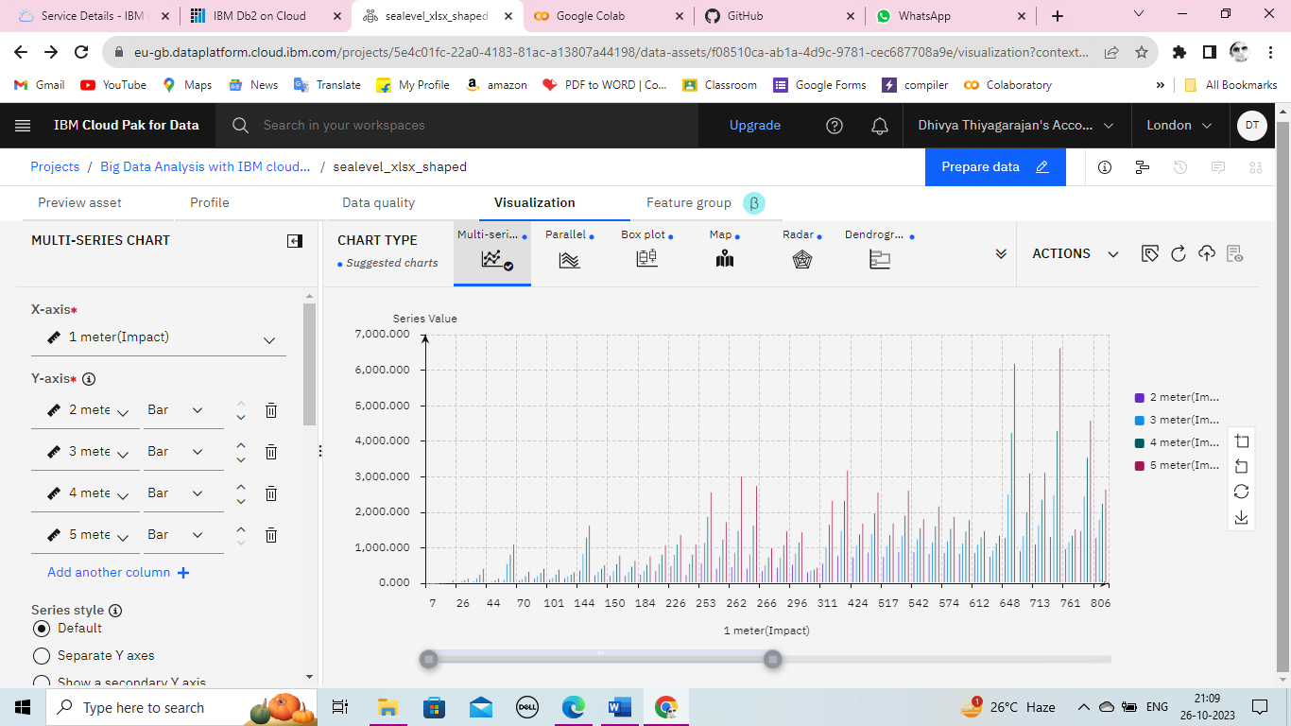**Visualized result between 1meter (Impact), 2meter (Impact), 3meter (Impact), 1meter (Impact), And 5meter (Impact):**

**6.BUSINESS INSIGHTS:**

Analyzing sea level datasets for business insights can be valuable, especially for businesses located in coastal areas or those affected by sea level changes.

**Enhance Resilience:** Develop strategies for enhancing business resilience in the face of coastal flooding and extreme weather events, minimizing operational disruptions.

**Environmental Stewardship:** Assess the environmental impact of sea level changes, contributing to sustainable and responsible business practices.