Case Study 3: BlackBox Test Case Design Techniques
Design Equivalence Class Partitioning when application number field accepts 1 to 500 digits

Enter a Number_______________ *Allow Digits from 50 to 90
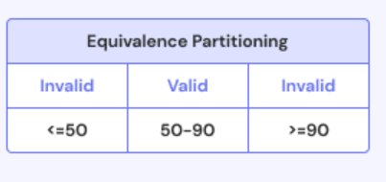
S No Normal Test Data Divide values into Equivalence classes Test Data Using ECP
1 1 0 to 19 -> 18 (Invalid) 18
2 2 20 to 39 ->34(Invalid) 34
3 3 40 to 59 ->49(Invalid) 49
4 4 40 to 59 ->50(Valid) 50
5 5 60 to 79 ->79(Valid) 79
6 6 80 to 99 ->90(invalid) 90

S NO | Normal Test Data | Divide values into Equivalence classes | Test Data Using ECP
1 | 17 | 0 to 17 ->17(Invalid) | 17
2 | 18 | 18 to 36 –>18(valid) | 18
3 | 50 | 37 to 52 ->52(valid) | 52
4 | 4 | 53 to 61 ->57(Invalid) | 57
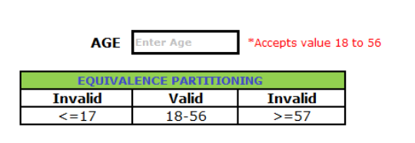

S no | Normal Test Data | Divide values into Equivalence classes | Test Data Using ECP
1 | 918254379 | 0 to 9 digits(Invalid) | 876543219
2 | 9191825439 | 10 digits(Valid) | 8765432190
3 | 919182654890 | Above 10 digits(Invalid) | 87654321909

