Test Plan for Shaadi.com Website
1. Test Plan Identifier
File Name: 1.0_Shaadi_tplan_v1.0.doc
- Document Name: Test Plan – Marriage Portal Application
- Version: SD_MP_1.0
- Date: 28-Jan-2026
- Location: Coforge Ltd, CBIT Hyderabad

2. Document History
REV | Author | Edits | Date
1.0 | B VISHNUVARDAN, Graduate Engineer Trainee | Initial Draft | 28/08/2026

- Introduction
Shaadi.com is a matrimonial/matchmaking platform where users create matrimonial profiles, set partner preferences, discover matches, send interests, communicate with matches, and use premium features. Its current features include profile verification, AI-powered recommendations, search/match filters, chat, voice/video communication, privacy controls, and premium memberships.
4. Test Items
Specifies what components/modules will be tested.
Example:
- User Registration Module
- User Login Module
- Dashboard Module
- Profile Management Module
- Matching Matches
- Nearby Matches
- Premium plans
- Profile Matching Page
- Logout Functionality

5. Features to be Tested
Medium priority features are features that have been stable and High Priority features are features that have been recently changed.

Feature to be Tested | Priority | Comments
User Registration | High
User Login | High
Dashboard Access | High
Profile Update | High
Match Details | High
Matches Section | High
Search | High
Logout | High

6. Features NOT to be Tested
- Help Contents and user manuals will not be tested.
- Installation and presentation will not be tested.
- Support of the other architectures also will not be tested.
- Third-party payment gateway internal logic
- Legacy modules not impacted by current release
- Experimental features

7. Test Environment

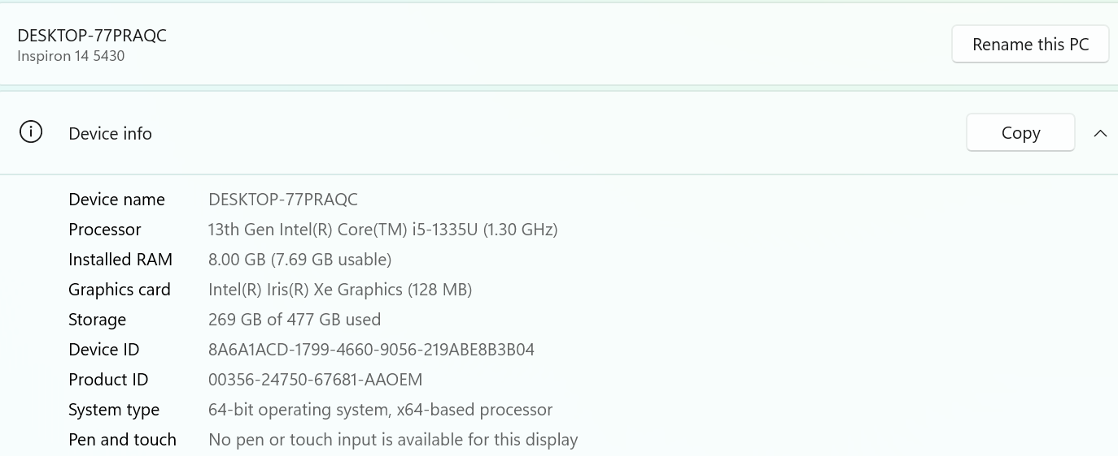

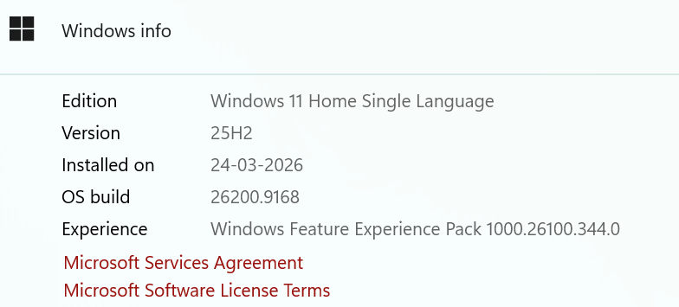
8. Test Approach / Test Strategy

Describes how testing will be performed.
The test strategy for Shaadi1.0 will include manual testing with automated testing(Selenium With Java) where time/need permits. Automated testing will be used to test the basic Interface objects keyboard and mouse navigation or any redundant tasks best translated to automation. Automated testing will be limited to a Win-64 platform because of Automation tool limitations.
- Sanity test will include an very short battery of tests to ensure the Shaadi1.0 runs/launches and can connect to the back end database(MySql /SQL Server 2025). Test execution will happen as individual component testing. These tests will be fully automated.
- Acceptance tests will include a short battery of tests that will only touch major features to ensure Shaadi1.0 will operate smoothly at a basic level. These tests will be executed on Windows 11 Home Single Language. The goal will be to automate all of these tests.
- Full Functional tests will include a comprehensive test of all features listed in this document. These tests will be limited to the Windows 11 pro. These test will include automation with time allowing.

8.1 Types of Testing
- Smoke Testing
- Sanity Testing
- Functional Testing
- Integration Testing
- System Testing
- Regression Testing
8.2 Test Levels
- Unit Testing (by developers)
- Integration Testing
- System Testing
- Acceptance Testing
8.3 Test Techniques
- Black Box Testing
- Boundary Value Analysis
- Equivalence Partitioning
- Error Guessing Functionality Testing

Usability Testing
The usability testing will be accomplished by verifying the information in each window are accurate. Menus, icons and toolbar functionality will be tested as applicable to the navigation and results panes. Multi Window Overlapping will be tested because product supports opening of multiple documents.

Robustness/Reliability Testing
Test the GUI for correct keyboard and mouse navigation, windows, menus, buttons, etc. These tests will include Keyboard only navigation of Shaadi1.0, Mouse only navigation. Correctness and existence of warning/error dialog boxes. The correct/expected functionality of buttons, icons and menus.

Stress Testing
Not applicable

9. Entry and Exit Criteria
9.1 Entry Criteria
Conditions to start testing:
- Requirements approved
- Test environment ready
- Test data available
- Build deployed
9.2 Exit Criteria
Conditions to stop testing:
- All planned test cases executed
- Critical and high defects closed
- Test summary report prepared

10. Test Deliverables
Test plan 1.0_ Shaadi_tplan.doc
Test Specification 1.0_ Shaadi_tspec.doc
Test Automation Plan TBD()
Test Checklist TBD
Test Logs TBD
Test tools Selenium 4.38, Postman, Rest Assured, Jmeter, Jenkins, Git and Git Hub and Appium and MySql Server 2025

11. Testing Tasks & Resource Needs
  - Use of MySql Server database.
  - Write Test Specification.
  - Write Test Automation plan.
  - Write Test Checklist.
  - Setup workspace.
  - Develop Automation script.
- Minimum requirements for platforms:

12. Schedule
Test Documentation
Document | Development Time |  | Sign-off Date | Dependencies
 | Person-Days | Completion Date
Test Plan | 1day | 28/08/2026 | 28/08/2026 | Functional Spec. Review
Test Specifications | 1 day | 28/08/2026 | 28/08/2026 | Test plan, Functional Spec, Review
Test Logs | TBD | 28/08/2026
Test Summary Report | TBD | 28/08/2026
Checklist | TBD | 28/08/2026

Test Development
Deliverable | Development Time |  | Dependencies
 | Person-Days | Completion Date
Functional Test Suite | 1 | 28/08/2026
Automation build

Test Execution
Test Activity |  | Execution Time (Person-Days) |  |  | Dependencies
 |  | Alpha | Beta | FCS
Acceptance |  | 1 Day | 1 Day | 1Days
Functional | Functionality | 1 | 1
 | Usability | All High to Medium test cases
 | Robustness | All High to Medium test cases
 | Stress | All High to Medium test cases
 | Multi Inst. | All High to Medium test cases
Regression
Documentation Review |  | 1 | 1 | 1
Total Test Cycle |  | 1 | 1 | 1

13. Risks and Assumptions
Risks:
- Environment Instability: Delays in setting up the test environment could impact the schedule- VM is not working port no.-5103
- Resource Availability: Limited availability of testers could delay test execution.
- Late Requirement Changes: Changes in requirements during the testing phase could lead to additional testing efforts.
- Contingencies:
- Backup Resources: Have backup resources ready to join the testing effort if required.
- Flexible Schedule: Allocate buffer time in the schedule to accommodate unexpected delays.
- Regular Communication: Hold daily stand-up meetings to quickly address any issues that arise

14. Approvals \Sign of
POSITION  *Approval required | NAME | SIGNATURE | REVIEWED | APPROVAL
Prepared by | B VISHNUVARDAN
Project Manager |  |  | Raghavendra BN | Raghavendra BN
Client Approval | Coforge

