NC State University
Department of Electrical and Computer Engineering
ECE 463/563: Fall 2019
Project #3: Dynamic Instruction Scheduling

by

<< VISHNU SURESH MENON>>

NCSU Honor Pledge: "I have neither given nor received unauthorized aid on this test or assignment."

Student’s electronic signature: __________Vishnu Suresh Menon__________________
(sign by typing your name)

Course number: _________563________
(463 or 563 ?)

Trends of IPC on Scheduling Queue Size

val_gcc_trace_mem.txt
N=1 | S | 8 | 16 | 32 | 64 | 128 | 256
N=1 | IPC | 0.99 | 1 | 1 | 1 | 1 | 1
N=2 | S | 8 | 16 | 32 | 64 | 128 | 256
N=2 | IPC | 1.88 | 1.99 | 1.99 | 1.99 | 1.99 | 1.99
N=4 | S | 8 | 16 | 32 | 64 | 128 | 256
N=4 | IPC | 2.67 | 3.54 | 3.9 | 3.97 | 3.97 | 3.97
N=8 | S | 8 | 16 | 32 | 64 | 128 | 256
N=8 | IPC | 2.82 | 4.54 | 6.48 | 7.52 | 7.83 | 7.83

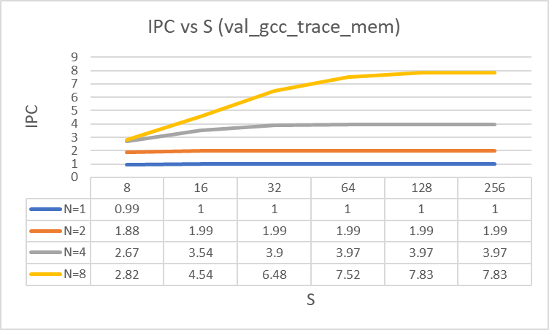

Observations

- For a given value of N, the trend between the number of instructions per cycle and scheduling queue
size is observed to increase slightly to a particular value where it gets saturated, ie; for a given a pipeline width the throughput of the processor increases marginally and gets saturated to a constant value.
- This trend is common for all the values of N as shown above but the slope of the trend becomes more steeper as the value of N increases (as described in the above graph), ie; for processors with higher pipeline width microarchitecture configuration the variation of throughput against instruction queue size is considerably significant.
- For a given value of S , the trend of IPC on pipeline width N is also found to be increasing and as the value of S increases the trend variation becomes significant and steeper.

val_perl_trace_mem.txt
N=1 | S | 8 | 16 | 32 | 64 | 128 | 256
N=1 | IPC | 0.98 | 1 | 1 | 1 | 1 | 1
N=2 | S | 8 | 16 | 32 | 64 | 128 | 256
N=2 | IPC | 1.68 | 1.89 | 1.98 | 1.98 | 1.98 | 1.98
N=4 | S | 8 | 16 | 32 | 64 | 128 | 256
N=4 | IPC | 2.18 | 2.91 | 3.68 | 3.91 | 3.94 | 3.94
N=8 | S | 8 | 16 | 32 | 64 | 128 | 256
N=8 | IPC | 2.28 | 3.37 | 5.18 | 6.95 | 7.61 | 7.75

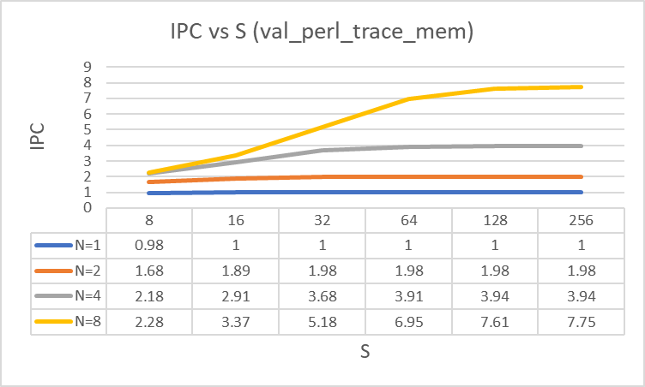

Observations

- For a given value of N, the trend between the number of instructions per cycle and scheduling queue
size is observed to increase slightly to a particular value where it gets saturated, ie; for a given a pipeline width the throughput of the processor increases marginally and gets saturated to a constant value.
- This trend is common for all the values of N as shown above but the slope of the trend becomes more steeper as the value of N increases (as described in the above graph), ie; for processors with higher pipeline width microarchitecture configuration the variation of throughput against instruction queue size is considerably significant.
- For a given value of S , the trend of IPC on pipeline width N is also found to be increasing and as the value of S increases the trend variation becomes significant and steeper.

Reasoning

The minimal increase in IPC w.r.t S is due to the fact that as the capacity of the issue queue increases the processor gets higher probability of ready instructions to get issued to the execution unit ie; processor can perform register renaming for the operands of higher number of instructions and issue for execution in out of order. But again, this largely is limited by the processor pipeline width due to which the trend gets saturated to a constant value beyond which the instructions can’t be issued even if there exist ready instructions seating inside the instruction scheduling queue.

At lower issue peak rate configurations (N), the IPC doesn’t increase much w.r.t S but at higher values of issue peak rate the variation is observable and significant which is due to the fact that as pipeline stage width increases the size of dispatch and execute queues and the number of functional units increases, ie; the structural hazard/restriction gets loosened which in turn facilitates the execution of more number of instructions in parallel out of order sequence.

Also, it can be inferred from the above graphs that for a microarchitecture configuration with a given issue peak rate, as the size of issue queue is increased, the IPC of the processor increases but with diminishing returns.

Benchmarks Comparison

The IPC saturates at lower value of issue queue in the case of gcc compared to the perl benchmark which provides the conclusion that the instruction set of the perl contains more dependent instructions and the time duration that these instructions get seated in the issue queue is longer.

