Name: Ganesh Gouru |Title: Senior Python Developer | Data Engineer | GenAI | Cloud | Devops
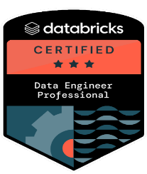
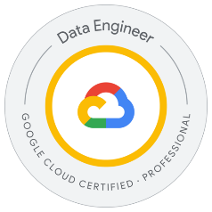
Mobile: (682) 549-9695 |Email: ganesh.gouru91@gmail.com | LinkedIn: linkedin.com/in/ganeshgouru91
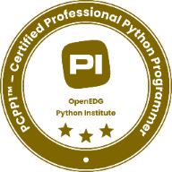
CERTIFICATIONS
- PCPP1™ - Certified Professional Python Programmer
- DataBricks Certified Data Engineer - Professional
- GCP Cloud Certified Data Engineer - Professional

PROFESSIONAL SUMMARY
{% for k in SUMMARY %}
- {{r k }} {% endfor %}
TECHNICAL SKILLS
{%tr for category in TECHNICAL_SKILLS %}
{{ category.NAME }} | {{ category.SKILLS }}
{%tr endfor %}
PROFESSIONAL EXPERIENCE
CLIENT: Atlantic Health, Remote Dec 2022 – Present
ROLE: Senior Python Developer
RESPONSIBILITIES
{% for k in RESPONSIBILITES_AL %}
- {{r k }} {% endfor %}
ENVIRONMENT
{{ENVIRONMENT_AL}}
CLIENT: Fidelity, Mckinney, Tx Dec 2020 – Nov 2022
ROLE: Senior Full Stack Developer

RESPONSIBILITIES
{% for k in RESPONSIBILITES_FD %}
- {{r k }} {% endfor %}
ENVIRONMENT
{{ENVIRONMENT_FD}}

CLIENT: State of Michigan, Lansing, MI Jul 2017 – Nov 2020
ROLE: Python Developer
RESPONSIBILITIES
{% for k in RESPONSIBILITES_SM %}
- {{r k }} {% endfor %}
ENVIRONMENT
{{ENVIRONMENT_SM}}
CLIENT: Airtel, Mumbai, India May 2012 – Jul 2015
ROLE: Software Engineer

RESPONSIBILITIES
- Developed Python (Flask) utilities and command-line scripts for data extraction, log parsing, and daily report automation.
- Built and scheduled ETL jobs with Python and Shell, cleaning and transforming subscriber usage and recharge data for internal dashboards.
- Created REST APIs with Flask to expose processed data to CRM and reporting tools.
- Wrote and optimized SQL (Oracle 11g / MySQL) procedures, triggers, and views for large-volume billing and usage datasets.
- Assisted in R&D proof-of-concepts using Kafka and RabbitMQ for streaming and async data exchange.
- Integrated MongoDB for flexible log storage and Redis for caching subscriber session data.
- Used Pandas and Matplotlib (POC) to analyse and visualize usage metrics for management reports.
- Deployed and monitored services on AWS EC2, using S3 for data backup and RDS for structured storage.
- Set up builds and CI jobs in Jenkins, ensuring data scripts and API jobs ran reliably.
- Helped implement ELK Stack and Nagios for log analysis and system monitoring.
- Collaborated with QA and DevOps teams to validate data accuracy, automate releases, and improve reliability.
- Followed Agile (Scrum) sprints with Git and TFS for source control and review cycles.
ENVIRORNMENT
Python 3.x, Flask, Shell, Pandas, Matplotlib, Oracle 11g, MySQL, MongoDB, Redis, RabbitMQ, Kafka (POC), AWS (EC2, S3, RDS), Jenkins, ELK Stack, Nagios, Git, TFS, Agile (Scrum)
EDUCATION DETAILS

Master’s in computer science, Aug 2015 - May 2017
Florida Atlantic University Boca Raton

Bachelor’s in computer science June 2008 - Apr 2012
Parul Institute of Science and technology, India

