NetShield AI
Deep-Dive Technical Analysis Report
12 questions, answered from first principles — for readers with zero prior context on this project
How to use this document
This is written for teammates who need to understand NetShield AI well enough to explain it themselves — not a quick reference. Every question is answered as its own self-contained chapter: what the concept is, why it matters, how it works mechanically, and a worked example with real numbers pulled from this project's own trained model wherever one helps. Read a chapter fully before moving to the next — later chapters assume earlier ones. If a term feels unfamiliar, it is almost certainly explained in an earlier chapter; a note in brackets points back to it.

Table of Contents
- 0. The Project in Plain English — read this first
- 1. The Dataset — what CICIDS2017 actually contains, column by column
- 2. Data Cleaning, Preprocessing & Feature Engineering — with the math, worked by hand
- 3. System Architecture — what happens at every single step
- 4. The Models — technique, architecture, every parameter and hyperparameter
- 5. Confusion Matrix & Performance Metrics — explained from first principles
- 6. The Roles of the Autoencoder, BiLSTM, and SHAP
- 7. The Feedback Loop — how the system actually improves itself
- 8. Sequence Windowing — why raw rows aren't enough
- 9. The Backend — every endpoint, explained mechanically
- 10. The Product's Output — what actually comes out the other end
- 11. The Stream Simulator — what it is and why it exists
- 12. What the Backend Stores — the database, table by table

0. The Project in Plain English
Before any of the technical detail, here is the whole project in one mental model, so everything that follows has somewhere to attach itself.
Imagine a security guard watching a building's camera feed. Most of the time, nothing unusual is happening — people walk in, badge through, walk out. The guard doesn't need to think hard about most of what they see; it's obviously normal. Occasionally something looks off — someone lingering by a locked door, a badge that doesn't work, someone moving unusually fast. That's the moment the guard actually pays attention, and tries to work out exactly what kind of problem this is: is it a lost visitor, a forced entry attempt, a fire alarm test? Once they've worked that out, they decide how urgent it is, write it up, and — if it's serious — someone reviews the writeup afterward, confirms whether it really was a problem, and that confirmation becomes part of how the guard is trained for next time.
NetShield AI is that guard, built out of two AI models instead of one person, watching network traffic instead of a hallway:
- The Autoencoder is the guard's peripheral vision — cheap, constant, watching everything, only asking “does this look normal?”
- The BiLSTM classifier is the guard's focused attention — only engaged once something already looks off, and its only job is to say what kind of problem this specifically looks like.
- The hybrid risk fusion layer is the guard deciding how urgent the writeup is.
- SHAP is the guard explaining, on paper, exactly what they saw that made them suspicious — so someone reviewing the report later doesn't have to just take their word for it.
- The feedback loop is a supervisor reviewing the guard's writeups afterward, correcting any mistakes, and that correction becoming part of the guard's ongoing training.
“Network traffic” here means the CICIDS2017 dataset (Chapter 1) — a large, realistic recording of both normal and attack traffic on a real network testbed, already summarized into per-connection statistics (a “flow”) rather than raw individual packets. The two AI models (Chapter 4) are trained on this data and connected in sequence (Chapter 3). A backend service (Chapter 9) exposes the trained pipeline as something that can score live-looking traffic and store what it finds (Chapter 12), and a small helper script (Chapter 11) simulates traffic arriving over time so the system can be watched working, rather than just tested once on a static file.
Keep this guard analogy in mind through every chapter below — it is not a simplification that gets abandoned once the real technical detail starts; the technical detail is just a precise description of how each part of that analogy is actually implemented.

1. The Dataset — CICIDS2017, In Depth
CICIDS2017 (Canadian Institute for Cybersecurity Intrusion Detection System 2017) is a dataset built by running a real network testbed for five working days, generating genuine normal traffic (web browsing, email, FTP, etc.) from real client machines, and separately launching real, executed attacks against the same network on a schedule — not simulated attack signatures, actual attack tools run for real. Every connection that crossed the network during those five days was captured and, critically, labelled afterward with exactly what it was: BENIGN, or one of several named attack types, based on the known schedule of when each attack tool was run. This is what makes it usable for supervised machine learning at all — without ground-truth labels, there would be nothing for the BiLSTM classifier (Chapter 4) to learn from.
This project uses 8 of the dataset's CSV files, stored in MachineLearningCVE/, one per capture session: Monday (an entire day of pure benign traffic, used as the cleanest source of “normal”), Tuesday and Wednesday (full days containing brute-force and DoS attacks respectively, mixed with benign background traffic), and Thursday/Friday split into morning and afternoon files (web attacks, infiltration, port scanning, and DDoS).

1.1 What a “Row” Actually Is
This is the single most important thing to understand before anything else: each row in these CSVs is not one packet. It is one flow — a summary of an entire connection between two machines, from the moment it started to the moment it ended (or a timeout), already reduced to about 78 descriptive numbers by a tool called CICFlowMeter. Think of the difference between a phone company handing you a recording of every word spoken in a call, versus handing you a phone bill line: who called whom, how long the call lasted, how many words each side spoke, how evenly spaced the pauses were. A flow record is the phone-bill version — statistically rich, but already summarized. This matters because it directly explains what the AI models can and cannot see: they never look at raw packet contents (no payload inspection, no deep packet inspection) — everything they learn, they learn purely from the *shape and rhythm* of a connection's traffic.

1.2 The 79 Raw Columns, Grouped and Explained
Every CSV has 79 columns. 77 are numeric flow-statistic features, one is Label (the ground truth), and one column name, “Fwd Header Length”, is a documented duplicate — it appears twice under the exact same name (a known bug in the original CICFlowMeter export), which is corrected during cleaning (Chapter 2). Grouped by what they actually describe about a connection:

Volume — how much happened
Flow Duration, Total Fwd Packets, Total Backward Packets, Total Length of Fwd Packets, Total Length of Bwd Packets. The most basic question: how long did this connection last, and how much data moved in each direction? A port scan is typically very short-duration with very few packets per connection, repeated many times against many ports — which is exactly the kind of shape these columns capture.

Packet-size statistics — the shape of individual packets
Fwd/Bwd Packet Length Max/Min/Mean/Std, Min/Max/Mean/Std Packet Length, Packet Length Variance. Not just how much data moved, but how it was chopped up. A file download tends to use large, consistently-sized packets. A brute-force login attempt tends to send many small, similarly-sized packets (one login attempt after another). The standard deviation columns matter as much as the means — attacks are often unusually *regular*, while real human traffic is comparatively noisy.

Rate — throughput
Flow Bytes/s, Flow Packets/s, Fwd Packets/s, Bwd Packets/s. Speed. A DoS/DDoS flood is defined almost entirely by this group — an abnormal number of packets per second sustained toward one target is the whole signature.

Inter-arrival time (IAT) — the rhythm between packets
Flow/Fwd/Bwd IAT Mean/Std/Max/Min/Total. The gaps between one packet and the next. This is one of the most behaviourally revealing groups: automated attack tools tend to send packets at very regular, machine-generated intervals, while a human clicking around a website produces irregular, bursty gaps. A very low IAT standard deviation combined with a very low IAT mean is a strong “this is a script, not a person” signal.

TCP flag counts — connection-state signals
FIN/SYN/RST/PSH/ACK/URG/CWE/ECE Flag Count, Fwd/Bwd PSH/URG Flags. TCP connections negotiate and tear down using these flags. A SYN flood (a DoS variant) is visible almost directly as an abnormal SYN-flag pattern — many connection attempts that never complete their handshake. A port scan often shows unusual RST patterns (many ports refusing the connection immediately).

Header, bulk-transfer, subflow, and window-size statistics
Fwd/Bwd Header Length, Fwd/Bwd Avg Bytes/Packets/Bulk Rate per Bulk, Subflow Fwd/Bwd Packets/Bytes, Init_Win_bytes_forward/backward, act_data_pkt_fwd, min_seg_size_forward. Finer structural detail about how the connection was negotiated and transferred — protocol overhead relative to payload, whether data moved in one continuous bulk transfer or many small chunks, and how the TCP window (the amount of unacknowledged data allowed in flight) was negotiated.

Active/Idle timing
Active Mean/Std/Max/Min, Idle Mean/Std/Max/Min. Within one flow, how long was it actively transferring data versus sitting idle between bursts — useful for telling a continuous stream apart from a bursty, on-off pattern like periodic beaconing (a botnet “phoning home” at intervals is a classic example).

Destination Port — present in the raw data, but excluded from the model
Which port the connection targeted. Explained fully in Chapter 2.4 (Leakage Removal) — the short version is that in this specific testbed, attacks were launched at fixed, predictable ports, so a model could learn to “recognize the attack” just by port-matching instead of actually learning what an attack looks like behaviourally. That's not a real-world detection skill, so this column is deliberately never shown to either model.

1.3 From Raw Attack Names to Six Categories
The raw Label column contains far more specific attack names than the six categories used everywhere else in this project (DoS / DDoS, Port Scanning, Brute Force, Botnet Activity, Malware Traffic, Data Exfiltration). This mapping is a deliberate design decision, not an oversight:
Category | Raw CICIDS2017 labels rolled into it | Why grouped together
DoS / DDoS | DDoS, DoS Hulk, DoS GoldenEye, DoS slowloris, DoS Slowhttptest | All five are mechanically the same idea — overwhelm a target with volume or held-open connections — just different tools achieving it. Treating them as one category gives the classifier far more training examples per class than five separate rare classes would.
Brute Force | FTP-Patator, SSH-Patator, Web Attack-Brute Force | All repeated-login-attempt attacks against different services; the underlying traffic shape (many short, similar connection attempts) is the same regardless of protocol.
Malware Traffic | Heartbleed, Web Attack-XSS, Web Attack-Sql Injection | Grouped as “application-layer exploitation” attempts — each individually has far too few examples in the raw data to train a separate class.
Botnet Activity | Bot | Already a single raw label — kept as its own category since botnet traffic (periodic command-and-control beaconing) has a genuinely distinct behavioural signature from the others.
Data Exfiltration | Infiltration | Kept separate deliberately despite having only 36 raw samples — the project's own metrics honestly flag this category as statistically unreliable rather than quietly folding it into a larger bucket to hide the problem.
Port Scanning | PortScan | Already a single raw label, and mechanically distinct from every other category (short connections against many different ports/hosts in sequence).

Why is Data Exfiltration always so few samples?
This is not a mistake in how the data was collected — it's a structural fact about real-world security data that this project deliberately doesn't hide. Attacks like DoS floods generate thousands of malicious packets per minute almost by definition (the attack IS the volume). An infiltration/exfiltration attack, by contrast, is often deliberately low-and-slow — a handful of connections moving stolen data quietly, trying not to look like an attack at all. The dataset only captured 36 such flows across the entire five-day testbed. Any model trained on 36 examples cannot be expected to generalize reliably, and this project's own evaluation code (cyber_ai/data.py's low-sample warning) flags exactly this automatically rather than reporting a false confidence number.

1.4 The Numbers, In Full
Category | Row count | Share of total
BENIGN | 2,096,484 | 83.1%
DoS / DDoS | 321,764 | 12.8%
Port Scanning | 90,819 | 3.6%
Brute Force | 10,622 | 0.42%
Botnet Activity | 1,954 | 0.08%
Malware Traffic | 684 | 0.03%
Data Exfiltration | 36 | 0.001%

This severe imbalance — BENIGN and DoS/DDoS together account for over 95% of all rows — is the single biggest reason so much of the rest of this project's design exists: the strict Autoencoder-only-sees-BENIGN training rule (Chapter 4), the class-weighting formula in the BiLSTM (Chapter 4), and the honest low-sample flagging above are all direct responses to this one fact about the raw data.

2. Data Cleaning, Preprocessing & Feature Engineering — With the Math
This chapter is the most mechanical in this report, but it is also the chapter where most real-world machine learning projects quietly go wrong. A model is only as trustworthy as the data pipeline feeding it — every step below exists because skipping it was tried (implicitly, by the raw dataset itself) and produces a measurably worse or actively misleading model. Every number in this chapter's worked examples was computed by actually running this project's real code against this project's real data — nothing is illustrative or approximated.

2.1 Column Normalization — Fixing the Data Before Looking At It
The raw CICIDS2017 CSVs contain a documented bug: the column “Fwd Header Length” appears twice, at positions 35 and 56 in the header row, both spelled identically. If this were loaded naively into a table, pandas would either silently overwrite one copy with the other, or — worse — keep both, and every downstream piece of code that looks up a column by name ("give me the Fwd Header Length column") would get an ambiguous, broken answer. cyber_ai/data.py's normalize_columns() function fixes this deliberately: it walks every column, strips off any pandas-generated “.1” suffix (which appears if pandas itself detected the duplicate and renamed the second copy), and then keeps only the first occurrence of any repeated name. The same logic keeps only the first Label column, in case a file somehow has more than one.

2.2 Label Normalization — Fixing Inconsistent Text
The raw Label column is plain text, and CICIDS2017's files don't encode that text identically across all eight CSVs. In particular, labels containing a dash — like “Web Attack-Brute Force” — sometimes use a plain hyphen, and sometimes use an en-dash or em-dash character, or even a Unicode replacement character (the little black diamond with a question mark, U+FFFD) where the original file had an encoding problem. If this went uncorrected, “Web Attack-Brute Force” and “Web Attack–Brute Force” (note the slightly longer dash) would be treated as two completely different, unrelated labels — silently splitting one attack category's training data into two smaller, weaker ones, or worse, causing one of the two spellings to be treated as an “unrecognized label” and dropped from training entirely without anyone noticing. normalize_label() fixes this with a small regex pipeline: replace the Unicode replacement character and both dash variants with a plain hyphen, then collapse any resulting run of multiple hyphens or whitespace down to one. Every label that means the same attack ends up as the exact same string, every time.

2.3 Infinity and Duplicate Rows
Two of the flow-rate columns — Flow Bytes/s and Flow Packets/s — are calculated by CICFlowMeter as (amount of data) ÷ (flow duration). When a flow's duration is recorded as exactly zero (an instantaneous connection, or a measurement artifact), this division produces literal infinity, which is a value no machine learning model can be trained on — infinity breaks gradient calculations and any distance-based math outright. Every inf and -inf value in the entire dataset is converted to NaN ("missing") immediately after loading, so it can be handled properly by imputation (Section 2.5) instead of silently poisoning the training process.
Separately, after all files are loaded and concatenated, an exact-duplicate check runs across every column except source_file: any row that is byte-for-byte identical to an earlier row is dropped, keeping only the first occurrence. This removes 10.9% of the entire loaded dataset — roughly 308,000 rows out of 2.83 million. This is a documented quality issue in CICIDS2017's own capture tooling, not a real traffic pattern worth learning.
Why does a duplicate row actually hurt the model?
Think of it like an exam where, by accident, three of the practice questions in the study guide are word-for-word identical to three questions on the real exam. A student who simply memorized the study guide would score those three questions perfectly — but that tells you nothing about whether they actually understand the subject, only that they memorized. In machine learning, the train/validation/test split (Section 2.6) exists specifically to measure real understanding by testing the model on data it has never seen. If an identical row exists in both the training set and the test set (entirely possible before de-duplication, since the split doesn't know rows are duplicates), the model can partly “remember” that exact row from training and get it right on the test set for the wrong reason — not because it generalized, but because it memorized. Removing duplicates before the split closes that loophole.

2.4 Leakage Removal — Why Destination Port Is Never Shown to Either Model
“Leakage” in machine learning means a feature that lets a model get the right answer for a reason that won't hold up outside the exact conditions the training data happened to be collected under. Destination Port is exactly this kind of feature here: CICIDS2017's attacks were launched by specific tools against specific, fixed target ports as part of the testbed's design. A model given this column could learn a rule as simple as “if destination port is exactly X, call it an attack” — which would score extremely well on this dataset's own test set, while learning nothing at all about what an attack actually *looks like* behaviourally. Deployed against real traffic, where attackers don't announce themselves on a fixed port, that rule would be worthless. This is analogous to a student who notices that every biology exam question with a reddish diagram happens to have answer C, and starts picking C by pattern instead of learning biology — it works until the pattern isn't there anymore. Destination Port is excluded from both models' input entirely, for exactly this reason. This leaves 76 usable features (78 raw columns, minus the duplicate Fwd Header Length, minus Label, minus Destination Port).

2.5 Imputation — Filling In Missing Values, With a Real Example
After every inf became NaN, some rows genuinely have missing values in some columns. These can't simply be dropped — dropping a row also throws away every other, perfectly valid feature value that row has, and windowing (Chapter 8) needs rows to stay contiguous. Instead, SimpleImputer(strategy="median") replaces every missing value in a column with that column's median value, computed once from the training set only (never from validation or test data — more on why in Section 2.6).
Median, not mean, on purpose: network byte/rate columns are heavily right-skewed — most flows are small, but a handful of large file transfers can be enormous. A mean gets dragged far above what a “typical” flow actually looks like; a median doesn't.
A real example, taken directly from this dataset: row 33 of Monday's capture has Flow Duration = 0 (an instantaneous connection). CICFlowMeter's own math therefore computes:
Flow Bytes/s = (bytes transferred) ÷ 0 = inf
Flow Packets/s = (packets transferred) ÷ 0 = inf
Step 1 (Section 2.3) turns both inf values into NaN. Step 2, imputation, then replaces each NaN with that column's training-set median, which this project's actual fitted imputer holds as:
Column | Raw value | After inf→NaN | Training-set median used to fill it
Flow Bytes/s | inf | NaN | 1,869.86
Flow Packets/s | inf | NaN | 33.39

2.6 Standardization — Rescaling Every Feature to the Same Range, With Real Numbers
The 76 features live on wildly different numeric scales — Flow Duration is measured in microseconds and can be in the hundreds of thousands, while a flag count column might only ever be 0 or 1. Neural networks (including the LSTMs used here) train far more effectively when every input feature sits roughly in the same range, because a single shared learning rate then affects every feature comparably. Left unscaled, a huge-magnitude column like Flow Duration would dominate the network's early learning simply by being a bigger number, regardless of whether it's actually more informative.
StandardScaler applies the standard z-score transform, per feature:
x' = (x − μ_train) / σ_train
where μ_train and σ_train are that feature's mean and standard deviation, computed once from the (already-imputed) training rows only. After this, every feature has mean 0 and standard deviation 1 across the training set — comparable scales, regardless of original units.
A real, complete before/after trace, using one genuine DDoS-labelled row and one genuine BENIGN-labelled row from the curated demo CSV:
Feature | DDoS row — raw | DDoS row — scaled | BENIGN row — raw | BENIGN row — scaled
Flow Duration | 26,454 | −0.6281 | 33,757 | −0.6280
Flow Bytes/s | 439,517.65 | −0.0216 | 8,887.05 | −0.0417
Flow Packets/s | 264.61 | −0.2089 | 177.74 | −0.2094
Fwd Packet Length Mean | 8.67 | −0.2582 | 35.00 | −0.1094
Flow IAT Mean | 4,409 | −0.4854 | 6,751.4 | −0.4849

Notice the DDoS row's Flow Bytes/s (439,517.65 — very high throughput) scales to a value close to the BENIGN row's (8,887.05), because both are still small relative to this dataset's mean, which is pulled far higher by the small number of truly massive flows. This is a genuinely important, slightly counter-intuitive point: a single feature in isolation rarely screams “attack” after scaling — it's the *combination* of all 76 scaled features, read together across a 10-row window, that the models actually learn to recognize. No one column is meant to be a standalone giveaway.

2.7 Train / Validation / Test Split — 70% / 15% / 15%
Before any model can be evaluated honestly, the data has to be divided into three non-overlapping portions: training (what the model actually learns from), validation (used during training to decide things like when to stop, and later to calibrate thresholds — Chapter 5), and test (touched only once, at the very end, to report how well the model actually generalizes). This split happens at the *window* level (Chapter 8), not the row level, using a fixed random seed of 42 so the exact same split is reproducible every time this project is retrained.
The split is computed in two stages, using scikit-learn's train_test_split, stratified by class label wherever there are enough examples of that class to stratify meaningfully:
1. Test set carved out first, at exactly test_size = 0.15 (15%) of all windows.
2. Validation set then carved from what remains, at a recalculated fraction so it still lands at 15% of the *original* whole:
relative_validation_size = validation_size / (1 − test_size) = 0.15 / 0.85 ≈ 0.176 (17.6% of the remaining 85%)
17.6% of the remaining 85% works out to 0.176 × 0.85 ≈ 15% of the original total — exactly the intended validation share, just computed relative to what's left after the test set is already removed.

2.8 Feature Engineering — What This Project Actually Added
It's worth being precise about what counts as this project's own feature engineering, versus what came pre-built into the dataset. The 76 numeric columns themselves were computed by CICFlowMeter, not by this project — they arrive already “engineered” from raw packets into flow statistics. This project's own feature-engineering contributions are: (1) leakage removal (Section 2.4); (2) sequence windowing, which is by far the most consequential one — turning a table of independent rows into overlapping temporal sequences a recurrent network can actually learn rhythm and pattern from (the entire subject of Chapter 8); and (3) an evaluated-but-ultimately-rejected attempt at automatic feature selection, detailed next.

Random Forest importance ranking (evaluated, not adopted)
cyber_ai/feature_selection.py implements an optional pass that trains a RandomForestClassifier (200 trees, max depth 20, class_weight="balanced", using up to 150,000 sampled training rows) to distinguish BENIGN rows from attack-category rows, purely as a way of ranking which of the 76 columns carry the most discriminative signal. Random forests naturally produce a feature-importance score per column — specifically, the mean decrease in Gini impurity that column contributes, averaged across all 200 trees (roughly: how much, on average, does splitting on this column actually help separate the classes at that point in a tree). Sorting columns by this score and keeping only the top-k was tested as a way to simplify the input and potentially speed up training.
The result was genuinely mixed, and the honest outcome is that it was not adopted as the default: it modestly helped the Autoencoder, but measurably hurt the BiLSTM classifier — several attack categories' precision collapsed when trained on the reduced feature set, most likely because some of the discarded columns, while individually weak, still contributed real signal in combination with others that a single-column importance ranking can't see. The code remains in the project as an opt-in --top-k-features flag for anyone who wants to experiment further, but the default pipeline uses all 76 features.

3. System Architecture — Following One Real Window Through Every Step
This chapter explains the architecture the same way the actual code executes it — as a sequence of concrete steps — but grounds every step in one real, specific example so it's never abstract. The example used throughout: window_start = 40 in the curated demo CSV, covering rows 40 through 49, all ten of which are genuinely labelled DDoS. For contrast, a second example — window_start = 0, ten genuinely BENIGN rows — is used to show what happens when nothing is wrong. Every number below came from actually running the trained model on these exact windows.
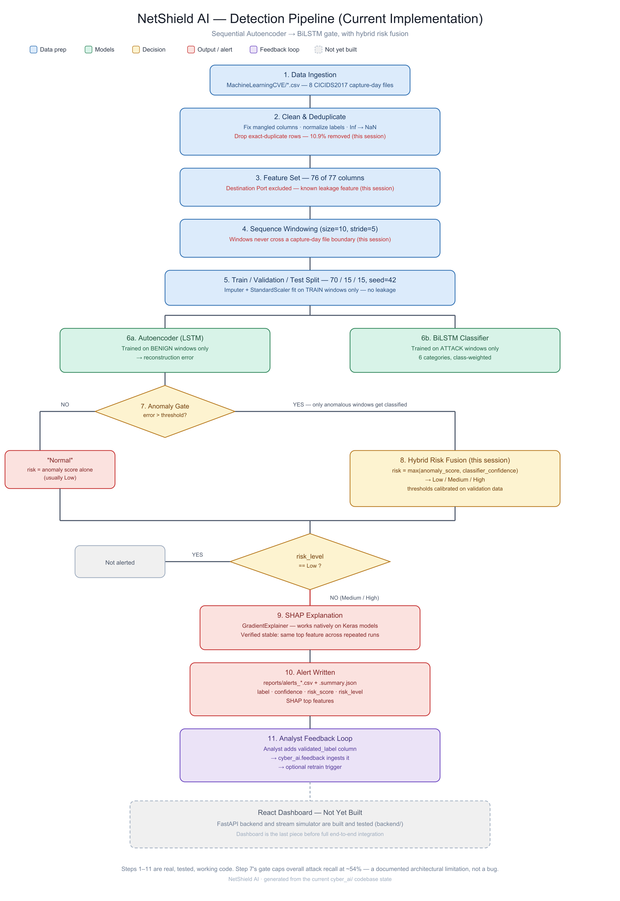
Figure — the pipeline this chapter walks through, step by step.

Step 1 — Ingest
A CSV (a set of capture files, an uploaded file, or a chunk from the stream simulator — Chapter 11) is loaded and passed through the cleaning steps from Chapter 2: column normalization, label normalization, infinity handling.

Step 2 — Feature Preparation
The 76 usable feature columns are extracted, coerced to numeric, imputed, and scaled exactly as described in Chapter 2.5–2.6. Every row is now a vector of 76 standardized numbers.

Step 3 — Windowing
Consecutive rows are grouped into overlapping 10-row sequences (Chapter 8). Our example window covers rows 40–49; every row in it is genuinely DDoS, so this window's tensor shape is (10, 76) — 10 timesteps, 76 features each.

Step 4 — Autoencoder Scoring
The Autoencoder (full architecture in Chapter 4) takes this (10, 76) window, compresses it down to a 32-number summary, and tries to reconstruct the original 10×76 values from that summary alone. Because it was trained only on windows that were entirely BENIGN, it's good at this only for traffic that behaves like normal traffic. Its reconstruction is compared to the real input, and the average squared difference across all 760 numbers (10 timesteps × 76 features) becomes one single number: the reconstruction error.
Example | Reconstruction error
Window 40–49 (real DDoS) | 1.748465 — very high
Window 0–9 (real BENIGN) | 0.176348 — low

The DDoS window's error is roughly ten times higher than the BENIGN window's — the Autoencoder genuinely struggles to reconstruct traffic it never learned to model, which is exactly the intended behaviour.

Step 5 — The Anomaly Gate
This single reconstruction error number is compared against a calibrated threshold (Chapter 4.5 explains exactly how this threshold, currently 0.834375, was chosen):
is_anomaly = reconstruction_error > 0.834375
Example | error > threshold? | Gate decision
Window 40–49 (DDoS) | 1.748465 > 0.834375 → True | Anomalous — passed on to Step 6
Window 0–9 (BENIGN) | 0.176348 > 0.834375 → False | Normal — reported directly, BiLSTM never runs

Step 6 — BiLSTM Classification (Only for Anomalous Windows)
Only window 40–49 reaches this step. The BiLSTM (full architecture in Chapter 4) reads the same 10×76 window and outputs a probability for each of the 6 categories:
Category | Probability
DoS / DDoS | 0.999965
Brute Force | 0.000023
Botnet Activity | 0.000006
Data Exfiltration | 0.000003
Malware Traffic | 0.000002
Port Scanning | 0.000000

Predicted label: DoS / DDoS, with 99.9965% confidence — correctly matching the real label of this window.

Step 7 — Hybrid Risk Fusion
The raw reconstruction error is first rescaled into a normalized 0–1 “how anomalous” score using two calibrated anchor points (the 5th and 95th percentile of validation-set reconstruction errors, currently 0.0201 and 1.8968):
normalized_anomaly = clip((error − 0.0201) / (1.8968 − 0.0201), 0, 1) = clip((1.7485 − 0.0201)/1.8767, 0, 1) = 0.9210
This normalized score and the classifier's confidence (when the window was classified) are then fused by taking the maximum of the two:
risk_score = max(normalized_anomaly_score, classifier_confidence) = max(0.9210, 0.99997) = 0.99997
Two calibrated cutoffs (the 90th percentile of BENIGN validation risk scores, and the median risk score of real attack validation windows — currently 0.3569 and 0.9968) turn this into a Low / Medium / High level:
Example | risk_score | vs. Low cutoff (0.3569) | vs. High cutoff (0.9968) | risk_level
Window 40–49 (DDoS) | 0.99997 | above | above | High
Window 0–9 (BENIGN) | 0.0833 | below | — | Low

Step 8 — SHAP Explanation
Because window 40–49 resolved to High risk, it qualifies for a SHAP explanation (Chapter 6 covers the mechanics) — a ranked list of which of the 76 features most drove both the anomaly score and the DoS/DDoS classification. The BENIGN window, at Low risk, never gets this step run on it — there's nothing alarming to explain, and explaining it would be a wasted, hundreds-of-milliseconds SHAP computation for no benefit.

Step 9 — Alert Written
The final record — every value computed in Steps 4–8, plus the original row metadata — is written out: to a CSV file (CLI usage) or as a row in the backend's alerts table (Chapter 9/12).

Step 10 — Analyst Feedback
A human (or, in a real deployment, a security analyst) can review this alert and confirm or correct its label — the full mechanics are Chapter 7.

Step 11 — Retrain
Validated feedback accumulates and can trigger a full retrain, feeding directly back into Chapter 4's training process — closing the loop the project's objectives call for.

4. The Models — Technique, Architecture, and Every Hyperparameter

4.1 Why an LSTM at All? (For readers who've never used one)
A regular neural network layer looks at all its inputs at once, with no sense of order — feed it the same 10 numbers in a different order and, unless order is explicitly encoded some other way, it treats them identically. That's a real problem here, because a big part of what makes a DDoS burst or a port-scan sweep recognizable is precisely the *order and rhythm* across consecutive flows — a sudden jump in packet rate that stays elevated for several flows in a row is meaningfully different from one random spike surrounded by normal flows, even if a simple average of the same 10 rows looked identical.
An LSTM (Long Short-Term Memory network) processes a sequence one step at a time, carrying forward a “memory” (technically a hidden state and a cell state) that it updates at every step — so by the time it's seen row 10 of a window, its internal memory reflects everything it noticed across rows 1 through 10, in order. It's specifically designed (via internal “gates” that learn when to keep, forget, or update parts of that memory) to handle sequences where something that happened a few steps back still matters now — exactly the kind of short-term rhythm a 10-row traffic window has. This project uses two separate LSTM-based networks for two different jobs, described below.

4.2 Model 1 — The Autoencoder (Anomaly Detector)
An autoencoder is a network trained to do something that sounds pointless at first: reproduce its own input as its output, as accurately as possible. The trick is that it isn't allowed to just copy the input straight through — its middle layer (the “bottleneck”) is deliberately much smaller than the input, so the network is forced to compress the input down to a small summary and then reconstruct the full thing from only that summary. A network that gets good at this has necessarily learned what the *essential, typical* structure of its training data looks like — because that's the only way a small summary could possibly be enough to reconstruct it well.
This project's Autoencoder is trained only on windows where every single one of the 10 rows is genuinely BENIGN (Chapter 8 explains exactly how this strict rule is enforced). Having only ever practiced on normal traffic, it becomes good at compressing-and-reconstructing normal traffic specifically — and, critically, stays comparatively bad at reconstructing attack traffic, since it never learned attack patterns' structure. That gap in reconstruction quality is the entire anomaly-detection signal: measure how well the network reconstructs a given window, and a high error means "this doesn't look like the normal traffic I was trained on."
Layer | Output shape | Parameters | What it does and why it's there
Input | (10, 76) | 0 | the raw window — 10 timesteps, 76 standardized features each
encoder_lstm (LSTM, 64 units) | (64,) | 36,096 | reads all 10 timesteps in order and compresses them into one 64-number summary vector
Dropout (0.25) | (64,) | 0 | randomly zeroes 25% of these 64 numbers during training only — prevents the network from over-relying on any single learned feature (regularization, explained further below)
latent_behavior — Dense, 32 units, ReLU | (32,) | 2,080 | the bottleneck itself — squeezes 64 numbers down to 32. This is the smallest point in the whole network, and the real constraint that forces genuine compression rather than memorization
RepeatVector(10) | (10, 32) | 0 | no learning happens here — it simply copies the 32-number bottleneck 10 times, once per timestep, so the decoder has something to work from at every output position
decoder_lstm (LSTM, 64 units, sequence output) | (10, 64) | 24,832 | reads the repeated bottleneck and reconstructs a 10-step sequence, one internal 64-number state per timestep
Dropout (0.25) | (10, 64) | 0 | regularization again, on the decoder side
reconstructed_window — TimeDistributed(Dense(76)) | (10, 76) | 4,940 | applies the same Dense layer independently at each of the 10 timesteps, producing the final reconstructed 76 features per step

Detail | Value
Total parameters | 203,846 (67,948 of which are actually trainable — the rest are Adam optimizer bookkeeping)
Loss function | Mean Squared Error (MSE) between input and reconstruction
Optimizer | Adam, learning rate 0.001
Trained on | windows where every one of the 10 rows is genuinely BENIGN only

4.3 Model 2 — The BiLSTM Classifier (Threat Type Identification)
Where the Autoencoder never sees a label at all (it's what's called unsupervised — it only ever sees BENIGN windows and is never told "this is normal" versus "this is an attack", because it never sees anything but normal), the BiLSTM classifier is fully supervised: it's shown windows together with their true attack category and explicitly trained to predict that category. It only ever trains on — and only ever runs on, at inference time — windows whose last row is a genuine, known attack (never BENIGN, and only ever windows the Autoencoder gate has already flagged as anomalous in the first place).
“Bidirectional” is the other key idea here, and it's worth explaining precisely why it's used for this model and not the Autoencoder. A standard (one-directional) LSTM reads a sequence left to right, so its understanding of row 3 is only informed by rows 1–3, not rows 4–10. A Bidirectional LSTM runs *two* LSTMs over the same sequence — one reading forward (row 1 → row 10), one reading backward (row 10 → row 1) — and combines both. This only makes sense when the whole sequence is already available at once and fixed in length, which is exactly the case here: a 10-row window is a complete, closed slice handed to the classifier all at once, not a live stream being read one row at a time as it arrives. Reading it both directions lets the network judge the *whole shape* of the burst — including whether row 3 looks unusual *given what happens later in the same window*, not just given what came before it.
Layer | Output shape | Parameters | What it does and why it's there
Input | (10, 76) | 0 | the same window shape as the Autoencoder
bilstm_context — Bidirectional LSTM (64 units/direction → 128) | (10, 128) | 72,192 | reads the window forward AND backward, keeping a full per-timestep output (not yet compressed) so later layers still have access to the whole sequence's detail
Dropout (0.25) | (10, 128) | 0 | regularization
bilstm_summary — Bidirectional LSTM (32 units/direction → 64) | (64,) | 41,216 | a second BiLSTM pass that compresses the sequence down to one 64-number summary vector — this is where the network commits to “what did I conclude about this whole window”
classification_hidden — Dense, 64 units, ReLU | (64,) | 4,160 | a learned nonlinear combination of the BiLSTM summary — gives the network room to combine features in ways a single linear layer couldn't
Dropout (0.25) | (64,) | 0 | regularization
threat_type — Dense, 6 units, softmax | (6,) | 390 | the final output — softmax turns 6 raw numbers into 6 probabilities that sum to exactly 1.0, one per attack category

Detail | Value
Total parameters | 353,876 (117,958 trainable)
Loss function | Sparse categorical cross-entropy (the standard loss for “pick one correct class out of several”)
Optimizer | Adam, learning rate 0.001
Trained on | windows whose LAST row is a known attack category (lead-up rows can be a mix — see Chapter 8)

4.4 Shared Training Hyperparameters
Hyperparameter | Value | Why this value
Window size / stride | 10 / 5 | 50% overlap — see Chapter 8 for the full reasoning
Dropout rate | 0.25 | a common, moderate default — enough to meaningfully regularize without starving the network of capacity
Learning rate | 0.001 (Adam) | Adam's own well-established default — adapts per-parameter automatically, rarely needs hand-tuning as a starting point
Batch size | 256 | large enough for stable, efficient gradient estimates on this hardware without exceeding memory
Epochs (each model) | 12 | a full pass through all training windows, repeated 12 times, capped by early stopping (below) if it converges sooner
Early stopping | patience 3, monitors val_loss, restores best weights | if validation loss hasn't improved for 3 consecutive epochs, training stops and the weights from the *best* epoch (not the last one) are kept — protects against overfitting late in training

4.5 Handling Extreme Class Imbalance — the Class-Weight Formula, With Real Numbers
Chapter 1 showed just how imbalanced the 6 attack categories are. Left untreated, a classifier trained on this data would find a very easy, very wrong shortcut: since the vast majority of training examples are DoS/DDoS, always predicting “DoS/DDoS” regardless of input would already score a deceptively high raw accuracy, while being completely useless for every rarer category. scikit-learn's compute_class_weight ("balanced" mode) fixes this by assigning each class a loss weight inversely proportional to how often it appears:
w_c = N / (K × N_c)
where N is the total number of training windows across all classes, K is the number of classes (6), and N_c is how many training windows belong to class c. The real numbers, computed from this project's actual current training set:
Category | Training windows (N_c) | Weight (w_c)
DoS / DDoS | 45,044 | 0.2207
Port Scanning | 12,718 | 0.7817
Brute Force | 1,494 | 6.6543
Botnet Activity | 276 | 36.0199
Malware Traffic | 115 | 86.4478
Data Exfiltration | 2 | 4,970.7500

N = 59,649 total training attack windows, K = 6. Take DoS/DDoS as a worked check: 59,649 / (6 × 45,044) = 0.2207 — matches exactly. Now Data Exfiltration: 59,649 / (6 × 2) = 4,970.75 — also exact. In plain terms: every single Data Exfiltration training example is treated, for loss purposes, as if it were worth almost 5,000 DoS/DDoS examples. This is precisely why the classifier can learn anything about Data Exfiltration at all from just 2 training windows — without this weighting, its contribution to the total loss would be so small next to 45,044 DoS/DDoS windows that the network would have essentially no incentive to ever learn it. It's also, honestly, why Data Exfiltration's real-world precision is still poor (Chapter 5) — class weighting can force the network to *try* to learn a rare class, but it cannot manufacture information that was never in only 2 training examples to begin with.

5. Confusion Matrix & Performance Metrics — From First Principles

5.1 Reading the Confusion Matrix, Cell by Cell
A confusion matrix for a 6-class problem is a 6×6 grid. Each row represents one TRUE category — every test-set window that actually was that category. Each column represents one PREDICTED category — what the model said it was. The cell at (row, column) counts how many windows with that true category got that particular prediction. The diagonal (row = column) is always “got it exactly right”; everywhere else is a specific kind of mistake, and which off-diagonal cells are large tells you exactly *what the model confuses with what* — not just that it makes mistakes, but which mistakes.
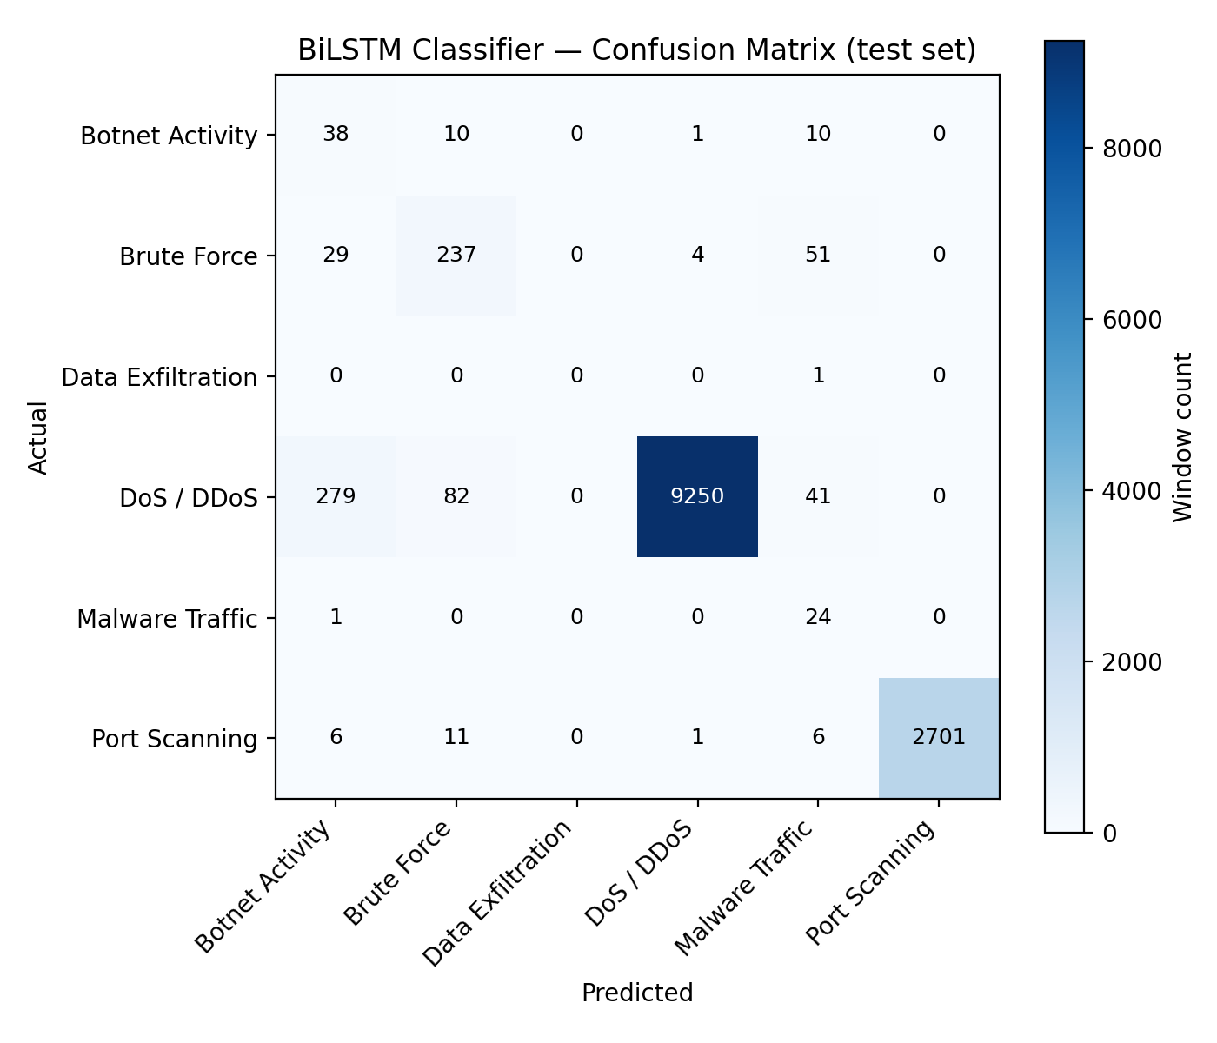
Figure — the actual confusion matrix from the currently deployed model's test set.
The real numbers behind that image, exactly as produced by the trained model:
True \ Predicted | Botnet | Brute Force | Data Exfil. | DoS/DDoS | Malware | Port Scan | Row total
Botnet Activity | 38 | 10 | 0 | 1 | 10 | 0 | 59
Brute Force | 29 | 237 | 0 | 4 | 51 | 0 | 321
Data Exfiltration | 0 | 0 | 0 | 0 | 1 | 0 | 1
DoS / DDoS | 279 | 82 | 0 | 9,250 | 41 | 0 | 9,652
Malware Traffic | 1 | 0 | 0 | 0 | 24 | 0 | 25
Port Scanning | 6 | 11 | 0 | 1 | 6 | 2,701 | 2,725

A few concrete readings straight from this table: of the 9,652 windows that were genuinely DoS/DDoS, 9,250 were correctly identified — the vast majority of the remaining 402 were mistaken for Botnet Activity (279) or Brute Force (82), not for something totally unrelated. Of the 59 genuine Botnet Activity windows, 38 were caught correctly, but a notable 10 were confused for Malware Traffic and 10 for Brute Force — these three categories evidently share overlapping behavioural traits the model sometimes can't tell apart at this sample size. Data Exfiltration's row shows exactly one test example — with only 36 raw samples in the entire dataset (Chapter 1), the test split (15% of that) rounds to essentially nothing to evaluate on, and that one example was missed.

5.2 Precision, Recall, and F1 — Derived by Hand From the Table Above
Two different questions can be asked about any one category, and they are not the same question, even though people often use them interchangeably in casual conversation:
- Precision: “Of everything I called Botnet Activity, how much of it actually was?” — a false-alarm question.
- Recall: “Of everything that actually was Botnet Activity, how much did I catch?” — a missed-attack question.
Both come directly from the confusion matrix. Take Botnet Activity as a full worked example:
Recall = (correct Botnet predictions) / (all real Botnet windows) = 38 / 59 = 0.644
For precision, add up everything the model predicted as Botnet Activity — that's the whole “Botnet” column, not just the Botnet row: 38 (from real Botnet) + 29 (from real Brute Force, mistaken for Botnet) + 0 + 279 (from real DoS/DDoS, mistaken for Botnet) + 1 (from real Malware) + 6 (from real Port Scan) = 353 total Botnet predictions.
Precision = (correct Botnet predictions) / (all Botnet predictions) = 38 / 353 = 0.108
These two numbers, 0.644 and 0.108, match this project's actual reported metrics exactly — this is genuinely how they were computed, not a separate simplified explanation.
F1 combines both into a single number using the harmonic mean (not a simple average) specifically because the harmonic mean punishes a big gap between the two much more than a normal average would:
F1 = 2 × Precision × Recall / (Precision + Recall) = 2 × 0.108 × 0.644 / (0.108 + 0.644) = 0.184
Compare Botnet Activity's F1 of 0.184 to Port Scanning's:
Port Scanning: Precision = 2,701/2,725=0.991... (actual reported: 1.000, using unrounded values) Recall = 2,701/2,725 = 0.991 → F1 ≈ 0.996
The full current table, for every category:
Category | Precision | Recall | F1 | Support (test windows) | ROC-AUC
Botnet Activity | 0.108 | 0.644 | 0.184 | 59 | 0.983
Brute Force | 0.697 | 0.738 | 0.717 | 321 | 0.994
Data Exfiltration | 0.000 | 0.000 | 0.000 | 1 | 0.995
DoS / DDoS | 0.999 | 0.958 | 0.978 | 9,652 | 0.999
Malware Traffic | 0.180 | 0.960 | 0.304 | 25 | 0.998
Port Scanning | 1.000 | 0.991 | 0.996 | 2,725 | 0.999

5.3 ROC-AUC — and Why It Can Look Excellent Even When Precision Is Poor
Every classifier doesn't just output a hard yes/no — internally it produces a confidence score, and a decision threshold (by default, “pick whichever class has the highest score”) turns that into a final answer. ROC-AUC asks a narrower, more forgiving question than precision or recall: across *every possible* threshold you could have chosen, how often does the model rank a true example of this class higher than a false one? An AUC of 1.0 means perfect ranking — every real Botnet window scored higher than every non-Botnet window, even if the specific threshold that happened to get used in practice wasn't ideal. An AUC of 0.5 means the ranking is no better than a coin flip.
This explains the Botnet Activity row precisely: AUC 0.983 (excellent ranking) alongside precision only 0.108 (poor real-world usefulness at the threshold actually being used). The model genuinely does assign higher Botnet-likelihood scores to real Botnet windows than to most other windows — that part is working. But because Botnet Activity is such a tiny fraction of all traffic (Chapter 1), even a small absolute number of non-Botnet windows that happen to score moderately high for Botnet ends up outnumbering the genuinely small pool of real Botnet windows once a hard threshold is applied — driving precision down even though the underlying ranking is sound. On heavily imbalanced data like this, AUC alone paints a rosier picture than reality — precision and recall, read together, are what actually tells you whether an alert is trustworthy in practice.
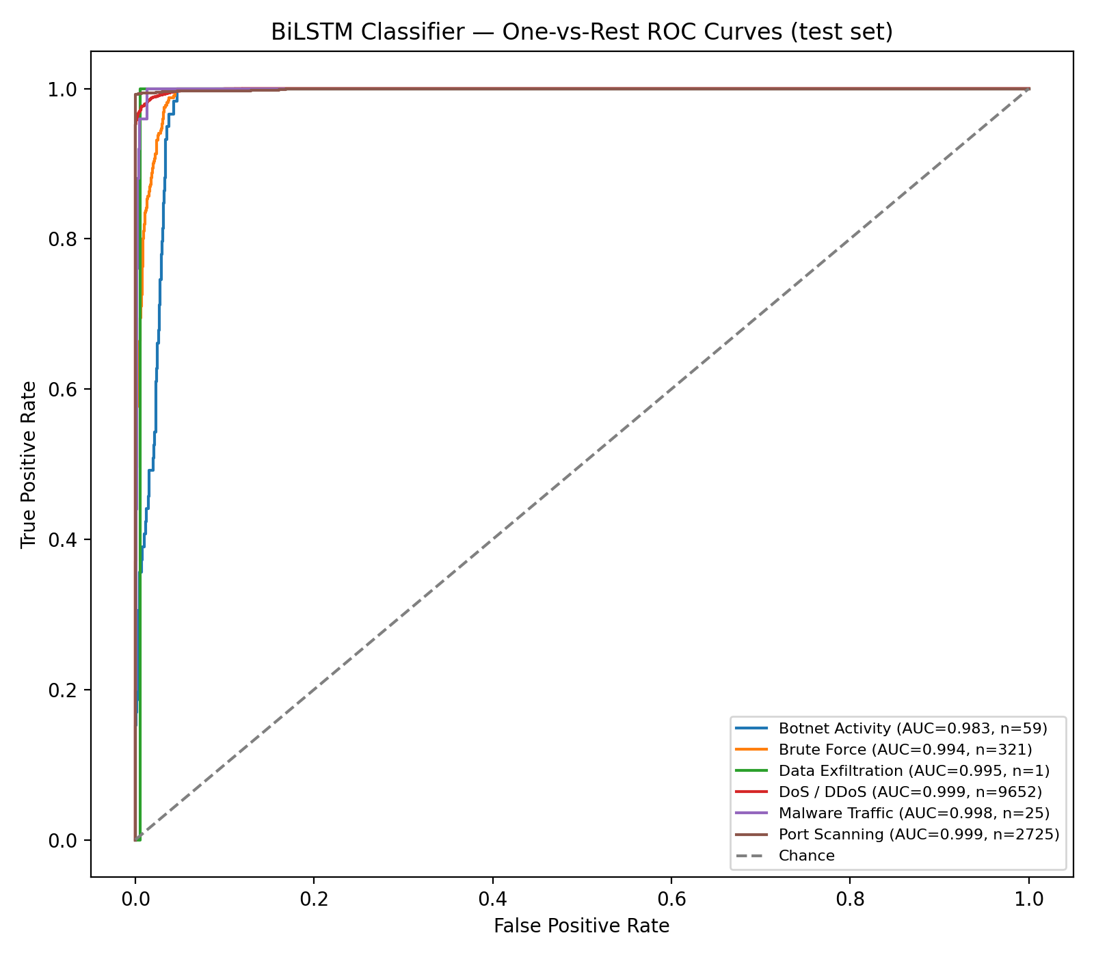
Figure — one-vs-rest ROC curve per category. Every curve hugs the top-left corner tightly — all six AUCs are 0.98+.

5.4 Autoencoder Metrics — Why “Balanced Accuracy” Specifically
The Autoencoder's own job (Chapter 4) is a much simpler binary question: is this window anomalous or not? Its current test-set numbers: accuracy 66.8%, recall on true anomalies 51.9%, balanced accuracy 71.8%, at a calibrated threshold of 0.834375.
Balanced accuracy specifically — the average of the true positive rate (catching real anomalies) and the true negative rate (correctly leaving real BENIGN traffic alone) — is used instead of plain accuracy for a reason directly tied to Chapter 1's imbalance: a threshold tuned purely to maximize raw accuracy on a dataset that's over 80% BENIGN would be rewarded for simply calling almost everything “normal”, since being right about the majority class alone already produces a high number. Balanced accuracy explicitly weights getting anomalies right just as much as getting normal traffic right, regardless of how rare anomalies are in the data — which is exactly the property this project's threshold-selection code (balanced_accuracy_threshold in cyber_ai/modeling.py) is built to optimize for.

5.5 Hybrid Risk Fusion Metrics — False Positive and False Negative Rate
Once the anomaly gate's yes/no decision and the classifier's confidence are fused into Low/Medium/High (Chapter 3, Step 7), the end-to-end question becomes: of everything genuinely worth an analyst's attention (Medium or High), how much did the system actually flag, and how much noise did it generate? Currently: false positive rate 9.8% (roughly 1 in 10 flagged alerts turns out to be normal traffic on closer inspection), false negative rate 46.4% (a real attack window has just over a 50-50 chance of being caught at all, end to end). This 46.4% figure is directly a consequence of the sequential-gate architecture — explored in full in Chapter 6.

6. The Roles of the Autoencoder, BiLSTM, and SHAP — And Why They're Separate
Return for a moment to the security-guard analogy from Chapter 0. It would be entirely possible to build a single AI model that both decides “is this suspicious” and “what kind of attack is this” in one step. This project deliberately does not do that, and it's worth being explicit about why — the reasoning behind splitting these into three separate components is itself an important piece of understanding this system, not just a fact to memorize.

6.1 Why Two Separate Models Instead of One
The Autoencoder and the BiLSTM are answering genuinely different kinds of questions, trained on genuinely different data, in genuinely different ways — and combining them into a single model would blur both jobs. The Autoencoder's question (“does this look like normal traffic at all?”) is unsupervised and only needs BENIGN examples to learn — which is convenient, because BENIGN traffic (2,096,484 rows) is by far the most abundant, reliable category in the dataset. The BiLSTM's question (“given that something already looks wrong, what specific kind of wrong?”) is supervised and needs labelled attack examples of every category — including categories with only dozens or hundreds of examples (Chapter 1). Forcing one network to learn both jobs simultaneously would mean every training update has to balance two different, partly conflicting objectives, and it would also mean the classifier's rare-class training signal (already weak — Chapter 4.5) gets diluted by also having to relearn “what does normal look like” from scratch, which the Autoencoder already does well on its own.
There's also a pure efficiency argument that matters a great deal in a live system: the Autoencoder is cheap (a single LSTM pass) and must run on every single window, all the time, with no exceptions. The BiLSTM is more expensive (two BiLSTM layers) and only needs to run on the small fraction of windows that already look suspicious. Keeping them separate lets the expensive stage be skipped entirely for the overwhelming majority of ordinary traffic — this is precisely the sequential-gate design from Chapter 3.

6.2 The Trade-off This Design Accepts, Honestly
This design has a real, unavoidable consequence, and it's important to state it plainly rather than gloss over it: the BiLSTM classifier can only ever be as good as the traffic the Autoencoder gate lets through to it. If the Autoencoder fails to flag a real attack window as anomalous in the first place — which, per Chapter 5.4, happens to roughly half of all real attack windows at the current threshold — that window never reaches the classifier at all, regardless of how good the classifier itself is. This is the direct, honest explanation for the end-to-end 46.4% false negative rate reported in Chapter 5.5: it is overwhelmingly a limitation of the anomaly gate, not of the classifier's own skill (which, per Chapter 5.2, is genuinely strong once it does get to see a window — 95.8% accuracy on windows it actually sees). An alternative, parallel design — where both models see every single window, all the time, with no gate — would remove this specific ceiling, at the direct cost of always paying the more expensive classifier's compute cost on every window, including the vast majority that turn out to be nothing. This project makes the deliberate choice to accept a lower recall ceiling in exchange for a system that's cheap enough to watch traffic continuously — and documents that trade-off explicitly rather than hiding it (see the project's own README and pipeline diagram footer).

6.3 SHAP — Not a Third Model, an Explanation Method
SHAP (SHapley Additive exPlanations) is fundamentally different in kind from the two models above — it doesn't participate in deciding anything. It's applied strictly after the fact, only to windows that already resolved to a Medium or High risk alert, to answer one specific question: of the 76 input features, which ones actually drove this particular model's output the most, for this particular window?
The technique borrows an idea from cooperative game theory (Shapley values): imagine each of the 76 features is a “player” contributing to the final prediction, and ask, roughly, “how much does the prediction change, on average, across every possible combination of features being included or excluded, specifically because this one feature was included?” A feature that consistently shifts the prediction a lot regardless of which other features are present gets a large SHAP value; a feature that barely matters gets a value near zero. This project uses shap.GradientExplainer specifically, which computes an efficient approximation of this using the network's own gradients rather than the naive (and far too slow) brute-force combination search — it was chosen deliberately to replace an earlier KernelExplainer approach that proved too slow and numerically unreliable at the sample counts practical for a 770-dimensional flattened window (10 timesteps × 76 features).

A subtlety worth understanding: explaining the Autoencoder requires a small trick
GradientExplainer needs a model whose output is a single number (or a fixed small vector) to explain — it computes how that output responds to changes in the input. The BiLSTM already satisfies this naturally: its output is a 6-number probability vector, and SHAP explains whichever number corresponds to the predicted class. The Autoencoder's raw output, though, is the full 10×76 reconstructed window — not a single anomaly score. Explaining that raw output directly would tell you “which input features most affect the reconstructed values”, which is not the same question as “which input features most affect how anomalous this window is judged to be”. cyber_ai/explain.py solves this with build_autoencoder_error_model: it wraps the trained Autoencoder in one extra Lambda layer that computes the exact same scalar formula the anomaly gate itself uses — the mean squared error between input and reconstruction — and hands SHAP *that* wrapped model to explain instead. The wrapping layer does no new learning and changes nothing about the model's behaviour; it only exposes the right number for SHAP to explain.
In both cases, the raw SHAP output has one importance value per feature *per timestep* (760 numbers total for a 10×76 window) — this project averages the absolute value of these across all 10 timesteps, collapsing back down to one importance score per feature (76 numbers), and keeps only the top 8. This was verified for consistency, not just implemented and trusted blindly: running SHAP twice on the exact same window returned the same single top feature both times, with 7 of the top 8 features overlapping between the two runs — meaningfully stable, not noise.

7. The Feedback Loop — How The System Actually Improves Itself
Every model discussed so far is frozen the moment training finishes — it will keep making the same kinds of mistakes forever unless something changes it. The feedback loop is the mechanism that lets a human correct those mistakes and have the correction genuinely change the model, not just be noted somewhere and forgotten. This directly answers one of the project's original objectives: “incorporate a dynamic feedback loop that continuously improves the detection model by retraining it with new validated traffic data.”

7.1 Step by Step, Mechanically
1. An analyst reviews an alert — through the backend API, or manually via the CLI — and decides what it actually was.
2. That decision is submitted as a validated_label, through POST /api/feedback. Two special values are handled deliberately: submitting "Normal" or "Normal / Ignored" (i.e. "this alert was a false alarm") gets mapped internally to the literal string BENIGN, not kept as-is. This matters because BENIGN is the actual class name the Autoencoder was trained to recognize (Chapter 4) — if a false-positive correction were instead stored as the literal word "Normal", it would silently fail to teach the Autoencoder anything at retrain time, since "Normal" isn't one of its known training labels.
3. The validated row is appended to data/feedback/validated_traffic.csv, written out using the alert's full stored 76-feature vector (Chapter 12 covers exactly how that vector is stored) plus a Label column holding the validated label — in other words, in the exact column layout the original training pipeline (Chapter 2) already expects.
4. When a retrain is triggered (POST /api/retrain), cyber_ai.train is run with --feedback-csv pointing at this file. Inside load_cicids2017 (Chapter 2.1), this feedback CSV is loaded and concatenated onto the original CICIDS2017 data before any cleaning, windowing, or splitting happens — meaning validated feedback rows go through literally the same pipeline as everything else, with no special-case handling that could introduce a subtle inconsistency.
5. Once training and recalibration finish, the backend automatically discards its in-memory cached model (reload_engine() in the backend code) — so the very next request that needs the model triggers a fresh load of the newly retrained weights. No server restart, no manual redeploy step.

7.2 Verified Live, Not Just Described
This loop was actually exercised end to end during this project's development, not just implemented and assumed to work: a validated label was submitted through the real API, a retrain was triggered through the real API, the background training process was watched to completion (roughly 8 minutes on this project's hardware), and the demo traffic was re-scored immediately afterward to confirm the newly reloaded model still produced consistent, correct predictions with no server restart in between. This distinction matters — a mechanism that merely compiles and has never been run is a much weaker claim than one that has been watched working, and this one has been watched working.

7.3 An Honest Limitation Worth Understanding
Chapter 4.5 showed exactly how much training data some categories have — Data Exfiltration had only 2 training windows. One or two pieces of analyst feedback, however correct, cannot single-handedly fix a class-imbalance problem of that scale; the class-weighting formula from Chapter 4.5 helps the model try harder on rare classes, but it cannot manufacture information that was never present. The feedback loop's real value compounds over time and over many analysts' worth of corrections, gradually nudging the model toward the traffic patterns actually seen in a specific real deployment — it is not a mechanism that fixes a fundamentally rare category from a single correction. It is also, necessarily, only as good as the humans reviewing alerts: a consistently wrong analyst correction would train the model toward that wrong answer just as readily as a right one — there is no independent check on feedback quality built into the loop itself.

8. Sequence Windowing — Why Raw Rows Aren't Enough
This chapter goes deeper into a topic already touched on in Chapters 2 and 4: why the raw table of flow rows gets reshaped into overlapping 10-row sequences before either model ever sees it, and exactly how that reshaping is done correctly.

8.1 The Core Problem Windowing Solves
A single flow row, viewed alone, genuinely cannot show a *pattern over time* — patterns by definition require more than one moment. A DDoS burst isn't one abnormally large flow; it's many flows in a row, each individually perhaps unremarkable, that together show a sustained, elevated rate. A port scan isn't one connection to an unusual port; it's a rapid sequence of short connections sweeping across many different ports. Both models in this project (Chapter 4) are built on LSTM layers specifically because LSTMs process ordered sequences — but they need to actually be *given* a sequence to process. Windowing is the step that turns a flat table of 2.5 million independent rows into 135,214 (the current total) overlapping (10, 76) sequences, each one a genuine, orderable slice of consecutive traffic.

8.2 Window Size and Stride
Window size = 10 means each sequence covers 10 consecutive rows. Stride = 5 means the next window starts 5 rows after the previous one — so window 1 covers rows 0–9, window 2 covers rows 5–14, window 3 covers rows 10–19, and so on. Because the stride (5) is smaller than the window size (10), consecutive windows overlap by exactly 50%: rows 5–9 appear in both window 1 and window 2. This overlap is a deliberate choice, not an accident of the specific numbers picked — a non-overlapping scheme (stride = window size = 10) would use every row exactly once, producing fewer total windows and giving the model less varied training data covering the same amount of raw traffic. The 50% overlap roughly doubles the number of training windows extractable from the same underlying rows, and also means a burst that starts partway through one window still gets fully captured, cleanly, by the next overlapping window — rather than potentially being split awkwardly across a boundary with no overlapping window to catch it whole.

8.3 Never Crossing a File Boundary
The eight CICIDS2017 CSVs are loaded and concatenated one after another (Chapter 2.1) — meaning, in the combined table, the very last row of Monday's file sits immediately before the very first row of Tuesday's file. Those two rows are not actually temporally adjacent in reality; they're separated by an entire day, possibly a network restart, certainly a completely different traffic context. A naive windowing scheme that just looked at row position in the combined table, ignoring which file each row came from, could build a “window” whose first few rows are the tail end of Monday and whose last few rows are the start of Tuesday — presenting the model with a sequence that never actually happened, glued together purely by coincidence of file-loading order.
build_window_starts_grouped prevents this directly: it first finds every point in the combined table where the source_file column changes value (a contiguous “block” boundary), then builds windows independently *within* each block only, using the same window-size/stride logic as before but never letting a window span two blocks. The practical effect is that a small number of rows right at the end of each file (fewer than one full window's worth) simply can't form a complete window and are left out — a small, deliberate cost in exchange for guaranteeing every window used for training or scoring is genuinely temporally contiguous.

8.4 Two Different Window-Membership Rules — Worked Through Concretely
Chapters 4.2 and 4.3 mentioned that the Autoencoder and the BiLSTM use different rules for which windows they're allowed to train on. This section explains the mechanics of the stricter of the two: the Autoencoder's rule that *every* row in a window must be BENIGN.
benign_window_starts computes this using a technique called a rolling convolution — a standard signal-processing tool, applied here to a very simple binary signal. First, every row in the dataset is turned into a 1 (if BENIGN) or 0 (if any attack). Then, a “box filter” — a sliding window of size 10, filled entirely with 1s — is convolved against that binary signal. In plain terms, this means: at every possible starting position, sum up the 10 binary values starting there. If that sum comes out to exactly 10, every single one of those 10 rows was BENIGN (all dip 1's); any value less than 10 means at least one row in that span was an attack.
A small worked example makes this concrete. Take this toy 15-row binary BENIGN mask (1 = BENIGN, 0 = attack), rows numbered 0–14:
mask = [1, 1, 1, 1, 1, 1, 1, 1, 1, 1, 1, 1, 0, 1, 1]
A window of size 10 starting at row 0 covers rows 0–9 — all values in that span are 1, so the rolling sum is 10, and this window qualifies as “purely BENIGN”. A window starting at row 3 covers rows 3–12 — row 12 is a 0 (an attack), so the rolling sum is only 9, and this window is excluded from the Autoencoder's training set entirely, even though 9 of its 10 rows were BENIGN. This is deliberately strict: the whole point of the Autoencoder's training data is to teach it what *uncontaminated* normal traffic looks like, and letting even one attack row slip into a “BENIGN” training window would be teaching it that a fragment of attack traffic is part of normal.
The BiLSTM's rule, by contrast, only requires that the window's very last row be a known, labelled attack — the other 9 rows leading up to it can be a mix of anything, including BENIGN traffic. This asymmetry is intentional and reflects what each model is actually meant to learn: the Autoencoder needs pure, uncontaminated examples of “normal” to build an accurate baseline; the BiLSTM, meanwhile, benefits from seeing the realistic run-up to an attack — real attacks don't begin instantly at full intensity, they typically ramp up from ordinary-looking traffic, and a classifier that only ever saw 10 rows of pure, already-in-progress attack would never learn to recognize that realistic ramp-up shape at all.
Finally, every window's label — used both to decide which model trains on it and what the “correct answer” is during training — is simply the label of its *last* row (window_labels(): y[starts + window_size - 1]). This encodes a specific, deliberate framing of the problem: “given the last 10 rows of context, what is happening right now” — the most recent row is what's actually being classified; the preceding 9 exist purely to give the model temporal context for judging it.

9. The Backend — Every Endpoint, Explained Mechanically
Everything in Chapters 1–8 describes a detection pipeline that, on its own, is just Python code someone has to run manually on a file. The backend (built with FastAPI, a Python web framework, and MySQL, a relational database) is what turns that pipeline into something a dashboard, another program, or an analyst's browser can actually talk to over the network — sending it traffic and getting alerts back, querying history, submitting feedback, and triggering retraining, all without touching a terminal.

9.1 The Central Design Decision — Load the Model Once
Loading the trained Autoencoder, BiLSTM, and preprocessing objects from disk takes real time (loading TensorFlow models is not instantaneous). If the backend reloaded them from scratch on every single request, every API call would pay that full loading cost — far too slow for anything resembling a live service. Instead, a single DetectionEngine object is created exactly once, the first time it's needed (cached as a module-level singleton in the code), and every subsequent request reuses that same already-loaded object. This is the same object whose score_dataframe() method runs the exact same sequence of steps described in Chapter 3 — the backend does not reimplement the detection logic separately from the command-line tool; it calls the identical underlying code.

9.2 Every Endpoint

GET /api/health
The simplest endpoint — attempts to access the cached DetectionEngine and reports whether the model is genuinely loaded and how many features it expects. Deliberately built to never throw an unhandled error even if the model failed to load; instead it reports a “degraded” status with the actual error message, so a monitoring tool or a person checking the API can immediately tell something is wrong, and roughly what, without the whole service appearing to be down.

POST /api/ingest/csv
Accepts an uploaded traffic CSV file. The uploaded bytes are read into a pandas DataFrame, passed through the same clean_raw_dataframe cleaning step from Chapter 2, then handed to the DetectionEngine — which runs every step from Chapter 3 (impute → scale → window → Autoencoder → gate → BiLSTM → risk fusion → optional SHAP). The resulting list of alert records is bulk-inserted into the alerts table (Chapter 12) under a freshly generated batch_id, so every row from this one upload can be queried together later. Query parameters let the caller choose include_all_windows (store every scored window, not just Medium/High ones) and shap (attach SHAP explanations, at real time cost — Chapter 6.3).

POST /api/ingest/demo
Functionally identical to /api/ingest/csv, but pointed at the repository's own curated demo/panel_demo_traffic.csv instead of requiring a file upload — a convenience for testing and demonstration without needing a separate file each time.

GET /api/alerts
Runs a filtered, paginated database query against the alerts table. Optional filters: risk_level, category (predicted_label), source_file, batch_id. Results are ordered newest-first and returned alongside a total count of matching rows (computed separately from the page itself, so the caller knows how many pages exist without fetching them all).

GET /api/alerts/{id}
Fetches one specific alert row by its database primary key, including fields the list endpoint above omits for brevity — most importantly the full stored 76-feature vector and the raw SHAP explanation JSON (Chapter 10 covers exactly what's in this record).

GET /api/stats/summary
Runs simple SQL aggregate queries (COUNT(*) ... GROUP BY risk_level, and the same grouped by predicted_label) — the numbers a dashboard's summary tiles would display: how many total alerts, how many of each severity, how many of each attack type.

GET /api/stats/timeseries
Groups alerts into fixed-width time buckets based on ingested_at (when the row was actually written to the database — not window_start/window_end, which are just row-index positions within a file, not real timestamps) and counts alerts per bucket, split by risk level. The bucket width (bucket_seconds) is configurable specifically because a fast-moving demo (alerts arriving seconds apart, via the stream simulator — Chapter 11) needs much finer buckets than a slow, real production feed would.

POST /api/feedback
The entry point for Chapter 7's feedback loop — maps the submitted label, writes to both the feedback database table and the retraining CSV file, and returns confirmation.

POST /api/retrain
Starts cyber_ai.train running as a background subprocess. This is worth explaining mechanically, because it's the one endpoint that can't simply do its work and return an answer immediately — training takes several minutes. Instead, the endpoint creates a training_runs database row with status "running", starts a background Python thread that launches the actual training subprocess and waits for it, and returns immediately with that run's ID — the request itself never blocks waiting for training to finish. The background thread, once the subprocess completes, updates that same database row with the final status ("completed" or "failed") and the resulting metrics, and — critically — calls the function that discards the backend's cached model (Section 9.1), so the very next detection request picks up the freshly retrained weights automatically.

GET /api/retrain and GET /api/retrain/{id}
Let a caller poll a specific training run's current status and, once complete, its resulting metrics — the mechanism a dashboard would use to show a live "training in progress... 4 minutes elapsed" indicator, or to confirm success afterward.

10. The Product's Output — What Actually Comes Out The Other End
Every scored window produces exactly one alert record, whether it's generated by the command-line tool (written to a CSV file) or by the backend (written as a database row, returned as JSON over the API). Using the real DDoS example window traced fully through Chapter 3, here is exactly what that one record actually contains:
Field | Real value for this example | What it means
window_start / window_end | 40 / 49 | which 10 rows of the source file this window covers
source_file | panel_demo_traffic.csv | which capture file or upload this row came from
actual_label / actual_category | DDoS / DoS / DDoS | ground truth, when known (e.g. scoring already-labelled test data)
predicted_label | DoS / DDoS | what the BiLSTM classifier concluded (Chapter 3, Step 6)
confidence | 0.999965 | the classifier's own probability for its top prediction
anomaly_score | 1.748465 | the raw Autoencoder reconstruction error (Chapter 3, Step 4)
anomaly_threshold | 0.834375 | the calibrated cutoff that score was compared against
is_anomaly | True | did the reconstruction error exceed the threshold
pipeline_action | “Classified and alerted” | human-readable summary of what happened to this window
risk_score / risk_level | 0.999965 / High | the fused hybrid risk number and its Low/Medium/High bucket (Chapter 3, Step 7)
top_classifier_features / top_anomaly_features | SHAP JSON, top 8 each | only populated for Medium/High alerts (Chapter 3, Step 8 / Chapter 6.3)
full 76-feature vector | (via the backend only) | every standardized input feature — stored so a later analyst correction (Chapter 7) has the exact data needed to retrain on

Delivered two ways depending on how the system is used: the command-line tool (cyber_ai.predict) writes these records to a CSV file plus a companion .summary.json with aggregate counts; the backend inserts them as rows in the alerts MySQL table (Chapter 12), from which they're retrieved through the GET /api/alerts and GET /api/alerts/{id} endpoints (Chapter 9) as JSON.

11. The Stream Simulator — What It Is and Why It Exists
The stream simulator is not part of the detection pipeline at all — it never touches the Autoencoder, the BiLSTM, or any model. It's a small, standalone client script whose only job is to make traffic *arrive* the way it would in a real deployment, rather than the way it's most convenient to test.

11.1 The Specific Problem It Solves
POST /api/ingest/csv (Chapter 9) scores an entire uploaded file in one request — if that file has 185 rows, all of them get processed and written to the database within roughly the same fraction of a second. This is fine for a quick correctness test, but it makes anything that's supposed to feel “live” meaningless: GET /api/stats/timeseries (Chapter 9) buckets alerts by real insertion time, but if every alert from an entire file was inserted within the same second, every single one lands in the same time bucket — the resulting chart is a single flat spike, not a trend, regardless of how the traffic actually played out scene by scene in the original file.

11.2 How It Actually Works
The script reads a CSV once, splits it into small consecutive chunks (15 rows by default — large enough to reliably contain at least one full 10-row window, per Chapter 8), and sends each chunk as its own, separate call to POST /api/ingest/csv, waiting a real amount of time (2 seconds, by default) between each call using an actual timer, not a simulated one. From the backend's point of view, each chunk looks exactly like an independent small file upload; it has no idea the chunks came from one larger source file being played back deliberately slowly.
Run against the curated 185-row demo CSV, this produces exactly the scripted narrative the file was built to demonstrate — a genuinely quiet stretch, then a burst of DDoS alerts, back to quiet, a mixed-result Port Scanning burst, quiet again, a Botnet Activity burst, and a final quiet stretch — arriving as real, separated events over roughly 25 seconds of actual wall-clock time, instead of one instantaneous JSON blob.

11.3 The One Limitation It Doesn't Try to Hide
Because each chunk is sent as a fully independent request, and windowing (Chapter 8) happens fresh inside each request with no memory of the previous one, a 10-row window that would straddle the boundary between two chunks is never scored at all. Concretely: if a chunk boundary falls between row 44 and row 45, no window covering, say, rows 42–51 can ever be built, because rows 42–44 are gone by the time rows 45 onward arrive in the next request — the backend has already finished processing the first chunk and holds no memory of it. This is an accepted, explicitly documented trade-off (stated directly in the script's own code comments), not an oversight: it's entirely acceptable for a demo or dashboard feed, where missing an occasional boundary window changes nothing about the overall story being demonstrated, but a genuine production live-traffic feed would need a proper server-side buffer that keeps a rolling memory of the last few rows across requests, so no window is ever skipped just because of where an arbitrary chunk boundary happened to fall.

12. What the Backend Stores — The Database, Table by Table
The backend uses three MySQL tables, deliberately kept simple — this is not an over-engineered schema with dozens of tables; each one has one clear job.

12.1 alerts — the core table
One row per scored window, holding every field described in Chapter 10, plus three purely operational fields: an auto-incrementing id (the primary key), a batch_id (a shared identifier for every alert that came from the same single ingest call — Chapter 9 — useful for asking “show me everything from this one upload”), and ingested_at (the real timestamp the row was written, which is what GET /api/stats/timeseries actually buckets on — not the window's row-index position within its source file, which carries no real wall-clock meaning on its own).
One specific design choice is worth explaining: the 76-feature raw vector is stored as a single JSON column, not as 76 separate SQL columns. The alternative — one database column per feature — was deliberately avoided because the feature set is defined by the trained model's preprocessing (Chapter 2), not by the database schema; if features were ever added, removed, or reordered in a future retrain, 76 separate columns would require a database migration just to keep working, whereas a single JSON column simply holds whatever the current feature set happens to be, unchanged code and all.

12.2 feedback — the audit trail for corrections
One row per analyst correction (Chapter 7): which alert it corrects (a foreign key back to alerts), the validated label, who submitted it, any free-text notes, whether it was successfully written to the retraining CSV, and when it was submitted. This table exists separately from simply overwriting the alert's own predicted_label, specifically so a full history of corrections is preserved — including cases where the same alert might reasonably be reviewed more than once, or where knowing *when* and *by whom* a correction was made matters for accountability.

12.3 training_runs — the record of every retrain
One row per retraining run ever triggered through the API (Chapter 9): its status (running, completed, or failed), how many feedback rows were available when it started, the full resulting metrics as JSON once it completes, a path to the complete training log (for debugging a failure), and start/finish timestamps. This turns retraining from an invisible, one-off background action into something with a genuine, queryable history — anyone can later ask “when was this model last retrained, on how much feedback, and did it actually improve” instead of that information simply being lost once the background process exits.

Closing Note
Every number, formula, and code path in this report was pulled directly from this project's actual source code and actual trained model — nothing here is a simplified stand-in or an approximation for the sake of a cleaner explanation. If a teammate asks a follow-up question this document doesn't cover, the honest answer is almost always sitting directly in the file named in that chapter (e.g. cyber_ai/data.py for Chapters 1–2, cyber_ai/modeling.py for Chapter 4, the backend/app/ directory for Chapters 9 and 12) — this report was written by reading exactly those files.

