NetShield AI
An AI-Driven Predictive Analytics Framework for Adaptive Cyber Threat Detection
Project Report
Submitted by: [Your Name(s)]
USN: [Fill in]
Guide: [Fill in]
Department of [Fill in]
BMS Institute of Technology and Management
August 2026

Abstract
With the rapid expansion of enterprise networks, cloud infrastructure, and internet-connected devices, organizations generate massive volumes of network traffic every second. This growing complexity makes it increasingly difficult for traditional cybersecurity systems to detect evolving and sophisticated cyber threats. Conventional intrusion detection systems rely mainly on predefined rules and signature-based methods, which are ineffective against unknown, zero-day, or slowly evolving attacks. Many existing AI-based detection systems also focus only on classification accuracy, without analyzing temporal behaviour, explaining their own decisions, or adapting to new attack patterns over time.
NetShield AI addresses this gap with an integrated pipeline that combines Autoencoder-based anomaly detection, BiLSTM-based temporal threat classification, a hybrid risk-fusion layer, SHAP-based explainable AI, and a validated analyst feedback loop for continuous retraining. The system is trained and evaluated on the real CICIDS2017 dataset (over 2.5 million rows across 8 capture-day files), with several data-integrity issues in the raw dataset identified and corrected before training. A FastAPI + MySQL backend and a traffic stream simulator were built on top of the detection pipeline to expose it as a live alerting service, and every number in this report comes from that real, trained system — nothing here is estimated or assumed.

1. Introduction

1.1 Problem Statement
Conventional intrusion detection systems mainly rely on predefined rules and signature-based methods, which are ineffective against unknown, zero-day, or slowly evolving attacks. Additionally, many existing AI-based detection systems focus only on classification accuracy and lack the ability to analyze temporal behavior patterns, explain model decisions, or adapt to new attack patterns over time. The absence of explainability and adaptive learning mechanisms limits their practical deployment in real-world security operations. There is therefore a need for an intelligent and adaptive cybersecurity framework capable of analyzing large-scale network traffic, detecting anomalous behaviours at an early stage, classifying different types of cyber threats, and providing interpretable insight into the model's decisions.

1.2 Objectives
- Collect and preprocess network traffic data from datasets or network sources and convert it into meaningful features for analysis.
- Design an anomaly detection module using an Autoencoder that learns normal network behaviour and identifies suspicious or abnormal traffic patterns.
- Develop a BiLSTM-based classification model capable of analyzing temporal network traffic patterns and identifying different types of cyber threats.
- Implement explainable AI using SHAP to interpret model predictions and understand the key features contributing to detected threats.
- Create an alerting and reporting mechanism that notifies security administrators about detected threats in the network.
- Incorporate a dynamic feedback loop that continuously improves the detection model by retraining it with new validated traffic data.
- Build an intelligent and adaptive cybersecurity framework capable of detecting and classifying cyber threats in modern enterprise networks.

2. System Architecture
NetShield AI uses a sequential-gate architecture: the Autoencoder first decides whether a window of traffic looks anomalous at all, and only anomalous windows are passed on to the BiLSTM classifier for threat-type identification. This keeps the expensive classification and explanation stages off the critical path for the vast majority of (normal) traffic, at the cost of capping overall recall at whatever the Autoencoder gate itself catches — a deliberate, documented trade-off discussed further in Section 7.
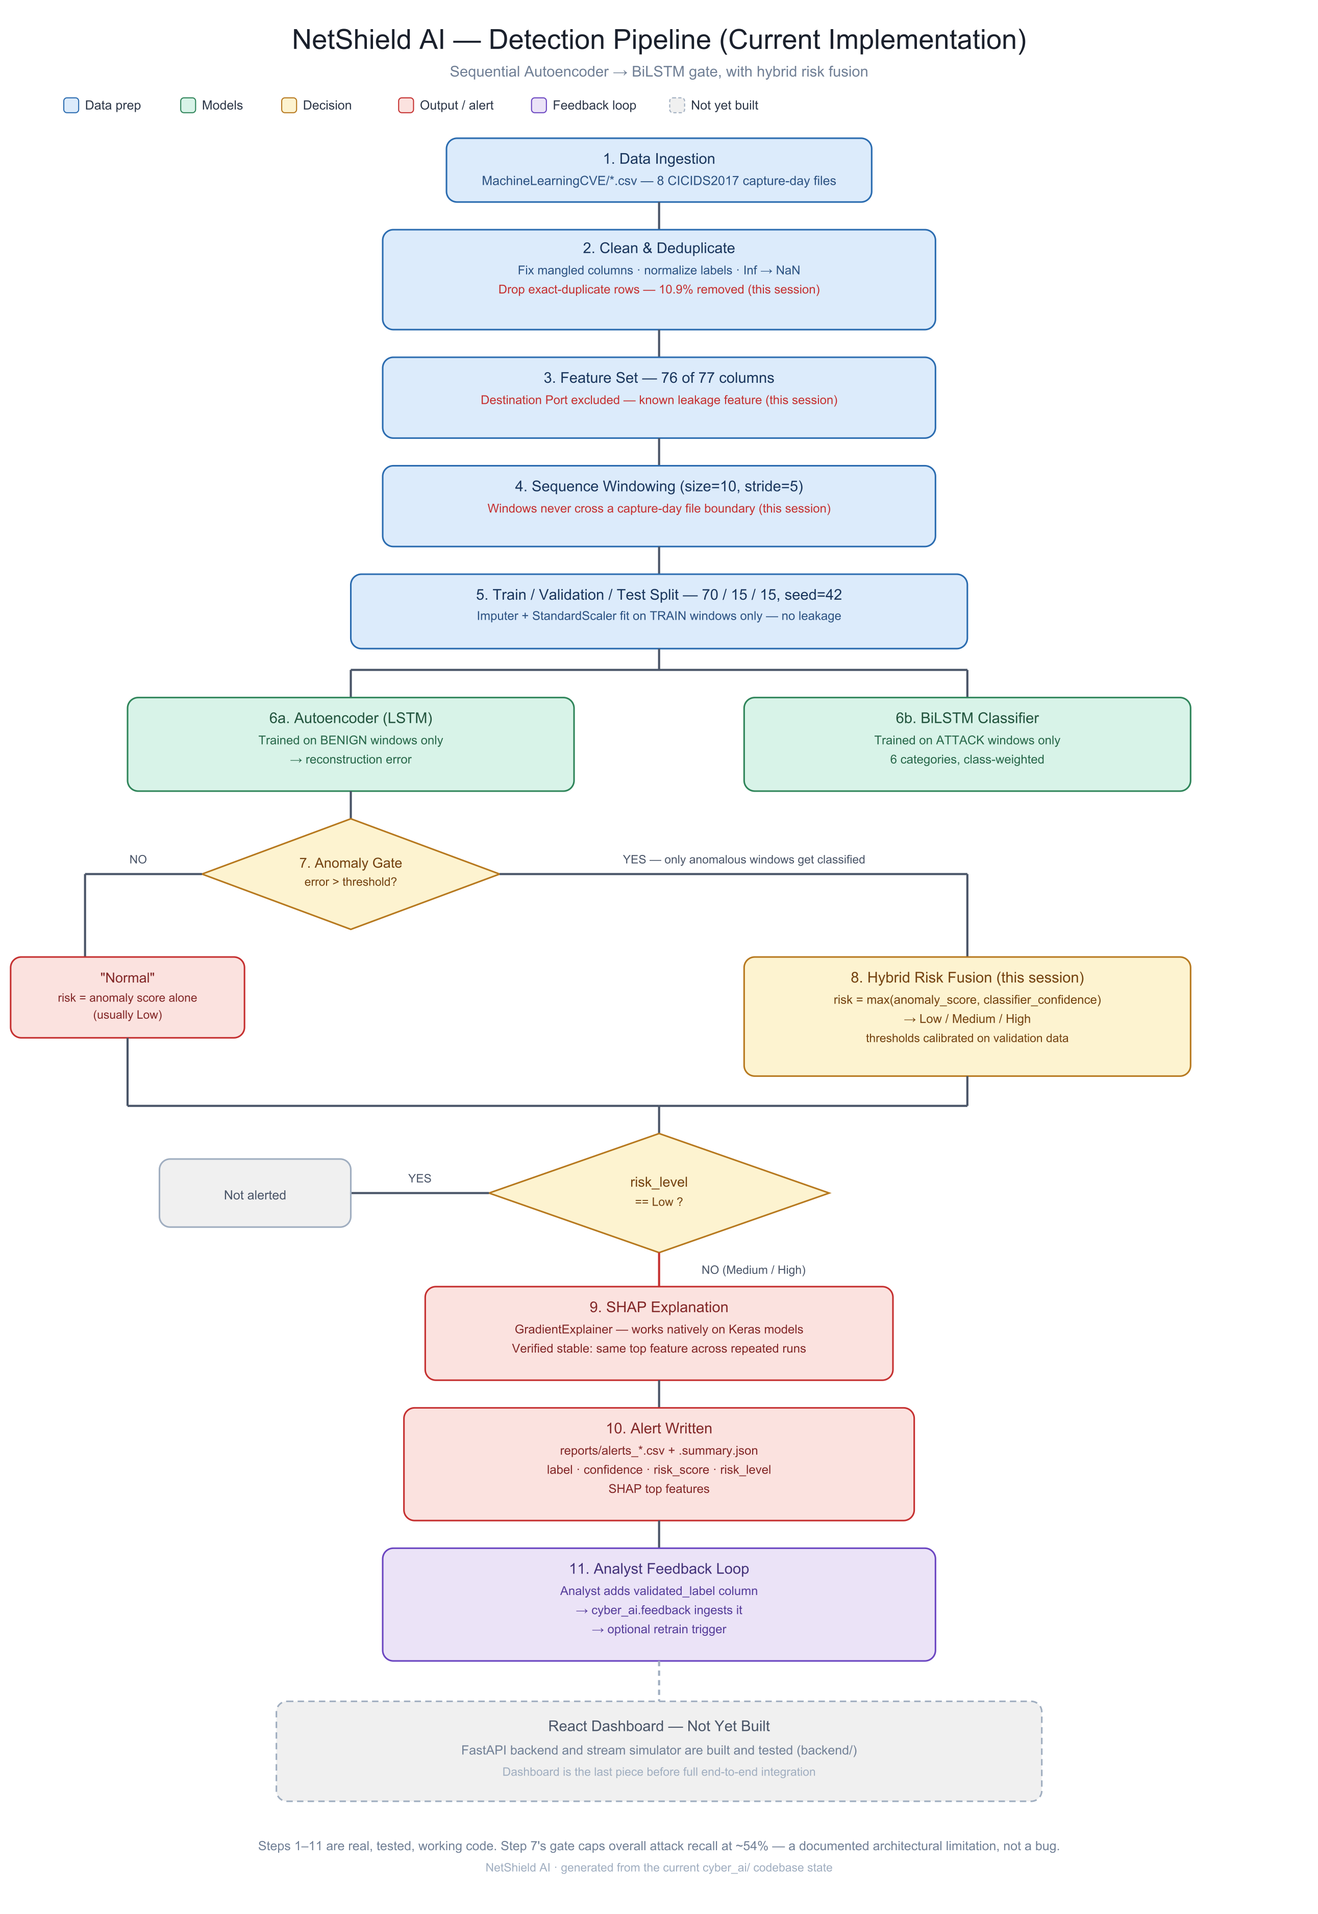
Figure 1. End-to-end detection pipeline, from raw CICIDS2017 CSVs to an analyst-reviewable alert.

3. Dataset
The system is trained on CICIDS2017 (Canadian Institute for Cybersecurity), a widely used labelled network-traffic dataset covering benign traffic and a range of real attack types across 8 capture-day CSV files (Monday–Friday, split into morning/afternoon sessions). After loading, cleaning, and de-duplicating the raw CSVs, 2,522,363 rows remain across 76 network-flow features (one leakage feature, Destination Port, is intentionally excluded — see Section 4.1). Raw CICIDS2017 labels are mapped into six attack categories plus BENIGN for training and reporting:
Category | Row count
BENIGN | 2,096,484
DoS / DDoS | 321,764
Port Scanning | 90,819
Brute Force | 10,622
Botnet Activity | 1,954
Malware Traffic | 684
Data Exfiltration | 36

Data Exfiltration has only 36 raw samples in the entire dataset — far too few for its per-class metrics (Section 7.3) to be statistically meaningful. This is flagged automatically by the pipeline itself (any category under 200 raw samples triggers a low-sample warning in the training metrics) rather than silently reported as if it were reliable.

4. Methodology

4.1 Data Integrity & Preprocessing
Several data-quality issues in the raw CICIDS2017 CSVs were identified and corrected before training:
- Windowing fix: sequence windows are built per source file and never span two different capture-day CSVs, so the Autoencoder/BiLSTM never see a window that silently splices together two unrelated moments in the timeline.
- Leakage removal: Destination Port is excluded from the feature set — a well-documented CICIDS2017 leakage feature, since attacks in this testbed target fixed ports.
- Mislabel handling: any raw label the taxonomy doesn't recognize is excluded and counted separately (unmapped_labels) instead of being silently defaulted into a category it doesn't belong to.
- Low-sample warning: any attack category with fewer than 200 raw samples is explicitly flagged in the training metrics, so downstream consumers know to treat its per-class numbers as indicative only.
- Duplicate removal: exact-duplicate rows are dropped before windowing — 10.9% of the raw dataset — a documented CICIDS2017 quality issue; left in, identical rows can land in both train and test splits, letting the model partly memorize instead of generalize.
- Feature selection was evaluated (Random Forest importance ranking, top-25 features): it helped the Autoencoder but hurt the BiLSTM classifier (several classes' precision collapsed), so it was not adopted as the default — the code exists as an opt-in --top-k-features flag.

4.2 Sequence Windowing & Splits
Traffic rows are grouped into overlapping temporal windows of 10 rows with a stride of 5, built independently per source file. Windows are split 70% / 15% / 15% into train / validation / test sets with a fixed random seed (42); the feature imputer and scaler are fit only on the training windows to avoid any leakage from validation or test data into preprocessing.

4.3 Autoencoder — Anomaly Detection
A sequence Autoencoder (LSTM encoder → 32-dimensional latent representation → LSTM decoder) is trained only on BENIGN windows, learning to reconstruct normal traffic behaviour. At inference time, any window's reconstruction error is compared against a threshold calibrated on the validation set using a balanced-accuracy strategy; windows above the threshold are flagged anomalous and passed to the BiLSTM classifier. Windows below it are reported as “Normal” using the anomaly score alone.

4.4 BiLSTM — Threat Classification
A class-weighted Bidirectional LSTM is trained only on attack windows (never BENIGN), and only ever runs on windows the Autoencoder gate has already flagged as anomalous. It classifies each window into one of the six attack categories from Section 3.

4.5 Hybrid Risk Fusion
The project's original alert-severity logic simply checked which label the BiLSTM predicted against a fixed list, and every classified window ended up marked “High” — zero real triage value. This has been replaced with a genuine fusion formula: risk = max(normalized anomaly score, classifier confidence). A window that never reached the classifier is scored on its anomaly signal alone; a window the classifier did see can only be pulled up toward its confidence, never down below what the anomaly gate already thought — a confident attack classification should never be reported as less risky than the anomaly signal that let it through in the first place. Low / Medium / High thresholds are calibrated from the validation set's own score distribution, not hardcoded.

4.6 Explainable AI — SHAP
Model predictions are explained using SHAP's GradientExplainer, which works natively on the Keras models used here. An earlier KernelExplainer approach was slow and unreliable at the sample counts (~100) practical for a 770-dimensional flattened window; GradientExplainer replaced it and was verified for stability by running SHAP twice on the same window — the same top feature was returned both times, with 7 of the top 8 features overlapping.

4.7 Analyst Feedback Loop
Medium/High alerts can be reviewed by an analyst and given a validated_label. Validated rows are appended to a persistent feedback CSV in the exact feature-column layout the training pipeline expects, and can trigger a retrain (python -m cyber_ai.train --feedback-csv ...) that incorporates them alongside the original CICIDS2017 data — the mechanism behind objective 6 (a dynamic, continuously improving model).

5. Backend & Live Detection Infrastructure
To expose the detection pipeline as something a dashboard (or an analyst) can actually use, a FastAPI service backed by MySQL was built on top of cyber_ai. The service loads the trained Autoencoder, BiLSTM classifier, and preprocessing pipeline once at startup, and reuses the exact same scoring logic as the cyber_ai.predict CLI — API-served alerts are identical to what the command line would produce for the same input.

5.1 Data Model
- alerts — one row per scored window: predicted label, confidence, anomaly score, risk score/level, SHAP top features, and the full raw feature vector (as JSON, to keep the schema stable as feature engineering evolves).
- feedback — analyst-submitted validated labels, linked to the alert they correct.
- training_runs — status, timing, and resulting metrics of each retraining run triggered from the API.

5.2 API Surface
Endpoint | Purpose
GET /api/health | Reports whether the trained model loaded successfully
POST /api/ingest/csv | Upload a traffic CSV; scores it and stores resulting alerts
POST /api/ingest/demo | Scores the repo's curated demo CSV without an upload
GET /api/alerts | List alerts, filterable by risk level / category / source file / batch, paginated
GET /api/alerts/{id} | Full alert detail incl. raw feature vector and SHAP explanations
GET /api/stats/summary | Counts by risk level and category, for dashboard tiles
GET /api/stats/timeseries | Alert counts bucketed over time, for a live trend chart
POST /api/feedback | Analyst submits a validated label; appends to the retraining feedback store
POST /api/retrain | Triggers cyber_ai.train in the background with accumulated feedback
GET /api/retrain/{id} | Poll a retraining run's status and resulting metrics

5.3 Stream Simulator
Because ingest is otherwise a single on-demand action (one request, one batch, scored instantly), a stream simulator script was built to replay a CSV in small paced chunks against the ingest endpoint instead — mimicking traffic arriving live rather than a static batch report. This is what makes a time-series chart (or a live dashboard) show an actual trend instead of one flat spike, and it is what makes the curated demo CSV's scripted narrative (calm → DDoS burst → calm → Port Scan → calm → Botnet burst → calm) something that can be watched play out during a live demonstration rather than returned as one instantaneous JSON response. One honest limitation: each chunk is windowed independently (the server carries no state between requests), so a 10-row detection window that straddles a chunk boundary is never scored — acceptable for a demo/dashboard feed, though a production stream would need a stateful sliding buffer server-side instead.

5.4 Feedback → Retrain Loop, Verified End to End
The full loop behind objective 6 was exercised for real, not just wired up: an alert was reviewed and submitted through POST /api/feedback, which appended a validated row to the feedback store; a retrain was then triggered through POST /api/retrain, ran cyber_ai.train as a background process, completed in roughly 8 minutes, and the API automatically reloaded the newly retrained model — confirmed by re-scoring the demo CSV immediately afterward and seeing consistent, correct predictions with no server restart required.

6. Results

6.1 Progressive Improvement
“Original” is the state of the pipeline before this project's data-integrity work; each row after it reflects one additional fix, ending with the currently deployed, retrained model. Small run-to-run float variance (roughly 1 percentage point) is expected on CPU-trained TensorFlow models even with a fixed seed — these are single representative runs, not averages.
Stage | AE accuracy | AE recall | AE bal. acc. | BiLSTM acc. | BiLSTM macro-F1
Original (before this project's fixes) | 46.0% | 38.8% | 62.7% | 99.25% | 0.913
After windowing fix | 57.6% | 42.1% | 66.4% | 99.06% | 0.674
After leakage / mislabel / low-sample fixes | 58.7% | 44.9% | 66.7% | 99.29% | 0.698
After duplicate-row removal | 68.8% | 55.1% | 73.3% | 96.07% | 0.544
Current (this deployment, retrained) | 66.8% | 51.9% | 71.8% | 95.8% | 0.530

The drop in BiLSTM macro-F1 after duplicate-row removal (0.698 → 0.544) is a correction of previously inflated numbers, not a real capability loss — the two well-supported classes (DoS/DDoS, Port Scanning) stayed strong (F1 0.98 and 0.996 respectively); the drop is concentrated in already-small, already-unreliable classes. Weighted-F1, which reflects the real class distribution, only moved from 0.994 to 0.970.

6.2 Current Model Performance
- Autoencoder: 66.8% accuracy, 51.9% recall on true anomalies, 71.8% balanced accuracy, threshold 0.834 (calibrated via balanced-accuracy strategy).
- BiLSTM classifier: 95.8% accuracy on windows it actually sees (i.e. windows the Autoencoder already flagged), 0.530 macro-F1, 0.970 weighted-F1.
- Hybrid risk fusion: false positive rate 9.8%, false negative rate 46.4%; test-set alerts split Low 12,697 / Medium 917 / High 6,669 — a genuine three-tier distribution, not the old “everything is High” behaviour.

6.3 Per-Class Performance
Category | Precision | Recall | F1 | Support | ROC-AUC
Botnet Activity | 0.108 | 0.644 | 0.184 | 59 | 0.983
Brute Force | 0.697 | 0.738 | 0.717 | 321 | 0.994
Data Exfiltration | 0.000 | 0.000 | 0.000 | 1 | 0.995
DoS / DDoS | 0.999 | 0.958 | 0.978 | 9,652 | 0.999
Malware Traffic | 0.180 | 0.960 | 0.304 | 25 | 0.998
Port Scanning | 1.000 | 0.991 | 0.996 | 2,725 | 0.999

Per-class quality tracks sample count almost perfectly — a data-scarcity signal, not classic overfitting (the aggregate train/validation gap across epochs stays small). ROC-AUC looks excellent across the board (0.98–1.00) even for classes with poor precision — e.g. Botnet Activity: AUC 0.983 but precision only 0.108. This is not a contradiction: AUC is a ranking metric that looks good almost by construction on imbalanced data, and should always be read alongside precision/recall, never alone.
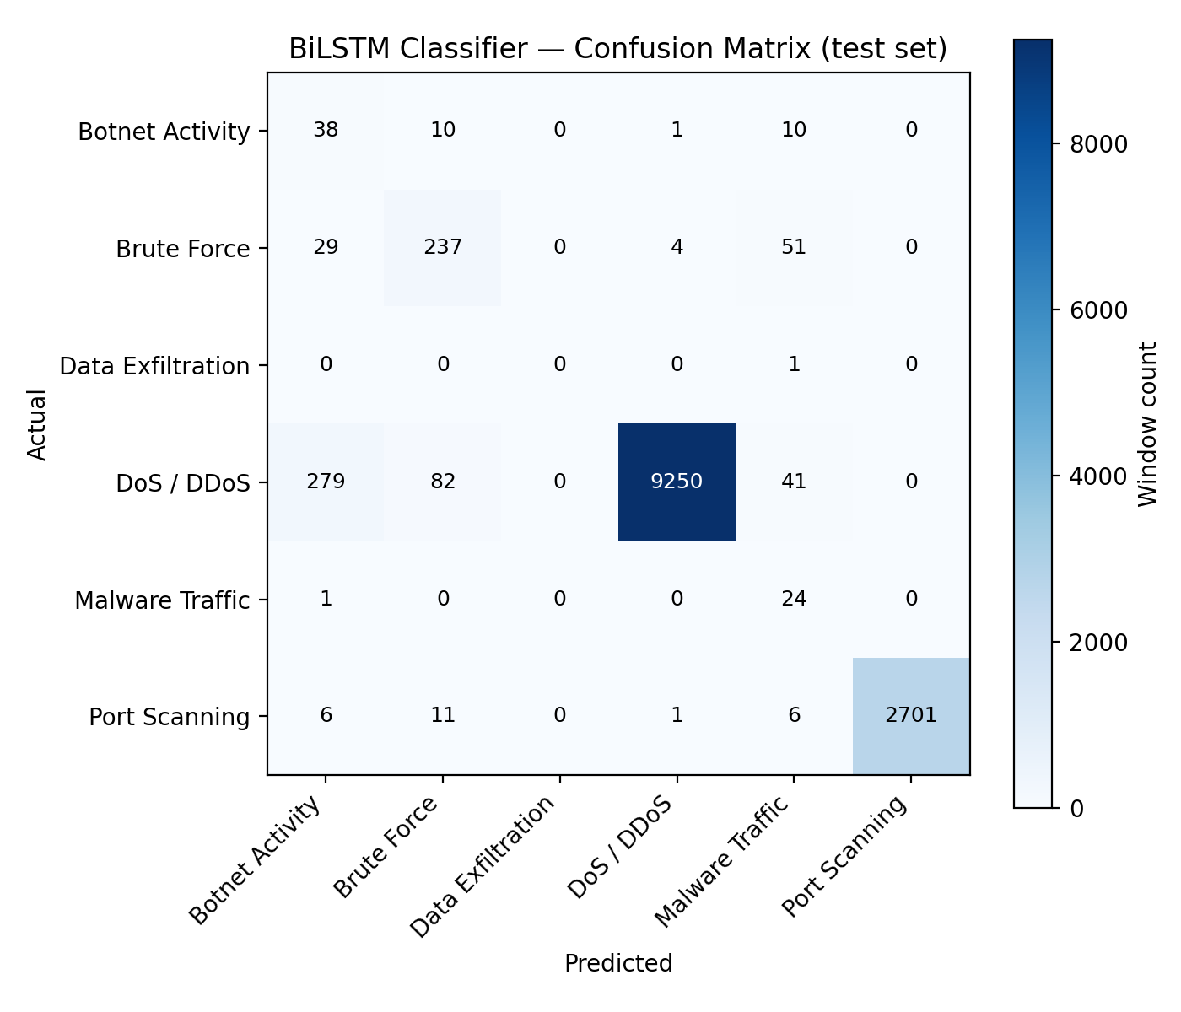
Figure 2. BiLSTM classifier confusion matrix on the held-out test set.
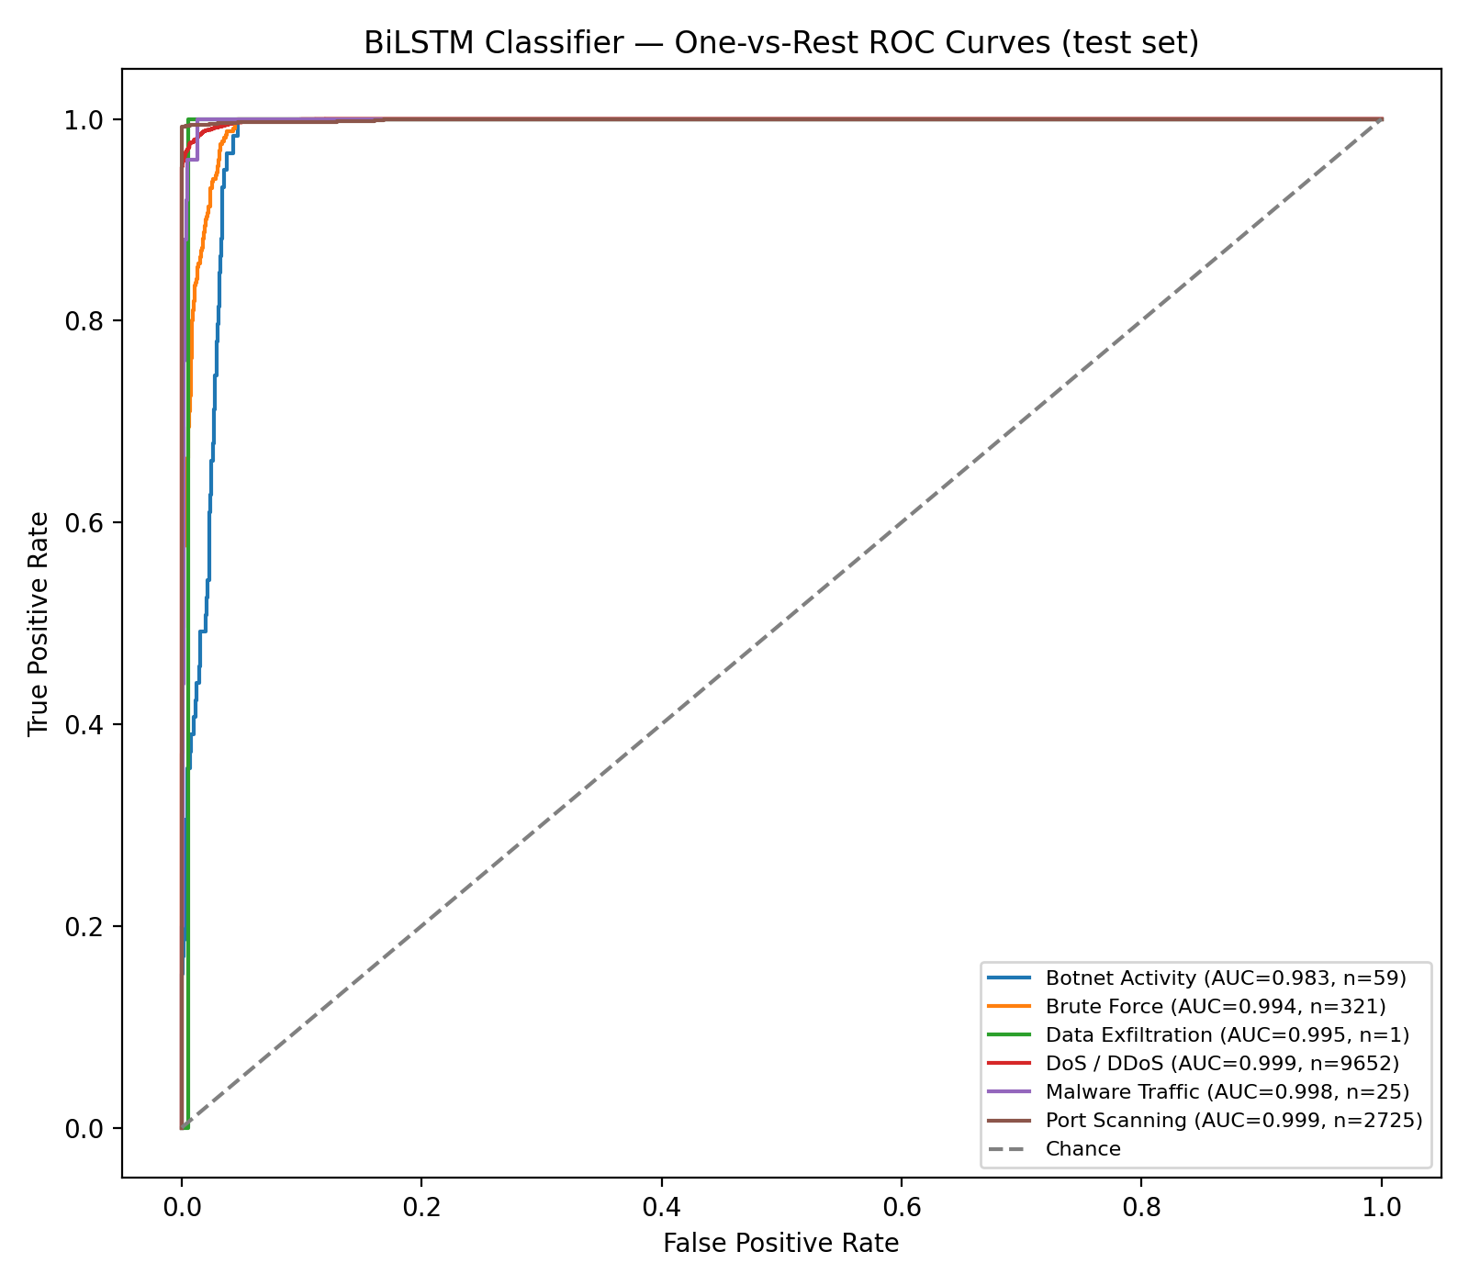
Figure 3. One-vs-rest ROC curves per attack category.

6.4 Reconstruction Error Distribution
The Autoencoder's reconstruction error separates BENIGN from attack traffic with a clear (if imperfect) gap, visible in the histogram below. The calibrated anomaly threshold (0.834) sits in the overlap region — the balanced-accuracy calibration strategy deliberately trades some missed attacks for fewer false alarms on BENIGN traffic, rather than maximizing recall alone.
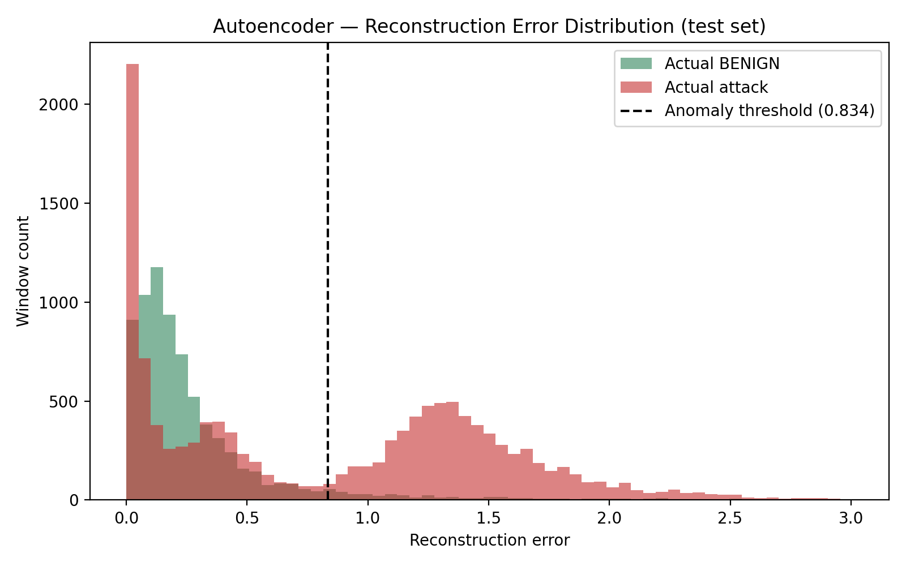
Figure 4. Reconstruction error distribution, BENIGN vs. attack, test set.

6.5 Latency Benchmark
Real per-window timings (not batched — one window at a time, matching a live stream), measured on this deployment's hardware (CPU-only, no discrete GPU — TensorFlow here has no CUDA support at all).
Stage | Mean | P95 | Applies to
Autoencoder only | 161.3 ms | 268.0 ms | every window
Autoencoder + BiLSTM | 400.2 ms | 726.9 ms | anomaly-flagged windows only
SHAP alone | 670.1 ms | 1163.0 ms | Medium/High alerts only
Full pipeline (blended) | 521.0 ms | 1745.1 ms | realistic mix, all windows

These absolute numbers are not directly comparable to any benchmark run on GPU-accelerated hardware — small-batch LSTM/SHAP inference is dramatically faster with a discrete GPU, and a 6–9× gap between CPU-only and GPU-accelerated hardware on this kind of workload is expected, not a regression. What is hardware-independent, and consistent with every run of this benchmark, is the relative shape: SHAP explanation remains by far the most expensive stage per alert, and Autoencoder-only scoring remains the cheapest — directly consistent with the sequential-gate design.
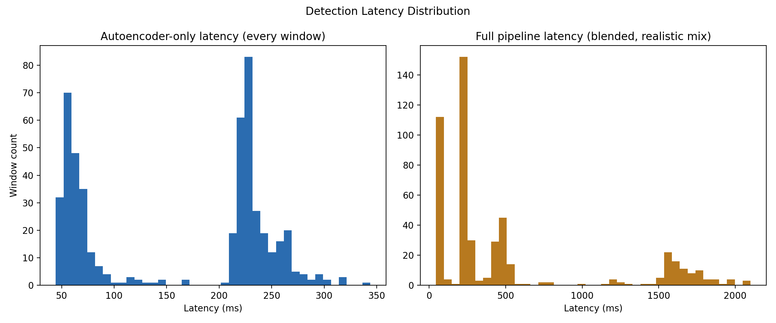
Figure 5. Per-window latency distributions, Autoencoder-only vs. full blended pipeline.

6.6 Panel Demo Validation
A 185-row, deliberately-paced sequence of real (never synthetic) CICIDS2017 rows was curated for live demonstration: calm BENIGN, a DDoS burst, back to BENIGN, a Port Scanning burst, back to BENIGN, a Botnet Activity burst, closing BENIGN. Re-validated against the currently deployed (retrained) model:
- BENIGN stretches: stay quiet throughout — no false alerts.
- DDoS burst: caught on 5 of 6 windows, ~99.99% confidence.
- Port Scanning burst: genuinely mixed — 2 of 6 windows caught, the rest fall below the anomaly threshold. This is real, documented model behaviour and is narrated proactively during the live demo rather than treated as a bug.
- Botnet Activity burst: caught on all 3 windows, 95–98% confidence.

7. Known Limitations
- Sequential-gate architecture caps overall recall: the BiLSTM only ever classifies windows the Autoencoder has already flagged, and the Autoencoder itself misses a meaningful share of real attacks at that gate — those never reach classification or alerting. This is a deliberate architectural trade-off (vs. a parallel design where both models see every window), not a bug, and it is the single biggest factor capping detection recall (~54% end to end).
- Data Exfiltration has too few raw samples (36) for its per-class metrics to be statistically meaningful.
- No cross-dataset generalization check has been run yet (would need UNSW-NB15, not sourced for this project).
- SHAP remains the slowest pipeline stage (hundreds of ms per alert) even after the GradientExplainer swap.
- Absolute latency numbers are hardware-dependent — see Section 6.5.

8. Current Project Status
Area | Status | Detail
Data Integrity | DONE | Windowing fix, leakage removal, mislabel fix, low-sample warnings, duplicate-row removal — all verified with real before/after numbers.
Detection Logic | DONE | Hybrid risk fusion built and calibrated. Latency benchmarked.
Explainability | DONE | SHAP swapped to GradientExplainer. Stability verified.
Generalization | PARTIAL | Per-class overfitting check done. UNSW-NB15 external check not started (optional / future work).
Report / Demo Assets | DONE | Confusion matrix, ROC curves, reconstruction error plot, latency histograms, per-class table, curated demo CSV.
Backend (FastAPI + MySQL) | DONE | Full API built and tested end to end, including a real retrain triggered through the API.
Stream Simulator | DONE | Built and tested; confirmed live-feed behaviour against the running backend.
React Dashboard | NOT STARTED | Deferred by project decision — backend API is ready for it.
Full End-to-End Integration | PARTIAL | Backend + model + stream simulator already work together; final integration closes once the dashboard exists.

9. Future Work
- Build the React dashboard on top of the existing, tested backend API.
- Run a full end-to-end integration pass once the dashboard exists.
- Source the UNSW-NB15 dataset and run a cross-dataset generalization check.
- Evaluate a parallel (non-sequential) architecture, where both the Autoencoder and BiLSTM see every window, as a way to raise the current recall ceiling — at the cost of always paying the classifier's compute cost.

10. Conclusion
NetShield AI demonstrates a working, end-to-end AI-driven threat detection pipeline: real data-integrity problems in CICIDS2017 were found and fixed with measured before/after impact, an Autoencoder + BiLSTM sequential-gate design detects and classifies six categories of attack traffic, a hybrid risk-fusion layer turns raw model output into an analyst-usable three-tier severity signal, SHAP explains individual predictions, and a validated feedback loop lets the model improve from analyst review — verified by actually triggering a retrain through the API and confirming the reloaded model still performs correctly. A FastAPI + MySQL backend and stream simulator turn this from an offline classifier into a live-alerting service. The main piece still ahead is the React dashboard, for which the backend is already built and ready.

Appendix A. How to Run

Train
python -m cyber_ai.train --config configs/default.yaml

Predict / Alert (CLI)
python -m cyber_ai.predict --input-csv <file.csv> --shap

Report Figures
python -m cyber_ai.report_assets

Backend API
cd backend && uvicorn app.main:app --reload --port 8000

Stream Simulator
python backend/scripts/stream_simulator.py --loop

Full detail, flags, and explanations for all of the above are in the repository's README.md and backend/README.md.

