Experiment: Configuring and Testing Windows Defender Firewall

Aim
To configure Windows Defender Firewall by creating and testing firewall rules, allowing and blocking specific ports, and understanding how firewall rules filter network traffic.

Objectives
- Open the Windows Defender Firewall configuration tool.
- View existing firewall rules.
- Create an inbound rule to block Telnet traffic (Port 23).
- Test the firewall rule.
- Create an inbound rule to allow SSH (Port 22).
- Remove the temporary block rule.
- Understand how firewall filters traffic.

System Requirements
Operating System: Windows 10/11
Tool Used: Windows Defender Firewall with Advanced Security
Administrator privileges

Procedure

Step 1: Open Windows Defender Firewall
1. Press Windows + R.
2. Type wf.msc and press Enter.
3. Windows Defender Firewall with Advanced Security opens.
Figure 1: Windows Defender Firewall with Advanced Security
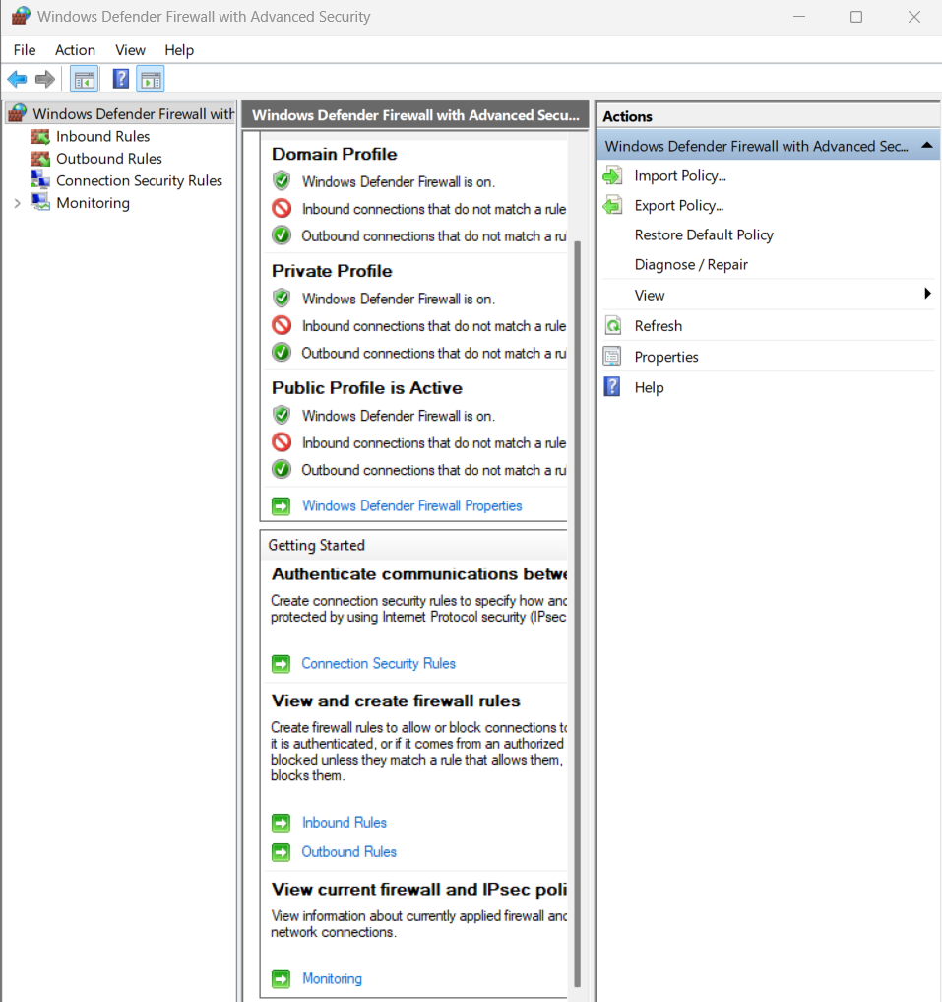

Step 2: View Existing Firewall Rules
1. Click Inbound Rules.
2. Observe the list of rules.
Figure 2: List of Existing Inbound Firewall Rules
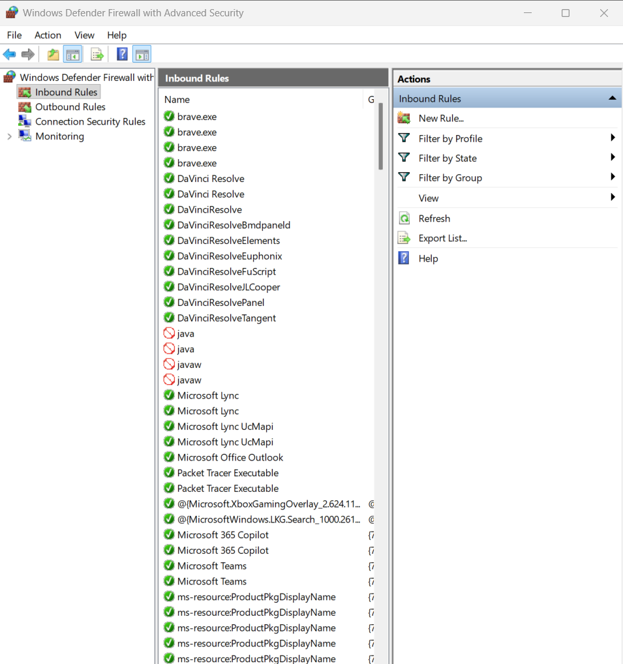

Step 3: Block Port 23
1. Inbound Rules → New Rule.
2. Select Port.
3. TCP, Specific local ports: 23.
4. Block the connection.
5. Select all profiles.
6. Name: Block Telnet Port 23.
Figure 3: Inbound Rule Blocking Port 23
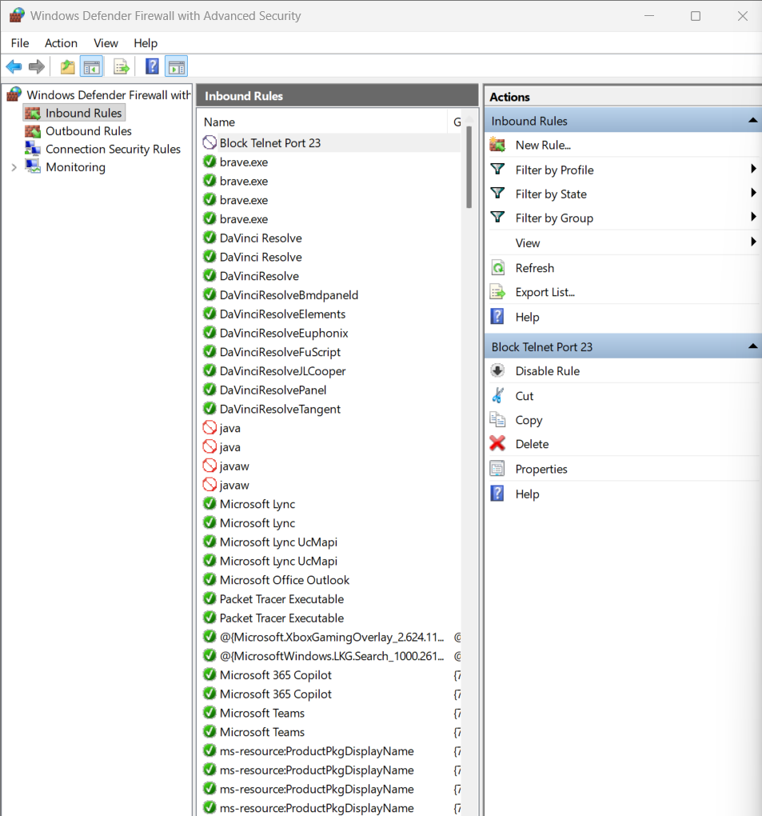

Step 4: Test the Rule
Run in PowerShell:
Test-NetConnection localhost -Port 23
Expected: TcpTestSucceeded : False
Figure 4: PowerShell Test Result
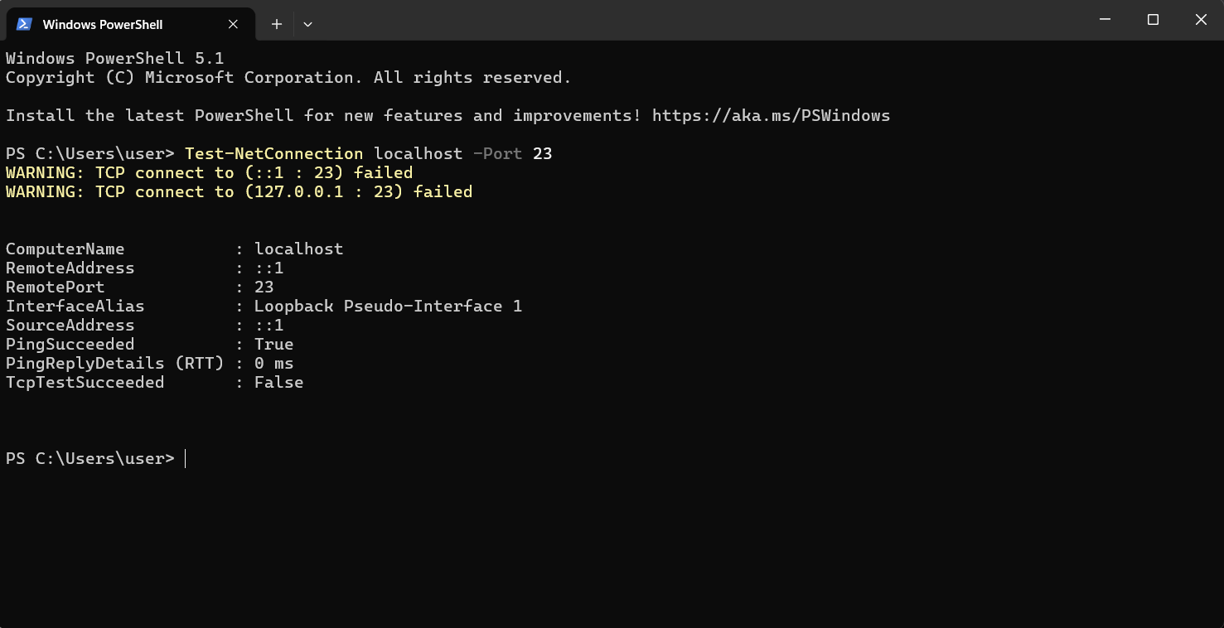

Step 5: Allow SSH
Create a new inbound rule for TCP port 22 and Allow the connection. Name it Allow SSH Port 22.
Figure 5: Inbound Rule Allowing SSH
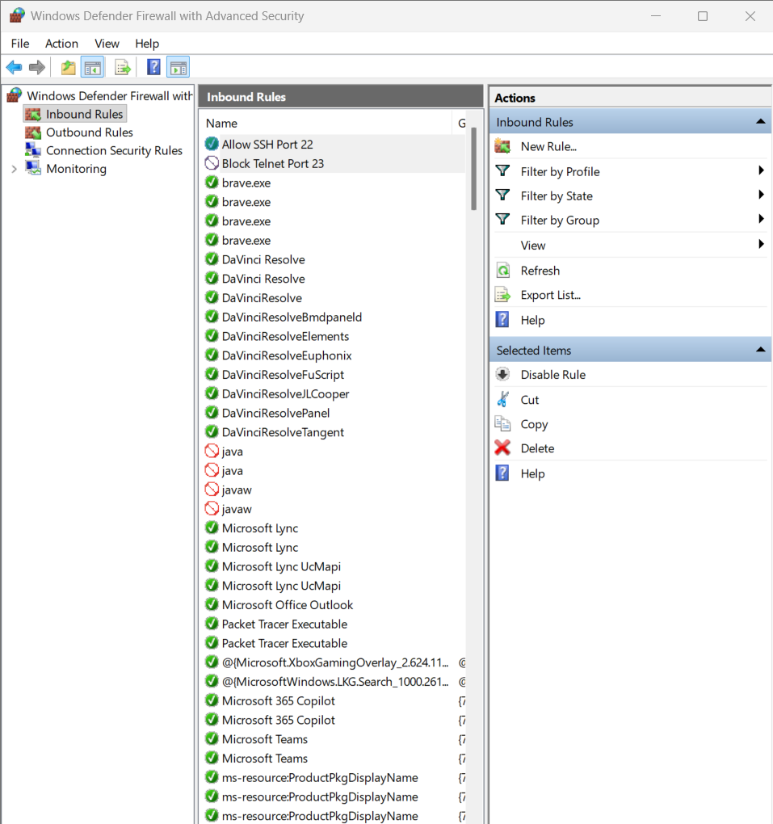

Step 6: Remove Test Rule
Delete the 'Block Telnet Port 23' rule from Inbound Rules.
Figure 6: Firewall Rules After Removing Test Rule
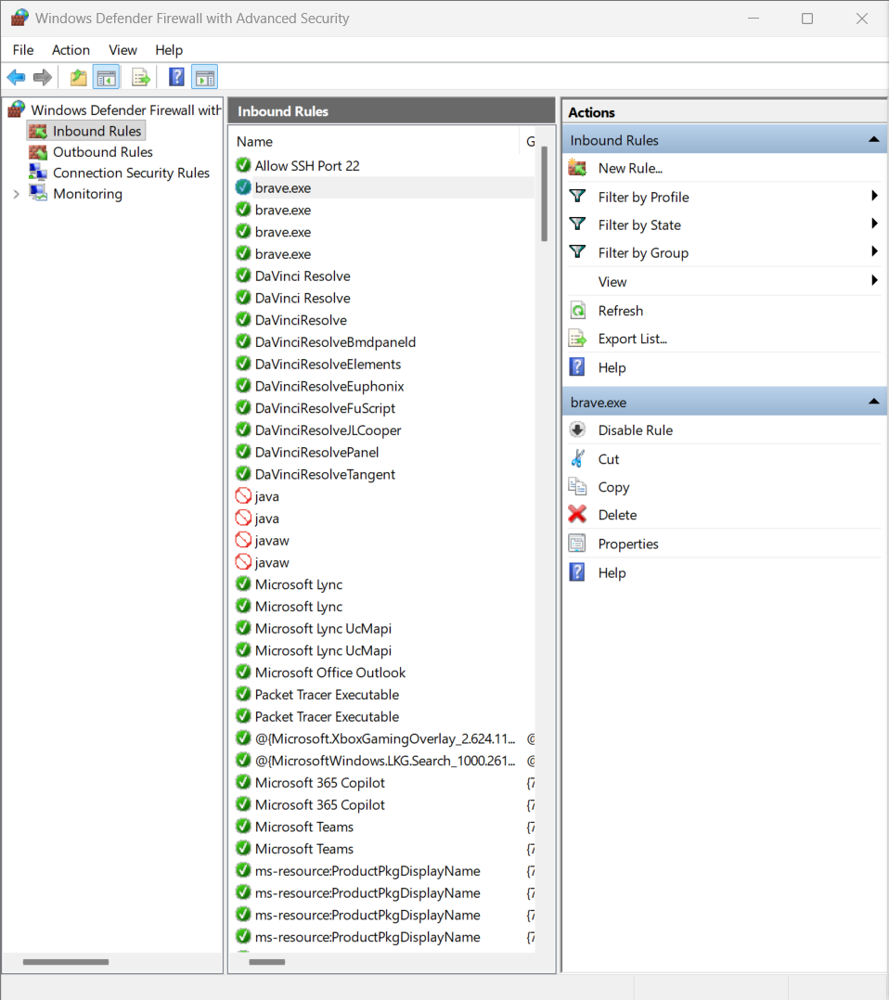

Results
- Opened Windows Defender Firewall.
- Viewed inbound rules.
- Blocked Port 23.
- Tested blocked port.
- Allowed Port 22.
- Removed temporary rule.

Discussion
Windows Defender Firewall filters incoming and outgoing network traffic according to configured security rules. It examines connection requests based on parameters such as port numbers, protocols, IP addresses, and applications. Matching allow rules permit traffic, while matching block rules deny it. Blocking unused ports such as Telnet (23) improves security, while allowing required services such as SSH (22) enables secure communication.

Conclusion
The experiment successfully demonstrated creating, testing, and removing firewall rules using Windows Defender Firewall. The firewall effectively blocked Telnet traffic, allowed SSH traffic, and illustrated how firewall rules protect systems from unauthorized access.

