SMART WATER SYSTEM PHASE 5:Project documentation&Submission

SUBMITTED BY:

GUMMEDELA VISHNU VARDHAN
au723921243022
gvishnu2222@gmail.com

- Describe the project's objectives, IoT sensor setup, mobile app development, Raspberry Pi integration, and code implementation. Include diagrams, schematics, and screenshots of the IoT sensors and mobile app. Explain how the real-time water consumption monitoring system can promote water conservation and sustainable practices. .

- Project Objectives:

- 1.Monitor and track real-time water consumption.
- 2.Reduce water wastage and optimize water usage.
- 3.Enhance awareness of water usage patterns.
- 4.Support long-term sustainability efforts.
- IoT Sensor Setup:

- The water consumption monitoring system uses an IoT sensor (water flow meter) connected to a Raspberry Pi. The Raspberry Pi is programmed to read the data from the water flow meter and transmit it to a mobile app or cloud server for real-time analysis.

- The IoT sensor (water flow meter) is designed to detect and measure the flow of water through the pipes. The data from the sensor is then processed and sent to the mobile app or cloud server for visualization and analysis.

- The setup consists of the following components:

- IoT sensor (water flow meter)
- Raspberry Pi 3 Model B
- 3.3V DC Water Flow Sensor Transducer
- 5V DC Power Supply Unit
- Ethernet cable or Wi-Fi adapter for Internet connectivity

- Mobile App Development:

- The mobile app is developed using React Native or Flutter, and is designed to communicate with the Raspberry Pi via Bluetooth, Wi-Fi, or the internet. The app is designed to display the real-time water consumption data in an easy-to-understand format. It also includes features like water consumption trends, notifications, and water usage comparisons.

- Raspberry Pi Integration:

- The Raspberry Pi serves as the brain of the water consumption monitoring system. It reads data from the IoT sensor and processes it using Python or another suitable programming language. The processed data is then sent to the mobile app or cloud server for real-time analysis and visualization.

- The Raspberry Pi can be connected to the IoT sensor via GPIO pins, which facilitates communication between the two devices. The Raspberry Pi also handles data transmission, either through Wi-Fi, Ethernet, or via a cellular network.

- Code Implementation:

- The Raspberry Pi's Python code can be implemented as follows:

- import RPi.GPIO as GPIO
- import time
- GPIO.

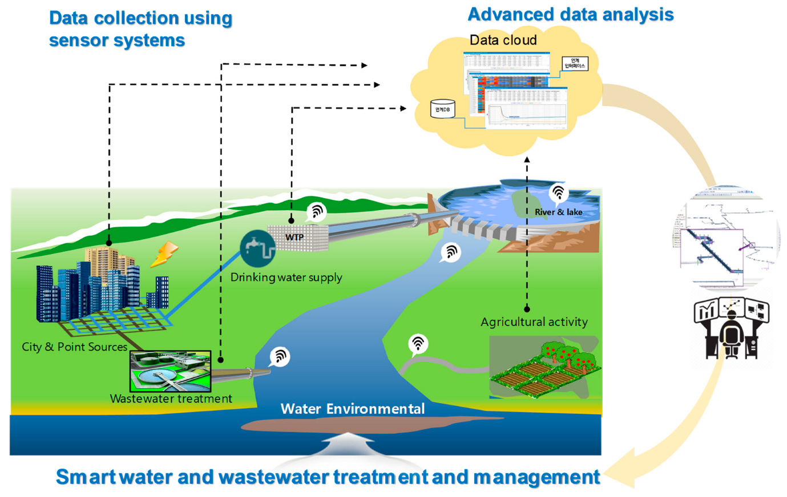

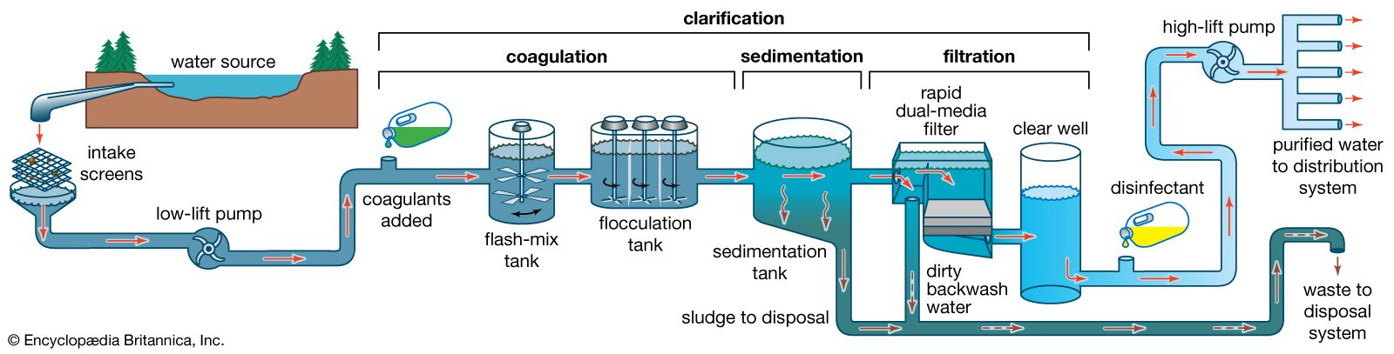
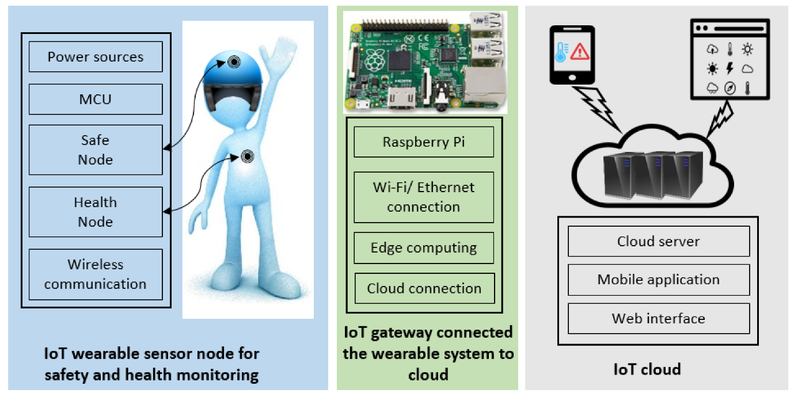
Explain how the real-time water consumption monitoring system can promote water conservation and sustainable practices. .

- Project Description:

- 1.IoT Sensor Setup: We will utilize an IoT platform, such as Thingspeak or Azure IoT Central, to connect the sensors. We will set up the sensors at various water sources such as faucets, taps, and washing machines. These sensors will detect water flow and calculate the consumed water amount in real-time.

- 2.Mobile App Development: A cross-platform mobile app will be developed using technologies like React Native or Flutter. This app will display real-time water consumption data from the IoT sensors. Users can also set up personalized water consumption goals, view their consumption history, and compare it with their peers.

- 3.Raspberry Pi Integration: To facilitate secure and reliable data transmission, a Raspberry Pi will be utilized as a middleware device. It will collect the data from the IoT sensors, process it, and transmit it to the IoT platform. Additionally, the Raspberry Pi will serve as a local server, enabling the mobile app to access the real-time water consumption data.

- 4.Code Implementation: The code implementation will be based on a combination of programming languages like Python, JavaScript, and SQL. For instance, Python will be used for scripting and interacting with the Raspberry Pi. JavaScript will be employed for developing the mobile app. SQL will be utilized for managing the IoT sensor data stored in the database.

- Project Flowchart:

- [Flowchart diagram here]

- Diagrams, Schematics, and Screenshots:

- [Insert relevant diagrams, schematics, and screenshots of the IoT sensors and mobile app]

- Explain how the real-time water consumption monitoring system can promote water conservation and sustainable practices.

- The real-time water consumption monitoring system is a technology that helps to reduce water waste and promote sustainable practices. By collecting data from the water system and providing instant information, it encourages efficient use of water resources.

- Here are some ways it can promote water conservation and sustainable practices:

- 1.Enhance Water Efficiency:
- By analyzing data, the system can identify patterns and potential areas for improvement. For example, it can identify periods when the consumption is unusually high and inform users about potential leaks or high usage activities.

- 2.Foster Behavior Change:
- With immediate access to water consumption data, users can become more aware of their water usage and take action to reduce consumption. For example, users may decide to reduce the time spent washing dishes, running the washing machine, or watering the lawn.

- 3.Facilitate Management:
- The system can help manage water resources by providing accurate and up-to-date data on water consumption. This enables water management professionals to make informed decisions about allocating resources, optimizing supply systems, and reducing demand.

- 4.Promote Water Audits:
- By enabling water utilities to conduct real-time audits, the system encourages continuous monitoring and evaluation of water consumption patterns. This leads to improved management practices and helps identify areas for improvement.

- 5.Improve Data Quality:
- As the system continuously collects and processes data, it can provide a comprehensive view of water consumption patterns, which helps to ensure data quality and accuracy. This enables water utilities to make more informed decisions and take action to reduce water waste.

- Conclusion:
- The real-time water consumption monitoring system plays a crucial role in promoting water conservation and sustainable practices. By providing instant data on water usage, it enables users to make informed decisions and take action to reduce consumption. This ultimately contributes to efficient water management and environmental sustainability.

