WCF Fundamentals

EndPoint :
- It defines the address where a message is to be sent or received .
- It is a portal for communicating with the world.
- All communication take place through end points.
- Structure contains following parts – Address , Binding & Contract.

Eg - <endpoint address=”http://localhost:8090/MyService/MathService.svc” contract=”IMathService” binding=”WsHttpBinding” />

Address -
- Specifies the exact location to receive messages.
- URI – scheme://domain[:port]/[path]
Eg- net.tcp://localhost:9000/ServiceA/ServiceA.svc http://localhost:8090/MyService/SimpleCalculator.svc

Binding -
- Describes how the client will communicate with service as per the client needs.
- Binding has the following characteristics
Transport – Defines the base protocol to be used like HTTP,TCP,named pipes & MSMQ.
Encoding – Encoding types like Text , Binary or MTOM.
Protocol – Defines information to be used in the binding such as Security, Transaction etc.

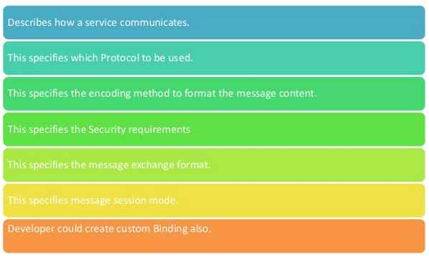

Various types of bindings available -

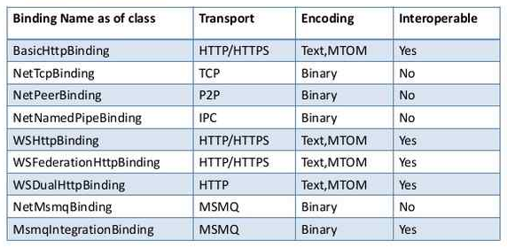
BasicHTTPBinding -
- BasicHttpBinding is suitable for communicating with ASP.NET Web Service (ASMX) based services.
- Security is disabled by default.
- Uses HTTP as transport protocol and encoding as text or xml.
- It is weak in interoperable.

WsHTTPBinding -
- It is more secure, reliable and interoperable as compared to basic http binding.
- WSHttpBinding uses both HTTP and HTTPS transport for communication.
- It has WS-Security enabled by default. So the data is not sent in plain text.

WsDualHttpBinding -
- It is same as WSHttpBinding rather than it supports duplex service. Duplex is a message pattern that is used by client and service to exchange their message via callback.

NetTcpBinding -
- It supports TCP as protocol and binary encoding by default.
- It provides cross machine communication and supports WS-ReliableMessaging by default. It provides more secure transfer and reliable communication.

NetNamedPipeBinding -
- It uses NamedPipe protocol to communicate with client with full support of SOAP security and transaction. It also uses WS-ReliableMessaging for secure transfer of data over the network and delivering the data in binary encoding.

Contract -
- Specifies what the endpoint will communicate with the outside world.
- Usually name of the interface will be mentioned in the contract, so the client application will be aware of the operations which are exposed to the client.
- Each operation is a simple message exchange pattern such as one-way, duplex & request/reply.

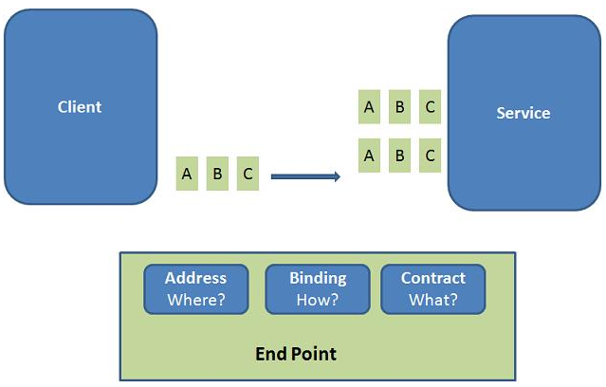

Binding & Behaviour -
- If the service has to be used by two types clients.One of the client will access SOAP using http and other client will access Binary using TCP. we need to add extra endpoint in the configuration file.

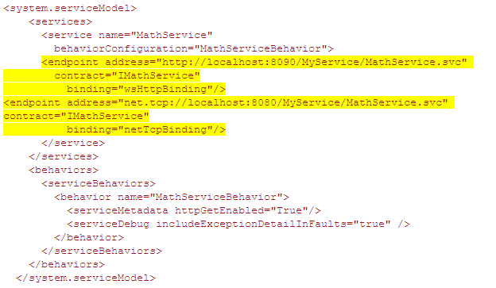
- The Service Behavior defines how the endpoint interacts with clients. Attributes like security, concurrency, caching, logging, etc. - those are all part of the behavior.

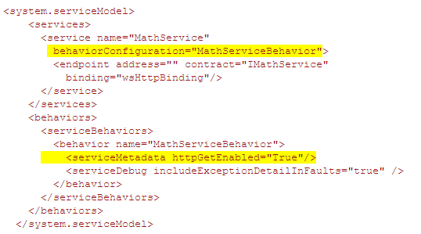
Contracts and Service Host -
Four types of service contracts

Service Contracts -
- Service contract describes the operations, or methods, that are available on the service endpoint, and exposed to the outside world.
- To create a service contract you define an interface with related methods representative of a collection of service operations, and then decorate the interface/class with the ServiceContract Attribute to indicate it is a service contract. Methods in the interface that should be included in the service contract are decorated with the OperationContract Attribute.

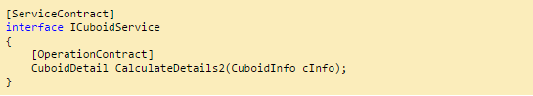
Data Contracts -
- It defines the structure and types of data exchanged in service messages.
- Data contract can be explicit or implicit. Simple type such as int, string etc has an implicit data contract.
- User defined object are explicit or Complex type, for which you have to define a Data contract using [DataContract] and [DataMember] attribute.

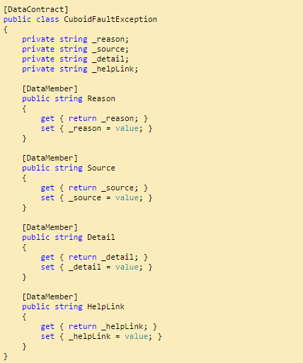

Message Contract -
- Data contract takes care of the SOAP message , but in come case we need control over the SOAP message, we need to add data to Soap header and to the body of the envelope.

Fault Contract -
- Suppose the service I consumed is not working in the client application. I want to know the real cause of the problem. How I can know the error? For this we are having Fault Contract. Fault Contract provides documented view for error occurred in the service to client. This helps us to easy identity, what error has occurred.

