EPAM AWS JS COURSE Task 2: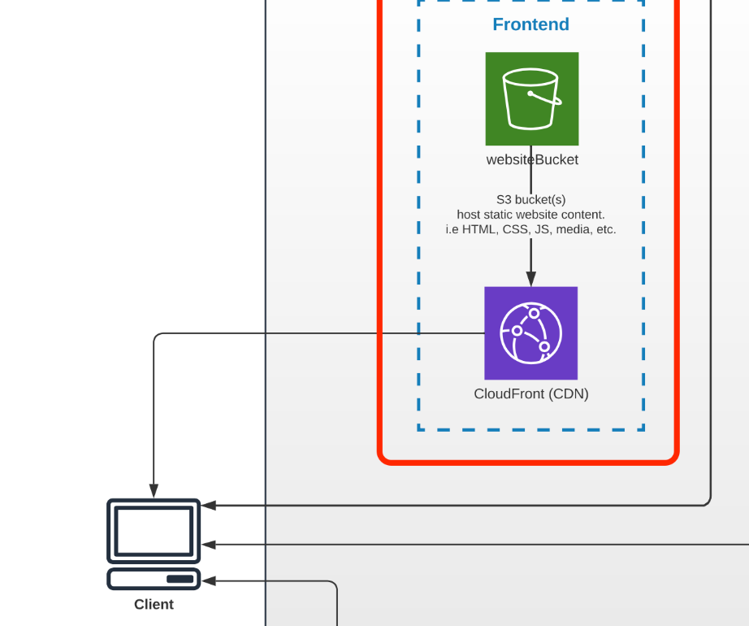

ReaD: AWS IAM, S3 BUCKET POLICY, CLOUD FRONT

[Vishnu1302/shop-angular-cloudfront at vishnu/EpamAwsJSCourse-task2 (github.com)](https://github.com/Vishnu1302/shop-angular-cloudfront/tree/vishnu/EpamAwsJSCourse-task2)

# Task 2 (Serve SPA in AWS S3 and Cloudfront Services)

* **0** - Nothing has been done. *(Link to repository is not provided. Nothing to check.)*
* **60** - S3 bucket has been created and configured properly. The app has been uploaded to the bucket and is available though the Internet. Nothing else has been done. *(Link to S3 bucket/website is provided. There is no Pull Request in the YOUR OWN frontend repository.)*
* **80** - In addition to the previous work a CloudFront distribution is created and configured properly and the site is served now with CloudFront and is available through the Internet over CloudFront URL, not S3-website link (due to changes in bucket’s policy...). *(Link to CloudFront website is provided. S3-website shows 403 Access Denied error. There is no Pull Request in the YOUR OWN frontend repository.)*
* **100** - Serverless-finch and serverless-single-page-app plugins are added and configured. The app can be built and deployed by running npm script command. *(Link to CloudFront website is provided. PR with all changes is submitted in the YOUR OWN frontend repository and its link is provided for review.)*

Task 3 :

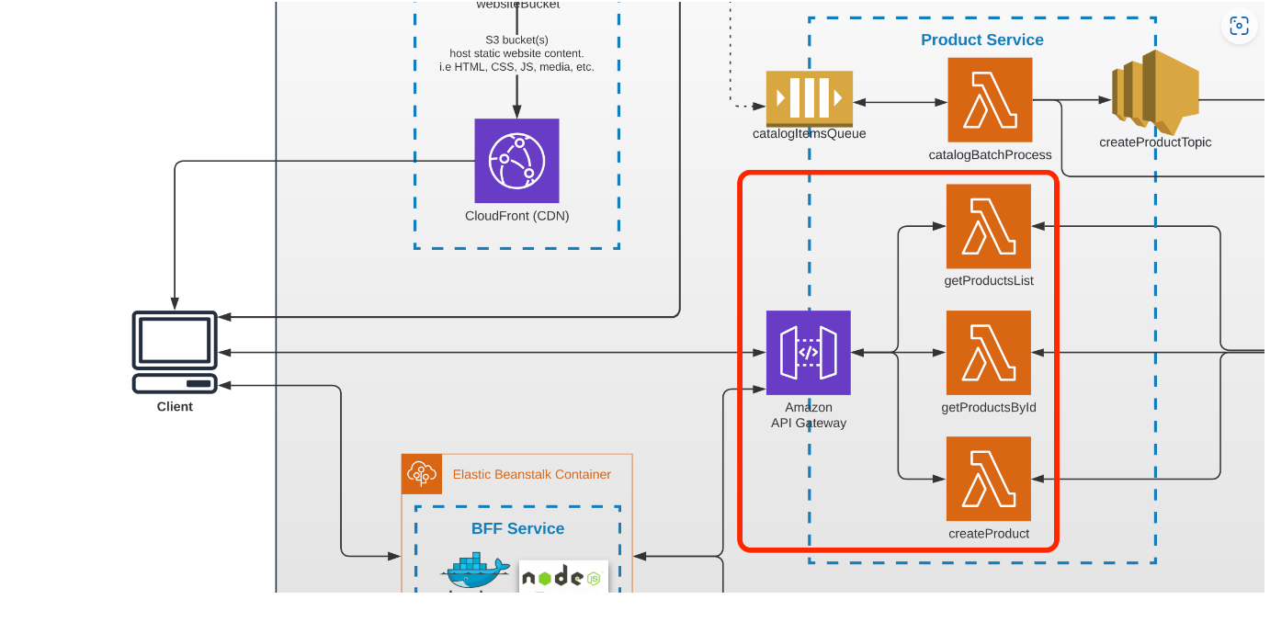

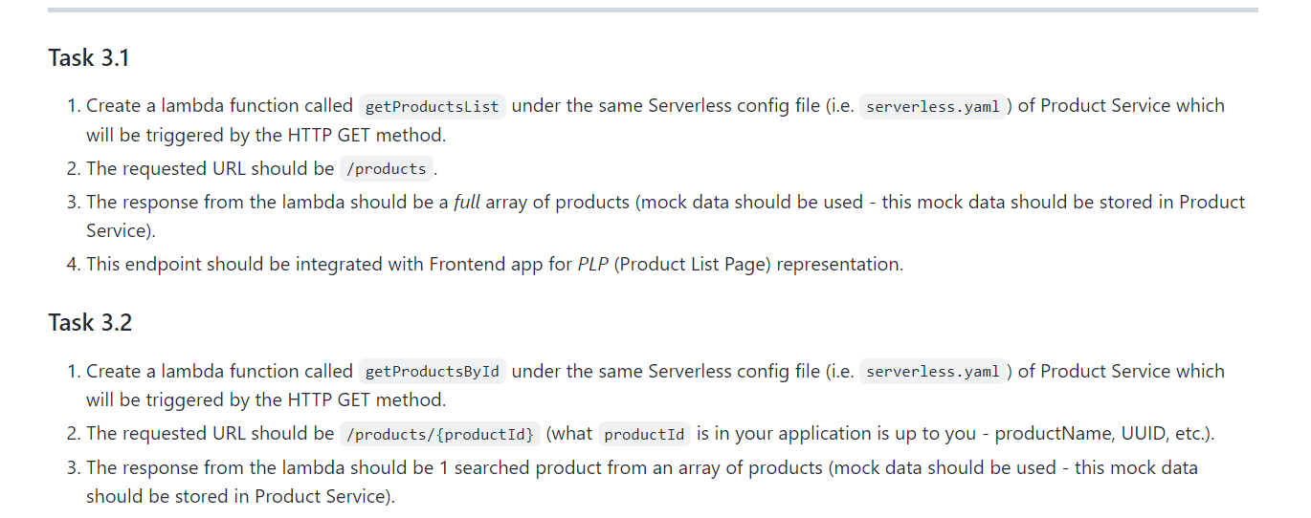

AWS Lambda, AWS API Gateway concepts are covered in this and everything is created with serverless.yml

[Vishnu1302/shop-angular-cloudfront at vishnu/task3 (github.com)](https://github.com/Vishnu1302/shop-angular-cloudfront/tree/vishnu/task3) - Front end

[Vishnu1302/EpamAWSJSBackEnd at vishnu/task-3 (github.com)](https://github.com/Vishnu1302/EpamAWSJSBackEnd/tree/vishnu/task-3) --Backend Nodes js simple API