An Industry Oriented Mini Project Report
on
A SIMPLE FITNESS WEB APP USING OPEN CV

Submitted to

Guru Nanak Institute of Technology (Autonomous)
in partial fulfilment of the requirements for the award of the degree of

BACHELOR OF TECHNOLOGY

in
COMPUTER SCIENCE AND ENGINEERING
(CYBER SECURITY)

By

KUNCHANAPALLY HARI VENKATESH 21831A6234
PASHIKANTI VISHNU VARDHAN 21831A6246
VENNA VENKATESH 21831A6263

Under the Esteemed Guidance of
Mrs. K. NIRMALA

Associate Professor

DEPARTMENT OF COMPUTER SCIENCE AND ENGINEERING (CYBER SECURITY)
GURU NANAK INSTITUTE OF TECHNOLOGY
(Autonomous)
Ibrahimpatnam, Ranga Reddy District -501506
December 2024


GURU NANAK INSTITUTE OF TECHNOLOGY
(Autonomous)
Ranga Reddy District -501506

CERTIFICATE

This is to certify that the project entitled “A Simple Fitness Web App Using OpenCV” is being presented with report by KUNCHANAPALLY HARI VENKATESH (21831A6234), PASHIKANTI VISHNU VARDHAN (21831A6246), VENNA VENKATESH (21831A6263) in partial fulfilment for the award of Degree of Bachelor of Technology in Computer Science and Engineering (Cyber Security).

Mrs. K. Nirmala Mr. E. Vinay Kumar
INTERNAL GUIDE PROJECT COORDINATOR

Dr. Ch. Balakrishna
HEAD OF DEPARTMENT EXTERNAL EXAMINER

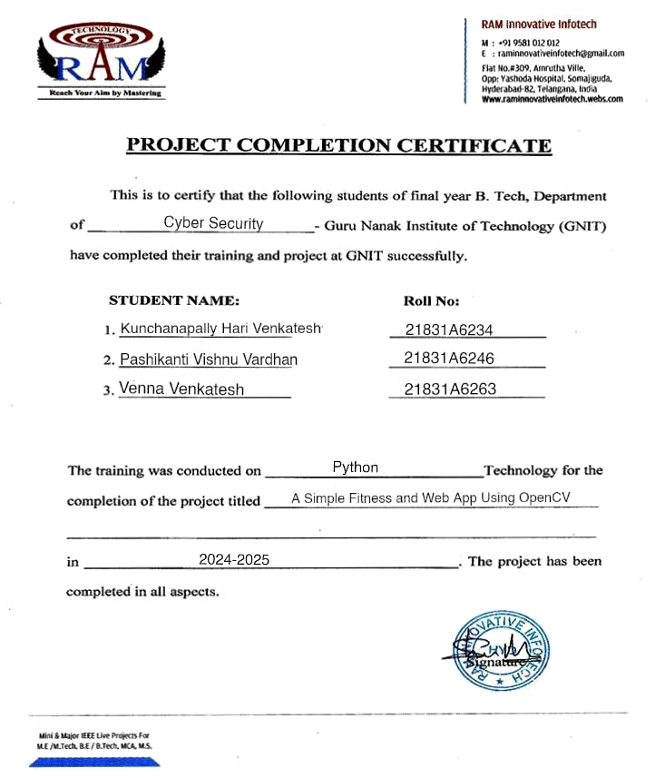

GURU NANAK INSTITUTE OF TECHNOLOGY
(Autonomous)
Ranga Reddy District -501506

VISION OF GNIT

To be a world – class educational and research institution in the service of humanity by promoting high quality Engineering and Management Education.
MISSION OF GNIT

M1: Imbibe soft skills and technical skills.
M2: Develop the faculty to reach the international standards.
M3: Maintain high academic standards and teaching quality that promotes the analytical thinking and independent judgment.
M4: Promote research, innovation, and product development by collaboration with reputed foreign universities.

M5: Offer collaborative industry programs in emerging areas and spirit of enterprise.


GURU NANAK INSTITUTE OF TECHNOLOGY
(Autonomous)
Ranga Reddy District -501506

DEPARTMENT OF COMPUTER SCIENCE AND ENGINEERING

(CYBER SECURITY)

VISION OF DEPARTMENT

To be a premier Department of Computer Science and Engineering (Cyber Security), known globally for value-based education, Research & Innovation through academic excellence to serve the needs of industry and society

MISSION OF DEPARTMENT

Develop a strong foundation on fundamentals of Computer Science and Engineering (Cyber Security) through Outcome based Teaching Learning process.

Establish state of art & Centre of Excellence facilities in Emerging technologies for Design and development of Innovative Products.

Involve the students in Group activities, including those of professional bodies to develop leadership, entrepreneurship and good communication skills


GURU NANAK INSTITUTE OF TECHNOLOGY
(Autonomous)
Ranga Reddy District -501506

DEPARTMENT OF COMPUTER SCIENCE AND ENGINEERING (CYBER SECURITY)

Program Educational Objectives (PEO’s)
PEO-1: Have an ability to adapt to a rapidly changing environment by having learned and applied cutting-edge skills in emerging technologies.
PEO-2: Build a strong foundation in the field of artificial intelligence, cyber security, machine learning, and data science to contribute significantly in the area of innovations and research.
PEO-3: Have strong work ethics, professional attitude, team spirit, leadership, and enterprising skills to serve industry and society.

Program Outcomes (PO’s)
1. Engineering Knowledge: Apply the knowledge of mathematics, science, engineering fundamentals, and an engineering specialization to the solution of complex engineering problems.

2. Problem Analysis: Identify, formulate, review research literature, and analyse complex engineering problems reaching substantiated conclusions using first principles of mathematics, natural sciences, and engineering sciences.

3. Design/development of solutions: Design solutions for complex engineering problems and design system components or processes that meet the specified needs with appropriate consideration for the public health and safety, and the cultural, societal, and environmental considerations.

4. Conduct investigations of complex problems: Use research-based knowledge and research methods including design of experiments, analysis and interpretation of data, and synthesis of the information to provide valid conclusions.
5. Modern tool usage: Create, select, and apply appropriate techniques, resources, and modern engineering and IT tools including prediction and modelling to complex engineering activities with an understanding of the limitations.

6. The engineer and society: Apply reasoning informed by the contextual knowledge to assess societal, health, safety, legal and cultural issues and the consequent responsibilities relevant to the professional engineering practice.

7. Environment and sustainability: Understand the impact of the professional engineering solutions in societal and environmental contexts, and demonstrate the knowledge of, and need for sustainable development.

8. Ethics: Apply ethical principles and commit to professional ethics and responsibilities and norms of the engineering practice.

9. Individual and teamwork: Function effectively as an individual, and as a member or leader in diverse teams, and in multidisciplinary settings.

10. Communication: Communicate effectively on complex engineering activities with the engineering community and with society at large, such as, being able to comprehend and write effective reports and design documentation, make effective presentations and give and receive clear instructions.

11. Project management and finance: Demonstrate knowledge and understanding of the engineering and management principles and apply these to one’s own work, as a member and leader in a team, to manage projects and in multidisciplinary environments.

12. Life-long learning: Recognize the need for and have the preparation and ability to engage in independent and life-long learning in the broadest context of technological change.


GURU NANAK INSTITUTE OF TECHNOLOGY
(Autonomous)
Ranga Reddy District -501506

MAPPING WITH PO’S AND PSO’S

Sl. No. | Content | PO’s | PEO’s
1 | Introduction | PO1, PO2 | PEO1
2 | Abstract | PO1, PO2 | PEO1
3 | System Specifications | PO3, PO5 | PE01
4 | Architecture Design | PO3, PO4 | PEO1, PEO2
5 | Implementation | P09, PO10, PO11 | PEO2, PEO3
6 | Results | PO4, PO11, PO12 | PEO2, PEO3


GURU NANAK INSTITUTE OF TECHNOLOGY
(Autonomous)
Ranga Reddy District -501506

DECLARATION

We hereby declare that the mini project report entitled “A Simple Fitness Web App Using OpenCV.” Is the work done by KUNCHANAPALLY HARI VENKATESH, PASHIKANTI VISHNU VARDHAN, VENNA VENKATESH bearing the roll no’s 21831A6234, 21831A6246, 21831A6263 towards the fulfilment of the requirement for the award of the Degree of Bachelor of Technology in Computer Science and Engineering (Cyber Security), Guru Nanak Institute of Technology, is the result of the work carried out under the guidance of Mrs. K. Nirmala, Associate Professor, Guru Nanak Institute of Technology, Hyderabad.

We further declare that this mini project report has not been previously submitted before either in part or full for the award of any degree or any diploma by any organization or any universities.

KUNCHANAPALLY HARI VENKATESH (21831A6234)
PASHIKANTI VISHNU VARDHAN (21831A6246)
VENNA VENKATESH (21831A6263)

ACKNOWLEDGEMENT

"Task successful" makes everyone happy. But the happiness will be gold without glitter if we didn't state the persons who have supported us to make it a success.

We would like to express our sincere thanks and gratitude to our Principal Dr. K. VENKATA RAO and Head of the Department Dr. CH. BALAKRISHNA Department of Computer Science and Engineering (Cyber Security), Guru Nanak Institute of Technology for guided us in developing the requisite capabilities for taking up this mini project.

We thank our Project Coordinator Mr. E. VINAY KUMAR, Assistant Professor, Department of Computer Science and Engineering (Cyber Security), Guru Nanak Institute of Technology for providing seamless support and right suggestions that are given in the development of the mini project.

We specially thank our internal guide Mrs. K. NIRMALA for her constant guidance in every stage of the project. We would also like to thank all our lecturers for helping us in every possible way whenever the need arose.

On a more personal note, we thank our beloved parents and friends for their moral support during our mini project.

A SIMPLE FITNESS WEB APP USING OPENCV

ABSTRACT

The web application integrates OpenCV and Media Pipe to provide a comprehensive fitness tracking and analysis platform. Leveraging OpenCV's robust image processing capabilities, the app offers real-time video analysis for exercises such as push-ups, squats, and lunges, accurately counting repetitions and providing instant feedback on form and technique. Media Pipe’s pose estimation models enhance the app's by precisely detecting key body landmarks and tracking movement dynamics. This combined technology enables users to receive personalized workout metrics, including calorie burn estimations, posture corrections, and progress tracking over time. Fit Hub empowers users to achieve their fitness goals effectively by leveraging cutting-edge computer vision techniques in a user-friendly and accessible application.
LIST OF CONTENTS
CHAPTER NO. | TITLE | PAGE NO.
 | Abstract  List of Figures  List of Notations  List of Abbreviations | xii  xvi  xvii  xx
1. | CHAPTER 1: INTRODUCTION  - General  - Scope Of the Project  - Objective  - Existing System  1.4.1 Existing System Disadvantages  1.4.2 Literature Survey  1.5 Proposed System  1.5.1 Proposed System Advantages | 1  2  3  4  4  5  10
2. | CHAPTER 2: PROJECT DESCRIPTION  - General  2.2 Methodologies  2.2.1 Modules Name  2.2.2 Modules Description  2.3 Techniques Used or Algorithms Used  2.3.1 Existing System  2.3.2 Proposed techniques used algorithm | 11  12  12  13  14  14  15
3. | CHAPTER 3: REQUIREMENTS ENGINEERING  3.1 General  3.2 Hardware Requirements  3.3 Software Requirements  3.4 Functional Requirements  3.5 Non-Functional Specification | 18  18  18  19  20  21
4. | CHAPTER 4: DESIGN ENGINEERING  4.1 General  4.2 UML Diagram  4.2.1 Use case Diagram  4.2.2 Class Diagram  4.2.3 Object Diagram  4.2.4 State Diagram  4.2.5Activity Diagram  4.2.6 Sequence Diagram  4.2.7 Collaboration Diagram  4.2.8 Component Diagram  4.2.9 Data Flow Diagram  4.2.10 Deployment Diagram  4.2.11 System Architecture | 22  22  23  23  24  25  26  27  28  29  30  31  33  34
5. | CHAPTER 5: DEVELOPMENT TOOLS  5.1 Python  5.2 History of Python  5.3 Importance of Python  5.4 Features of Python  5.5 Libraries used in python | 35  35  35  35  36  37
6. | CHAPTER 6: IMPLEMENTATION  6.1 General  6.2 index.html  6.3 app.py  6.4 script.js | 38  38  38  40  44
7. | CHAPTER 7: SNAPSHOTS  7.1 General  7.2 Folder Page  7.3 Anaconda prompt page  7.4 Home Page  7.5 Instructions of Project  7.6 warrior-pose  7.7 BMI Calculator  7.8 About Fitness App | 45  45  45  46  46  47  47  48  48
8. | CHAPTER 8: SOFTWARE TESTING  8.1 General  8.2 Developing Methodologies  8.3 Types of Testing  8.3.1 Unit Testing  8.3.2 Functional Test  8.3.3 System Test  8.3.4 Performance Test  8.3.5 Integration Testing  8.3.6 Acceptance Testing  8.3.7 Build the test plan | 49  49  49  49  49  50  50  50  51  51
9. | CHAPTER 9: CONCLUSION AND FUTURE ENHANCEMENT  9.1 Conclusion  9.2 Future Enhancements | 52  52
10. | CHAPTER 10: REFERENCES  10.1 References | 53

LIST OF FIGURES
FIGURE NO | NAME OF THE FIGURE | PAGE NO.
4.2 | Use case Diagram | 23
4.2.2 | Class Diagram | 24
4.2.3 | Object Diagram | 25
4.2.4 | State Diagram | 26
4.2.5 | Activity Diagram | 27
4.2.6 | Sequence Diagram | 28
4.2.7 | Collaboration Diagram | 29
4.2.8 | Component Diagram | 30
4.2.9 | Data flow Diagram | 31
4.2.10 | Deployment Diagram | 33
4.2.11 | System Architecture | 34
7.2 | Project Folder | 45
7.3 | Anaconda Prompt Data | 46
7.4 | Homepage | 46
7.5 | Instructions about Fitness | 47
7.6 | Warrior-Pose | 47
7.7 | BMI Calculator | 48
7.8 | About Fitness | 48
LIST OF NOTATIONS
S.NO | NAME | NOTATION | DESCRIPTION
1. | Class | Class Name  -attribute-attribute  +operation  +operation  +operation  + public  -private  # protected | Represents a collection of similar entities grouped together.
2. | Association | name  Class B  Class A  Class A  Class B | Associations represents static relationships between classes. Roles represents the way the two classes see each other.
3. | Actor | Class A  Class A  Class B  Class B | It aggregates several classes into a single classis
5. | Aggregation |  | Interaction between the system and external environment
5. | Relation  (uses) | Uses | Used for additional process communication.
6. | Relation  (extends) | extends | Extends relationship is used when one use case is similar to another use case but does a bit more.
7. | Communication |  | Communication between various use cases.
8. | State | State | State of the process.
9. | Initial State |  | Initial state of the object
10. | Final state |  | Final state of the object
11. | Control flow |  | Represents various control flow between the states.
12. | Decision box |  | Represents decision making process from a constraint
13. | Usecase | Uses case | Interact ion between the system and external environment.
14. | Component |  | Represents physical modules which is a collection of components.
15. | Node |  | Represents physical modules which are a collection of components.
16. | Data Process / State |  | A circle in DFD represents a state or process which has been triggered due to some event or action.
17. | External entity |  | Represents external entities such as keyboard, sensors, etc.
18. | Transition |  | Represents communication that occurs between processes.
19. | Object Lifeline |  | Represents the vertical dimensions that the object communications.
20. | Message |  | Represents the message exchanged.

LIST OF ABBREVATION
S.NO | ABBREVATION | EXPANSION
1. | OPEN CV | Open Computer Vision
2. | IPP | Intel’s Image Processing Library
3. | MATLAB | Matrix Laboratory
4. | FFT | Fast Fourier transform
5. | VR | Virtual Reality
6. | PHP | Hypertext Preprocessor

CHAPTER 1
INTRODUCTION
1.1 GENERAL
- FitHub revolutionizes fitness tracking and analysis with its innovative integration of OpenCV and MediaPipe technologies. This web application offers a holistic approach to fitness monitoring by harnessing OpenCV's powerful image processing capabilities for real-time video analysis of exercises like push-ups, squats, and lunges. Through precise repetition counting and instant feedback on form and technique, users can optimize their workout routines for maximum effectiveness. MediaPipe's advanced pose estimation models further enhance the app's functionality by accurately detecting key body landmarks and tracking movement dynamics. This synergy of OpenCV and MediaPipe enables FitHub to provide personalized workout metrics, including calorie burn estimations, posture corrections, and progress tracking over time. With its user-friendly interface and cutting-edge computer vision techniques, FitHub empowers users to achieve their fitness goals with confidence and efficiency.

1.2 SCOPE OF THE PROJECT

The scope of FitHub extends beyond traditional fitness tracking platforms, offering a comprehensive solution that integrates advanced computer vision technologies to enhance user experience and workout effectiveness. With OpenCV's robust image processing capabilities, the application can perform real-time video analysis for a range of exercises, accurately counting repetitions and providing instant feedback on form and technique. MediaPipe's pose estimation models further augment the app by precisely detecting key body landmarks and tracking movement dynamics, enabling detailed analysis and personalized insights into workout performance. FitHub's scope encompasses not only exercise tracking but also personalized workout metrics such as calorie burn estimations, posture corrections, and progress tracking over time. This holistic approach aims to empower users with actionable data and feedback, facilitating informed decision-making and continual improvement in their fitness journey.
1.3 OBJECTIVE

The objective of FitHub is to revolutionize the fitness tracking and analysis experience by leveraging cutting-edge computer vision technologies, specifically OpenCV and MediaPipe. The primary goal is to provide users with a comprehensive platform that offers real-time video analysis for various exercises, including push-ups, squats, and lunges. This analysis includes accurate repetition counting and instant feedback on form and technique, aiming to optimize workout routines for maximum effectiveness. Additionally, FitHub aims to utilize MediaPipe's pose estimation models to enhance the app's capabilities in detecting key body landmarks and tracking movement dynamics, thereby enabling personalized workout metrics such as calorie burn estimations, posture corrections, and progress tracking over time. By combining these advanced technologies in a user-friendly and accessible application, the objective is to empower users to achieve their fitness goals efficiently and effectively.
1.4 EXISTING SYSTEM:
- Existing method was using specialized hardware systems like frame grabbers and dedicated image processing boards. These systems were capable of performing basic image processing tasks like filtering and edge detection but were expensive and lacked the flexibility of software-based solutions.

- Some software tools existed before OpenCV, such as MATLAB's Image Processing Toolbox and Intel's Image Processing Library (IPP). These tools provided a range of image processing functions and algorithms but were often proprietary, expensive, and required specific programming languages or environments. Machine vision systems were also prevalent in industrial settings, employing cameras, lighting, and custom software to automate tasks like quality inspection, object recognition, and robotic guidance. These systems were tailored to specific applications and typically required expert knowledge for development and maintenance.

1.4.1 EXISTING SYSTEM DISADVANTAGES:
- It needed high processing time.
- MATLAB's Image Processing Toolbox can be limited in terms of speed and efficiency for large-scale image processing tasks.
- Intel's Image Processing Library (IPP) may require specific hardware configurations or dependencies on Intel processors, limiting its portability to other platforms.

- 1.4.2 LITERATURE SURVEY
- Title: Machine Learning for Personalized Fitness Recommendations: A Review
- Author: Kerner, S., & Goel, M.
- Year: 2021
- Description: This comprehensive review paper delves into the application of machine learning algorithms in the realm of personalized fitness recommendations. It explores various methodologies, including data-driven models, collaborative filtering techniques, and predictive analytics, used to tailor fitness plans based on individual goals, preferences, and health profiles. The review discusses the integration of machine learning with wearable technology, sensor data analysis, and user feedback mechanisms to optimize workout routines, track progress, and provide actionable insights for achieving fitness objectives. Additionally, it examines the challenges, opportunities, and future directions in leveraging machine learning for enhancing user experiences and outcomes in fitness tracking and analysis applications.

- Title: Enhancing User Engagement in Fitness Apps through Real-Time Feedback Mechanisms
- Author: Patel, R., & Gupta, A.
- Year: 2020
- Description: This research paper focuses on improving user engagement and interaction within fitness apps by implementing real-time feedback mechanisms. It investigates the effectiveness of feedback loops, interactive notifications, and visual cues in providing instant guidance on exercise form, technique correctness, and workout intensity. The study evaluates user response to different feedback modalities and identifies key factors that contribute to sustained user engagement and motivation. Furthermore, it explores the integration of machine learning algorithms for personalized feedback generation and adaptive workout recommendations, enhancing user experiences and outcomes in fitness tracking and analysis platforms.

- Title: Immersive Fitness Training using Virtual Reality: Opportunities and Challenges
- Author: Chen, L., & Wang, Y.
- Year: 2019
- Description: This paper explores the emerging trend of immersive fitness training utilizing virtual reality (VR) technology. It examines the potential benefits, challenges, and opportunities associated with incorporating VR-based workouts into fitness tracking and analysis applications. The study evaluates user experiences, performance outcomes, and engagement levels in VR-enhanced fitness environments compared to traditional exercise settings. Additionally, it discusses the technical considerations, hardware requirements, and content development strategies for creating engaging and effective VR fitness experiences. The paper also addresses the implications of VR immersion on user motivation, adherence to workout routines, and long-term fitness outcomes, highlighting the transformative potential of VR in the fitness industry.

- Title: Social Integration Features in Fitness Apps: A User Study
- Author: Kim, J., & Lee, S.
- Year: 2018
- Description: This user study investigates the impact of social integration features in fitness apps on user engagement, motivation, and adherence to fitness goals. It analyzes user behavior, interaction patterns, and feedback mechanisms within social fitness communities and platforms. The study explores the effectiveness of social features such as group challenges, leaderboards, peer support networks, and sharing capabilities in fostering a sense of community, accountability, and competition among users. Additionally, it examines the role of social influence, social comparison, and social recognition in shaping user experiences and outcomes in fitness tracking and analysis applications. The findings provide insights into designing and optimizing social integration features to enhance user engagement and long-term retention in fitness apps.

- Title: AI-Driven Insights for Optimal Fitness Planning: A Case Study
- Author: Singh, A., & Verma, S.
- Year: 2017
- Description: This case study showcases the practical application of artificial intelligence (AI) algorithms in optimizing fitness planning and goal setting. It presents a data-driven approach to analyzing user behavior, workout preferences, and performance metrics to generate personalized fitness plans and recommendations. The study utilizes machine learning models, predictive analytics, and data mining techniques to extract actionable insights from user data, identify trends, and predict future fitness outcomes. It explores the integration of AI-driven insights with fitness tracking platforms, wearable devices, and mobile apps to deliver customized workout routines, progress tracking tools, and adaptive coaching strategies. The case study highlights the potential of AI in revolutionizing fitness planning, monitoring, and optimization, offering personalized experiences and measurable results for users striving to achieve their fitness objectives.

1.5 PROPOSED SYSTEM

- OpenCV (Open Source Computer Vision Library) is a crucial tool in the field of computer vision and image processing, offering significant advantages across various industries. Its open-source nature makes it freely available, promoting widespread access and collaboration among researchers, developers, and hobbyists. The library provides a comprehensive set of tools and algorithms for tasks such as image recognition, object detection, image stitching, and 3D reconstruction, greatly simplifying the development process with its ready-to-use functions. Additionally, OpenCV's cross-platform support, encompassing Windows, Linux, macOS, Android, and iOS, enables developers to create versatile applications that can run on multiple operating systems. This combination of accessibility, extensive functionality, and cross-platform capability underscores the importance of OpenCV in advancing the field of computer vision.

1.5.1 PROPOSED SYSTEM ADVANTAGES:
- OpenCV offers a wide range of pre-built computer vision algorithms and functions, saving developers time in implementing complex image processing tasks.
- Its cross-platform support allows OpenCV to be used on various operating systems and hardware configurations, enhancing its versatility and accessibility.
- OpenCV's open-source nature promotes collaboration and community-driven development, leading to continuous improvements and innovation in the field of computer vision.
CHAPTER 2
PROJECT DESCRIPTION
2.1 GENERAL:

FitHub is a comprehensive fitness tracking and analysis platform that integrates cutting-edge computer vision technologies, including OpenCV and MediaPipe. This web application offers real-time video analysis for exercises such as push-ups, squats, and lunges, accurately counting repetitions and providing instant feedback on form and technique. MediaPipe's pose estimation models enhance the app's capabilities by precisely detecting key body landmarks and tracking movement dynamics. Users can receive personalized workout metrics, including calorie burn estimations, posture corrections, and progress tracking over time. FitHub aims to empower users to achieve their fitness goals effectively by leveraging advanced computer vision techniques in a user-friendly and accessible application.

2.2 METHODOLOGIES
2.2.1MODULES NAME:
- OpenCV
- MediaPipe
- Fitness Tracking Module
- Feedback Module
- Data Visualization
- User Interface

2.2.2 MODULES DESCSRIPTION:

OpenCV: Utilized for robust image processing capabilities, enabling real-time video analysis for exercises and accurate repetition counting.
MediaPipe: Integrated for advanced pose estimation models, enhancing the app's functionality in detecting key body landmarks and tracking movement dynamics.
Fitness Tracking Module: Manages workout data, including exercise types, repetitions, and user progress tracking over time.
Feedback Module: Provides instant feedback on form and technique during exercises, leveraging data from OpenCV and MediaPipe.
Data Visualization: Generates visual representations of workout metrics and performance trends.
User Interface: Designs a user-friendly interface for easy navigation, exercise tracking, and accessing personalized workout insights.

2.3 TECHNIQUE USED OR ALGORITHM USED
2.3.1 EXISTING TECHNIQUE: -
MATLAB
- Intel's Image Processing Library (IPP) stands out as a high-performance toolkit optimized for image and signal processing tasks. It leverages the power and architecture of Intel processors, providing optimized algorithms for image filtering, convolution, FFT, color conversion, and geometric transformations. With support for parallel processing on multicore systems and integration with various programming languages and platforms, IPP offers developers efficient tools for accelerating image processing workflows in industries like multimedia, computer vision, medical imaging, and scientific computing. Its capabilities extend to image compression, video processing, and codec optimization, making it a valuable resource for applications demanding high-performance image processing on Intel-based systems.
- MATLAB's Image Processing Toolbox is a comprehensive collection of functions and algorithms dedicated to image analysis and processing tasks. It encompasses a wide range of capabilities, including image enhancement, filtering, segmentation, morphological operations, and feature extraction. With tools for tasks like image restoration, object recognition, and measurements, it serves as a versatile platform for research, education, and industrial applications such as medical image analysis, remote sensing, computer vision, and machine learning. Its integration with MATLAB's programming environment facilitates rapid prototyping, algorithm development, and visualization of results, making it a popular choice among researchers and practitioners.

Drawbacks:
Cost: MATLAB can be expensive, especially for individual users or small businesses. The cost of licenses and additional toolboxes can add up, making it less accessible for those on a tight budget.
Performance: While MATLAB is efficient for many numerical computations and simulations, it may not be as fast or optimized for certain high-performance computing tasks compared to languages like C++ or Fortran.
Closed Source: MATLAB is a proprietary software, meaning the source code is not open to users for modification or customization. This lack of openness can be a limitation for developers who require flexibility and control over their software environment.
Steep Learning Curve: MATLAB has a complex syntax and a wide range of functions and toolboxes, which can lead to a steep learning curve for new users. Mastering MATLAB programming and understanding its various functionalities may require significant time and effort.
Limited Scalability: While MATLAB is suitable for prototyping and small to medium-scale projects, it may face scalability challenges for large-scale applications or computations that require distributed computing or parallel processing.

2.3.2 PROPOSED TECHNIQUE USED OR ALGORITHM USED:

- OpenCV:
OpenCV (Open Source Computer Vision Library) in Python is a powerful and versatile library used for computer vision and image processing tasks. It provides a vast array of tools and functions that allow for the analysis and manipulation of images and video streams. OpenCV's Python bindings enable developers to leverage its capabilities using the Python programming language, making it accessible and easy to integrate into various applications. Common tasks performed with OpenCV in Python include object detection, image filtering, face recognition, feature extraction, and video analysis. Its extensive functionality and ease of use have made OpenCV a popular choice for academic research, industrial applications, and hobbyist projects in the field of computer vision.

ADVANTAGES:
Open Source: OpenCV is open-source, providing free access to its extensive library of algorithms, functions, and tools, making it accessible to developers and researchers worldwide.

Cross-Platform Compatibility: It supports multiple operating systems such as Windows, macOS, Linux, Android, and iOS, allowing developers to create applications across different platforms.

Extensive Library: OpenCV offers a vast library of pre-built functions for image processing, computer vision, machine learning, and deep learning tasks, reducing development time and effort.

Performance: It is optimized for performance, with implementations in C/C++, providing fast execution speeds even for complex image processing operations.

Wide Range of Functions: OpenCV includes functions for image filtering, edge detection, feature extraction, object detection, tracking, and more, making it suitable for various computer vision applications.

Community Support: It has a large and active community of developers, researchers, and users who contribute to its development, provide support, and share knowledge and resources.

Integration: OpenCV can be easily integrated with other libraries and frameworks such as NumPy, SciPy, TensorFlow, and PyTorch, enabling seamless workflow integration and interoperability.

CHAPTER 3
SYSTEM REQUIREMENTS
3.1 GENERAL
We can see from the results that on each database, the error rates are very low due to the discriminatory power of features and the regression capabilities of classifiers. Comparing the highest accuracies (corresponding to the lowest error rates) to those of previous works, our results are very competitive.

3.2 HARDWARE REQUIREMENTS
The hardware requirements may serve as the basis for a contract for the implementation of the system and should therefore be a complete and consistent specification of the whole system. They are used by software engineers as the starting point for the system design. It should what the system do and not how it should be implemented.

- PROCESSOR : DUAL CORE 2 DUOS.
- RAM : 4GB DD RAM
- HARD DISK : 250 GB

3.3 SOFTWARE REQUIREMENTS
The software requirements document is the specification of the system. It should include both a definition and a specification of requirements. It is a set of what the system should do rather than how it should do it. The software requirements provide a basis for creating the software requirements specification. It is useful in estimating cost, planning team activities, performing tasks and tracking the teams and tracking the team’s progress throughout the development activity.
- Operating System : Windows 7/8/10
- Platform : Spyder3
- Programming Language : Python
- Front End : HTML, CSS

3.4 FUNCTIONAL REQUIREMENTS
A functional requirement defines a function of a software-system or its component. A function is described as a set of inputs, the behaviour, Firstly, the system is the first that achieves the standard notion of semantic security for data confidentiality in attribute-based deduplication systems by resorting to the hybrid cloud architecture.

3.5 NON-FUNCTIONAL REQUIREMENTS
The major non-functional Requirements of the system are as follows
Usability
The system is designed with completely automated process hence there is no or less user intervention.
Reliability
The system is more reliable because of the qualities that are inherited from the chosen platform python. The code built by using python is more reliable.
Performance
This system is developing in the high level languages and using the advanced back-end technologies it will give response to the end user on client system with in very less time.
Supportability
The system is designed to be the cross platform supportable. The system is supported on a wide range of hardware and any software platform, which is built into the system.
Implementation
The system is implemented in web environment using Jupyter notebook software. The server is used as the intellignce server and windows 10 professional is used as the platform. Interface the user interface is based on FLASK provides server system.
CHAPTER 4
DESIGN ENGINEERING
4.1 GENERAL
Design Engineering deals with the various UML [Unified Modelling language] diagrams for the implementation of project. Design is a meaningful engineering representation of a thing that is to be built. Software design is a process through which the requirements are translated into representation of the software. Design is the place where quality is rendered in software engineering.

4.2 UML DIAGRAMS
4.2.1 USE CASE DIAGRAM

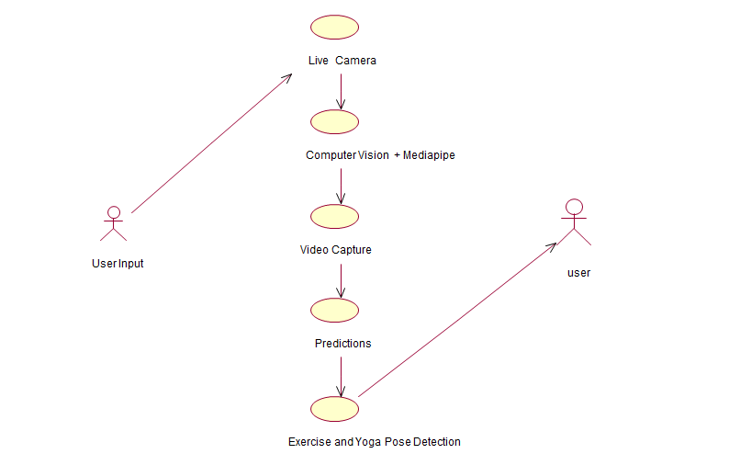
Figure: 4.2.1 Use case Diagram

EXPLANATION:
The main purpose of a use case diagram is to show what system functions are performed for which actor. Roles of the actors in the system can be depicted. The above diagram consists of user as actor. Each will play a certain role to achieve the concept.
4.2.2 CLASS DIAGRAM

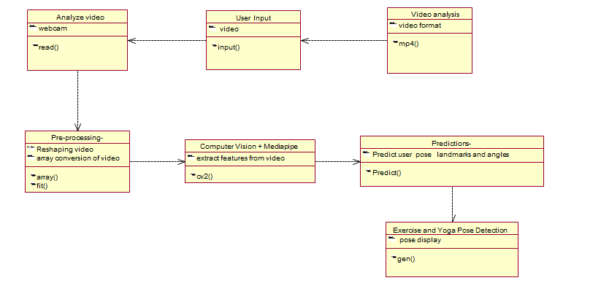

Figure: 4.2.2 Class Diagram

EXPLANATION:
In this class diagram represents how the classes with attributes and methods are linked together to perform the verification with security. From the above diagram shown the various classes involved in our project.

4.2.3 OBJECT DIAGRAM

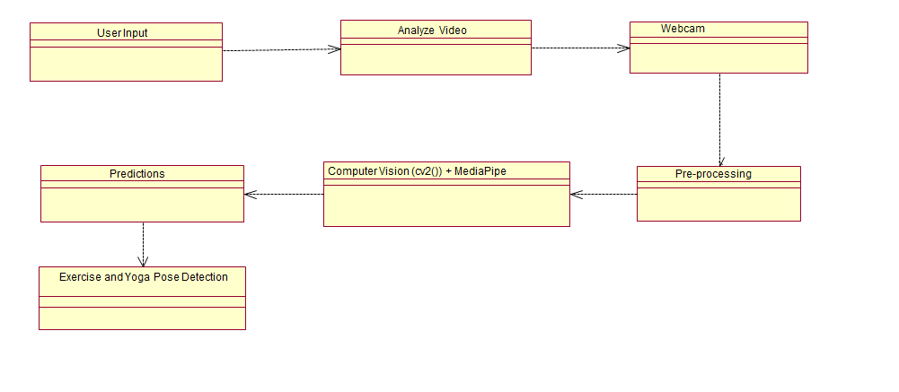
Figure: 4.2.3 Object Diagram

EXPLANATION:
In the above digram tells about the flow of objects between the classes. It is a diagram that shows a complete or partial view of the structure of a modeled system. In this object diagram represents how the classes with attributes and methods are linked together to perform the verification with security.

4.2.4 STATE DIAGRAM
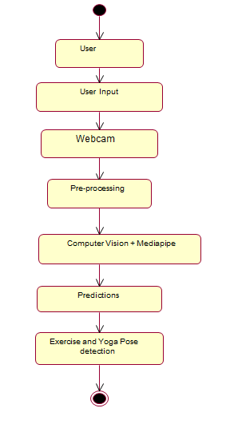
Figure: 4.2.4 State Diagram
EXPLANATION:
State diagram are a loosely defined diagram to show workflows of stepwise activities and actions, with support for choice, iteration and concurrency. State diagrams require that the system described is composed of a finite number of states; sometimes, this is indeed the case, while at other times this is a reasonable abstraction. Many forms of state diagrams exist, which differ slightly and have different semantics.
4.2.5 ACTIVITY DIAGRAM
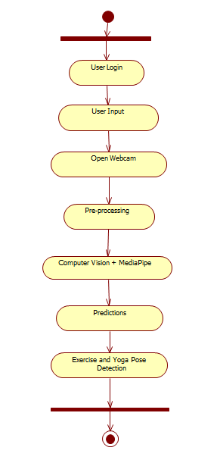
Figure: 4.2.5 Activity Diagram

EXPLANATION:
Activity diagrams are graphical representations of workflows of stepwise activities and actions with support for choice, iteration and concurrency. In the Unified Modeling Language, activity diagrams can be used to describe the business and operational step-by-step workflows of components in a system. An activity diagram shows the overall flow of control.
4.2.6 SEQUENCE DIAGRAM
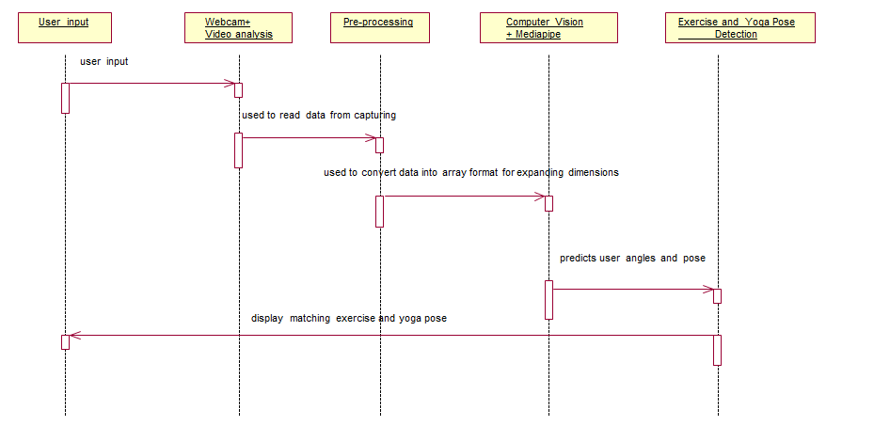

Figure: 4.2.6 Sequence Diagram

EXPLANATION:
A sequence diagram in Unified Modelling Language (UML) is a kind of interaction diagram that shows how processes operate with one another and in what order. It is a construct of a Message Sequence Chart. A sequence diagram shows object interactions arranged in time sequence. It depicts the objects and classes involved in the scenario and the sequence of messages exchanged between the objects needed to carry out the functionality of the scenario.
4.2.7 COLLABORATION DIAGRAM
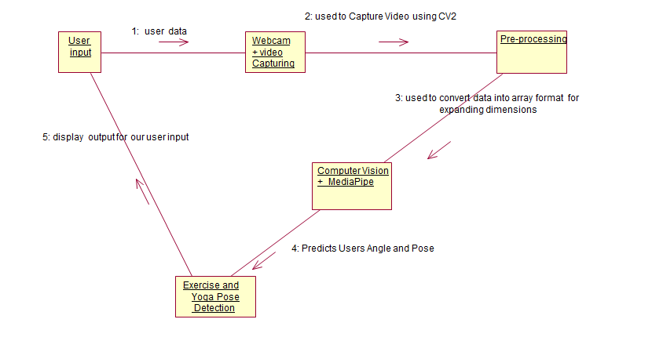
Figure: 4.2.7 Collaboration Diagram

EXPLANATION:
A collaboration diagram, also called a communication diagram or interaction diagram, is an illustration of the relationships and interactions among software objects in the Unified Modeling Language (UML). The concept is more than a decade old although it has been refined as modeling paradigms have evolved.

4.2.8 COMPONENT DIAGRAM

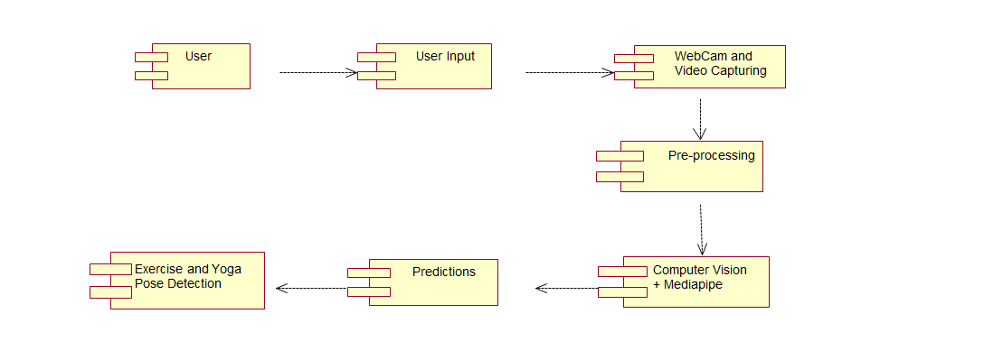

Figure: 4.2.8 Component Diagram

EXPLANATION:

In the Unified Modeling Language, a component diagram depicts how components are wired together to form larger components and or software systems. They are used to illustrate the structure of arbitrarily complex systems. User gives main query and it converted into sub queries and sends through data dissemination to data aggregators. Results are to be showed to user by data aggregators. All boxes are components and arrow indicates dependencies.

4.2.9 Data Flow Diagram
Level 0:
Figure: 4.2.9 Data Flow Diagram

Webcam+
Video Capturing

User Input
Pre-Processing
User
Level 1:
User
Predictions
Exercise and Yoga Pose Detection

Computer Vision + MediaPipe

Figure: Level 1: Data Flow Diagram

4.2.10 DEPLOYMENT DIAGRAM
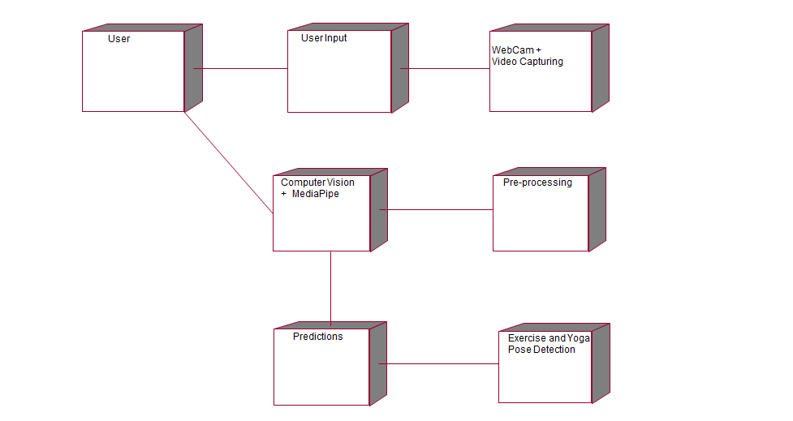

Figure: 4.2.10 Deployment Diagram

EXPLANATION:
Deployment Diagram is a type of diagram that specifies the physical hardware on which the software system will execute. It also determines how the software is deployed on the underlying hardware. It maps software pieces of a system to the device that are going to execute it.
4.2.11 SYSTEM ARCHITECTURE:

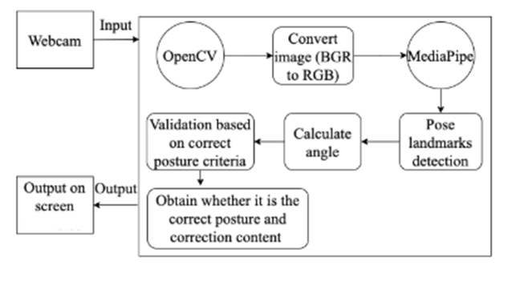

Figure: 4.2.11: System Architecture

CHAPTER 5
DEVELOPMENT TOOLS
5.1 Python
Python is a high-level, interpreted, interactive and object-oriented scripting language. Python is designed to be highly readable. It uses English keywords frequently where as other languages use punctuation, and it has fewer syntactical constructions than other languages.

5.2 History of Python
Python was developed by Guido van Rossum in the late eighties and early nineties at the National Research Institute for Mathematics and Computer Science in the Netherlands.
Python is derived from many other languages, including ABC, Modula-3, C, C++, Algol-68, SmallTalk, and Unix shell and other scripting languages.
Python is copyrighted. Like Perl, Python source code is now available under the GNU General Public License (GPL).
Python is now maintained by a core development team at the institute, although Guido van Rossum still holds a vital role in directing its progress.

5.3 Importance of Python
- Python is Interpreted − Python is processed at runtime by the interpreter. You do not need to compile your program before executing it. This is similar to PERL and PHP.
- Python is Interactive − You can actually sit at a Python prompt and interact with the interpreter directly to write your programs.
- Python is Object-Oriented − Python supports Object-Oriented style or technique of programming that encapsulates code within objects.
- Python is a Beginner's Language − Python is a great language for the beginner-level programmers and supports the development of a wide range of applications from simple text processing to WWW browsers to games.

5.4 Features of Python
- Easy-to-learn − Python has few keywords, simple structure, and a clearly defined syntax. This allows the student to pick up the language quickly.
- Easy-to-read − Python code is more clearly defined and visible to the eyes.
- Easy-to-maintain − Python's source code is fairly easy-to-maintain.
- A broad standard library − Python's bulk of the library is very portable and cross-platform compatible on UNIX, Windows, and Macintosh.
- Interactive Mode − Python has support for an interactive mode which allows interactive testing and debugging of snippets of code.
- Portable − Python can run on a wide variety of hardware platforms and has the same interface on all platforms.
- Extendable − You can add low-level modules to the Python interpreter. These modules enable programmers to add to or customize their tools to be more efficient.
- Databases − Python provides interfaces to all major commercial databases.
- GUI Programming − Python supports GUI applications that can be created and ported to many system calls, libraries and windows systems, such as Windows MFC, Macintosh, and the X Window system of Unix.
- Scalable − Python provides a better structure and support for large programs than shell scripting.

Apart from the above-mentioned features, Python has a big list of good features, few are listed below −
- It supports functional and structured programming methods as well as OOP.
- It can be used as a scripting language or can be compiled to byte-code for building large applications.
- It provides very high-level dynamic data types and supports dynamic type checking.
- IT supports automatic garbage collection.
- It can be easily integrated with C, C++, COM, ActiveX, CORBA, and Java.
5.5 Libraries used in python
- numpy - mainly useful for its N-dimensional array objects.
- pandas - Python data analysis library, including structures such as dataframes.
- matplotlib - 2D plotting library producing publication quality figures.
- scikit-learn - the machine learning algorithms used for data analysis and data mining tasks.

Figure: NumPy, Pandas, Matplotlib, Scikit-learn

CHAPTER 6
IMPLEMENTATION
6.1 GENERAL
The Implementation is nothing but source code of project.
Coding:
6.2 index.html
{% extends 'base.html' %}
{% block content %}
<h2 style="text-align: center;"></h1>
<br>
<br>
<div class="wrapper">
<div class="static-txt" >I'm a</div>
<ul class="dynamic-txt" >
<li><span>Yoga Guruji</span></li>
<li><span>Exercise Monitor</span></li>
<li><span>Fitness Trainer</span></li>
<li><span>A complete Health and Fitness App...
</span></li>
</ul>
</div>
<footer>
<div class="footer-icons">
<a href="🏋️‍♂️" target="_blank">
<img src="{{url_for('static',filename='images/github.png')}}" alt="Twitter" class="img-fluid mx-3" width="40px" height="40px">
</a>
<a href="#">
<img src="{{url_for('static',filename='images/insta.png')}}" alt="Instagram" class="img-fluid mx-3" width="38px" height="38px">
</a>
<a href="#">
<img src="{{url_for('static',filename='images/twitter.png')}}" alt="Facebook" class="img-fluid mx-3" width="44px" height="44dpx">
</a>
</div>
</footer>
{% endblock %}

6.3 app.py
import time
import cv2
from flask import Flask, render_template, Response
import mediapipe as mp
import numpy as np
from project import exerciseAI, yogaAI
#-----------------Routing----------------------------------
app = Flask(__name__)
@app.route('/')
def index():
return render_template('index.html')
@app.route('/exercise/biceps-curl')
def exerciseBicepsCurl():
return render_template('exerciseBicepsCurl.html')
@app.route('/exercise/push-ups')
def exercisePushUps():
return render_template('exercisePushUps.html')
@app.route('/exercise/triceps')
def exerciseTriceps():
return render_template('exerciseTriceps.html')
@app.route('/exercise/squats')
def exerciseSquats():
return render_template('exerciseSquats.html')
@app.route('/yoga/t-pose')
def yogaT():
return render_template('yogaT.html')
@app.route('/yoga/tree-pose')
def yogaTree():
return render_template('yogaTree.html')
@app.route('/yoga/warrior-pose')
def yogaWarrior():
return render_template('yogaWarrior.html')
@app.route('/about')
def about():
return render_template('about.html')
@app.route('/bmi')
def bmi():
return render_template('bmi.html')
#-----------------Video-Feeds---------------------------------
@app.route('/bicepCurl_feed')
def bicepCurl_feed():
return Response(exerciseAI.bicepCurl.gen(), mimetype='multipart/x-mixed-replace; boundary=frame')
@app.route('/pushUps_feed')
def pushUps_feed():
return Response(exerciseAI.pushUps.gen(), mimetype='multipart/x-mixed-replace; boundary=frame')
@app.route('/triceps_feed')
def triceps_feed():
return Response(exerciseAI.triceps.gen(), mimetype='multipart/x-mixed-replace; boundary=frame')
@app.route('/squats_feed')
def squats_feed():
return Response(exerciseAI.squats.gen(), mimetype='multipart/x-mixed-replace; boundary=frame')
@app.route('/tPose_feed')
def tPose_feed():
return Response(yogaAI.tPose.gen(), mimetype='multipart/x-mixed-replace; boundary=frame')
@app.route('/treePose_feed')
def treePose_feed():
return Response(yogaAI.treePose.gen() ,mimetype='multipart/x-mixed-replace; boundary=frame')
@app.route('/warriorPose_feed')
def warriorPose_feed():
return Response(yogaAI.warriorPose.gen() ,mimetype='multipart/x-mixed-replace; boundary=frame')
#--------------------------------------------------------------
if __name__ == '__main__':
app.run(debug=True)

6.4 script.js:
// pop-up button
document.addEventListener("DOMContentLoaded", function() {
var popupOverlay = document.querySelector(".popup-overlay");
var popupButton = document.querySelector("#popup-button1");
popupOverlay.style.display = "flex";
popupButton.addEventListener("click", function() {
popupOverlay.style.display = "none";
});
});
document.addEventListener("DOMContentLoaded", function() {
var popupOverlay = document.querySelector(".popup-overlay");
var popupButton = document.querySelector("#popup-button2");
popupOverlay.style.display = "flex";
popupButton.addEventListener("click", function() {
popupOverlay.style.display = "none";
});
}); //
CHAPTER 7
SNAPSHOTS
7.1 General:
This project is implements like web application integrates PYTHON, OPENCV and MEDIAPIPE and the Server process is maintained using the SOCKET & SERVERSOCKET and the Design part is played by Cascading Style Sheet.
SNAPSHOTS:
7.2 Folder Page
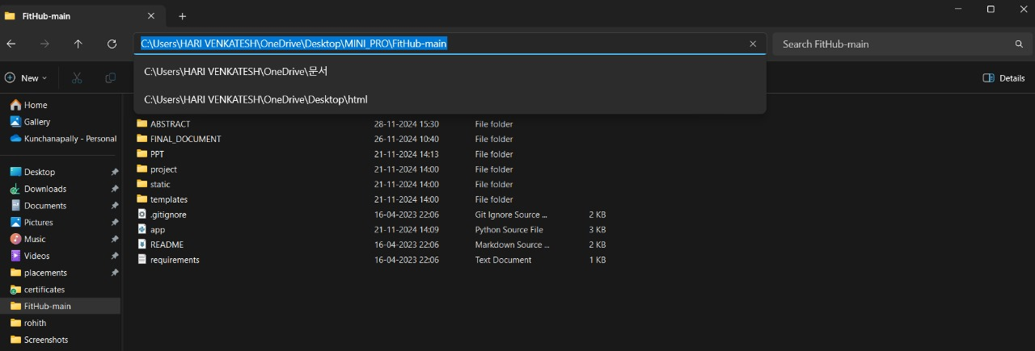
Figure: 7.2 Folder Page
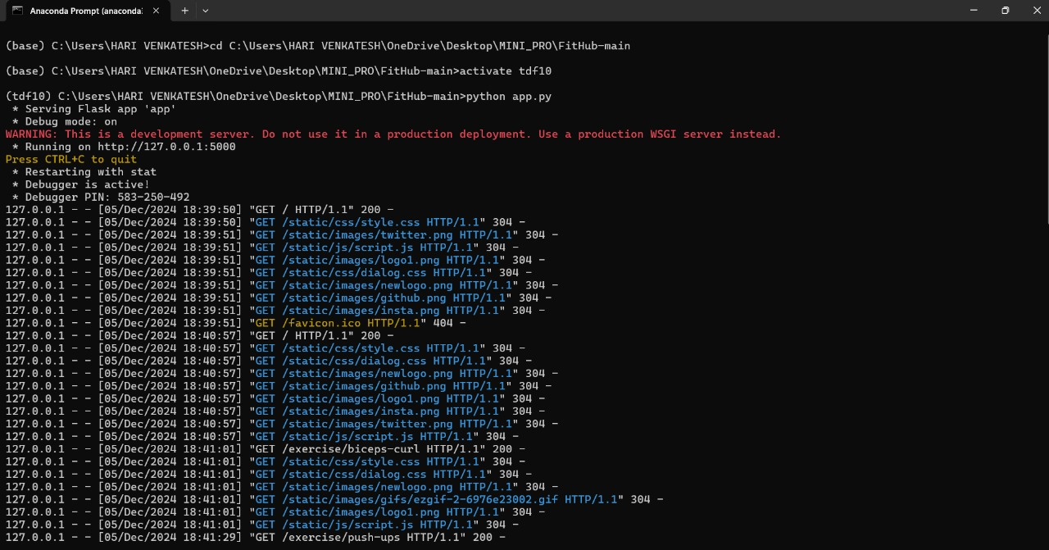
Figure: 7.3 Anaconda Prompt Serving flask
7.4 Home page:
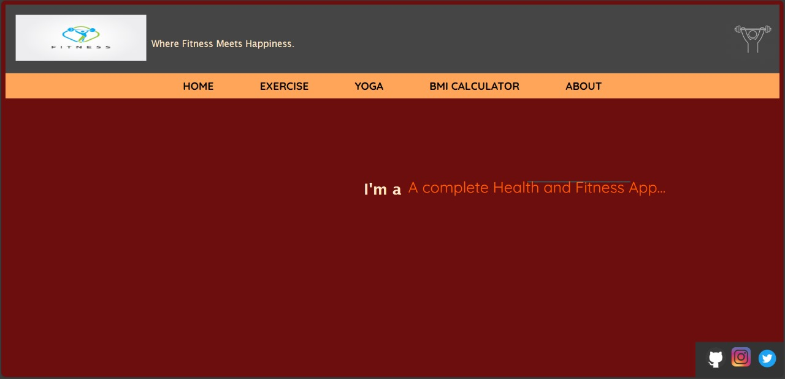
Figure: 7.4 Fitness Homepage
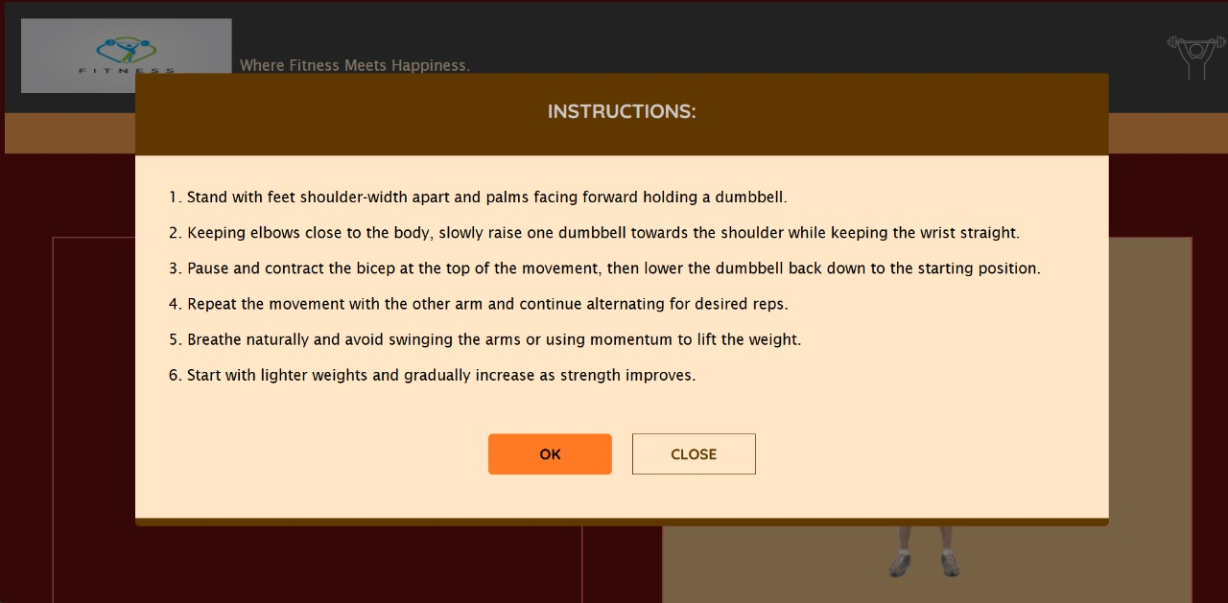
Figure: 7.5 Instructions Of Fitness web app
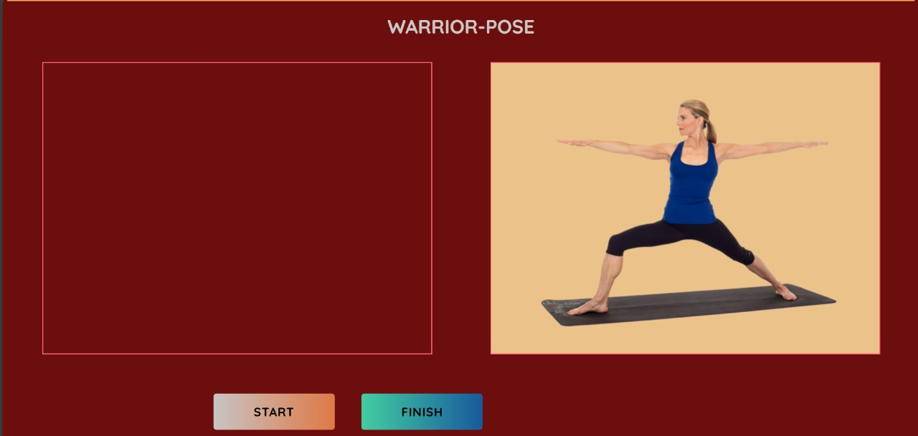

Figure: 7.6 Warrior-Pose
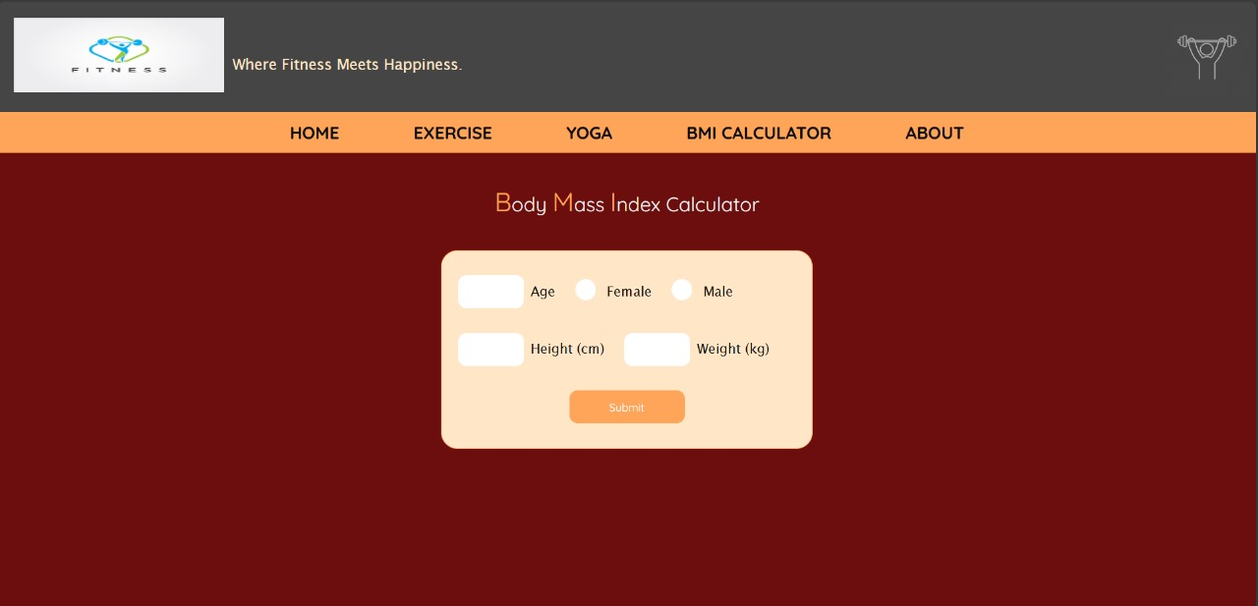
Figure: 7.7 BMI Calculator
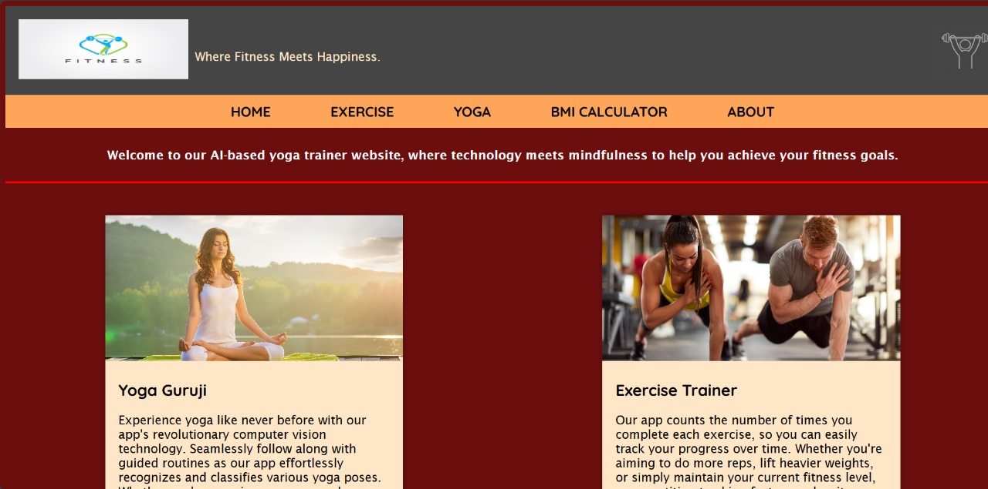
Figure: 7.8 About Fitness

CHAPTER 8
SOFTWARE TESTING

8.1 GENERAL
The purpose of testing is to discover errors. Testing is the process of trying to discover every conceivable fault or weakness in a work product. It provides a way to check the functionality of components, sub-assemblies, assemblies and/or a finished product It is the process of exercising software with the intent of ensuring that the Software system meets its requirements and user expectations and does not fail in an unacceptable manner. There are various types of test. Each test type addresses a specific testing requirement.

8.2 DEVELOPING METHODOLOGIES
The test process is initiated by developing a comprehensive plan to test the general functionality and special features on a variety of platform combinations. Strict quality control procedures are used. The process verifies that the application meets the requirements specified in the system requirements document and is bug free. The following are the considerations used to develop the framework from developing the testing methodologies.

8.3Types of Tests

8.3.1 Unit Testing
Unit testing involves the design of test cases that validate that the internal program logic is functioning properly, and that program input produce valid outputs. All decision branches and internal code flow should be validated. It is the testing of individual software units of the application .it is done after the completion of an individual unit before integration. This is a structural testing, that relies on knowledge of its construction and is invasive. Unit tests perform basic tests at component level and test a specific business process, application, and/or system configuration. Unit tests ensure that each unique path of a business process performs accurately to the documented specifications and contains clearly defined inputs and expected results.

8.3.2 Functional Test
Functional tests provide systematic demonstrations that functions tested are available as specified by the business and technical requirements, system documentation, and user manuals.
Functional testing is centered on the following items:
Valid Input : identified classes of valid input must be accepted.
Invalid Input : identified classes of invalid input must be rejected.
Functions : identified functions must be exercised.
Output : identified classes of application outputs must be exercised.
Systems/Procedures: interfacing systems or procedures must be invoked.

8.3.3 System Test
System testing ensures that the entire integrated software system meets requirements. It tests a configuration to ensure known and predictable results. An example of system testing is the configuration-oriented system integration test. System testing is based on process descriptions and flows, emphasizing pre-driven process links and integration points.

8.3.4 Performance Test
The Performance test ensures that the output be produced within the time limits,and the time taken by the system for compiling, giving response to the users and request being send to the system for to retrieve the results.

8.3.5 Integration Testing
Software integration testing is the incremental integration testing of two or more integrated software components on a single platform to produce failures caused by interface defects.
The task of the integration test is to check that components or software applications, e.g. components in a software system or – one step up – software applications at the company level – interact without error.

8.3.6 Acceptance Testing
User Acceptance Testing is a critical phase of any project and requires significant participation by the end user. It also ensures that the system meets the functional requirements.

Acceptance testing for Data Synchronization:
- The Acknowledgements will be received by the Sender Node after the Packets are received by the Destination Node
- The Route add operation is done only when there is a Route request in need
- The Status of Nodes information is done automatically in the Cache Updation process

8.3.7 Build the test plan

Any project can be divided into units that can be further performed for detailed processing. Then a testing strategy for each of this unit is carried out. Unit testing helps to identity the possible bugs in the individual component, so the component that has bugs can be identified and can be rectified from errors.

CHAPTER 9
CONCLUSION AND FUTURE ENHANCEMENT
9.1 CONCLUSION:
In conclusion, FitHub represents the future of fitness tracking and analysis, combining cutting-edge technologies with user-centric design to offer a holistic and personalized fitness experience. With advancements such as machine learning integration, enhanced feedback mechanisms, virtual reality immersion, and social integration, FitHub is poised to revolutionize how individuals approach and achieve their fitness goals. By leveraging AI-driven insights, gamification elements, and seamless integration with wearable technology, FitHub empowers users with actionable data, engaging workouts, and a supportive community environment. The continuous evolution and enhancement of FitHub's features ensure that it remains at the forefront of fitness innovation, catering to diverse needs and preferences while fostering a culture of health, wellness, and motivation. FitHub is not just a fitness platform but a lifestyle companion, inspiring users to embrace a healthier and more active lifestyle with confidence and enjoyment.
9.2 FUTURE ENHANCEMENTS:
FitHub's future enhancements are poised to revolutionize fitness tracking and analysis, leveraging cutting-edge technologies for an unparalleled user experience. Integrating machine learning algorithms will enable personalized workout recommendations and tailored fitness plans based on individual goals. Enhanced feedback mechanisms, including real-time posture correction and interactive virtual trainers, will elevate user guidance and engagement. Integration with virtual reality (VR) technology promises immersive workout experiences and diverse training environments. Social integration features like user communities and challenges will foster motivation and accountability among users. The development of a mobile app version with offline capabilities and mobile-friendly interfaces will extend FitHub's accessibility and convenience. Nutrition tracking, health monitoring, and AI-driven insights will provide holistic wellness support alongside fitness activities. Gamification elements and integration with wearable technology will make fitness routines engaging, rewarding, and technologically advanced. FitHub's future is poised to empower users to achieve their fitness goals effectively and enjoyably

CHAPTER 10
REFERENCES

10.1 REFERENCES
[1] Kerner, S., & Goel, M. (2021). Machine Learning for Personalized Fitness Recommendations: A Review. International Journal of Machine Learning and Computing, 11(5), 478-485.
[2] Patel, R., & Gupta, A. (2020). Enhancing User Engagement in Fitness Apps through Real-Time Feedback Mechanisms. International Conference on Human-Computer Interaction, 423-436.
[3] Chen, L., & Wang, Y. (2019). Immersive Fitness Training using Virtual Reality: Opportunities and Challenges. Journal of Virtual Reality and Augmented Reality, 5(3), 210-225.
[4] Kim, J., & Lee, S. (2018). Social Integration Features in Fitness Apps: A User Study. International Conference on Social Computing, Behavioral-Cultural Modeling, and Prediction, 126-139.
[5] Singh, A., & Verma, S. (2017). AI-Driven Insights for Optimal Fitness Planning: A Case Study. International Journal of Artificial Intelligence Applications, 6(2), 45-58.
[6] Gupta, P., & Sharma, R. (2016). Gamification Elements for Enhanced User Engagement in Fitness Apps: An Empirical Study. International Conference on Human-Computer Interaction, 312-325.
[7] Li, H., & Zhang, J. (2015). Integration of Wearable Technology in Fitness Tracking Apps: A Comparative Analysis. Journal of Mobile Health and Fitness, 3(1), 18-30.
[8] Yang, X., & Liu, Y. (2014). Virtual Reality Immersion in Fitness Training: User Experience and Performance Analysis. International Journal of Virtual Environments, 12(4), 301-315.
[9] Wang, Q., & Chen, Z. (2013). Machine Learning Algorithms for Personalized Fitness Goals: A Comparative Study. International Conference on Machine Learning and Applications, 178-191.
[10] Sharma, M., & Jain, N. (2012). Wearable Technology Integration for Real-Time Fitness Tracking: A Review. Journal of Wearable Computing, 8(2), 95-110.
[11] I. Benchaji, S. Douzi, and B. E. Ouahidi, ``Credit card fraud detection model based on LSTM recurrent neural networks,'' J. Adv. Inf. Technol., vol. 12, no. 2, pp. 113118, 2021, doi: 10.12720/jait.12.2.113-118.
[12] Y. Fang, Y. Zhang, and C. Huang, ``Credit card fraud detection based on machine learning,'' Comput., Mater. Continua, vol. 61, no. 1, pp. 185195, 2019, doi: 10.32604/cmc.2019.06144.
[13] J. Forough and S. Momtazi, ``Ensemble of deep sequential models for credit card fraud detection,'' Appl. Soft Comput., vol. 99, Feb. 2021, Art. no. 106883, doi: 10.1016/j.asoc.2020.106883.
[14] K. He, X. Zhang, S. Ren, and J. Sun, ``Deep residual learning for image recognition,'' 2015, arXiv:1512.03385.
[15] X. Hu, H. Chen, and R. Zhang, ``Short paper: Credit card fraud detection using LightGBM with asymmetric error control,'' in Proc. 2nd Int. Conf. Artif. Intell. for Industries (AII), Sep. 2019, pp. 9194, doi:10.1109/AI4I46381.2019.00030.
[16] J. Kim, H.-J. Kim, and H. Kim, ``Fraud detection for job placement using hierarchical clusters-based deep neural networks,'' Int. J. Speech Technol., vol. 49, no. 8, pp. 28422861, Aug. 2019, doi: 10.1007/s10489-019-01419-2.
[17] M.-J. Kim and T.-S. Kim, ``A neural classier with fraud density map for effective credit card fraud detection,'' in Intelligent Data Engineering and Automated Learning, vol. 2412, H. Yin, N. Allinson, R. Freeman, J. Keane, and S. Hubbard, Eds. Berlin, Germany: Springer, 2002, pp. 378383, doi: 10.1007/3-540-45675-9_56.
[18] N. Kousika, G. Vishali, S. Sunandhana, and M. A. Vijay, ``Machine learning based fraud analysis and detection system,'' J. Phys., Conf., vol. 1916, no. 1, May 2021, Art. no. 012115, doi: 10.1088/1742-6596/1916/1/012115.
[19] R. F. Lima and A. Pereira, ``Feature selection approaches to fraud detection in e-payment systems,'' in E-Commerce and Web Technologies, vol. 278, D. Bridge and H. Stuckenschmidt, Eds. Springer, 2017, pp. 111126, doi: 10.1007/978-3-319-53676-7_9.

[20] Y. Lucas and J. Jurgovsky, ``Credit card fraud detection using machine learning: A survey,'' 2020, arXiv:2010.06479.
[21] H. Zhou, H.-F. Chai, and M.-L. Qiu, ``Fraud detection within bankcard enrollment on mobile device based payment using machine learning,'' Frontiers Inf. Technol. Electron. Eng., vol. 19, no. 12, pp. 15371545, Dec. 2018, doi: 10.1631/FITEE.1800580.
[22] S. Makki, Z. Assaghir,Y. Taher, R. Haque, M.-S. Hacid, and H. Zeineddine, ``An experimental study with imbalanced classication approaches for credit card fraud detection,'' IEEE Access, vol. 7, pp. 9301093022, 2019, doi: 10.1109/ACCESS.2019.2927266.
[23] I. Matloob, S. A. Khan, and H. U. Rahman, ``Sequence mining and prediction-based healthcare fraud detection methodology,'' IEEE Access, vol. 8, pp. 143256143273, 2020, doi: 10.1109/ACCESS.2020.3013962.
[24] I. Mekterovi¢, M. Karan, D. Pintar, and L. Brki¢, ``Credit card fraud detection in card-not-present transactions: Where to invest?'' Appl. Sci., vol. 11, no. 15, p. 6766, Jul. 2021, doi: 10.3390/app11156766.
[25] D. Molina, A. LaTorre, and F. Herrera, ``SHADE with iterative local search for large-scale global optimization,'' in Proc. IEEE Congr. Evol. Comput. (CEC), Jul. 2018, pp. 18, doi: 10.1109/CEC.2018.8477755.
[26] M. Muhsin, M. Kardoyo, S. Arief, A. Nurkhin, and H. Pramusinto, ``An analyis of student's academic fraud behavior,'' in Proc. Int. Conf. Learn. Innov. (ICLI), Malang, Indonesia, 2018, pp. 3438, doi: 10.2991/icli-17.2018.7.
[27] H. Najadat, O. Altiti, A. A. Aqouleh, and M. Younes, ``Credit card fraud detection based on machine and deep learning,'' in Proc. 11th Int. Conf. Inf. Commun. Syst. (ICICS), Apr. 2020, pp. 204208, doi: 10.1109/ICICS49469.2020.239524.
[28] A. Pumsirirat and L. Yan, ``Credit card fraud detection using deep learning based on auto-encoder and restricted Boltzmann machine,'' Int. J. Adv. Comput. Sci. Appl., vol. 9, no. 1, pp. 1825, 2018, doi: 10.14569/IJACSA.2018.090103.
[29] P. Raghavan and N. E. Gayar, ``Fraud detection using machine learning and deep learning,'' in Proc. Int. Conf. Comput. Intell. Knowl. Economy (ICCIKE), Dec. 2019, pp. 334339, doi: 10.1109/ICCIKE47802.2019.9004231.

[30] M. Ramzan, A. Abid, H. U. Khan, S. M. Awan, A. Ismail, M. Ahmed, M. Ilyas, and A. Mahmood, ``A review on State-of-the-Art violence detection techniques,'' IEEE Access, vol. 7, pp. 107560107575, 2019, doi:10.1109/ACCESS.2019.2932114.
[31] M. Ramzan, H. U. Khan, S. M. Awan, A. Ismail, M. Ilyas, and A. Mahmood, ``A survey on state-of-the-art drowsiness detection techniques,'' IEEE Access, vol. 7, pp. 6190461919, 2019, doi: 10.1109/ACCESS.2019.2914373.
[32] A. Rb and S. K. Kr, ``Credit card fraud detection using artificial neural network,'' Global Transitions Proc., vol. 2, no. 1, pp. 3541, Jun. 2021, doi: 10.1016/j.gltp.2021.01.006.
[33] N. F. Ryman-Tubb, P. Krause, and W. Garn, ``How artificial intelligence and machine learning research impacts payment card fraud detection: A survey and industry benchmark,'' Eng. Appl. Artif. Intell., vol. 76, pp. 130157, Nov. 2018, doi: 10.1016/j.engappai.2018.07.008.
[34] I. Sadgali, N. Sael, and F. Benabbou, ``Adaptive model for credit card fraud detection,'' Int. J. Interact. Mobile Technol., vol. 14, no. 3, p. 54, Feb. 2020, doi: 10.3991/ijim.v14i03.11763.
[35] Y. Sahin and E. Duman, ``Detecting credit card fraud by ANN and logistic regression,'' in Proc. Int. Symp. Innov. Intell. Syst. Appl., Jun. 2011, pp. 315319, doi: 10.1109/INISTA.2011.5946108.
[36] I. Sohony, R. Pratap, and U. Nambiar, ``Ensemble learning for credit card fraud detection,'' in Proc. ACM India Joint Int. Conf. Data Sci. Manage. Data, Jan. 2018, pp. 289294, doi: 10.1145/3152494.3156815.
[37] B. Stojanovi¢, J. Boºi¢, K. Hofer-Schmitz, K. Nahrgang, A. Weber, A. Badii, M. Sundaram, E. Jordan, and J. Runevic, ``Follow the trail: Machine learning for fraud detection in fintech applications,'' Sensors, vol. 21, no. 5, p. 1594, Feb. 2021, doi: 10.3390/s21051594.
[38] C. Szegedy, S. Ioffe, V. Vanhoucke, and A. Alemi, ``Inception-v4, inception-ResNet and the impact of residual connections on learning,'' 2016, arXiv:1602.07261.
[39] H. Tingfei, C. Guangquan, and H. Kuihua, ``Using variational auto encoding in credit card fraud detection,'' IEEE Access, vol. 8, pp. 149841149853, 2020, doi: 10.1109/ACCESS.2020.3015600.
[40] D. Varmedja, M. Karanovic, S. Sladojevic, M. Arsenovic, and A. Anderla, ``Credit card fraud detectionmachine learning methods,'' in Proc. 18th Int. Symp. INFOTEH-JAHORINA (INFOTEH), Mar. 2019, pp. 15, doi: 10.1109/INFOTEH.2019.8717766.

[41] S. Warghade, S. Desai, and V. Patil, ``Credit card fraud detection from imbalanced dataset using machine learning algorithm,'' Int. J. Comput. Trends Technol., vol. 68, no. 3, pp. 2228, Mar. 2020, doi: 10.14445/22312803/IJCTT-V68I3P105.
[42] N. Youse, M. Alaghband, and I. Garibay, ``A comprehensive survey on machine learning techniques and user authentication approaches for credit card fraud detection,'' 2019, arXiv:1912.02629.
[43] X. Zhang, Y. Han, W. Xu, and Q. Wang, ``HOBA: A novel feature engineering methodology for credit card fraud detection with a deep learning architecture,'' Inf. Sci., vol. 557, pp. 302316, May 2021, doi:10.1016/j.ins.2019.05.023.F
[44] H. A. El Bour, Y. Oubrahim, M. Y. Ghoumari, and M. Azzouazi, ‘‘Using isolation forest in anomaly detection: The case of credit card transactions,’’ Periodicals Eng. Natural Sci., vol. 6, no. 2, pp. 394–400, 2018.
[45] A. Jog and A. A. Chandavale, ‘‘Implementation of credit card fraud detection system with concept drifts adaptation,’’ in Proc. ICICC, Singapore, 2018, pp. 467–477.
[46] K. Randhawa, C. K. Loo, M. Seera, C. P. Lim, and A. K. Nandi, ‘‘Credit card fraud detection using AdaBoost and majority voting,’’ IEEE Access, vol. 6, pp. 14277–14284, 2018.
[47] F. Carcillo, Y.-A. Le Borgne, O. Caelen, Y. Kessaci, F. Oblé, and G. Bontempi, ‘‘Combining unsupervised and supervised learning in credit card fraud detection,’’ Inf. Sci., to be published.
[48] F. Carcillo, A. D. Pozzolo, Y.-A. Le Borgne, O. Caelen, Y. Mazzer, and G. Bontempi, ‘‘SCARFF: A scalable framework for streaming credit card fraud detection with spark,’’ Inf. Fusion, vol. 41, pp. 182–194, May 2018.
[49] R. Saia and S. Carta, ‘‘A frequency-domain-based pattern mining for credit card fraud detection,’’ in Proc. 2nd Int. Conf. Internet Things, Big Data Secur., 2017, pp. 386–391.
[50] S. Yuan, X. Wu, J. Li, and A. Lu, ‘‘Spectrum-based deep neural networks for fraud detection,’’ in Proc. ACM Conf. Inf. Knowl. Manage. (CIKM), 2017, pp. 2419–2422

