Name : Vishnu Ram
Email : vishnuram1896@gmail.com
Github :

Assignment 3: Monitor Unencrypted S3 Buckets Using AWS Lambda and Boto3

Objective
The objective of this assignment is to detect Amazon S3 buckets that do not have Server-Side Encryption enabled using AWS Lambda and Boto3.

Introduction
This assignment uses AWS Lambda, IAM, S3, CloudWatch, and Boto3 to automatically identify unencrypted S3 buckets.

AWS Services Used
Amazon S3, AWS Lambda, AWS IAM, Amazon CloudWatch, Boto3 SDK

Step 1: S3 Bucket Creation
Create multiple S3 buckets and enable encryption on one bucket. Eg
- vishnu-encrypted-bucket
- vishnu-unencrypted-bucket1
- vishnu-unencrypted-bucket2
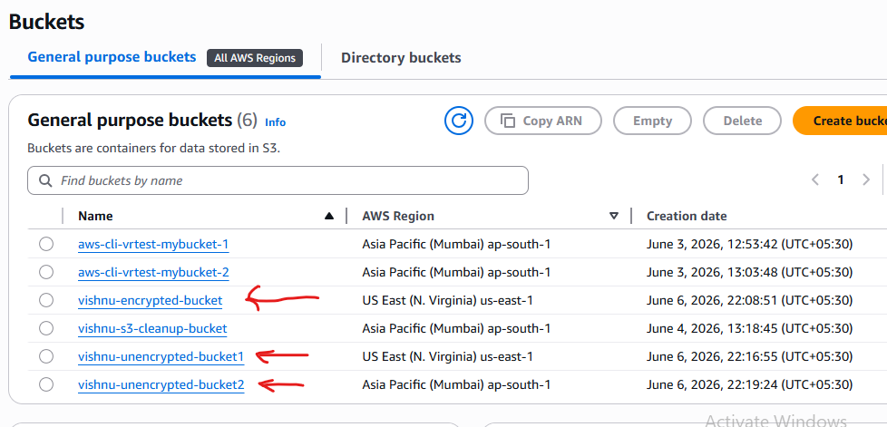

Configuration for Encrypted Bucket :
- Properties
- → Default Encryption
- → Edit
- Then Select - Server-side encryption with Amazon S3 managed keys (SSE-S3)
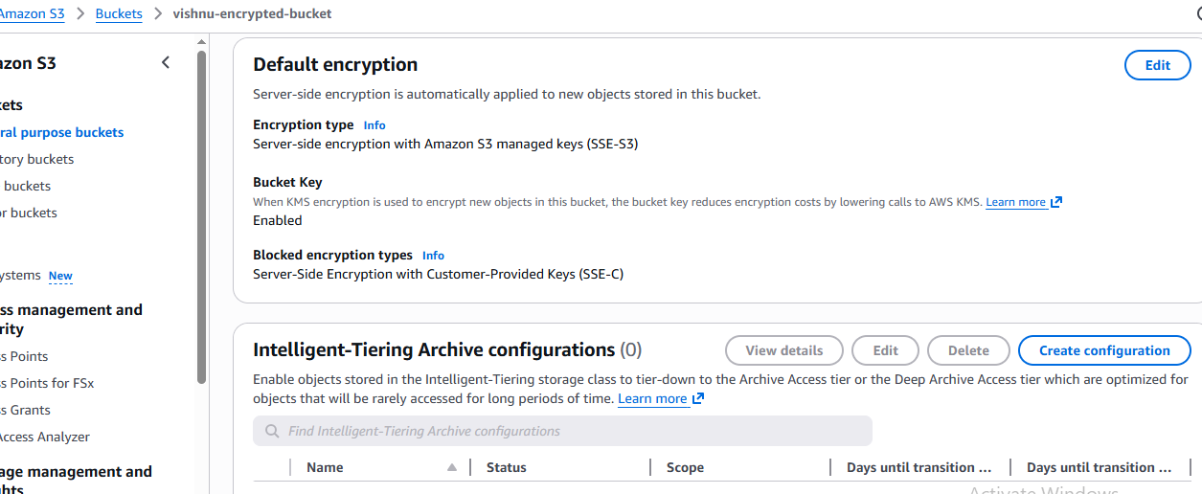
- Leave Other Buckets are Unencrypted.

Step 2: IAM Role Creation

Procedure
- Opened the IAM Dashboard.
- Selected Roles.
- Clicked Create Role.
- Selected AWS Service as trusted entity.
- Selected Lambda as the use case.
- Attached the following policy:
- AmazonS3ReadOnlyAccess
- Created the role successfully.
- Role Name : S3EncryptionMonitorRole

Outcome
An IAM role was created with permissions required to access.

Screenshot: IAM Role Creation.
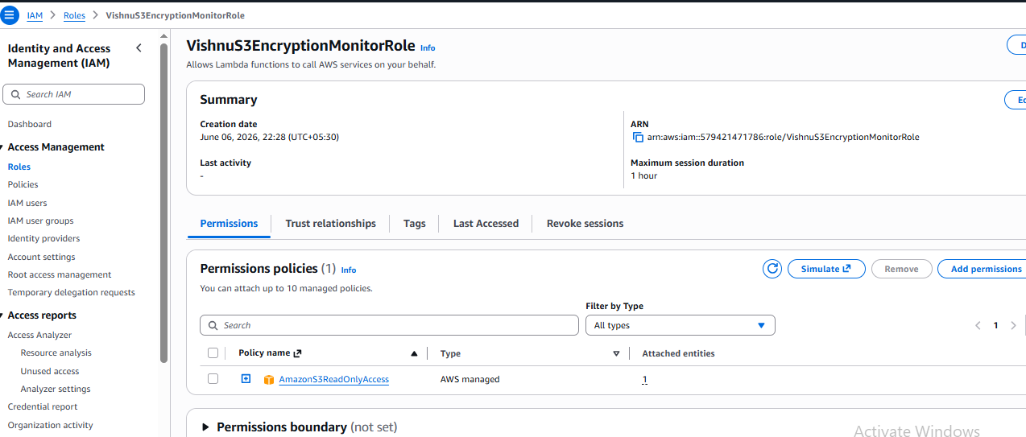

Step 3: Lambda Function Creation

Procedure
- Opened AWS Lambda Console.
- Clicked Create Function.
- Selected Author From Scratch.
- Entered Function Name.
- Selected Python Runtime.
- Assigned the IAM Role created previously.
- Created the Lambda Function.
- Lambda Function Name : MonitorUnencryptedBuckets

Outcome
Lambda function was successfully created and configured.
Screenshot: Lambda Function Configuration.
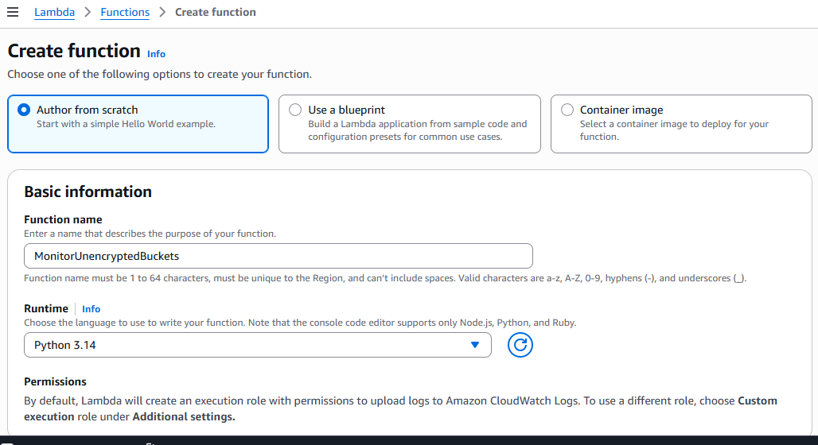

Step 4: Lambda Function Code
The Lambda code used in the assignment.
Screenshot
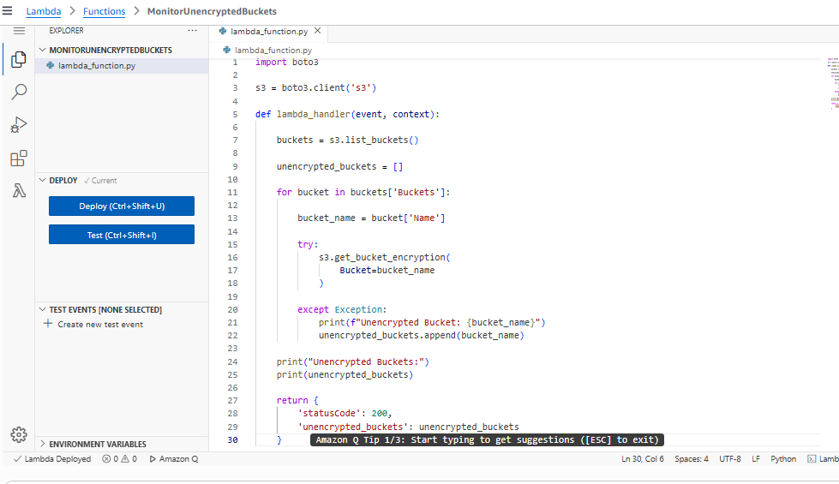

Step 5: Testing
Click on Deploy button and test the Lambda function.
Screenshot
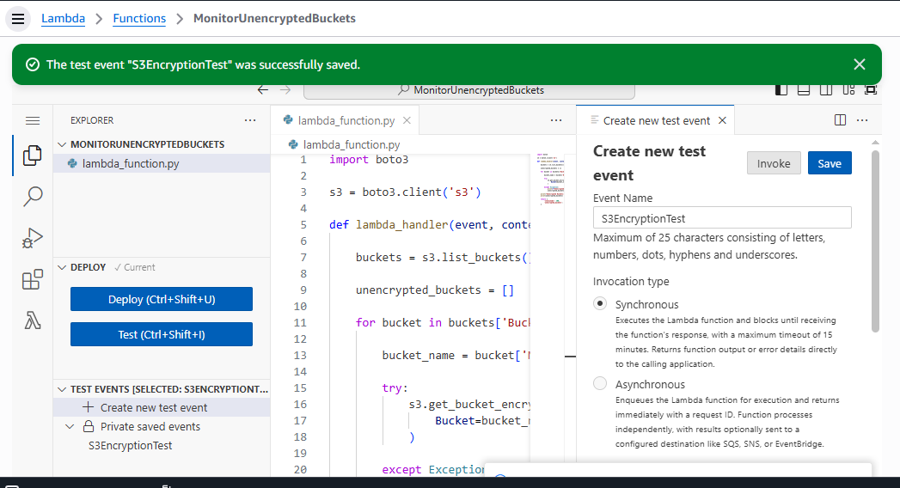

Step 6: CloudWatch Logs
Verify unencrypted buckets in CloudWatch Logs.
Go to Lambda - Monitor - View CloudWatch Log
Screenshot
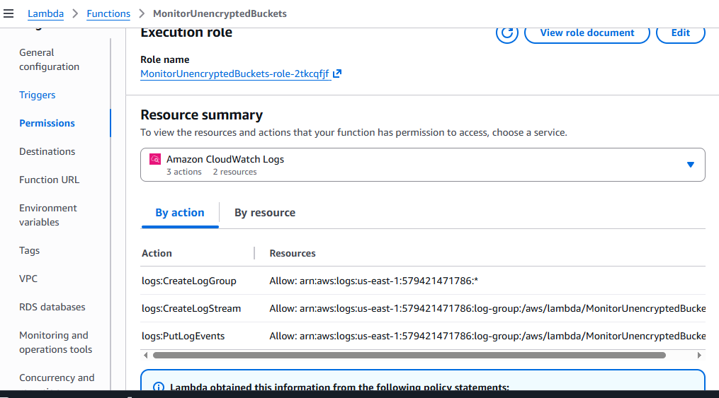

Results
The Lambda function successfully identified unencrypted S3 buckets.
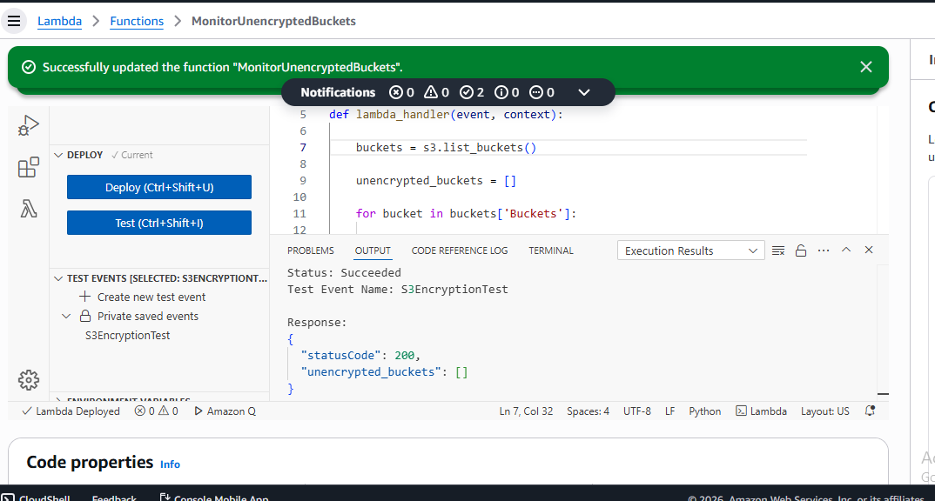

Conclusion
AWS Lambda and Boto3 automated the security validation process for S3 bucket encryption.

