HERO VIRED
INDUSTRY-ALIGNED LEARNING PROGRAM

CAPSTONE PROJECT
END-TO-END DEVOPS PIPELINE FOR A WEB APPLICATION WITH CI/CD
AWS | JENKINS | DOCKER | KUBERNETES | TERRAFORM | ANSIBLE | PROMETHEUS | GRAFANA
SUBMITTED BY
Vishnu Ram
Batch: 16B
PROJECT DETAILS
Project Type: DevOps Capstone
Cloud Platform: Amazon Web Services
Project Duration: Sprint 1 – Sprint 6
Submission Date: 31 Oct 2026
SUBMITTED TO
HERO VIRED
DEVOPS ENGINEERING PROGRAM

- Project Title: End-to-End DevOps Pipeline for a Web Application with CI/CD

Problem Statement
DevOps teams require a CI/CD pipeline to streamline the development and deployment process, ensuring that changes are consistently tested, built, and deployed across environments. Using Jenkins as the CI/CD orchestrator, this project will implement an automated pipeline for a Dockerized application that deploys to Kubernetes on AWS EKS. Jenkins will also automate infrastructure provisioning, configuration management, and deployment, reducing manual intervention and improving efficiency.

Project Goals
1. Design an application architecture that includes load balancing, container orchestration, and monitoring on AWS.
2. Provision AWS infrastructure using Terraform, including VPC, subnets, and EKS clusters.
3. Automate configuration management with Ansible to streamline server setup and application configuration.
4. Deploy the application on Kubernetes within AWS EKS, ensuring scalability and resilience.
5. Implement Jenkins CI/CD for continuous integration and deployment from code changes to production.
6. Set up monitoring with Prometheus and Grafana to monitor infrastructure and application performance.

Additional Tools for CI/CD Integration
- Jenkins: For orchestrating the CI/CD pipeline to automate testing, building, and deployment.
- Docker: For building container images as part of the CI pipeline.
- Kubernetes CLI (kubectl): For managing and deploying resources to EKS within the Jenkins pipeline.
- Jenkins Plugins: Docker, Kubernetes, and AWS CLI plugins for seamless integration with cloud infrastructure.

Project Sprints:

Sprint 1: Architecture Design, Dockerization, and Jenkins Setup
- Tasks:
- Design the application architecture for deployment on AWS EKS.
- Dockerize the web application by creating a Dockerfile and storing the image in AWS ECR.
- Set up a Jenkins server on AWS EC2 and configure necessary plugins (Docker, Kubernetes, AWS CLI).
- Configure Jenkins to access EKS and AWS resources using credentials and AWS IAM roles.
- Set up Git integration for Jenkins to trigger builds based on code changes.
- Goal: Complete the application architecture, Dockerize the application, and establish a Jenkins server for CI/CD.

Sprint 2: AWS Infrastructure Provisioning with Terraform and Jenkins Integration
- Tasks:
- Write Terraform scripts for AWS resources: VPC, EKS cluster, subnets, security groups, and EC2 instances.
- Create a Jenkins job to automate the Terraform infrastructure provisioning process.
- Test the Terraform job on Jenkins, ensuring that infrastructure is provisioned consistently across environments.
- Store Terraform state files securely in AWS S3 for consistent multi-user access.
- Goal: Automate AWS infrastructure provisioning through Jenkins and Terraform, enabling reproducible environments.

Sprint 3: Configuration Management with Ansible and Jenkins Pipeline
- Tasks:
- Write Ansible playbooks to configure EC2 instances, install Docker, kubectl, and other dependencies.
- Create a Jenkins pipeline job to run Ansible playbooks for setting up and configuring resources on AWS.
- Ensure the Ansible job on Jenkins is triggered after the Terraform job completes, creating a seamless flow.
- Test the Ansible playbooks on infrastructure provisioned by Terraform to validate configurations.
- Goal: Automate configuration management with Ansible through Jenkins, ensuring consistent and reliable server configurations.

Sprint 4: CI/CD Pipeline for Application Deployment on Kubernetes (EKS)
- Tasks:
- Create a multi-stage Jenkins pipeline for the application, including stages for build, test, and deployment.
- Build the Docker image in the pipeline and push it to AWS ECR.
- Use Jenkins to run Kubernetes manifests (Deployment, Service) that deploy the application to EKS.
- Configure Kubernetes health checks and auto-scaling in the deployment pipeline.
- Test the end-to-end pipeline from code push to deployment on EKS, ensuring proper functionality.
- Goal: Build a fully automated CI/CD pipeline that deploys the application to Kubernetes on AWS EKS.

Sprint 5: Monitoring Setup with Prometheus, Grafana, and Jenkins Alerts
- Tasks:
- Install Prometheus in the EKS cluster for monitoring metrics and configure it to collect data from the application and nodes.
- Set up Grafana to visualize Prometheus metrics and create dashboards for application performance and resource health.
- Integrate Jenkins with Prometheus/Grafana to monitor job and infrastructure health.
- Set up alerting rules in Prometheus for critical metrics and configure Jenkins to send notifications for failed deployments or resource issues.
- Test monitoring and alerting, ensuring visibility into the health of the infrastructure and application.
- Goal: Provide real-time monitoring and alerting using Prometheus, Grafana, and Jenkins notifications for efficient infrastructure management.

Sprint 6: Testing, Documentation, and Final Pipeline Automation
- Tasks:
- Write test cases to validate application functionality, deployment success, and infrastructure integrity.
- Document each step in the Jenkins pipeline, Terraform, and Ansible setup, including configuration and troubleshooting.
- Automate the Jenkins job triggers for each stage of the pipeline (e.g., code change triggers build, build triggers deploy).
- Conduct final end-to-end testing to verify the stability of the CI/CD pipeline, monitoring, and infrastructure setup.
- Collect feedback and make adjustments as needed for a production-ready setup.
- Goal: Finalize and document the CI/CD pipeline, testing its readiness for production deployment.

CI/CD Pipeline Stages in Jenkins

1. Build Stage:
- Triggers when code is pushed to the repository.
- Builds Docker images for the application and pushes them to AWS ECR.

2. Infrastructure Provisioning Stage:
- Runs Terraform scripts to provision infrastructure (VPC, EKS, EC2) on AWS.
- Stores Terraform state in AWS S3 for persistence and team collaboration.

3. Configuration Management Stage:
- Runs Ansible playbooks to configure EC2 instances and Kubernetes nodes.
- Installs necessary dependencies and ensures security and access configurations.

4. Deployment Stage:
- Deploys the application to the EKS cluster using Kubernetes manifests.
- Configures load balancing, auto-scaling, and health checks for resilient deployment.

5. Testing and Monitoring Stage:
- Runs test scripts to validate application functionality post-deployment.
- Sets up monitoring with Prometheus and Grafana, with alerts configured for real-time notifications.

Summary of Deliverables by End of Project
- End-to-End Jenkins CI/CD Pipeline: Fully automated pipeline with build, provisioning, configuration, deployment, testing, and monitoring stages.
- Multi-Cloud AWS Infrastructure: Automated infrastructure setup using Terraform, deploying VPC, EKS, EC2, and S3 resources.
- Configuration Management with Ansible: Ansible playbooks to automate server and application configurations on AWS.
- Application Deployment on EKS: Scalable and resilient Kubernetes-based deployment on AWS EKS.
- Monitoring and Alerts: Real-time monitoring with Prometheus and Grafana, with integrated alerts in Jenkins.
- Comprehensive Documentation: Setup guides, usage instructions, and troubleshooting for Terraform, Ansible, Kubernetes, and Jenkins.

Here's a detailed breakdown for the "Multi-Cloud Deployment and Management with Terraform" project. This project aims to help DevOps teams deploy and manage applications across multiple cloud providers, ensuring high availability, cost optimization, and disaster recovery using Infrastructure as Code (IaC) with Terraform.

Evaluation Criteria for Deliverables, Presentation and Viva:
- Documentation 15.00%
- Implementation 75.00%
- Cost Optimization 10.00%

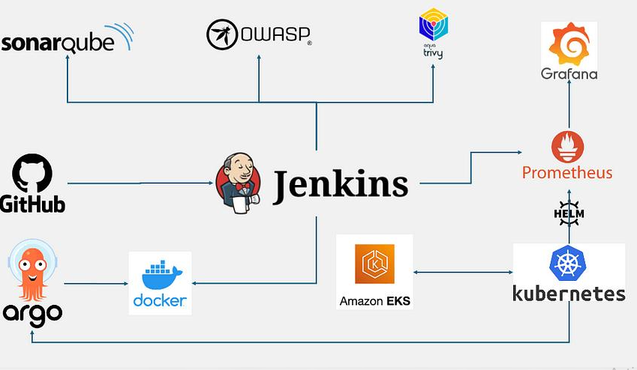

Assignment/Project : Solution step by step with Screenshots Attached through every sprints.
It should explain:
- What problem the project addresses.
- Which technologies were used.
- How infrastructure was provisioned.
- How the application was containerized and deployed.
- How monitoring was implemented.
- What the final implementation achieved.
- Suggested content:
- This project focuses on designing and implementing an end-to-end DevOps pipeline for deploying a Dockerized web application on Amazon Elastic Kubernetes Service (EKS). The primary objective is to streamline application development, testing, deployment and infrastructure management through automation.
- The project uses Jenkins as the CI/CD orchestration tool, Docker for application containerization, Terraform for Infrastructure as Code, and Ansible for configuration management. AWS services, including VPC, EC2, ECR and EKS, provide the underlying cloud infrastructure.
- The application is deployed on Kubernetes using Deployment and Service resources, with health checks and autoscaling configuration. Prometheus and Grafana are used to collect and visualize infrastructure and Kubernetes monitoring metrics.
- The project demonstrates the integration of DevOps practices across application development, infrastructure provisioning, deployment and monitoring. It also includes testing, troubleshooting and documentation of the implemented solution.

Create a table explaining each technology and its purpose.
Technology | Purpose in this project
- AWS | - Cloud infrastructure
- VPC | - Network isolation
- Subnets | - Network segmentation
- EC2 | - Compute infrastructure
- ECR | - Docker image repository
- EKS | - Managed Kubernetes cluster
- Terraform | - Infrastructure provisioning
- Ansible | - Configuration management
- Jenkins | - CI/CD orchestration
- Git/GitHub | - Source code management
- Docker | - Containerization
- Kubernetes | - Application deployment and orchestration
- kubectl | - Kubernetes management
- Prometheus | - Metrics collection
- Grafana | - Monitoring dashboards
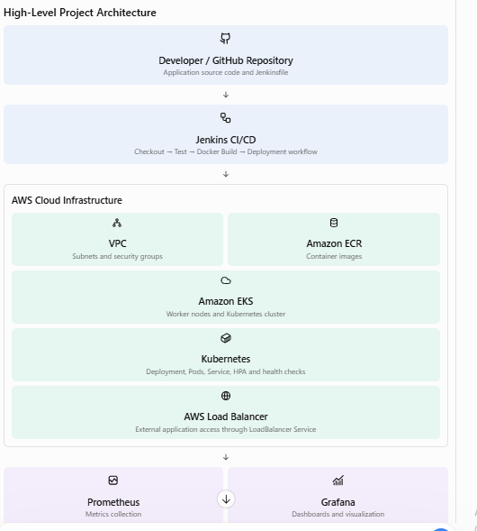

Sprint 1 – Architecture Design and Dockerization:
Explain:
- Application folder structure.
- Python environment setup.
- Dependencies installation.
- Application source code.
- Application health endpoint.
- Unit test creation.
Suggested screenshots:
- Python, Docker and Git versions.
- Successful pytest output showing two tests passed.
- Application home endpoint response.
- Application health endpoint response.
- Docker image build and docker images output.
- Running container shown by docker ps.
- Successful health endpoint response from Docker.

First of all, I have checked all the essentials tools and verify their version. See screenshots below.
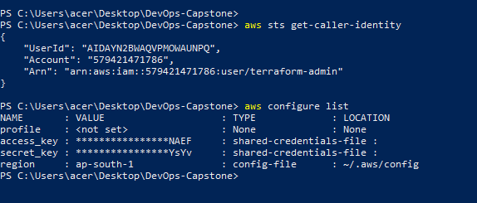
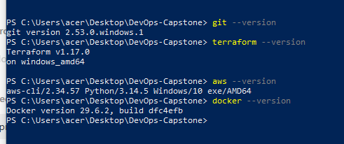
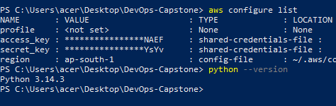
Explain that the objective was to design the application architecture, prepare the web application and containerize it using Docker.

Explain Dockerization :
- Why Docker was used.
- Dockerfile creation.
- Docker image build.
- Container execution.
- Port mapping.
- Container logs.
- Application health verification.
- Explain how you created the ECR repository and pushed the Docker image.

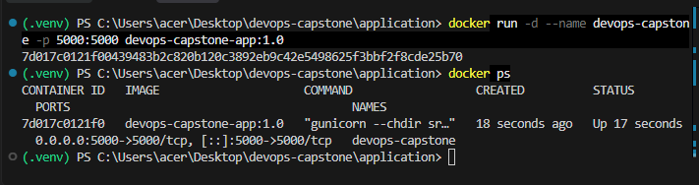

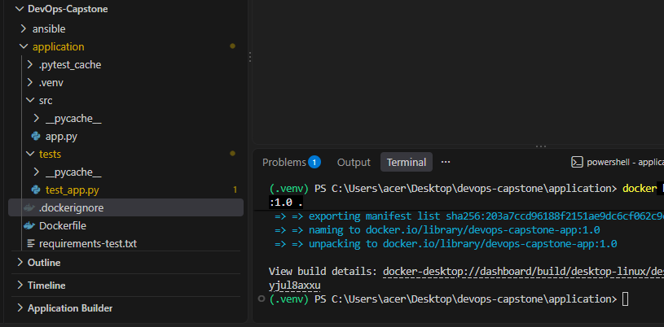
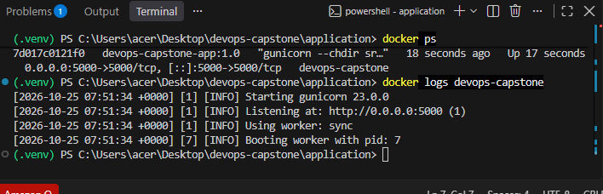

All the Screenshots attached.
devops-capstone/
└── application/
├── src/
│ └── app.py
├── tests/
│ └── test_app.py
├── Dockerfile
├── requirements.txt
└── requirements-test.txt

See application successfully setup .
What this code does:
- / returns a message confirming the application is running.
- /health provides a health-check endpoint that later monitoring and deployment tools can use.
- Port 5000 is the application's local development port.

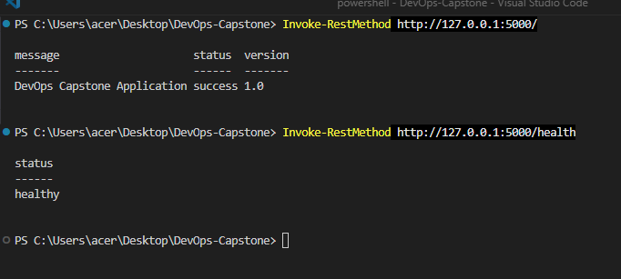
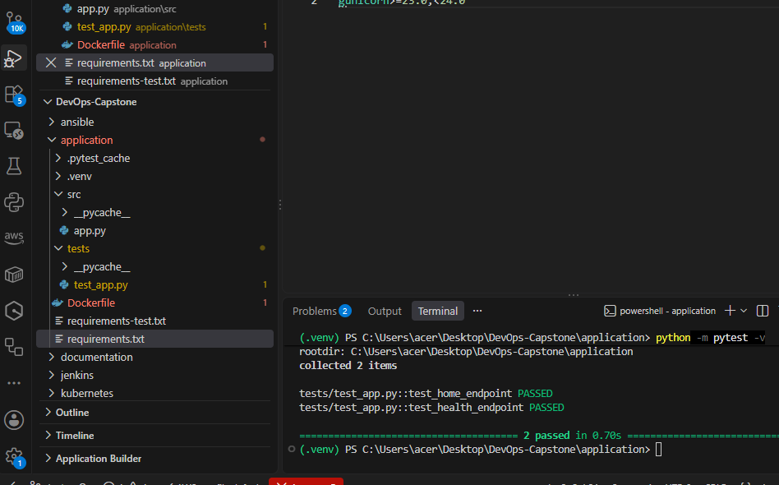

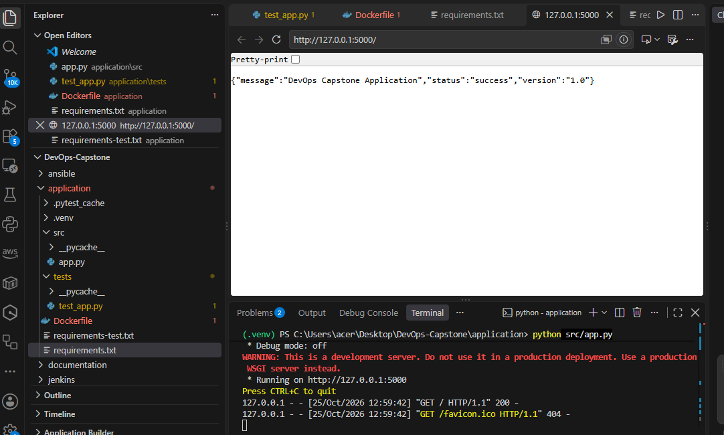
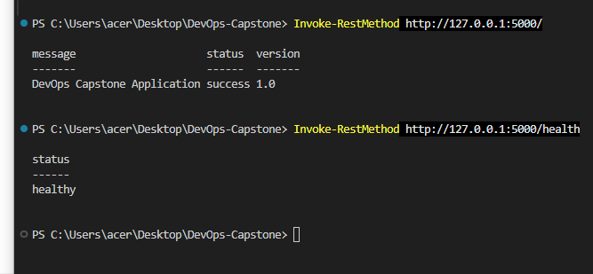
Flask is the web framework. Gunicorn will run the application inside the Linux Docker container.
Pytest will run our automated tests. Keeping the test dependencies separate makes it easier to distinguish runtime packages from development tools.
Open application/tests/test_app.py and paste the code
Run the automated tests and get the result as Success.

Keep this terminal open while the application runs. You should see Flask report that it is listening on 127.0.0.1:5000

You can also open these addresses in your browser:
- http://127.0.0.1:5000/
- http://127.0.0.1:5000/health
The browser will show the returned JSON.

Create the Dockerfile
Build and run the Docker container
Docker Desktop is running.
Start the container.
- docker run -d --name devops-capstone -p 5000:5000 devops-capstone-app:1.0
Explanation:
- -d runs the container in the background.
- --name gives the container a readable name.
- -p 5000:5000 maps port 5000 on your laptop to port 5000 in the container.
Verify the container is running and check logs
- docker ps
- docker logs devops-capstone
Then Test the containerized application
- Invoke-RestMethod http://127.0.0.1:5000/
- Invoke-RestMethod http://127.0.0.1:5000/health

Connecting the repository to GitHub and configuring Jenkins will be handled in the CI/CD sprint.
- Set-Location "$HOME\Desktop\devops-capstone"
- git init
- git status
- git config --global user.name "Vishnu250188"
- git config --global user.email https://github.com/Vishnu250188/HeroVired_Capstone-project_Batch-16B
- git add .gitignore application documentation
- git status
- git commit -m "Complete Sprint 1 application and Docker setup"
- git add screenshots
- git commit -m "Add Sprint 1 evidence screenshots"
Sprint 1 checklist :
- Project folders match the agreed architecture
- Flask application runs locally
- Both automated tests pass
- Home endpoint returns the expected response
- Health endpoint returns healthy status
- Docker image builds successfully
- Docker container starts successfully
- Both endpoints work through Docker
- Screenshots are saved in the screenshots folder
- Sprint report and test-case documents are saved
- Git commit is created

Sprint 2 — AWS infrastructure with Terraform
Prepare the Terraform configuration for networking, IAM, ECR and EKS, along with the required state-management setup. We will validate the AWS region, permissions and expected costs before provisioning resources.
The goal for this sprint is to prepare and validate the Terraform configuration for AWS networking, IAM, Amazon ECR, Amazon EKS, and remote Terraform state. We'll validate permissions and estimated costs before creating paid AWS resources.

Terraform Setup:
Document:
- Terraform installation.
- AWS CLI configuration.
- AWS IAM permissions.
- Terraform provider configuration.
- Terraform variables.
- Backend configuration.
- Jenkins integration

AWS Networking:
Explain your:
- VPC.
- Public and private subnets.
- Internet Gateway.
- Route tables.
- Security groups.
- Network configuration.

EKS Infrastructure:
Explain:
- EKS control plane.
- IAM roles and policies.
- OIDC provider.
- Managed node group.
- Worker nodes.

Terraform State Management and Validation:
- terraform init
- terraform fmt
- terraform validate
- terraform plan
- terraform apply

Sprint 2 flow will be:

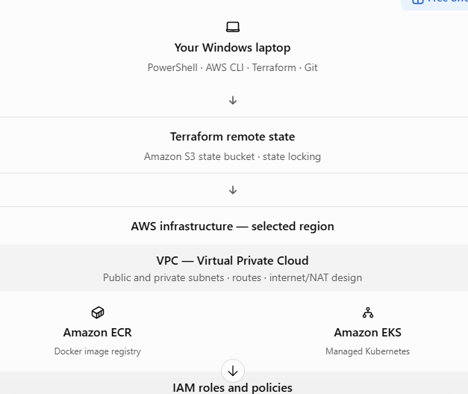
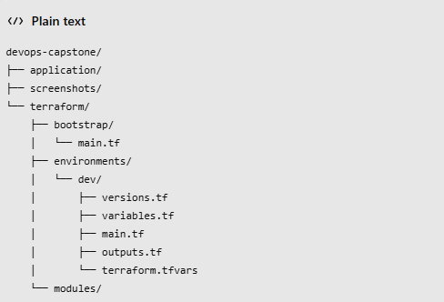

What each component does
Component Purpose
VPC and subnets Isolate your AWS network and organize resources
IAM Give AWS services the permissions they need
ECR Store the Docker image built from your Sprint 1 application
EKS Run the application in Kubernetes in a later sprint
S3 remote state Store Terraform's record of the infrastructure
State locking Help prevent simultaneous Terraform operations from corrupting state

Basic Tools :
Verify Terraform and AWS CLI:

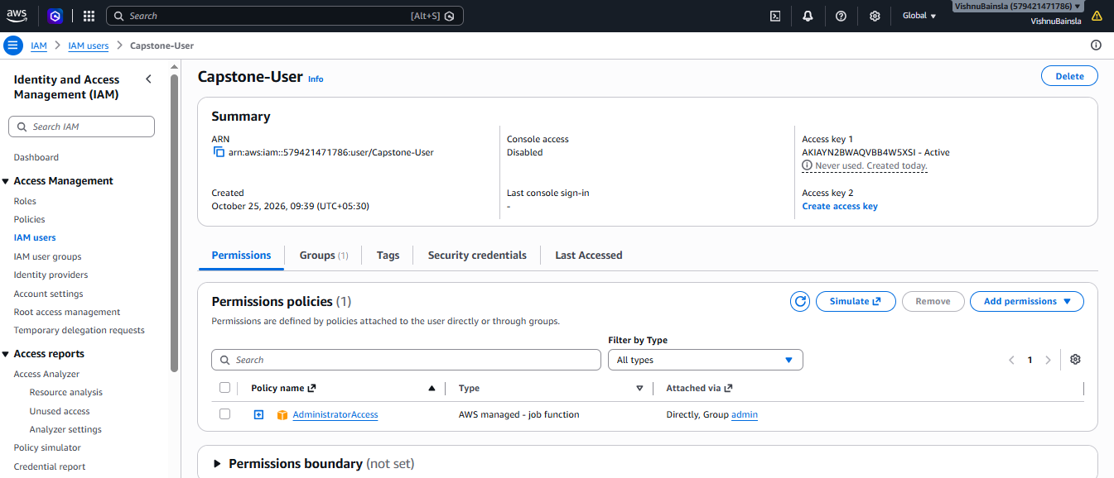
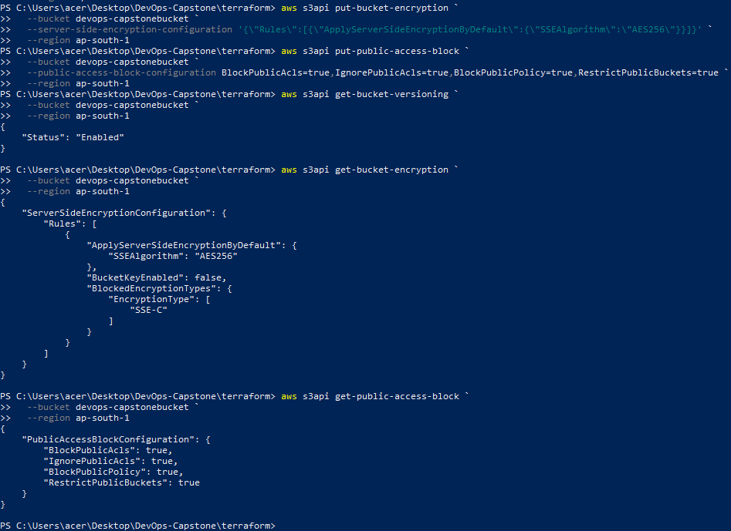

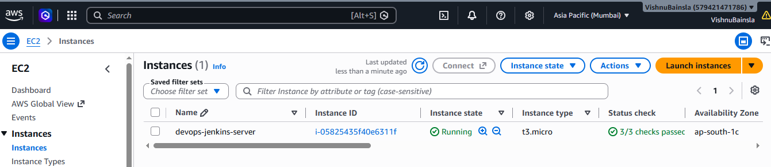

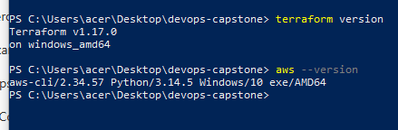
Check permissions before creating resources
- aws iam get-user
check basic access to the main services:
- aws ec2 describe-vpcs --region ap-south-1
- aws ecr describe-repositories --region ap-south-1
- aws eks list-clusters --region ap-south-1
- aws s3 list-buckets
Create the Terraform configuration files:
Under the Terraform folder/
- versions.tf
- provider.tf
- variables.tf
- terraform.tfvars
- network.tf
- iam.tf
- ecr.tf
- eks.tf
- outputs.tf
- backend.tf
What you should understand here:
- A public subnet has a route to the Internet Gateway.
- A private subnet sends outbound IPv4 internet traffic through the NAT Gateway.
- The private subnets don't automatically give their instances public IPv4 addresses.
- The EKS subnet tags help Kubernetes integrations place load balancers in the intended subnets.
The CIDR blocks are calculated from 10.0.0.0/16. We use two Availability Zones because EKS requires at least two subnets in different Availability Zones for the cluster.
Get-Location:

- terraform fmt –recursive
- terraform init -backend=false
- terraform validate
- terraform Plan

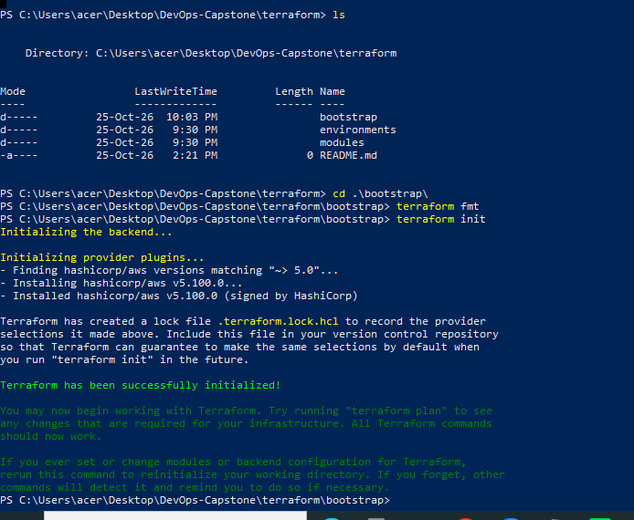

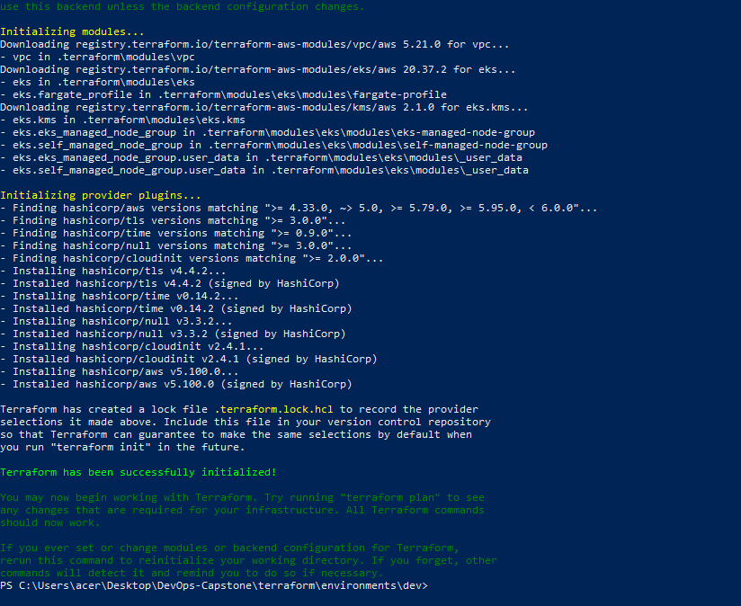
\
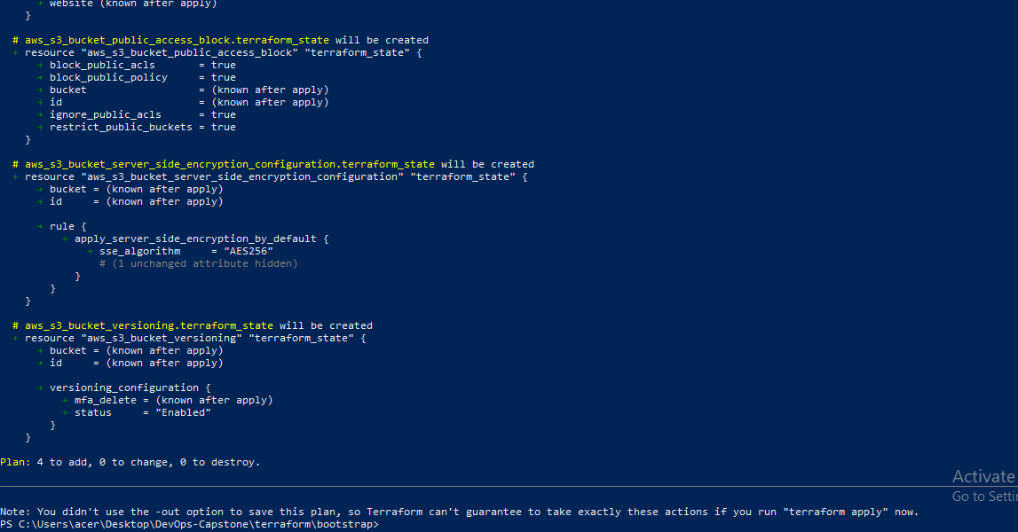

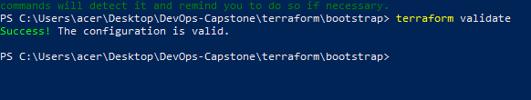

- One Amazon EKS cluster
- One EC2 worker node of type t3.small
- One NAT Gateway and its associated data processing
- One Elastic IP for the NAT Gateway
- One ECR repository and expected image storage
- One S3 state bucket
We should expect Terraform to propose resources for the VPC, subnets, route tables, Internet Gateway, NAT Gateway, IAM roles and policies, ECR, EKS, and the managed node group.

The S3 bucket must exist before Terraform can use it as a backend. We will create this small supporting resource separately.

Create the state bucket
1. aws s3api create-bucket `
--bucket $BucketName `
--region ap-south-1 `
--create-bucket-configuration LocationConstraint=ap-south-1

. Enable bucket versioning
2. aws s3api put-bucket-versioning `
--bucket $BucketName `
--versioning-configuration Status=Enabled

Enable encryption
3. aws s3api put-bucket-encryption `
--bucket $BucketName `
--server-side-encryption-configuration '{"Rules":[{"ApplyServerSideEncryptionByDefault":{"SSEAlgorithm":"AES256"}}]}'

Block public access

4. aws s3api put-public-access-block `
--bucket $BucketName `
--public-access-block-configuration BlockPublicAcls=true,IgnorePublicAcls=true,BlockPublicPolicy=true,RestrictPublicBuckets=true

Verify versioning:
- aws s3api get-bucket-versioning --bucket $BucketName

The S3 bucket is now created and protected.
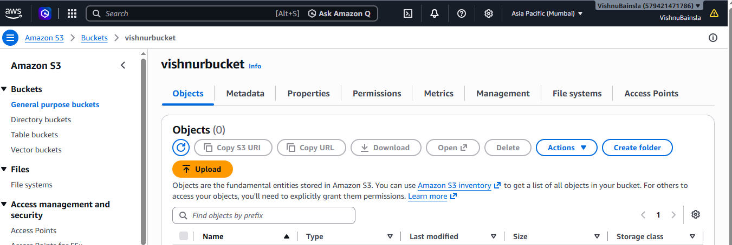
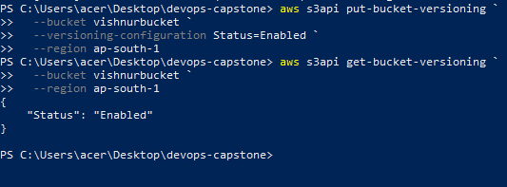
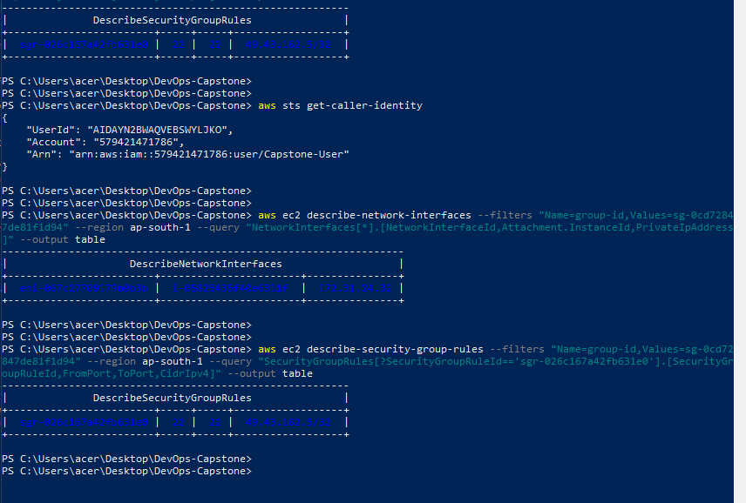

Configure the S3 backend
terraform {
backend "s3" {
bucket = "vishnurbucket "
key = "devops-capstone/terraform.tfstate"
region = "ap-south-1"
encrypt = true
use_lockfile = true
}
}
Now initialize Terraform with the remote backend:
- terraform init -migrate-state
- terraform validate
- terraform plan
Review the plan carefully. It should propose creating the resources in your Terraform files. The plan should not unexpectedly destroy or replace unrelated existing resources.

Sprint 2 screenshot checklist
- Terraform and AWS CLI version output
- AWS identity and configured region
- Terraform files in VS Code
- Successful terraform fmt and terraform validate
- S3 bucket versioning and encryption
- Terraform backend configuration with the actual bucket name (hide sensitive details)
- Successful terraform plan output
- AWS Pricing Calculator estimate
- Jenkins integration
- Jenkins dashboard after initial setup
- Jenkins job connected to the GitHub repository
- Jenkins job connected to the GitHub repository

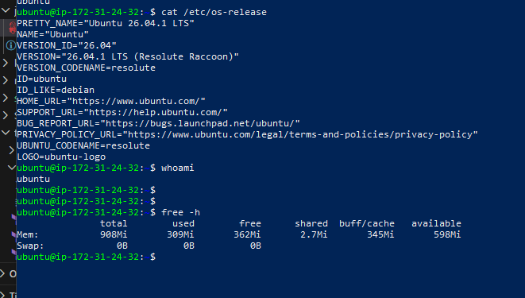
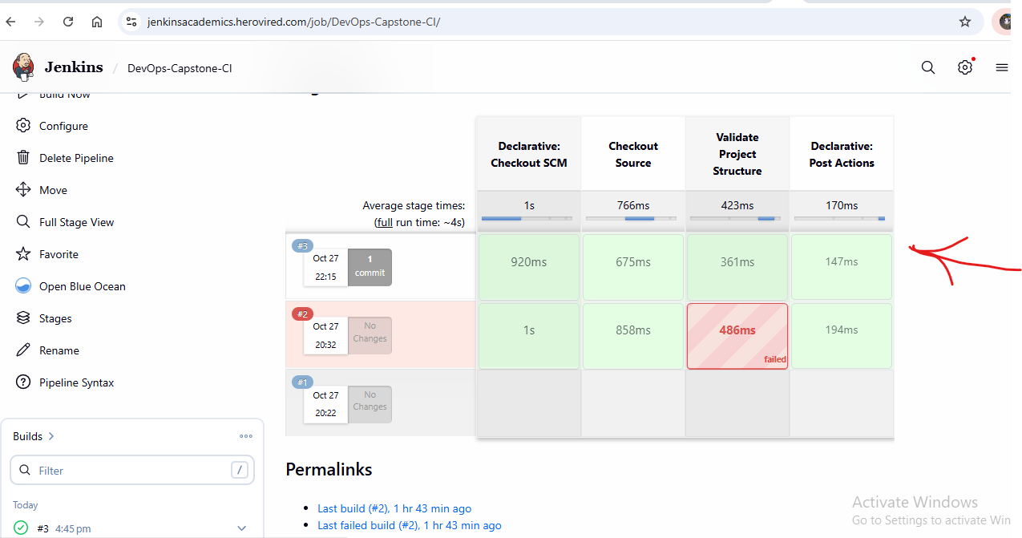
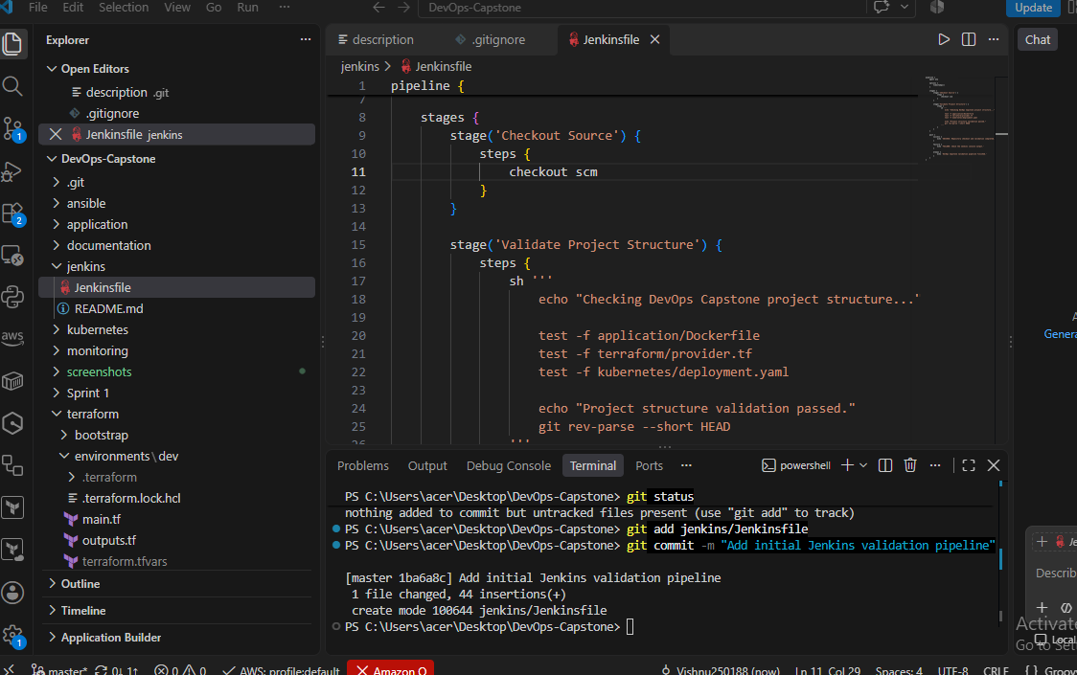

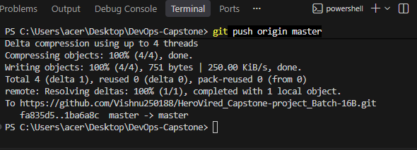
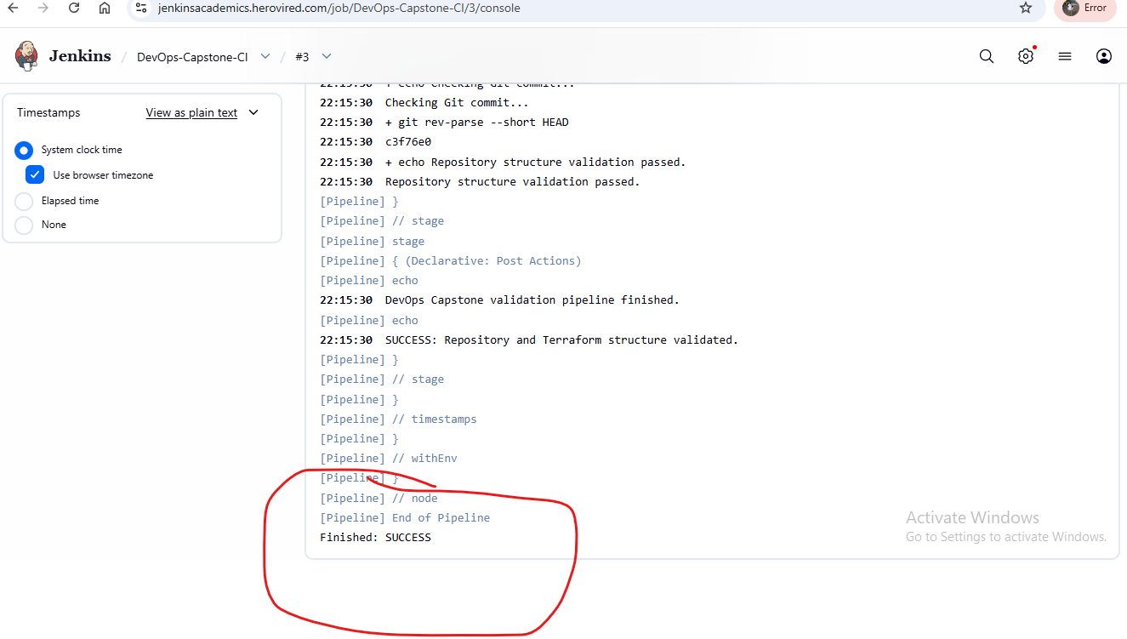

Sprint 3 - Configuration Management with Ansible and Jenkins Pipeline:
Use Ansible to configure your Jenkins EC2 host and validate the environment needed for the deployment pipeline.
Important architecture detail: EKS managed worker nodes are not the same as ordinary EC2 servers that you administer with SSH. Let EKS manage node lifecycle and Kubernetes-level configuration. Use Ansible for your Jenkins host or additional standalone EC2 servers that genuinely require configuration management.
Create a Jenkins pipeline that executes the playbook using securely configured credentials. If Ansible runs on a separate agent, verify that it can reach the target instance over the required network path.
For orchestration, Jenkins can run the stages in sequence:
Terraform validation → Infrastructure provisioning → Ansible configuration → Deployment

Sprint 3 flow/ Architecture:

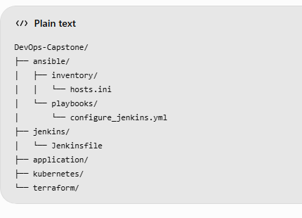

Sprint 3 execution flow:
• Checkout
Downloads source code from GitHub.
• Prepare Ansible
Installs Ansible inside a Python virtual environment.
• Configure EC2 Inventory
Adds the target server's public IP.
• Ansible Syntax Validation
Validates the playbook.
• Configure EC2 using Ansible

Configure the EC2 inventory:

Step 1: Find your EC2 public IP
- Login to AWS Console.
- Open EC2.
- Select Instances.
- Find your existing Ubuntu EC2 instance.
- Copy its Public IPv4 address.
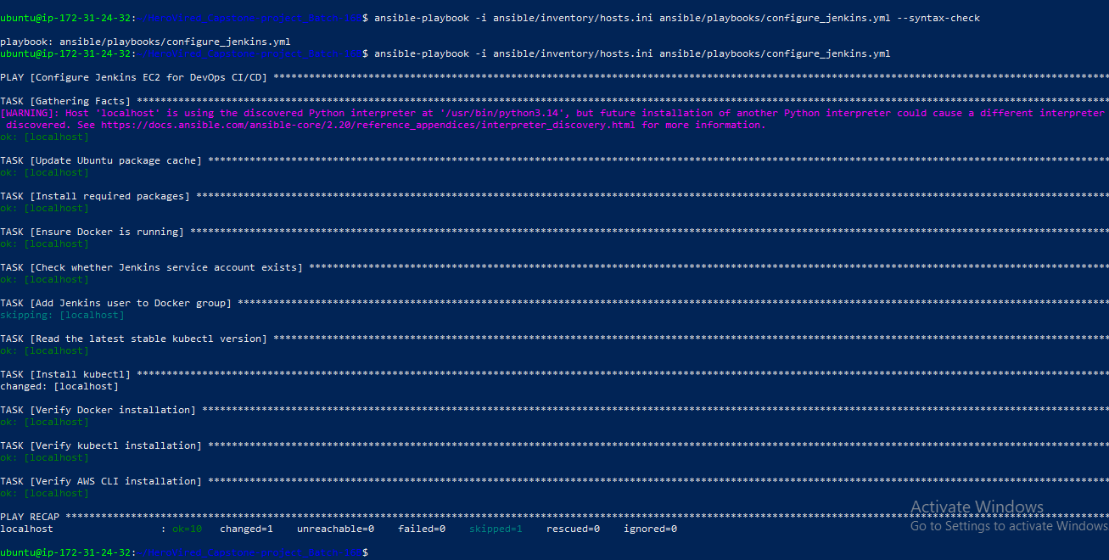

Step 2: Configure the inventory:
- ansible/inventory/hosts.ini

Step 3: Configure SSH access:
- Ansible connects to Ubuntu EC2 using SSH.
For Jenkins to connect, we must add this private key to Jenkins credentials.
First, check your EC2 security group:
- AWS Console → EC2 → Instances.
- Select your target instance.
- Open Security tab.
- Click its Security Group.
- Select Edit inbound rules.
- Ensure SSH TCP port 22 is permitted from the Jenkins agent's public IP with /32.

Step 3 : Create the Ansible Playbook:
This is the most important part of Sprint 3.
The playbook will automatically:
- Connect to Ubuntu EC2.
- Update the package repository.
- Install Docker.
- Start Docker.
- Enable Docker at system startup.
- Install Git.
- Install Python 3 and pip.
- Install kubectl.
- Verify the installed software.
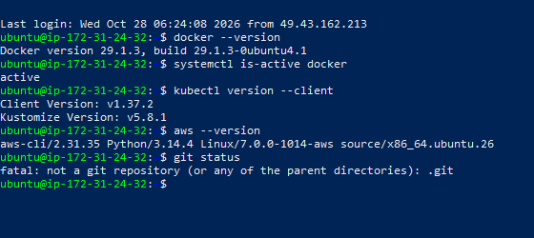

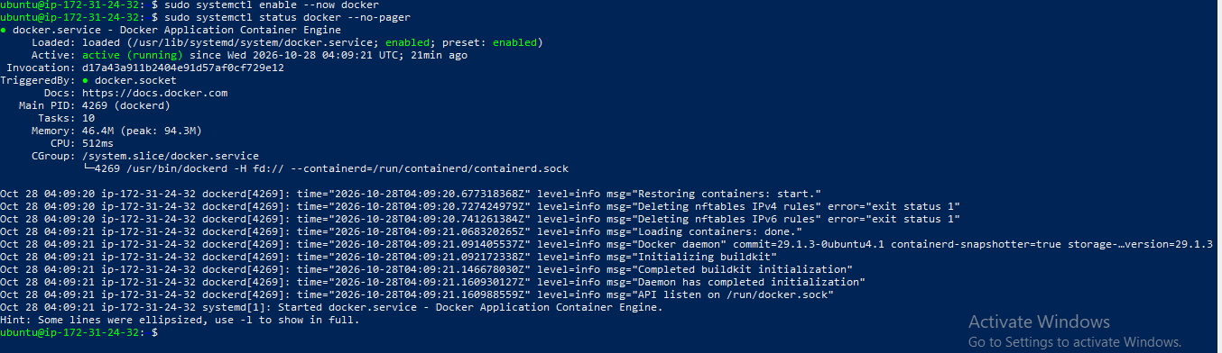

Create the Jenkins credential for EC2:
Follow these steps:
- Open Jenkins Dashboard.
- Click Manage Jenkins.
- Click Credentials.
- Open the appropriate global credentials store.
- Click Add Credentials.

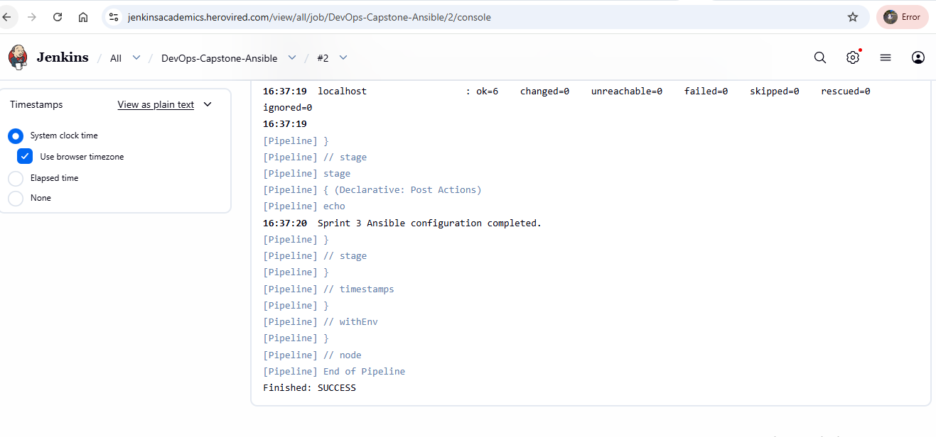

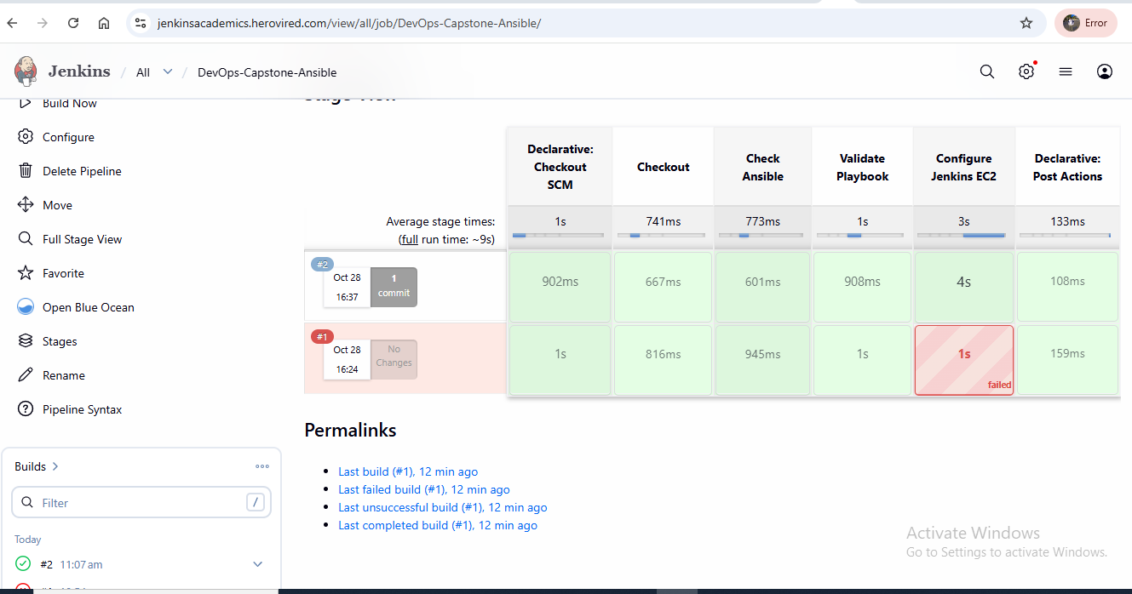

Create the Jenkins Pipeline for Sprint 3:
jenkins/Jenkinsfile

Now Verify the Docker Service is Running or not:

Verify the installation:

Now first we will verify the Terraform:

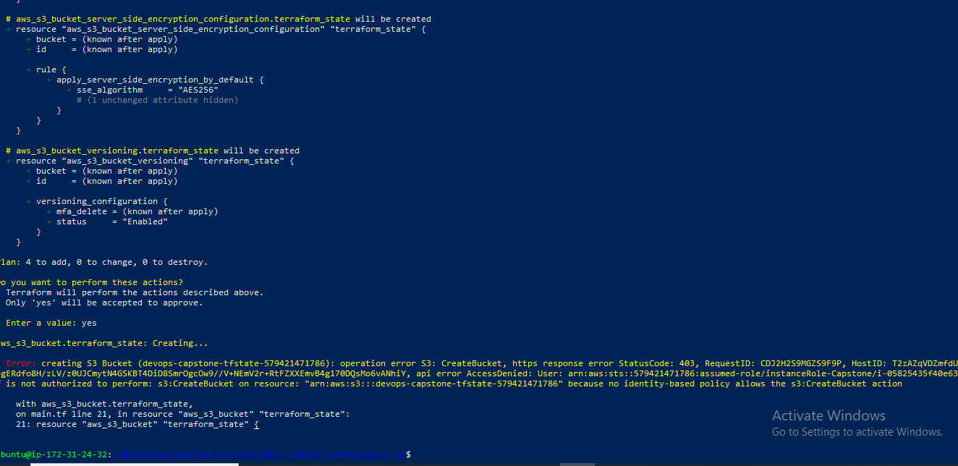

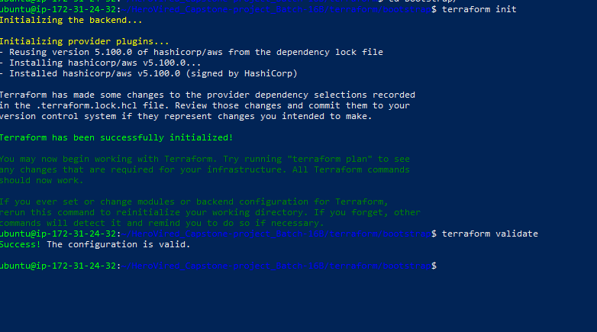
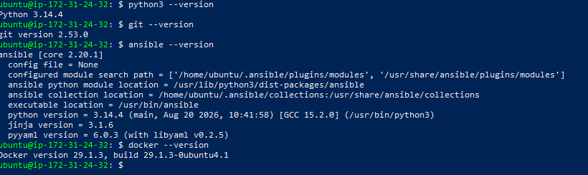

Creating the IAM Role and Permissions:

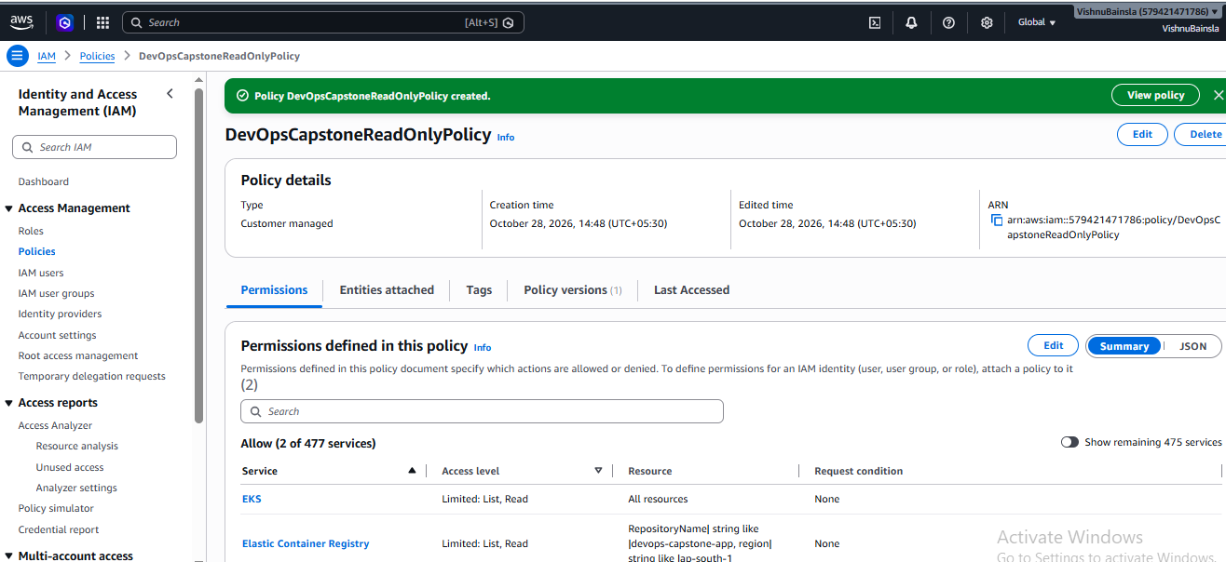
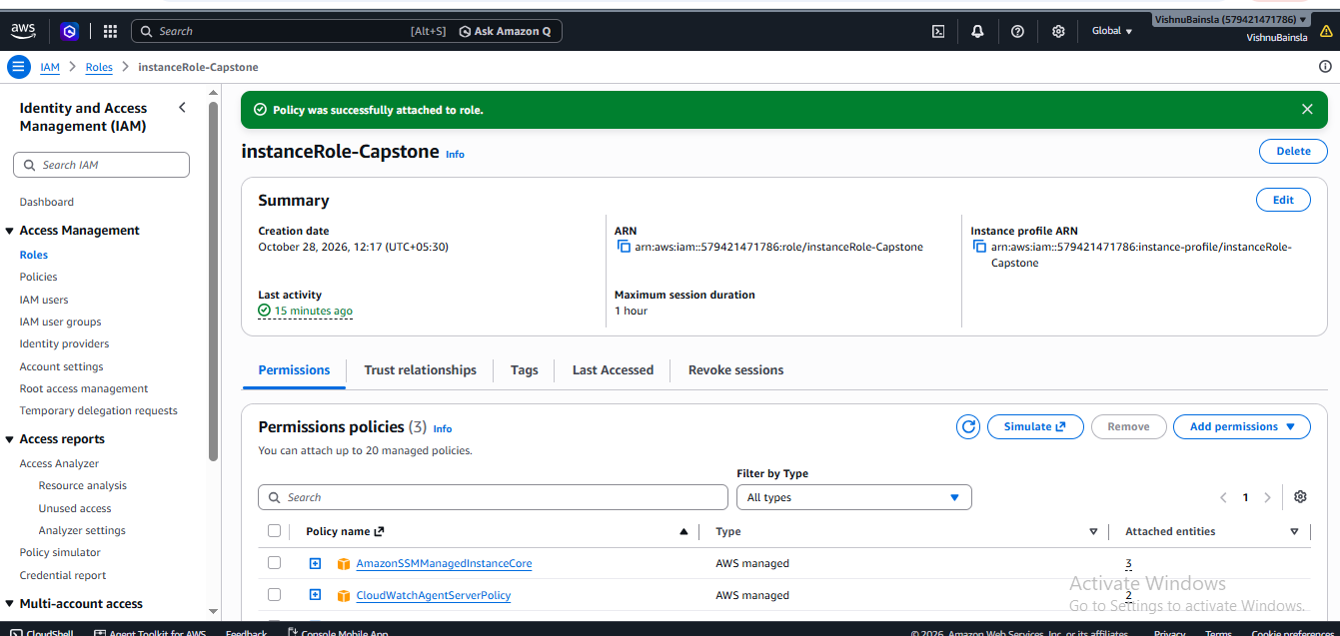

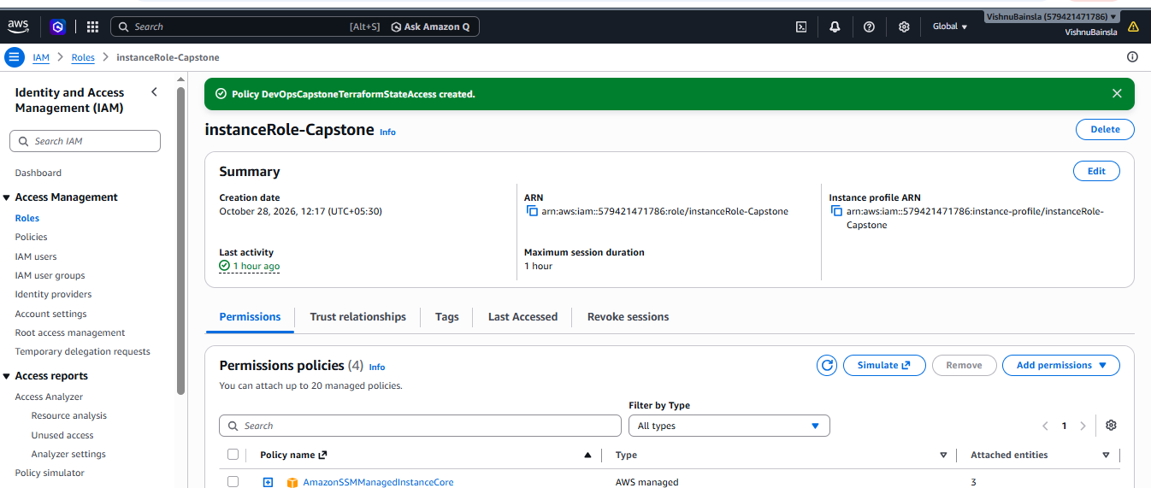

Verify the Kubernetes and AWS identity:
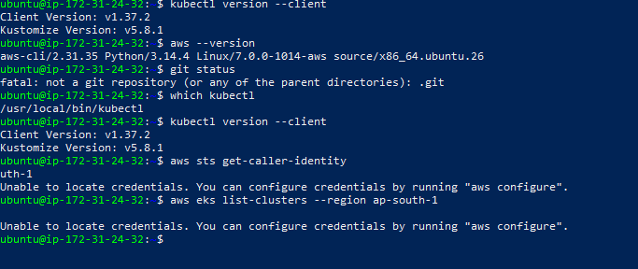

Push your changes to GitHub:
Create the Jenkins Pipeline Job-
- Open Jenkins Dashboard.
- Click New Item.
- Enter the name:
- Select Pipeline.
- Click OK.
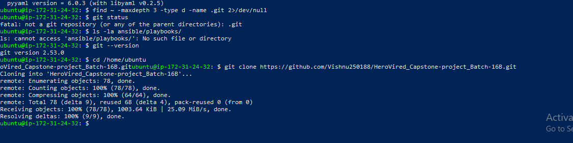

Execute the Jenkins CI/CD pipeline:
Hero Vired Jenkins browser.
- Open Jenkins Dashboard.
- Open DevOps-Capstone-EKS-CICD.
- Click Build Now.
- Click the latest build number.
- Click Console Output.

Configure Pipeline from GitHub.
Verify the configuration on AWS EC2

Sprint 4: CI/CD Pipeline for Application Deployment on Kubernetes (AWS EKS)

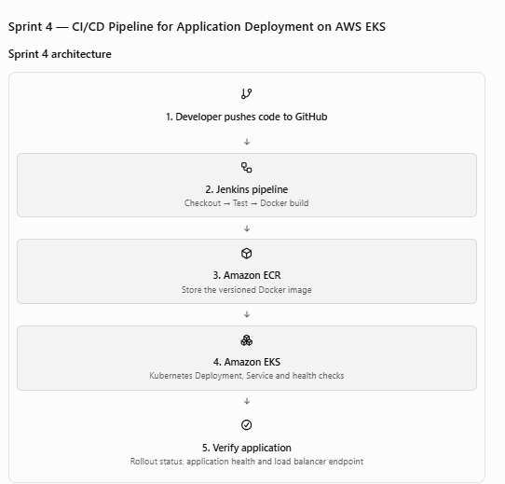

Objective
The objective of Sprint 4 was to implement an automated CI/CD pipeline using Jenkins to build, test, containerize and deploy the web application to Kubernetes running on AWS EKS.

Tools and Technologies
- Jenkins
- GitHub
- Docker
- AWS ECR
- AWS EKS
- Kubernetes
- kubectl
- Python
- AWS CLI

Implementation

3.1 GitHub Integration
Configured Jenkins to retrieve application source code from the GitHub repository.

3.2 Application Testing
Implemented automated application testing as part of the Jenkins pipeline.

3.3 Docker Image Creation
Configured Jenkins to build Docker images using the application Dockerfile.

3.4 AWS ECR Integration
Integrated Jenkins with Amazon Elastic Container Registry to authenticate and push Docker images.

3.5 Kubernetes Deployment
Configured Kubernetes Deployment and Service manifests to deploy the application on AWS EKS.

3.6 Health Checks
Configured Kubernetes readiness and liveness probes to monitor application health.

3.7 Auto-scaling
Configured a Horizontal Pod Autoscaler to support automatic scaling based on CPU utilization, subject to Metrics Server availability.

CI/CD Pipeline Stages
- Checkout Source Code
- Verify Build Tools
- Application Testing
- Build Docker Image
- Push Image to AWS ECR
- Connect to AWS EKS
- Deploy Application to Kubernetes
- Verify Kubernetes Deployment

Validation
The implementation was validated through:
- Jenkins pipeline execution.
- Docker image creation.
- ECR image verification.
- Kubernetes deployment verification.
- Pod and service status checks.
- Application health endpoint testing.
- Horizontal Pod Autoscaler verification.

Outcome
The Sprint 4 implementation established the application CI/CD deployment workflow using Jenkins, Docker, Amazon ECR and Amazon EKS.
The pipeline automates application testing, container image creation, image publishing and Kubernetes deployment.

All the screenshots :
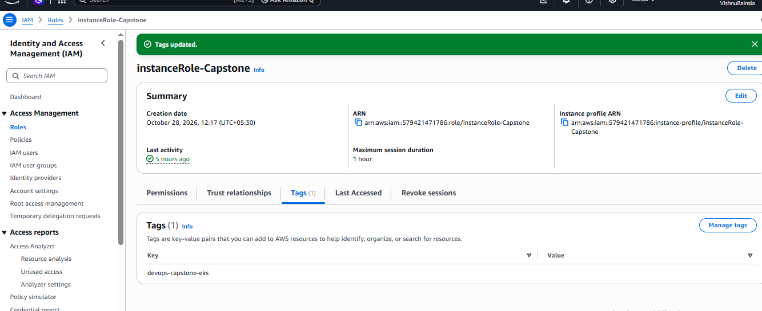
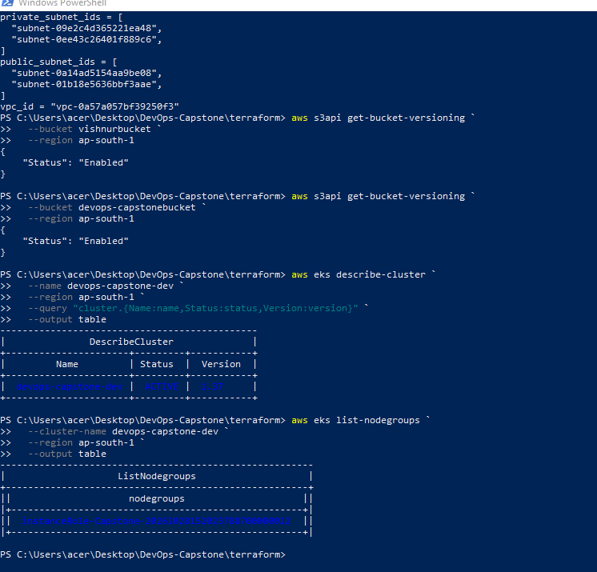

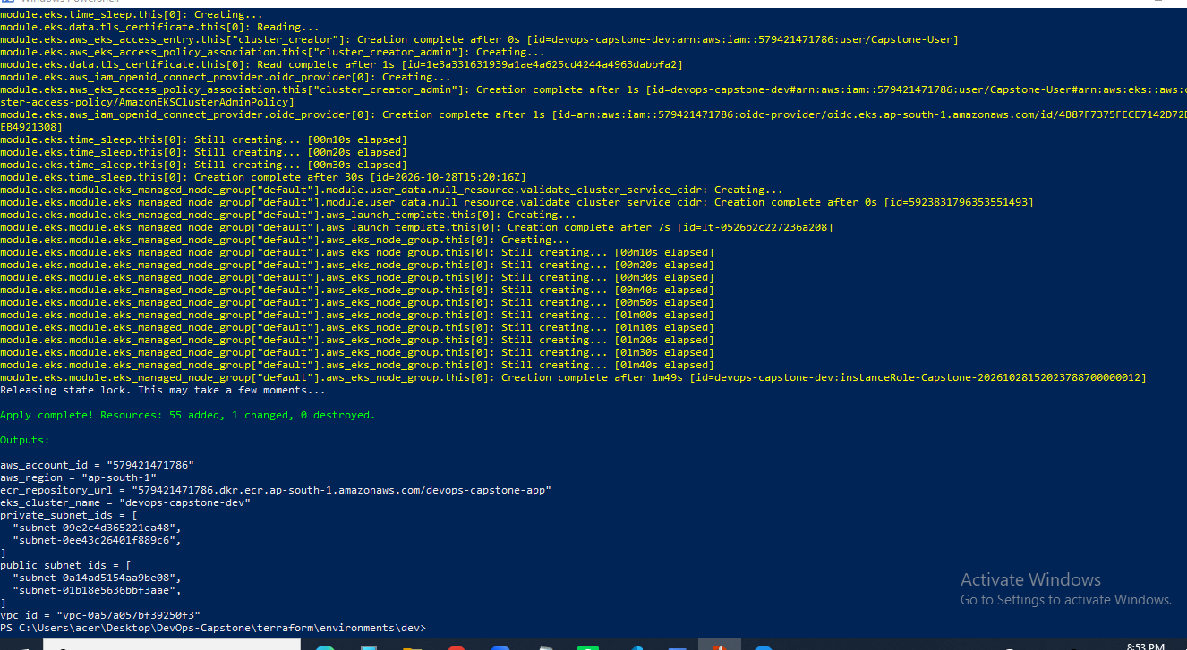

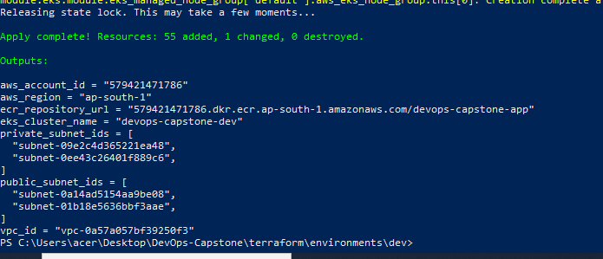
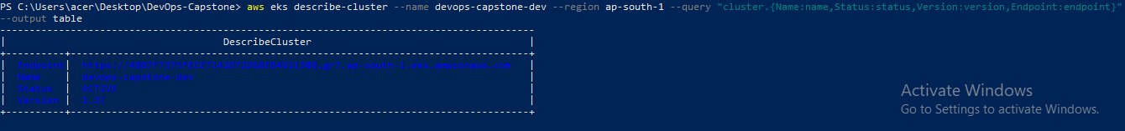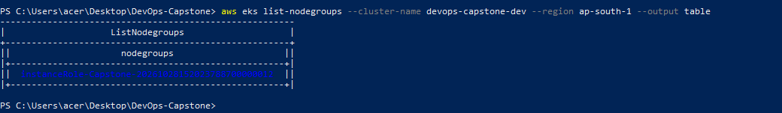
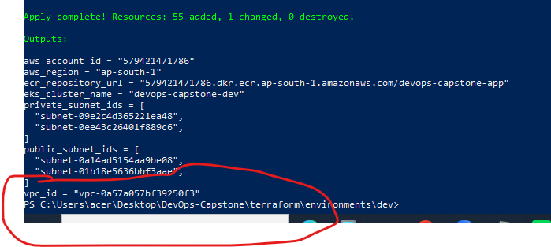

Troubleshooting common Sprint 4 errors
These are important for your implementation and viva.
Error | Reason | Solution
InvalidClientTokenId | Invalid AWS credentials | Update Jenkins AWS credentials
docker: command not found | Docker missing on Jenkins agent | Use a Docker-capable agent
Cannot connect to Docker daemon | Docker engine unavailable | Configure Docker daemon access
AccessDeniedException | IAM permissions missing | Update required ECR/EKS permissions
Unable to locate credentials | AWS credentials unavailable | Check Jenkins credentials binding
dial tcp: i/o timeout | EKS API connectivity problem | Check endpoint access and agent IP allowlist
ImagePullBackOff | EKS nodes cannot pull ECR image | Check node IAM permissions and image URI
CrashLoopBackOff | Application container repeatedly fails | Check application logs and startup command
Readiness probe failed | Health endpoint not responding | Verify /health and port 5000
LoadBalancer pending | AWS load balancer provisioning issue | Check service events and AWS integration
Metrics API not available | Metrics Server unavailable | Install/configure Metrics Server
SPRINT 5 – Monitoring Setup with Prometheus, Grafana and Jenkins Alerts:

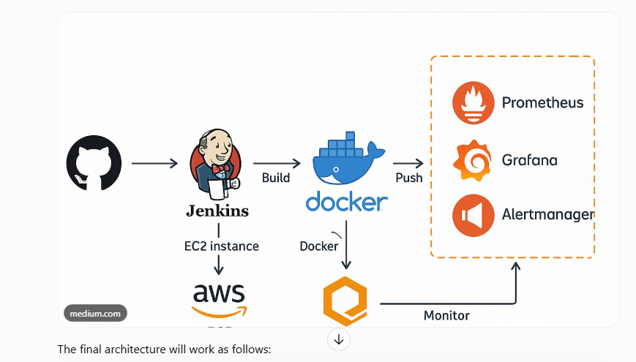

Task | Expected result
- Install Prometheus | - Metrics collection from EKS
- Install Grafana | - Monitoring dashboards
- Configure application monitoring | - Application health and performance visibility
- Configure Kubernetes monitoring | - Pod, node and cluster metrics
- Configure alerts | - Alerts for failures and high resource usage
- Integrate Jenkins | - Pipeline failure notifications
- Testing | - Verify that alerts actually work
Check your existing AWS and EKS configuration-

Check AWS CLI:
- aws --version
Check AWS identity:
- aws sts get-caller-identity
Check EKS:
- aws eks describe-cluster `
--name devops-capstone-dev `
--region ap-south-1 `
--query "cluster.status"

Configure kubectl:
- aws eks update-kubeconfig `
--region ap-south-1 `
--name devops-capstone-dev

Check nodes:
- kubectl get nodes

Check your application:
- kubectl get all -n capstone

Check the application deployment:
- kubectl rollout status deployment/devops-capstone-app -n capstone

Check the service:
- kubectl get svc -n capstone

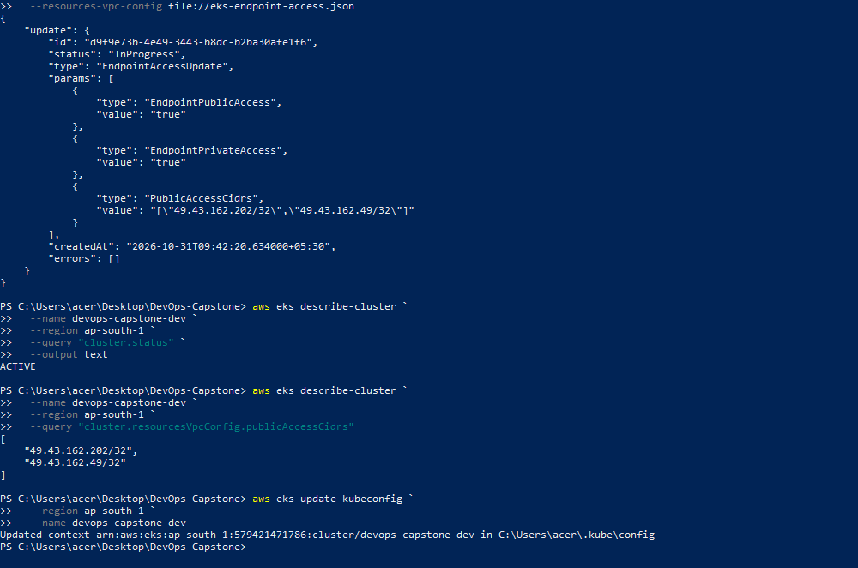

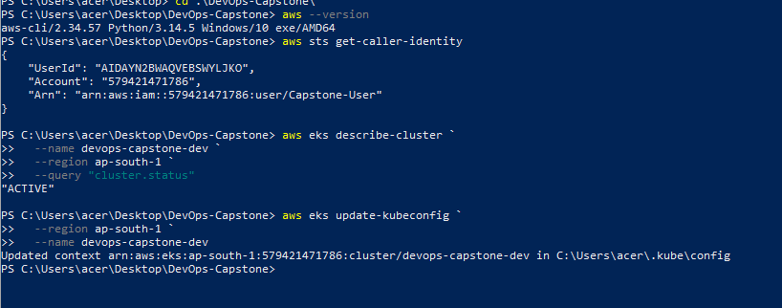

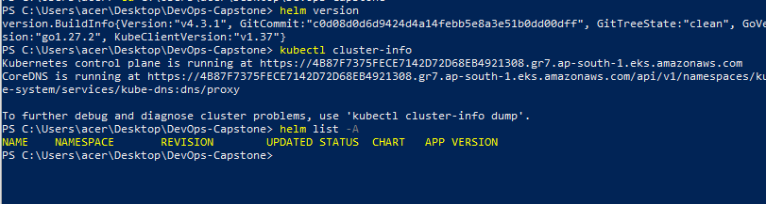
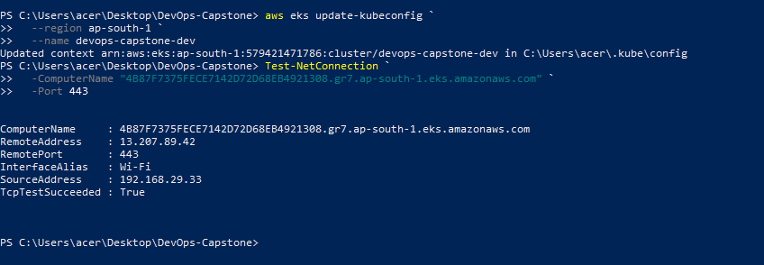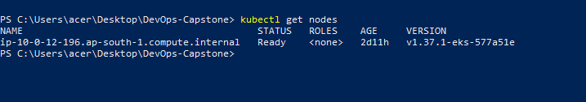

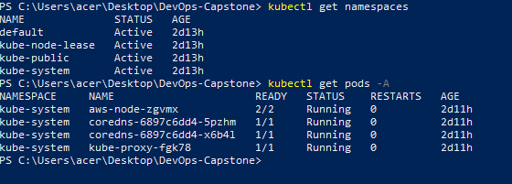

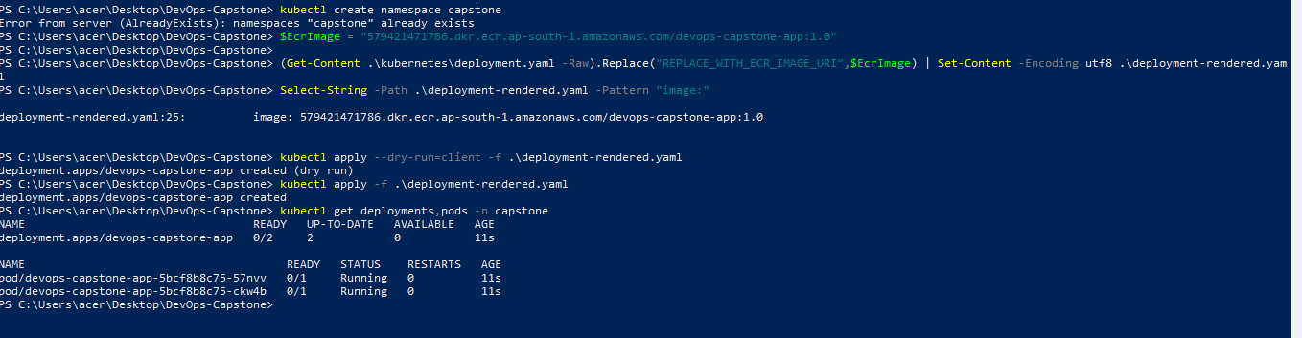

Step 2 – Install Helm :
Helm is a Kubernetes package manager. It simplifies installing applications such as Prometheus and Grafana.
Check whether Helm is installed:
- helm version
- winget install Helm.Helm
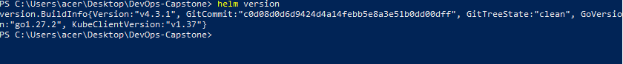
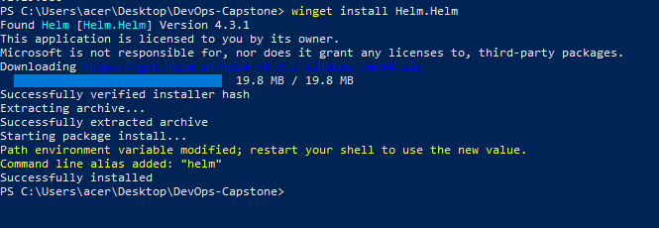

Step 3 – Create a monitoring namespace :
- kubectl create namespace monitoring
- kubectl get namespaces

- Check the current Terraform configuration
- Check the actual EKS node count
- Check Kubernetes nodes

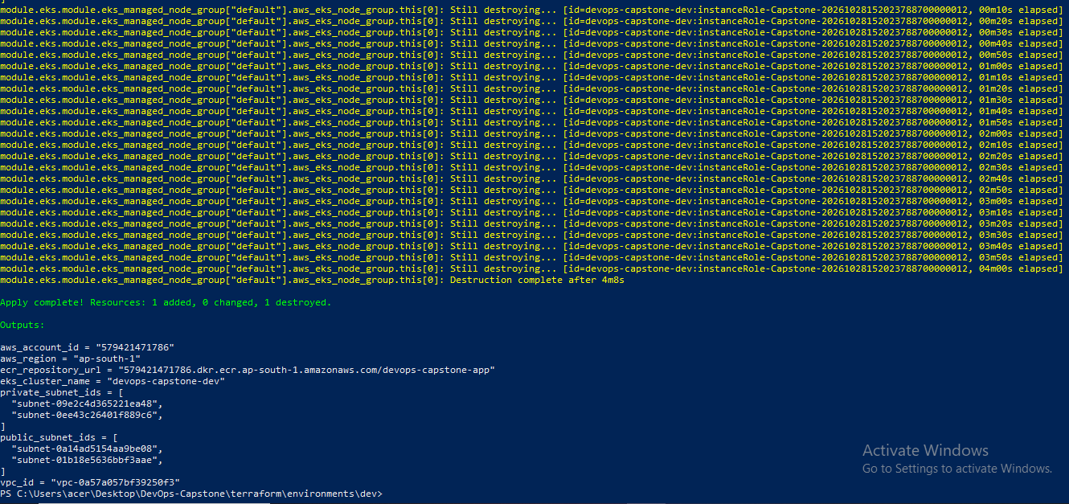

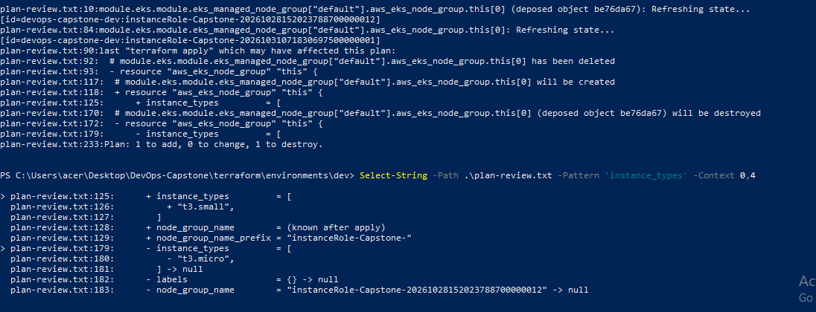

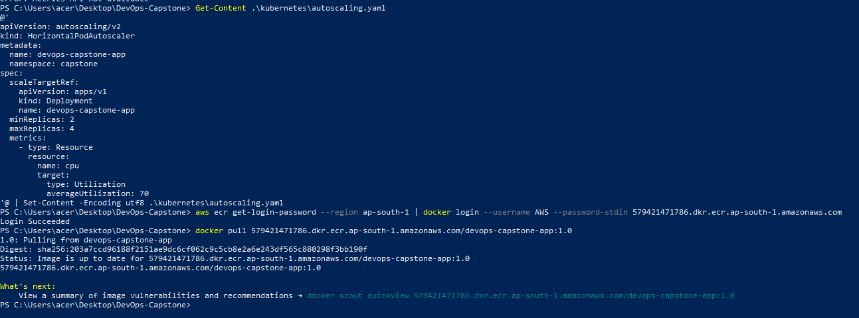

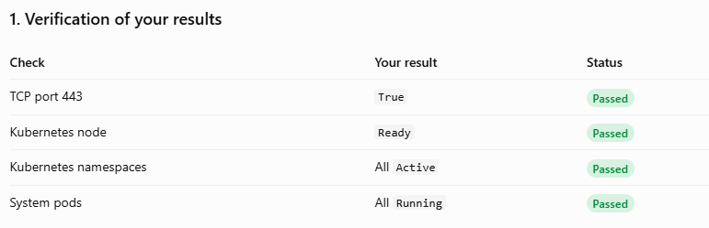
- Check node status
- Check Grafana status

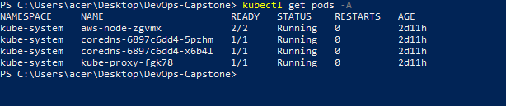
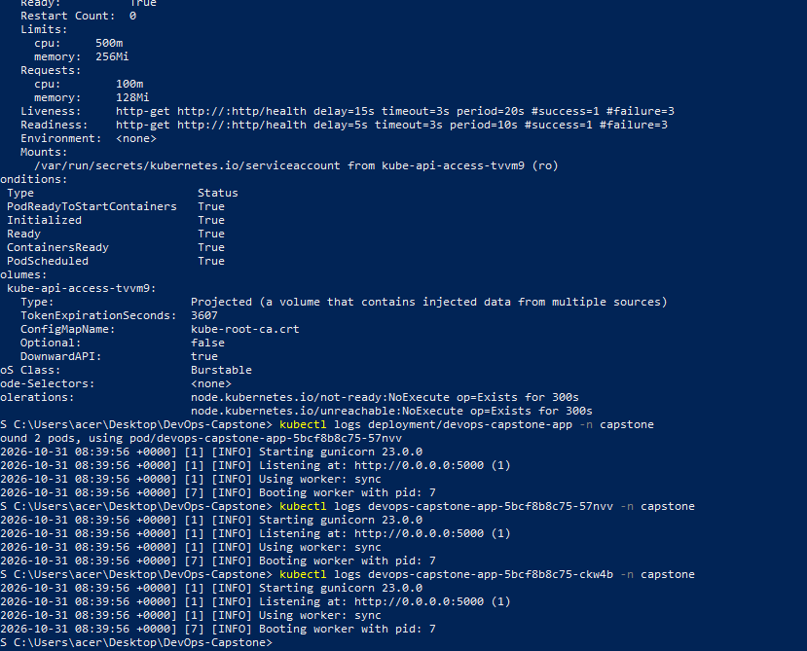
Install Prometheus and Grafana –
- helm install monitoring prometheus-community/kube-prometheus-stack `
--namespace monitoring `
--set grafana.adminPassword='ChangeThisStrongPassword123!' `
--wait `
--timeout 15m
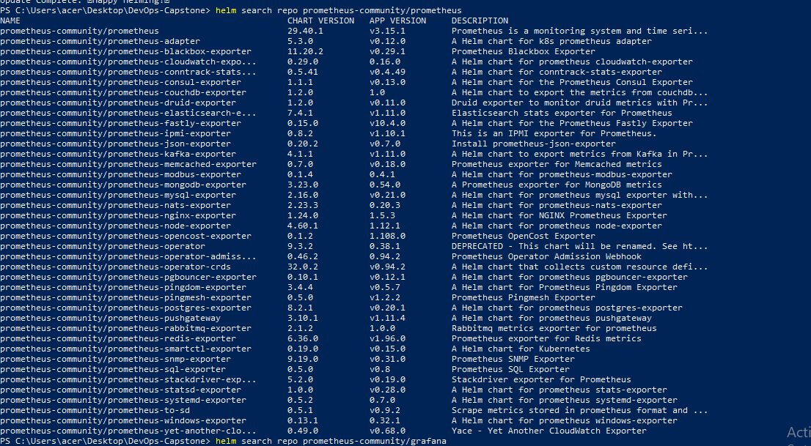

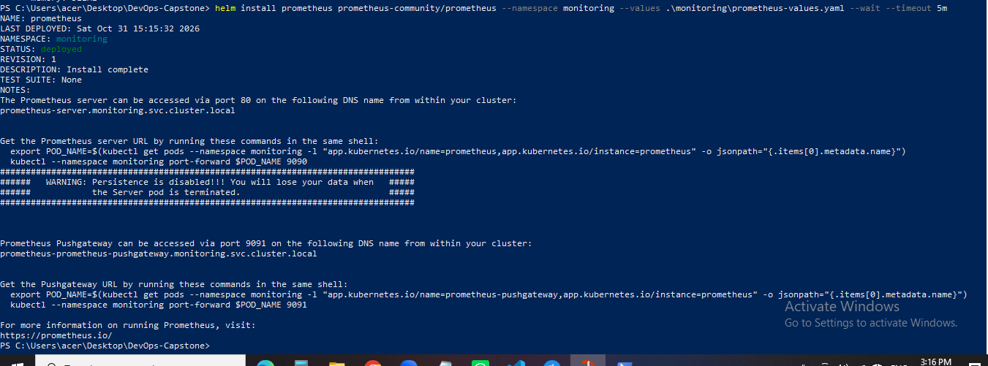

Check installed components:
- kubectl get pods -n monitoring
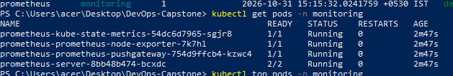
see resources with names similar to:
- monitoring-kube-prometheus-stack-prometheus
- monitoring-grafana
- monitoring-kube-prometheus-stack-alertmanager
- monitoring-kube-state-metrics
- monitoring-prometheus-node-exporter

Check Helm:
- helm list -n monitoring
Access the Grafana dashboard:
- kubectl get svc -n monitoring

Query 1 – CPU usage
- sum(rate(container_cpu_usage_seconds_total[5m]))

Query 2 – Memory usage
- sum(container_memory_working_set_bytes)

Query 3 – Running pods:
- count(kube_pod_info)

Configure application monitoring :
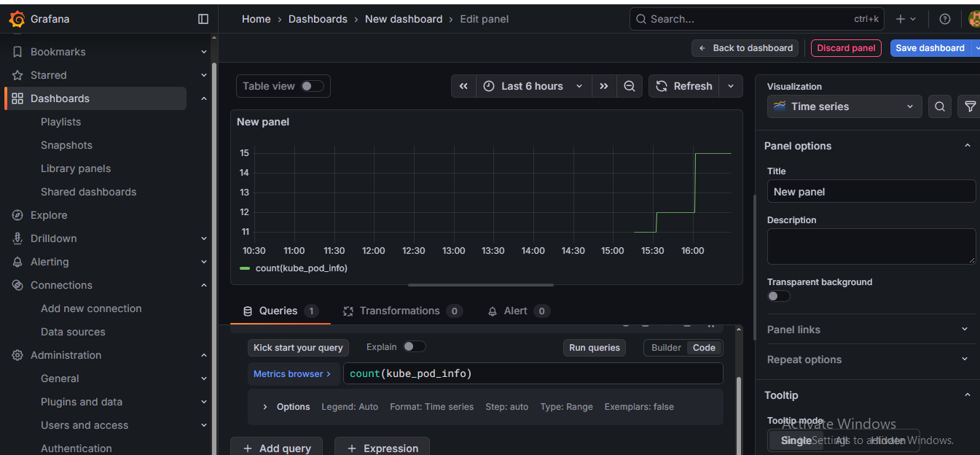

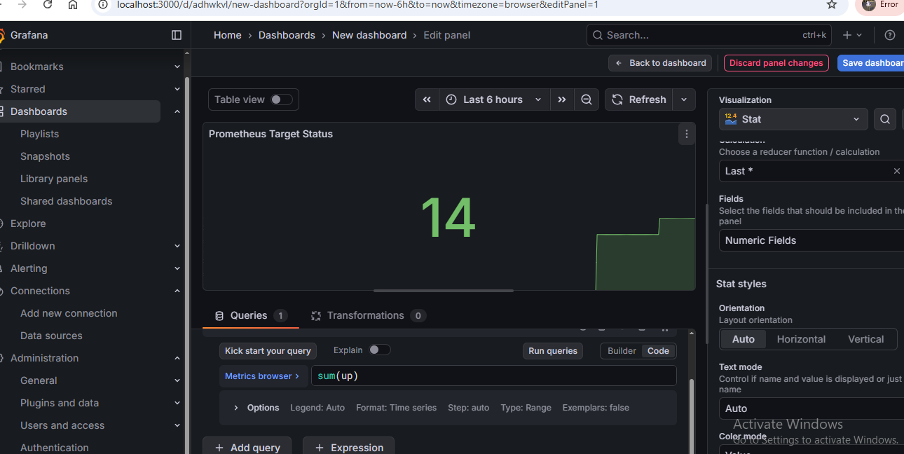
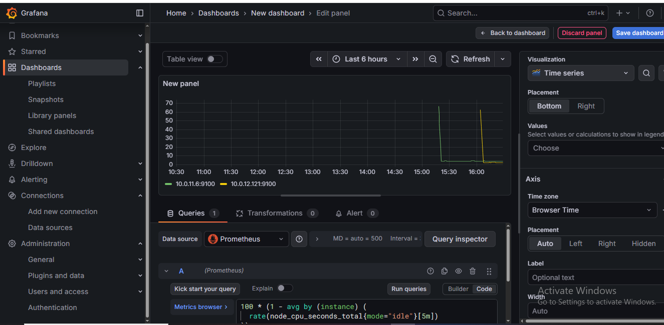

Configure Prometheus alerting rules :
- monitoring/alerts.yaml

Retrieve the Grafana admin password :
- $GrafanaPassword = kubectl get secret grafana -n monitoring -o jsonpath="{.data.admin-password}"
[System.Text.Encoding]::UTF8.GetString(
[System.Convert]::FromBase64String($GrafanaPassword)
)

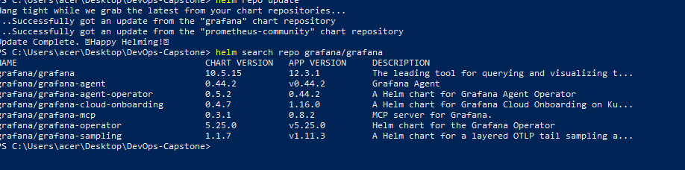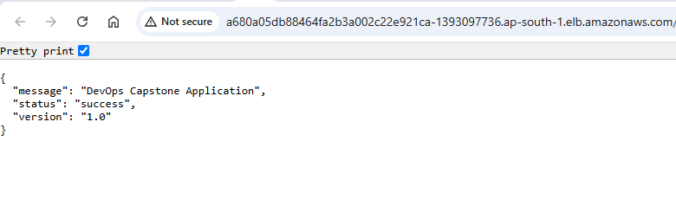

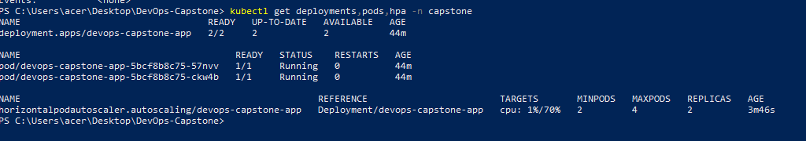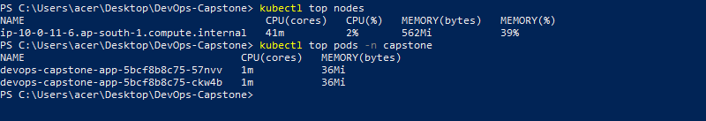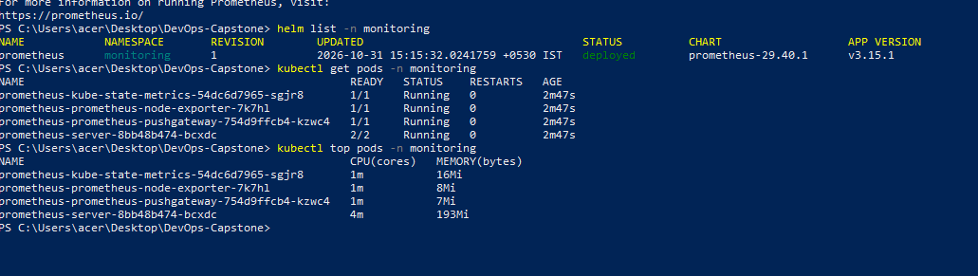
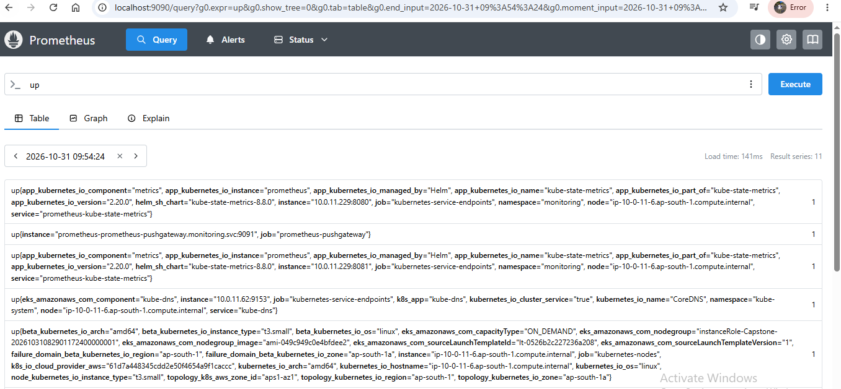

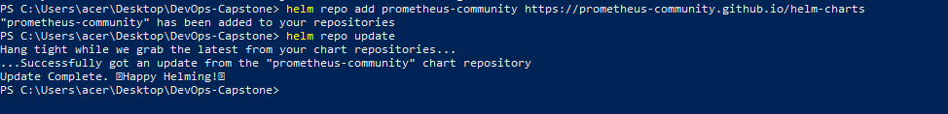

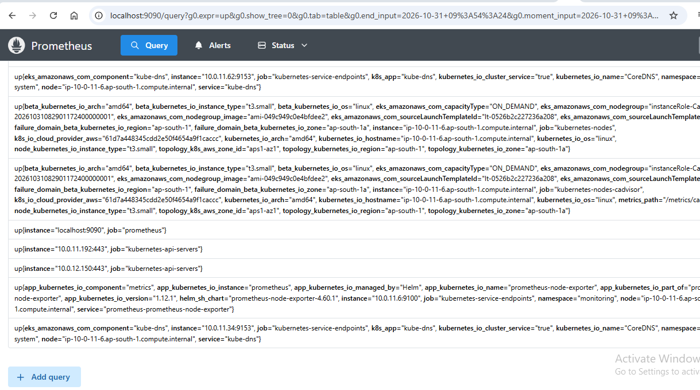
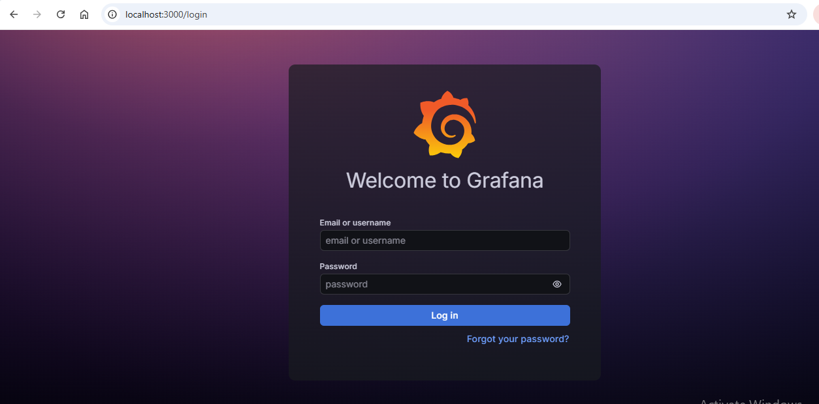

Now Log in to Grafana
Verify the Prometheus data source:
After login:
- Open Connections in the left menu.
- Select Data sources.
- Look for Prometheus.
- Open it and verify the URL is:

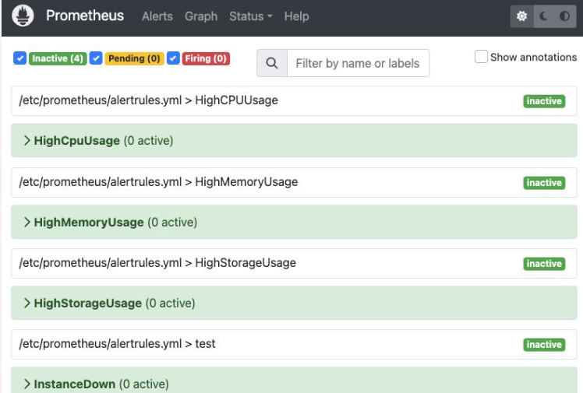

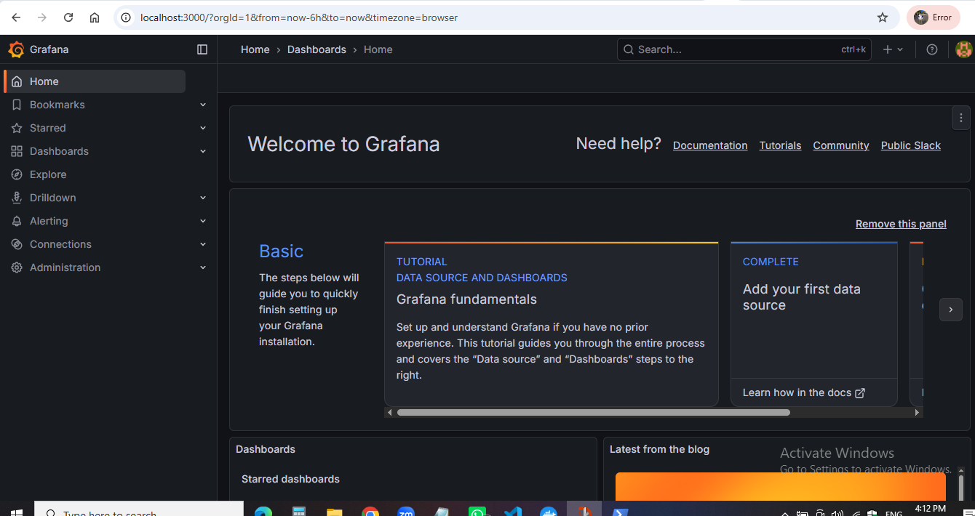

“Successfully queried the Prometheus API.”
This means:
- Prometheus is running in your EKS cluster.
- Grafana can communicate with Prometheus.
- Your monitoring data source is configured correctly.

Create application test cases :
Open application/tests/
Create file : - test_application.py
Install pytest
Execute test cases

Validate Terraform infrastructure –
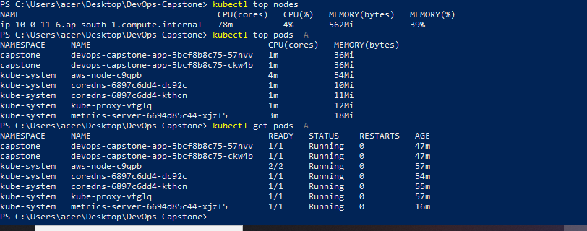

Terraform Destroy :
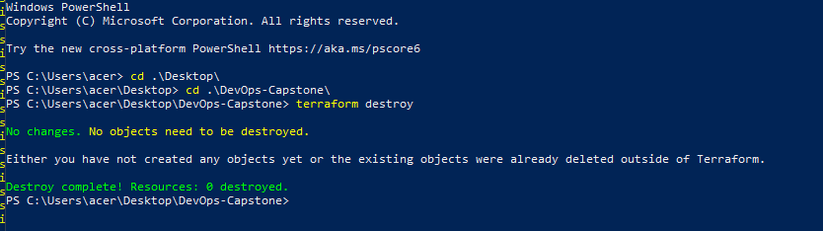

Final submission progress
Prometheus installed successfully
Grafana installed and accessible
Kubernetes metrics visible in Grafana
Application metrics available in Prometheus
ServiceMonitor target UP
Prometheus alert rules configured
Alertmanager notification tested
Jenkins success/failure notifications tested
Application unit tests passing
Docker image build successful
ECR image push successful
Kubernetes deployment successful
Application health endpoint responding
GitHub automatic trigger working
Jenkins complete pipeline successful
Terraform validation completed
Ansible configuration verified
Sprint 1–6 screenshots collected
README.md completed
Final project report completed
GitHub repository updated

Final project report structure
project-report.md should contain:
- Cover page.
- Project introduction.
- Problem statement.
- Project objectives.
- Technology stack.
- Architecture diagram.
- AWS infrastructure setup.
- Terraform implementation.
- Ansible configuration.
- Docker and ECR implementation.
- Jenkins CI/CD pipeline.
- Kubernetes deployment.
- Prometheus monitoring.
- Grafana dashboards.
- Alertmanager configuration.
- Testing and validation.
- Screenshots and evidence.
- Challenges and troubleshooting.
- Project outcome.
- Conclusion and future enhancements.

