Name : Vishnu Ram
Github : https://github.com/Vishnu250188/Microservices-Task.git

Microservices with Docker & Docker Compose

Step 1
Fork and clone the GitHub repository to the local machine.
Screenshot:
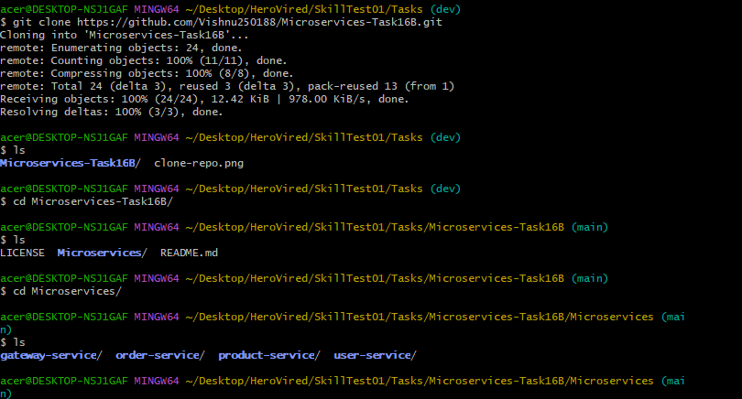

Step 2
Verify project structure contains user-service, product-service, product-service, order-service, gateway-service.

Step 3
Create Dockerfile in user-service using node:18-alpine, WORKDIR, COPY, RUN npm install, EXPOSE 3000, CMD ["npm","app.js"].
Screenshot:
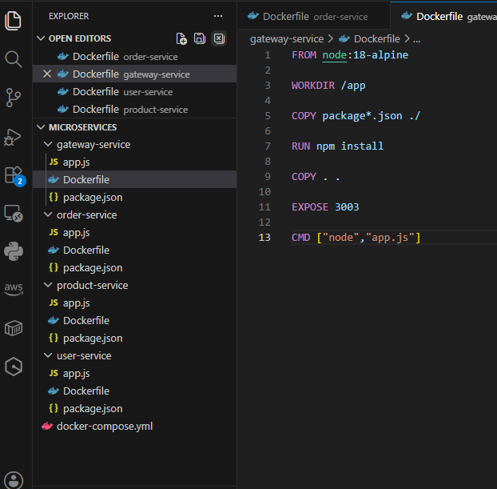

Step 4
Create docker-compose.yml in project root. Define all four services, bridge network and port mappings.
Screenshot
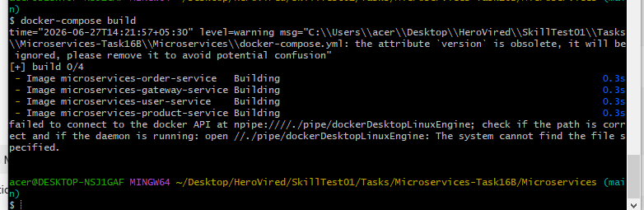
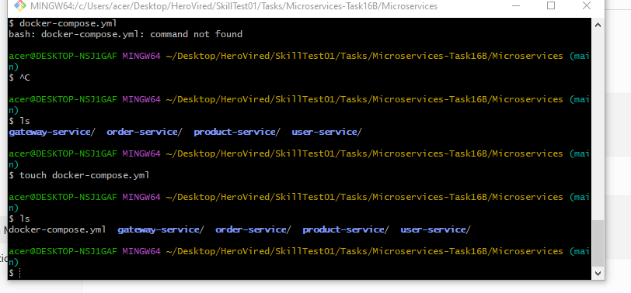
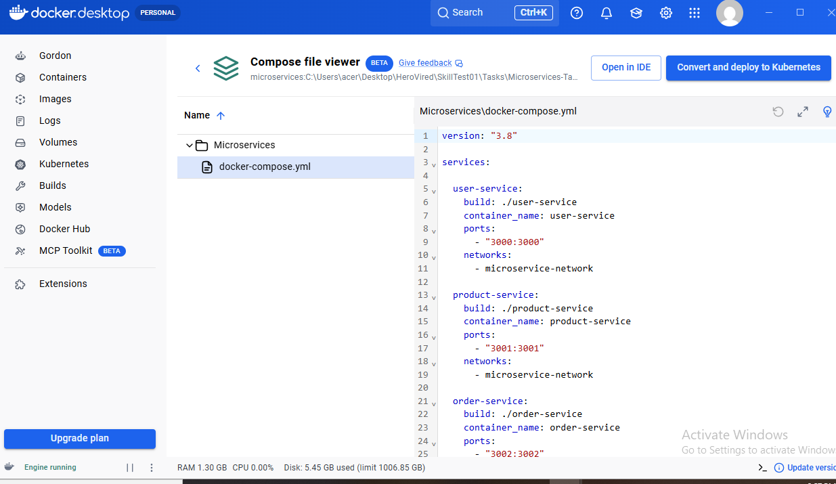

Step 8
Build images using: docker compose build --no-cache
Screenshot:
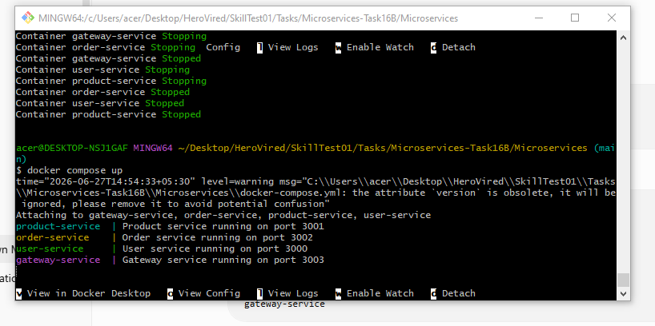
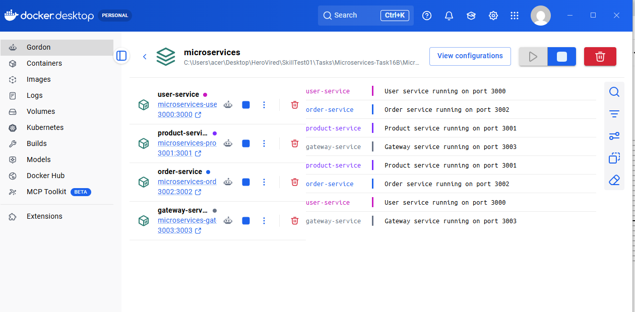

Step 9
Run containers using: docker compose up.Capture screenshots for docker build, docker compose up, docker ps and browser output. Insert your screenshots below each step in this document.
Screenshot:
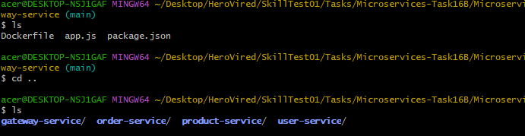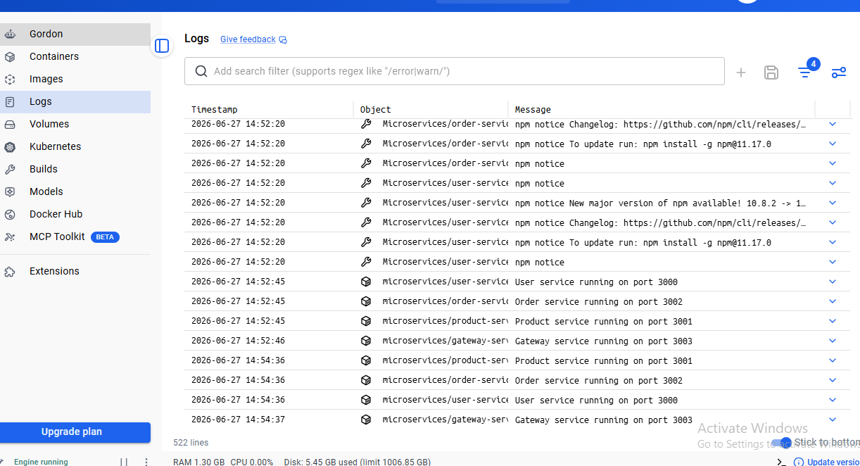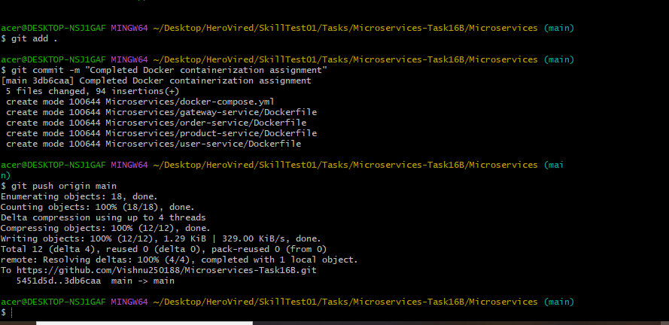

Step 10
Commit and push changes to GitHub fork.
Screenshot:

Due to less time, not able to create proper document but all the functionality according to Test, I have completed and successfully run and attached all the screenshots.

Thank you Herovired Team for your guidance.

