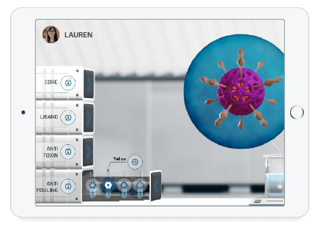

**ADAPTIVE COURSEWARE**

## Personalize their learning

Make your courseware adaptive to better support at-risk students, motivate high achievers and maximize each student's potential. The same benefits of a private lesson, but at unlimited scale across students, time, and location.

**[HOW ADAPTIVITY WORKS](https://www.smartsparrow.com/adaptivity/)**

**[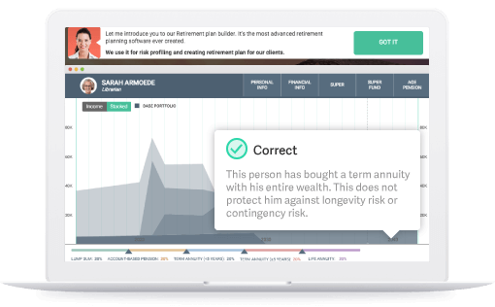](https://www.smartsparrow.com/adaptivity/)**

**LEARNER ANALYTICS**

## Continuously improve

Use powerful and real-time analytics to understand your students’ learning. You can zero in on common mistakes and misconceptions and continuously improve your instruction by adapting to your students' learning needs.

[**FIND OUT HOW**](https://www.smartsparrow.com/demos/introductory-chemistry/)