1. What is API?
2. What is Webservice? Api available over internet (why we need, Examples)
3. API testing types?

1. Types of webservices? SOAP, REST, RPC(remote procedure call) JSON/XML
2. What is SOAP?
3. What is REST?
4. REST vs SOAP?

1. CRUD?
2. JSON? JSON is lightweight and easy to transfer

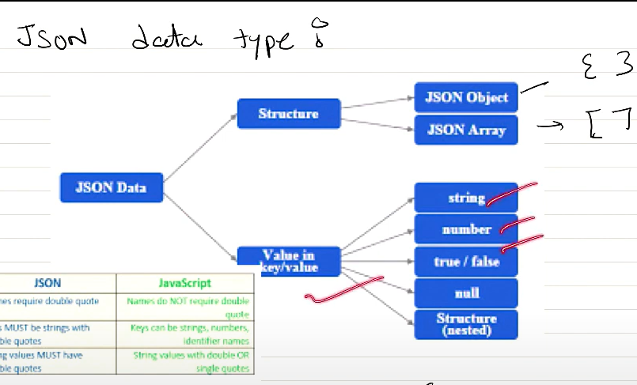

1. What is HTTP?
2. POCO (Plain Old CLR Object) use?

1. Tools for API testing?
2. HTTP Status codes
3. HTTP Methods
4. JSON Schema Validation

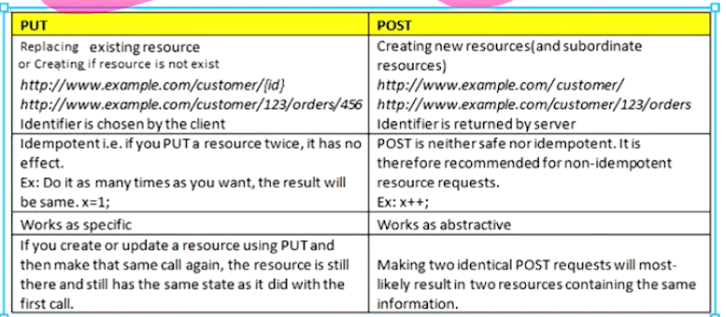

Put vs patch

1. Bugs in API testing

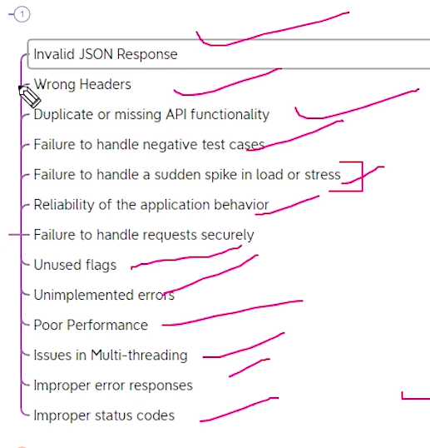

"Preemptive" authorization refers to the client sending the authorization credentials (such as a username and password) without waiting for the server to explicitly demand it. This is contrasted with "challenged" authorization,

