**OPD Management System**

Database Information:

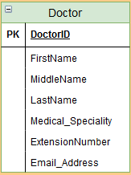

CREATE TABLE Doctors (

DoctorID INT NOT NULL AUTO_INCREMENT PRIMARY KEY,

FirstName VARCHAR(100) NOT NULL,

MiddleName VARCHAR(100),

LastName VARCHAR(100) NOT NULL,

MedicalSpeciality VARCHAR(100) NOT NULL,

ExtensionNumber VARCHAR(30),

EmailAddress VARCHAR(50)

);

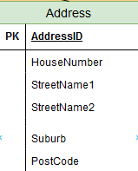

CREATE TABLE Address (

AddressID INT NOT NULL PRIMARY KEY AUTO_INCREMENT,

HouseNumber INT,

StreetName1 VARCHAR(100) NOT NULL,

StreetName2 VARCHAR(100) NOT NULL,

Suburb VARCHAR(50),

PostCode INT

);

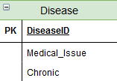

CREATE TABLE Diseases(

DiseaseID INT NOT NULL PRIMARY KEY AUTO_INCREMENT,

MedicalIssue VARCHAR(100) NOT NULL,

Chronic BOOL

);

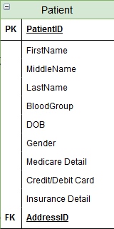

CREATE TABLE Patients (

PatientID INT NOT NULL PRIMARY KEY AUTO_INCREMENT,

FirstName VARCHAR(100) NOT NULL,

MiddleName VARCHAR(100),

LastName VARCHAR(100) NOT NULL,

AddressID INT NOT NULL,

BloodGroup VARCHAR(5),

Date_of_birth DATETIME NOT NULL,

Gender VARCHAR(10) NOT NULL,

CreditCardDetails VARCHAR(16),

InsuranceDetail VARCHAR(20),

FOREIGN KEY FK_AddressID(addressID)

REFERENCES Address(addressID)

);

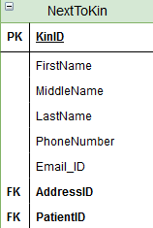

--PatientID INT NOT NULL,

--FOREIGN KEY PatientID(PatientID)

--REFERENCES Patient(PatientID)

CREATE TABLE NextToKins(

KinID INT NOT NULL PRIMARY KEY AUTO_INCREMENT,

FirstName VARCHAR(100) NOT NULL,

MiddleName VARCHAR(100),

LastName VARCHAR(100) NOT NULL,

AddressID INT NOT NULL,

PatientID INT NOT NULL,

PhoneNumber VARCHAR(20),

EmailID VARCHAR(100),

FOREIGN KEY AddressID(AddressID) REFERENCES Address(AddressID),

FOREIGN KEY PatientID(PatientID) REFERENCES Patients(PatientID)

);

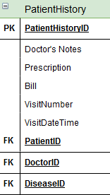

CREATE TABLE PatientHistory(

PatientHistoryID INT NOT NULL PRIMARY KEY AUTO_INCREMENT,

Prescription VARCHAR(500),

Bill DECIMAL(13, 2) NOT NULL,

PatientID INT NOT NULL,

DoctorID INT NOT NULL,

DiseaseID INT NOT NULL,

VisitNumber INT,

VisitDateTime DATETIME,

FOREIGN KEY FK_PatientID(PatientID) REFERENCES Patients(PatientID),

FOREIGN KEY FK_DoctorID(DoctorID) REFERENCES Doctors(DoctorID),

FOREIGN KEY FK_DiseaseID(DiseaseID) REFERENCES Diseases(DiseaseID)

);