IoT Smart Washroom Hygiene System

Hardware Setup & Pin-to-Pin Connection Documentation

1. System Overview
This document describes the complete hardware setup of the IoT-based Smart Washroom Hygiene System using XIAO ESP32-C6, MQ-136, MQ-137, and CCS811 sensors. It includes pin-to-pin wiring details, operating voltages, power requirements, and electrical considerations.

2. Components Used
1. XIAO ESP32-C6 Microcontroller
2. MQ-136 Gas Sensor (H2S detection)
3. MQ-137 Gas Sensor (NH3 detection)
4. CCS811 Air Quality Sensor (VOC & eCO2)
5. TP4056 Li-ion Charging Module
6. Li-ion Battery (Recommended: 2000–2500 mAh for 1-week backup)

3. Operating Voltages & Electrical Specifications
Component | Operating Voltage | Typical Current | Notes
XIAO ESP32-C6 | 3.3V | 80–120 mA (WiFi active) | Deep sleep ~20 µA
MQ-136 | 5V | ~150 mA (heater) | Analog output 0–5V
MQ-137 | 5V | ~150 mA (heater) | Analog output 0–5V
CCS811 | 3.3V | ~20 mA active | I2C communication

4. Pin-to-Pin Wiring Connections
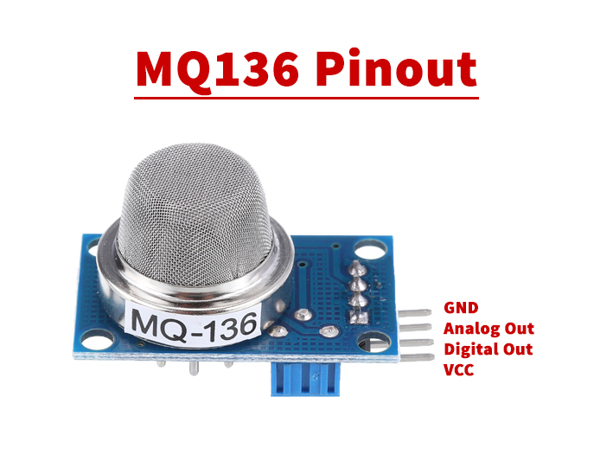

4.1 MQ-136 Connection
MQ-136 Pin | Connected To (XIAO ESP32-C6) | Description
VCC | 5V | Heater power supply
GND | GND | Common ground
AO | D0 (GPIO0) | Analog gas signal input
DO | Not Connected | Digital output not used

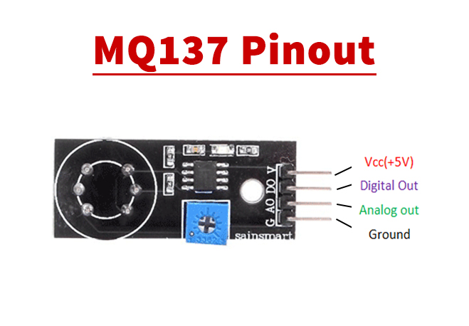

4.2 MQ-137 Connection
MQ-137 Pin | Connected To (XIAO ESP32-C6) | Description
VCC | 5V | Heater power supply
GND | GND | Common ground
AO | D1 (GPIO1) | Analog gas signal input
DO | Not Connected | Digital output not used
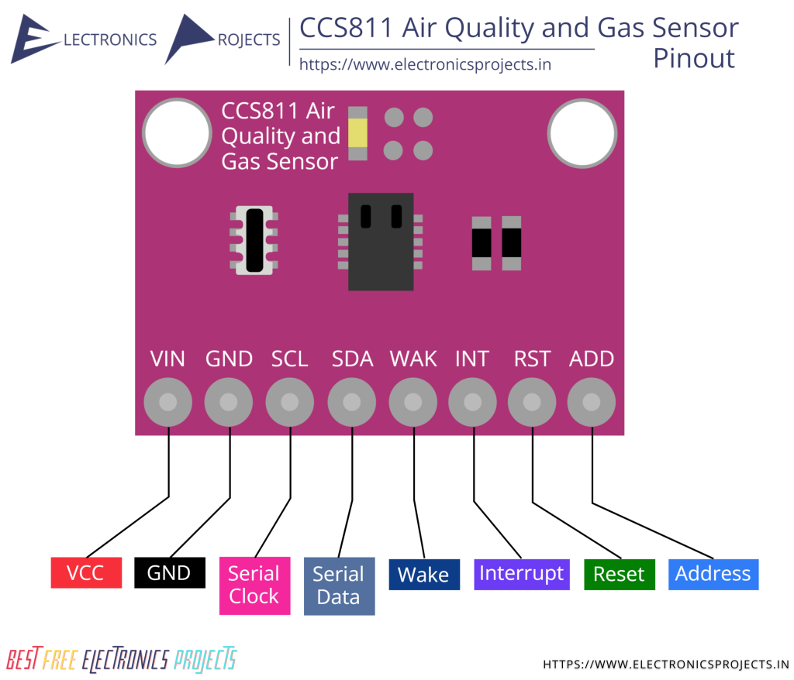

4.3 CCS811 Connection (I2C)
CCS811 Pin | Connected To (XIAO ESP32-C6) | Description
VCC / 3V3 | 3V3 | Power supply
GND | GND | Common ground
SDA | D6 (GPIO6) | I2C Data line
SCL | D7 (GPIO7) | I2C Clock line
WAKE | GND | Keep sensor active

5. Power System Configuration
TP4056 Pin | Connected To | Purpose
B+ | Battery + | Battery charging input
B- | Battery - | Battery ground
OUT+ | 5V (XIAO) | System power output
OUT- | GND (XIAO) | System ground

6. Important Electrical Considerations
• All GND connections must be common.
• MQ sensor analog outputs may reach 5V; ensure ADC protection if required.
• Recommended battery capacity for 1-week operation (2-hour interval reading): 2000–2500 mAh.
• Use deep sleep mode between readings for power optimization.

POWER MANAGEMENT
1. XIAO ESP32-C6
Parameter | Value
Operating Voltage | 3.3V
WiFi Active Current | 80–120 mA
CPU Active (no WiFi) | 40–60 mA
Light Sleep | ~2–5 mA
Deep Sleep | 15–25 µA

2. MQ-136

Parameter | Value
Heater Voltage | 5V
Heater Current | ~150 mA
Power | ~0.75 W
Output Voltage | 0–5V Analog

3. MQ-137

Same as MQ-136:
| Heater Voltage | 5V |
| Heater Current | ~150 mA |
| Power | ~0.75 W |
Total MQ heater current:
🔥 300 mA @ 5V
🔥 1.5W combined

4. CCS811
Parameter | Value
Operating Voltage | 3.3V
Active Current | ~15–20 mA
Idle Mode | ~1 mA

BASELINE TOTAL POWER (No Sleep)
Continuous Operation
Component | Current
ESP32 WiFi avg | 80 mA
MQ-136 | 150 mA
MQ-137 | 150 mA
CCS811 | 20 mA
Total ≈ 400 mA

🔋 Weekly Requirement (No Sleep)
400 mA × 168 hours = 67,200 mAh
❌ Requires ~67 Ah battery
❌ Completely impractical

💤 2️⃣ Scenario A — Sleep Every 10 Minutes
Assumptions
- Wake time = 2 minutes
- Sleep time = 8 minutes
- Total cycle = 10 minutes
- 6 cycles per hour
- 144 cycles per day
- 1008 cycles per week

🔹 Active Period Current
~400 mA
Duration = 2 min = 0.033 hr
Energy per cycle:
400 × 0.033 = 13.2 mAh

🔹 Weekly Active Consumption
13.2 × 1008 cycles = 13,305 mAh

🔹 Deep Sleep Consumption
ESP32 deep sleep = 0.02 mA
Sleep time per cycle = 8 min
Total sleep hours per week:
(8/60) × 1008 = 134.4 hours
Energy:
0.02 × 134.4 ≈ 2.7 mAh
Negligible.

✅ Total Weekly Requirement (10-minute interval)
≈ 13,305 mAh
Add 20% overhead:
🔋 ~16,000 mAh required

💤 3️⃣ Scenario B — Sleep Every 2 Hours
Assumptions
- Wake time = 2 minutes
- Sleep time = 118 minutes
- 12 cycles per day
- 84 cycles per week

🔹 Energy Per Cycle
Same as before:
400 mA × 0.033 hr = 13.2 mAh

🔹 Weekly Active Consumption
13.2 × 84 = 1108.8 mAh

🔹 Deep Sleep Energy
Sleep hours per week:
(118/60) × 84 = 165.2 hours
Energy:
0.02 × 165.2 ≈ 3.3 mAh
Negligible.

✅ Total Weekly Requirement (2-hour interval)
≈ 1112 mAh
Add 20% safety:
🔋 ~1350–1500 mAh required

📊 Final Comparison Table
Scenario | Weekly Consumption | Recommended Battery
No Sleep | ~67,000 mAh | Not feasible
10-min interval | ~13,300 mAh | 16,000 mAh
2-hour interval | ~1,100 mAh | 1,500–2,000 mAh

⚠️ Critical Engineering Insight
The system is NOT ESP32 limited.
It is:
🔥 MQ heater limited.
90–95% of power is consumed by MQ sensors.

🧠 Additional Practical Considerations
- MQ sensors require warm-up time.
- Frequent heater cycling may reduce accuracy.
- Cold environments increase heater stabilization time.
- Battery regulator efficiency impacts total capacity.

