Investigations on Multi Disease Prediction Framework for Dairy Cows Using Time Series Behavioural Analytics

Vishnu Bhuvanachandran Nair Rajeswari Amma
Department of Computing Science and Mathematics
School of Informatics and Creative Arts
Dundalk Institute of Technology

Supervised By: Dr. Zohaib Ijaz

This dissertation is submitted in part fulfillment of the Master of Science in Data Analytics
September 2025

Declaration of Authorship
I hereby certify that this material, which I now submit for assessment on the Master of Science in Data Analytics programme of study is entirely my own work, and that I have exercised reasonable care ensure that the work is original, and does not to the best of my knowledge breach any law of copyright, and has not been taken from the work of others save and to the extent that such work has been cited and acknowledged within the text of my work.

Signature: 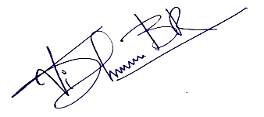

Name: Vishnu Bhuvanachandran Nair Rajeswari Amma
Date: 31.08.2025

Acknowledgements
All access and data used for this project was publicly available from the French National Research Institute for Agriculture, Food and Environment website and no fees were charged for the same. The data collected from this product tracker is strictly for non-commercial purposes. I would like to thank the head of the Department of Computing Science and Mathematics, Dr. Fiona Lawless, for supporting us towards the work. I would especially like to thank Dr. Zohaib Ijaz, the Assistant Lecturer of Data Analytics program in Dundalk Institute of Technology. As my lecturer and supervisor, he has taught me more than I could ever give him credit for here. He has shown me, by his example, what a good scientist (and person) should be. I am grateful to all of the lectures from the Data Analytics program, Dr. Jack McDonnell, Dr. Peadar Grant, Dr. Anesu Nyabadza, whom provided me extensive professional knowledge and taught me a great deal about data science skills during lectures, laboratories and projects. I would like to thank Dr. Abhishek Kaushik, Programme Director of M Sc, Data Analytics programme of DKIT for all the support and mentorship during the entire course. This work is self-funded, and I would like to thank Dundalk Institute of Technology (DkIT) for facilitate the MSc in Data Analytics program that has helped me to work on this project.

Abstract
The current day agriculture faces a huge task regarding livestock disease prediction for the unrecognized, hidden health issues in dairy cows tend to decrease the productivity, animal welfare problems, obvious economic losses. The complete lack of veterinary expertise nearby and the recording of a higher incidence of the disease on remote farms makes it nearly impractical to diagnose this disease with traditional diagnostics. Specifically, we presented an automatic data-driven herd-level multi-disease prediction framework on dairy cows using the time-series behavioural records in this work. It utilizes various machine learning and deep learning models including Random Forest, LightGBM, TabNet, MLP, LSTM, TCN and Hybrid to classify the disease conditions such as mastitis, lameness, oestrus and calving. Oversampling methods (ADASYN 5–25%) are applied to examine and investigate the imbalance and bias in such realistic datasets. We show results from varied experiments which show Random Forests consistently outperforming all other models with oversampling, showing an impressive results for F1 score in the range of 0.80 to 0.90. The hybrid ensemble models also performed for the rarest events giving an impressive result for F1 score accounting to 0.87 showing the power of interpretable ensemble methods in imbalance settings . The research says complex algorithms turning into data analytics early-warning systems for agriculture then further supports animal health and management for farmers.

Table of Contents
Declaration of Authorship i
Acknowledgements ii
Abstract iii
Chapter 1. Introduction 1
1.1 Background 1
1.2 Problem Definition 2
1.3 Research Questions 2
1.4 Relevance in Data Analytics 2
1.5 Overview of Methodology 3
Chapter 2. Literature Review 5
2.1 Introduction 5
2.2 Prior Work in Cattle Disease Prediction 5
2.3 Multi-Label and Multi-Output Prediction 5
2.4 Imbalance, Bias, and Oversampling 6
2.5 Temporal Modelling and Sequential Dependencies 7
2.6 Comparative Modeling Approaches 7
2.7 Evaluation Metrics in Imbalanced Settings 8
2.8 Research Gaps 8
Chapter 3. Materials and Methods 10
3.1 The Dataset 10
3.2 Methodology 11
3.2.1 Data Wrangling 11
3.2.2 Imbalance and Bias Study 11
3.2.3 Sampling Techniques 12
3.2.4 Modelling Techniques 12
3.2.5 Selection of Models 14
3.2.6 Calibration, Thresholding, and Deployment 15
Chapter 4. Results and Discussion 18
4.1 Exploratory Data Analysis 18
4.2 Imbalance and Biasness 25
4.3 Oversampling using ADASYN 27
4.4 Feature Engineering 27
4.5 Calibration and Thresholding 29
4.6 Performance of Models on Oversampling 29
4.6.1 Oestrus 29
4.6.2 Lameness 31
4.6.3 Mastitis 32
4.6.4 Calving 33
4.7 Deployment of the Model 36
5 Conclusions and Future Work 39
References 41
Appendices 44
Appendix A 44
Appendix B 54
Appendix C 55
Appendix D 64
Appendix E 65

List of Figures
Fig. 3.1. Methodology 13
Fig. 3.2. Calibration and Thresholding 17
Fig. 4.1. Count of activity level in the dataset 18
Fig. 4.2. Count of health and related factors 19
Fig. 4.3. Pair plot on features in the dataset 20
Fig. 4.4. Disease prevalence across the dataset 21
Fig. 4.5. Histogram distribution of features (a–d) 22
Fig. 4.6. Box plots of features vs targets 24
Fig. 4.7. Mean daily behavioural characteristics 24
Fig. 4.8. Count of disease presence by hour bin 25
Fig. 4.9. Disease distribution by disturbance factor 26
Fig. 4.10. Metrics comparison for Oestrus case 31
Fig. 4.11. Metric variation for Lameness case 32
Fig. 4.12. Metric variation for Mastitis case 34
Fig. 4.13. Metric variation for Calving case 35
Fig. 4.14. Input section of dashboard 37
Fig. 4.15. Disease prediction output page 37
Fig. 4.16. Metrics display in deployment 38

List of Tables
Table 3.1. Features of the dataset 10
Table 3.2. Count of disease conditions 11
Table 3.3. Comparison of models used in study 14
Table 3.4. Hyperparameter tuning and cross validation 15
Table 3.5. Calibration and thresholding methods 16
Table 4.1. Disease conditions (8-hour bins) 20
Table 4.2. Statistical summary of dataset 21
Table 4.3. Standardised differences (Cohen’s d) 23
Table 4.4. Feature engineering steps 27
Table 4.5. Calibration & threshold for mastitis case 29
Table 4.6. Metrics for Oestrus 29
Table 4.7. Metrics for Lameness 30
Table 4.8. Metrics for Mastitis 32
Table 4.9. Metrics for Calving 33
Table 4.10. Selected models for prediction 35

List of Abbreviations
ADASYN – Adaptive Synthetic Sampling
AUC – Area Under Curve
DKIT – Dundalk Institute of Technology
F1-Score – Harmonic mean of Precision and Recall
FN – False Negative
FP – False Positive
Light GBM – Light Gradient Boosting Machine
LSTM – Long Short-Term Memory
MLP – Multi-Layer Perceptron
RF – Random Forest
SMOTE – Synthetic Minority Oversampling Technique
SMOTEEN – SMOTE + Edited Nearest Neighbours
TCN – Temporal Convolutional Network
TN – True Negative
TP – True Positive

Chapter 1
Introduction
  - Background
Agriculture is the economic backbone of the country, the source of food security, and the pillar of the GDP. Milk and milk products together provide milk but dairy farming is of strategic importance in this sector for the livelihood it provides to millions of rural households. In contrast, on much of the globe, such as Europe, milk is a large proportion of the industry value as it constitutes one-sixth (16%) of total agriculture output. However, economic sustainability in dairy farming is constantly threatened by diseases that affect cattle, such as mastitis, lameness, reproduction problems related to oestrus and calving difficulties (krishikosh 2025). They also result in fewer fertility rates as well as higher culling & death during the long run. Therefore, disease diagnosis targets at the very early stage of its development are not only a problem with health in farm animals; it is critical to the economic viability and sustainability of dairy production, as well. Discussion Diagnosis of cattle diseases has historically depended on veterinary examination and farmer observations. However, these traditional approaches have structural constraints, especially in geographically widespread and rural farming communities. Veterinary experts are usually out of reach, while farmers are not always adequately trained to recognize early incipient symptoms. So, diseases get worse without anyone noticing until they are really bad, which makes treatment more expensive and less effective. This situation shows how important it is to have systematic, automated, and scalable diagnostic systems that can give early warnings quickly (Hogeveen, Steeneveld & Wolf 2019).
Wearable sensors and devices that track behavior can collect huge amounts of time-series data, which is changing the way we study cattle. The sensors don't just keep track of behavior; they only give them activity data for a few minutes at a time, like when they eat, rest, or move. Changes in giraffe diet are similar to changes in nutrition stress and shifts, especially in savannah ecosystems. These are inevitable features in any living organisms as these features such as beahvioural changes like time for eating, lying, grazing etc, could point out insights o the diseases especially in dairy cows. The problems associated with this data are their minute variations with respect to time and situations which naked eye cannot perceive. But this can be perceived by an algorithm especially neural network algorithm. However, the making these mixed , vague data into meaningful data is the tedious task associated with the ML engineers. Following to this the imbalance and biasness associated with the data further adds to the difficulty in the modelling. To summarise, the setting of this project is at the intersection of agriculture, data analysis and AI. This work aims to offer a novel large scale, interpretable and practical framework for farmers and veterinarians, through solutions to the interdependent challenges of imbalance, bias, oversampling, and temporal dependencies. Further, the methods we enclose such as multioutput learning, adaptive oversampling and temporal modelling have wider implications beyond the agriculture domain by offering useful insights to any domain in which imbalanced and temporally correlated data cripple predictive analytics (Hyde et al. 2020).
1.2 Problem Definition
This research mainly addresses the problem of multi-disease prediction in cattle, where the precise prediction of multiple cattle diseases in concurrent way using sensor-driven behavioural data has not been pursued to-date. There are three main challenges that make this harder:
- Unbalanced datasets: Disease instances are heavily outweighed by healthy instances, so classifiers become skewed toward identifying the "no-disease" state.
- Data distribution bias: Breed-specific, farm-specific, or environmental biases decrease the applicability of most models.
- Temporal habits: Time dependent analysis is an inevitable part as the disease appear gradually over time rather than sudden appearance which have underlying temporal pattern
- The time split was taken for two purpose in order to stream line the data with less noise and reduce the model working time.
- To fix the imbalance, ADASYN oversampling was carried out at different levels (5%, 10%, 15%, 20%, and 25%). These oversampled models are subjected to various modelling approaches to check its effectiveness.

  - Research Questions

- How good are multi-output models in simultaneously predicting multiple cattle diseases from biased and imbalanced behavioural data?
- How much does oversampling with ADASYN help in enhancing the prediction performance, particularly for minority classes?
- Can time-dependent models like LSTM and TCN perform better than standard classifiers in identifying temporal patterns of disease occurrence?
- Which of the metrics best fairly compares the models trained under imbalance? (In this research, F1-score was selected to balance precision and recall.)
1.4 Relevance in Data Analytics
This current investigation is relevant real scenarios in the agricultural contexts where majority contributes to a higher concentration resulting in the imbalance and biasness. In addition to the above, the difficulty associated with the incomplete data further adds to the complexity of the modelling. Cattle disease prediction is one of the cases in the agriculture which is very prominent which needs high attention at the same time. For instance, in medicine, predictive models for rare illnesses must deal with data distributions that are very biased toward healthy samples, like in cow health data (transfer learning). ADASYN oversampling and similar methods have been widely assessed in clinical analytics for increased minority class sensitivity without excessive false positive inflation. In the emerging data analytics stream with very high prediction potentials, the prediction of rare diseases especially in cattles can be carried out easily by extending the potential of ML. Bias From Perspective: Why Machine Learning Models Are Always Limited to the Context of Their Learning. Similar to cattle disease models that are trained on a certain type of cow or a single farm but fail to generalize to other populations during testing, biased sample-trained models in credit scoring or fraud detection may inadequately generalize to new individual populations. In this current investigation. The bias and imbalanced are also handled with respect to conventional and oversampled models which in turn evade the effect of synthetic habit of the data. This kind of evaluation assists one to utilize analytics for it renders the system simpler to grasp as well as inspect.
An additional construct is temporal data analytics which capitalizes on patterns altering across time. To discern patterns within data, time-series analysis constitutes a necessity. The facts must arrive to allow for this assessment. This is helpful to forecasts regarding matters like energy consumption, for monitoring volcanic activity, and even the weather. Equally, manifestations regarding bovine wellness do not materialize instantaneously. Rather, they evolve incrementally amid daily cycles of activity. Fundamental configurations prove difficult for discernment via typical calculation methods consequently. This integrates temporal dimensions within disease modeling via categorizing behavioral data within 0, 8, 9, 16, then 17, 24 hour temporal intervals. Attaining equilibrium between ephemeral trends as well as enduring dependencies is realized via employing architectures like LSTM and Temporal Convolutional Networks (TCN) to render this endeavor state-of-the-art in time-series analytics. The F1-score equates precision with recall concurrently, revealing to modern analytics the current project's importance. It represents the harmonic average concerning precision and recall, which balances both of them at the same time.
This is consistent with a broader trend towards data analytics-based decision-support systems. The multi-disease prediction system described here seeks to give useful information to farmers, akin to how predictive analytics is being used in the medical triage, fraud detection, climate risk management, etc. By comparing Random Forest, LightGBM, TabNet, MLP, LSTM, TCN, and hybrid ensembles, it can be sure that the system is not only correct, but also scalable and easy to understand. The study demonstrates the extent to which data analytics can connect unprocessed sensor data to actionable insights that can transform cattle farming into a more sustainable, technology-driven enterprise.
1.5 Overview of Methodology
In order to handle the complexity of modeling multiple diseases in dairy cows from large behavioral datasets, this project employed a novel methodology. The core of the strategy is a public dataset on dairy cows from France that contains over 2 million time series from 386 cows. In addition to health event labels for mastitis, lameness, oestrus, and calving, it includes a thorough behavioral profiling of the animals' eating, resting, and movement patterns. In order to ensure appropriate temporal habit recording, they could also complete the dataset during three different time of day observation windows [0–8, 9–16, and 17–24 hours]. This type of segmentation gives predictions more temporal resolution, which lets the analysis see how cattle activities change over time and how they are related to the start of disease. Before putting the data into a model, it had to be preprocessed. These steps were necessary to get the dataset ready for training. First, the missing values were filled in correctly and the features were handled correctly. This way, features that didn't make sense for the main prediction, like lipopolysaccharide values or an overall "OK" status, were also removed to cut down on noise. Trimming the dataset down to only include the most important health and behaviour measures ensured our models focused on significant trends, not just irrelevant variables.
A frequent problem with the participants in this dataset is extreme class imbalance: healthy conditions are much more frequent than any diseased state classes like mastitis have fewer than 1,100 positives out of millions. Unless remediated, imbalance results in all models predicting "healthy" nearly all the time, ineffective sensitivity for the less frequent but more critical, diseased conditions. Therefore, this experiment used ADASYN (Adaptive synthetic sampling), an oversampling technique that outputs synthetic samples for the minority class by diverting the potential on more challenging samples at the decision boundaries (Haibo He et al. 2008). Oversampling occurred at 5% increments (5% through 25%) to test the incremental impact on prediction results. The incremental approach not only benefits performance gains down the road but also teaches oversampling more easily relative to other models.
After preprocessing and imbalance adjustment, machine learning and deep learning modelling was performed with the following models chosen for their strengths which complement each other. Random Forest (RF) and LightGBM are standard ensemble approaches that are interpretable and effective with hybrid data types. TabNet and Multi-Layer Perceptrons (MLP) are more complex deep learning models that can learn non-linear interactions between features. For time-series features, TCN (Temporal Convolutional Networks) and LSTM (Long Short-Term Memory) networks were used to demonstrate the importance of sequential patterns of actions leading to disease progression. In addition to the above, the efficiency of the hybrid ensembled models combining the good performer models were also checked whether they were capable to pick up the underlying patterns.
The main way to measure how well the model worked was the F1-score. The F1-score, by contrast, weighs precision (number of positive examples) and recall (number of all actual positive examples) equally. This differs from accuracy, which can be misleading when working with extremely unbalanced data. This choice as a measure guarantees the performance of a model is properly and realistically measured, especially when working with rare diseases, where false negatives will have profound financial and social consequences. We also added secondary measures like confusion matrices and class-wise recalls to help explain how the model works in different situations. Then, the same models were retrained on datasets that were even more oversampled (5–25% ADASYN) to see how much better they were at finding the minority class. From the comparison of the conventional tree based models, neural networks and hybrid models, it was observed that the tree based model out performed all others. However, on higher oversampling rates, ensembled hybrid models also captured fruitful patterns for rare cases such as mastitis.
The methodology for the current investigation was discussed in detail in the subsequent sections. Overall, the methodology consists of systematic preprocessing of data , followed by imbalance handling which in turn was subjected to modelling techniques. The approach of imbalance handling by calibration and thresholding adds to the yet another highlight of the work. Finally, the results aim to effectively diagnose the cattle disease with utmost efficiency which is deployed for the easy access of farmers.

Chapter 2
Literature Review
2.1 Introduction
In the present research scenario, the emergence of precision agriculture has generated interest in research on disease prediction in dairy cattle. As farms transition to wearable sensors and automated monitoring systems: Huge amounts of behavioural and physiological data are being outsourced (Liseune et al. 2021). Yet learning from such data is tricky: the imbalanced, biased, and incomplete nature of this data make accurate disease prediction a difficult problem .This is the situation in agriculture, but a problem one also finds in other scientific situations for example the forecasting of volcanic eruptions on time-series data that is sufficiently noisy to mask weak signals as well. Just as volcanologists have integrated seismic and satellite data to enhance eruption predictions in Iceland and within the Pacific Ring of Fire, researchers on cattle health have recently run multi-output machine learning and deep learning methods that combine several behavioural metrics into a single prediction to forecast disease (Bita Ghasemkhani et al.) 2024).
2.2 Prior Work in Cattle Disease Prediction
Although early studies in cattle disease analytics were mainly based on statistical models or single-disease prediction frameworks. Hyde et al. However, for example, (Dmitry Yu. Pavkin et al. 2021) aimed to predict mastitis corrected imbalanced datasets by SMOTE oversampling yet noticed only modest improvements which pointed out that synthetic sampling alone could not solve deep bias in data. One attempt to introduce the Apriori algorithm in order to diagnose infectious diseases on the farms by animal clinicians (Ilayaraja & Meyyappan 2013), is however scarcely generalizable across herds. (van der Heide et al. 2020), tested ensemble regression showed enhanced prognostic risk assessment of cattle mortality, illustrating the power and utility of regression-based ensembles in filtering different ensemble approaches.
More recently, (van der Heide et al. 2020), then collated foundation datasets of more than 300 cattle to set the stage for improved machine learning inquiries. The results of their study showed that Random Forest classifiers performed well in reproductive event detection suggesting the use of ensemble methods for tabular agricultural data. Nonetheless, the static behaviour of data by which these models often worked did not model a flow characteristic or temporal trend of sequential behaviour that underlies most disease development. In their analysis of this limitation, they pointed out that the inability to model thermal features through time required for methods capable of capturing these dependencies.
2.3 Multi-Label and Multi-Output Prediction
Multi-label and multi-output classification have become crucial methods in predictive modelling where multiple results can occur concurrently. In contrast to conventional binary classifiers, where only one disease or event is centered at a time such multi-label frameworks test multiple conditions simultaneously (Meike van Leerdam et al. 2024). This is of particular relevance in dairy cattle where multiple health challenge levels may be present concurrently (i.e. reproductive disorders e.g. anoestrus, lameness or nutritional disorders). It also introduced the possibility to capture correlations between conditions, which would be missed when awake & asleep are treated as independent events.
This methodology is already proven in other fields. For example (Palma et al. 2025) aided with deep neural network to assume multi-label chronic disease of human beings, with better generalization than single-output models. The methods developed in (Hyde et al. 2020) reported the studies on protein subcellular localization with the help of feature extraction and dimensionality reduction. This method very easily improved the computations efficiency with accuracy. They show the ability of multilabel frameworks to utilize interdependencies between outcomes that do not exist in single-disease models.
However, multi-output models in agricultural analytics are underutilized but growing (Zhang et al. 2019) combined a larger collection of dairy cattle datasets into one to increase the number of health outcomes predicted, showing that predicting multiple diseases simultaneously is plausible. The imbalance associated with the data and their noise adds to the disadvantage of dealing with these type of data. ADASYN among other methods such as SMOTE, SMOTEEN etc is a proven method for dealing with the minority cases like this. Moreover, incorporating temporal models such as LSTM and TCN in a multi-output framework enables the system to forecast the progression of one disease condition into another.
Even though the multi-label and multi-output prediction approaches are efficient in various facets of health care systems, it still remains inactive to an extent in the case of livestock health (Wagner et al. 2020). This current investigation boosts the existing prediction framework by combining multiple health data of cattle which in turn results in a generalized model(Zhang et al. 2019).
2.4 Imbalance, Bias, and Oversampling
However, data imbalance is one of the most repeated problems in cattle disease prediction. Most of the data are from “normal” cases, where as positive disease cases (like mastitis, calving complications or lameness) are very rare. When the proportion of selected disease in datasets is less than 0.05%, however, the learning environment gives biased towards minority or majority class label and models tend to learn from only majority classes which leads to unbalanced accuracy. As a result, consequences of this imbalance are dire in terms that models seem right for most years, but nowhere or nearly as accurate to include minority species disease events in the crop-ipm management and ultimate to false security to the farmers.
In fact, this problem is recognized and many solutions have already been evaluated one of them being using oversampling methods like SMOTE or ADASYN. In this specific case, I want to point out ADASYN that focuses on generating synthetic samples near decision boundaries which results into a better classifier sensitivity only to minority cases by avoiding adding too much oversampling as it may cause introducing noise or lead to overfitting, and thus systematic testing of the levels of oversampling is required. There are limited studies on the comparison of oversampling intensity, and this study extends another one by giving a view on ADASYN with intensities of 5%, 10%, 15%, 20% and up to to see how much recall can be improved at which levels while maintaining model robustness (Haibo He et al. 2008).
2.5 Temporal Modelling and Sequential Dependencies
The majority of cattle disease studies prior to this investigation do not take behaviour evolution into account, instead involving static features. Lameness or reproductive disorders are slow to develop and evident in changes in action over hours and days. The move to looking at cattle activities in 3 different windows of the day (0–8, 9–16 and 17–24 relative hour) allows circadian rhythms to be preserved within long-term trends we can see from time periods but note changes over the course of a week.
In the same way, research on similar fields like LSTM (Long Short-Term Memory) networks and TCN (Temporal Convolutional Networks) has made these advanced time-series models even more useful (Hyde et al. 2020). An example in telemedicine that uses LSTM to keep track of a patient's symptoms over time, or in volcanology where recurrent neural networks are used to find tiny seismic precursors of upcoming eruptions (Liu et al. 2019). TCNs are a better choice for scaling because they use convolutions to model long-range dependencies and don't have the computational load of recurrent architectures. The practical application of these models for predicting cattle diseases represents a significant advancement that addresses temporal data deficiencies identified in prior research.
2.6 Comparative Modeling Approaches
Random Forest and LightGBM have been reliable traditional model since a long time. This is due to the fact that they provide the best interpretability and generalization in all predictions. However, newer models like TabNet and MLPs efficiently captures the underlying patterns which tree based models cannot handle especially non-linear feature interactions (Wiwik Anggraeni et al. 2013). Temporal models (LSTM, TCN) can unfold the temporal patterns which is another neural network model. But the requirement of higher computational cost adds to the con of the algorithm. A hybrid ensemble solution that uses tree-based and deep learning models, is being considered as a bright light revealing new promise of accuracy-interpretability-generalizability trade off. The project contains a comparison study among these models and located this work at the frontier both in application of big data model to livestock industry and engineering precision livestock analytics (Morota et al. 2018).
Apart from the evaluation of individual models, there is an increased interest in hybrid, ensemble and fusion frameworks that combine the respective strengths of more than one algorithm. For instance, in other domains such as healthcare and fraud detection marrying the interpretability of Random Forest with the representational capacity of deep neural networks has been demonstrated to enhance robustness towards data noise and imbalance (M. Priyadharshini et al. 2023). This hybrid setting can be beneficial in domain-specific applications for instance, machine learning applications often require a set of time-series and categorical data that the Tree model is ideally designed to address (dairy cattle disease prediction), along with good susceptibility to sequential type data which is why it might be better to use LSTM or TCN. A hybrid ensemble is advantageous, because it utilizes the benefits of both, so rates of accuracy and recall/pr were disembodied with better overall performance. This is consistent with what is required for application at the farm-level decision-making, where adoption by farmers and veterinarians will depend on both reliability and interpretability (Wagner et al. 2020).
2.7 Evaluation Metrics in Imbalanced Settings
The focus on accuracy support by prior research is another weak point. Although easily understood, accuracy does not do justice to the importance of false negatives in imbalanced datasets (i.e., models can achieve 95% accuracy by labelling everything as ‘healthy. Better evaluation would need precision, recall, and F1 score. This finding is relevant as the F1-score is important to balance both precision and recall, therefore avoiding diseases that are rare events to be non-reported or over-predicted. By changing our methodical focus from accuracy to F1 score, our project moves to a more acceptable level of missing rare events as is common in other high-risk industries like healthcare diagnostics and fraud detection (Divya & Jeba, 2024).
There is some added value in class-wise evaluation and confusion matrix analysis when dealing with highly imbalanced agricultural datasets, other than the F1-score. These methods help the researcher to determine if a model is biased because of its tendency to predict only majority and seldom any minority labels (mastitis, laminitis.). Structured performance metrics such as Area Under the Precision-Recall Curve are encouraged more and more EL fields when few positive cases exist because they provide a better sense of how well a model differentiates positives from negatives than ROC curves in imbalance scenario (Hyde et al. 2020). Applying this kind of subtle analyses also prevents the model from overfitting, and hence the farmers and veterinarians may trust that the early warnings are both reliable and practical, which is central to using ML for dairy cattle disease prediction (Ma & Álvarez 2023).
However, probability calibration and threshold selection are an under-investigated, but critical component in evaluating accuracy of disease prediction from cattle data. There are classifiers whose scores are probability scores, these need a decision threshold for converting to binary predictions. By default, this threshold is set to 0.5, but when the dataset is unbalanced, this usually leads to bad detection of minority classes. This default value should be set to a new point such that they meet the criterions of oversampling. This can be achieved by sing regression calibrator and thresholders. They can fit predicted probabilities to their true probabilities, which helps you make better choices. In the same way, performance can also change a lot depending on the best threshold chosen. The Youden Index (sensitivity + specificity – 1) is often used to find the cut-off point that balances true positives with false positives and false negatives. Taking into account calibration and threshold optimization will ensure that predictive systems are not only theoretically accurate, but also practically deployed systems are genuinely reliable when early disease warnings are necessary on farms (Rossi et al. 2020).
2.8 Research Gaps
Even though there have been big improvements in predicting diseases in dairy cows, there are still some gaps that make the methods that are available less effective and less applicable. The most important issue is the type of dataset, which has a lot more healthy cases than sick ones (Rasmussen et al. 2024). This situation makes almost all models class-biased because most of them tend to predict the majority class and show falsely high accuracy while missing important health events like mastitis or lameness that happen to a small number of cattle. The first issue is aggravated by the bias of data distribution as well, given that numerous studies are tied to a specific breed or a particular farm, making them irrelevant for cattle populations in general. The classification systems that do not acknowledge these biases are threatened by overfitting to the local conditions and lose their reliability in new environments without addressing those. The second gap is the deficient exploration of oversampling strategies. Although studies applied oversampling in the form of SMOTE, there are hardly any studies that empirically test the impact of increasing oversampling levels on model performance. Given that different levels of oversampling impact the trade-off between increased recall for minority classes and overfitting due to the abundance of synthetic data in different ways, it is necessary to studied. This research engages ADASYN at different levels, ranging from 5% to 25%, to amend this. The third gap is the temporal factor of cattle behaviour that has rarely been explored thus far. Most works used static features or daily aggregations, which omitted the temporal patterns, essential for disease prediction. Most health disorders, such as reproductive events or lameness, develop gradually, and the failure to take this into account mitigates the prediction accuracy. Daily segmentation into the 0–8, 9–16, and 17–24 hours combined with time-series models such as LSTM and TCN allows modelling dependencies more accurately and enhancing early disease detection. Finally, the lack of proper evaluation is the most critical gap; accurate remains the most frequent metric due to its misleading abilities in imbalanced datasets. Although F1-score, class-wise recall, and AUPRC are rarely used, they offer a balanced perspective on performance. Thus, this study combines all these gaps into a comprehensive framework and contributes to the PLF field and broadens the application of analytics within domains where rare-event prediction is necessary (Gopisetti et al. 2023).

Chapter 3
Materials and Methods
3.1 The Dataset
The dataset for the analysis was taken from the source published by the National Research Institute for Agriculture, food and Environment of France. The dataset is available to public for analysis, which is sensor based real data collected from 386 dairy cows and the same is anonymized with numbers (Lardy et al., 2023). The dataset contains the features listed below in the table 1.
Features | Particulars | Measurement Units
Cow | Cow identification number | Identification number
Date | Sensor reading date | Date-time
Hour | Observed hour | Hour
In Alleys | Time in seconds spent in alleys | Time in seconds
Rest | Time in seconds took for resting | Time in seconds
Eat | Time in seconds took for eating | Time in seconds
Activity Level | Activity level calculated from alleys, rest and eating behaviour | Simple Integer
Oestrus | Disease condition | Binary (0 and 1)
Calving | Disease condition | Binary (0 and 1)
Lameness | Disease condition | Binary (0 and 1)
Mastitis | Disease condition | Binary (0 and 1)
Disturbance | Disturbance observed | Binary (0 and 1)
Accidents | Accidents observed | Binary (0 and 1)
Management | Dairy management change observed | Binary (0 and 1)
OK | Overall health observed | Binary (0 and 1)
LPS | Lipopolysaccharide inflammation observed | Binary (0 and 1)
Acidosis | Acidosis observed | Binary (0 and 1)
Other Diseases | Other diseases observed | Binary (0 and 1)
Mixing | Cow herd mixing observed | Binary (0 and 1)
Table 3.1. Features of the dataset
The dataset was merged from the 4 datasets available from the public repository which contains 2,351,345 rows. The features such as LPS and acidosis are eliminated due to the presence of Nan values accounting to more than 90 percentage. In addition to this, the features management and OK are also eliminated as it is not relevant to the current study. Even though an ample quantity of data is present, the condition having presence of disease is very low compared to non-disease state which can contribute to imbalance in the data. The count of these conditions, which are the presence of disease indicated by 1 and healthy condition represented by 0 is portrayed in table 2.

Disease Condition | Absent | Present | Total | Percentage Present
Oestrus | 2343401 | 7944 | 2351345 | 0.33784918844321016
Calving | 2347049 | 4296 | 2351345 | 0.18270394178650942
Lameness | 2348129 | 3216 | 2351345 | 0.1367727832368283
Mastitis | 2350289 | 1056 | 2351345 | 0.04491
Other Disease | 2349329 | 2016 | 2351345 | 0.085738
Accidents | 2350985 | 360 | 2351345 | 0.015310386183227045
Disturbance | 2037783 | 313562 | 2351345 | 13.335431423291775
Mixing | 2349617 | 1728 | 2351345 | 0.07349
Table 3.2. The count of disease conditions in the dataset
From the above table, it can be observed that the severe imbalance occurs in the data due to very low presence of disease condition compared to non-disease condition. This will be further handled in the subsequent sections.
3.2 The Methodology
The detailed methodology driving the entire process in the project is shown with the help of flow diagram in the figure 1 below. The specific steps included data wrangling , followed by handling of imbalance and bias. Subsequently the dataset is subjected to further modelling and deployment.
3.2.1 Data wrangling
The data wrangling is carried out to make the dataset perfect for analysis. In this regard, firstly, the unwanted features which did not give any information or useful trend in the dataset are eliminated. The eliminated features are accidents, OK, LPS, other diseases, acidosis and mixing. Subsequently, the dataset features are checked for the missing and incorrect values. For this the missing values in the eat, rest and grazing times are checked and the missing data is imputed as per the hourly time frame matches with the others. Apart from the above, in order to evade the imbalance caused by very lower cases of disease present conditions, the data containing the no disease and disturbance are eliminated. Subsequently, the size of the dataset changed from the 2,351,345 rows to 1,935,667. In order to achieve faster processing in the modelling part, this data is reformed in such a way that the data is taken for three times in a day which is 8 hour mean data, which effectively transformed further to 645,222 rows.
3.2.2 The imbalance and bias study
The data imbalance and bias was the integral part of the datasets involving the disease prediction. This was due to the fact that the presence of any specific disease in any living organism with respect to a time will be negligible compares to healthy state unless it is a chronic case. In addition to the above, the current case deals with the sensor data giving information about the time for which the cattle performed eating, resting and grazing. In this severe imbalance, it is inevitable to consider the bias study. Therefore, feature label correlation and associations are studied. In this regard, in order to compliment this,Cohen’s d value was measured for each feature and their corresponding correlations were also calculated (Li., 2016). As different from p values, value of d expresses the difference of standard deviations in practicable way which is not dependent on scales. The values are such that if d is in the range of 0.2,0.5 and greater than 0.8, the effects will be small, medium and large respectively. This not only let us knows the relevance of conventional approaches, but also with respect to these values it gives us an idea whether to go with the temporal or hybrid approaches.
3.2.3 Sampling techniques
The conventional dataset was selected for analysis at first stage. Following to this, the dataset was subjected to ADASYN (Adaptive Synthetic Sampling) oversampling technique. In this method, the dataset is oversampled with minority boosted to 5%, 10%, 15%, 20% and 25%. The oversampling is stopped till 25 percent in order to eliminate higher synthetic data contents in the real time dataset. The ADASYN is chosen over SMOTE (Synthetic Minority Oversampling Technique) and SMOTEEN (SMOTE with Edited Nearest Neighbours) due to its capability in handling the minority cases. Whereas, SMOTE randomly develops the samples which are interpolated and SMOTEEN uses k nearest neighbours and it also performs a cleaning action which may result in data loss.
3.2.4 Modelling Techniques
The dataset is subjected to traditional tree based modelling techniques such as random forest (RF) and gradient boosting (light GBM) methods in the first step. This was done due to its exemplary capability handle imbalance as well as the non linear relationship between the variables which is very predominant in this case. Apart from this, deep learning networks such as multi layer perceptron (MLP) and TabNet were used to detect the underlying patterns connecting the features to prediction. MLP is selected due to its capability in capturing non linearities between the features which are common in cattle disease data. In addition to the above, TabNet a deep learning architecture developed by google research is also applied here to study the behaviour of feature and predict the diseases, which is a proven efficient technique in tabular data.
In addition to the above, the progression of the condition of cattle from healthy to disease is an important factor. In this regard, the timely behavioural progress capturing the presence and absence of disease is inevitable in this study. Therefore, the most efficient temporal pattern capturing models such as Long Short term Memory (LSTM) and Temporal Convolution Network (TCN) are employed in this section. The effective models from the above is subjected to hybrid ensembling also in the final step. The table 3 below shows the comparison of the various models used in this current investigations.
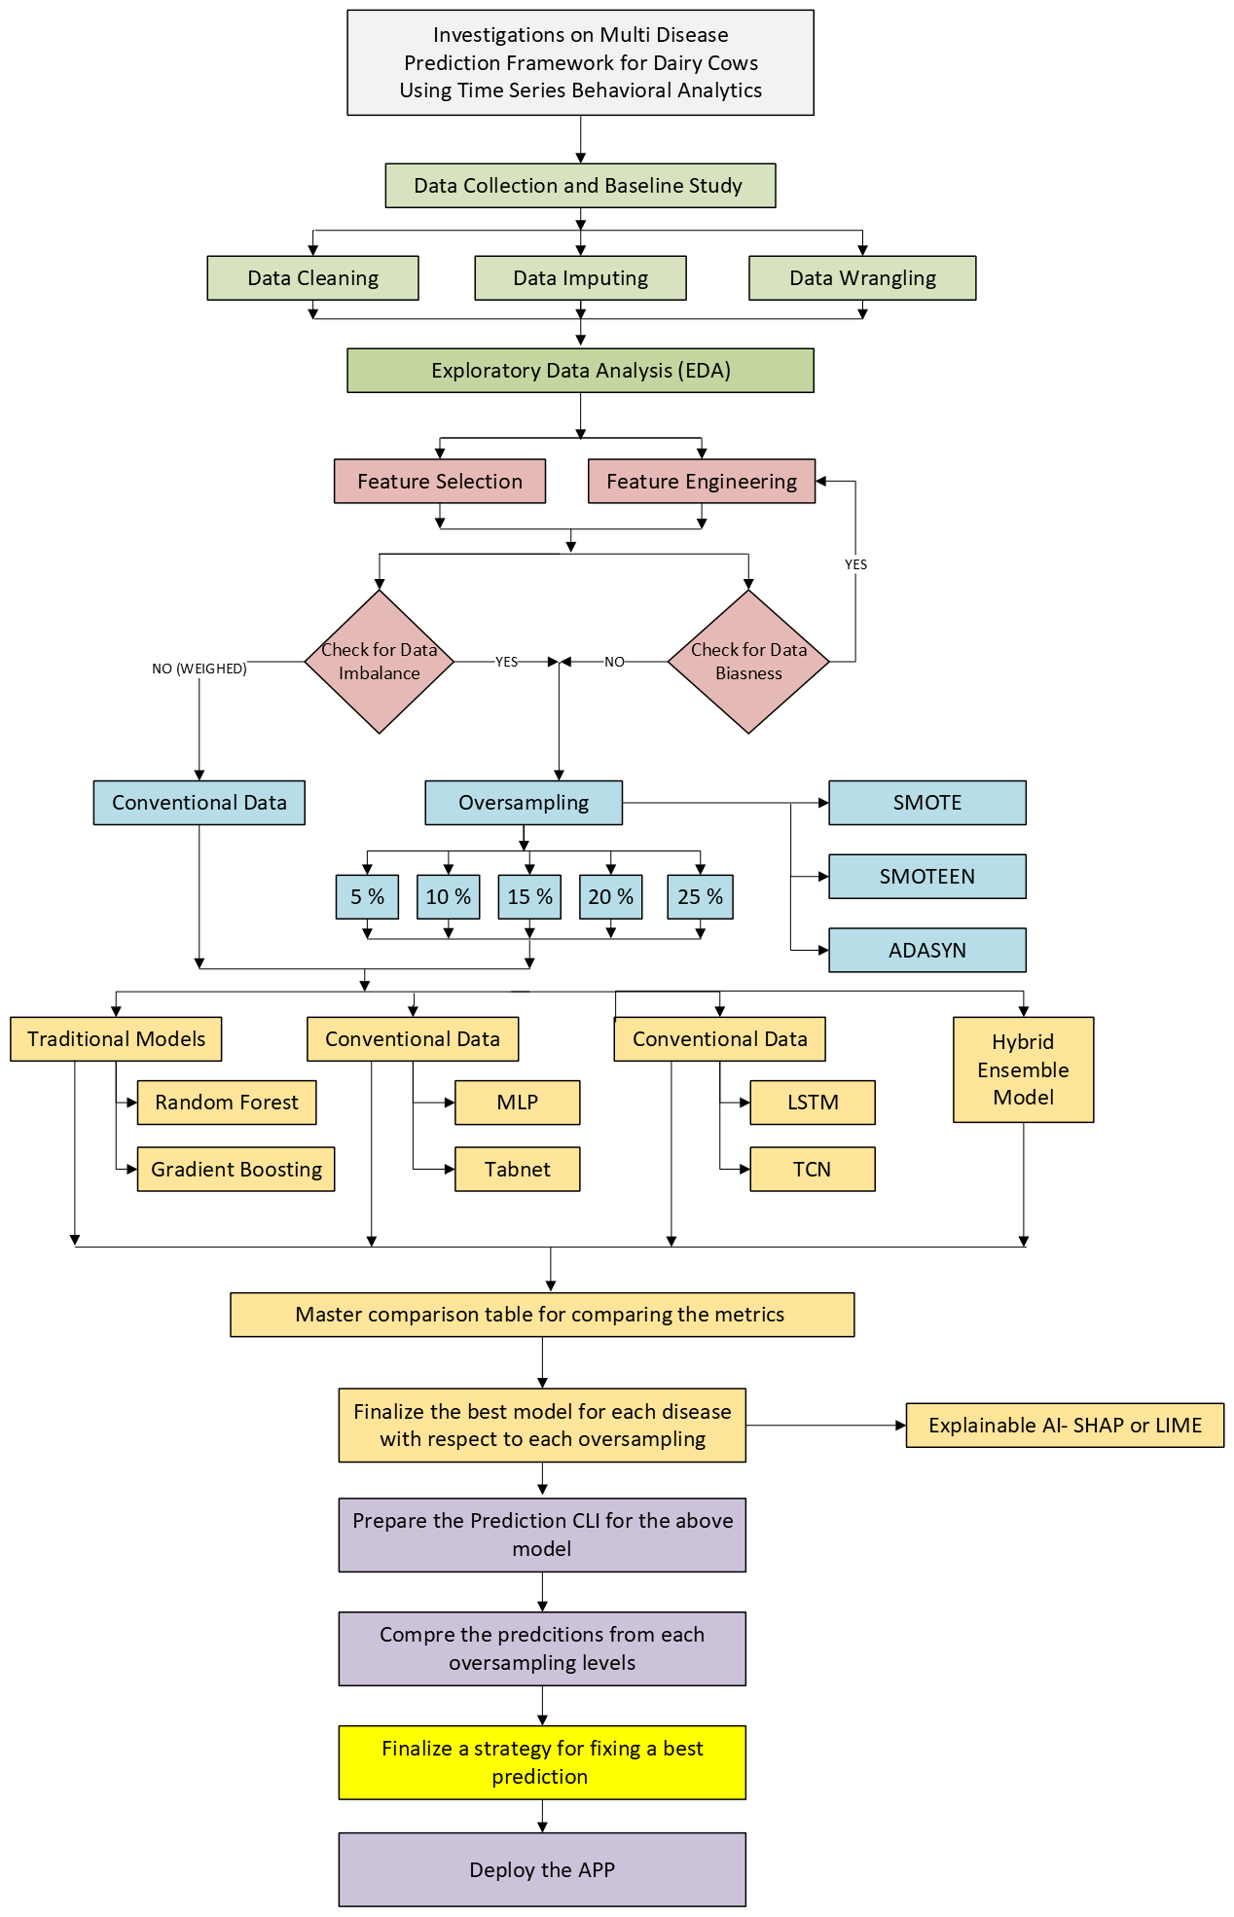

Fig 3.1. Methodology
Model | Type | Strengths | Limitations | Why Selected in This Study
Random Forest (RF) | Tree-based (bagging) | captures non-linear feature interactions, interpretable (feature importance) | Difficult with rare positives, slower with very large datasets | Stable and Interpretable.
LightGBM | Gradient boosting tree | Faster training and handles imbalanced large datasets | Overfitting noisy features and less interpretable compared to RF | Benchmark model especially for tabular data
MLP (Multi-Layer Perceptron) | Deep neural network | Capturing non linearities and good for tabular data | Weaker than trees while handling imbalanced tabular data | Baseline deep learning method for comparison
TabNet | Deep neural network for tabular data | In -built feature selection and performs well for tabular data like boosting | New method and computationally more time required. | Designed for tabular data, balances accuracy with explainability
LSTM | Recurrent neural network (temporal model) | Captures sequential/temporal dependencies in multi-day patterns | Computationally expensive, needs large data, risk of overfitting | Cattle behaviour is time-dependent;
TCN | Convolutional deep model for sequences | Captures long-range dependencies with dilated convolutions, | Requires more compute than trees, less interpretable | Strong sequential model; tested as alternative to LSTM for multi-day disease patterns
Hybrid Ensemble | Combined RF + LightGBM + Neural MLP/TabNet/LSTM/TCN) | Leverages strengths of multiple model families, improves robustness, balances bias-variance tradeoff | Higher complexity, requires careful calibration | Final integrated model to maximize predictive accuracy and stability across oversampling levels
Table 3.3. Comparison of models selected in the study
3.2.5 Selection of models in prediction of disease
The accuracy, precision, recall and f1 score are the metrics used in the study. However, precision and recall are the important metrics which should be considered in the study so as to handle the false positive (FP) and negative (FN). In this regard, F1 score which is the harmonic mean of the precision and recall is selected due to the fact that f1 score clearly balances both precision and recall. In addition to the above, the condition false positive can result in unnecessary interventions and false negatives can lead to missing the diagnosis when needed. The models from all the oversampling levels such as conventional data (0% oversampled), 5%, 10%, 15%, 20% and 25% are compared and the models with best f1 score for each disease will be selected for the prediction. Subsequently, each model is subjected to their corresponding hyper parameter tuning and cross validation as per the table 3.4 below.
Model | Key Tuned Hyperparameters | Final Values (Best Config)
Random Forest (RF) | n_estimators, max_depth, min_samples_split, min_samples_leaf | n_estimators=200, max_depth=20, min_samples_split=2, min_samples_leaf=1
LightGBM (LGBM) | num_leaves, max_depth, learning_rate, feature_fraction | num_leaves=63, max_depth=20, learning_rate=0.05, feature_fraction=0.8
MLP (Neural Net) | Hidden layers, dropout, activation, learning rate, batch size | Layers=(128,64), Dropout=0.2, Activation=ReLU, LR=0.001, Batch=64
TabNet | n_steps, gamma, lambda_sparse, batch size, learning rate | n_steps=5, gamma=1.3, lambda_sparse=1e-3, batch=1024, LR=0.02
LSTM | Sequence length, hidden units, layers, dropout, learning rate | Seq_len=10 days, Hidden=64, Layers=2, Dropout=0.3, LR=0.001
TCN | Kernel size, dilations, num_channels, dropout | Kernel=3, Dilations=[1,2,4], Channels=[16,32,64], Dropout=0.2
Hybrid Ensemble | Weighted averaging of tuned base learners | Weights: RF=0.25, LGBM=0.25, MLP=0.15, LSTM=0.15, TCN=0.10, TabNet=0.10
Table 3.4. Parameters selected for hyper parameter tuning and cross validation
3.2.6 Calibration, thresholding and deployment
The problem associated with the highly imbalanced modelling with rare minorities according to the current investigation can be classified into 2 : 1. The imbalance caused by the rare minorities will give very low metrics making it unfit for prediction and impossible to adjust the biasness pushing it to oversampling, 2. The oversampled models makes synthetic models which will make the cases inside the dataset itself difficult to predict correctly pushing into lots of FPs and FNs. Therefore, it is important to calibrate the model according to the current needs and set the thresholding for reliability. In this regard, Platt scaling was applied to the model with the help of logistic regression. The platt probability value is obtained by the following equation given below.
$P\left(y=1 | s\right)= \frac{1}{1+e^{As+B}}$………………………………………………………………Eq. 1
The s represents the raw probabilistic score, and A and B represents the scaling and shifting parameter learned from the logistic regression. This is further subjected to remapping in order to match with the known cases in the validation set. This is further subjected to thresholding using Youden J index method. While considering the calibration and thresholding approaches there are various other methods like isotonic regression, Beta calibration, Temperature scaling, Cost sensitive thresholding, Prevalence based thresholding etc. However, the selection of Platt scaling and Youden thresholding was due to the reason mentioned in the table 3.5 below.
Method | Category | Strengths | Limitations | Reason for selection
Platt Scaling (Logistic Regression) | Calibration | Simple, robust, avoids overfitting, works good with imbalanced small datasets | Assumes sigmoid-shaped miscalibration; less flexible than isotonic | Good trade-off of simplicity and reliability. Can be used for rare disease prediction
Isotonic Regression | Calibration | Flexible, non-parametric, captures non-sigmoid miscalibration | Requires more data; risk of overfitting with very few positives | Not selected due overfitting risk, not suitable for rare positives
Beta Calibration | Calibration | More expressive than Platt, models skewed probability distributions | Needs larger sample sizes; risk of instability in rare events | Unstable with rare positives
Temperature Scaling | Calibration | Widely used in deep learning, smooths probabilities consistently | Does not change ranking; less effective in imbalanced data | Suited for deep networks with balanced data
Youden J Index (Thresholding) | Thresholding | Balances recall (sensitivity) and specificity; interpretable | Does not consider cost asymmetry explicitly | Objective, interpretable threshold for balancing detection with respect to false alarms
Cost-Sensitive Thresholding | Thresholding | Allows explicit control when false positives/negatives have known costs | Needs reliable cost estimates; not available in this study | Not selected- doesnot have explicit cost parameters
Prevalence-Based Thresholding | Thresholding | Corrects oversampling bias by matching predicted rates to prevalence | May underperform if population prevalence shifts between farms | Not selected- prevalence may vary across farms, lower generalizability
Table 3.5. Comparison of calibration and thresholding methods.
With the help of simple sigmoid transformation, platt scaling method corrects the tendency of the base models to undervalue true disease conditions and this results in the shifting of actual probabilities of prediction closer to one which in turn lowers the TN and FP improving the precision and recall. Subsequently, this will be subjected to Youden J index thresholding approach which will optimize the sensitivity (recall ) and specificity of the prediction. The final model will be deployed for further prediction subjected to the mean input time in minutes per hour for the 8 hour period with data from at least 3 consecutive days . However, as the days increase, the prediction accuracy also will increase. The strategy for calibration and thresholding prior to deployment is visualized using a flowchart in the figure 3.2 below.
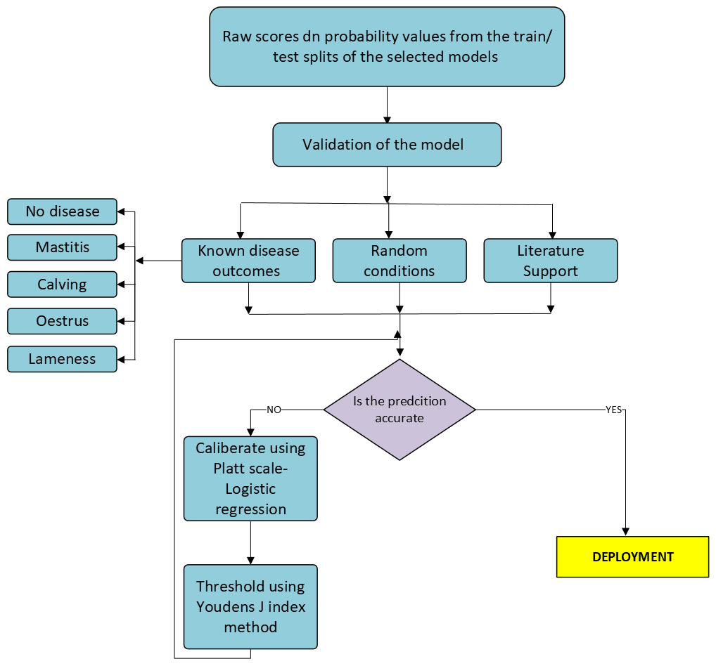
Fig 3.2. Calibration and threholding

Chapter 4
Results and discussion
4.1. Exploratory data analysis
The preliminary exploration of the data was carried out to understand the general trend. From the description of the data it was found that the time spend in alleys, rest and feeding varied from 0 to 3600 seconds, the range of activity level which was calculated from the equation 2 below varied from -828 to 1500 approximately. The equation was established with respect to the weight given such as -0.23, +0.16 and +0.42 for the time spend in rest, alleys and eating.
$Activity_{-}Level= -0.23\left(Rest\right)+0.16\left(Alleys\right)+0.42\left(Eating\right)$…………………………… Eq. 2.
The count of activity levels and their associated distribution is presented in the figure 1 below. It can be observed that there is a huge right skewness in the histogram. In other words, the count of activity in the left portion is higher compared to the right. The activity in the range of -828 tends to be higher in the range of 0.6 million compared to others which were in the range of 0.1 million. This is due to the fact that weightage towards the resting time is higher compared to others.
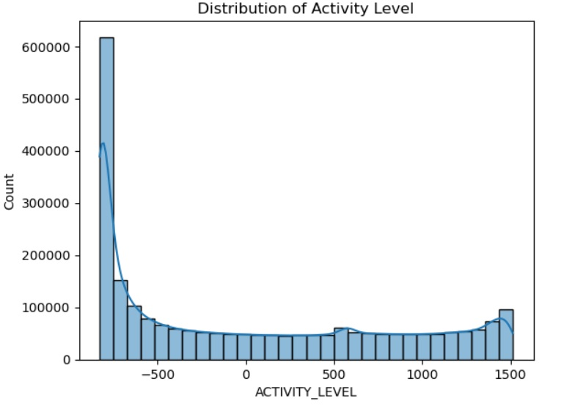
Fig. 4.1 Count of activity level in the dataset
The count of diseases and other binary factors are shown in figure 4.2 below. The diseases such as oestrus, lameness, mastitis, calving, disturbance, and management factors are presented in the bar plot. The count of disturbance gave the highest number accounting to approximately 3.25 million. Following to this, oestrus, calving, lameness, other diseases, mixing, mastitis and accidents occurred in order. However, the disturbance, other diseases and management factors did not gave a clearcut specific ideas in the data. Hence they are eliminated in the further analysis.
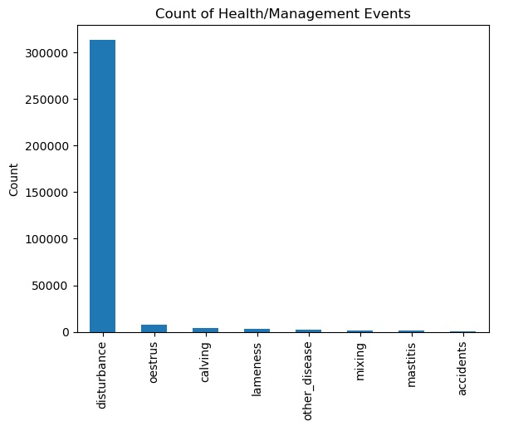
Fig. 4.2 Count of health and other related factors

The pair plot of activities of cattle is portrayed in figure 4.3. From the pair plot it can be observed that the time spent in alleys and eating time exhibited a right skewness. While the resting time gave a unique trend with higher resting time exhibited by most of the cattle. In addition to this, lower resting time was also exhibited by most of the cattle, but slightly less than the higher resting time. Finally, the activity level also exhibited a right skewness as explained above which is the result of higher count exhibited by higher resting time, lower eating time and lower time spent in alleys. From the plot, it was observed that higher the resting time and eating time resulted in the plot converging towards lower and higher activity levels respectively. Whereas in case of alleys, it converged towards the activity level of approximately 500.
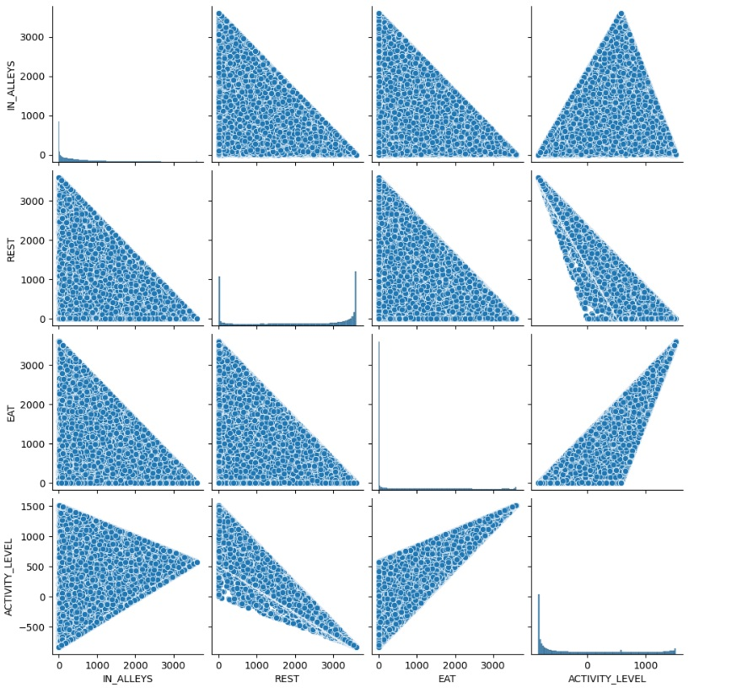
Fig. 4.3 Pair plot on features represented in the dataset
The dataset is again reshaped without affecting its features and contents for the ease of modelling in such a way that the time frame is re modelled from 0-24 hours to 3 time steps (0-8 hours), (9-16 hours) and (17-24 hours). This resulted in reduced rows and the count of disease conditions for the same is given in the table 4.1 below.
Disease | Present Cases | Total Rows | Percentage Present
Lameness | 532 | 318166 | 0.17%
Mastitis | 167 | 318166 | 0.05%
Calving | 708 | 318166 | 0.22%
Oestrus | 1283 | 318166 | 0.40%
Table 4.1. Disease conditions and their data content
Table 4.2 represents the statistical summary of the features in the dataset. On comparing the Tables 4.1 and the table 4.2, the severe imbalance in the target features can be understood which accounts to more than 99 percent. The data which was in the hourly range of each day is now converted to 8 hour bins for easiness in modelling. The behavioural features such as the time spend for eat rest and alleys were also noted. It was observed that the maximum and minimum time spent were 3600 seconds and 0 seconds. The median and mean time spent in the grazing accounts to approximately 536 and 494 seconds. Whereas in case of rest and eat it was 2125 and 2137 seconds , and 795 and 658 seconds respectively. The mean and median of activity level accounts to -43.32 and -34.8 respectively. The behavioural properties shows a widespread characteristics and expresses a non linear beahaviour. This confirms the significance of tree based models in the investigation. In addition tot eh above, the quartiles also expresses the widespread characteristics due to the 0 value for all quartiles shows the absence of diseases at almost all levels.
Statistic | ALLEYS | REST | EAT | ACTIVITY  LEVEL | oestrus | calving | lameness | mastitis | disturbance
count | 318166 | 318166 | 318166 | 318166 | 318166 | 318166 | 318166 | 318166 | 318166
mean | 632.193 | 2137.787 | 826.6961 | -43.3278 | 0.004032 | 0.002225 | 0.001672 | 0.000525 | 0.13223
std | 494.4368 | 841.3649 | 657.5588 | 476.8384 | 0.063374 | 0.04712 | 0.040857 | 0.022904 | 0.338741
min | 0 | 0 | 0 | -828 | 0 | 0 | 0 | 0 | 0
25% | 333.2897 | 1637.749 | 312.7307 | -383.051 | 0 | 0 | 0 | 0 | 0
50% | 535.7131 | 2125.386 | 794.5702 | -34.7994 | 0 | 0 | 0 | 0 | 0
75% | 800.815 | 2714.354 | 1199.441 | 245.7794 | 0 | 0 | 0 | 0 | 0
max | 3599.999 | 3599.999 | 3599.999 | 1512 | 1 | 1 | 1 | 1 | 1
Table 4.2. Summary statistics of the features
The imbalance in the disease conditions in the dataset can be understood with the help of prevalence in percentage which is portrayed in the figure 4.4. It can be clearly understood that the present condition of diseases accounts to less than 1 percent. The oestrus condition which is the condition at which cattle is sexually receptive accounts to 0.40 percent which is the highest in the series. This is followed by calving which accounts to approximately 0.22 percent. Lameness condition is the next in the series followed by mastitis which is the rarest in this. Bu t in real condition, the mastitis and the lameness is the major disease caused to cattle which is contrary to the current dataset due to the fact that this is for selected cattle and may be the cattle is in lactating healthy condition.
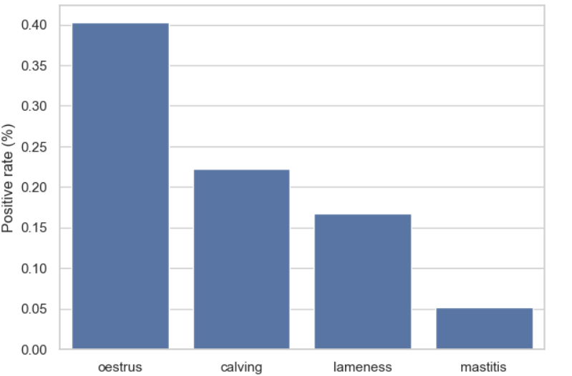
Fig. 4.4 Disease prevalence across the entire data
The distribution of the features are represented via. histogram plots in the figure 4.5. It can be observed that the time spent in alleys for grazing is more or less right skewed but a bump showing 0 seconds spend is also present in the same. This in turn indicates a wide behaviour and at the same time most of the cattle spend time in the range of 0-1000 seconds for grazing compared to the very negligible number of cattle which spend time in the range of above 2000 seconds per hour. Whereas in the case of rest, the cattle resting time is bimodal distribution which is expressed by a central bump and 2 hikes at the extremes. In this distribution, one group rested for approximately 1000-1500 seconds , and the other I the range of 2000 – 3000 seconds. In addition to this, there are a huge group of cows who rested for the whole hour accounting to approximately 2000. The eating shows a highly skewed distribution, with a large number of cows with very negligible eating time which can be a result of presence of mastitis. The wide spread variation in the activity level is yet another factor which makes the dataset distribution complex . This is due to the fact that it varies very widely from negative to positive. This is due to the fact that higher the rest time results in negative and higher the eating and grazing time can result in positive activity level. Thus can further be understood by the cohen’s factor which brings out the interactive change within the features.
a  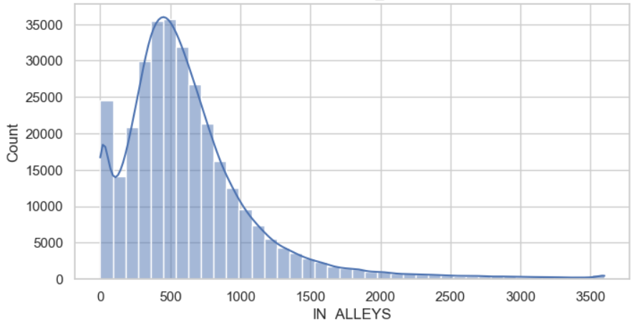 | b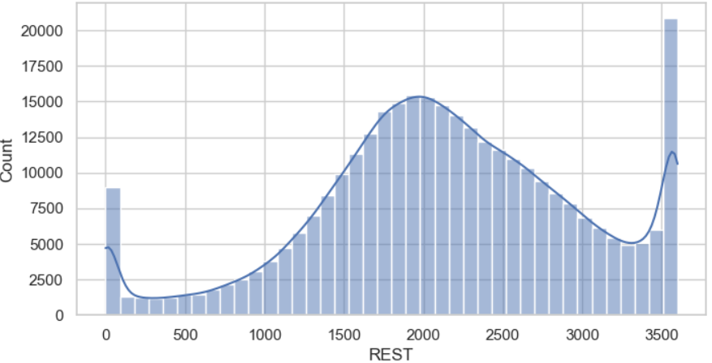
c  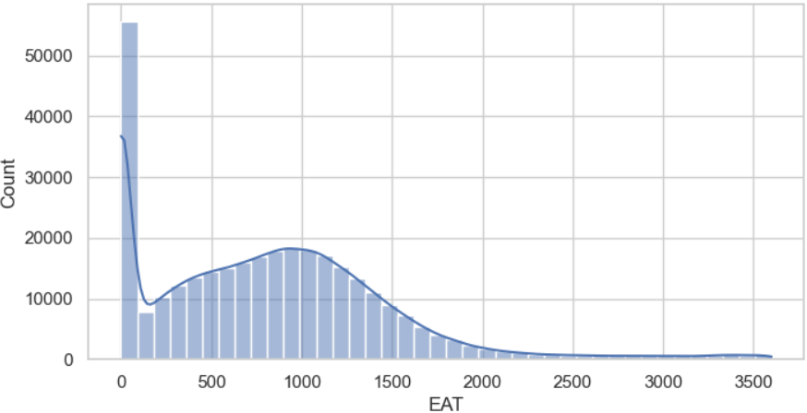 | d  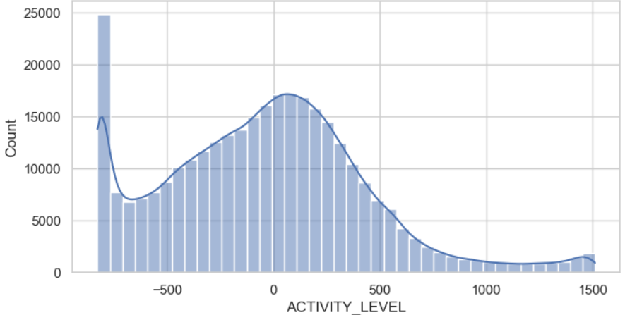
Fig. 4.5 Count of features in the dataset a) time spent in alleys, b) time of rest c) time for feeding, d) activity level
The cohen’s factor d represented in Table 4.3 give the standardised difference between the feature and target groups in the dataset. The factor is found out by the equation given below.
$d=\frac{\overline{X_{1}}-\overline{X_{2}}}{S_{p}}$…………………………………………………………………………………………………………….……. Eq. 3
Where X₁ and X₂ are the two groups which are features and targets respectively and Sp represents the pooled standard deviation between the two groups. Which is represented by the equation below.

$S_{p}=\sqrt{\frac{\left(n_{1}-1\right){s_{1}}^{2}+(n_{2}-1){s_{2}}^{2}}{\left(n_{1}+n_{1}-2\right)}}$…………………………………………………………………………………………. Eq. 4
The cohen’s value d is such that , the effect will be small , medium and high for the values approximately to 0.2, 0.5 and greater than 0.8 respectively.
Disease | Feature | Cohen_d
oestrus | IN_ALLEYS | 1.000248
oestrus | REST | -0.40133
oestrus | EAT | -0.2356
oestrus | ACTIVITY_LEVEL | 0.192011
calving | IN_ALLEYS | -0.06995
calving | REST | -1.54376
calving | EAT | 2.031194
calving | ACTIVITY_LEVEL | 1.790655
lameness | IN_ALLEYS | 0.199127
lameness | REST | 0.110442
lameness | EAT | -0.29198
lameness | ACTIVITY_LEVEL | -0.18089
mastitis | IN_ALLEYS | 0.018236
mastitis | REST | -0.15677
mastitis | EAT | 0.187705
mastitis | ACTIVITY_LEVEL | 0.175364
Table 4.3 Standardised difference between features and targets
From the above table, it can be observed that the grazing time (IN_ALLEYS) bared a strong relation with oestrus. Whereas the activity level and eat gave a small effect. Whereas, in the case of eating time , a mild effect but in the inverse proportion was contributed to oestrus. Whereas in the case of calving, eating and resting time gave a very strong effect in direct and inverse proportions. Lameness was affected very mildly with the features as it is less than 0.2. Mastitis also experienced same condition as that of lameness. Calving and oestrus can be found from the single characteristic behaviours such as grazing time and eating time respectively. On the contrary, the mastitis and lameness responded very lightly making it difficult to predict.
Figure 4.6 portrays the box plots of feature vs target in the dataset . The combined boxplots shows that the behavioural differences were most expressed in calving and oestrus cases. The cows with calving condition showed lower resting and higher eating and activity levels. In addition to the above, oestrus cows spent more time in alleys. On the contrary, mastitis and lameness exhibited only small changes, with large overlaps between healthy and diseased groups. This plot supports the Cohen’s d results presented in the table 4.3 above, confirming that calving and oestrus have strong behavioural markers, whereas mastitis and lameness require advanced multivariate modelling to detect.
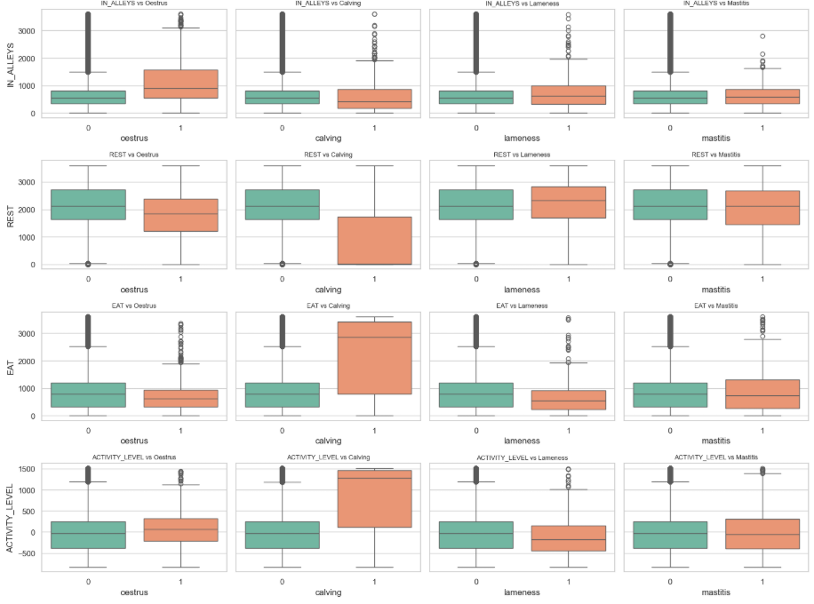
Fig. 4.6 Box plot on feature vs targets
The daily mean behavioural characteristics exhibited by the features are showed in the figure 4.7. The general behaviour of living individuals were shown here. Eating and activity were high during day time. Whereas, the higher resting time was observed at night time. Even though the cycle repeats, some fluctuations were also observed across the day to day variations which may be due to the management changes, environmental stress or any disturbance. The combination of the characteristics shows that the disease monitoring should be more effective towards individual monitoring rather than multi scaling.
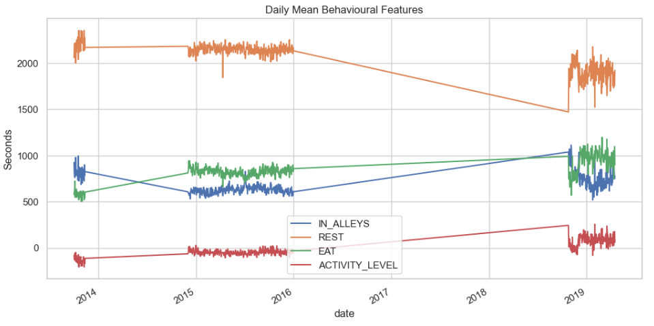
Fig. 4.7 Mean daily behavioural characteristics of dataset
4.2 Imbalance and Biasness
Fig 4.8 shows the imbalance associated with the targets of the dataset. As discussed earlier, the disease present conditions represented by 1 is less than 0.5 percentage contributing to 99.5 percent imbalance. The disease presence by 3 bins per day with 8 hour split is made and expressed in the figure below. This clearly shows the negligible presence of disease. This in turn was checked with the feature disturbance in figure 4.9 below. It was interestingly observed that the feature disturbance showcased a huge improvement with respect to prediction of the diseases such that approximately 50000 present cases compared to that of healthy condition was observed for each diseases .
In this condition of relatively good prevalence of diseases with respect to the diseases may contradictorily bias the model. Therefore, the prediction should make sure that the disturbance should be placed appropriately in the feature and no the target. This was the first step selected in the model. Even though the disease presence by hour of the day is also severely imbalance, there is some improvement in the 24th hour. Subsequently, in order to avoid the discontinuity of evaluation of results with respect to hours, it is inevitable to encode cyclic time using sine and cosine functions.
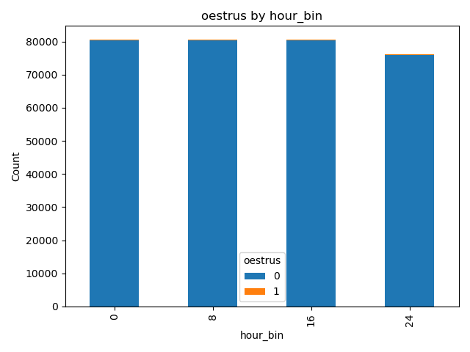 | 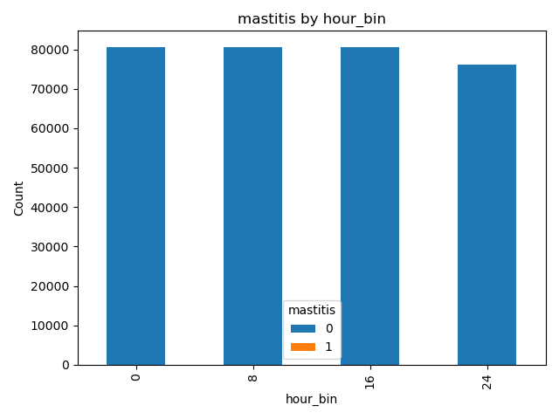
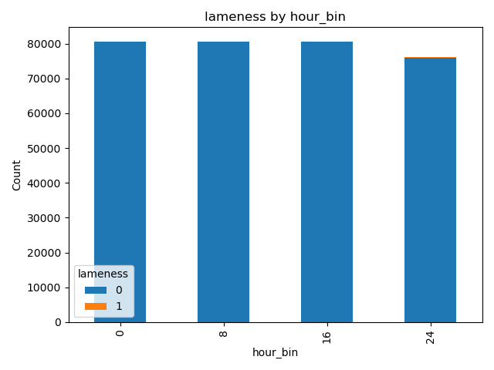 | 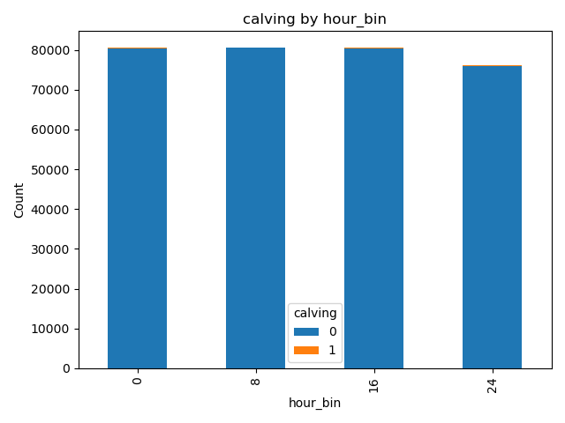
Fig. 4.8 Count of presence of disease by hour bin

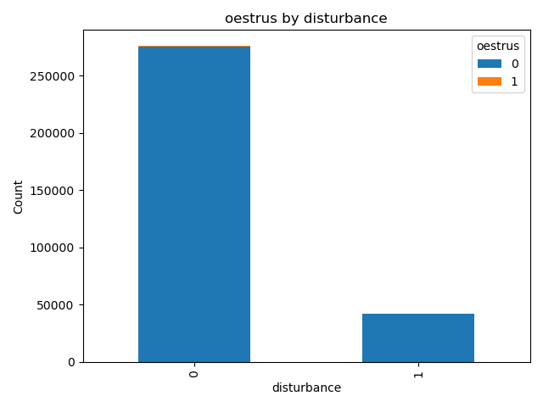 | 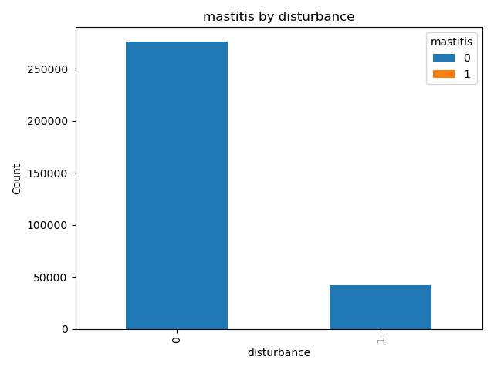
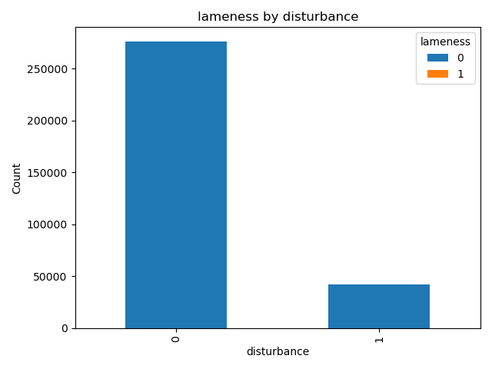 | 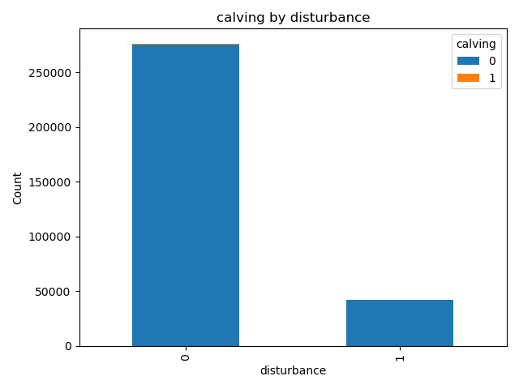
Fig. 4.9. Distribution of count of disease by disturbance observed with the cattle
In order to further understand the one to one interactive behaviour of the target features the difference of the statistical means are checked with one another using the various approaches and the result of which is shown in the table 4.4 below. The cohen’s factor (d) also can be an alternative to the heat map with additional features such as the variate progression of targets with respect to the features.

Disease | Feature | Mean  pos | Mean  neg | cohens | ttest_p | Mann  whitney | ks_p | Univariate  auc
mastitis | hour_bin | 11.3533 | 11.83 | -0.0536 | 0.4825 | 0.491 | 0.9975 | 0.4851
mastitis | IN_ALLEYS | 641.2051 | 632.1883 | 0.0182 | 0.8013 | 0.3856 | 0.408 | 0.5194
mastitis | REST | 2005.953 | 2137.857 | -0.1568 | 0.0942 | 0.268 | 0.0623 | 0.4753
mastitis | EAT | 950.0578 | 826.6313 | 0.1877 | 0.0832 | 0.7158 | 0.1443 | 0.5081
mastitis | ACTIVITY_LEVEL | 40.2478 | -43.3717 | 0.1754 | 0.0814 | 0.447 | 0.1176 | 0.517
mastitis | disturbance | 0.0898 | 0.1323 | -0.1253 | 0.0577 | 0.1056 | 0.9118 | 0.4788
lameness | hour_bin | 11.9098 | 11.8297 | 0.009 | 0.8362 | 0.8365 | 1 | 0.5025
lameness | IN_ALLEYS | 730.481 | 632.0284 | 0.1991 | 0.0001 | 0.0002 | 0 | 0.5475
lameness | REST | 2230.553 | 2137.632 | 0.1104 | 0.0143 | 0.0016 | 0 | 0.5395
lameness | EAT | 635.0343 | 827.0171 | -0.292 | 0 | 0 | 0 | 0.4048
lameness | ACTIVITY_LEVEL | -129.436 | -43.1836 | -0.1809 | 0 | 0 | 0 | 0.4411
lameness | disturbance | 0.6316 | 0.1314 | 1.4793 | 0 | 0 | 0 | 0.7501
calving | hour_bin | 11.8644 | 11.8297 | 0.0039 | 0.9176 | 0.9179 | 1 | 0.5011
calving | IN_ALLEYS | 597.6843 | 632.27 | -0.0699 | 0.1133 | 0 | 0 | 0.4384
calving | REST | 845.2295 | 2140.67 | -1.5438 | 0 | 0 | 0 | 0.1861
calving | EAT | 2153.293 | 823.7375 | 2.0312 | 0 | 0 | 0 | 0.7636
calving | ACTIVITY_LEVEL | 805.61 | -45.2211 | 1.7907 | 0 | 0 | 0 | 0.8013
calving | disturbance | 0.1441 | 0.1322 | 0.035 | 0.3698 | 0.3519 | 0.9999 | 0.5059
oestrus | hour_bin | 11.6165 | 11.8307 | -0.0241 | 0.3859 | 0.3921 | 0.9733 | 0.4933
oestrus | IN_ALLEYS | 1123.772 | 630.2027 | 1.0002 | 0 | 0 | 0 | 0.7003
oestrus | REST | 1801.589 | 2139.149 | -0.4013 | 0 | 0 | 0 | 0.391
oestrus | EAT | 672.4202 | 827.3207 | -0.2356 | 0 | 0 | 0 | 0.4299
oestrus | ACTIVITY_LEVEL | 47.8546 | -43.697 | 0.192 | 0 | 0 | 0 | 0.5665
oestrus | disturbance | 0.1395 | 0.1322 | 0.0216 | 0.4506 | 0.4401 | 1 | 0.5037
Table 4.3. Bias report of one to one relations of feature and target.
Cohen’s d analyzed behavioural differences and not their statistical certainty. It was observed that the diseases Calving and Oestrus had strong significance , while Mastitis and Lameness were vague. Whereas in the case of t test, the majority of the results were non-significant, showing that the behaviours of diseased cattle and healthy cows overlapped strongly. Subsequently, Mann–Whitney U test which checked the significance without normality showed only minor shifts. This again confirms that single features alone do not capture disease well. As different from the above. KS test compared full distributions. It was interestingly observed that slight shape differences in the feature REST and ACTIVITY_LEVEL, but not large enough for good prediction. Finally Univariate AUC showed that the most features scored near the value of 0.5 which showed that there wasn’t a good regressive connection more likely to be random guessed. On an overall, the comparisons showed that there is not a strong single behavioural feature variable provides a good prediction signal. Which in turn, strongly proves the need for multivariate, temporal, and ensemble models that combine this week patterns across features. Also, in that case also the models finally needs some mechanisms to be incorporated so as to threshold or calibrate the probabilistic values.
4.3 Oversampling using ADASYN
The handling of imbalance in the dataset is the biggest of all concerns when dealing with the disease prediction datasets. In order to handle this, oversampling strategy to boost the minority cases which are the presence of selected disease features was carried out. IN this regard, ADASYN among the other methods such as SMOTE and SMOTEEN are selected due to its exceptional quality to handle the minority cases. The other 2 methods were note selected is due to the fact that the former does not handles the minority while the later has the chance to delete the samples which may also delete the underlying connections. Therefore, in the current investigation, oversampling was carried out using ADASYN in the varying proportion sog 5%, 10%, 15%, 20% and 25%, and the same was compared with that of the 0% which is the unsampled one. The oversampling was carried out till 25% in order to prevent the data from excess synthetic samples in order not to loss the reliability of the modelling.
4.4 Feature Engineering
The best selected features were, IN_ALLEYS, EAT, REST, ACTIVITY_LEVEL, hour_bin and disturbance as per the imbalance and bias report. However, as per the report of biasness and associated imbalance the feature are insufficient for a good prediction due to its inability to make significant associations with the targets. Especially, univariate approach is meaningless as per the report of cohen’s parameter. Therefore, strong feature engineering is required to fir the targets with the features. In this regard, first approach was to fix the hourly continuous rhythm of progression. There is a possibility for the algorithm to take up a huge difference while progressing towards the beginning and end of the hour stamp which is between 24th and 0 the hour is evaded by using the sine and cosine variant of the same. The cyclic encoding of the hour stamps are carried out with the equations given below.
$hour_\sin{=Sin(\frac{2πhour_bin}{24})}$………………………………………………………………………………….… Eq. 5
$hour_\cos{=Cos(\frac{2πhour_bin}{24})}$…………………………………………………………………………………… Eq. 6
This not only evades the continuity issue in the progressive monitoring but also the temporal models such as LSTM and TCN will align the featural changes smoothly with the targets. The feature engineering was carried out with developing eat vs rest and activity vs rest ratios to understand the appetite and restlessness of the cattle. In order to handle the disease manifestation in shorter period, the 3 bin rolling window of mean and standard deviation is also considered which will ensure the capture of deviation of values from the baseline. Subsequently, feature redundancy and transformation was applied to the model by retaining the highly collinear features such as eat to rest and rest to activity levels were subjected to feature redundancy. The associated scaling was applied to the temporal and neural models and it was excluded in tree based models such as RF. In addition to the above, the disturbance factor was included as a contextual factor as it is important from the targets representing weak univariate signals such as mastitis and lameness. The factors considered for the study related to the feature engineering is presented in Table 4.4 below.
Step | Description | Purpose / Significance
Raw Features | IN_ALLEYS, REST, EAT, ACTIVITY_LEVEL, hour_bin, disturbance flag | Base data from sensors; direct behavioural measures.
Time Encoding | Converted hour_bin into hour_sin & hour_cos (cyclical encoding) | Captures circadian rhythms; avoids artificial discontinuity between 0h and 24h.
Behavioural Ratios | EAT/REST ratio, Activity/Rest ratio | Highlights relative changes in feeding vs resting; proxies for abnormal appetite/restlessness.
Rolling Window Stats | 3-bin rolling mean & std for IN_ALLEYS, REST, EAT, ACTIVITY_LEVEL | Detects deviations from individual baselines; captures gradual disease effects.
Disturbance Features | Binary indicators for mixing, accidents, management changes | Prevents misclassification of disturbance-driven behaviour as disease; reduces bias.
Feature Transformation | Retained correlated features but allowed models to down-weight redundancy | Ensures no loss of potentially useful signals; prepares data for calibration.
Final Engineered Dataset | Combination of raw + engineered features | Enables multivariate & temporal models to learn subtle, non-linear behavioural patterns.
Table 4.4. Feature Engineering
4.5 Calibration and thresholding
Raw probabilities generated by the ML models in this imbalanced cases even with the oversampling can misinterpret the predictions due to less imbalance or unaligned synthetic data. In this case, in order to prevent this and adjust the probabilities a most commonly used threshold is set which is at 0.5. This in turn is subjected to testing in the case of known conditions of mastitis, lameness, calving, oestrus, no disease and healthy lactating condition from the literature. The condition of specific lactating cows were recorded at 9-12 hours per day, 6-8 hours per day and 4-5 hours per day for lying, grazing and eating respectively(Florit et l., 2023, Romain and Remy 2025, Tucker et al., 2021). The logistic regression based calibration was applied to the model and subsequently the same was subjected to thresholding using Yuden’s J index. The thresholds were fixed by maximising the specificity and sensitivity resulting in the range of 0.16-0.18. Table 4.5 shows the calibrated and threshold set values obtained for a known mastitis condition.
Disease | Calibrated Probability | Threshold | Final Prediction
Mastitis | 0.4378 | 0.1686 | 1
Lameness | 0.1563 | 0.1702 | 0
Calving | 0.14 | 0.1722 | 0
Oestrus | 0.1591 | 0.1658 | 0
Table 4.5. Calibration and threshold applied for known mastitis condition
4.6 Performance of Models on oversampling
As discussed in section 3, the various models such as RF, Light GBM, TabNet, MLP, TCN, LSTM, Hybrid models were selected and compared in the study.
4.6.1 Oestrus
The table 4.8 shows the metric associated with the oestrus prediction in the cattle. It was interestingly observed that the tree based model captured the patterns faster and efficiently compared to the others. RF and Light GBM showed consistent improvement in F1 score from 10% to 25 percent oversampling. Deep neural models also picked up the patterns with an F1 score of 0.65 – 0.70%. MLP and Tabnet gave intermediate results underperforming compared to others . This is due to the fact that there were no predictable patterns for the neurons to pick up in the case of MLP and TabNet where as in case of RF and Light GBM, the clear behavioural markers such as higher time spend in alleys compared to rest made it easier to detect the balanced minority cases. The LSTM and TCN were also able to pick up the temporal patterns due to the timely behaviors as well as the rolling window interference. The comparison showing the metrics of the same is presented in the figure 4.10.

Metrics of modelling Oestrus
Model |  | Hybrid | LGBM | LSTM | MLP | RF | TCN | TabNet
Oversampling- ADASYN | 0% | 1 | 0.89 | 0.99 | 0 | 0.99 | 0.99 | 1 | Accuracy
 | 5% | 0.966 | 0.91 | 0.985 | 0 | 0.96 | 0.986 | 0.99
 | 10% | 0.974 | 0.92 | 0.972 | 0.974 | 0.95 | 0.973 | 0.973
 | 15% | 0.928 | 0.91 | 0.92 | 0.862 | 0.94 | 0.914 | 0.92
 | 20% | 0.811 | 0.91 | 0.89 | 0.89 | 0.94 | 0.891 | 0.9
 | 25% | 0.881 | 0.914 | 0.87 | 0.868 | 0.936 | 0.873 | 0.873
 | 0% | 0 | 0.02 | 0 | 0 | 0.06 | 0 | 0 | F1 Score
 | 5% | 0.332 | 0.49 | 0.048 | 0 | 0.66 | 0 | 0
 | 10% | 0.001 | 0.67 | 0.006 | 0 | 0.75 | 0 | 0.016
 | 15% | 0.752 | 0.75 | 0.64 | 0.24 | 0.82 | 0.614 | 0.62
 | 20% | 0.124 | 0.81 | 0.67 | 0.66 | 0.85 | 0.649 | 0.67
 | 25% | 0.704 | 0.838 | 0.69 | 0.665 | 0.875 | 0.683 | 0.686
 | 0% | 0 | 0.01 | 0 | 0 | 0.04 | 0 | 0 | Precision
 | 5% | 0.229 | 0.34 | 0.247 | 0 | 0.62 | 0 | 0
 | 10% | 0.111 | 0.54 | 0.312 | 0 | 0.71 | 0 | 0.267
 | 15% | 0.77 | 0.65 | 0.93 | 0.663 | 0.78 | 0.929 | 0.93
 | 20% | 0.903 | 0.73 | 0.91 | 0.91 | 0.82 | 0.923 | 0.9
 | 25% | 0.934 | 0.789 | 0.91 | 0.909 | 0.85 | 0.905 | 0.898
 | 0% | 0 | 0.34 | 0 | 0 | 0.1 | 0 | 0 | Recall
 | 5% | 0.604 | 0.86 | 0.027 | 0 | 0.7 | 0 | 0
 | 10% | 0.001 | 0.88 | 0.003 | 0 | 0.8 | 0 | 0.008
 | 15% | 0.736 | 0.89 | 0.48 | 0.146 | 0.85 | 0.458 | 0.46
 | 20% | 0.067 | 0.9 | 0.53 | 0.52 | 0.88 | 0.5 | 0.54
 | 25% | 0.565 | 0.894 | 0.55 | 0.524 | 0.902 | 0.548 | 0.555
Table 4.6 Metrics obtained for oestrus condition

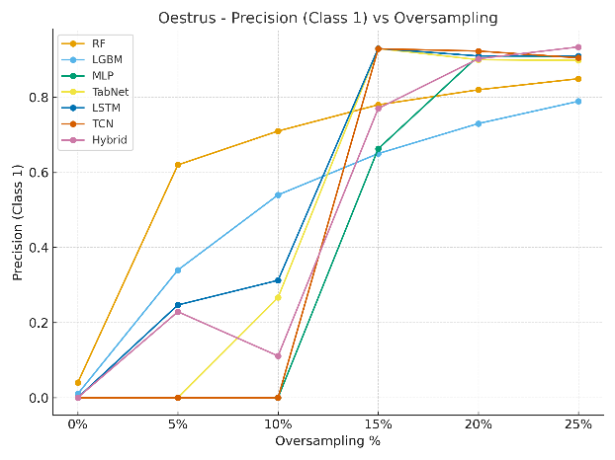 | 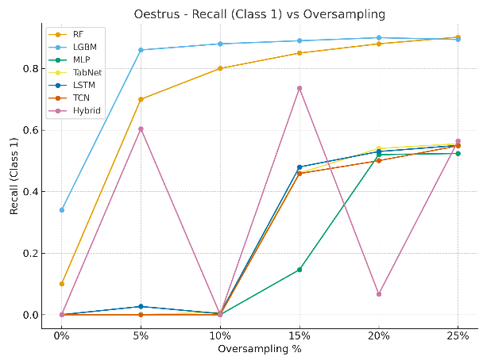
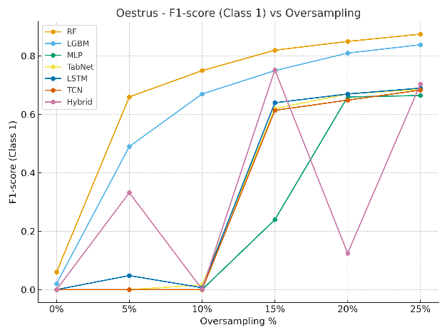 | 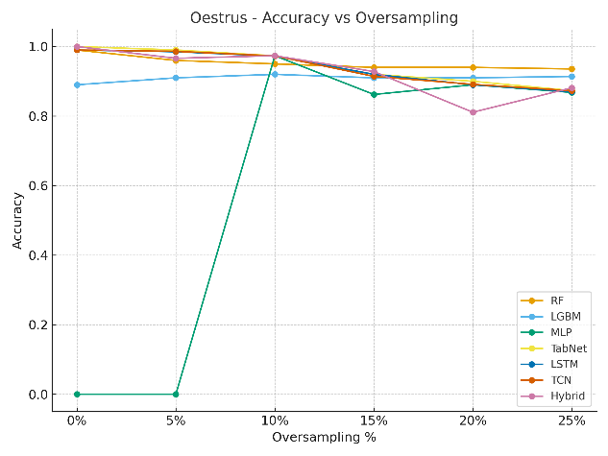
Fig. 4.10 Comparison of metrics obtained for Oestrus
4.6.2 Lameness
Table 4.7 shows the metrics corresponding to lameness for all oversampling modes. The conventional dataset without oversampling underperformed as usual due to its high imbalance accounting to less than 0.30. With oversampling it improved especially in 15-25% oversampling the RF and Light GBM models showed exemplary result compared to all others as usual. The trend was same as that of the oestrus. LSTM and TCN models retained its position keeping the ranges of F1 score in the range of 0.65 for oversampling from 15-25%. Figure 4.11 shows the variation of metrics for the lameness.
Metrics for Lameness
Model |  | Hybrid | LGBM | LSTM | MLP | RF | TCN | TabNet
Oversampling- ADASYN | 0% | 1 | 0.94 | 1 | 0 | 1 | 1 | 1 | Accuracy
 | 5% | 0.967 | 0.92 | 0.989 | 0 | 0.96 | 0.99 | 0.99
 | 10% | 0.976 | 0.91 | 0.977 | 0.98 | 0.95 | 0.98 | 0.976
 | 15% | 0.89 | 0.92 | 0.92 | 0.85 | 0.94 | 0.92 | 0.92
 | 20% | 0.803 | 0.92 | 0.89 | 0.9 | 0.94 | 0.9 | 0.9
 | 25% | 0.832 | 0.918 | 0.87 | 0.87 | 0.933 | 0.87 | 0.863
 | 0% | 0 | 0.01 | 0 | 0 | 0 | 0 | 0 | F1 Score
 | 5% | 0.274 | 0.53 | 0 | 0 | 0.66 | 0 | 0.01
 | 10% | 0.007 | 0.67 | 0 | 0 | 0.76 | 0 | 0.004
 | 15% | 0.463 | 0.77 | 0.63 | 0 | 0.82 | 0.64 | 0.65
 | 20% | 0.028 | 0.81 | 0.65 | 0.66 | 0.85 | 0.66 | 0.67
 | 25% | 0.502 | 0.849 | 0.66 | 0.65 | 0.873 | 0.67 | 0.647
 | 0% | 0 | 0 | 0 | 0 | 0 | 0 | 0 | Precision
 | 5% | 0.183 | 0.37 | 0 | 0 | 0.62 | 0 | 0.31
 | 10% | 0.454 | 0.54 | 0 | 0 | 0.7 | 0 | 0.107
 | 15% | 0.862 | 0.67 | 1 | 0 | 0.76 | 0.86 | 0.97
 | 20% | 0.973 | 0.72 | 0.97 | 0.96 | 0.8 | 0.94 | 0.96
 | 25% | 0.964 | 0.786 | 0.95 | 0.96 | 0.832 | 0.92 | 0.907
 | 0% | 0 | 0.13 | 0 | 0 | 0 | 0 | 0 | Recall
 | 5% | 0.545 | 0.89 | 0 | 0 | 0.71 | 0 | 0.01
 | 10% | 0.004 | 0.91 | 0 | 0 | 0.83 | 0 | 0.002
 | 15% | 0.317 | 0.92 | 0.46 | 0 | 0.88 | 0.51 | 0.49
 | 20% | 0.014 | 0.93 | 0.49 | 0.5 | 0.91 | 0.51 | 0.51
 | 25% | 0.34 | 0.922 | 0.51 | 0.49 | 0.917 | 0.53 | 0.503
Table 4.7. Metrics obtained for lameness condition
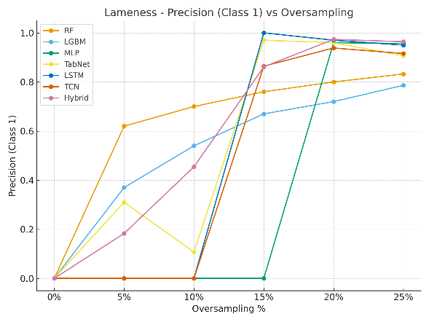 | 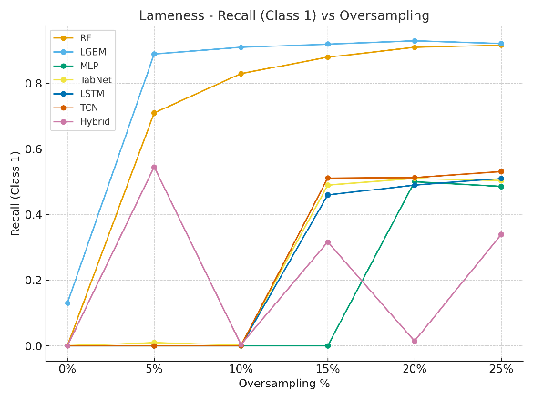
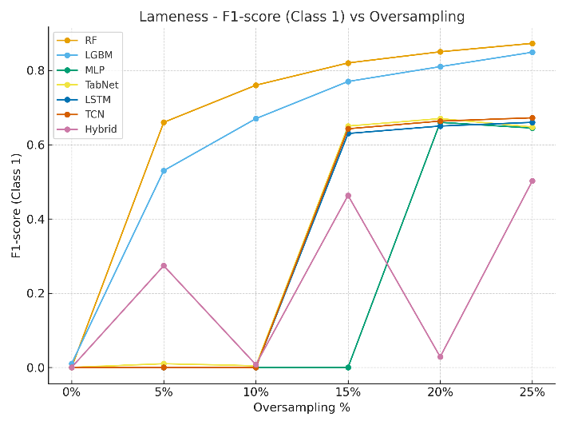 | 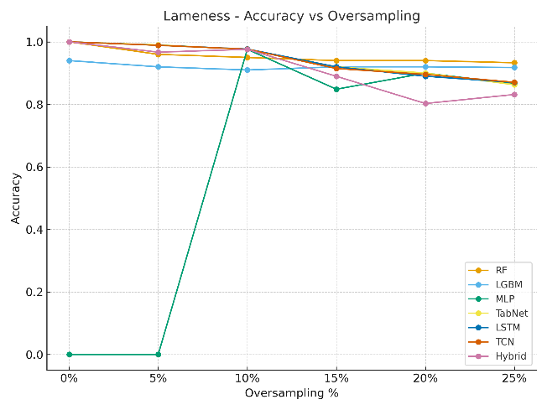
Fig. 4.11 Metric variation for lameness condition
4.6.3 Mastitis
Table 4.8 shows the values of metrics obtained for the Mastitis condition. Nearly all models failed to pick up a reasonable value for the mastitis condition at 0 percent oversampling. This was due to the very rare presence in the dataset causing extreme imbalance. But surprisingly, the hybrid ensemble models clearly took the patterns and made out an impressive F1 score of approximately 0.88 for the 25 percent oversampled model which was more or less similar to that of the 15% oversampled model. RF and Light GBM also performed with the hybrid models but not up to them. This was due to the fact that the tree based models failed to connect the very rare positives. Whereas the ensemble model picked up the patterns from 15% to 25% oversampling easily with the combined strategy as it combined the weak signals using different architectures to make up a pattern. RF and Light GBM should have performed better, which may be due to the confusion built up by the disturbance feature. Figure 4.12 shows the variations in the metrics for the mastitis condition.

Metrics for Mastitis
Model |  | Hybrid | LGBM | LSTM | MLP | RF | TCN | TabNet
Oversampling - ADASYN | 0% | 1 | 0.99 | 1 | 0 | 1 | 1 | 1 | Accuracy
 | 5% | 0.957 | 0.91 | 0.99 | 0 | 0.96 | 0.989 | 0.99
 | 10% | 0.977 | 0.91 | 0.976 | 0.98 | 0.95 | 0.976 | 0.976
 | 15% | 0.958 | 0.92 | 0.92 | 0.85 | 0.94 | 0.92 | 0.92
 | 20% | 0.858 | 0.92 | 0.89 | 0.89 | 0.94 | 0.892 | 0.89
 | 25% | 0.933 | 0.923 | 0.87 | 0.88 | 0.94 | 0.869 | 0.886
 | 0% | 0 | 0 | 0 | 0 | 0 | 0 | 0 | F1 Score
 | 5% | 0.19 | 0.53 | 0 | 0 | 0.67 | 0 | 0.02
 | 10% | 0.006 | 0.69 | 0.033 | 0 | 0.77 | 0 | 0.003
 | 15% | 0.847 | 0.78 | 0.63 | 0 | 0.83 | 0.638 | 0.64
 | 20% | 0.613 | 0.83 | 0.65 | 0.65 | 0.86 | 0.655 | 0.67
 | 25% | 0.878 | 0.864 | 0.67 | 0.7 | 0.89 | 0.664 | 0.73
 | 0% | 0 | 0 | 0 | 0 | 0 | 0 | 0 | Precision
 | 5% | 0.118 | 0.37 | 0 | 0 | 0.57 | 0 | 0.36
 | 10% | 0.333 | 0.54 | 0.228 | 0 | 0.67 | 0 | 0.087
 | 15% | 0.936 | 0.65 | 0.97 | 0 | 0.75 | 0.988 | 0.98
 | 20% | 0.672 | 0.73 | 0.95 | 0.96 | 0.79 | 0.903 | 0.89
 | 25% | 0.805 | 0.776 | 0.94 | 0.89 | 0.83 | 0.928 | 0.891
 | 0% | 0 | 0 | 0 | 0 | 0 | 0 | 0 | Recall
 | 5% | 0.487 | 0.96 | 0 | 0 | 0.82 | 0 | 0.01
 | 10% | 0.003 | 0.97 | 0.018 | 0 | 0.89 | 0 | 0.002
 | 15% | 0.774 | 0.98 | 0.47 | 0 | 0.92 | 0.472 | 0.47
 | 20% | 0.563 | 0.98 | 0.49 | 0.5 | 0.94 | 0.514 | 0.54
 | 25% | 0.965 | 0.974 | 0.52 | 0.57 | 0.95 | 0.517 | 0.619
Table 4.8 Metrics obtained for Mastitis

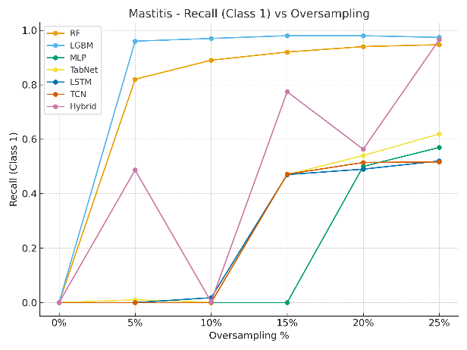 | 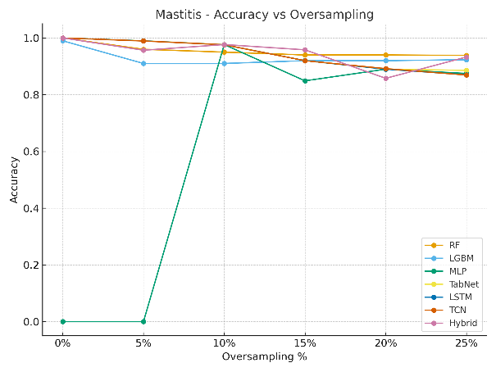
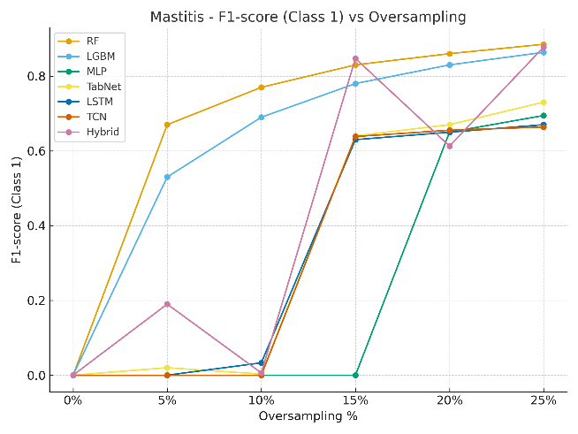 | 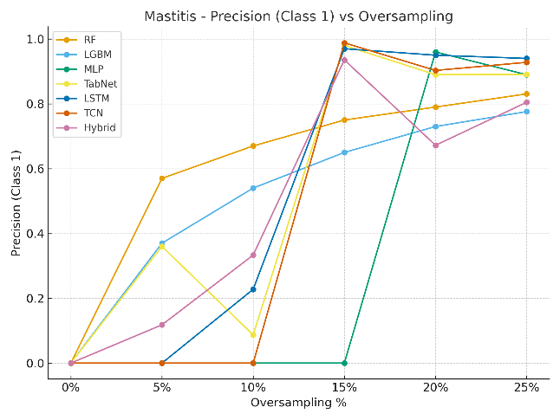
Fig. 4.12 Variation in metric for mastitis condition
4.6.4 Calving
Table 4.9 shows the metric values obtained for the calving and the variation is plotted in the figure 4.13. The calving also expressed the same characteristics as that of the oestrus and lameness with good models for RF and Light GBM. As different from the above, RF and light GBM performed in such a way that even the 5% oversampled model performed well and reached more than 90% F1 score on higher oversampling rates. Temporal models such as LSTM and TCN also performed well. This was due to the strong signal contributed by lesser imbalance corresponding to others and when boosted connected properly. Therefore, trees was sufficient for the prediction rather than the ensembled hybrid models. These prediction is boosted my sharp rise in eating and activity with lesser rest as per the cohen’s parameter discussed I the earlier section.

Metrics for Calving
Model |  | Hybrid | LGBM | LSTM | MLP | RF | TCN | TabNet
Oversampling- ADASYN | 0% | 1 | 0.97 | 1 | 0 | 1 | 1 | 1 | Accuracy
 | 5% | 0.974 | 0.97 | 0.988 | 0 | 0.98 | 0.988 | 0.99
 | 10% | 0.975 | 0.96 | 0.975 | 0.98 | 0.97 | 0.976 | 0.973
 | 15% | 0.782 | 0.96 | 0.95 | 0.91 | 0.96 | 0.946 | 0.95
 | 20% | 0.849 | 0.96 | 0.93 | 0.93 | 0.96 | 0.934 | 0.94
 | 25% | 0.796 | 0.961 | 0.92 | 0.92 | 0.96 | 0.922 | 0.924
 | 0% | 0 | 0.07 | 0 | 0 | 0.1 | 0 | 0.01 | F1 Score
 | 5% | 0.35 | 0.74 | 0 | 0 | 0.8 | 0 | 0
 | 10% | 0.007 | 0.83 | 0 | 0 | 0.85 | 0 | 0.058
 | 15% | 0.57 | 0.87 | 0.79 | 0.64 | 0.88 | 0.796 | 0.8
 | 20% | 0.517 | 0.9 | 0.81 | 0.81 | 0.91 | 0.817 | 0.82
 | 25% | 0.687 | 0.925 | 0.82 | 0.82 | 0.92 | 0.824 | 0.832
 | 0% | 0 | 0.03 | 0 | 0 | 0.09 | 0 | 1 | Precision
 | 5% | 0.246 | 0.61 | 0 | 0 | 0.79 | 0 | 0.5
 | 10% | 0.333 | 0.74 | 0 | 0 | 0.83 | 0 | 0.22
 | 15% | 0.404 | 0.81 | 0.92 | 0.79 | 0.86 | 0.918 | 0.92
 | 20% | 0.717 | 0.86 | 0.93 | 0.93 | 0.89 | 0.929 | 0.94
 | 25% | 0.558 | 0.895 | 0.94 | 0.93 | 0.91 | 0.94 | 0.934
 | 0% | 0 | 0.49 | 0 | 0 | 0.12 | 0 | 0.01 | Recall
 | 5% | 0.606 | 0.94 | 0 | 0 | 0.81 | 0 | 0
 | 10% | 0.004 | 0.95 | 0 | 0 | 0.88 | 0 | 0.033
 | 15% | 0.965 | 0.95 | 0.7 | 0.54 | 0.91 | 0.703 | 0.71
 | 20% | 0.404 | 0.96 | 0.72 | 0.72 | 0.93 | 0.728 | 0.72
 | 25% | 0.894 | 0.956 | 0.72 | 0.73 | 0.94 | 0.734 | 0.75
Table 4.9 Metrics obtained for Calving
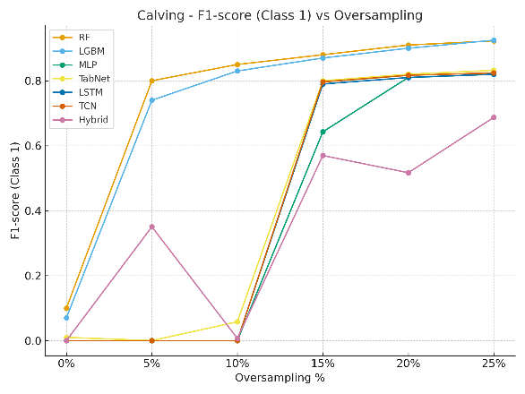 | 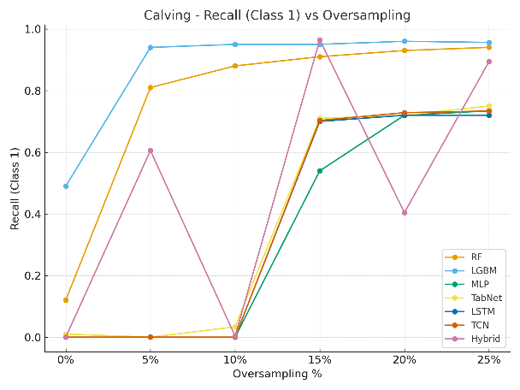
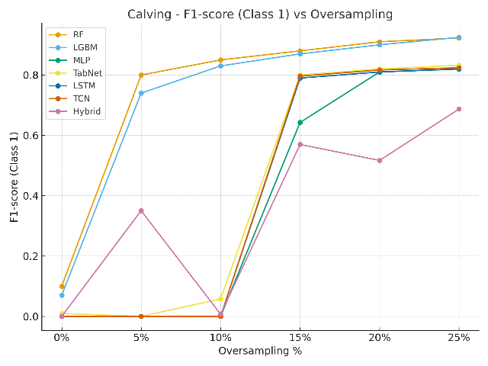 | 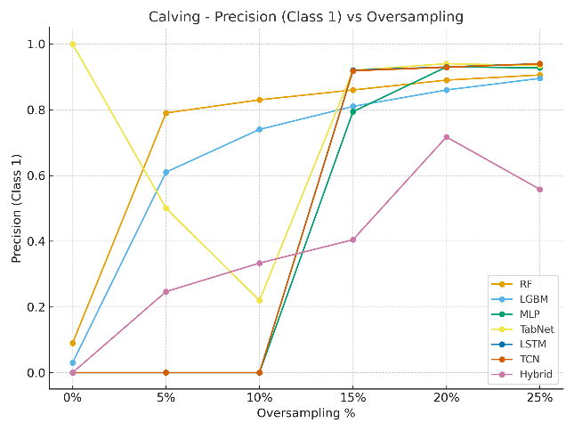
Fig. 4.13 Variation in the metric for calving conditions
On an overall, RF and Light GBM models performed strongly and consistently in the case of oestrus, lameness and calving with oversampling. Whereas, in the case of mastitis, hybrid ensemble out performed others. These results also confirms that single model architecture out performed other and the best-performing approach depends on disease characteristics, prevalence, and the strength of behavioural patterns.
However, for further predictions the models are selected based on the following assumptions.
1. The model should not be oversampled above 15 percent
2. The best model for the disease was selected from 5-15 percent oversampled data where the F1 score is above at least 70 percent in order to reduce the effect of higher synthetic nature in the data. An exception was taken for the oestrus due to its higher variation with the metric compared to lower sampled data. In addition to the above, the accuracy also is considered in selection of the model.
3. The 0 percent model is not selected for the study due to poor metrics and higher imbalance.
Based on the above factors, the model selected for the study was as mentioned in the table 4.10 below.
Sl No. | Disease | Metric | Oversampling rate
1 | Mastitis | Hybrid | 15%
2. | Oestrus | RF | 25%
3. | Calving | RF | 10%
4. | Lameness | RF | 10%
Table 4.10. Selected models for multiple prediction
4.7 Deployment of the model
The deployment of the model is carried out with the help of streamlit in python. The model is deployed with the comments which will focus on the following:
1. The disease prediction and its nature or rarity.
2. The additional comments based on the interactive nature of the disease
3. The sensor issues while recording the data.
The deployed model page layout is portrayed in the figure 4.14 and 4.15 below. In this images, figures 4.14 and 4.15 shows a sample input and out sections of the disease prediction model. In the input section, there is a provision for the master comparison table uploading with our metric and selection of prediction format which is whether multiple or single. In addition to the above, the selection of number of days for input feature to be added is also available. The days could be from 3-20 days and the values in minutes for the mean per hour for the 8 hour time should be input to get the predictions.
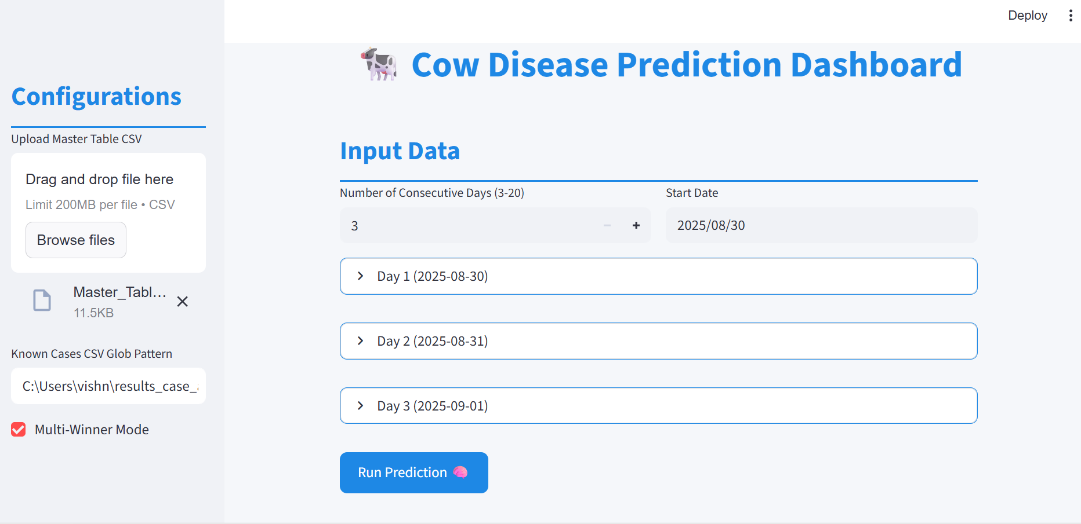
Fig. 4.14 The input section of the dashboard
The predictions based on the best models from the list of master comparison table will be made and displayed as shown in the figure below.
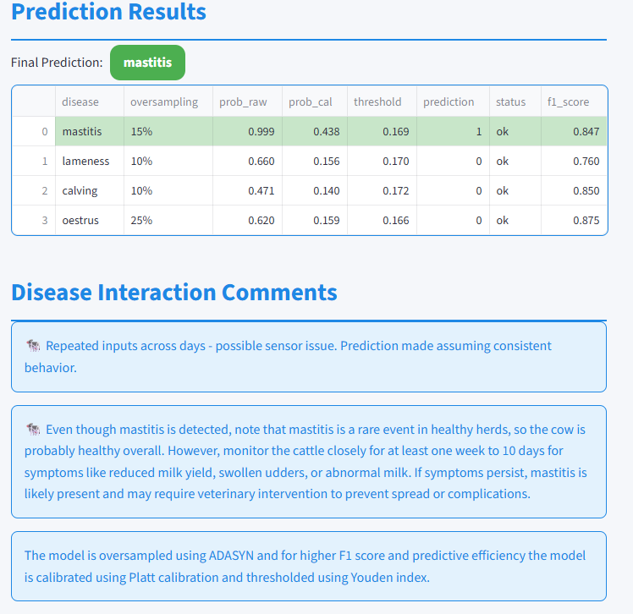
Fig. 4.15 The disease prediction page with the comments.
Subsequently, the selected metric and the associated models will also be displayed along with the prediction as shown in the figure 4.16 below.
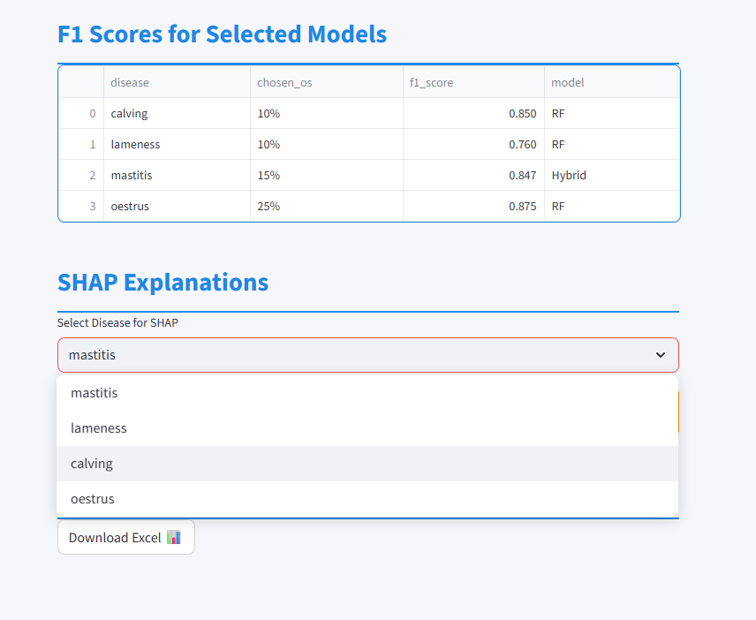
Fig. 4.16 The metric selected for the prediction and the downloads

Chapter 5
Conclusions and Future Work
This aim of this dissertation was to develop a machine learning framework for predicting multiple cattle diseases such as mastitis, lameness, oestrus, and calving using time-series behavioural data. With the help of traditional tree based, nueral and hybrid including Random Forest, LightGBM, MLP, TabNet, LSTM, and TCN, the study demonstrated that predictive performance can be very effective in the disease detection.
The application of ADASYN oversampling at different levels (0%–25%) is the highlight of this modelling approach which effectively addressed the severe class imbalance. This not only enhanced the imbalance but also the metrics associated with the model such as accuracy, precision and recall. Bias handling and imbalance handling which are nearly impossible for the rare event data like disease prediction, which was also effectively addressed with the help of calibration and thresholding using Platt scale and Youden index respectively. This improved the reliability of the model despite the fact that it contained synthetic samples.
The research further developed an interactive prediction tools using python Streamlit dashboard, enabling practical usability of the models in farm-managementss.
Overall, the work provides evidence that data-driven approaches, when carefully balanced with calibration and domain-specific knowledge, can play an important role in improving herd health management and reducing economic losses in dairy farming.
5.1 Future Work
- Dataset Expansion – Despite the fact that, the successful models are created using the above approaches, the health data from sensor is an inevitable part such as ruminating characteristics, lactating characteristic, blood pressure, weight and age of the cattle which can enable perfect pattern distribution enabling the neural networks to pick up easily.
- Temporal Factors – The temporal networks are the important factors which can be effectively used in the disease predictions as the diseases progresses slowly and these underlying patterns can very well predict better than the conventional neural models, for that also the additional features discussed above is needed.
- Calibration under Real-world Conditions – Validation is one of the disadvantage associated with the disease prediction dataset which are anonymised, else the calibration can be easily carried out. Instead of cow id, the features such as age and weight can also give a way for the easy calibration by comparison.
- Integration with IoT Systems – The current algorithm can be connected to an IoT and the real time monitoring and prediction of disease progression can be easily understood.
- Bias and Fairness Testing – Bias handling is a very interesting part where the future work could go deeper. Instead of platt and isotonic scaling the combined approach of other methods could also be studied for effective bias handling of rare cases which can bring out a major outbreak in disease prediction scenarios.
- Multi-modal Fusion – The additional features such as environmental factors (temperature, humidity), feed intake, or milk yield could significantly improve predictive accuracy. The ruminating and lactating characteristics are a significant factor guiding the disease in case of bovines.
- Deployment and User Adoption – Even though, Streamlit app was built as a prototype in the current investigation, future work should focus on software which could easily process data from sensors and update the farmers automatically.

References
Bita Ghasemkhani, Ozlem Varliklar, Dogan, Y, Semih Utku, Kokten Ulas Birant & Derya Birant 2024, ‘Federated Multi-Label Learning (FMLL): Innovative Method for Classification Tasks in Animal Science’, Animals, vol. 14, Multidisciplinary Digital Publishing Institute, no. 14, pp. 2021–2021.
Divya, R. & Jeba, J.R., 2024. A novel framework for multiple disease prediction in telemedicine systems using deep learning. Automatika, 65(3), pp.763–777. https://doi.org/10.1080/00051144.2024.2301889
Dmitry Yu. Pavkin, Dorokhov, AS, Vladimirov, FE, Dovlatov, IM & Lyalin, KS 2021, ‘Algorithms for Detecting Cattle Diseases at Early Stages and for Making Diagnoses and Related Recommendations’, Applied Sciences, vol. 11, Multidisciplinary Digital Publishing Institute, no. 23, pp. 11148–11148.
Florit, E., Romanzin, A., Corazzin, M. and Spanghero, M., 2023. Eating time of dairy cows: a study focusing on commercial farms. Italian Journal of Animal Science, 22(1), pp.1023-1032.
Gopisetti, LD, Kummera, SKL, Pattamsetti, SR, Kuna, S, Parsi, N & Kodali, HP 2023, Multiple Disease Prediction System using Machine Learning and Streamlit, IEEE Xplore, pp. 923–931, viewed 4 August 2023, <https://ieeexplore.ieee.org/document/10060903>.
Guyard, R. and Delagarde, R., 2025. Grazing time of dairy cows recorded using two devices based on accelerometers. Applied Animal Behaviour Science, 283, p.106515.
Haibo He, Yang Bai, Garcia, EA & Shutao Li 2008, ADASYN: Adaptive synthetic sampling approach for imbalanced learning, IEEE Xplore, pp. 1322–1328.
Hogeveen, H, Steeneveld, W & Wolf, CA 2019, ‘Production Diseases Reduce the Efficiency of Dairy Production: A Review of the Results, Methods, and Approaches Regarding the Economics of Mastitis’, Annual Review of Resource Economics, vol. 11, no. 1, pp. 289–312.
Hyde, RM, Down, PM, Bradley, AJ, Breen, JE, Hudson, C, Leach, KA & Green, MJ 2020, ‘Automated prediction of mastitis infection patterns in dairy herds using machine learning’, Scientific Reports, vol. 10, no. 1.
Ilayaraja, M & Meyyappan, T 2013, Mining medical data to identify frequent diseases using Apriori algorithm, IEEE Xplore, pp. 194–199.
krishikosh 2025, Egranth.ac.in, viewed 17 August 2025, <https://krishikosh.egranth.ac.in/bitstreams/e3124861-d559-418c-aa9d-a1460154be00/download>.
Lardy, R., Ruin, Q. and Veissier, I., 2023. Discriminating pathological, reproductive or stress conditions in cows using machine learning on sensor-based activity data. Computers and Electronics in Agriculture, 204, p.107556.
Li, J.C.H., 2016. Effect size measures in a two-independent-samples case with nonnormal and nonhomogeneous data. Behavior research methods, 48(4), pp.1560-1574.
Liseune, A, den Poel, DV, Hut, PR, van Eerdenburg, FJCM & Hostens, M 2021, ‘Leveraging sequential information from multivariate behavioral sensor data to predict the moment of calving in dairy cattle using deep learning’, Computers and Electronics in Agriculture, vol. 191, p. 106566.
Liu, M, Zhang, J, Adeli, E & Shen, D 2019, ‘Joint Classification and Regression via Deep Multi-Task Multi-Channel Learning for Alzheimer’s Disease Diagnosis’, IEEE Transactions on Biomedical Engineering, vol. 66, no. 5, pp. 1195–1206, viewed 30 September 2020, <https://ieeexplore.ieee.org/document/8463559>.
M. Priyadharshini, A. Faritha Banu, Sharma, B, Chowdhury, S, Rabie, K & Thokozani Shongwe 2023, ‘Hybrid Multi-Label Classification Model for Medical Applications Based on Adaptive Synthetic Data and Ensemble Learning’, Sensors, vol. 23, Multidisciplinary Digital Publishing Institute, no. 15, pp. 6836–6836.
Ma, C & Álvarez, MA 2023, ‘Large scale multi-output multi-class classification using Gaussian processes’, Machine Learning.
Meike van Leerdam, Hut, PR, Arno Liseune, Slavco, E, Hulsen, J & Miel Hostens 2024, ‘A predictive model for hypocalcaemia in dairy cows utilizing behavioural sensor data combined with deep learning’, Computers and Electronics in Agriculture, vol. 220, Elsevier BV, pp. 108877–108877.
Morota, G, Ventura, RV, Silva, FF, Koyama, M & Fernando, SC 2018, ‘BIG DATA ANALYTICS AND PRECISION ANIMAL AGRICULTURE SYMPOSIUM: Machine learning and data mining advance predictive big data analysis in precision animal agriculture1’, Journal of Animal Science, vol. 96, no. 4, pp. 1540–1550.
Palma, O, Plà-Aragonés, LM, Cawley, AM & Albornoz, VM 2025, ‘AI and Data Analytics in the Dairy Farms: A Scoping Review’, Animals, vol. 15, Multidisciplinary Digital Publishing Institute, no. 9, pp. 1291–1291.
Rasmussen, P, Barkema, HW, Osei, PP, Taylor, J, Shaw, AP, Conrady, B, Chaters, G, Muñoz, V, Hall, DC, Apenteng, OO, Rushton, J & Torgerson, PR 2024, ‘Global Losses Due to Dairy Cattle diseases: a comorbidity-adjusted Economic Analysis’, Journal of Dairy Science, vol. 107, Elsevier BV, no. 9.
Rossi, M, Minicozzi, G, Pascarella, G & Capasso, A 2020, ‘ESG, Competitive Advantage and Financial performances: a Preliminary Research’, Handle.net, vol. 1, no. 1, pp. 969–986.
Tucker, C.B., Jensen, M.B., de Passillé, A.M., Hänninen, L. and Rushen, J., 2021. Invited review: Lying time and the welfare of dairy cows. Journal of Dairy Science, 104(1), pp.20-46.
van der Heide, EMM, Kamphuis, C, Veerkamp, RF, Athanasiadis, IN, Azzopardi, G, van Pelt, ML & Ducro, BJ 2020, ‘Improving predictive performance on survival in dairy cattle using an ensemble learning approach’, Computers and Electronics in Agriculture, vol. 177, Elsevier, p. 105675.
Wagner, N, Antoine, V, Koko, J, Marie-Madeleine Mialon, Lardy, R & Veissier, I 2020, ‘Comparison of Machine Learning Methods to Detect Anomalies in the Activity of Dairy Cows’, Lecture notes in computer science, Springer Science+Business Media, pp. 342–351.
Wiwik Anggraeni, A. Muklason, A.F. Ashari, A. Wahyu & None Darminto 2013, ‘Developing Mobile Intelligent System for Cattle Disease Diagnosis and First Aid Action Suggestion’, pp. 117–121, viewed 17 August 2025, <https://ieeexplore.ieee.org/abstract/document/6603876>.
Zhang, X, Zhao, H, Zhang, S & Li, R 2019, ‘A Novel Deep Neural Network Model for Multi-Label Chronic Disease Prediction’, Frontiers in Genetics, vol. 10.

APPENDIX A
ETHICAL APPROVAL FROM THE INSTITUTE












APPENDIX B
GitLab Repository- https://gitlab.comp.dkit.ie/D00275640/Prediction_of_cattle_disease_using_machine_learning_Vishnu/-/tree/81687dc70af1c5001cbc004c0f3887534549d6d6/

APPENDIX C
WEEKLY JOURNAL PROJECT LOG





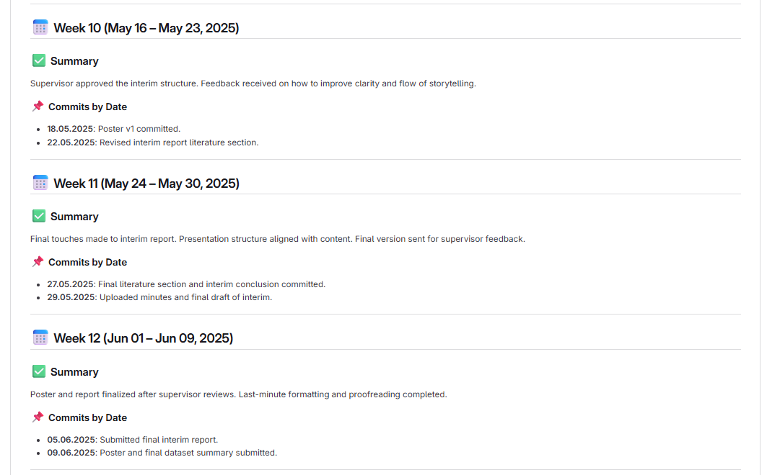

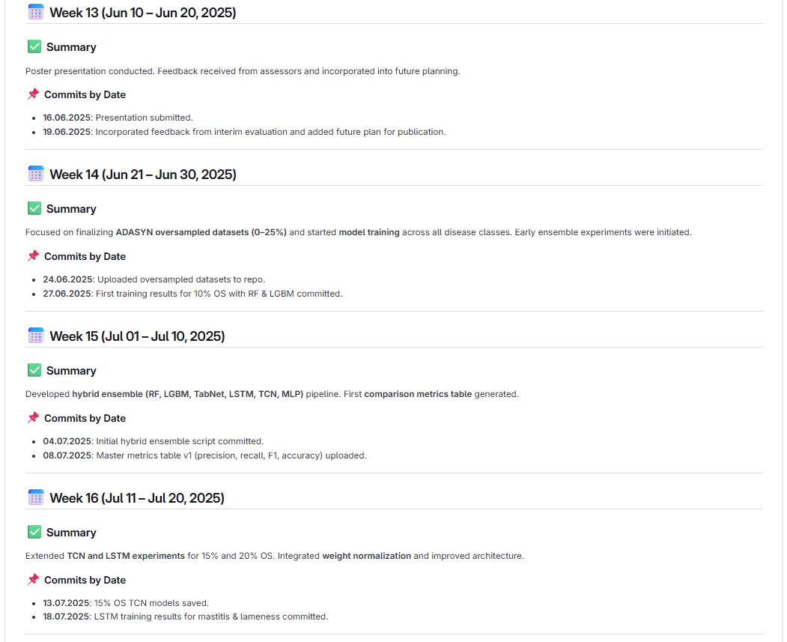
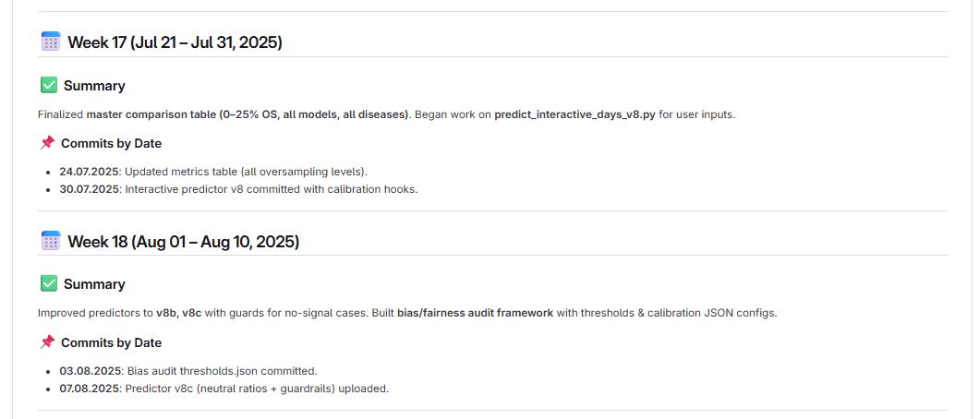


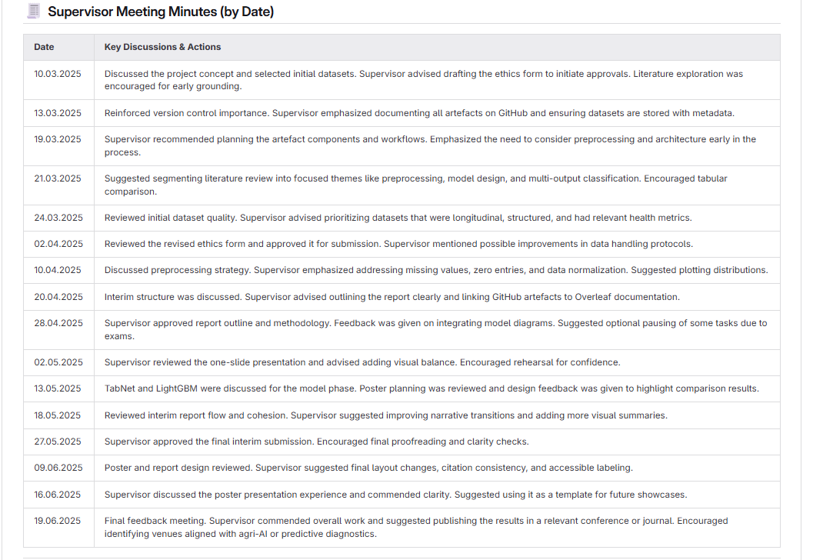

APPENDIX D
CODE REPOSITORY LINK AND BUILD INSTRUCTIONS
Link- https://gitlab.comp.dkit.ie/D00275640/Prediction_of_cattle_disease_using_machine_learning_Vishnu/-/tree/81687dc70af1c5001cbc004c0f3887534549d6d6/scripts
Steps | Instructions
1 | Download and copy the master comparison table to the parent folder
2 | Download and copy the calibration zip files to the parent folder
3. | Copy and extract the model.zip file – large size to the parent folder
4. | Either run  1. python C:\Users\vishn\predict_interactive_days_v12_plus.py ^  --table "C:\Users\vishn\Master_Table_Updated_25pct.csv" ^  --known "C:\Users\vishn\results_case_all_*.csv" ^  --out "C:\Users\vishn\results_v12_corrected.xlsx" ^  --multi  or  2. python C:\Users\vishn\predict_interactive_days_v12.py ^  --table "C:\Users\vishn\Master_Table_Updated_25pct.csv" ^  --known "C:\Users\vishn\results_case_all_*.csv" ^  --out "C:\Users\vishn\results_v12_corrected.xlsx" ^  --multi
5. | Execute the dashboard using  python streamlit dashboard_final.py

APPENDIX E
Generative AI- Prompts
No. | Prompt
1 | Please give me a script to train an MLP model for multi-output classification.
2 | Please modify my MLP code so it can run on CUDA GPU.
3 | Please adjust my MLP model so that it saves the best checkpoint per epoch.
4 | Please help me tune the learning rate and hidden layer sizes for my MLP model.
5 | Please create a training script for Random Forest across all oversampling levels.
6 | Please modify my LightGBM training script to include class weights.
7 | Please create a TabNet training script with early stopping.
8 | Please show me how to add weight normalization to my TCN model.
9 | Please extend my TCN architecture to three layers with channels [16, 32, 64].
10 | Please add batch normalization to my LSTM model.
11 | Please change my LSTM to support multiple diseases simultaneously- Error Fixing.
12 | Please implement a hybrid ensemble combining RF, LGBM, TabNet, LSTM, and TCN.- Error Fixing
13 | Please extend my hybrid ensemble to also include MLP.
14 | Please create JSON config files for hybrid ensembles- with the thresholds matching the calibration file
15 | Please fix my hybrid JSON to point to the correct predictions dictionary.
16 | Please generate ROC curves for all models across oversampling levels.
17 | Please create calibration plots for each disease.
18 | Please show me how to perform Platt scaling for calibration.
19 | Please show me how to apply isotonic regression calibration.
20 | Please add threshold selection based on Youden’s J statistic.
21 | Please adjust thresholds so that precision is always above 0.85.
22 | Please add prevalence-aware posterior correction.
23 | Please show me how to generate random input grids for threshold testing.
24 | Please make my prediction script robust to errors.
25 | Please add neutral ratio handling to my predictor.
26 | Please add no-signal guards in the predictor when all inputs are zero.
27 | Please update predictor v8 to predictor v8b with BOM tolerance.
28 | Please extend predictor v8b to predictor v8c with guardrails.
29 | Please create predictor v12 with corrected thresholds and calibration.
30 | Please make predictor accept oversampling levels as arguments.
31 | Please add option for user to specify number of days of input.
32 | Please allow predictor to accept time-of-day input (0–8, 9–16, 17–24).
33 | How to manually calibrate the model with the known values
34 | Help me create a json file for the threshold settings
35 | Please integrate thresholds.json into predictor.
36 | Please integrate calibrators/*.pkl into predictor.
37 | Please add per-row threshold column option to predictor.
38 | Please make predictor output both binary result and probability.
39 | Please update predictor to save results as Excel file.
40 | Please add argument for known case predictions.
41 | Please add argument for unknown case predictions.
42 | Please show me how to compare predictions across oversampling levels.
43 | Please show me how to generate metrics tables per disease.
44 | The ensemble model temporal features and others vary how to unify both of them to get a predcition
45 | Please produce per-disease plots of accuracy, precision, recall, and F1.
46 | Fis the error in the calling of ensemble model
47 | How to create 4 and 8 features separately to call ensemble models from the comparison table
48 | Please explain why high oversampling inflates positive rates.
49 | Error- fixing due to calling of ensemble models
50 | Please explain why TCN outperforms LSTM for sequence data.
51 | Please show me how to use SHAP for feature explainability.
52 | Please show me how to use LIME for feature explainability.
53 | Please add SHAP explainability into my Streamlit app as the dashboard functioning is too slow
54 | Please add LIME explainability into my Streamlit app as SHAP is too slow
55 | Please show me how to generate SHAP summary plots.
56 | Please show me how to generate LIME explanations for a single instance.
57 | Please create a Streamlit app for predicting all four diseases simultaneously.
58 | Please add user input for oversampling level in Streamlit.
59 | Please add sliders for EAT, REST, IN_ALLEYS in Streamlit.
60 | Please add dropdown for time of day in Streamlit.
61 | Please add input for number of days in Streamlit.
62 | Please add results table in Streamlit output.
63 | Please add SHAP plots in Streamlit output.
64 | Please add comparison plots in Streamlit output.
65 | Please add option to upload CSV in Streamlit app.
66 | Please show me how to deploy Streamlit app locally.
67 | Please show me how to deploy Streamlit app on GitHub Pages.
68 | Please show me how to deploy Streamlit app on Heroku.
69 | Please create master comparison table with all oversampling levels.
70 | Please update master comparison table to include macro and weighted averages.
71 | Please prepare tables for each disease separately.
72 | Please prepare combined plot showing metrics across diseases.
73 | Please explain how to calibrate across oversampling levels.
74 | Please create bias/fairness audit JSON for thresholds.
75 | Please create bias/fairness audit JSON for couplings.
76 | Please create bias/fairness audit JSON for context.
77 | Please update predictor to use bias_audit.py.
78 | Please explain how to measure fairness across subgroups.
79 | Please explain coupling between diseases.
80 | Please list which diseases often occur together in dairy cows.
81 | Please list which diseases rarely co-occur.
82 | Please give probabilities of one disease leading to another.
83 | Please show me how to validate with known positive cases.
84 | Please show me how to validate with known negative cases.
85 | Please explain differences between SMOTE and ADASYN.
86 | Please add option for synthetic data generation in predictor.
87 | Please show me how to log all predictions in a results file.
88 | Please show me how to track model versions in repo.
89 | Please show me how to use Git properly for week-by-week commits.
90 | Please prepare docs folder with journal and appendix.
91 | Please update weekly research journal in Markdown.
92 | Please expand weekly journal up to submission date.
93 | Please prepare appendix listing all prompts used.
94 | Please rewrite prompts in correct grammar for submission.
95 | Please explain how to structure my artefact for submission.

