Mini Shell in C

This is a shell, written in c.

Used basic functions such as pid, process forking, threading for all the commands to execute. This shell contains 9 basic functions, of a general linux shell. There will be a loading screen, when the user starts the shell and then it gives the provision to enter commands and view their output.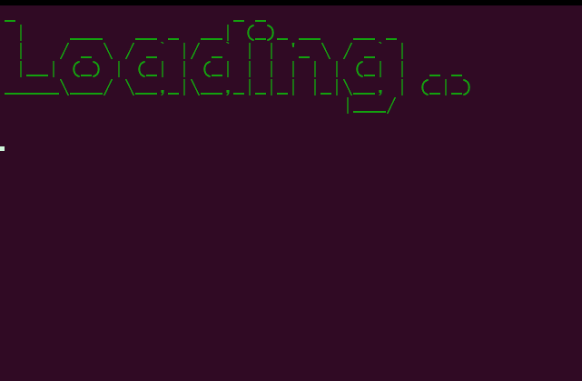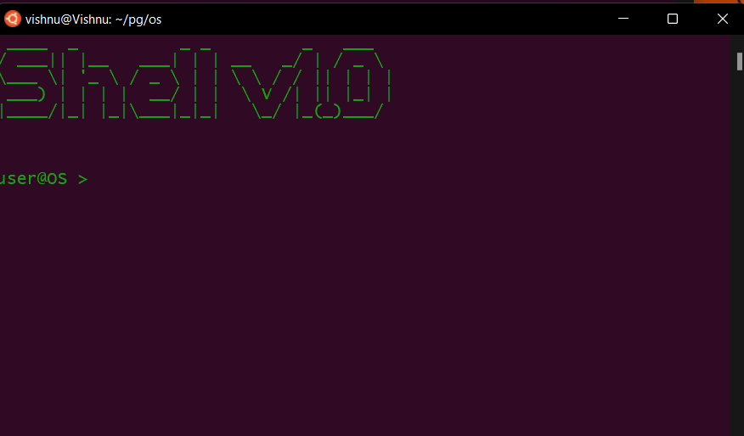

Instead of having normal commands, here, I’ve recreated all the functions with inbuilt error handling feature. 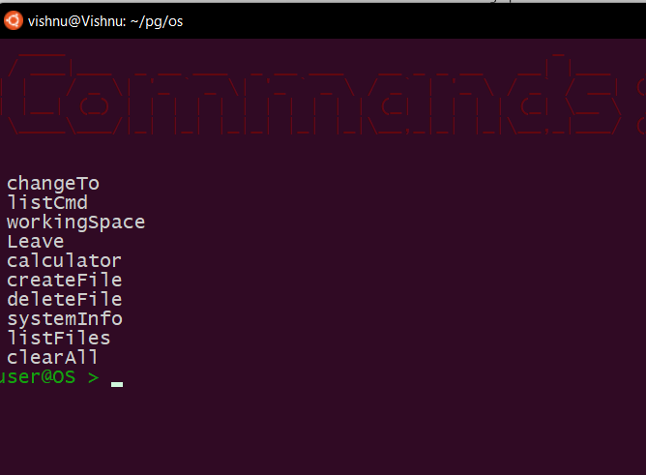

This calculator calculates the value of the expression given using the default rules of python.

