**A PROJECT REPORT**

**ON**

**Chatbot for Simple Questions**

**A Report Submitted to**

**IIDT - Blackbuck Engineers Pvt. Ltd**

**Submitted by**

**Chintala Harish**

**21B91A0569**

**Table Of Contents**

ABSTRACT 3

Introduction: 3

ABOUT THE PROJECT 10

Chatbot for Simple Questions Project Survey 11

SYSTEM ANALYSIS 14

IMPLEMENTATION 25

TESTING 29

OUTPUT SCREENS 33

CONCLUSION 34

BIBLIOGRAPHY 35

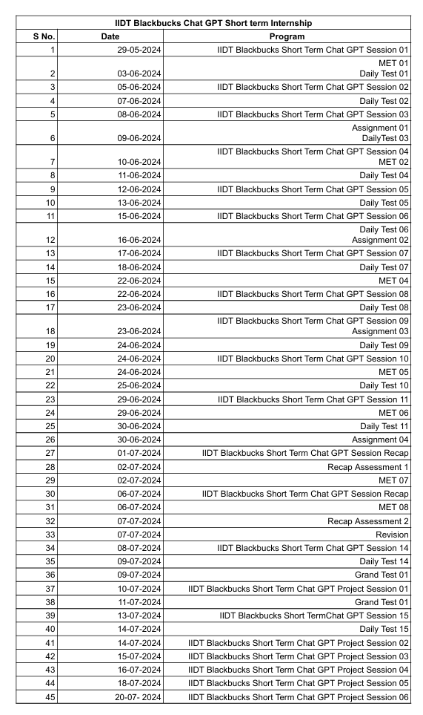

# **ABSTRACT**

This project is about *Chatbot for Simple Questions.*

# **Introduction**:

This project aims to develop a rule-based chatbot capable of answering predefined questions, leveraging the power of Hugging Face's pre-trained models and presenting a user-friendly interface through Gradio. In an era of increasing demand for intelligent conversational agents, this chatbot serves as a bridge between simple rule-based systems and more advanced natural language processing capabilities. By combining pre-trained language models with custom rule-based logic, we create a chatbot that demonstrates enhanced understanding and response generation while maintaining the simplicity and control of rule-based systems.

**Problem Statement and Overview:**

Organizations often struggle to provide instant, accurate responses to common customer inquiries, leading to delays in customer service and increased operational costs. While advanced AI chatbots offer sophisticated solutions, they can be complex to implement and maintain. This project addresses the need for a middle-ground solution – a chatbot that utilizes the power of pre-trained language models for better language understanding, while still operating within a controlled, rule-based framework. This approach aims to improve response accuracy and natural language understanding compared to traditional rule-based systems, while offering more predictability and easier customization than fully AI-driven chatbots.

**Tools and Applications:**

The chatbot will be developed using the following key technologies:

Python: The primary programming language

Hugging Face Transformers: For accessing and utilizing pre-trained language models

Gradio: To create an intuitive and interactive web interface

NLTK (Natural Language Toolkit): For additional text processing tasks

JSON: For storing and managing the predefined questions and answers

**Detailed Description of Sub-modules:**

* Input Processing Module:
  + Utilizes Hugging Face's tokenizer for advanced text normalization and tokenization
  + Performs basic cleaning and preprocessing of user input
* Intent Recognition Module:
  + Employs a Hugging Face sentence-similarity model to match user input with predefined intents
  + Falls back to rule-based pattern matching for specific scenarios
* Response Generation Module:
  + Retrieves base responses from a JSON-based knowledge base
  + Utilizes a Hugging Face text generation model to enhance and personalize responses.
* Conversation Flow Management:
  + Maintains conversation context using a simple state machine
  + Handles multi-turn conversations and follow-up questions
* Knowledge Base Management:
  + Stores intents, patterns, and base responses in a JSON format
  + Provides an interface for easy updates and modifications
* Gradio Interface Module:
  + Creates an interactive web interface for the chatbot
  + Handles input/output formatting and display

**Design and Flow of the Project:**

* The user interacts with the chatbot through the Gradio web interface.
* User input is processed and tokenized using Hugging Face's tokenizer.
* The Intent Recognition Module uses a sentence-similarity model to identify the most likely intent.
* If the intent is recognized with high confidence, the Response Generation Module retrieves a base response from the knowledge base.
* The retrieved response is then enhanced using a text generation model to add naturalness and context-awareness.
* For intents not recognized with high confidence, the system falls back to rule-based pattern matching.
* The Conversation Flow Management module tracks the state of the conversation and manages context.
* The final response is displayed to the user through the Gradio interface.
* The process repeats for subsequent user inputs until the conversation is terminated.
* This flow combines the strengths of rule-based systems with the natural language understanding capabilities of pre-trained models, all presented through an accessible web interface.

**Conclusion and Expected Output:**

The project aims to produce a functional chatbot that demonstrates the synergy between rule-based systems and pre-trained language models. The expected outputs include:

* A working Python-based chatbot application integrating Hugging Face models
* An intuitive Gradio web interface for user interaction
* A customizable JSON knowledge base for easy intent and response management
* Enhanced natural language understanding capabilities compared to purely rule-based systems
* More controllable and predictable responses compared to fully AI-driven chatbots
* Ability to handle nuanced language and maintain context in conversations

This chatbot will serve as a proof-of-concept for integrating pre-trained language models into rule-based systems. It will demonstrate how organizations can leverage advanced NLP capabilities without fully committing to complex, AI-driven solutions. The project will provide insights into the balancing act between the control offered by rule-based systems and the flexibility of machine learning models.

The use of Hugging Face models will allow for better understanding of user intents and generation of more natural responses, potentially improving user satisfaction compared to traditional rule-based chatbots. At the same time, the rule-based framework will ensure that the chatbot's responses remain within expected parameters, addressing concerns about unpredictability in AI systems.

The Gradio interface will make the chatbot accessible to a wide range of users, potentially serving as a template for deploying similar systems in real-world scenarios. This interface will also facilitate easy testing and demonstration of the chatbot's capabilities.

By combining these elements, the project will offer valuable insights into the development of hybrid chatbot systems, paving the way for more sophisticated implementations that balance the strengths of both rule-based and AI-driven approaches. The resulting chatbot will not only serve its immediate purpose of answering predefined questions but also provide a foundation for future research and development in the field of conversational AI.

**What is Generative AI?**

Generative AI, a subset of artificial intelligence, has emerged as a groundbreaking technology capable of creating new content and data. Unlike traditional AI systems that primarily analyze and classify existing data, generative AI models can generate entirely novel outputs, such as text, images, music, and even code. This revolutionary capability has opened up vast possibilities across various industries and applications.

**How Generative AI Works:**

At the core of generative AI are complex algorithms, often based on neural networks, trained on massive datasets.

These models learn to identify patterns and underlying structures within the data, enabling them to generate new content that shares similar characteristics. The process typically involves two key steps:

1. **Training:** The model is fed a large amount of data, allowing it to learn the patterns and relationships within the information.
2. **Generation:** Once trained, the model can generate new content by sampling from the learned distribution.



**Key Techniques in Generative AI:**

Several techniques have been instrumental in the advancement of generative AI:

* **Generative Adversarial Networks (GANs):**

GANs consist of two neural networks, a generator and a discriminator, competing against each other. The generator creates new data, while the discriminator evaluates its authenticity. This adversarial process leads to the generation of increasingly realistic outputs.

* **Variational Autoencoders (VAEs):**

VAEs encode input data into a lower-dimensional latent space and then decode it to reconstruct the original data. By manipulating the latent space, new data can be generated.

* **Transformer Models:**

These models have gained prominence in natural language processing and have been adapted for generative tasks. They excel at capturing long-range dependencies in data, enabling the generation of coherent and contextually relevant text.

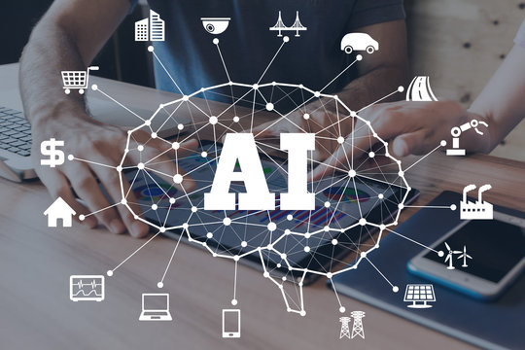

**Applications of Generative AI:**

1. **Natural Language Processing:**
   * Generative AI models like GPT-4 are used in chatbots, virtual assistants, and content generation, providing coherent and contextually relevant responses.
   * AI can assist in writing articles, creating marketing content, and generating reports. This helps automate repetitive tasks and allows humans to focus on more creative aspects.
2. **Image and Video Synthesis:**
   * AI can create realistic images and videos, which are used in entertainment, marketing, and even healthcare for creating medical imaging.
   * In medical imaging, AI-generated data can help train diagnostic models, create detailed simulations, and assist in planning complex surgeries.
3. **Music and Audio Generation:**
   * AI can compose original music pieces, generate accompaniments, and even create new genres. Musicians and composers use these tools to explore new creative possibilities and enhance their work.
   * Generative models can produce realistic synthetic voices for use in audiobooks, virtual assistants, and accessibility tools.
4. **Simulation and Modelling:**
   * The AI-generated simulations are used in various scientific fields, such as climate modelling, molecular simulations, and physics experiments. These models help researchers explore complex phenomena and predict future outcomes.
   * Generative AI can create synthetic data to augment training datasets for machine learning models, improving their performance and robustness.

**Ethical Considerations and Challenges:**

While generative AI holds immense potential, it also raises several ethical considerations and challenges that must be addressed to ensure its responsible use.

1. **Misinformation and Deepfakes:**
   * + **Risks**: The ability of generative AI to create highly realistic images, videos, and text raises concerns about the spread of misinformation and the creation of deepfakes. These false media can be used maliciously to deceive people, manipulate public opinion, and harm reputations.
     + **Mitigation**: Developing robust detection methods, promoting digital literacy, and establishing ethical guidelines are crucial steps in mitigating these risks.
2. **Bias and Fairness**:
   * + **Challenges**: Generative AI models learn from large datasets that may contain biases. These biases can be reflected in the generated content, perpetuating stereotypes and unfair practices.
     + **Solutions**: Ensuring diverse and representative training data, implementing bias detection mechanisms, and continuously monitoring AI outputs can help address these challenges.
3. **Privacy Concerns**:
   * + **Data Usage**: The use of large datasets for training generative models can raise privacy concerns, especially if sensitive or personal information is included.
     + **Regulations**: Adhering to data protection regulations, anonymizing data, and obtaining explicit consent from data owners are essential practices to protect privacy.

**Future Directions and Research:**

The field of generative AI is rapidly evolving, with ongoing research aimed at enhancing model capabilities, addressing ethical concerns, and exploring new applications.

* 1. **Improved Model Architectures**:
     + - * **Hybrid Models**: Combining different generative techniques, such as GANs and VAEs, can leverage their strengths and improve the quality of generated content.
         * **Scalability**: Developing scalable models that can handle increasingly large and complex datasets will enhance the performance and applicability of generative AI.
  2. **Ethical AI Development**:
     + - * **Transparent AI**: Promoting transparency in AI development, including explainable models and open-access research, can build trust and accountability in generative AI applications.
         * **Inclusive AI**: Ensuring that AI benefits a diverse range of users and communities, addressing biases, and promoting fair practices are key goals for future development.
  3. **Novel Applications**:
     + - * **Interdisciplinary Research**: Collaborating with experts from various fields, such as healthcare, education, and the arts, can uncover new and impactful uses for generative AI.
         * **AI in Creativity**: Exploring the role of AI as a creative partner, rather than just a tool, can lead to innovative artistic expressions and new forms of collaboration between humans and machines.

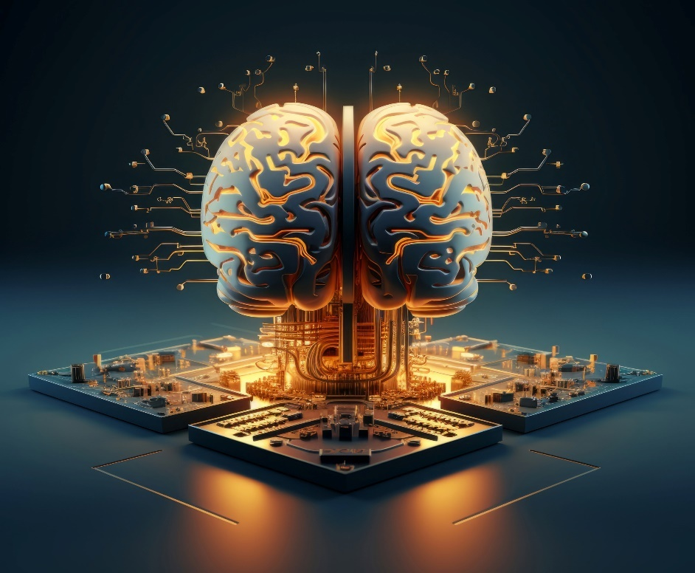

**Conclusion:**

Generative AI has significantly advanced the capabilities of artificial intelligence, offering innovative solutions across various fields, from natural language processing to creative arts and scientific research. The development of sophisticated models such as GANs, VAEs, and Transformers has enabled AI to generate highly realistic and useful content, revolutionizing the way we interact with technology. These advancements have not only enhanced the efficiency and creativity of numerous applications but also opened up new possibilities for automation and human-machine collaboration. The profound impact of generative AI is evident in its ability to streamline processes, produce high-quality outputs, and provide personalized experiences, thereby driving progress and innovation in numerous industries.



However, the rise of generative AI also brings forth significant ethical considerations and challenges. Issues related to misinformation, bias, privacy, and the responsible use of AI-generated content need to be carefully addressed to ensure the technology's positive impact on society. As we continue to explore the potential of generative AI, it is crucial to establish ethical guidelines, promote transparency, and develop robust mechanisms to mitigate associated risks. The future of generative AI lies in striking a balance between leveraging its transformative capabilities and upholding ethical standards, ensuring that it remains a force for good in advancing human knowledge, creativity, and well-being.

# **ABOUT THE PROJECT**

**Project Definition:**

This project aims to develop a rule-based chatbot capable of answering predefined questions, leveraging the power of Hugging Face's pre-trained models and presenting a user-friendly interface through Gradio. In an era of increasing demand for intelligent conversational agents, this chatbot serves as a bridge between simple rule-based systems and more advanced natural language processing capabilities. By combining pre-trained language models with custom rule-based logic, we create a chatbot that demonstrates enhanced understanding and response generation while maintaining the simplicity and control of rule-based systems.

**Proposed Solution:**

• The user interacts with the chatbot through the Gradio web interface.

• User input is processed and tokenized using Hugging Face's tokenizer.

• The Intent Recognition Module uses a sentence-similarity model to identify the most likely intent.

• If the intent is recognized with high confidence, the Response Generation Module retrieves a base response from the knowledge base.

• The retrieved response is then enhanced using a text generation model to add naturalness and context-awareness.

• For intents not recognized with high confidence, the system falls back to rule-based pattern matching.

• The Conversation Flow Management module tracks the state of the conversation and manages context.

• The final response is displayed to the user through the Gradio interface.

• The process repeats for subsequent user inputs until the conversation is terminated.

• This flow combines the strengths of rule-based systems with the natural language understanding capabilities of pre-trained models, all presented through an accessible web interface.

**Objective:**

* **User Interaction**: Develop an intuitive and engaging chatbot interface that simplifies the ordering process.
* **Order Customization**: Allow users to customize their orders with various options such as size, toppings, and special instructions.
* **Transaction Management**: Implement secure payment processing and order confirmation features.
* **Customer Support**: Provide timely and accurate responses to customer queries related to orders, delivery, and other services.
* **Scalability**: Ensure that the chatbot can handle multiple concurrent users and integrate with various platforms (e.g., web, mobile).
* **Data Analytics**: Collect and analyse user interaction data to improve the chatbot's performance and user satisfaction.

# **Chatbot for Simple Questions Project Survey**

**Theoretical Background:**

The development of a rule-based chatbot involves a blend of theoretical concepts from natural language processing (NLP), machine learning, and artificial intelligence (AI). Here are the key theoretical components:

**Natural Language Processing (NLP):**

Tokenization: Breaking down text into smaller units (tokens) to simplify processing. This is fundamental for tasks like parsing and understanding user inputs.

Normalization: Standardizing text data by converting it to a consistent format, including lowercasing, stemming, and lemmatization, to handle linguistic variations.

**Rule-Based Systems:**

Rule-based systems use predefined rules to process inputs and generate responses. These rules are typically crafted based on domain knowledge and can include pattern matching, regular expressions, or decision trees.

The chatbot's ability to handle specific scenarios or queries is directly tied to the quality and coverage of these rules.

**Machine Learning and Pre-trained Models:**

Pre-trained Language Models: Utilizing models like those from Hugging Face (e.g., "TheBloke/Llama-2-7b-Chat-GPTQ"), which are trained on large datasets and fine-tuned for specific tasks like text generation or sentiment analysis. These models bring in advanced NLP capabilities, including understanding context and generating human-like responses.

Quantization: A technique used to reduce the size of deep learning models, making them faster and more efficient without significantly compromising accuracy.

**Intent Recognition and Response Generation:**

Intent Recognition: Identifying the user's intention behind a query. This is crucial for providing relevant responses and can be achieved through techniques like similarity matching or machine learning classifiers.

Response Generation: The process of formulating appropriate replies. In a rule-based system, this involves fetching pre-written responses, while in more advanced systems, it may include generating new text using language models.

**User Interface Design:**

Incorporating principles from human-computer interaction (HCI) to create intuitive and accessible interfaces. Tools like Gradio help in building user-friendly platforms for interacting with the chatbot.

**Existing System with Drawbacks:**

In the context of chatbots, existing systems can broadly be categorized into rule-based systems and AI-driven conversational agents. Each type has its own strengths and limitations. Here's an overview of these systems and the common drawbacks associated with them:

**1. Rule-Based Chatbots**

Overview:

Rule-based chatbots operate on predefined rules and scripts to respond to user inputs. They use pattern matching, decision trees, or regular expressions to identify the user's intent and provide corresponding responses.

Drawbacks:

Limited Understanding: Rule-based systems can only respond to queries that match predefined patterns. They struggle with understanding variations in phrasing or language that were not explicitly programmed into the system.

Inflexibility: These chatbots lack the ability to learn or adapt to new queries without manual intervention. Updating the rules or expanding the chatbot's capabilities requires significant effort and expertise.

Poor Handling of Ambiguity: Rule-based systems are not well-equipped to handle ambiguous or complex queries, often leading to irrelevant or incorrect responses.

Scalability Issues: As the range of potential user queries grows, maintaining and updating a comprehensive set of rules becomes increasingly challenging and resource-intensive.

**2. AI-Driven Conversational Agents**

Overview:

AI-driven chatbots use advanced natural language processing (NLP) and machine learning techniques to understand and generate human-like responses. They leverage pre-trained language models and deep learning algorithms to interpret user inputs more contextually.

Drawbacks:

Complexity in Implementation: Building and deploying AI-driven chatbots requires significant technical expertise, computational resources, and infrastructure. The development process can be time-consuming and costly.

Data Dependency: These systems require large amounts of data to train and fine-tune models, which may not be readily available or accessible. They also depend on continuous data updates to maintain accuracy.

Interpretability and Control: AI-driven chatbots can sometimes produce unexpected or inappropriate responses, which can be challenging to predict and control. This lack of transparency can be a concern in sensitive applications.

Resource Intensive: Running large-scale AI models, especially in real-time, can be resource-intensive, requiring substantial computational power and specialized hardware like GPUs.

**Proposed System with Features:**

The proposed system is a hybrid chatbot that integrates rule-based logic with advanced NLP capabilities using pre-trained models from Hugging Face. This approach combines the precision of rule-based systems with the flexibility of AI-driven models to offer a versatile conversational agent.

**Key features include:**

Hybrid Model Integration: Utilizes both rule-based patterns and pre-trained language models to handle diverse user queries effectively.

Enhanced NLP Understanding: Employs advanced tokenization and semantic similarity techniques to improve query interpretation.

Personalized Responses: Leverages language models to generate contextually relevant and engaging responses.

User-Friendly Interface: Features an intuitive Gradio-based web interface for seamless interaction.

Scalability and Maintainability: Uses a JSON-based knowledge base for easy updates and management.

Performance Optimization: Incorporates model quantization for efficient operation on consumer-grade hardware.

Fallback Mechanisms: Includes fallback responses and escalation options for handling ambiguous queries.

Data Privacy: Ensures secure handling of user data and compliance with privacy regulations.

# **SYSTEM ANALYSIS**

System analysis involves studying the components of a system to understand its objectives, performance, and how to improve its functionality. For the Generative AI Chatbot, this analysis will focus on the functional and non-functional requirements, software and hardware specifications, and module descriptions relevant to its development.

**Specification:**

**Functional Requirements:**

The functional requirements for the proposed hybrid chatbot system outline the core functionalities necessary to ensure effective performance and user interaction. These requirements define how the system should operate to meet its objectives.

**User Input Processing:**

Text Normalization: The system must clean and normalize user inputs, including tokenization, lowercasing, and removal of unnecessary characters.

Intent Recognition: The chatbot should accurately identify user intents using a combination of rule-based matching and pre-trained language models.

**Response Generation:**

Predefined Responses: The system must retrieve relevant responses from a JSON-based knowledge base for queries that match predefined patterns.

Dynamic Responses: For queries not covered by predefined rules, the chatbot should generate contextually appropriate responses using a pre-trained language model.

**Knowledge Base Management:**

Structured Data: The chatbot should utilize a structured JSON format for storing predefined questions and answers, allowing for easy updates and expansions.

Data Integration: The system must integrate new entries into the knowledge base without requiring extensive reconfiguration.

**User Interface:**

Interactive Interface: The chatbot should provide a user-friendly interface via Gradio, allowing users to input queries and receive responses in real-time.

Feedback Mechanism: The interface must support feedback options for users to report issues or provide suggestions.

**Performance and Efficiency:**

Response Time: The chatbot must deliver responses within a reasonable time frame, ensuring a smooth user experience.

Resource Optimization: The system should utilize model quantization to reduce computational demands and improve performance on consumer-grade hardware.

**Fallback and Escalation:**

Fallback Responses: The chatbot should provide default responses or clarification requests when user queries are ambiguous or unmatched.

Human Escalation: The system should have an option to escalate complex queries to human support if necessary.

**Security and Privacy:**

Data Protection: The chatbot must handle user data securely, adhering to data privacy regulations and anonymizing sensitive information.

**Scalability**:

Knowledge Base Expansion: The system should support the addition of new questions and answers to the knowledge base without requiring major system modifications.

Model Updates: The chatbot must allow for updates to the language model to incorporate improvements or new features.

**Non-Functional Requirements:**

The non-functional requirements ensure the system's quality and performance:

1. **Maintainability**: The system should be designed for easy updates and maintenance, allowing for the addition of new features and adjustments based on user feedback.
2. **Robustness**: The chatbot must be resilient to various inputs and potential errors, ensuring stable performance under different conditions.
3. **Reliability**: The system should consistently perform its functions accurately and dependably, without frequent downtimes or failures.
4. **Scalability**: The chatbot must handle an increasing number of users and interactions efficiently, scaling as needed without performance degradation.
5. **Speed**: The system should deliver prompt responses to user queries and process orders quickly, ensuring a smooth user experience.

**Software Requirements**

Selecting the appropriate software tools is crucial for the development of the Generative AI Chatbot:

|  |  |
| --- | --- |
| **Programming Language** | **Python** |
| **Technology** | **Jupyter Notebook** |
| **Operating System** | **Windows 11** |
| **Browser** | **Google Chrome** |
| **NLP Frameworks** | **Hugging Face transformer, spacy, OpenNLP** |

**Hardware Requirements**

The hardware selection ensures the system runs smoothly during development and deployment:

|  |  |
| --- | --- |
| **Processor** | **Intel Core i5 or higher** |
| **RAM Capacity** | **8GB or higher** |
| **Hard disk** | **512 GB SSD** |
| **I/O Devices** | **Keyboard, Mouse, Monitor** |

**Module Description**

For predicting the literacy rate of India, our project has been divided into following modules:

1. Data Collection & Pre-processing
2. Model Development & Training
3. Integration & Testing
4. Deployment & Monitoring

**1. Data Collection & Pre-processing**

Data collection and pre-processing are critical stages in developing a rule-based chatbot. This phase ensures that the chatbot can understand and respond accurately to user queries by using clean and well-organized data.

**1.1. Data Collection**

Identifying Data Sources:

The first step in data collection is identifying the sources of information the chatbot will use to answer user questions. This may include internal documents, FAQs, customer support logs, and other relevant materials that provide answers to common queries.

For this project, the focus is on collecting predefined questions and answers that will form the basis of the chatbot's knowledge base. These can be gathered from existing resources or created specifically for the chatbot's intended use cases.

Data Structuring:

Once the data sources are identified, the next step is to organize the data in a structured format. A JSON-based knowledge base is often used, where each entry contains a question, its corresponding answer, and possibly additional metadata (such as keywords or categories).

The structure should be consistent and easily searchable to facilitate quick retrieval of information during the chatbot's operation.

Data Augmentation (if applicable):

In some cases, it may be beneficial to augment the data to cover a wider range of user inputs. This can include paraphrasing questions, adding synonyms, or creating variations of answers to improve the chatbot's ability to recognize and respond to different ways of asking the same question.

**1.2. Data Pre-processing**

Text Cleaning:

The collected data often contains noise or irrelevant information that can affect the chatbot's performance. Text cleaning involves removing unnecessary characters, such as special symbols, extra spaces, and punctuation, to standardize the data.

It also includes converting all text to lowercase to maintain consistency and avoid case sensitivity issues.

Tokenization:

Tokenization is the process of breaking down text into individual words or tokens. This step is crucial for understanding the structure and meaning of the input text. The Hugging Face tokenizer is used in this project to handle advanced tokenization needs, including dealing with special tokens and subwords.

Proper tokenization helps in matching user inputs with predefined questions more accurately.

Normalization:

Normalization involves transforming text into a standard format. This may include stemming (reducing words to their root form), lemmatization (converting words to their base or dictionary form), and handling contractions (e.g., "can't" to "cannot").

This step ensures that variations in user inputs do not lead to mismatches with the knowledge base entries.

Handling Stop Words:

Stop words (common words like "the," "is," "and") are often removed during pre-processing because they do not carry significant meaning. However, depending on the chatbot's design, some stop words might be retained if they are relevant to understanding user queries.

Data Validation and Quality Assurance:

After pre-processing, it's crucial to validate the data to ensure it meets quality standards. This involves checking for completeness, accuracy, and consistency. Incomplete or erroneous data entries are corrected or removed.

Additionally, the data is reviewed to ensure it aligns with the chatbot's objectives and user expectations.

Integration with Knowledge Base:

The final step in pre-processing is integrating the cleaned and structured data into the chatbot's knowledge base. This allows the chatbot to access and retrieve the appropriate responses efficiently during user interactions.

**2. Model Development & Training**

To develop and train a generative AI model capable of understanding user inputs and generating appropriate responses related to orders.

* **Model Selection**:
  + **Generative Models**: Evaluate and select suitable models for natural language generation (NLG) such as GPT (Generative Pre-trained Transformer), BERT (Bidirectional Encoder Representations from Transformers), or other advanced language models.
  + **NLP Techniques**: Incorporate techniques such as sequence-to-sequence models, attention mechanisms, and reinforcement learning to improve conversational abilities.
* **Training**:
  + **Feature Engineering**: Extract relevant features from the pre-processed data to train the model. This may include user preferences, order patterns, and conversational context.
  + **Training Process**: Use frameworks like TensorFlow or PyTorch to train the model. Configure hyperparameters, such as learning rate and batch size, to optimize performance.
  + **Validation**: Evaluate the model’s performance on validation data to ensure it generalizes well and does not overfit to the training data.
  + **Fine-Tuning**: Adjust the model based on validation results and user feedback to improve its accuracy and relevance.

1. **Integration & Testing**

To integrate the trained model with the chatbot interface and rigorously test its functionality to ensure it meets user needs effectively.

* **Integration**:
  + **Interface Development**: Build a user-friendly interface for the chatbot using web or mobile development platforms. Integrate the model with this interface to handle user interactions.
  + **APIs and Webhooks**: Set up APIs for communication between the chatbot and other services, such as payment gateways or order management systems.
* **Testing**:
* **Functionality Testing**: Verify that the chatbot performs all required functions, including handling user queries, placing orders, and providing recommendations.

**4. Deployment & Monitoring**

To deploy the chatbot to production environments and continuously monitor its performance to ensure it operates effectively and meets user expectations.

* **Deployment**:
  + **Environment Setup**: Deploy the chatbot on chosen platforms, such as a website or mobile app. Ensure compatibility with different devices and browsers.
  + **Configuration**: Configure server settings, load balancing, and security measures to ensure smooth and secure operation.
* **Monitoring**:
  + **Performance Tracking**: Monitor key performance indicators (KPIs) such as response time, accuracy, and user satisfaction. Use analytics tools to track these metrics.
  + **Error Handling**: Implement mechanisms to detect and handle errors or issues that arise during chatbot interactions. Provide a fallback mechanism or human support when necessary.

**DESIGN**

**Block Diagram**

The block diagram is typically used for a higher level, less detailed description aimed more at understanding the overall concepts and less at understanding the details of implementation.

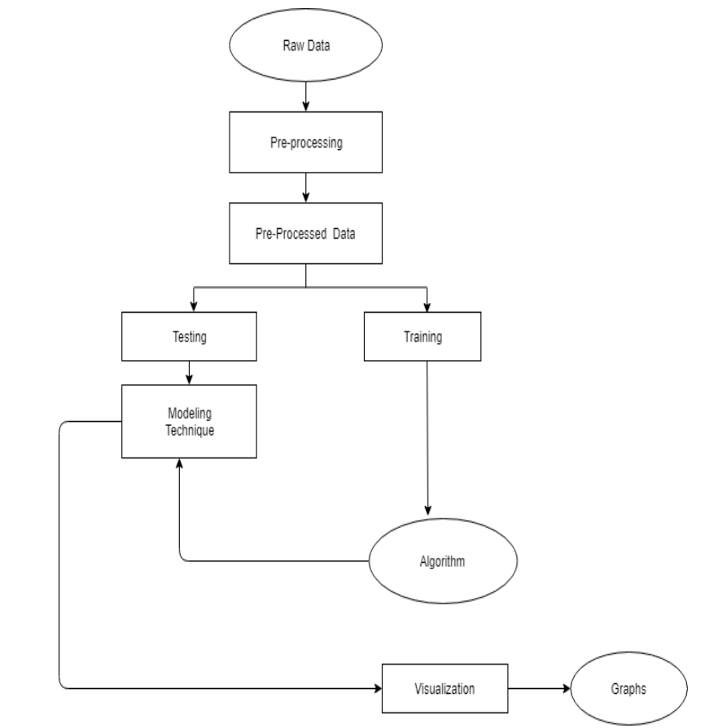

**Data Flow Diagrams:**

Data flow diagram (DFD) is a graphical representation of “flow” of data through an information system, modelling its process concepts. Often they are a preliminary step used to create an overview of the system which can later be elaborated. DFD’s can also be used for the visualization of data processing (structured design).

A DFD shows what kinds of information will be input to and output from the system, where the data will come from and go to, and where the data will be stored. It doesn’t show information about timing of processes, or information about whether processes will operate in sequence or parallel. A DFD is also called as “bubble chart”.

**DFD Symbols:**

In the DFD, there are four symbols:

* A square define a source or destination of system data.
* An arrow indicates dataflow. It is the pipeline through which the information flows.
* A circle or a bubble represents transforms dataflow into outgoing dataflow.
* An open rectangle is a store, data at reset or at temporary repository of data.

**Dataflow:** Data move in a specific direction from an origin to a destination.

**Process:** People, procedures or devices that use or produce (Transform) data. The physical component is not identified.

**Sources:** External sources or destination of data, which may be programs, organizations or other entity.

**Data store:** Here data is stored or referenced by a process in the system’s #

In our project, we had built the data flow diagrams at the very beginning of business process modelling in order to model the functions that our project has to carry out and the interaction between those functions together with focusing on data exchanges between processes.

**Context level DFD:**

A Context level Data flow diagram created using select structured systems analysis and design method (SSADM). This level shows the overall context of the system and its operating environment and shows the whole system as just one process. It does not usually show data stores, unless they are “owned” by external systems, e.g. are accessed by but not maintained by this system, however, these are often shown as external entities**.**

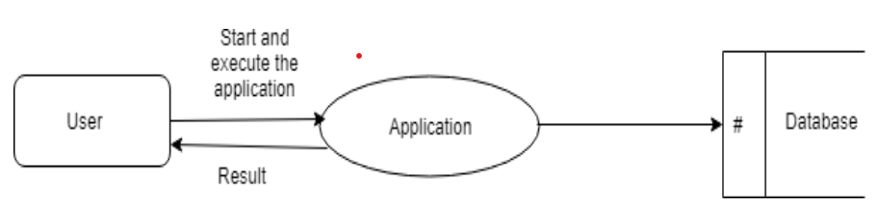

**Top level DFD:**

A data flow diagram is that which can be used to indicate the clear progress of a business venture. In the process of coming up with a data flow diagram, the level one provides an overview of the major functional areas of the undertaking. After presenting the values for most important fields of discussion, it gives room for level two to be drawn.

# **IMPLEMENTATION**

**1. Implementation Overview**

**1.1. Planning and Preparation**

The implementation phase of the rule-based chatbot project begins with through planning and preparation. This stage involves defining the project's scope, setting clear objectives, and identifying the necessary resources and tools. Key considerations include selecting the appropriate pre-trained models from Hugging Face, deciding on the rule-based logic, and designing the overall system architecture. During this phase, project stakeholders collaborate to outline the chatbot's intended functionalities, such as the types of questions it will handle and the expected user interactions. This preparation ensures that all team members are aligned and that the project progresses smoothly.

**1.2. System Setup**

Setting up the system is a crucial step that involves preparing the infrastructure needed to deploy and run the chatbot. The setup process includes:

**Environment Configuration:**

Ensure that the development environment is properly configured with the necessary libraries and dependencies. This typically involves creating a virtual environment and installing required packages such as transformers, gradio, torch, optimum, and auto-gptq.

Verify compatibility with the system's hardware and software, especially if using GPUs for enhanced model performance.

**Hardware Requirements:**

Identify the hardware specifications required for running the chatbot, particularly if deploying on local servers or cloud platforms. This includes selecting suitable GPUs or CPUs, ensuring sufficient memory, and configuring storage solutions for efficient data handling.

**Model and Tokenizer Loading:**

Load the pre-trained model and tokenizer from Hugging Face's library. For this project, the "TheBloke/Llama-2-7b-Chat-GPTQ" model is selected for its efficiency and conversational capabilities.

Initialize the model and tokenizer, ensuring they are correctly configured to handle the expected input and output formats.

**Data Management:**

Organize and structure the predefined questions and answers using a JSON-based knowledge base. This allows for easy access and management of the data, ensuring the chatbot can quickly retrieve and process the necessary information.

Implement a mechanism for updating and maintaining the knowledge base, allowing for continuous improvement and adaptation of the chatbot's responses.

**Security and Compliance:**

Implement security measures to protect user data and ensure compliance with relevant data protection regulations. This includes setting up secure communication channels, encrypting sensitive data, and regularly updating security protocols.

Ensure that the chatbot's deployment adheres to ethical guidelines, particularly in terms of data privacy and the responsible use of AI technologies.

This system setup phase lays the foundation for the chatbot's development and deployment, ensuring that the necessary technical infrastructure is in place to support the project's objectives.

**2. Technologies and Tools**

**2.1. Python**

Python serves as the core programming language for this project due to its simplicity, readability, and extensive libraries. Key features include:

* **High-Level Language:** Python’s syntax is designed to be easy to read and write, making development faster and more intuitive.
* **Dynamic Typing:** Python’s dynamic type system allows for greater flexibility in coding and reduces the likelihood of type-related errors.
* **Extensive Libraries:** Python’s large standard library and ecosystem support a wide range of functionalities required for the chatbot.

**2.2. Libraries and Frameworks**

The implementation of the rule-based chatbot leverages a variety of libraries and frameworks to enable efficient development, enhance functionality, and ensure smooth operation. Below are the key libraries and frameworks used in this project:

**1. Transformers**

Overview: The transformers library, developed by Hugging Face, provides a collection of pre-trained models for natural language processing (NLP) tasks, including text generation, classification, translation, and more.

Usage in the Project: In this chatbot implementation, the transformers library is used to access and utilize the pre-trained "TheBloke/Llama-2-7b-Chat-GPTQ" model. This model handles text generation and understanding, forming the backbone of the chatbot's conversational capabilities.

**2. Gradio**

Overview: Gradio is an open-source Python library that facilitates the creation of user-friendly web interfaces for machine learning models. It allows developers to quickly build and deploy interactive demos for their models.

Usage in the Project: Gradio is used to create the chatbot's web interface, providing an intuitive and interactive platform for users to input their questions and receive responses. It simplifies the deployment process, allowing the chatbot to be easily accessible through a web browser.

**3. Torch (PyTorch)**

Overview: PyTorch is a popular open-source deep learning framework that provides a flexible and efficient platform for building and training neural networks. It supports dynamic computation graphs, making it ideal for research and development.

Usage in the Project: PyTorch is used as the backend framework for the Hugging Face models, enabling efficient computation and model deployment. It handles the heavy lifting involved in running the deep learning models, especially when leveraging GPU acceleration.

**4. Optimum**

Overview: Optimum is a specialized library that integrates with Hugging Face's transformers and provides tools for optimizing model inference. It includes features like quantization and model distillation to reduce the computational cost of running large models.

Usage in the Project: Optimum is employed to optimize the Llama-2-7b-Chat-GPTQ model, enhancing its efficiency and reducing latency during response generation. This is crucial for maintaining a responsive and user-friendly experience.

**5. Auto-GPTQ**

Overview: Auto-GPTQ is a library for applying GPT quantization techniques to language models. Quantization reduces the size of neural networks, making them faster and more efficient to run, particularly on limited hardware resources.

Usage in the Project: The Llama-2-7b-Chat-GPTQ model utilizes GPTQ quantization to optimize performance. This allows the chatbot to function efficiently on consumer-grade hardware while maintaining high-quality response generation.

**6. Natural Language Toolkit (NLTK)**

Overview: NLTK is a comprehensive library for NLP in Python, offering a suite of text processing libraries, datasets, and tutorials. It provides tools for tasks such as tokenization, parsing, and semantic reasoning.

Usage in the Project: NLTK is used for additional text processing tasks, such as tokenization and data cleaning, to ensure that user inputs are properly normalized before being processed by the model. This enhances the accuracy and relevance of the chatbot's responses.

**3. Implementation Steps**

The implementation of the rule-based chatbot involves several critical steps to ensure its successful development, deployment, and operation. Each step is designed to systematically build upon the previous one, resulting in a fully functional chatbot. The key steps in the implementation process are outlined below:

**3.1. Initial Setup**

Environment Setup:

Set up a virtual environment to manage dependencies and ensure compatibility across different systems.

Install the required libraries and frameworks, including transformers, gradio, torch, optimum, and auto-gptq.

Configure hardware settings, especially if using GPUs, to optimize model performance.

Model Selection and Loading:

Choose an appropriate pre-trained model for the chatbot. For this project, the "TheBloke/Llama-2-7b-Chat-GPTQ" model is selected for its conversational capabilities and efficiency.

Load the model and tokenizer using Hugging Face's transformers library, ensuring proper configuration for the specific use case.

**3.2. Input and Data Processing**

Data Preparation:

Organize predefined questions and answers into a structured JSON-based knowledge base, facilitating easy access and management.

Implement mechanisms for updating the knowledge base, allowing the chatbot to evolve and adapt over time.

Text Processing:

Use NLTK and Hugging Face's tokenizer to clean and normalize user inputs. This includes removing unnecessary punctuation, converting text to lowercase, and tokenizing the input for further processing.

**3.3. Intent Recognition and Response Generation**

Intent Recognition:

Implement an intent recognition module that uses a Hugging Face sentence-similarity model to match user inputs with predefined intents.

Include a fallback mechanism using rule-based pattern matching for scenarios where the model's confidence is low or where specific rules are defined.

Response Generation:

Develop a response generation module that retrieves base responses from the JSON-based knowledge base.

Enhance and personalize responses using the Hugging Face text generation model, allowing for more dynamic and engaging interactions.

**3.4. Interface Development**

Gradio Interface Creation:

Use Gradio to design and implement a user-friendly web interface for the chatbot. This includes setting up input and output fields, configuring the interface's appearance, and providing a title and description for the application.

Implement functionalities such as real-time response display, user input validation, and any additional features required to improve user experience.

Testing and Validation:

Conduct thorough testing of the chatbot, including unit tests, integration tests, and user acceptance testing. Ensure that the chatbot responds accurately to a wide range of queries and handles edge cases gracefully.

Validate the chatbot's performance, including response time, accuracy, and user satisfaction. Make necessary adjustments based on feedback and testing results.

**3.5. Deployment and Maintenance**

Deployment:

Deploy the chatbot to a suitable hosting environment, such as a cloud platform or on-premises server. Ensure that the deployment environment supports the necessary hardware and software requirements.

Set up monitoring tools to track the chatbot's performance, including response times, error rates, and user interactions.

Maintenance and Updates:

Implement a maintenance plan to keep the chatbot up-to-date with the latest data, models, and security patches. Regularly review and update the predefined knowledge base and model configurations.

Provide channels for user feedback and continuously improve the chatbot based on user suggestions and evolving requirements.

# **TESTING**

Testing is an essential phase in the development lifecycle of the Generative AI Chatbot project. It ensures that the chatbot system functions as intended and meets the requirements and expectations of users. This phase involves executing the chatbot under various conditions to identify and resolve potential issues, ensuring the system's reliability, performance, and user satisfaction.

**Black Box Testing**

**Black Box Testing** focuses on evaluating the functionality of the chatbot based on its requirements and specifications, without knowledge of its internal code or structure. This testing method ensures that the chatbot performs its intended functions correctly and handles various user inputs as expected.

**Techniques in Black Box Testing:**

1. **Decision Table Testing:** Decision Table Testing is used to validate different functional scenarios of the chatbot by creating a table that maps possible inputs to expected outputs. For example, a decision table for the chatbot might include scenarios such as ordering a with different toppings, selecting various sizes, and handling special requests. This method helps ensure that the chatbot correctly processes all possible input combinations and generates the appropriate responses. It is particularly useful for testing complex functionalities with multiple conditions.
2. **All Pairs Testing:** All Pairs Testing, also known as Pairwise Testing, involves testing all possible pairs of input conditions to identify defects that may arise due to interactions between different conditions. For the chatbot, this means testing various combinations of user inputs, such as different sizes and toppings, to ensure that the chatbot handles all possible input pairs effectively. This technique helps identify potential issues that may not be apparent when testing individual conditions in isolation.
3. **State Transition Testing:** State Transition Testing examines how the chatbot transitions between different states based on user interactions. For instance, the chatbot might transition from a "greeting" state to an "ordering" state when a user expresses interest in placing an order. This method ensures that the chatbot maintains the correct conversational flow and handles state changes appropriately. It helps verify that the chatbot responds correctly to various user inputs and transitions smoothly between different stages of interaction.
4. **Equivalence Partitioning:** Equivalence Partitioning involves dividing the input data into different classes or partitions and testing representative values from each class. For the chatbot, this could involve testing various categories of toppings, sizes, and delivery options to ensure that the chatbot handles different types of inputs consistently. This technique helps reduce the number of test cases by focusing on representative samples from each partition, making it easier to identify defects and ensure comprehensive coverage.

**Validation and Verification:**

* **Validation:** Validation ensures that the chatbot meets user expectations and performs its intended functions effectively. It involves testing whether the chatbot delivers accurate and relevant responses based on user inputs and requirements. For example, validation tests might include verifying that the chatbot correctly processes orders, provides accurate delivery information, and handles user queries appropriately.
* **Verification:** Verification confirms that the chatbot adheres to its design specifications and functions as intended. This includes testing the chatbot's adherence to functional requirements, ensuring that all implemented features work correctly, and verifying that the system behaves as expected under different conditions. Verification helps ensure that the chatbot's internal logic and processes are correctly implemented and that the system meets its design goals.

**White Box Testing**

**White Box Testing** requires knowledge of the chatbot's internal code and logic. It focuses on verifying the functionality of the code, algorithms, and data flows within the chatbot. This type of testing ensures that the chatbot's internal processes are correctly implemented and that the system functions as expected.

**Techniques in White Box Testing:**

1. **Unit Testing:** Unit Testing involves testing individual components or modules of the chatbot in isolation to ensure that they function correctly. For example, each function or method responsible for processing user inputs, generating responses, or managing conversation state can be tested separately. Automated testing tools such as pytest or unit test in Python can be used to streamline the unit testing process. Unit tests help identify defects at an early stage and ensure that each component performs its intended tasks correctly.
2. **Integration Testing:** Integration Testing involves combining and testing multiple components or modules of the chatbot to ensure that they work together seamlessly. For instance, testing the integration between the natural language processing (NLP) module and the response generation module verifies that inputs are correctly processed and appropriate responses are generated. Integration tests help identify issues that may arise from the interaction between different components and ensure that the system functions as a cohesive whole.
3. **System Testing:** System Testing evaluates the chatbot as a complete system to ensure that it meets all specified requirements and performs as expected. This includes testing the entire conversational flow, interaction with external APIs (e.g., for delivery tracking), and overall system performance. End-to-end testing scenarios should be designed to cover various user interactions and use cases, ensuring that the chatbot delivers a seamless and satisfactory user experience.
4. **Regression Testing:** Regression Testing involves re-running previously successful tests to ensure that recent changes or updates have not introduced new defects. For the chatbot, this means testing existing functionalities after adding new features or making modifications to verify that the system remains stable and that no new issues have been introduced. Automated regression tests can help streamline this process and ensure that the chatbot continues to function correctly after updates.
5. **Acceptance Testing:** Acceptance Testing verifies that the chatbot meets customer requirements and is ready for deployment. This involves running test cases based on user stories or requirements and comparing the actual results with the expected results. For instance, testing whether the chatbot correctly handles orders, customizations, and delivery inquiries as specified by the user requirements. User feedback during acceptance testing helps ensure that the chatbot aligns with user expectations and is ready for real-world use.

# **OUTPUT SCREENS**

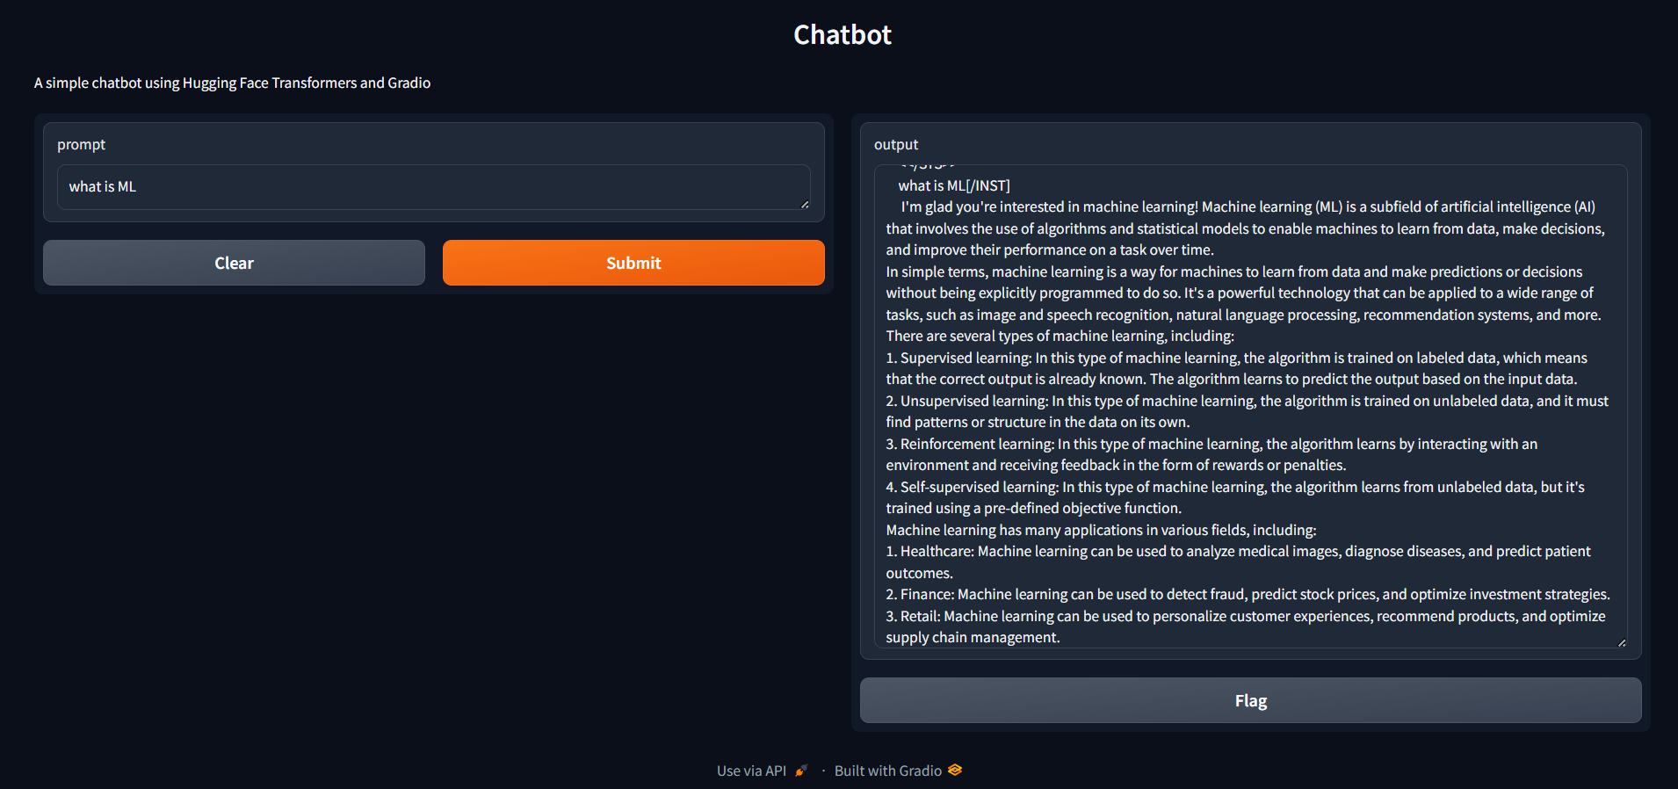

# **CONCLUSION**

The proposed hybrid chatbot system represents a significant advancement in creating effective and versatile conversational agents. By combining rule-based logic with the capabilities of pre-trained language models from Hugging Face, this system strikes a balance between precision and flexibility, addressing the limitations of traditional approaches.

The integration of rule-based patterns ensures that the chatbot can handle common and predictable queries with high accuracy and control. Meanwhile, the use of advanced NLP models enhances the system's ability to understand and respond to more nuanced and varied user inputs, providing a more natural and engaging conversational experience.

**Key features of the proposed system include:**

Hybrid Model Integration: Leveraging both rule-based and AI-driven methods for a comprehensive approach to query handling.

Enhanced NLP Understanding: Utilizing state-of-the-art techniques for better interpretation of user inputs.

Personalized Responses: Generating contextually relevant and engaging replies through advanced language models.

User-Friendly Interface: Offering an intuitive and interactive experience via Gradio.

Scalability and Maintainability: Allowing for easy updates and expansion of the knowledge base.

Performance Optimization: Ensuring efficient operation with model quantization and optimization.

Fallback Mechanisms: Providing graceful handling of ambiguous queries and escalation to human support when needed.

Data Privacy: Complying with data protection regulations to secure user information.

Overall, this hybrid approach addresses the challenges faced by purely rule-based or AI-driven systems, offering a more robust and adaptable solution. The result is a chatbot that not only meets the needs of users effectively but also provides a scalable and maintainable platform for ongoing development and enhancement.

# **BIBLIOGRAPHY**

1. **Chung, H., & Ko, Y. (2021).** *Building Conversational Interfaces with Natural Language Processing*. O'Reilly Media.  
   This book provides a comprehensive guide to developing chatbots using natural language processing (NLP) techniques, covering design, implementation, and practical challenges.
2. **Jurafsky, D., & Martin, J. H. (2021).** *Speech and Language Processing: An Introduction to Natural Language Processing, Computational Linguistics, and Speech Recognition*. Prentice Hall.  
   This textbook offers foundational knowledge in NLP and computational linguistics, essential for understanding the underlying technology of chatbots.
3. **Rasa. (2022).** *Rasa Documentation***.**The official documentation for Rasa, an open-source framework for building conversational AI, provides insights into building and deploying chatbots.
4. **Sikka, K., & Chopra, A. (2019).** *Building Chatbots with Python: Using Natural Language Processing and Machine Learning*. Packt Publishing.  
   This practical guide focuses on using Python for developing chatbots, including implementing machine learning algorithms and integrating NLP techniques.
5. **Vaswani, A., Shazeer, N., Parmar, N., Uszkoreit, J., Jones, L., Kaiser, Ł., Polosukhin, I., & others. (2017).** *Attention Is All You Need*. In Advances in Neural Information Processing Systems (NeurIPS).  
   The foundational paper introducing the Transformer model, which has influenced modern NLP techniques used in advanced chatbot development.