**CHAPTER 1**

**INTRODUCTION**

* 1. **Introduction to the title of project**

The era of mobile technology opens the windows to the android app. The websites are vanishing, and mobile phones are emerging. It's the time to change from conventional websites to apps, which has become a part of our daily routine. We are introducing “Clock.apk '' the android application software which would be a miniature of the Clock Application.

* 1. **Mobile Application**

Mobile application software is a computer program which is designed to run on smartphones. They have emerged in the past and are a hot trend in the market now. The most common mobile operating systems are Android from Google, iOS from Apple, Blackberry and Windows Phone from Microsoft. Android is a free and open-source mobile platform based on Linux kernel for making apps which is currently developed by Google. The user-interface is based on human-computer interaction. Before running the mobile applications in a real time environment, they are first tested in the integrated development environments using emulators. Emulators provide an inexpensive way of testing mobile applications.

* 1. **Organisation of the report**

The next chapter 2 contains the problem statement of the project. Chapter 3 deals with the software requirement and analysis. Chapter 4 defines the design. Chapter 5 explains the detailed description. Chapter 6 describes the results. Chapter 7 interprets the applications. Chapter 8 illustrates the conclusion. References are added at the end.

**CHAPTER 2**

**PROBLEM STATEMENT**

In real time scenario, synchronization of time system across the world is very important. If the time is not synchronized, many problems may occur.

The project is implemented with APIs where the user selects the location of their choice which is passed through the APIs to get the time zone of the selected location. The user can also set a timer and get a message when timer expires. The user can use the stopwatch as counter of time to note down the timings at different intervals.

**2.1 PROJECT SCOPE**

This software product is designed for phone and tablet users, which is developed for the Android mobile operating system. The users of the product can use the services provided by the world clock API, stopwatch, and the timer for their own benefits. All three applications are integrated. The client-side application is developed in Java and the XML is used for styling.

**CHAPTER 3**

**SOFTWARE REQUIREMENT AND ANALYSIS**

**3.1 FUNCTIONAL REQUIREMENTS**

Users must have an Android device running on Android 5.0 or later versions so that the app can run effectively on an Android phone.

**3.2 SOFTWARE REQUIREMENTS**

**Operating System**

Windows 7 or more is used as the operating system as it is stable and supports more features and is more user friendly.

**Android Studio**

In recent times, Android became the world's most popular operating system for various reasons. As an Android programmer, I want to share what the Android Studio is? Android Studio is an IDE for Google Android Development launched on 16th May 2013, during Google's I/O 2013 event. Android Studio contains all the Android tools to design, test, debug, and profile your application. The Android Studio uses Gradle to manage your project, a Build Automation Tool.

Android Studio is the official integrated development environment for Google’s Android operating system, built on JetBrains’ IntelliJ IDEA software and designed specifically for Android development. It is available for download on Windows, macOS and Linux based operating systems or as a subscription-based service.

It is a replacement for Eclipse Android Development Tools as the primary IDE for native Android application development. The following features are provided in the current version:

* Gradle-based build support.
* Android-specific refactoring and quick fixes.
* Lint tools to catch performance, usability, version compatibility.
* Template-based wizards to create common Android designs and components.
* A layout editor that allows users to drag-and-drop UI components, option to preview layouts on multiple screen configurations.
* Android Virtual Device (Emulator) to run and debug apps in the Android studio.

**3.1.1 Software Requirements**

* 64-bit Microsoft® Windows® 8/10.
* x86_64 CPU architecture; 2nd generation Intel Core or newer, or AMD CPU with support for a Windows Hypervisor.
* 8 GB RAM or more.
* 50 GB of available disk space minimum (IDE + Android SDK + Android Emulator).
* 1280 x 800 minimum screen resolution.

**CHAPTER 4**

**DESIGN**

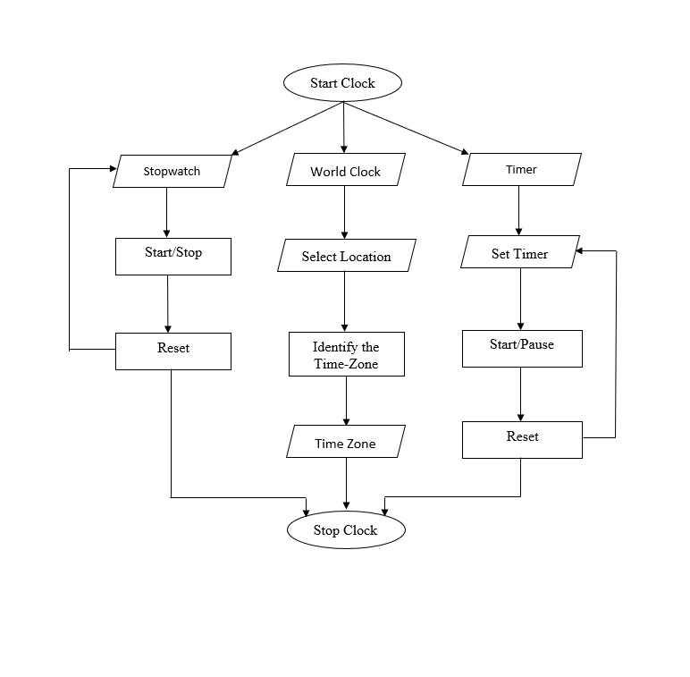

**CHAPTER 5**

**DETAILED DESCRIPTION**

The Clock application is designed in such a way that the application is user friendly, and any new user finds it easy to use the application.

When the application starts, the user is redirected to world clock fragment where they can select any location of their choice from number of locations by using dropdown spinner menu. The world clock API returns the time zone and date of the selected location which is then displayed on the screen. The user can then navigate to stopwatch or timer fragment by using the bottom navigation menu.

In the stopwatch fragment the user is provided with three options: start, stop and reset. By clicking on these buttons, the user can start, stop, and reset the stopwatch respectively. When the stopwatch is turned on, the counter is incremented every second and can extend to hours.

In timer fragment the user is provided with an option to enter number of minutes and to set the timer. Once the timer is set the user can start the timer using the start button. After the timer expires, a message is toasted on the screen saying, “Timer Expired” and the timer is reset to 00:00. By clicking on the reset button, the user can terminate the timer.

There are different classes that are made in the backend of the application where there are separate classes for each page displayed on the screen. The functionality of these pages is handled in different classes.

**CHAPTER 6**

**RESULTS**

1. **Android**

**Emulator**

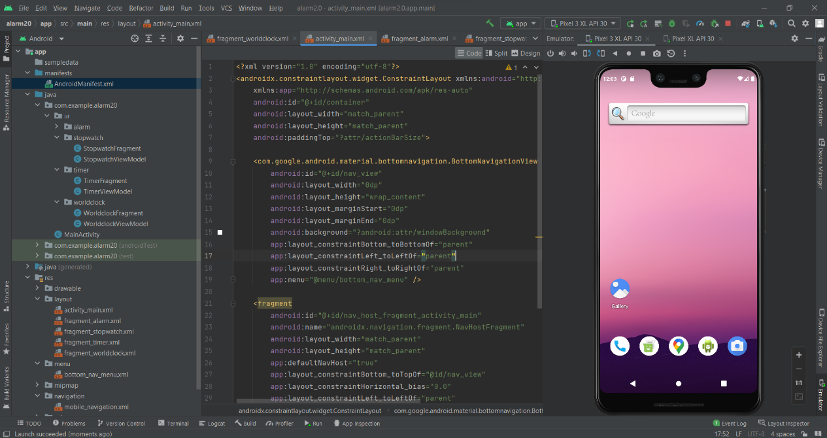

Fig 6.1: Android Emulator Screen

**2. App in App Drawer**

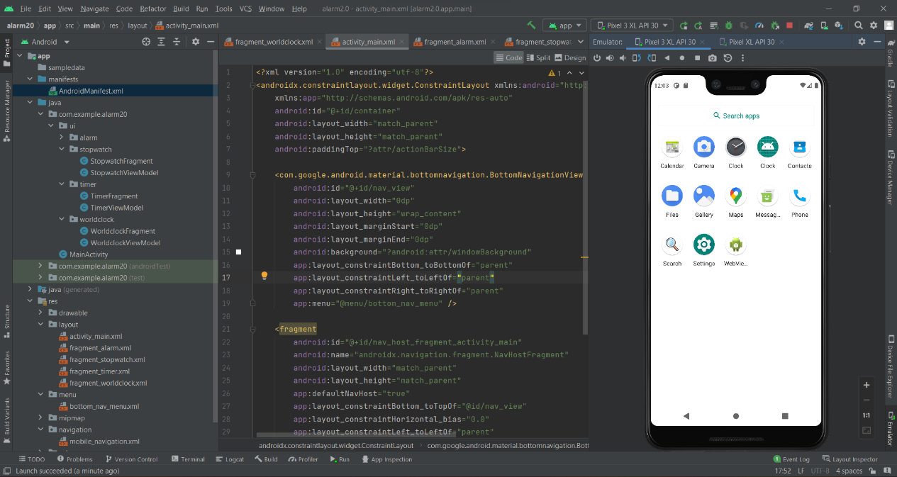

Fig 6.2 : App icon in app drawer

**3. Application Home Screen (World Clock)**

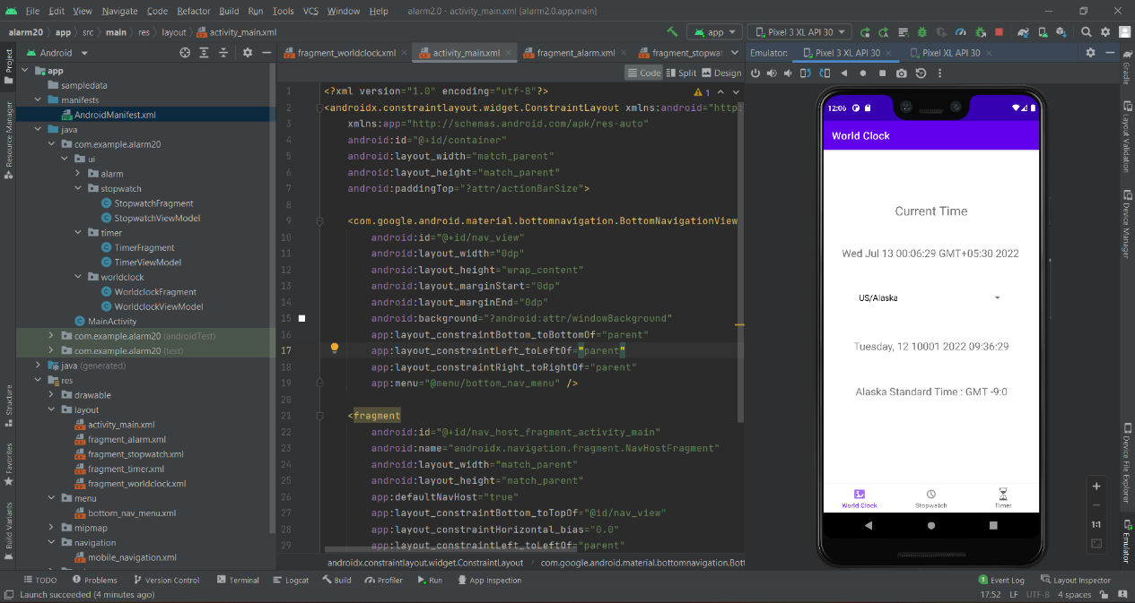

Fig 6.3 : Application Home Screen (World Clock)

**4. Stopwatch**

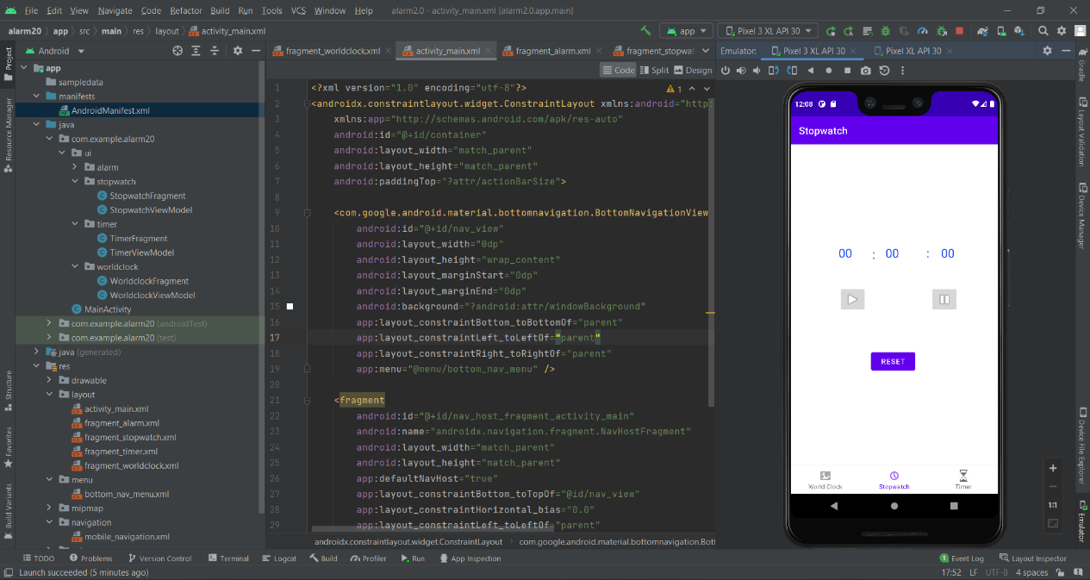

Fig 6.4 : Stopwatch Page

**5. Timer**

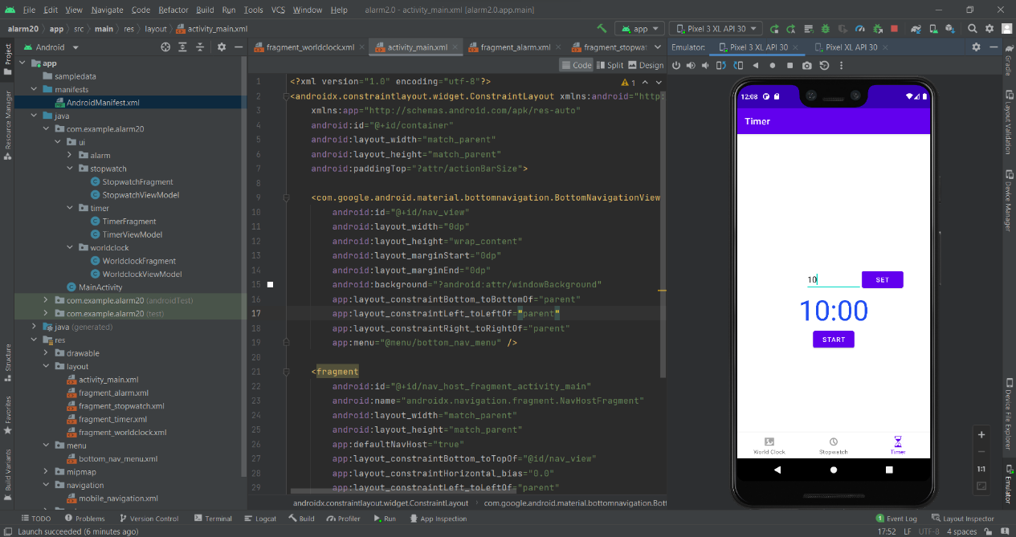

Fig 6.5 : Timer Page

**6. Timer Expired**

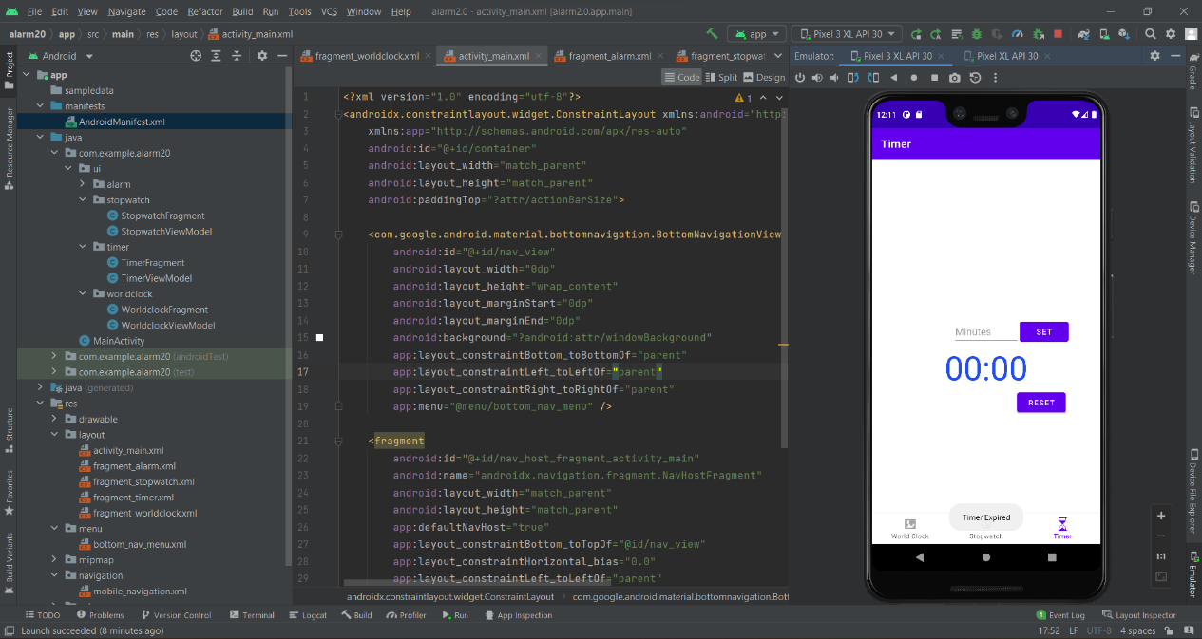

Fig 6.6 : Timer Expired

**CHAPTER 7**

**APPLICATIONS**

Clock apps were among the first apps available. After all, smartphones are excellent for telling time. You always have it on you.  Phones have evolved a lot and Clock apps have too. These apps are also easier to use, because they are available at once, without any need to purchase or carry separate devices. These timer apps can be used for tracking working or training time.

The applications of world clock are vast from high level Business applications to the house hold use. There are multiple advantages of world clock, and timers and few of them as listed below,

* A time clock displaying time of several countries helps you synchronise with them.
* With different regions come different time zones, and it becomes challenging to follow the time. That is when you need to know the exact time of other countries.
* With timers, you see exactly how much time you have left to complete your task.
* if you have a list of tasks that you can check off before time runs out on the timer, you feel accomplished and motivated for the next challenge ahead.

In today’s world, time is the key factor which leads to success of a business. Therefore, synchronization of activities across the world can be achieved using the world clock app. Getting things done within the deadline also plays an important role. Hence, timer can be used to accomplish it.

**CHAPTER 8**

**CONCLUSION**

The thought of trying to know the time in different parts of the world like America UK and India all at the same time was not an easy task which could be performed. However, the Joy of Android has people from different continents working together. Because of the location differences, world clock apps for Android come in really handy.

Mobile apps can be very distracting, so much that you can’t finish even the smallest task on time. But, with this application, you have the help you need to get things done.

Future scope and further enhancement of the Project:

The application user interface can be beautified to make the app more user friendly to use.

A feature of alarm can be added which could be used to set alarms and get notification when the time has reached.

A lap feature can be added to the stopwatch where the users can note down the time intervals of different events simultaneously.

A notification can be made to pop-up when the timer set by the user expires.

**REFERENCES**

[1] <https://practice.geeksforgeeks.org>

[2] <https://www.youtube.com>

[3] <https://www.w3schools.com>

[4] <https://developer.android.com/docs>

[5] <https://www.indiabix.com>