AWS Services Involved
- Application Load Balancer
- Amazon CloudWatch
- AWS Auto Scaling
- Amazon EC2

Target Outcome (What We’re Building)
If ALB RequestCount > 100 (for 5 minutes)
→ Auto Scaling Group adds +2 EC2 instances

Architecture Flow (Conceptual)
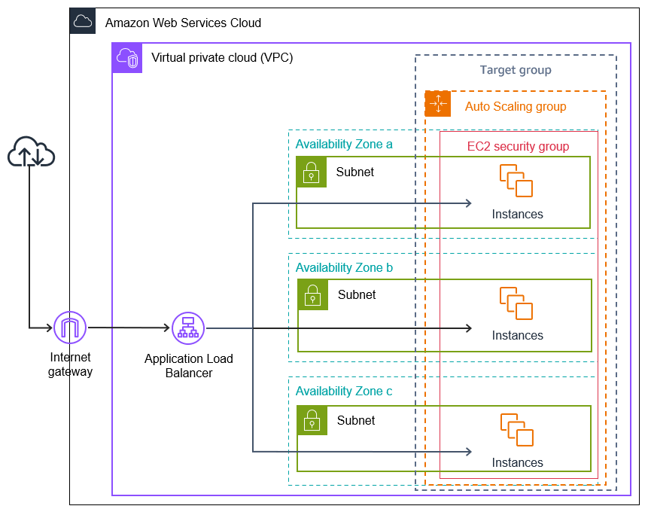

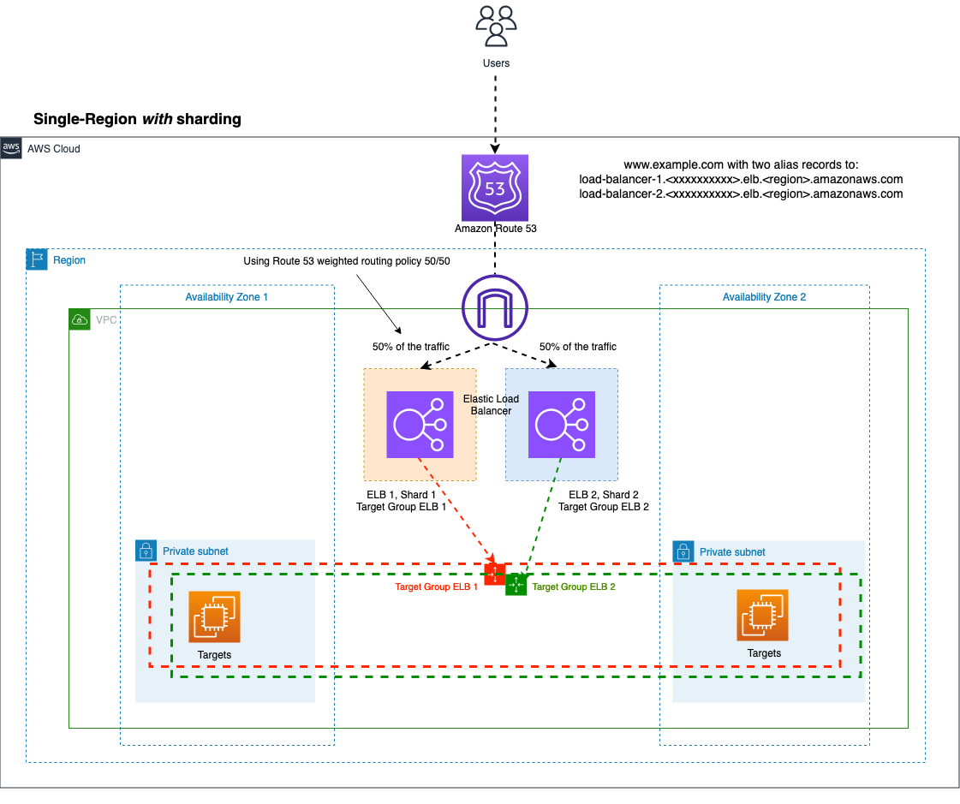
Client Traffic
↓
ALB
↓ (RequestCount metric)
CloudWatch Alarm
↓
Auto Scaling Policy (+2 capacity)
↓
New EC2 instances launched

Prerequisites (Must Exist)
✔ Application Load Balancer
✔ Target Group attached to ALB
✔ Auto Scaling Group (ASG) using a Launch Template
✔ EC2 instances registered in the Target Group
⚠️ Important: ALB itself does NOT scale instances.
Auto Scaling Group does.

Step 1: Create / Verify the Auto Scaling Group
Ensure your ASG has:
- Min capacity: e.g., 1
- Desired capacity: e.g., 1
- Max capacity: e.g., 5
- Target Group attached (ALB)

Step 2: Create a Scaling Policy (Add +2 Instances)
Go to:
EC2 → Auto Scaling Groups → Your ASG → Automatic scaling
Create Scaling Policy
- Policy type: Simple scaling
- Scaling action: Add
- Capacity change: +2
- Cooldown: 300 seconds (recommended)
Example:
Increase capacity by 2
Save the policy.

Step 3: Create CloudWatch Alarm on ALB RequestCount
Go to:
CloudWatch → Alarms → Create alarm
Metric Selection
Namespace: AWS/ApplicationELB
Metric: RequestCount
Dimension: LoadBalancer
Statistic: Sum
Period: 5 minutes

Alarm Condition
RequestCount > 100
for 1 consecutive period (5 minutes)

Alarm Action
- Select Auto Scaling action
- Choose:
  - Your ASG
  - The scaling policy (+2 instances)
Finish creating the alarm.

Step 4: How This Works at Runtime
- Traffic increases
- ALB receives >100 requests in 5 minutes
- CloudWatch alarm goes ALARM
- Scaling policy triggers
- ASG launches 2 new EC2 instances
- New instances register to Target Group
- ALB starts routing traffic to them

Step 5: Test the Scaling (Optional)
Generate traffic:
for i in {1..120}; do
curl http://<ALB-DNS-NAME>/
done
Then check:
- ASG → Activity history
- CloudWatch → Alarm state
- Target Group → New instances become healthy

Important Notes (Very Common Mistakes)
❌ Scaling ALB directly (not possible)
❌ Expecting CloudWatch to create instances (it only triggers actions)
❌ Using Average instead of Sum for RequestCount
❌ Forgetting cooldown → scale-out storms

