Below is a clear, end-to-end summary of how Blue/Green deployment works using an Application Load Balancer (ALB) in AWS.

Core Services Involved
- Application Load Balancer
- Target Group
- Amazon EC2 / Amazon ECS / Amazon EKS
- AWS Auto Scaling (optional)
- Amazon Route 53 (optional)

What Is Blue/Green Deployment (In One Line)
Blue/Green deployment runs two identical environments (Blue = current, Green = new) and shifts traffic between them instantly using ALB target groups.

High-Level Architecture
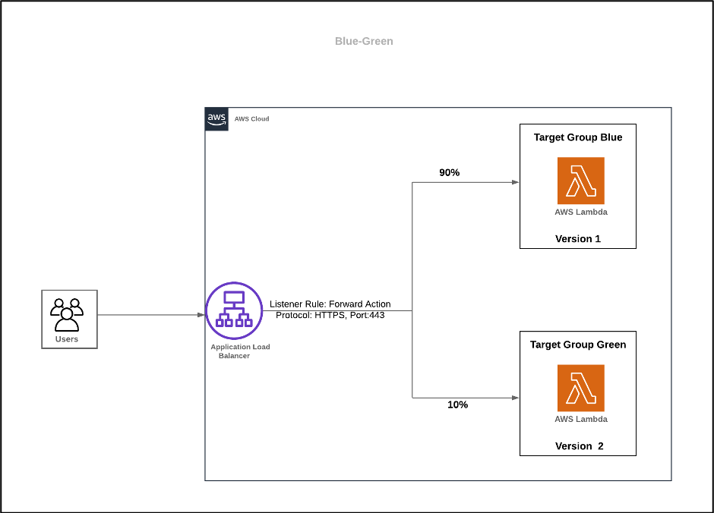
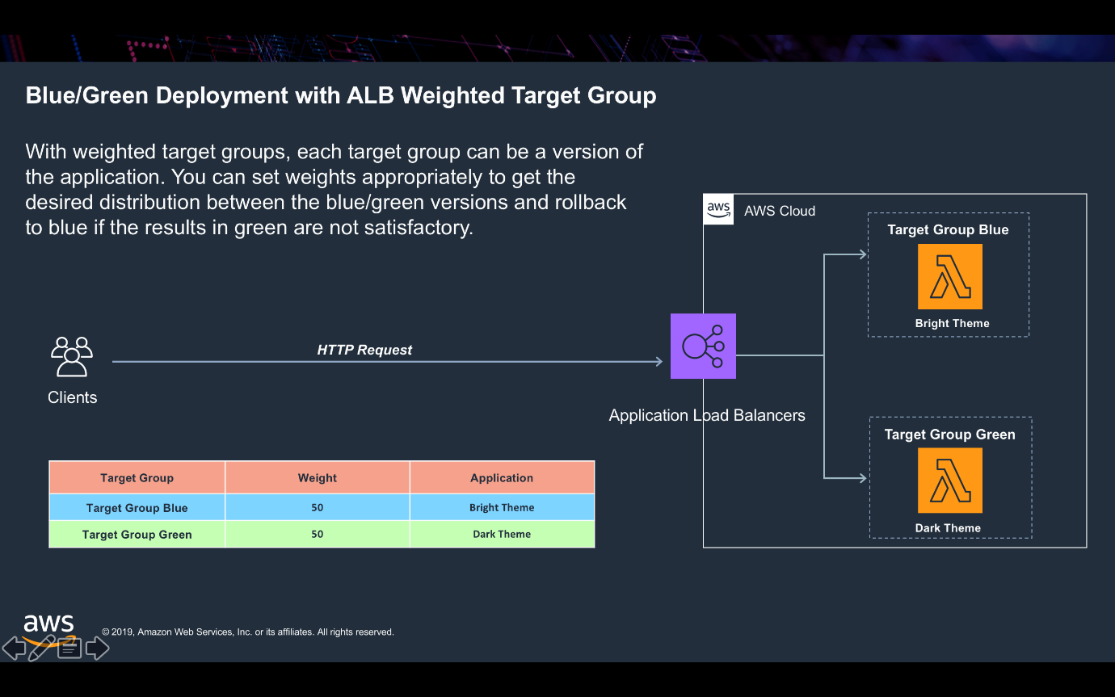
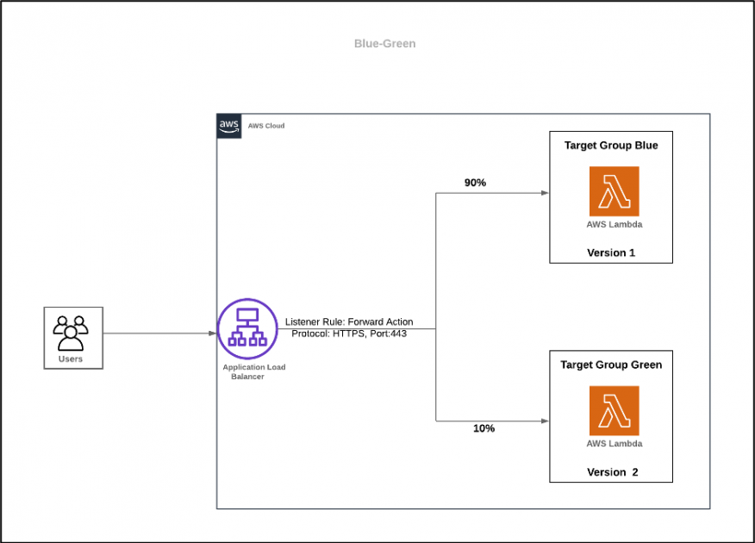
Client
↓
ALB (HTTP/HTTPS Listener)
↓
Listener Rules / Weights
├─ TG-BLUE → Old Version
└─ TG-GREEN → New Version

Step-by-Step Summary
1️⃣ Create Two Target Groups
- TG-BLUE → Current production version
- TG-GREEN → New application version
Each TG:
- Same protocol & port
- Independent health checks
- Separate backend instances / tasks / pods

2️⃣ Create Application Load Balancer
- Internet-facing or internal
- Enable at least 2 Availability Zones
- Attach Security Group (allow 80/443)

3️⃣ Configure Listeners
- HTTP : 80 (optional → redirect to HTTPS)
- HTTPS : 443 (primary)
Default action initially:
Forward 100% → TG-BLUE

4️⃣ Deploy New Version (Green)
- Launch EC2 / ECS / EKS resources
- Register them to TG-GREEN
- Verify:
  - Health checks → healthy
  - App works via TG test URL

5️⃣ Shift Traffic (Blue → Green)
Option A: Instant Switch
100% traffic → TG-GREEN
Option B: Canary / Weighted Routing
90% → TG-BLUE
10% → TG-GREEN
Gradually increase until:
100% → TG-GREEN

6️⃣ Validate & Monitor
- ALB target health
- Application logs
- CloudWatch metrics (latency, 5xx)
- User experience

7️⃣ Rollback (If Needed)
Rollback is instant:
100% traffic → TG-BLUE
No redeploy, no downtime.

8️⃣ Decommission Old Environment
After success:
- Deregister TG-BLUE
- Terminate old instances/tasks
- Or keep as rollback safety

Why ALB Is Ideal for Blue/Green
Feature | Benefit
Multiple Target Groups | Separate versions
Listener Rules | Traffic control
Weighted Forwarding | Canary releases
Health Checks | Safe cutover
Instant Rollback | Zero downtime

What This Gives You
✅ Zero downtime deployments
✅ Instant rollback
✅ Safe testing in production
✅ Works with EC2, ECS, EKS, Lambda
✅ No DNS TTL delays

