Below is a clear, end-to-end summary of how path-based routing works with an Application Load Balancer (ALB) in AWS.

Core AWS Services Involved
- Application Load Balancer
- Target Group
- Elastic Load Balancing
- Backends: EC2 / ECS / EKS / Lambda

What Is Path-Based Routing (One Line)
Path-based routing allows an ALB to forward requests to different backend target groups based on the URL path of the HTTP/HTTPS request.

High-Level Architecture
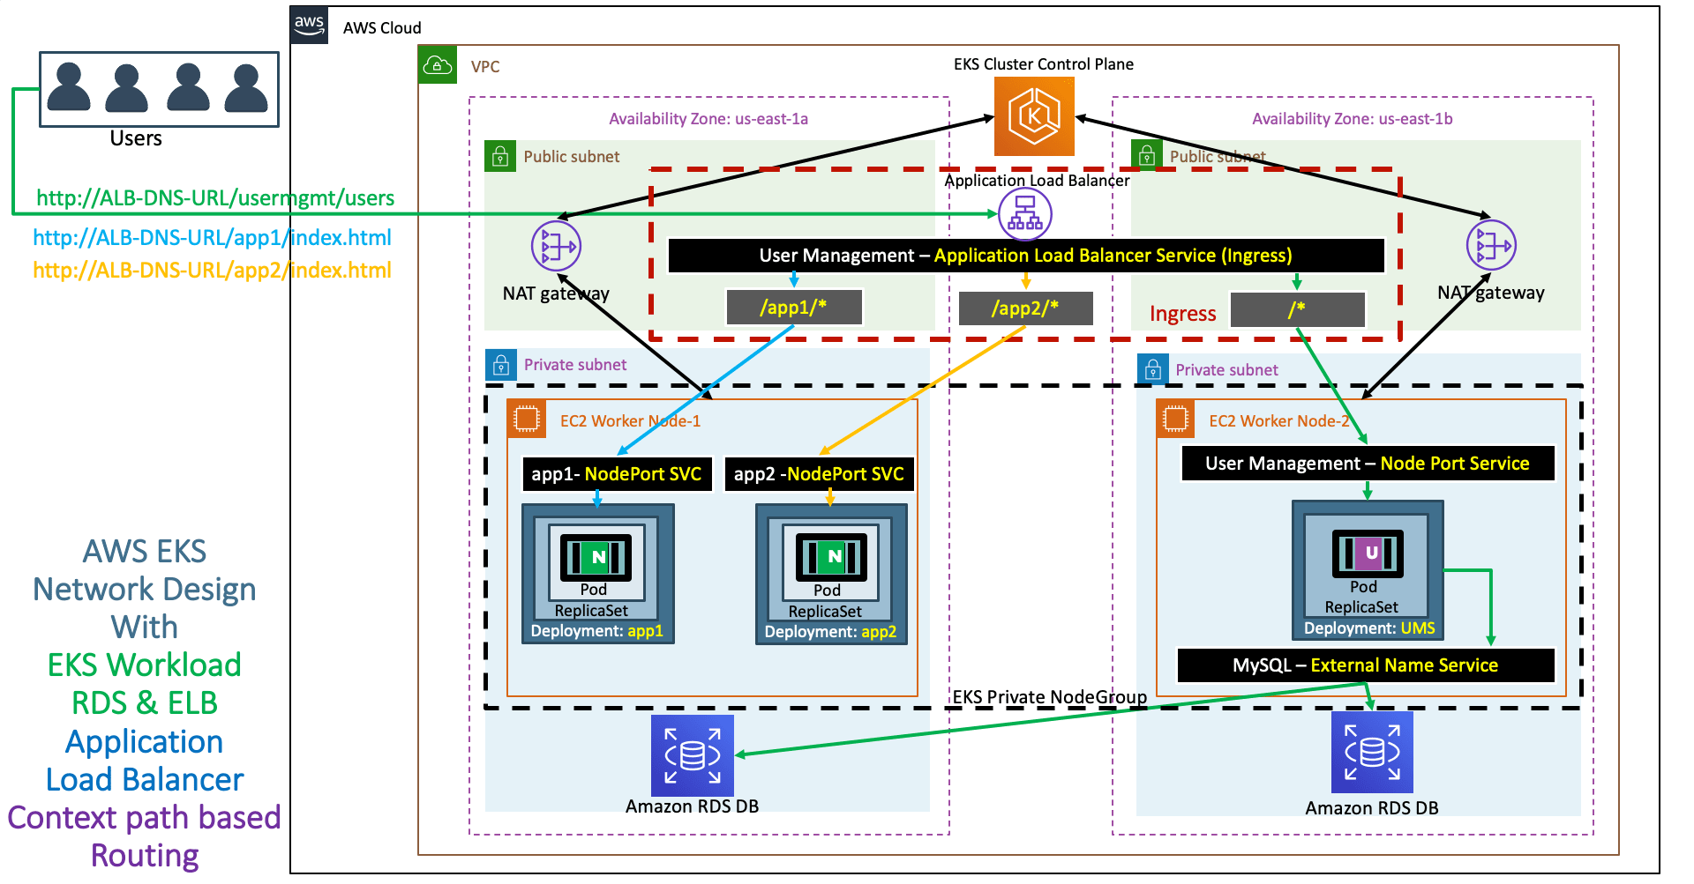
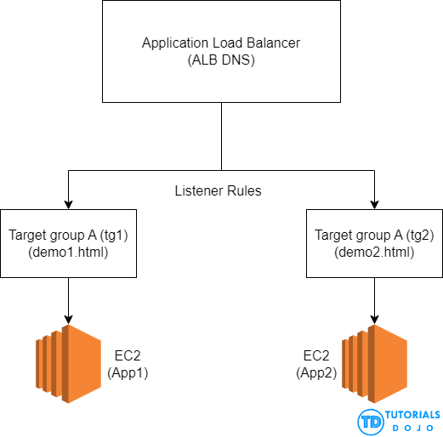
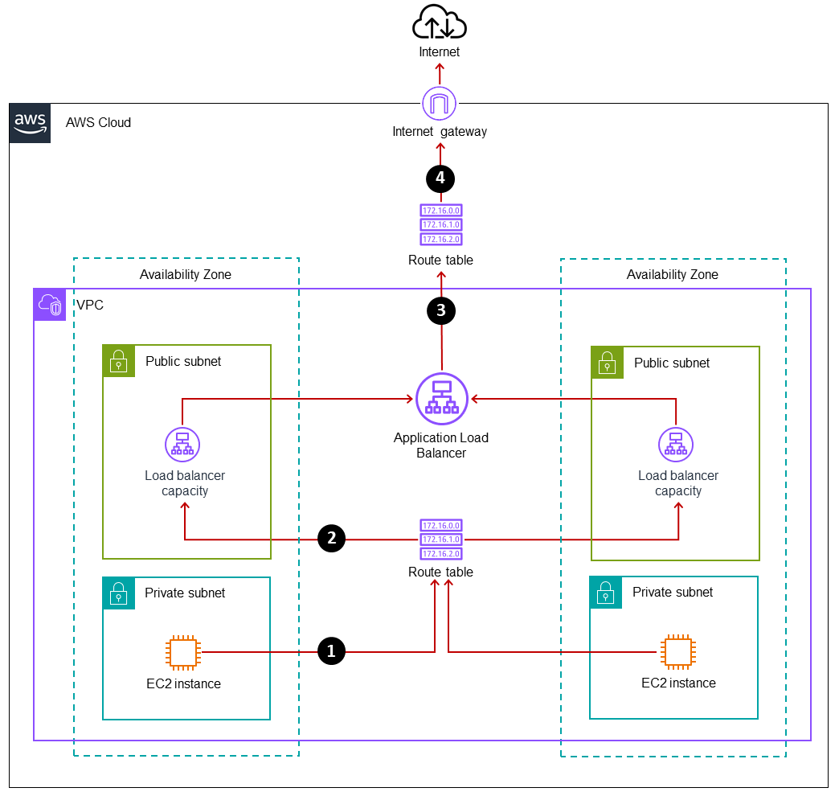
Client
↓
ALB (Listener : 80 / 443)
↓
Listener Rules (Path Conditions)
├─ /api/* → TG-API
├─ /admin/* → TG-ADMIN
└─ /* → TG-WEB (default)

End-to-End Flow (Step by Step)
1️⃣ Client Sends Request
Example:
https://example.com/api/users

2️⃣ Request Reaches ALB Listener
- Listener listens on HTTP : 80 or HTTPS : 443
- HTTPS listener decrypts traffic (SSL termination)

3️⃣ ALB Evaluates Listener Rules
Rules are processed:
- Top to bottom
- Lowest priority number first
Each rule has:
- Condition → Path pattern
- Action → Forward to a Target Group

4️⃣ Path Matching Happens
Example rules:
Priority | Path Condition | Action
1 | /api/* | Forward → TG-API
2 | /admin/* | Forward → TG-ADMIN
Default | /* | Forward → TG-WEB
Request path /api/users:
- Matches /api/*
- Routed to TG-API

5️⃣ Target Group Selection
Each target group:
- Has one backend type (EC2 / ECS / EKS / Lambda / IP)
- Performs independent health checks
- Routes traffic only to healthy targets

6️⃣ Backend Handles Request
ALB forwards the request to a healthy backend instance/pod/function.

7️⃣ Response Sent Back
Response flows back through ALB to the client.

Target Group Flexibility
You can route different paths to different compute types:
/api/* → ECS service
/admin/* → EC2 instances
/lambda/* → Lambda function
One ALB → Multiple architectures.

Important Rules & Constraints
✔ Supported
- Multiple path rules per listener
- Wildcards (/api/*)
- Multiple target groups
- Independent health checks
- Works with HTTPS
❌ Not Supported
- Path routing with NLB
- Multiple target groups in one rule
- Protocols other than HTTP/HTTPS

Common Use Cases
- Microservices routing
- Blue/Green deployments
- Canary releases
- Monolith → microservices migration
- API + UI separation

Best Practices
- Always define a default rule
- Use simple, explicit paths
- Avoid overlapping path patterns
- Keep health-check paths separate
- Redirect HTTP → HTTPS

One-Paragraph Executive Summary
Path-based routing with an Application Load Balancer works by inspecting the URL path of incoming HTTP/HTTPS requests at the listener level and forwarding them to different target groups based on defined rules. Each rule matches a path pattern and routes traffic to an independent backend, enabling clean separation of services, flexible architectures, and zero-downtime deployments.

