Below is the clean, AWS-accurate way to set up a Target Tracking Scaling policy using an Application Load Balancer (ALB). I’ll explain what happens automatically vs what you must configure, because that’s where most confusion comes from.

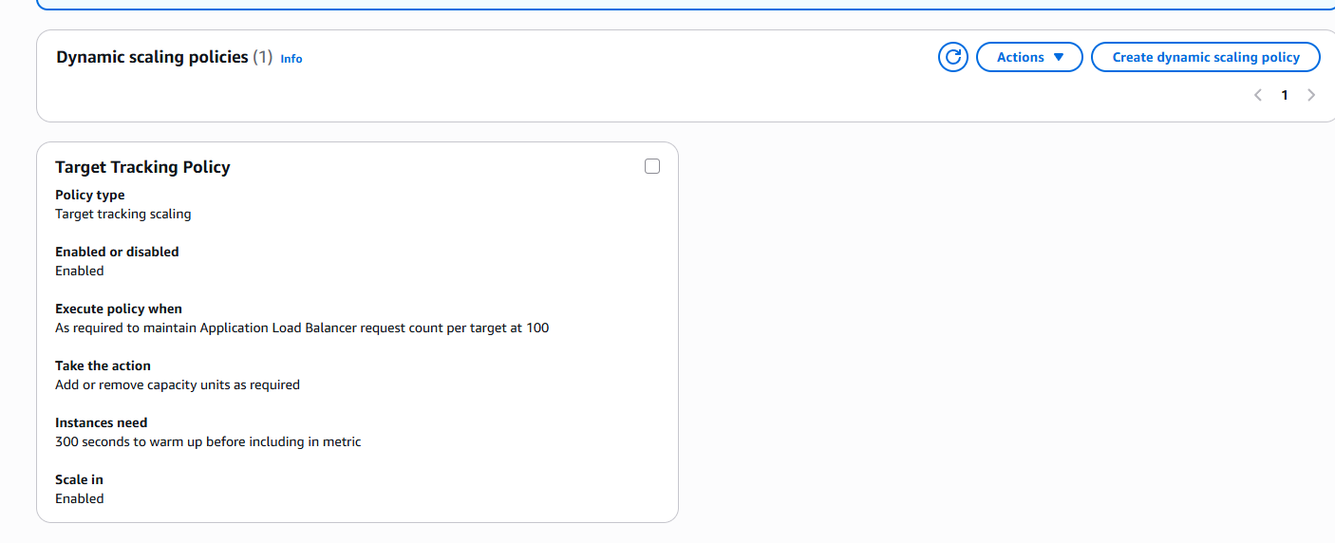

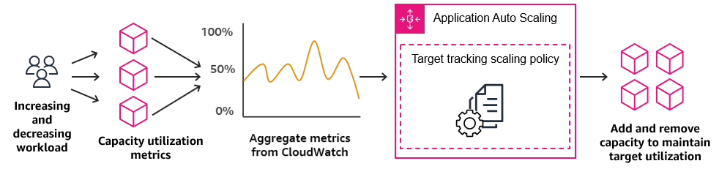

🎯 What Target Tracking with ALB Actually Does
You define a target value (for example, 100 requests per instance).
AWS automatically:
- Creates CloudWatch alarms
- Scales out before overload
- Scales in when traffic drops
- Keeps the metric near the target, not exactly equal
You do NOT define:
- Exact scale-out count
- Exact scale-in count
- Alarm thresholds

🧩 Required Components
You must already have:
- Application Load Balancer
- Target Group attached to ALB
- Auto Scaling Group
- EC2 instances registered to the Target Group

✅ Step-by-Step: Configure Target Tracking Using ALB

1️⃣ Attach ALB to the Auto Scaling Group
Go to:
EC2 → Auto Scaling Groups → Select ASG → Load balancing
Attach:
- Application Load Balancer
- Target Group
⚠️ Mandatory — scaling won’t work without this.

2️⃣ Create Target Tracking Scaling Policy
Navigate:
Auto Scaling Group → Automatic scaling → Create policy
Choose:
- Policy type: Target tracking scaling
- Metric type: ALB RequestCountPerTarget

3️⃣ Select the ALB Metric
Configure:
- Load balancer: Your ALB
- Target group: Your TG
- Metric: RequestCountPerTarget
Example:
Target value = 100
Meaning:
Maintain ~100 requests per EC2 instance

4️⃣ Configure Instance Limits (Critical)
Set ASG capacity:
- Minimum capacity: 1
- Desired capacity: 1 (or more)
- Maximum capacity: e.g., 10
Target tracking cannot exceed max capacity.

5️⃣ Cooldowns (Optional but Recommended)
You can leave defaults, or set:
- Scale-out cooldown: 60 seconds
- Scale-in cooldown: 300 seconds
Prevents rapid oscillation.

🔁 What Happens Internally (AWS Automation)
AWS automatically creates:
- Two CloudWatch alarms
  - One for scale-out
  - One for scale-in
- Adjusts thresholds dynamically
You’ll see alarms like:
TargetTracking-ASG-AlarmHigh
TargetTracking-ASG-AlarmLow
You should not edit or delete them.

📊 Example Timeline
Traffic | Behavior
80 req/instance | No scaling
90 req/instance | Pre-scale (proactive)
100 req/instance | Target met
130 req/instance | Scale-out
60 req/instance | Scale-in
⚠️ These numbers are approximate — AWS uses predictive logic.

🧠 Important Characteristics
✔ Scaling is continuous, not step-based
✔ No need to define “add 2 instances”
✔ Works best for web / HTTP workloads
✔ ALB metrics are per-target, not total

❌ Common Misconceptions
Myth | Reality
I must define scale-out count | ❌ No
I must create CloudWatch alarms | ❌ No
Scaling happens only at target | ❌ Happens before
One ALB IP controls scaling | ❌ Uses metrics, not IPs

🏆 Best Practices
- Prefer RequestCountPerTarget over CPU for web apps
- Always define max capacity
- Combine with Health checks
- Avoid mixing with Simple scaling

🔑 One-Line Summary
Target tracking with ALB lets you define “how busy one instance should be,” and AWS automatically scales EC2s to maintain that level.

