We will define Desired, Min and Max Capacity in action along with start date/time .

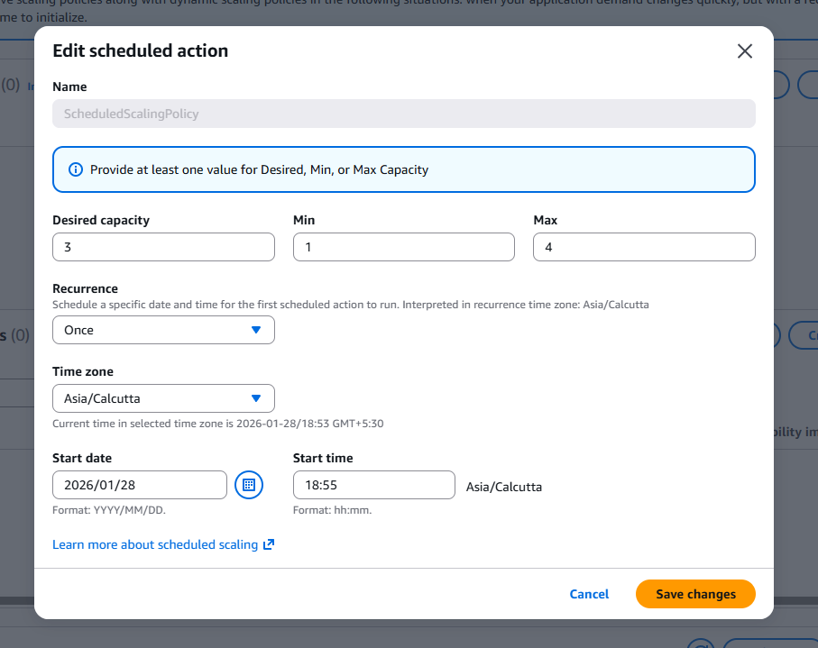

Once the scheduled action is completed then it will be get cleared off/deleted .

