Below is a precise, AWS-correct walkthrough to configure a Step Scaling policy using an Application Load Balancer (ALB).
Unlike target tracking, you explicitly control when and how much to scale.

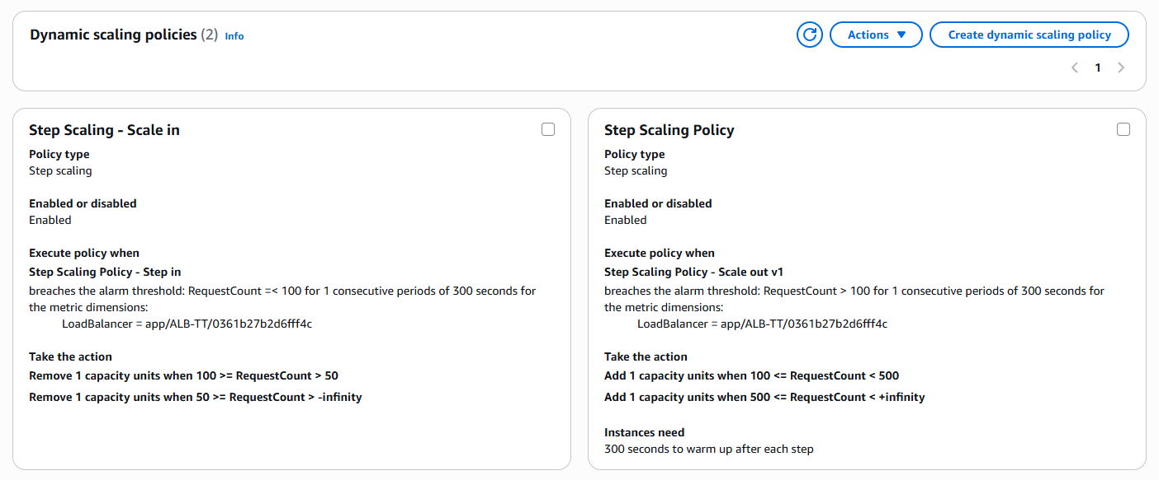

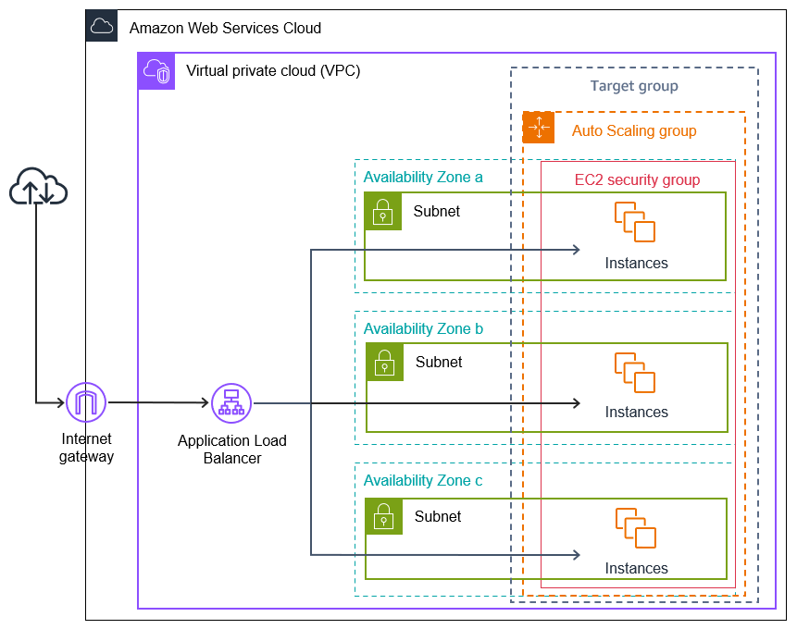

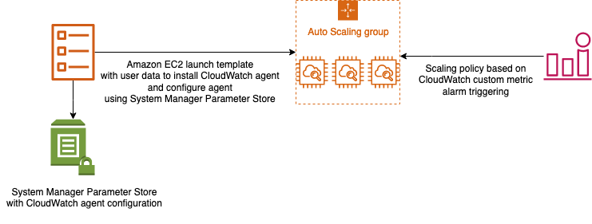

🧠 Concept First (Very Important)
Step scaling = Alarm-driven + Explicit actions
You must:
- Choose the metric
- Create CloudWatch alarm(s)
- Define scaling steps (add/remove N instances)
This is different from target tracking (which auto-creates alarms).

🧩 Prerequisites
- Application Load Balancer
- Target Group attached to ALB
- Auto Scaling Group
- EC2 instances registered to the Target Group

✅ Step-by-Step: Step Scaling with ALB

1️⃣ Attach ALB Target Group to ASG
EC2 → Auto Scaling Groups → Select ASG → Load balancing
Attach:
- ALB
- Target Group

2️⃣ Create a CloudWatch Alarm (ALB Metric)
Go to:
CloudWatch → Alarms → Create alarm
Select metric:
ApplicationELB → Per Target Metrics → RequestCountPerTarget
Choose:
- Load Balancer
- Target Group
Example alarm:
RequestCountPerTarget ≥ 100 for 2 periods of 60s

3️⃣ Create Step Scaling Policy (Scale-Out)
Navigate:
Auto Scaling Group → Automatic scaling → Create policy
Choose:
- Policy type: Step scaling
- Scaling direction: Scale out
- Adjustment type: Change in capacity
Define steps (example):
Metric deviation | Action
+0 to +20 | Add 1 instance
+20 to +50 | Add 2 instances
> +50 | Add 4 instances
Set:
Cooldown: 60 seconds

4️⃣ Attach Alarm to Scaling Policy
While creating the alarm (or later):
- Alarm action → Auto Scaling
- Select the scale-out policy
⚠️ Alarm is mandatory.

5️⃣ Create Scale-In Policy (Separate)
Repeat the above steps for scale-in.
Example alarm:
RequestCountPerTarget ≤ 60 for 5 periods of 60s
Scaling steps:
Metric deviation | Action
−0 to −20 | Remove 1 instance
< −20 | Remove 2 instances
Use a longer cooldown (e.g., 300s).

🔁 How AWS Executes Step Scaling
- Alarm enters ALARM
- Step policy evaluates deviation
- Applies matching step
- Cooldown starts
- No further scaling during cooldown

📊 Example Traffic Behavior
Requests / Target | Result
80 | No action
110 | +1 EC2
135 | +2 EC2
180 | +4 EC2
55 | −1 EC2

⚠️ Critical Rules & Limits
- Step scaling requires alarms
- Scale-in & scale-out must be separate policies
- ALB IPs are irrelevant (metric-based)
- Respect Min / Max ASG capacity

🏆 When to Use Step Scaling (vs Target Tracking)
Scenario | Best Choice
Predictable traffic bursts | Step scaling
Spiky web traffic | Target tracking
Strict capacity control | Step scaling
Simpler setup | Target tracking

🔑 One-Line Summary
Step scaling with ALB lets you define exact scaling actions based on CloudWatch alarms using ALB metrics like RequestCountPerTarget.

