Below is a clear, concise summary of how to create query-string–based routing using an Application Load Balancer (ALB) in AWS.

Services Involved
- Application Load Balancer
- Target Group

What Query-String Routing Is
ALB can inspect URL query parameters (e.g., ?name=green) and route requests to different target groups based on key/value matches.
This works only for HTTP/HTTPS (Layer 7).

High-Level Flow

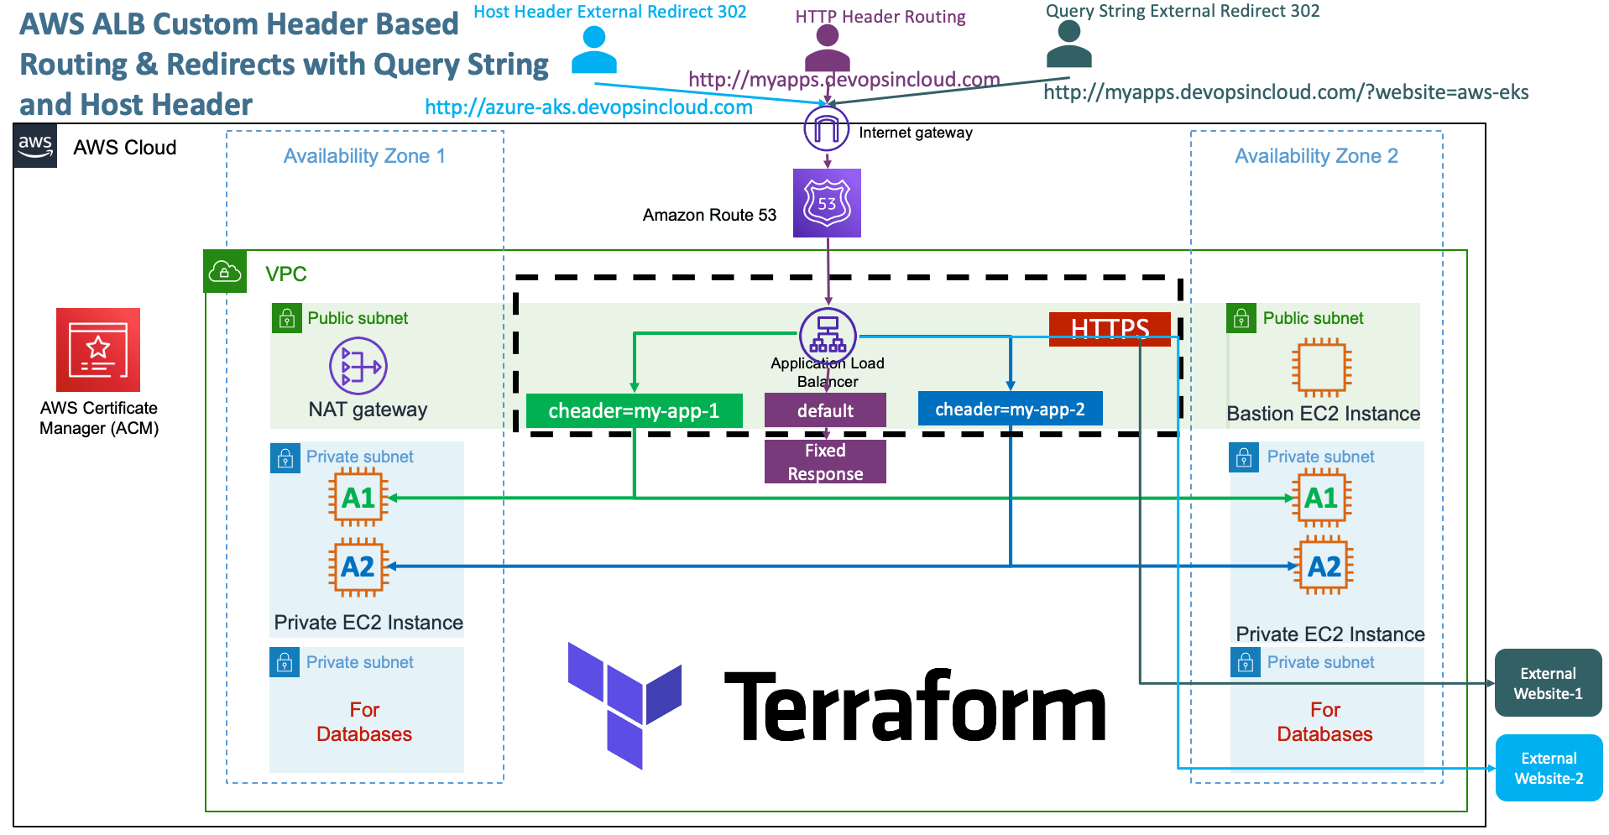
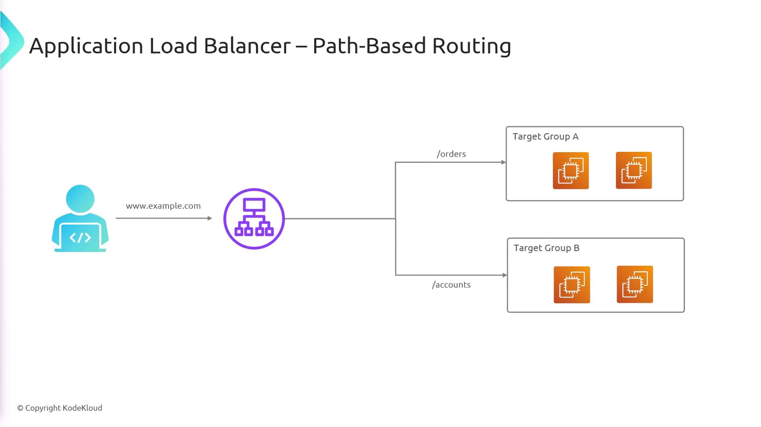
Client → https://app.example.com/?name=green
↓
ALB (Listener : 443)
↓
Listener Rules (Query String)
├─ name=green → TG-QS
└─ Default → TG-DEFAULT

End-to-End Steps (Summary)
- Create Target Groups
  - One TG per backend (e.g., TG-QS, TG-DEFAULT)
  - Configure health checks (must return HTTP 200)
- Create / Use an ALB
  - Application Load Balancer
  - Listener on HTTPS : 443 (recommended)
  - Set a default target group
- Add Listener Rules
  - Go to ALB → Listeners → 443 → Edit rules
  - Add conditions:
    - Query string key = value (e.g., env = green)
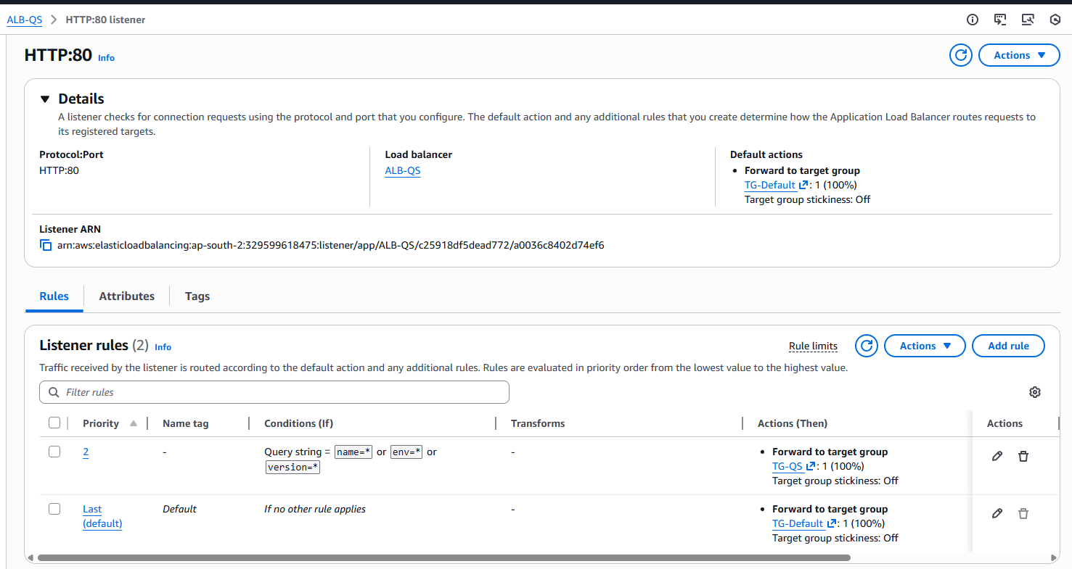
  - Action:
    - Forward to the matching TG
  - Set rule priority (top rules evaluated first)
- Test Routing
  - https://vg-cloudlabs.in/?name=green&env=prod&version=4
  - No query string → Default TG

Supported & Not Supported
✔ Supported
- Exact query matches (name=green)
- Key-only checks (env exists)
- Combine with path-based or host-based routing
- Blue/Green and Canary use cases
❌ Not Supported
- Regex or wildcard query values
- Numeric comparisons
- Query routing with NLB

Best Practices
- Always configure a default rule
- Use query routing for temporary traffic steering
- Do not pass sensitive data in query strings
- Monitor health checks before shifting traffic

One-Line Summary
Query-string routing in ALB is configured by adding listener rules that inspect URL query parameters and forward requests to different target groups based on ordered rule matches.

