Below is a clear, end-to-end summary of host-based routing using an Application Load Balancer (ALB) in AWS.

Core AWS Services Involved
- Application Load Balancer
- Target Group
- Amazon Route 53 (for DNS mapping)

What Is Host-Based Routing (One Line)
Host-based routing lets an ALB forward requests to different target groups based on the Host header (domain or subdomain) in the HTTP/HTTPS request.

High-Level Architecture

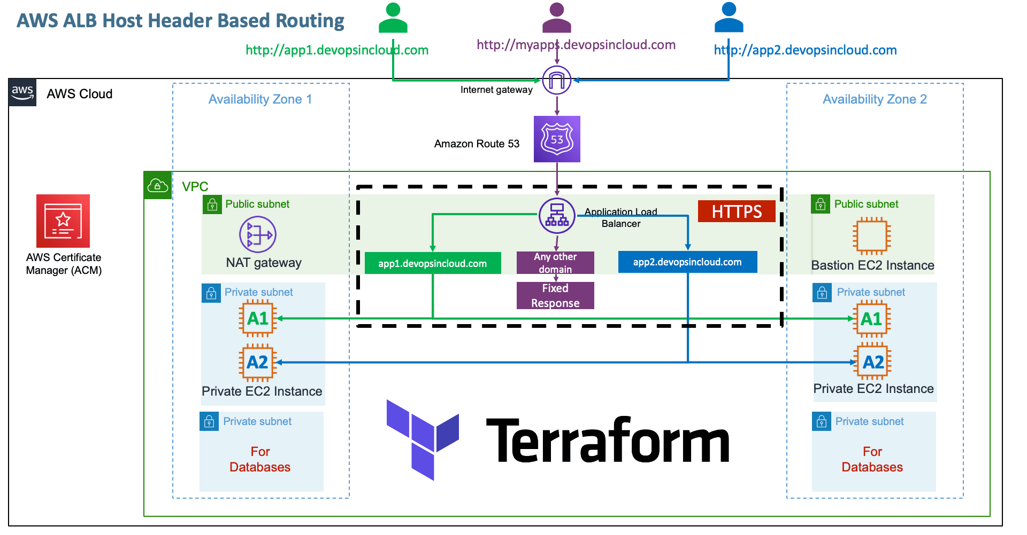
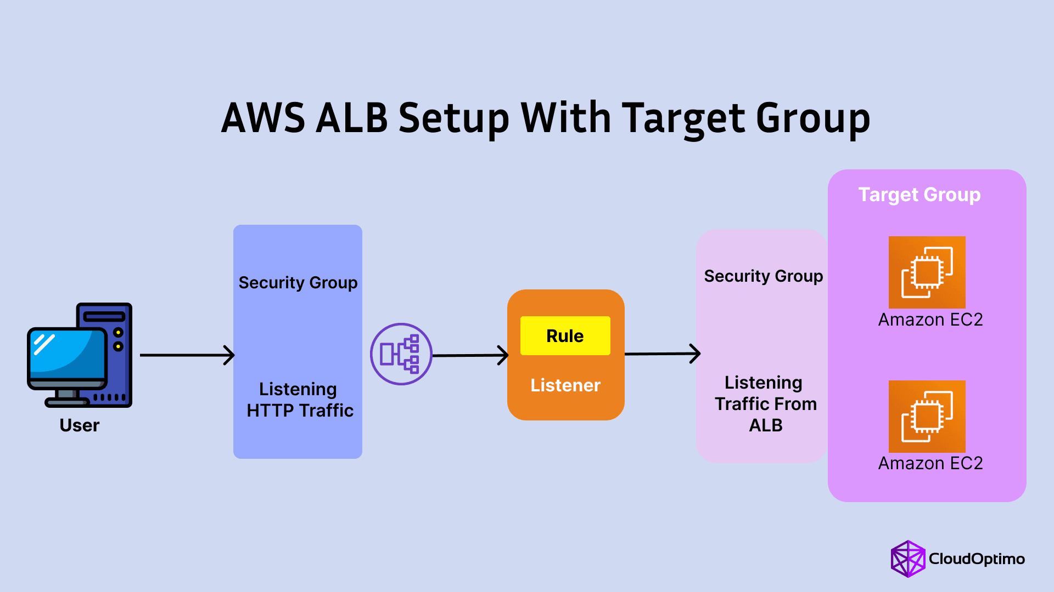
Client
↓
https:// vg-cloudlabs.in
https://api.vg-cloudlabs.in
↓
ALB (HTTPS : 443)
↓
Listener Rules (Host Header)

├─ api.vg-cloudlabs.in → TG-API
└─ Default → TG-DEFAULT

End-to-End Workflow
1️⃣ Prepare Backend Services
- Deploy backends (EC2 / ECS / EKS / Lambda)
- Each backend registers to its own Target Group
- Health checks must return HTTP 200

2️⃣ Create Target Groups
Example:
- TG-API → API service
- TG-DEFAULT → Fallback

3️⃣ Create / Use an ALB
- Type: Application Load Balancer
- Subnets: ≥ 2 AZs
- Listener: HTTPS : 443
- Attach ACM certificate covering all hostnames (SAN or wildcard)

4️⃣ Configure Host-Based Listener Rules
Go to:
ALB → Listeners → 443 → View/Edit rules
Example rules:
Priority | Condition (Host header) | Action
1 | api.vg-cloudlabs.in | Forward → TG-API
Default | — | Forward → TG-DEFAULT
Rules are evaluated top → bottom.

5️⃣ Configure DNS (Route 53)
Create A / AAAA Alias records:
Record | Points to
api. vg-cloudlabs.in | ALB

6️⃣ Test Routing
URL | Routed To
https:// api.vg-cloudlabs.in | TG-API
https:// vg-cloudlabs.in | Default TG

