Author: Vishnu Godse: Test Automation Developer []

08/04/2022

Test Automation: Java without Maven -TDD Framework Documentation

Completed

**\*\*\*\*\*\*\*\*\*\*\*\*\*\*\*\*\*\*\*\*\*\*\*\*\*\*\*\*\*\*\*\*\*\*\*\*\*\*\*\*\*\*\*\*\***

1. **Framework Structure**

**Below image shows the overall basic structure of designed TDD framework [Simple JAVA project without MAVEN] which mainly Involved below components:**

* 1. **Java [JDK 1.8.0.321]**
  2. **Selenium 3.14.0**
  3. **Edge Browser v 99+**
  4. **TestNG**
  5. **Apache POI to Pick Test Data from Excel**

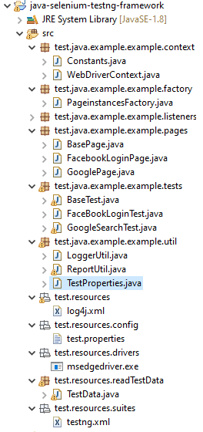

1. **Detailed Overview of Framework**

**Detailed structure overview and workflow of this TDD framework is as mentioned below: the information of every package and usage of classes designed under each package as given below:**

* 1. **SRC/TEST/JAVA**

**Under this directory we will be having below packages and classes: Please refer description provided under each**

* + 1. **Context:**



* **Constants:** The Class is for Constants.
* **WebDriverContext:** The Class is responsible in maintaining single instance of webdriver in any given thread.
  + 1. **Factory:**



* **PageInstanceFactory:** A factory for creating Pageinstances objects.
  + 1. **Listeners:**



* **LogListener:** The listener interface for receiving log events. The class that is interested in processing a log event
* **ReportListener :** The listener interface for receiving report events. The class that is interested in processing a report event
  + 1. **Pages:**

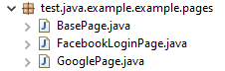

* **BasePage:** The Class BasePage every Page [Page Object] should extend this class.
* **FacebookLoginPage:** The Class represents FacebookLoginPage and all page objects , actions.
* **GooglePage:** The Class represents GooglePage and all page objects, actions.
  + 1. **Tests:**

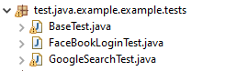

* **BaseTest:** Every test class should extend this calss. This class has pre and Post requisites for all test to start and end.
* **FaceBookLoginTest:** The Class has FaceBook Login Test
* **GoogleSearchTest:** The Class has Google Search Test
  + 1. **Utils:**

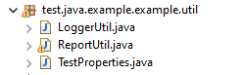

* **LoggerUtils:** The Class has all Logging related utilities.
* **ReportUtils:** The Class is responsible for Reporting
* **TestProperties:** The Class is responsible for Read properties file and set some properties if required
  + 1. **TestData:**



* **TestData :** The Class is responsible for Read Test data file and provide test data to test cases.

1. **TestNG.xml:** This file is being used to run test suite as TestNG .



**\*\*\*\*\*\*\*\*\*\*\*\*\*\*\* END of Document \*\*\*\*\*\*\*\*\*\*\*\*\*\*\*\*\***