**AI-BASED E-COMMERCE PRODUCT RECOMMENDATION SYSTEM**

**A MINI PROJECT-I REPORT**

***Submitted by***

|  |  |
| --- | --- |
| **HARISH VISHNU K** | **(621321205016)** |
| **NAVEEN J N** | **(621321205030)** |
| **VISHAL S** | **(621321205062)** |

***In partial fulfilment for the award of the degree***

***of***

# BACHELOR OF TECHNOLOGY

**IN**

**INFORMATION TECHNOLOGY**

**KONGUNADU COLLEGE OF ENGINEERING AND TECHNOLOGY**

**(AUTONOMOUS) THOTTIAM**

# ANNA UNIVERSITY:: CHENNAI 600 025

**NOV 2023**

**KONGUNADU COLLEGE OF ENGINEERING AND TECHNOLOGY**

**(AUTONOMOUS)**

**NAMAKKAL- TRICHY MAIN ROAD, THOTTIAM, TRICHY.**

**COLLEGE VISION & MISSION STATEMENT**

**VISION**

**"To become an Internationally Renowned Institution in Technical Education,**

**Research and Development by Transforming the Students into Competent Professionals with Leadership Skills and Ethical Values."**

**MISSION**

* Providing the Best Resources and Infrastructure.
* Creating Learner-Centric Environment and continuous Learning.
* Promoting Effective Links with Intellectuals and Industries.
* Enriching Employability and Entrepreneurial Skills.
* Adapting to Changes for Sustainable Development.

**DEPARTMENT OF INFORMATION TECHNOLOGY**

**VISION:**

To produce competent IT and software professionals with entrepreneurial attitudes for successful software organizations/ventures.

**MISSION**:

* Enrich the students’ programming and computing skills through best teaching, learning processes, laboratory practices and through project based learning.
* Inculcate real world challenges, emerging technologies and endeavour the students to become entrepreneurs or make them employable.
* Inculcating moral and ethical values to serve the society and focus on students’ overall development.

**PROGRAM EDUCATIONAL OBJECTIVES (PEOs)**

* **PEO I:** Graduates shall become IT professionals with specialization in Software Engineering, Networking, Data Mining and Cloud computing.
* **PEO II:** Graduates shall build IT solutions through analysis, design and development of software and firmware solutions for real-world problems and social issues.
* **PEO III:** Graduates shall have professional ethics, team spirit, life-long learning, good oral and written communication skills and adopt corporate culture, core values and leadership skills.

**PROGRAM SPECIFIC OUTCOMES (PSOs)**

* **PSO1: Professional skills:** Students shall understand, analyse and develop IT applications in the field of Data Mining/Analytics, Cloud Computing, Networking etc., to meet the requirements of industry and society.
* **PSO2: Competency:** Students shall qualify at the State, National and International level competitive examination for employment, higher studies and research.

## PROGRAM OUTCOMES (POs)

**Engineering Graduates will be able to:**

1. **Engineering knowledge**: Apply the knowledge of mathematics, science, engineering fundamentals, and an engineering specialization to the solution of complex engineering problems.
2. **Problem analysis**: Identify, formulate, review research literature, and analyze complex engineering problems reaching substantiated conclusions using the first principles of mathematics, natural sciences, and engineering sciences.
3. **Design/development of solutions**: Design solutions for complex engineering problems and design system components or processes that meet the specified needs with appropriate consideration for public health and safety, and cultural, societal, and environmental considerations.
4. **Conduct investigations of complex problems**: Use research-based knowledge and research methods including design of experiments, analysis, and interpretation of data, and synthesis of the information to provide valid conclusions.
5. **Modern tool usage**: Create, select, and apply appropriate techniques, resources, and modern engineering and IT tools including prediction and modelling to complex engineering activities with an understanding of the limitations.
6. **The engineer and society**: Apply reasoning informed by the contextual knowledge to assess societal, health, safety, legal and cultural issues and the consequent responsibilities relevant to the professional engineering practice.
7. **Environment and sustainability**: Understand the impact of the professional engineering solutions in societal and environmental contexts, and demonstrate the knowledge of, and need for sustainable development.
8. **Ethics**: Apply ethical principles and commit to professional ethics and responsibilities and norms of the engineering practice.
9. **Individual and team work**: Function effectively as an individual, and as a member or leader in diverse teams, and in multidisciplinary settings.
10. **Communication**: Communicate effectively on complex engineering activities with the engineering community and with society at large, such as, being able to comprehend and write effective reports and design documentation, make effective presentations, and give and receive clear instructions.
11. **Project management and finance**: Demonstrate knowledge and understanding of the engineering and management principles and apply these to one’s own work, as a member and leader in a team, to manage projects and in multidisciplinary environments.
12. **Life-long learning**: Recognize the need for, and have the preparation and ability to engage in independent and life-long learning in the broadest.

**ANNA UNIVERSITY::CHENNAI 600 025**

# BONAFIDE CERTIFICATE

Certified that this mini project report titled **FACE EMOTION**

**RECOGNITION USING PYTHON** is a bonafide work of **HARISH VISHNU K** (621321205016), **SUNIL SANTHOSH S** (621321205056), DHANUSH RJ **(621321205009),**” who carried out the mini project under my supervision.

|  |  |
| --- | --- |
| **SIGNATURE** | **SIGNATURE** |
| **Mr.N.PREMKUMAR, M.E., (Ph.D)** | **Dr.K.MUTHUMANICKAM, M.E., Ph.D** |
| HEAD OF THE DEPARTMENT | SUPERVISOR |
| Associate Professor, | Professor, |
| Department of Information | Department of Information |
| Technology, | Technology, |
| Kongunadu College of Engineering | Kongunadu College of Engineering |
| and Technology (Autonomous). | and Technology (Autonomous). |

Submitted for the project work and viva-voce held on ………………

**INTERNAL EXAMINER EXTERNAL EXAMINER**

# ABSTRACT

Face emotion recognition is the ability of a technology to identify and categorise human emotions from their manifestations on the face. Because of the potential uses for this technology in a variety of industries, including psychology, marketing, healthcare, and security, it has attracted a lot of attention recently. We give a general introduction of the idea of facial emotion recognition in this abstract, including its significance, difficulties, and potential applications. We cover the many methods for identifying facial expressions, including conventional computer vision techniques, deep learning-based techniques, and multimodal methods that integrate diverse information modalities. We also draw attention to the drawbacks and moral challenges with face emotion detection algorithms, such as privacy and bias concerns.

# ACKNOWLEDGEMENT

We wish to express our sincere gratitude to our beloved chairman **Dr.PSK.R.PERIASWAMY** for providing the facilitation to make us extensively internationalized to meet global competence with almost perfection.

We would like to express our sincere thanks to our Principal **Dr.R.ASHOKAN, M.S., M.Tech., Ph.D.,** for the facilities and the encouragement given to the progression and completion of this project.

We proudly render our immense gratitude to **Mr.N.PREMKUMAR, M.E., (Ph.D).,** Associate Professor and Head of the Department, Department of Information Technology for his effective leadership, encouragement and supportive guidance to this project.

We proudly render our thanks to our mini project Coordinator

**Dr.N.MAGENDIRAN, M.E, Ph.D.,** Professor, Department of Information Technology for his valuable ideas, encouragement and supportive guidance throughout this project.

We wish to extend our heartfelt regard and sincere thanks to our mini project guide **Dr.K.MUTHUMANICKAM, M.E., Ph.D**  Professor, Department of Information Technology for her Motivation, Continuous encouragement and expert guidance throughout this project.

We wish to extend our sincere thanks to all faculty members of Information Technology Department for their valuable suggestions, kind cooperation and encouragement on successful completion of this project.

Finally, we profound gratitude to the almighty for his presence and who gave me the bravery, privilege, power and belief to complete this project.

**TABLE OF CONTENT**

**CHAPTER TITLE PAGE NO.**

**NO**

**ABSTRACT VII**

**1 INTRODUCTION 1**

1.1 OVERVIEW 2

1.2 PROBLEM STATEMENT 2

**2 LITERATURE SURVEY 3**

**3 SYSTEM ANALYSIS 6**

3.1 EXSISTING SYSTEM 6

3.2 PROPOSED SYSTEM 6

1. **DESIGN 7**

4.1 SYSTEM ARCHITECTURE 7

4.2 UML DIAGRAMS 7

1. **SYSTEM IMPLEMENTATION 10**
   1. MODULE SPECIFICATION 11

5.2 MODULE DESCRIPTION 11

**6 SYSTEM SPECIFICATION 12**

6.1 SOFTWARE REQUIREMENTS 12

6.2 HARDWARE REQUIREMENTS 12

## 7 ALGORITHM DESCRIPTION 13

7.1 HAAR CASCADE ALGORITHM 13

7.2 CALCULATING HAAR FEATURES 14

7.3 CREATING INTEGRAL IMAGES 14

7.4 ADABOOST TRAINING 14

7.5 IMPLEMENTING CASCADING CLASSIFIER 15

**8** **TESTING**  **16**

8.1 SOFTWARE TESTING 16  8.2 TESTING TECHNIQUES 19

## 9 APPENDICES 21

9.1 SAMPLE PROGRAM 21

9.2 OUTPUT 22

10 CONCLUSION **23**

11 REFERENCE **24**

## 

## 

## LIST OF FIGURES

**FIG NO NAME OF THE FIGURE PAGE NO**

4.1 System Architecture 7

4.2 Sequence Diagram 8

4.4 Activity Diagram 9

9.2 Output 22

**CHAPTER 1**

# INTRODUCTION

Facial Emotion Recognition is a technology used for analysing sentiments by different sources, such as pictures and videos. It belongs to the family of technologies often referred to as ‘affective computing’, a multidisciplinary field of research on computer’s capabilities to recognise and interpret human emotions and affective states and it often builds on Artificial Intelligence providing hints for human emotions. For decades, decoding such emotion expressions has been a research interest in the field of psychology (Ekman and Friesen 2003; Lang et al. 1993) but also to the Human Computer Interaction field (Cowie et al. 2001; Abdat et al. 2011). Recently, the high diffusion of cameras and the technological advances in biometrics analysis, machine learning and pattern recognition have played a prominent role in the development of the FER technology. Many companies, ranging from tech giants such as NEC or Google to smaller ones, such as Affectiva or Eyeris invest in the technology, which shows its growing importance. There are also several EU research and innovation program Horizon2020 initiatives1 exploring the use of the technology.

**1.1 OVERVIEW**

One of the easiest, and yet also the most effective ways of analyzing how people feel is looking at their facial expressions. Most of the time, our face best describes how we feel in a particular moment. This means that emotion recognition is a simple multiclass classification problem. You need to analyze a person's face and put it in a particular class, where each class represents a particular emotion.Analyzing faces is not always enough to gauge how somebody feels. Humans often try to hide how they feel. This can sometimes lead to misleading results if only emotion recognition in images is performed. However, in combination with other techniques (such as body language in images, or voice analysis in videos), you can get a pretty solid idea of how somebody feels.Let's demonstrate how easy it is to perform emotion detection in images. You can use pre-built libraries that will allow you to easily analyze faces and get the results you want very quickly without using too much code.

**1.2 PROBLEM STATEMENT**

The problem statement for face emotion recognition is to develop a system or algorithm that can accurately detect and classify human emotions based on facial expressions in real-time or from images/videos. This involves identifying the key facial features and patterns associated with different emotions and creating a model that can accurately classify them into different categories such as happy.

**CHAPTER 2**

# LITERATURE SURVEY

"Facial expression recognition: a brief tutorial overview" by L. P. Morency, J. F. Cohn, and T. S. Kanade. This paper provides a comprehensive review of the key methods and techniques used for facial expression recognition, including feature extraction, machine learning algorithms, and databases. "A Survey on Facial Expression Recognition Techniques" by Shima Akhavan and Azadeh Mansouri, published in the Journal of Artificial Intelligence and Data Mining in 2020. This paper provides a comprehensive survey of different techniques and algorithms used for facial expression recognition, including traditional methods such as template matching and machine learning-based approaches such as neural networks and support vector machines.

"Deep Learning for Emotion Recognition on Small Datasets Using Transfer Learning" by Akshay Rangesh, et al., published in the Journal of Visual Communication and Image Representation in 2018. This paper explores the use of deep learning algorithms for emotion recognition, specifically using transfer learning to adapt pre-trained models for small datasets. The authors also present a dataset of facial expressions they created to test their approach.

"Facial Expression Recognition with Deep Le arning: A Review" by Hui Wang, et al., published in the International Conference on Neural Information Processing in 2018. This paper provides a detailed review of the use of deep learning methods for facial expression recognition, including convolutional neural networks and recurrent neural networks. The authors also discuss the challenges and future directions of this field.

"A Comprehensive Survey on Facial Expression Recognition Techniques, Databases and Applications" by K. Shanmugavadivu and V. Vaidehi, published in the International Journal of Advanced Research in Computer Science and Software Engineering in 2019. This survey covers various aspects of facial expression recognition, including the use of different features and classifiers, datasets and benchmarks, and applications of the technology in fields such as healthcare and security.

"Real-time Facial Expression Recognition using Convolutional Neural Networks" by B. Chaithanya and G. Rajashekar, published in the International Journal of Advanced Research in Computer and Communication Engineering in 2019. This paper presents a real-time system for facial expression recognition using a convolutional neural network architecture. The authors evaluate their system using the FER-2013 dataset and achieve high accuracy in emotion recognition.

"Real-Time Face Emotion Recognition using Convolutional Neural Networks" by Shanmugavadivu P. et al. (2021): This paper proposes a real-time face emotion recognition system using convolutional neural networks (CNNs) that achieves high accuracy in emotion classification.

"Facial Emotion Recognition: State of the Art Performance on the Emotion Recognition in the Wild (EmotiW) Challenge" by Kostas Karpouzis et al. (2020): This paper presents a comprehensive survey of the state-of-the-art methods for facial emotion recognition and evaluates their performance on the EmotiW dataset.

"Facial Emotion Recognition using Deep Learning: A Review" by Mihir M. Karandikar et al. (2019): This paper reviews the recent advances in facial emotion recognition using deep learning techniques, including CNNs, recurrent neural networks (RNNs), and hybrid models.

"Facial Emotion Recognition: A Survey" by Huimin Xu et al. (2018): This paper provides a survey of the traditional and deep learning-based methods for facial emotion recognition and discusses the challenges and future directions in this field.

"Facial Expression Recognition: A Brief Review of the Literature" by S. Shyamala et al. (2016): This paper presents a brief review of the literature on facial expression recognition, including the feature extraction techniques, classification algorithms, and applications.

**CHAPTER 3**

# SYSTEM ANALYSIS

## 3.1 EXISTING SYSTEM

In the existing system they have gone through with the open CV but while extraction of the face emotions they got the wrong outputs. There is no exact face emotions representation of expression with accuracy. Existing work includes the application of feature extraction of facial expressions with the combination of neural networks for the recognition of different facial emotions (happy, sad, angry, fear, surprised. Humans are capable of producing thousands of facial actions during communication that varies in complexity, intensity, and meaning. The existing system is capable of analyzing the limitations of the existing system of Emotion recognition using brain activity.

**3.2 PROPOSED SYSTEM**

Where the data subjects’ facial expressions are captured in a remote manner, it may not be clear to them which system or application will process their data, for which purposes, and who the controllers are. As a result, they would not be in the position to freely give consent or exercise control over the processing of their personal data, including sharing with third-parties. Where data subjects are not provided with accurate information, access and control over the use of FER

**CHAPTER 4**

# SYSTEM DESIGN

## 4.1 SYSTEM ARCHITECTURE

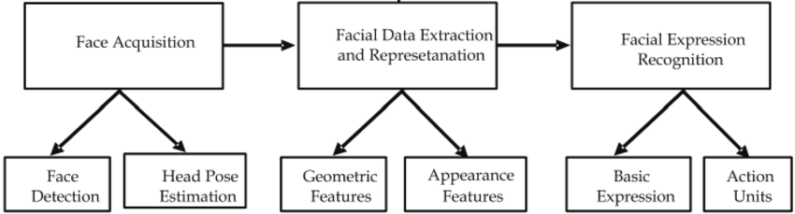

Fig 4.1: System Architecture

## 4.2 UML DIAGRAMS

A**class diagram** is used to represent, explain, and document the parts (classes) of an **face emotion recognition system**. It can also be a reference or way to create executable software code. **Class diagrams** provide an overview of the system’s **classes**, **functions**, and **relationships**

**4.1.1 SEQUENCE DIAGRAM**

The **Sequence Diagram for Face Emotion Recognition System** describes the series of interactions that occur with the objects to perform the system’s process. A sequence diagram is one of the UML models used for presenting the workflow, sequence of messages, and interactions within the face recognition system.

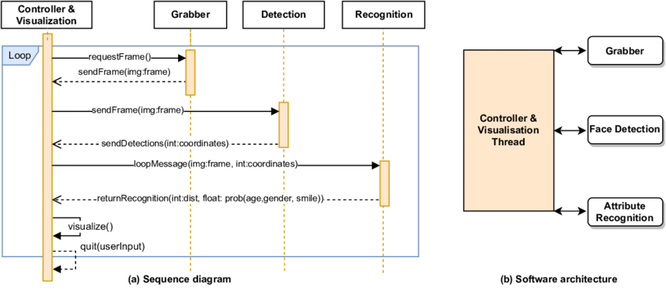

Fig 4.2: Sequence Diagram

4.1.2 ACTIVITY DIAGRAM

The UML **activity diagram for face recognition system** is a diagram that presents the flow of system activities. It is one of the methods used to document the system behavior in terms of activities and development.Additionally, the activity diagram uses symbols to define the overall workflow of the face recognition system. It is composedof **activities**, **decisions**,and **paths**(flows).

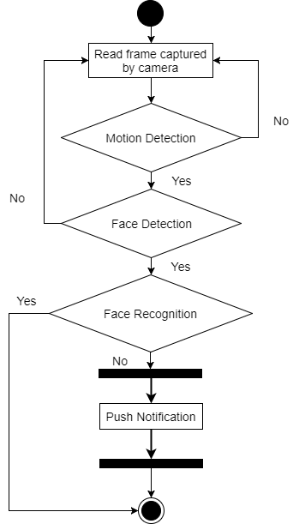

Fig 4.3: Activity Diagram

**CHAPTER 5**

# SYSTEM IMPLEMENTATION

## 

Through the CCTV data streaming, faces are captured and matched with the database. Therefore, it is further used to detect their facia emotions. Furthermore, it is marked and stored into the database. This system prototype is developed by big data technology to tackle this complexity of data.

**5.1 MODULE SPECIFICATIONS**

1. Capturing the Image

2. Face Detection

3. Image Preprocessing

4. Training Set

5. Face Emotion Recognition

## 

## 5.2 MODULE DESCRIPTION

5.2.1 CAPTURE THE IMAGE

The camera will capture the face images perfectly. Then it goes to further process of face detection.

5.2.2 FACE DETECTION

In this part, implements face detection, which helps to determines captured image with location and sizes of faces. The image will be captured from detected faces using haar cascade classifier.

5.2.3 IMAGE PREPROCESSING

There is a preprocessing requirement for enhance the input image for improve the quality of image .We converts input image to grey scale image using color to grey image conversion technique.

5.2.4 TRAINING SET

Comparing the faces which to be recognized with some other similar faces to did recognition process. Supply algorithm faces in training set for tell which person who belongs. When recognize face by algorithm, it uses the training set to make recognition.

5.2.5 FACE EMOTION RECOGNITION

The important part of this system is face emotion recognition. Face emotion recognition of an automatic method of identifying and verifying a person’s emotion from images and videos from camera.

# CHAPTER 6

**SYSTEM SPECIFICATION**

## 6.1 SOFTWARE REQUIREMENTS

Operating System : Windows Pro

Front End : Python

Language : Python

## 6.2 HARDWARE REQUIREMENTS

|  |  |  |
| --- | --- | --- |
| Processor | : | Intel Core i3 |
| Hard Disk | : | 512 GB |
| RAM | : | 8 GB |

**CHAPTER 7**

# ALGORITHM DESCRIPTION

HAAR Cascades are machine learning object detection algorithms that are used to identify faces in an image or a real-time video. The HAAR Cascade algorithm uses edge or line detection features that are proposed by Viola and Jones within their research paper named “Rapid Object Detection employing Boosted Cascade of Simple Features”.

**7.1 HAAR CASCADE ALGORITHM**

STEP 1: Importing OpenCV

STEP 2: Importing XML file

STEP 3: Importing test Image

STEP 4: Converting the image to greyscale

STEP 5: Detecting Multi-scale faces

STEP 6: Mentioning sides of the rectangle for face detection

STEP 7: Displaying the emotion of detected image

MAKING A HAAR CASCADE CLASSIFICATION

The algorithm can be explained in four stages:

* Calculating Haar Features
* Creating Integral Images
* Using Adaboost
* Implementing Cascading Classifier

## 7.2 CALCULATING HAAR FEATURES

## 

## The first step is to collect the Haar features. A Haar feature is essentially calculations that are performed on adjacent rectangular regions at a specific location in a detection window. The calculation involves summing the pixel intensities in each region and calculating the differences between the sums. Here are some examples of Haar features.

**7.3** **CREATING INTEGRAL IMAGES**

Creating integral image without going into too much of the mathematics behind it integral images essentially speed up the calculation of these Haar features. Instead of computing at every pixel, it instead creates sub-rectangles and creates array references for each of those sub-rectangles. These are then used to compute the Haar features. It’s important to note that nearly all of the Haar features will be irrelevant when doing object detection, because the only features that are important are those of the object.

**7.4 ADABOOST TRAINING**

Adaboost essentially chooses the best features and trains the classifiers to use them. It uses a combination of “weak classifiers” to create a “strong classifier” that the algorithm can use to detect objects.Weak learners are created by moving a window over the input image, and computing Haar features for each subsection of the image. This difference is compared to a learned threshold that separates non-objects from objects.

**7.5** IMPLEMENTING CASCADING CLASSIFIER

The cascade classifier is made up of a series of stages, where each stage is a collection of weak learners. Based on this prediction, the classifier either decides to indicate an object was found (positive) or move on to the next region (negative). Stages are designed to reject negative samples as fast as possible, because a majority of the windows do not contain anything of interest. It’s important to maximize a low false negative rate, because classifying an object as a non-object will severely impair your object detection algorithm. A video below shows Haar cascades in action. The red boxes denote “positives” from the weak learners. Haar cascades are one of many algorithms that are currently being used for object detection. One thing to note about Haar cascades is that it is very important to reduce the false negative rate, so make sure to tune hyperparameters accordingly when training your model.

**CHAPTER – 8**

# TESTING

## 8.1 SOFTWARE TESTING

Testing is a set of activities that can be planned in advanced and conducted systematically. A strategy for software testing must accommodation low-level tests that are necessary to verify that a small source code segment has been correctly implemented as well as high-level tests that validate major system functions against customer requirements

Types of testing strategies

1. Unit test

1. Integration test

1. Performance test

1. System testing

1. Smoke testing

1. Regression testing

1. Beta Testing

1. Acceptance testing

**UNIT TESTING:**

Unit testing focuses verification efforts on the smallest unit of software designmodule. The unit test is always white box oriented. The tests that occur as part of unit testing are testing the module interface, examining the local data structures,testing the boundary conditions, execution all the independent paths and testing error-handling paths

**INTEGRATION TESTING:**

Integration testing is a systematic technique or construction the program structure while at the same time conducting tests to uncover errors associated with interfacing. Scope of testing summarizes the specific functional, performance, and internal design characteristics that are to be tested. It employs top-down testing and bottom-up testing methods for this case.

**PERFORMANCE TESTING:**

Timing for both read and update transactions should be gathered to determine whether system functions are being performed in an acceptable timeframe.

**SYSTEM TESTING:**

System testing of software or hardware is testing conducted on a complete, integrated system to evaluate the system's compliance with its specified requirements.System testing falls within the scope of black-box testing. and as such, should require no knowledge of the inner design of the code or logic

**SMOKE TESTING:**

In software testing, smoke testing is preliminary testing to reveal simple failures severe enough to, for example, reject a prospective software release. Smoke tests are a subset of test cases that cover the most important functionality of a component or system, used to aid assessment if main functions of the software appear to work correctly. When used to determine if a computer program should be subjected to further, more fine-grained testing. Alternately, it is a set of tests run on each new build of a product to verify that the build is testable before the build is released into the hands of the test team.

**REGRESSION TESTING:**

Regression testing is the process of testing changes to computer programs to make sure that the older programming still works with the new changes. Regression testing is a normal part of the program development process and, in larger companies, is done by code testing specialists. Test department coders develop code test scenarios and exercises that will test new units of code after they have been written. These test cases form what becomes the test bucket. Before a new version of a software product is released, the old test cases are run against the new version to make sure that all the old capabilities still work. The reason they might not work is because changing or adding new code to a program can easily introduce errors into code that is not intended to be changed.

**BETA TESTING:**

Beta Testing is one of the Acceptance Testing types, which adds value to the product as the end-user (intended real user) validates the product for functionality, usability, reliability, and compatibility. Since Beta Testing happens at the end user’s side, it cannot be the controlled activity.

**ACCEPTANCE TESTING:**

Acceptance testing, a testing technique performed to determine whether or not the software system has met the requirement specifications. The main purpose of this test is to evaluate the system's compliance with the business requirements and verify if it is has met the required criteria for delivery to end users.

## 8.2 TESTING TECHNIQUES

### 8.2.1 WHITE BOX TESTING

White box testing is a test case design method that uses the control structure of the procedural design to derive test cases. After performing white box testing it was identified that:

* The Leave Recording System (LRS) software guarantees that all independent paths within the modules have been exercised at least once.
* It has been exercised all logical decisions on their true and false sides.
* It was tested to execute all loops at their boundaries and within their Operational bounds
* It was tested for the internal data structures to ensure their validity.

### 8.2.2 BLACK BOX TESTING

Black Box Testing a testing the software without any knowledge of the inner workings, structure or language of the module being tested. Black box tests, as most other kind of tests must be written from a definitive source document, such as specification requirements document. It is a testing in which the software under test is treated as black box you cannot see into it. The test provides inputs and responds to outputs without considering how the software works.

### 8.2.1 TEST PLAN

A document describing the scope, approach, resources and schedule of intended test activities.It identifies amongst others test items, the features to be tested, the testing tasks, who will doeach task, degree of tester independence, the test environment the test design techniques andentry and exit criteria to be used, and the rationale for their choice, and any risks requiring contingency planning. It is a record of the test planning process. Follow the below steps tocreatea test plan as per IEEE 829.

### 8.2.2 ANALYZE THE SYSTEM

A system product can be analyzed only when the tester has any information about it i.e., how the system works, who the end users are, what software/ hardware the system uses,what the system is for etc.

**CHAPTER 9**

**APPENDICES**

## 9.1 SAMPLE PROGRAM

import cv2 as cv

from facial_emotion_recognition import EmotionRecognition

emotion_recognition = EmotionRecognition(device = 'cpu')

cam = cv.VideoCapture(0)

while True:

_, frame = cam.read()

frame = emotion_recognition.recognise_emotion(frame, return_type = 'BGR')

cv.imshow ('emotion recognition', frame)

key = cv.waitKey(1)

if key == 27:

break

cam.release()

cv.destroyAllWindows()

**9.2 OUTPUTS**

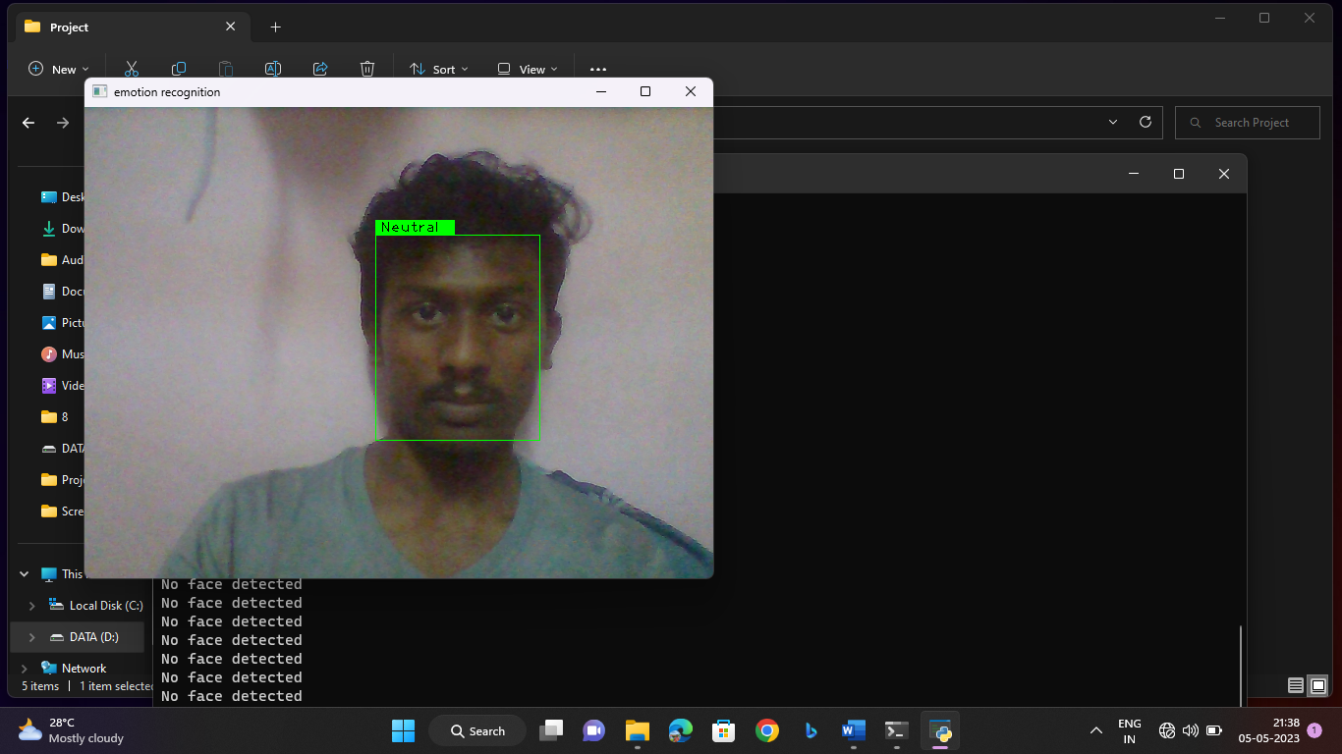

Fig 9.1: Output

**CHAPTER 10**

## CONCLUSION

Face emotion recognition technology is a rapidly advancing field that has the potential to revolutionize various industries, including healthcare, entertainment, and marketing. It involves the use of machine learning algorithms to detect and analyze facial expressions in real-time, enabling computers to accurately identify the emotional state of a person. Although there are concerns regarding the accuracy and ethics of face emotion recognition, ongoing research and development efforts are focused on improving the technology to address these issues.

**CHAPTER-11**

# REFERENCE

[1] Bettadapura, V. (2012). Face expression recognition and analysis: the state

of the art. *arXiv preprint arXiv:1203.6722*.

[2] Shan, C., Gong, S., & McOwan, P. W. (2005, September). Robust facial

expression recognition using local binary patterns. In Image Processing,

ICIP 2005. IEEE International Conference on (Vol. 2, pp. II-370). IEEE.

[3] Bhatt, M., Drashti, H., Rathod, M., Kirit, R., Agravat, M., & Shardul, J.

A Study of Local Binary Pattern Method for Facial Expression Detection.

arXiv preprint arXiv:1405.6130.

[4] Chen, J., Chen, Z., Chi, Z., & Fu, H. (2014, August). Facial expression

recognition based on facial components detection and hog features. In

International Workshops on Electrical and Computer Engineering

Subfields (pp.884-888).

[5] Ahmed, F., Bari, H., & Hossain, E. (2014). Person-independent facial

Expression recognition based on compound local binary pattern (CLBP).

Int. Arab J. Inf. Technol., 11(2), 195-203.

[6] Happy, S. L., George, A., & Routray, A. (2012, December). A real time facial

expression classification system using Local Binary Patterns. In *Human Computer Interaction (IHCI), 2012 4th International Conference on*

(pp. 1-5).IEEE.

[7] Zhang, S., Zhao, X., & Lei, B. (2012). Facial expression recognition based on

local binary patterns an local fisher discriminant analysis. *WSEAS*

*Trans Signal*