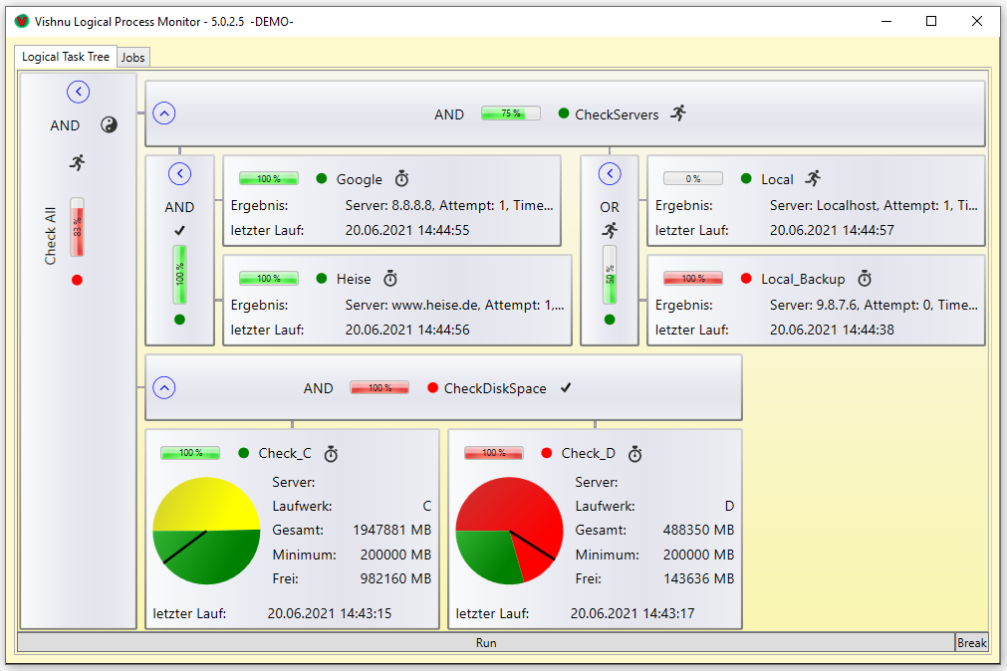

Sub-Job

Main-Job

Sub-Job

Checker

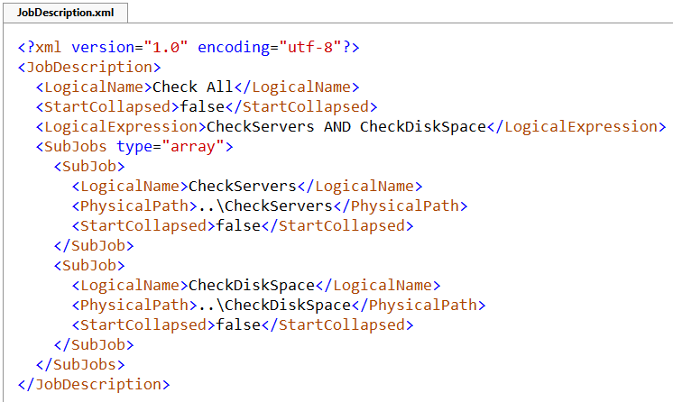

*(XML identifier, always the same)*

Job-start

Job-name

logical expression

...

*(Job-content)*

...

Job-ending

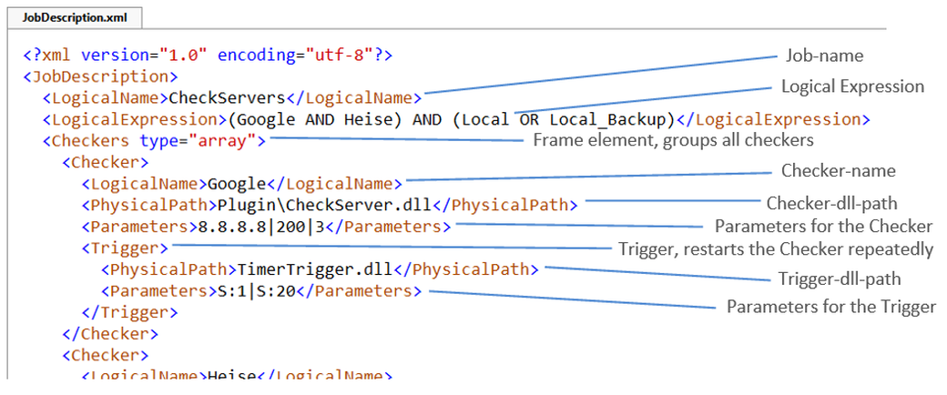

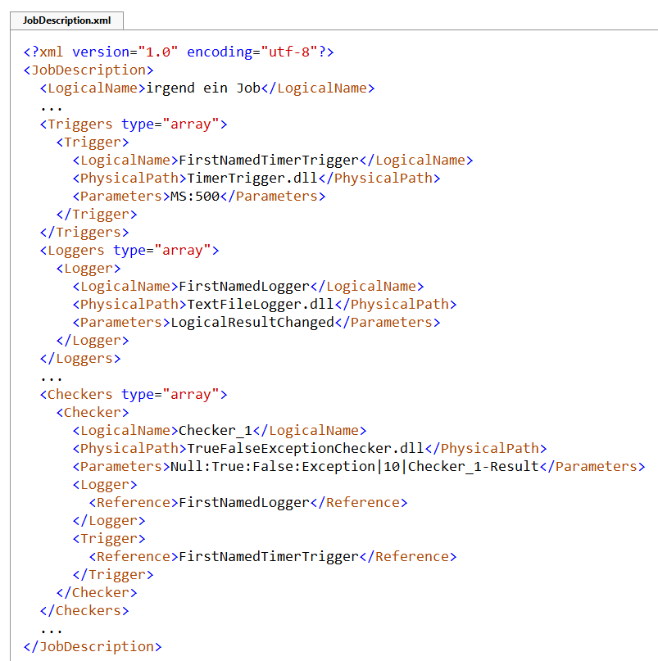

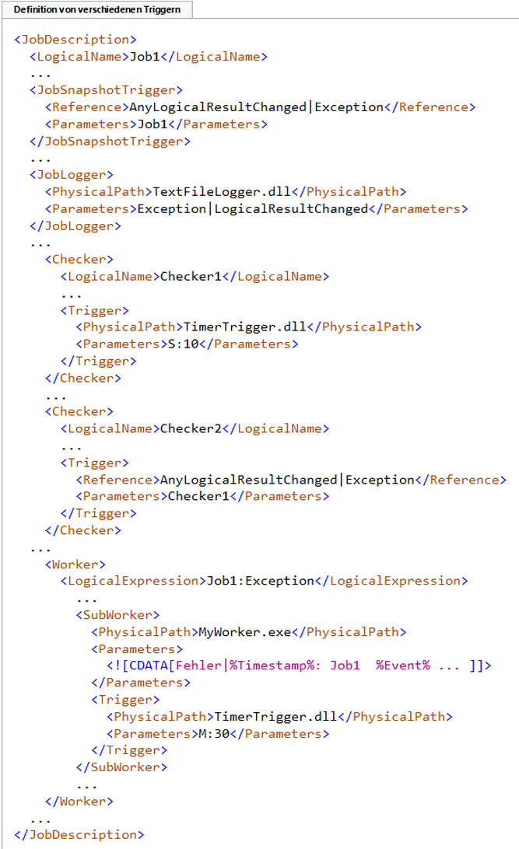

TreeEventTrigger: a Snapshot will be saved,

when the logical result of Job1 changes

or an Exception raises.

Implicit TreeEventTrigger: a log entry will be written,

when the logical result of the Job changes

or an Exception raises.

TimerTrigger: Checker1 is started every 10 seconds.

TreeEventTrigger: Checker2 is always started

when the logical result of Checker1 changes

or an exception occurs in Checker1

Implicit TreeEventTrigger: The subworkers are started

when an exception occurs in Job1.

TimerTrigger: MyWorker.exe is annoying every 30 minutes.

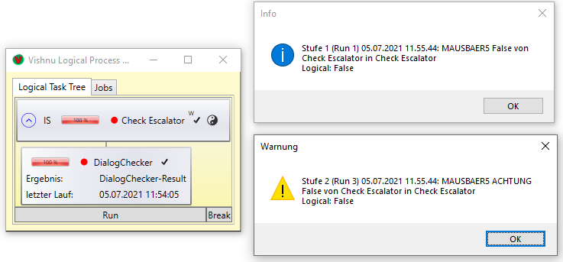After **„False“** in Check Escalator:

First message – level 1

Second message – level 2

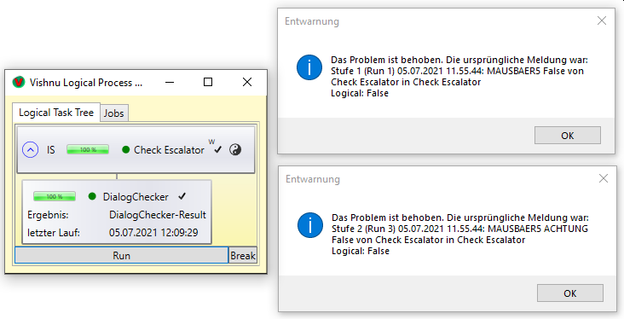Then **„True“** in Check Escalator:

All clear for level 1

All clear for level 2

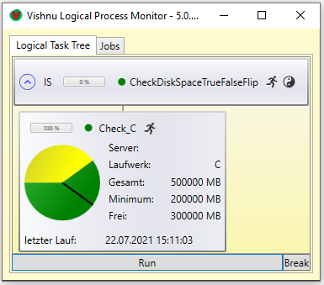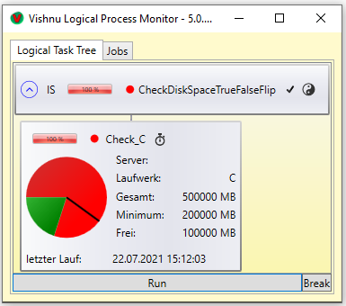

Some trigger definitions

**Call parameters for checkers and triggers**

|  |
| --- |
| some trigger definitions |
| CheckServers excerpt |
|  |
|  |

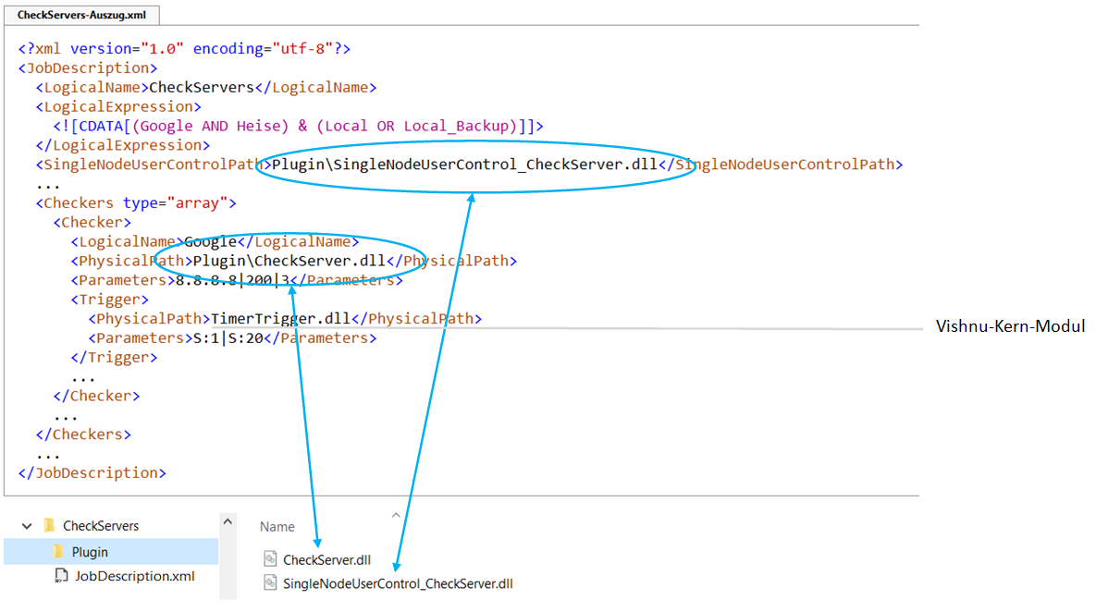

Vishnu trigger