d:\NetEti\Tools\Sandcastle Help File Builder\PresentationStyles\VS2013\styles\branding.css

*pageHeader*

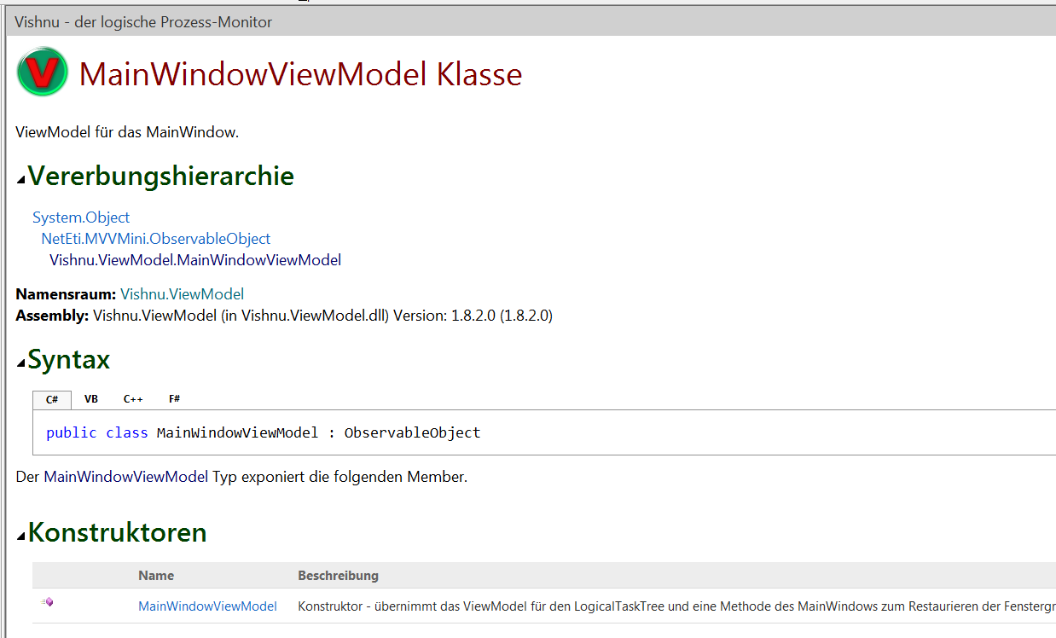

*collapsibleRegionTitle*

*td.titleColumn*

*span.identifier*

*Body (Zeilenabstand über: p{line-height: 22px})*

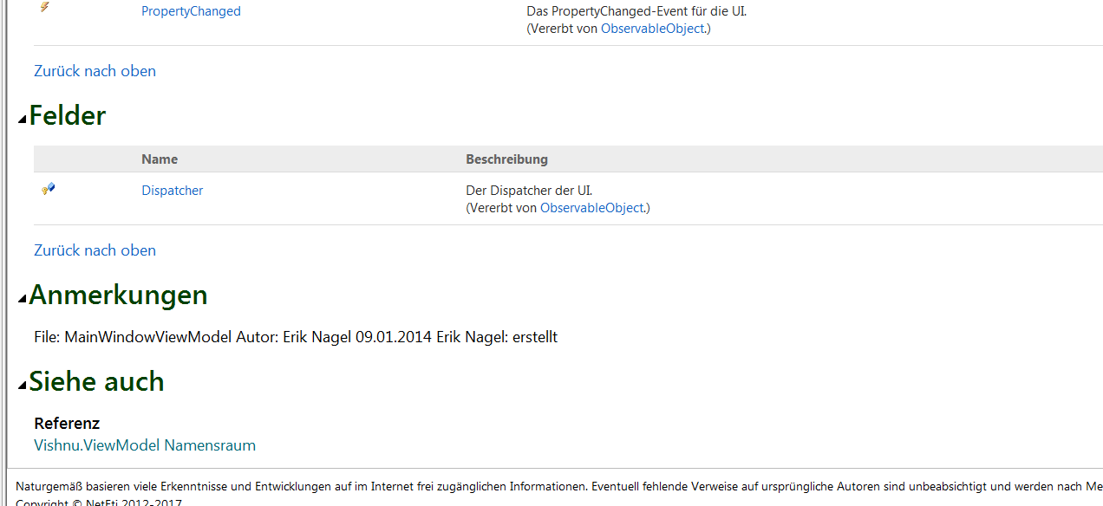

*pageFooter*

*h4 subHeading*