|  |  |
| --- | --- |
|  | **PES UNIVERSITY**  **(Established under Karnataka Act No. 16 of 2013)**  **100 Ft. Road, BSK III Stage, Bengaluru – 560 085**  **DEPARTMENT OF COMPUTER SCIENCE AND ENGINEERING** |

|  |  |  |
| --- | --- | --- |
| **Course Title: Problem Solving with C Laboratory** | | |
| **Course code: UE19CS152** | | |
| **Semester : II sem** | **Section: L** | **Team Id: 6** |
| **SRN:PES1UG19CS574** | **Name:Vishnu J G** | |
| **SRN:PES1UG19CS509** | **Name:Srujan A S** | |
| **SRN:PES1UG19ME088** | **Name:Suraj K V** | |
| **SRN:PES1UG19CV044** | **Name:Sheshadri J** | |

**PROJECT REPORT**

**Problem Statement**

ATM simulator including calculations regarding loan application.

**Description**

This program has the necessary codes for all the normal functions performed by a typical ATM machine.Apart from withdrawal, mini-statement and pin-reset we have also added the feature of money deposit and loan related information which also calculates the interest money that is to be paid on the principle based on the time period specified by the user. We have achieved this with a text file which stores the info about each and every customer in the form of CARDNUMBER****** BALANCE PIN*. The program runs through the text file in search of the customers card number that has been inputted. Specified function is done on this card number details and is returned to the text file.

1. **concepts used**

The ATM simulator works mainly on search, append, overwrite and simple calculations for interest rates. These functions work primarily on a predefined text file which is secure and out of reach of any end user. File opening, reading and appending are the main functions extensively used in the program.

We have also created a function to update the text file dynamically using fputc() as when new customers enter, when withdrawal or deposition is done or when the pin to specific customer is changed. Each customer is assigned a specific card number using which he/she can access his account. The pin to this account is given by the customer himself.search(), checkpass(), password() all these functions help having a security check on the user and his account.

Since we were unable to find a device which could read or write a hard copy of information we have just stopped at requesting the card number to be typed by the customer into the terminal.

**Learning Outcome**

This has helped us to get a hold on the read and write command over files.

We now have good hold over array sorting, appending and changing its contents.

We understood the concept of loan and interest calculations and the varied number of loans provided by many centralized banks in India.

**OutputScreenshots**

Withdraw and deposit:-

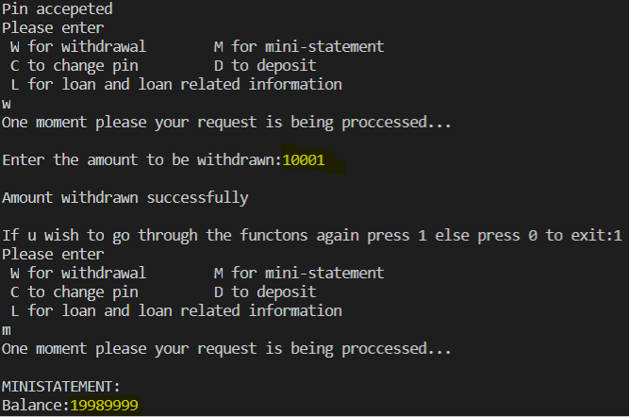

File pointers:-

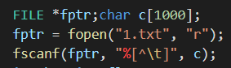

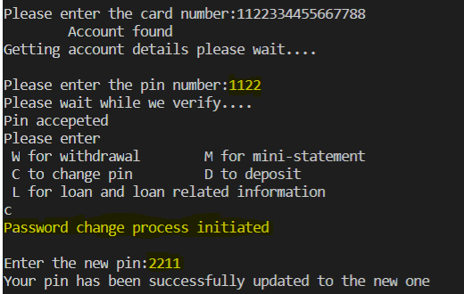

**New card number**

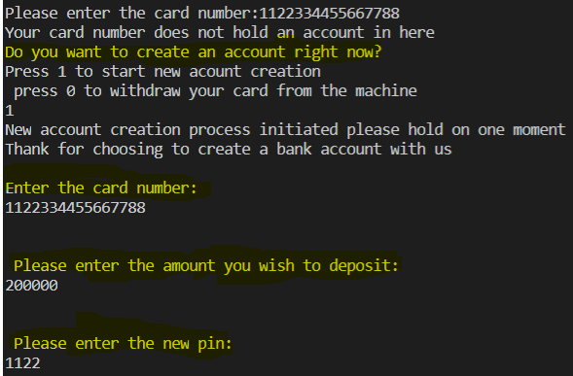

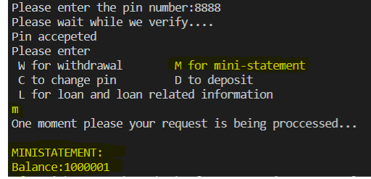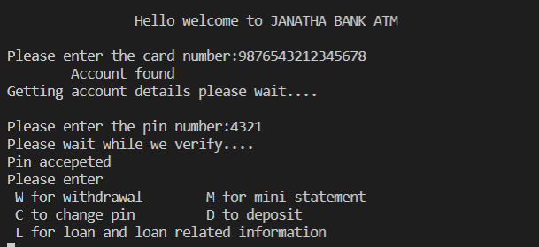

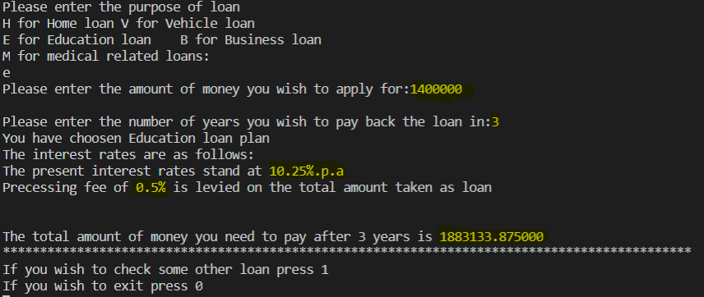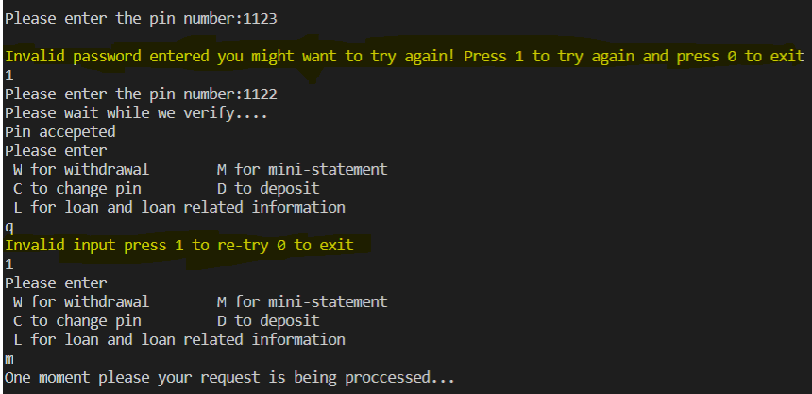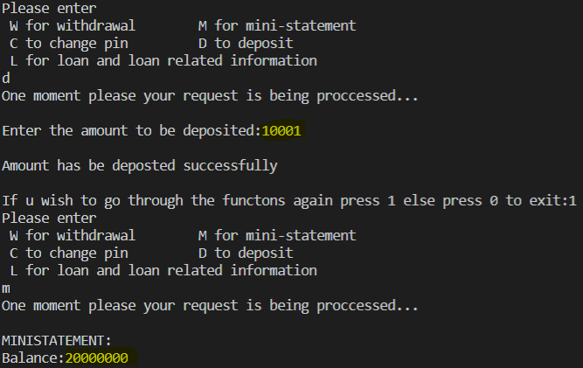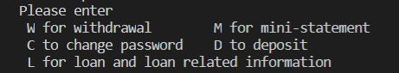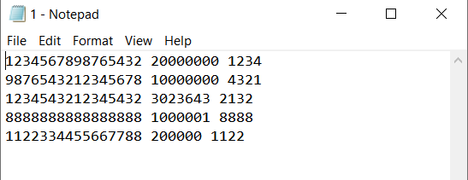

**Name and Signature of the Faculty**