Jenkins

Update the instance (RHEL)  
#yum update -y

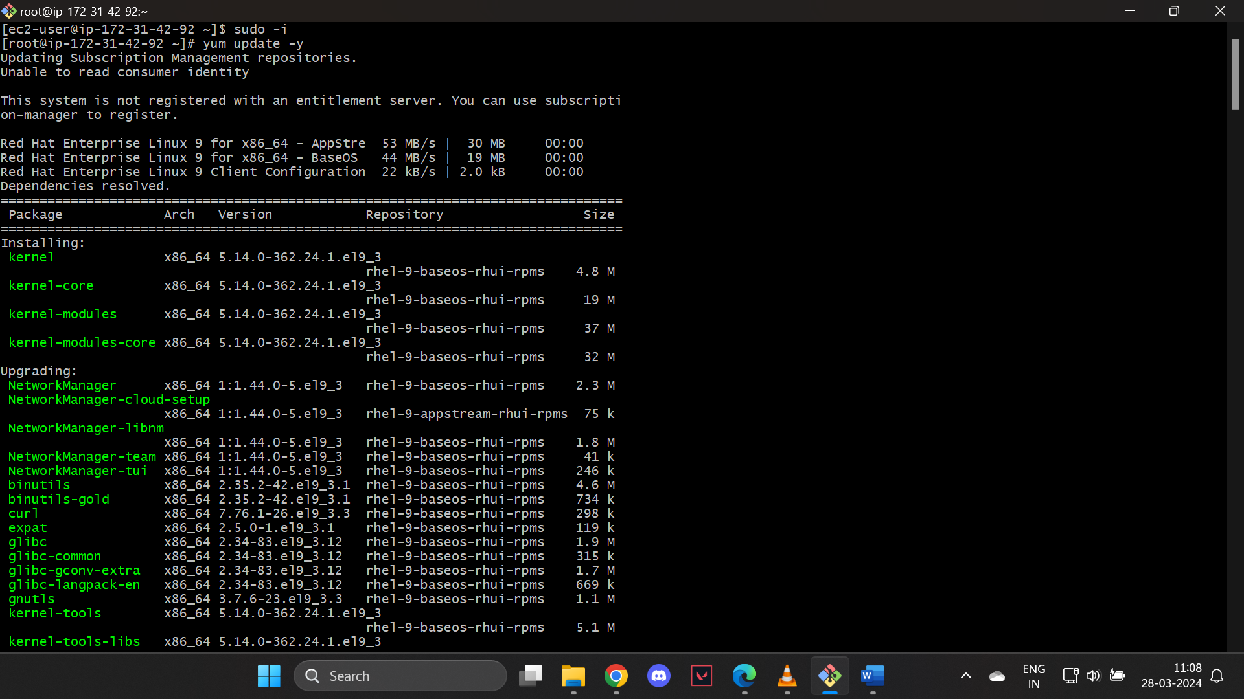

Install Java Development Kit (JDK)

# #yum install fontconfig java-17-openjdk -y

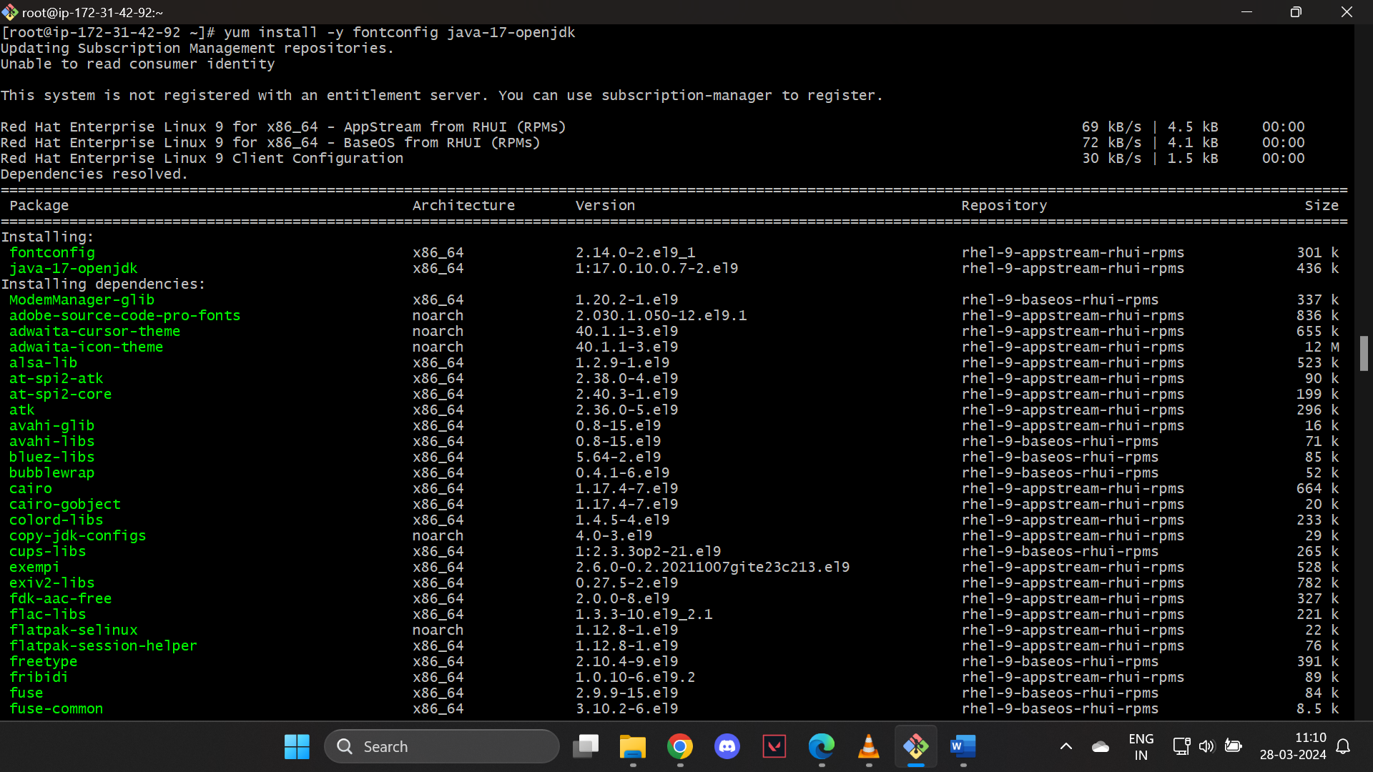

Verify the java version

# #java --version

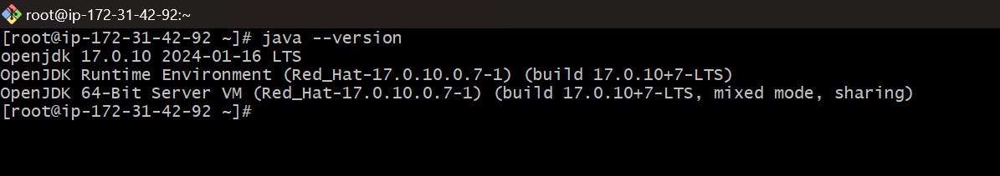

Add Jenkins Repository Jenkins is not available in the default repositories of RHEL 9 or Rocky Linux 9. To install Jenkins, you need to add the official Jenkins repository. Execute the beneath commands one after the another.

# #yum install wget -y

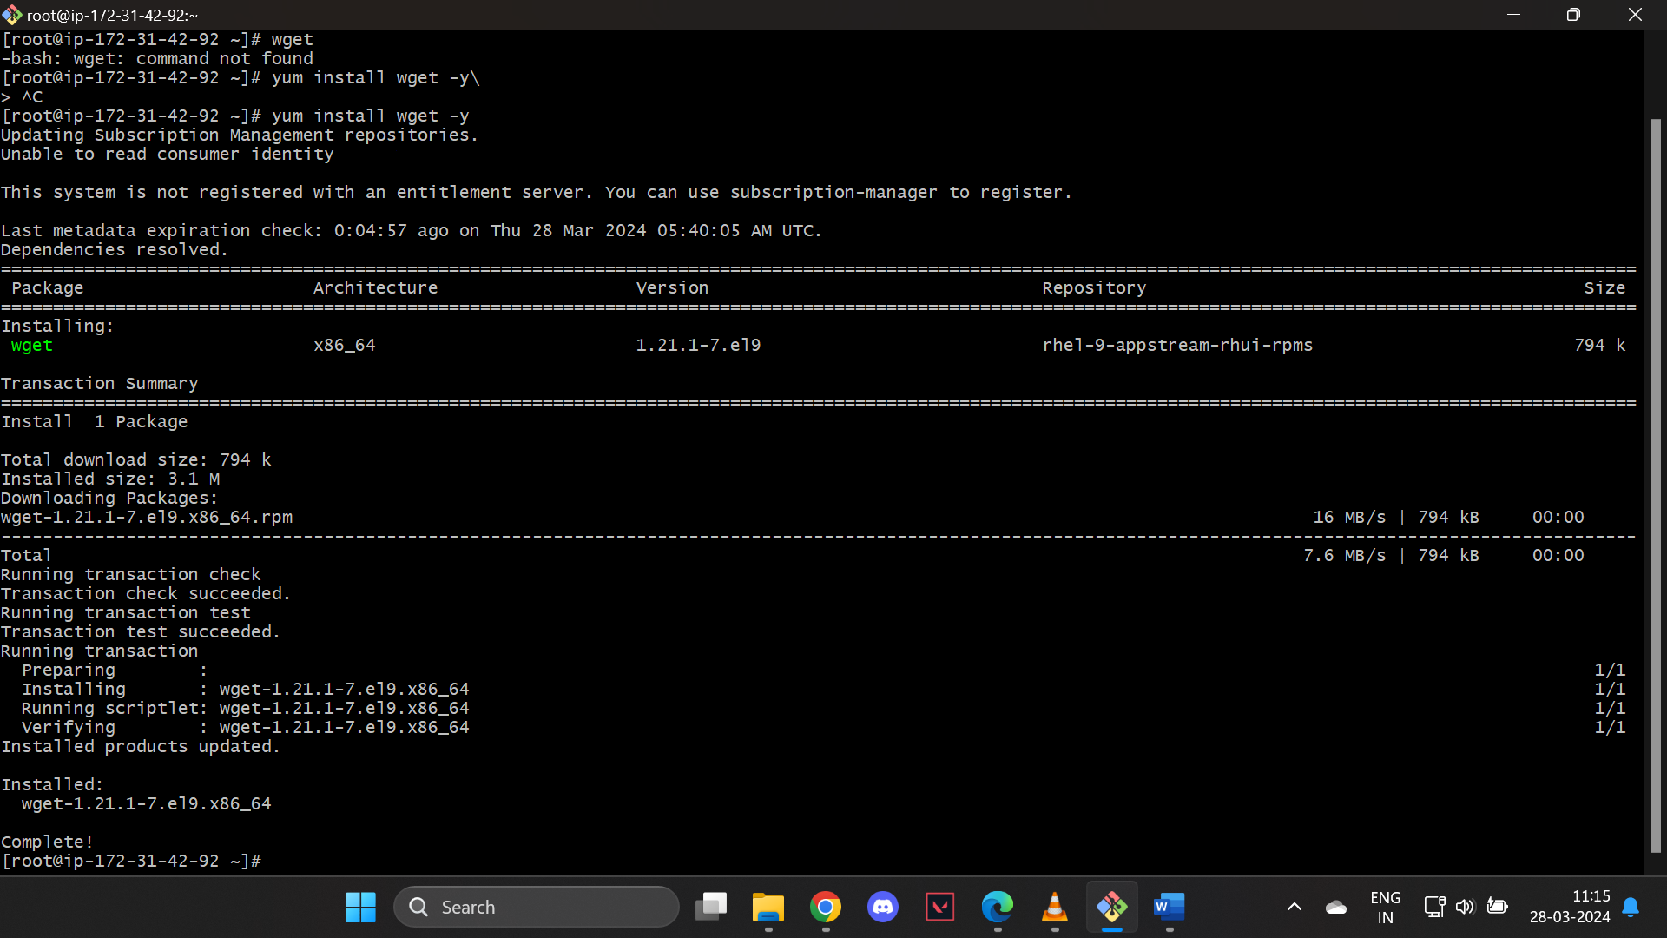

# #wget https://pkg.jenkins.io/redhat/jenkins-2.451-1.1.noarch.rpm

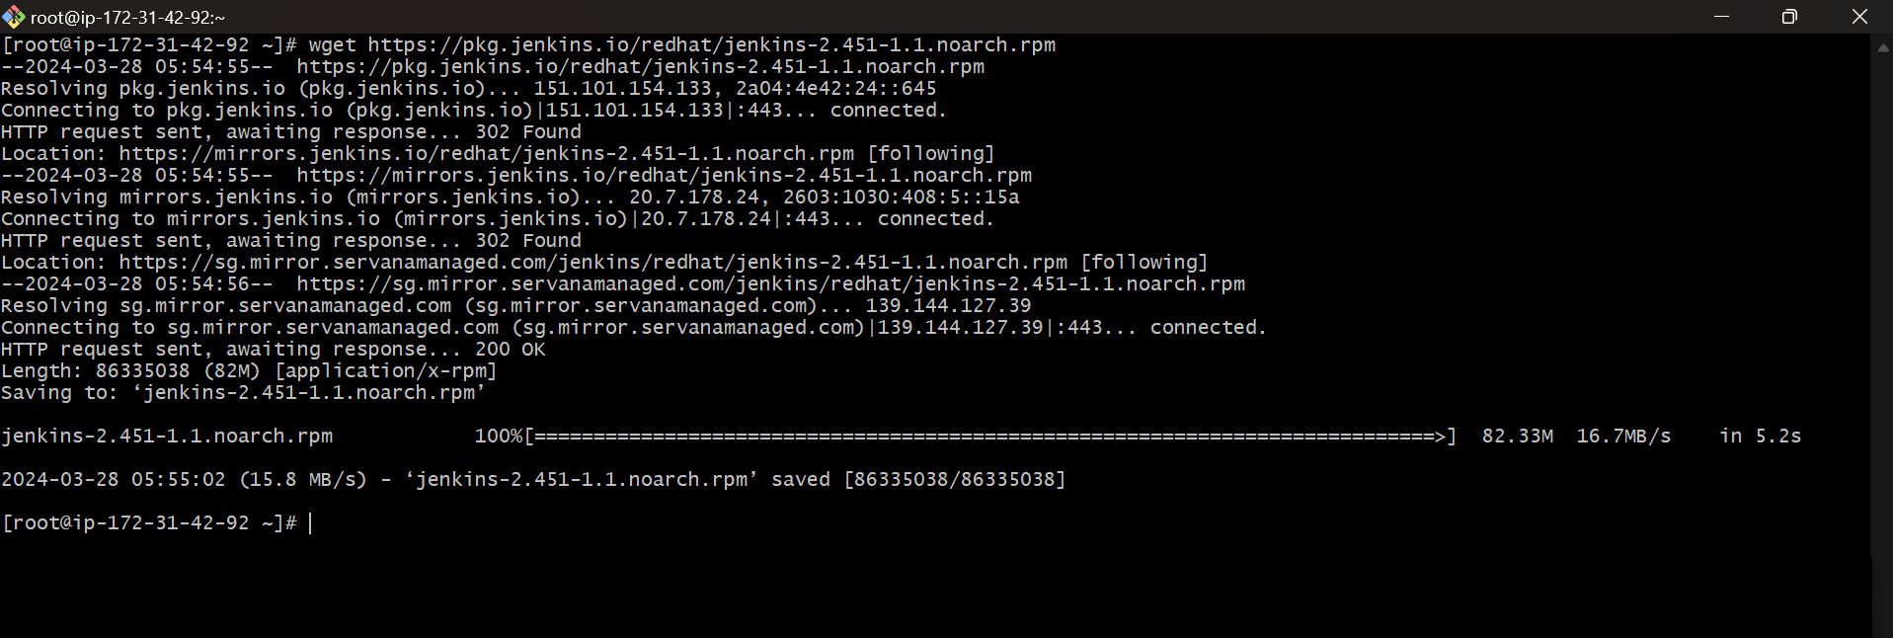

Install the package with gpg check disabled

# # sudo rpm --import https://pkg.jenkins.io/redhat/jenkins.io.key

# #sudo rpm -ivh --nosignature jenkins-2.451-1.1.noarch.rpm

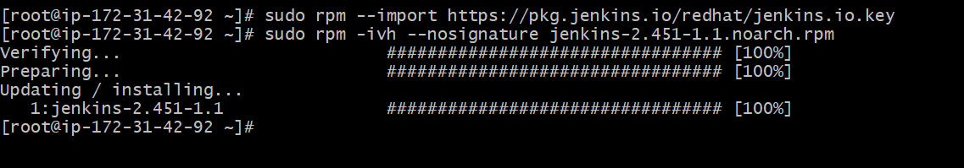

# #sudo systemctl start jenkins

# #sudo systemctl enable jenkins



**Access Jenkins**: You should now be able to access Jenkins through your web browser using the URL **http://localhost:8080** (if accessing from the same machine) or **http://<your_server_ip>:8080** (if accessing from a remote machine). Follow the on-screen instructions to complete the initial setup of Jenkins.

To access the Jenkins on a browser, copy the public IP address of your EC2 instance and go to the port 8080.Before that add port 8080 in your security group.

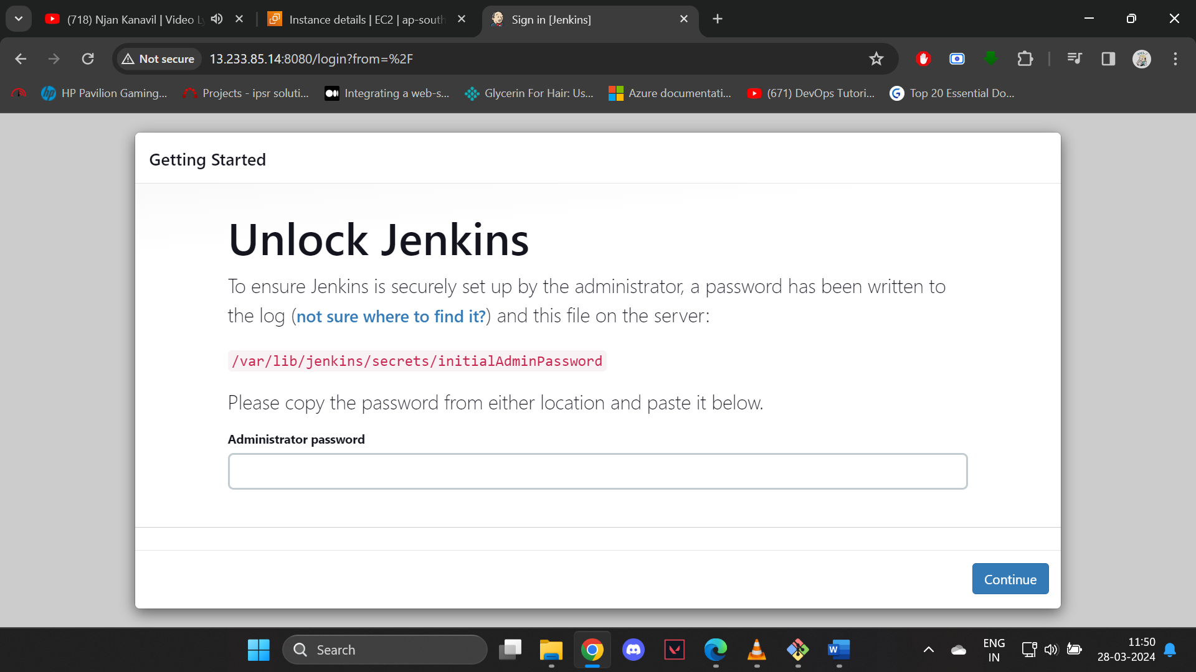

You’ll find the password in the path given

Continue with the installation

