**Project 2**

1. How many movies were directed by George Lucas?
2. movies were directed by George Lucas.

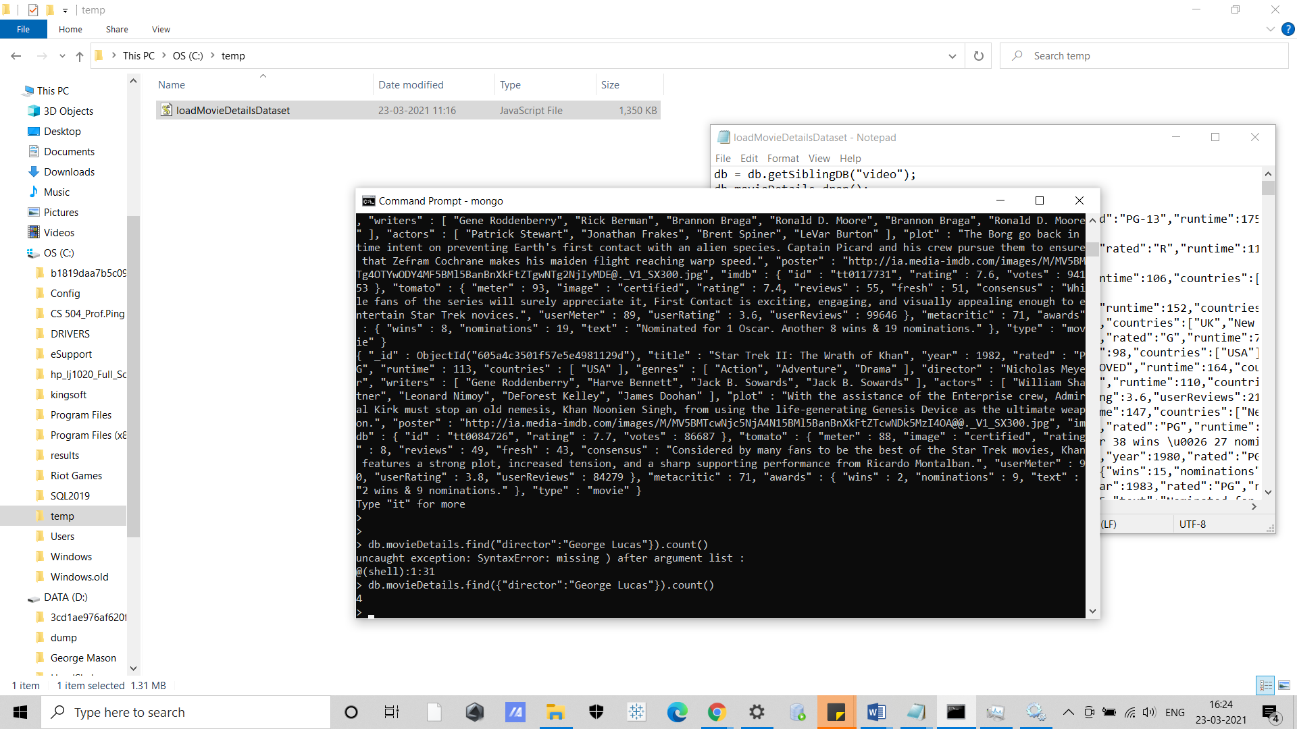

1. Find the director of each movie that is released in 2010 and rated as PG?

The director of each movie that is released in 2010 and rated as PG is as follows:

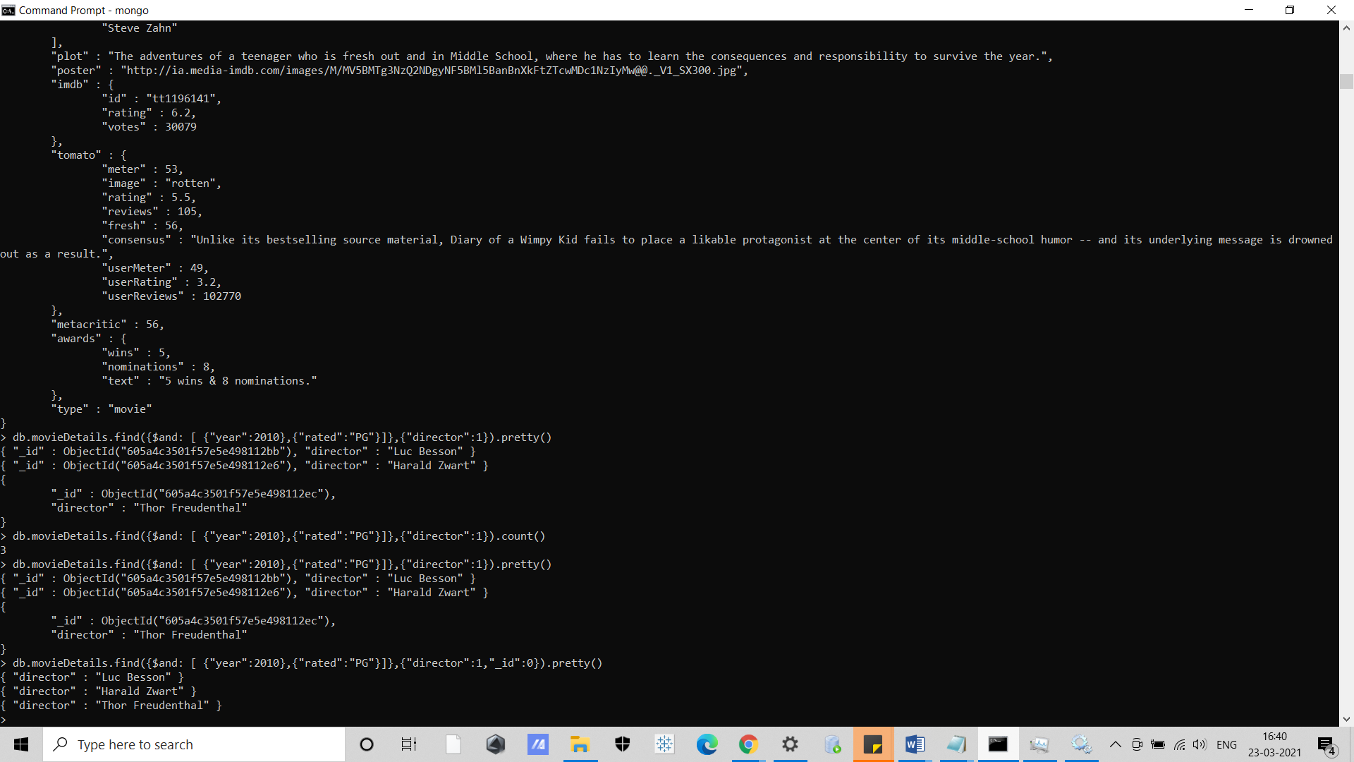

1. Show only the titles of the movies that are rated PG and have exactly 10 award nominations.

The titles of the movies that are rated PG and have exactly 10 award nominations are as follows:

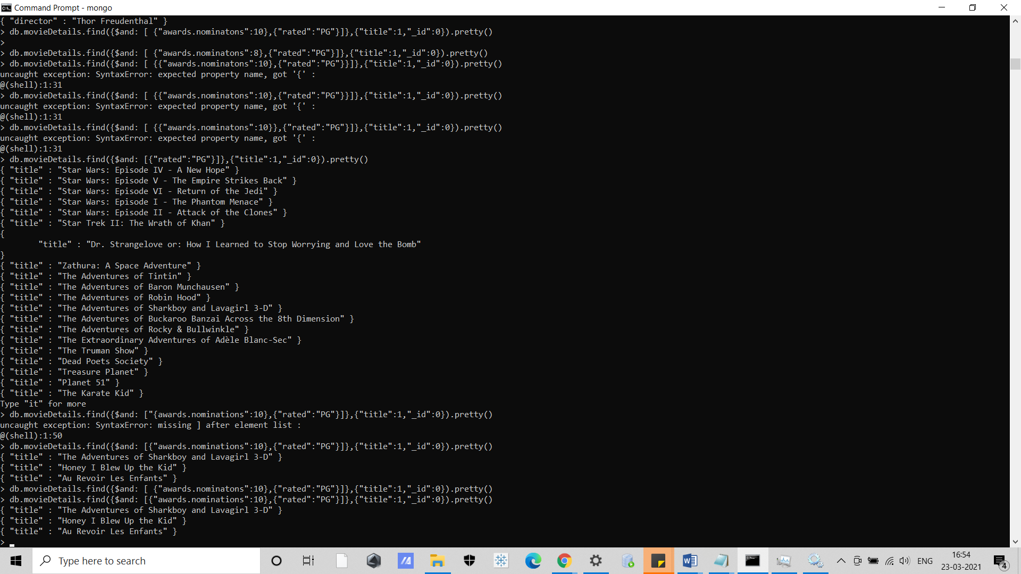

1. How many movies have exactly 2 award wins and 2 award nominations?

12 movies have exactly 2 award wins and 2 award nominations:

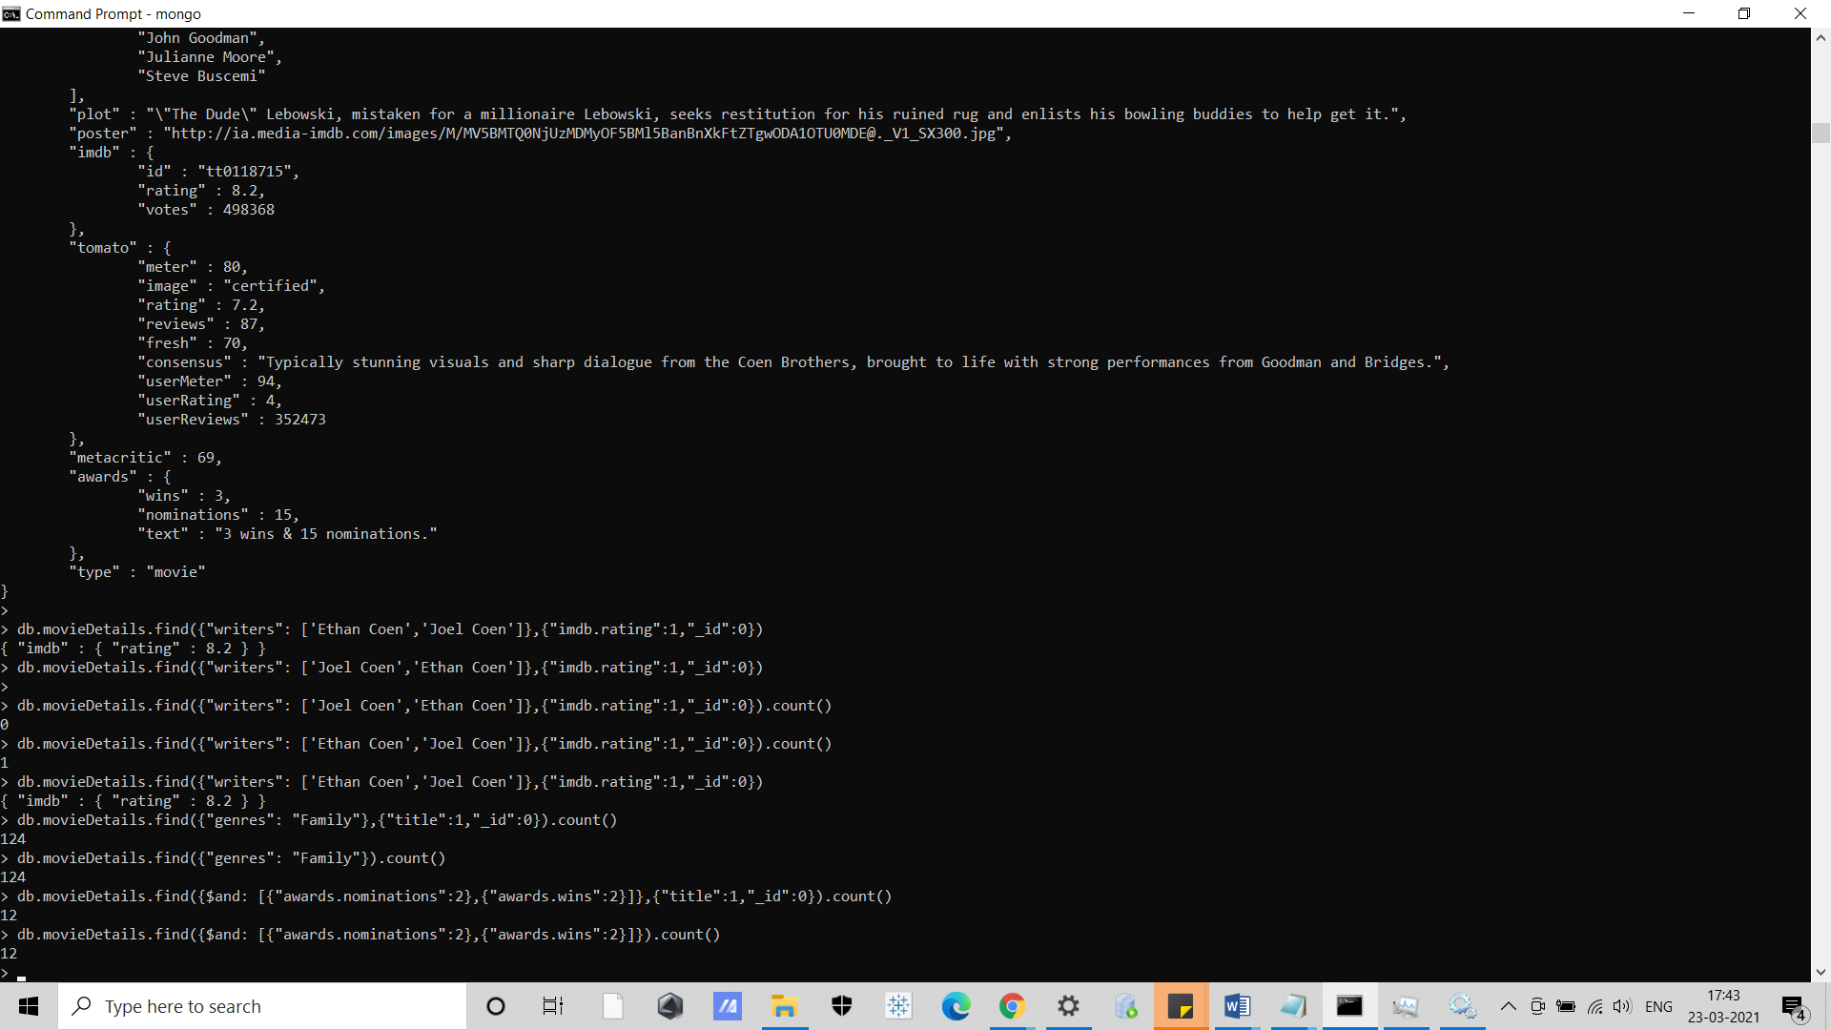

1. How many movies do not contain the metacritic field.

1919 movies do not contain the metacritic field:

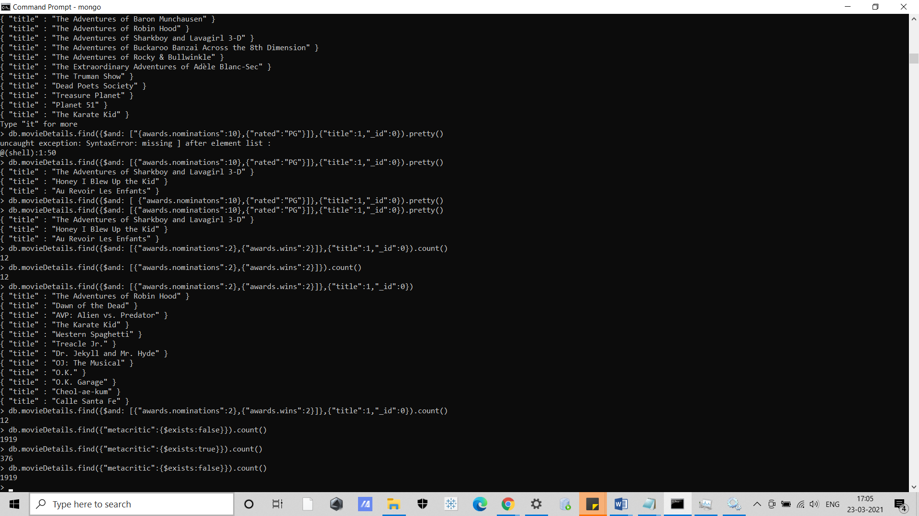

1. Find the imdb rating for the movie that lists just two writers: "Ethan Coen" and "Joel Coen", in that order.

8.2 is the imdb rating for the movie that lists just two writers: "Ethan Coen" and "Joel Coen", in that order.

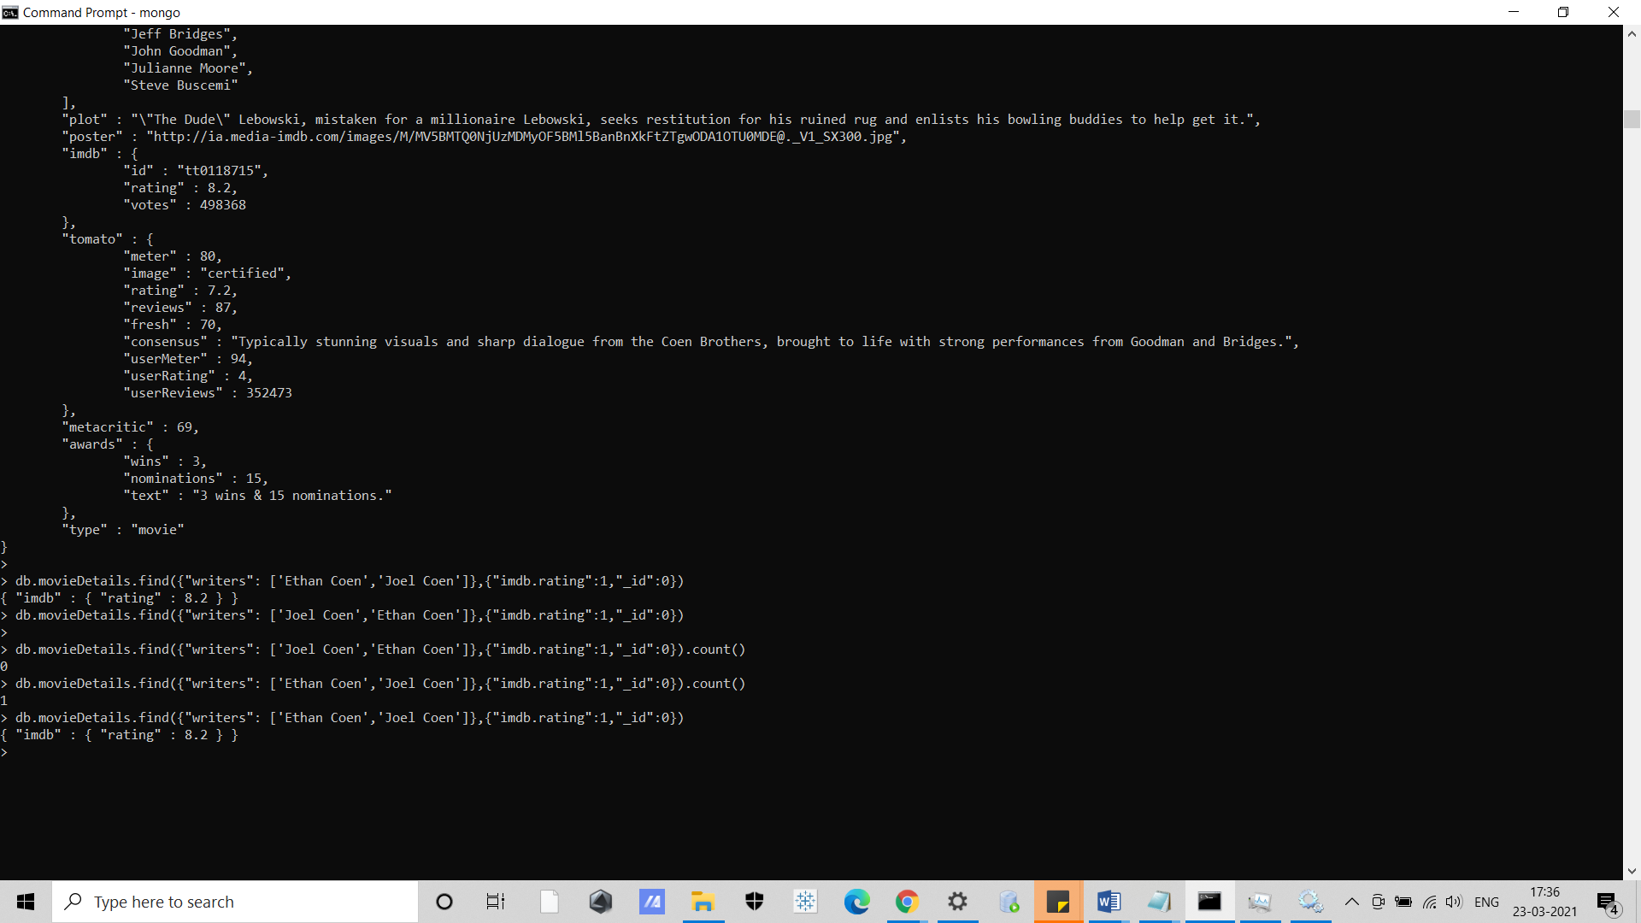

1. How many movies list "Family" among its genres?

124 movies list "Family" among its genres

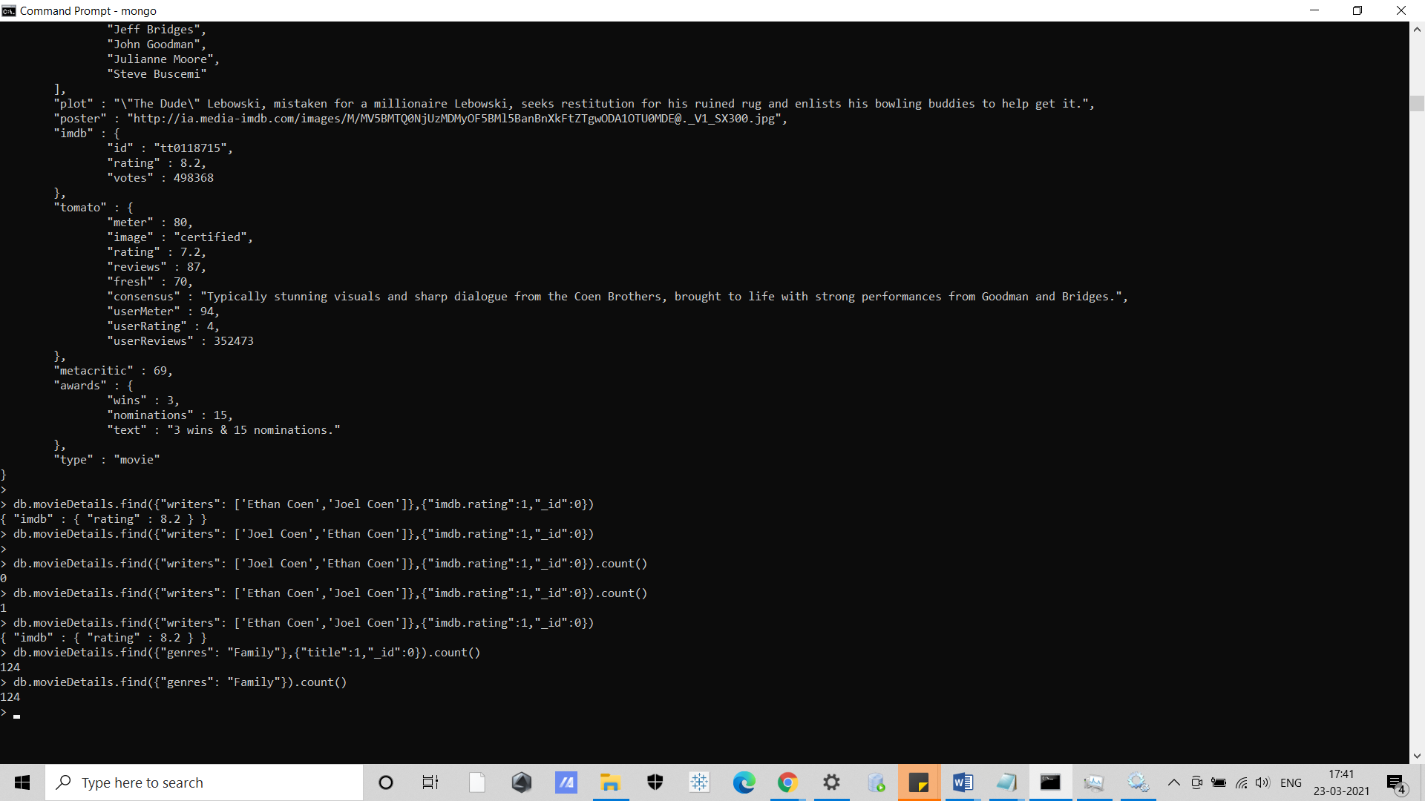

1. How many movies list "Western" second among its genres?

14 movies list "Western" second among its genres

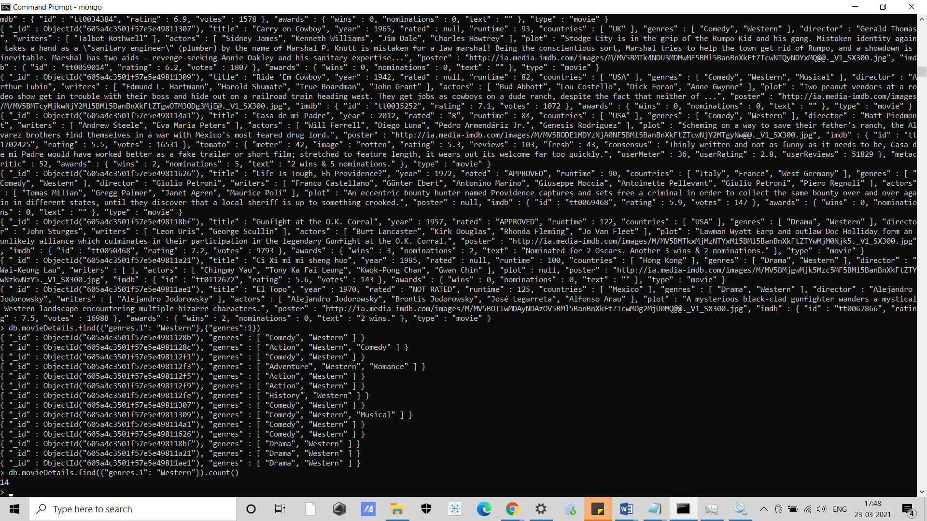

1. Find the title and the plot for each movie that has an imdb rating greater than 9 and the plot field is not null.

The title and the plot for each movie that has an imdb rating greater than 9 and the plot field is not null is as follows:

Unclear overall output:

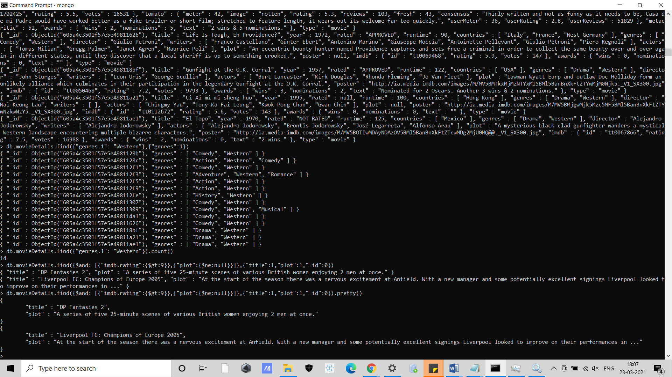

Clear output:



1. Show the leading actor (the first element of the array “actors”) of each movie that lists "Ethan Coen" or "Joel Coen" among their writers.

These are the leading actor (the first element of the array “actors”) of each movie that lists "Ethan Coen" or "Joel Coen" among their writers.

