**Name: Vishnu Mohan**

**Roll No:51**

**Batch: MCA-B**

**Date: 24-11-2022**

**DATA SCIENCE LAB**

**Experiment No.: 12**

**Aim**

Implementation of CNN using keras network

**Procedure**

import tensorflow as tf

from tensorflow.keras import datasets, layers, models

import matplotlib.pyplot as plt

(train_images, train_labels), (test_images, test_labels) = datasets.cifar10.load_data()

train_images, test_images = train_images / 255.0, test_images / 255.0

class_names = ['airplane', 'automobile', 'bird', 'cat', 'deer',

'dog', 'frog', 'horse', 'ship', 'truck']

plt.figure(figsize=(10,10))

for i in range(25):

plt.subplot(5,5,i+1)

plt.xticks([])

plt.yticks([])

plt.grid(False)

plt.imshow(train_images[i])

plt.xlabel(class_names[train_labels[i][0]])

plt.show()

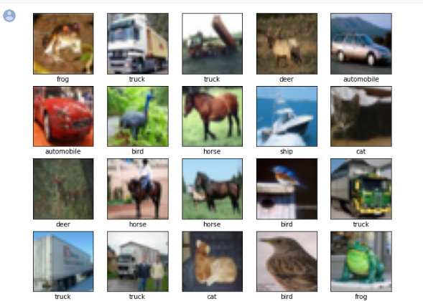

model = models.Sequential()

model.add(layers.Conv2D(32, (3, 3), activation='relu', input_shape=(32, 32, 3)))

model.add(layers.MaxPooling2D((2, 2)))

model.add(layers.Conv2D(64, (3, 3), activation='relu'))

model.add(layers.MaxPooling2D((2, 2)))

model.add(layers.Conv2D(64, (3, 3), activation='relu'))

model.summary()

model.add(layers.Flatten())

model.add(layers.Dense(64, activation='relu'))

model.add(layers.Dense(10))

model.summary()

Output

Model: "sequential"

_________________________________________________________________

Layer (type) Output Shape Param #

=================================================================

conv2d (Conv2D) (None, 30, 30, 32) 896

max_pooling2d (MaxPooling2D (None, 15, 15, 32) 0

)

conv2d_1 (Conv2D) (None, 13, 13, 64) 18496

max_pooling2d_1 (MaxPooling (None, 6, 6, 64) 0

2D)

conv2d_2 (Conv2D) (None, 4, 4, 64) 36928

flatten (Flatten) (None, 1024) 0

dense (Dense) (None, 64) 65600

dense_1 (Dense) (None, 10) 650

=================================================================

Total params: 122,570

Trainable params: 122,570

Non-trainable params: 0

model.compile(optimizer='adam',

              loss=tf.keras.losses.SparseCategoricalCrossentropy(from_logits=True),

              metrics=['accuracy'])

history = model.fit(train_images, train_labels, epochs=5,

                    validation_data=(test_images, test_labels))

Output

Epoch 1/5

1563/1563 [==============================] - 16s 5ms/step - loss: 1.5253 - accuracy: 0.4442 - val_loss: 1.2627 - val_accuracy: 0.5531

Epoch 2/5

1563/1563 [==============================] - 8s 5ms/step - loss: 1.1625 - accuracy: 0.5867 - val_loss: 1.1056 - val_accuracy: 0.6121

Epoch 3/5

1563/1563 [==============================] - 8s 5ms/step - loss: 1.0065 - accuracy: 0.6467 - val_loss: 0.9735 - val_accuracy: 0.6567

Epoch 4/5

1563/1563 [==============================] - 7s 5ms/step - loss: 0.9101 - accuracy: 0.6816 - val_loss: 0.9356 - val_accuracy: 0.6720

Epoch 5/5

1563/1563 [==============================] - 7s 5ms/step - loss: 0.8382 - accuracy: 0.7062 - val_loss: 0.9111 - val_accuracy: 0.6862

test_loss, test_acc = model.evaluate(test_images,  test_labels, verbose=2)

print(test_acc)

Output

0.6862000226974487

**Result**

The program was executed and the result was successfully obtained. Thus CO4 was obtained.