TERRAFORM AWS DEPLOYMENT
DEVOPS ASSIGNMENT — FINAL DOCUMENTATION
Flask + Express on AWS using Terraform
Single EC2 • Separate EC2 • ECR/ECS Fargate/ALB
Student: Vishnu Mor
Region: us-east-1
AWS Account used for deployment: 783722568360

1. Assignment Objective
The assignment deploys a Flask backend and Express frontend on AWS using Terraform in three architectures: Part 1 uses one EC2 instance, Part 2 uses separate EC2 instances in a Terraform-created VPC, and Part 3 uses Docker images in ECR running as ECS Fargate services behind an Application Load Balancer (ALB).
The project also implements remote Terraform state in Amazon S3 with encryption, versioning and native S3 state locking.

2. Final Verification Status
Component | Status | Evidence
Remote state bootstrap | SUCCESS | S3 bucket created successfully
Part 1 — Single EC2 | CODE + FIRST-RUN EVIDENCE | Initial Free Tier error documented; t3.micro fix is in source
Part 2 — Separate EC2 | SOURCE INCLUDED / NOT VERIFIED | Terraform configuration and user-data templates included; no successful apply screenshot was captured
Part 3 — ECR/ECS/ALB | SUCCESS | 25 resources created; images pushed; ECS services ACTIVE; frontend and /api verified

3. Project Structure
Terraform_Vishnu/
├── README.md
├── GitHub-Link.txt
├── bootstrap-state/
├── part1-single-ec2/
├── part2-separate-ec2/
├── part3-ecs-ecr-alb/
├── application/
└── screenshots/
The source contains main.tf, variables.tf, outputs.tf and backend.tf for the Terraform parts, plus user-data templates for the EC2 deployments and Dockerfiles for the containerized applications.

4. Remote State Management — S3
A bootstrap Terraform configuration was used to create the remote state bucket. The bucket created during the verified run was vishnu-terraform-state-783722568360. The configuration enables S3 versioning, AES-256 server-side encryption and blocks public access.
cd bootstrap-state
terraform init
terraform validate
terraform apply
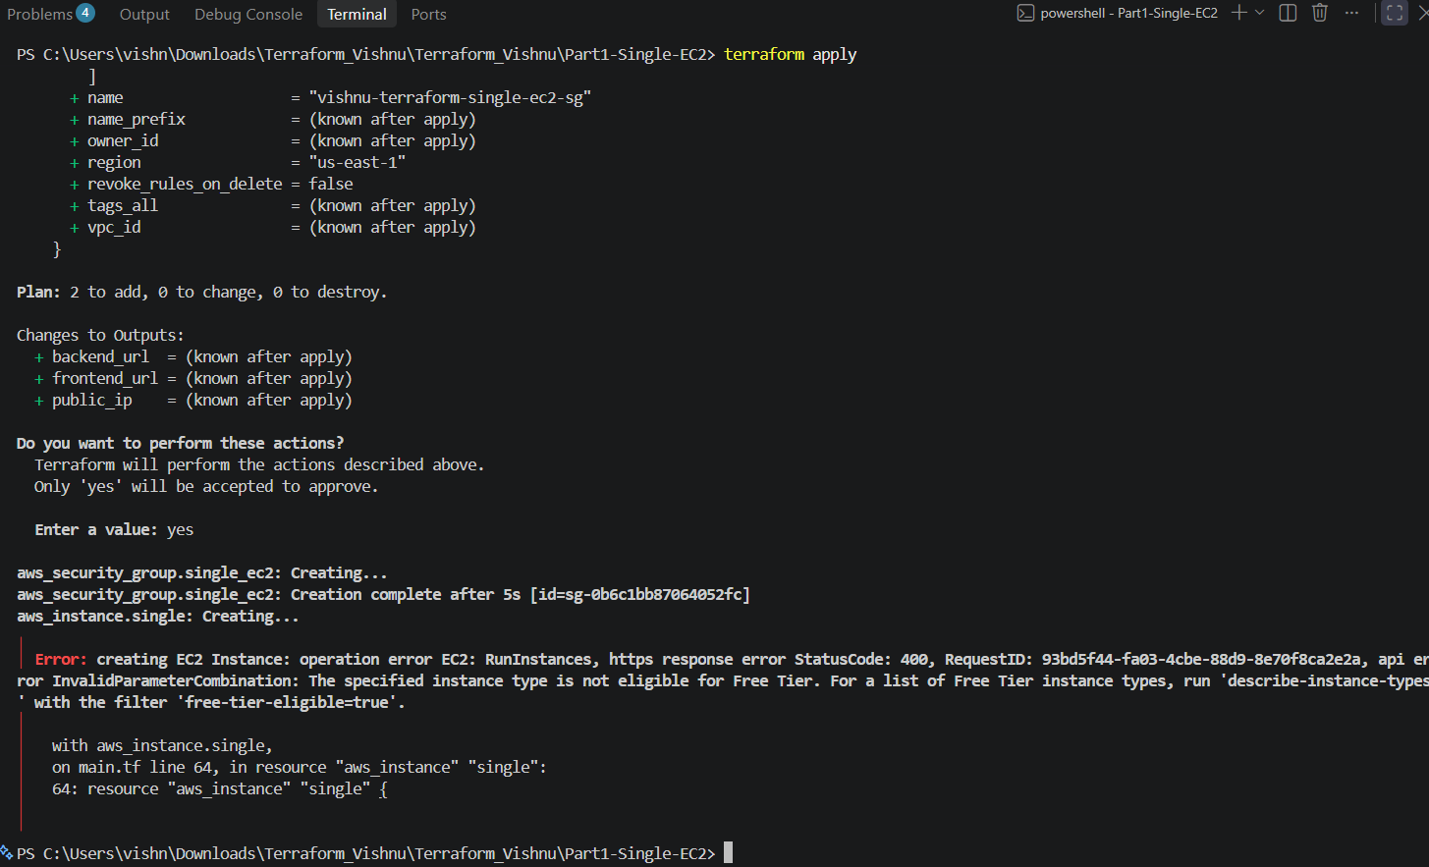
Figure 1 — Terraform initialization and validation for the remote-state bootstrap
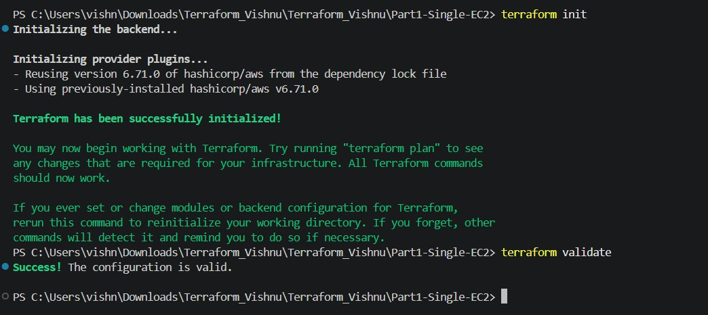
Figure 2 — Bootstrap apply: S3 remote-state bucket created successfully
The three deployment parts use separate state keys in the same S3 bucket, for example:
bucket = "vishnu-terraform-state-783722568360"
key = "terraform-assignment/part3/terraform.tfstate"
region = "us-east-1"
encrypt = true
use_lockfile = true

5. Part 1 — Single EC2
Part 1 provisions one EC2 instance and starts the Flask backend and Express frontend using the user-data template. Flask uses port 8000 and Express uses port 3000.
cd part1-single-ec2
terraform init
terraform validate
terraform plan -var="key_name=YOUR_KEY_PAIR"
terraform apply -var="key_name=YOUR_KEY_PAIR"
During the first run, Terraform successfully initialized, validated and generated a plan. The EC2 creation step was rejected by AWS because the selected t2.micro instance type was not eligible for the account Free Tier. This failure is retained as honest execution evidence rather than being presented as a successful deployment.
Figure 3 — Part 1 execution evidence retained from the original run
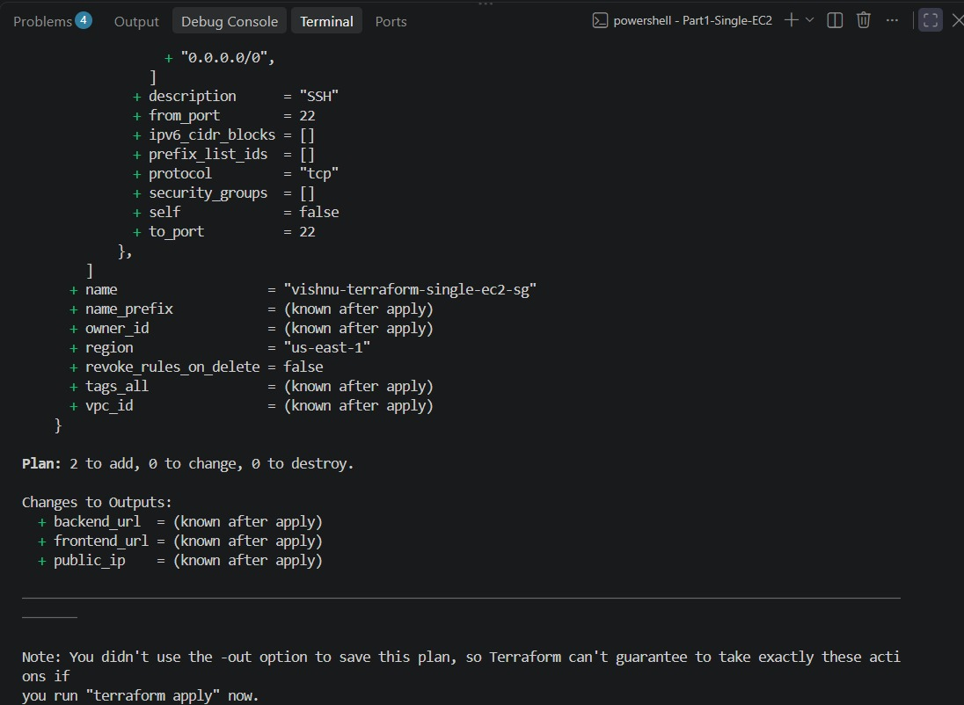
Figure 4 — Part 1 execution evidence retained from the original run
Figure 5 — Part 1 execution evidence retained from the original run
Fix applied in the source: the default instance type was changed to t3.micro. The required user-data template is also included in the final ZIP. A successful Part 1 verification screenshot was not captured in the current evidence set, so this document does not claim that Part 1 was successfully deployed.

6. Part 2 — Separate EC2 Instances
Part 2 is implemented as Terraform source. It creates a VPC (10.20.0.0/16), public subnet, Internet Gateway, route table, separate backend/frontend security groups and two EC2 instances. The backend runs Flask on port 8000 and the frontend runs Express on port 3000. The frontend receives the backend private IP through templatefile().
cd part2-separate-ec2
terraform init
terraform validate
terraform plan -var="key_name=YOUR_KEY_PAIR"
terraform apply -var="key_name=YOUR_KEY_PAIR"
The final package includes the Part 2 Terraform configuration, backend-user-data.sh.tftpl and frontend-user-data.sh.tftpl. No successful Part 2 apply/EC2 verification screenshot is present in the supplied evidence, so the documentation intentionally marks Part 2 as source-complete but not verified.

7. Part 3 — ECR + ECS Fargate + ALB
Part 3 is the successfully verified deployment. Terraform creates two ECR repositories, a VPC with two public subnets, security groups, an ECS cluster, Fargate task definitions and services, IAM execution role, CloudWatch log groups and an Application Load Balancer.
The ALB routes /api and /api/* to the Flask backend target group and routes other requests to the Express frontend. The frontend task definition uses BACKEND_URL pointing to the ALB /api endpoint.
cd part3-ecs-ecr-alb
terraform init -reconfigure
terraform plan
terraform apply
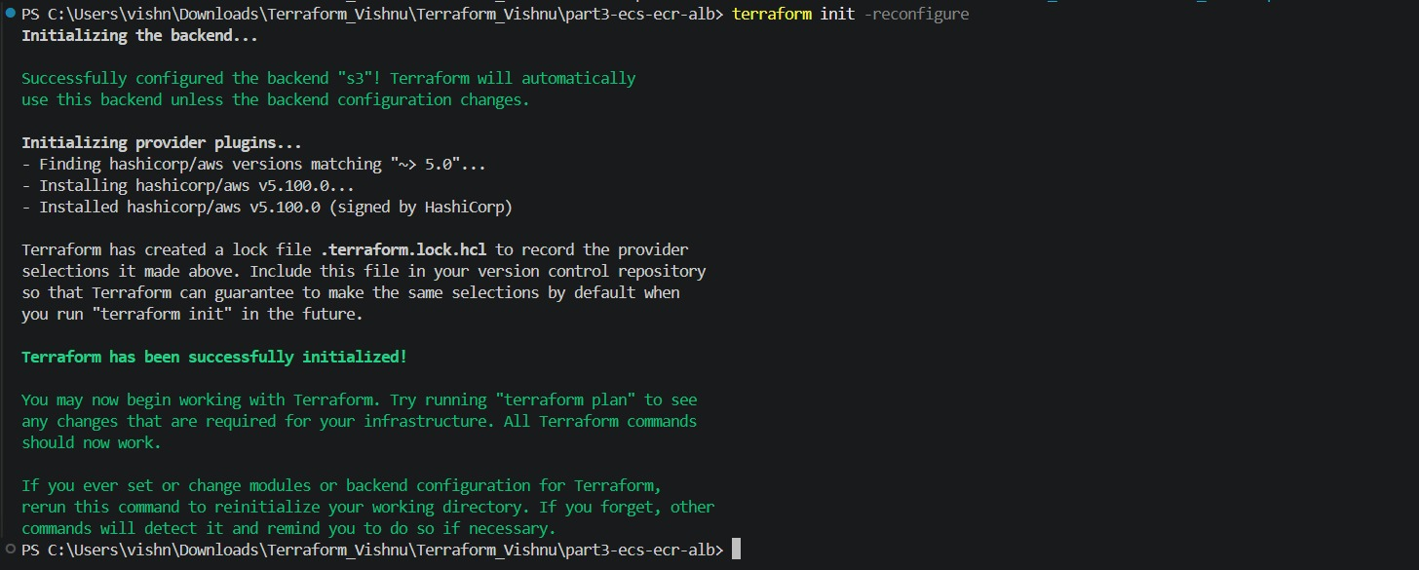
Figure 6 — Part 3 Terraform backend initialization completed successfully
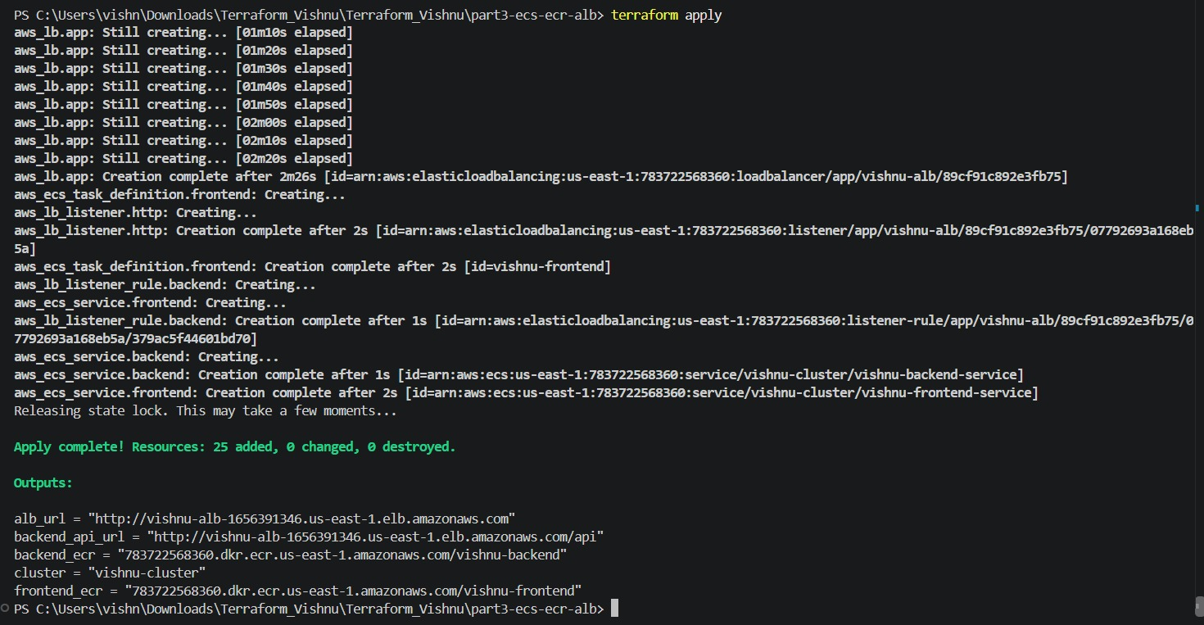
Figure 7 — Part 3 terraform apply completed: 25 resources added

8. Docker Build and ECR Push
The Flask and Express applications were built as Docker images and pushed to the Terraform-created ECR repositories.
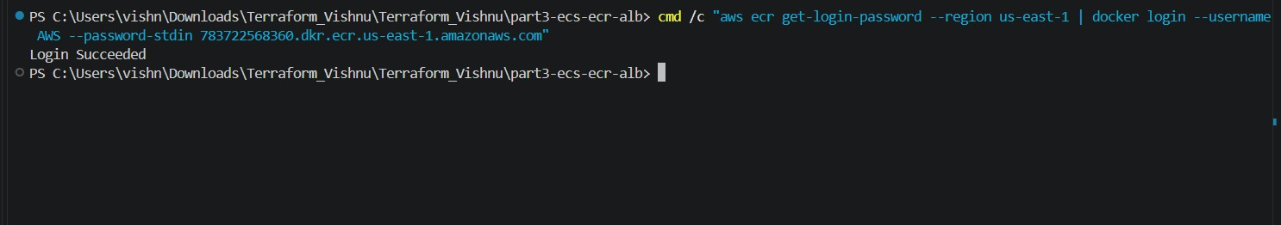
Figure 8 — Successful Docker login to Amazon ECR
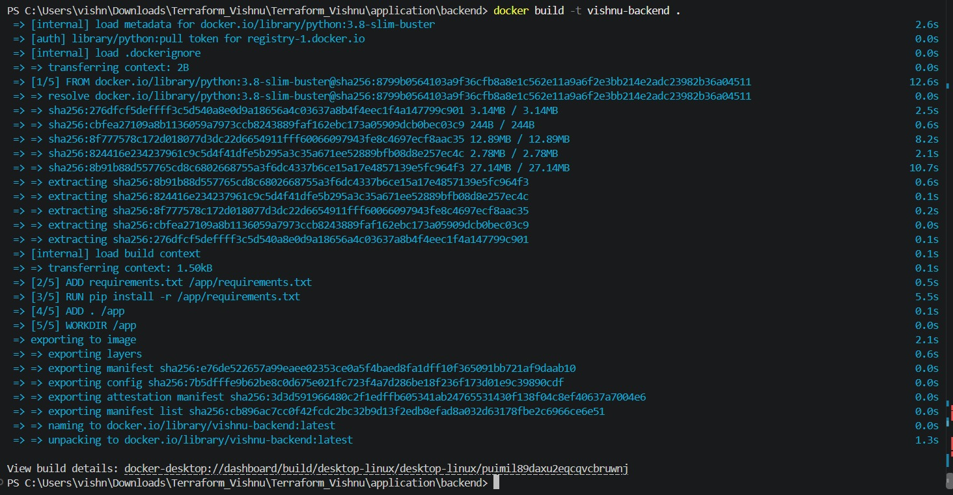
Figure 9 — Flask backend Docker image built successfully
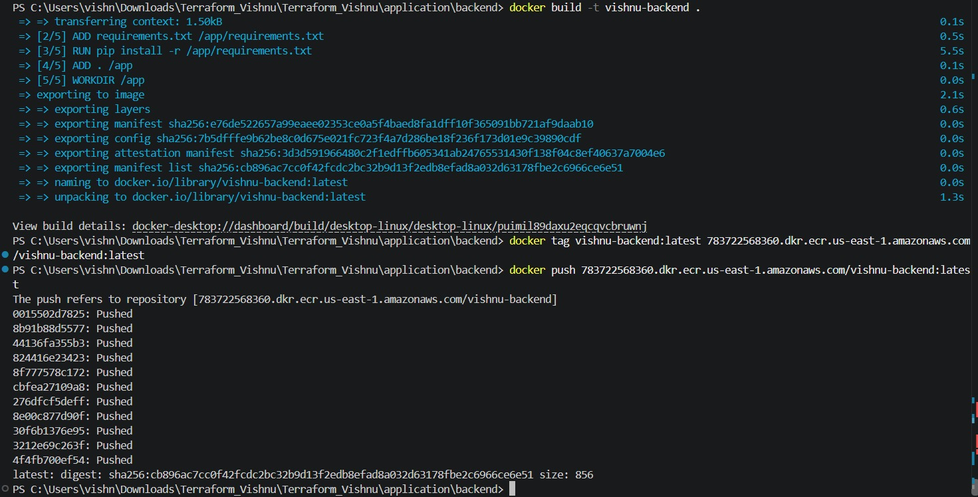
Figure 10 — Flask backend image pushed to ECR
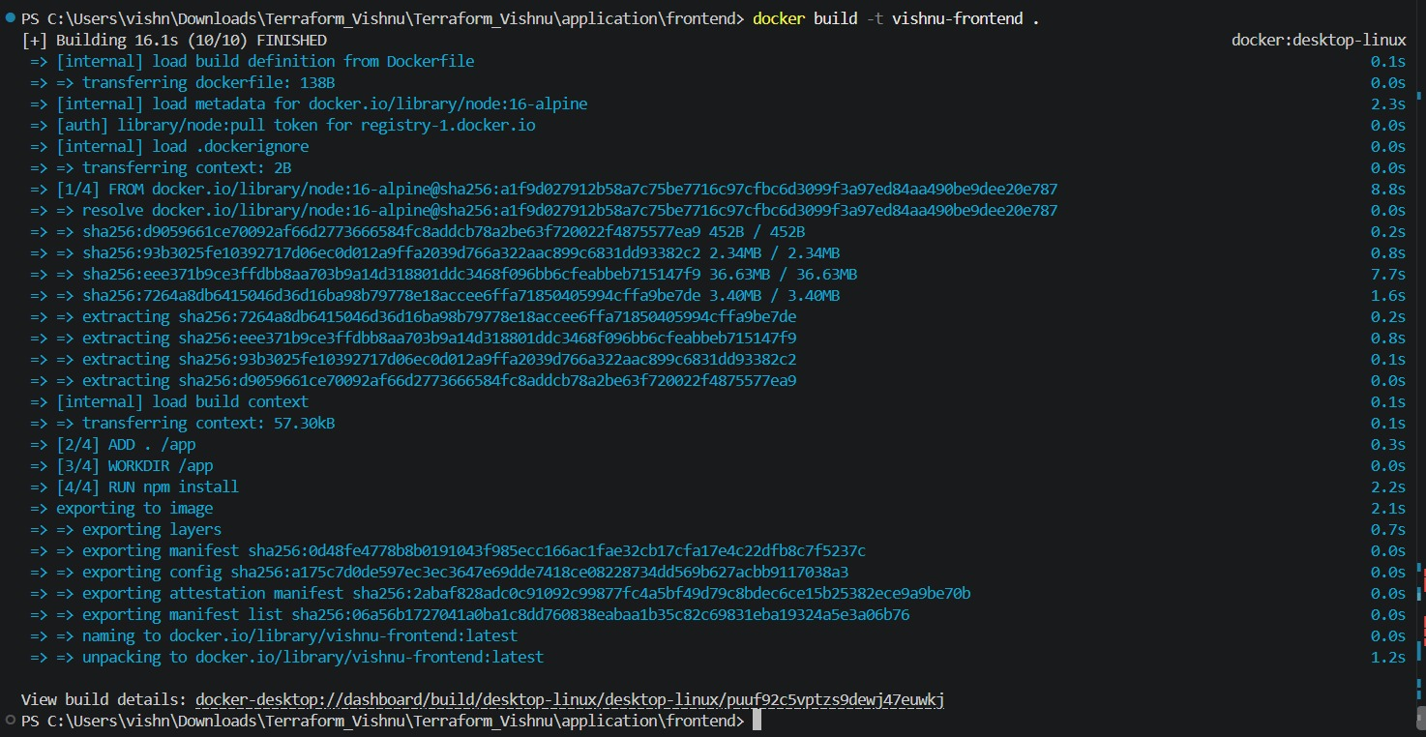
Figure 11 — Express frontend Docker image built successfully
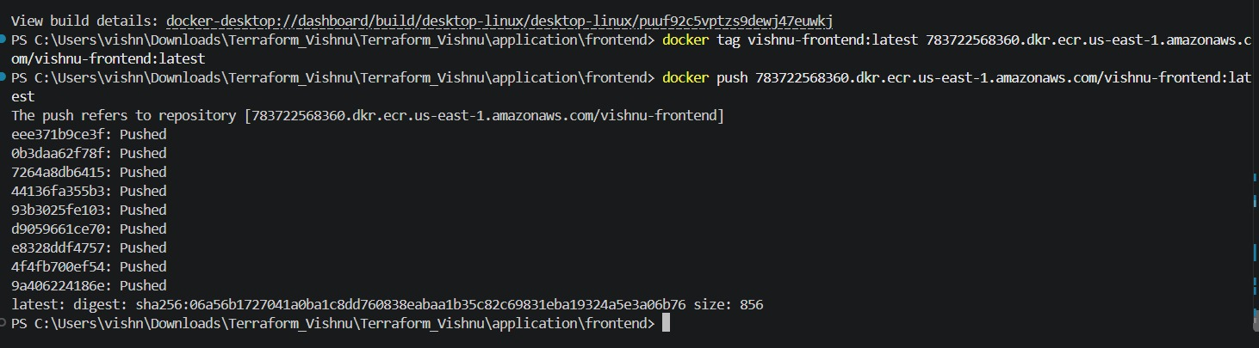
Figure 12 — Express frontend image pushed to ECR

9. ECS Service Verification
After the images were available in ECR, the ECS services were refreshed. The final service query showed both services ACTIVE with desired count 1 and running tasks available.
aws ecs describe-services --cluster vishnu-cluster --services vishnu-frontend-service vishnu-backend-service --region us-east-1 --query "services[*].[serviceName,runningCount,desiredCount,status]" --output table
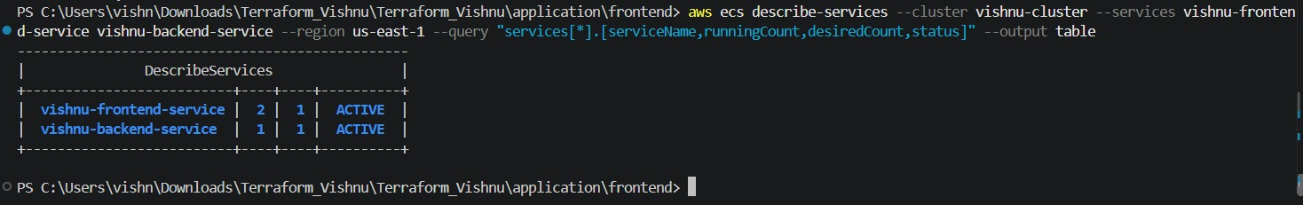
Figure 13 — ECS verification: frontend and backend services ACTIVE with desired count 1

10. ALB Application Verification
The ALB endpoint was opened in a browser. The frontend returned the Express page and displayed backend data. The /api route returned JSON directly from the Flask backend.
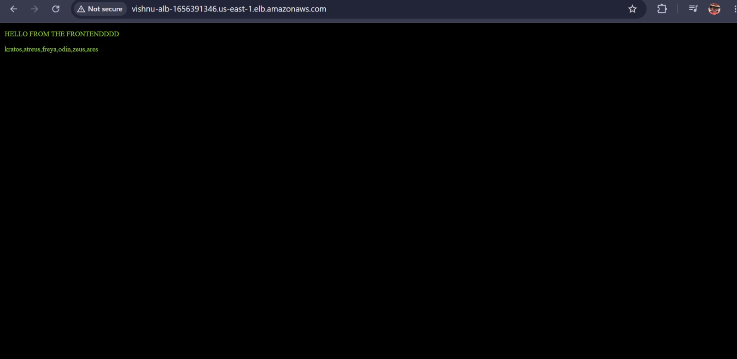
Figure 14 — ALB frontend verification: Express application is reachable
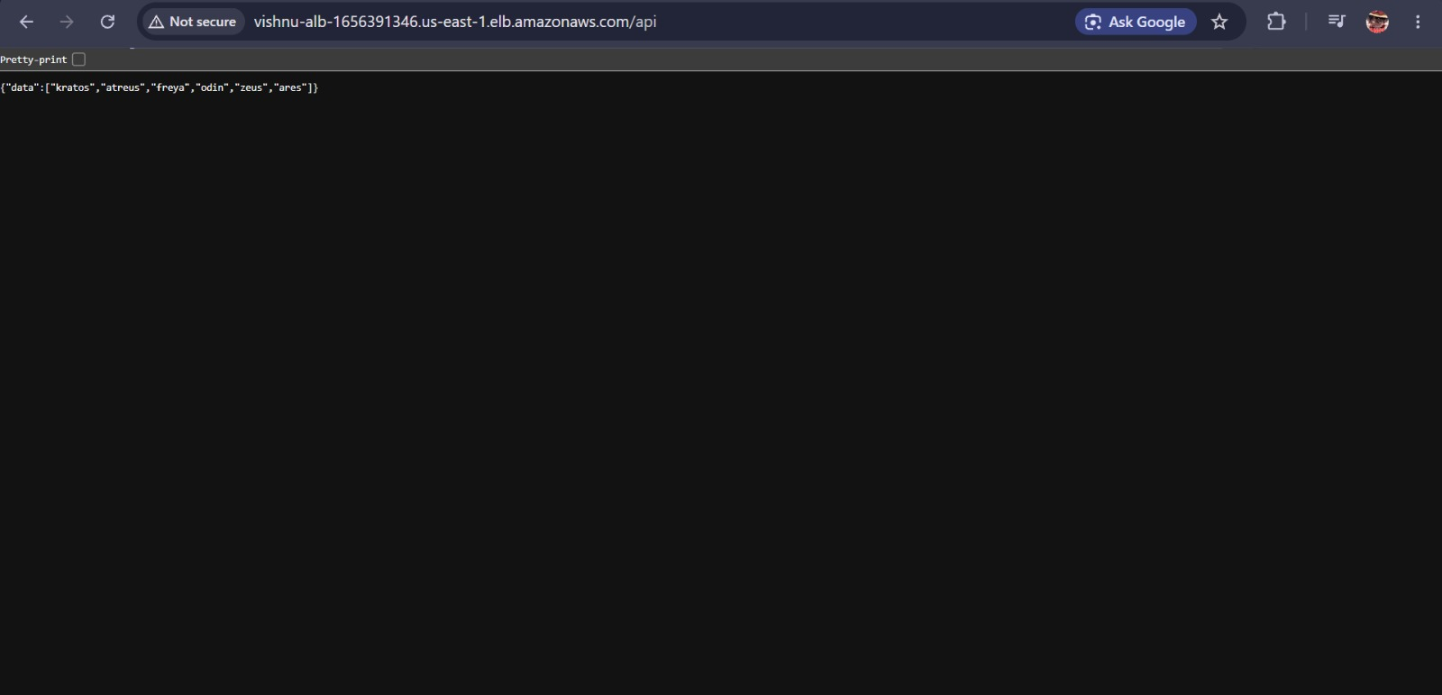
Figure 15 — ALB backend verification: /api returns Flask JSON data

11. Mentor Feedback — Resolution Status
• S3 remote state management: implemented with bootstrap-state and backend.tf files.
• User-data templates: included for Part 1 and Part 2.
• Successful deployment evidence: Part 3 is successfully deployed and verified; Part 1 first-run failure is documented honestly; Part 2 is not claimed as verified.
• ECS frontend BACKEND_URL: included in the Terraform task definition.
• ECR naming mismatch: build-and-push.sh now reads repository URLs from Terraform outputs, matching vishnu-backend and vishnu-frontend.
• Part 3 verification screenshots: included for Terraform apply, ECR login/build/push, ECS service status, frontend and /api browser tests.

12. GitHub Repository
GitHub repository:
https://github.com/VishnuMor369/Terraform.git

13. Cleanup
After verification, AWS resources should be removed to avoid unnecessary charges. The deployment directories support terraform destroy. The S3 state bucket should only be removed after the state files are no longer required.
terraform destroy

14. Conclusion
The final Terraform project contains all three requested architectures, reusable variables and outputs, user-data templates, Docker application source, ECR/ECS/ALB infrastructure and S3 remote-state configuration. Part 3 was successfully deployed and verified end-to-end: Terraform created 25 resources, both ECS services became ACTIVE, both Docker images were pushed to ECR, the frontend loaded through the ALB, and /api returned backend JSON. Part 1 and Part 2 are included in source with their verification status stated accurately based on the available evidence.

