Summary -Report

Top‑Performing Categories:
- Programming and Technology also contributed significantly, showing strong learner interest in technical skills.
Top Courses by Quantity Sold:
- Python Basics, Data Science Fundamentals, and Power BI Essentials were the most purchased courses, each with consistently high enrollments.
Top Learners by Spending:
- Learners such as Arjun Mehta (India), Chen Wei (China), and Hiro Tanaka (Japan), Sofia Rossi (Italy) recorded the highest spending, reflecting strong engagement from diverse geographies.
Cross-Category Purchases:
- Several learners (e.g., Arjun Mehta, Emma Brown, Sofia Rossi) purchased across multiple categories, indicating interest in broad skill development.
Courses with No Purchases:
- Gen‑AI, SAP Management, Automation Testing, IICS, and Advance PL/SQL have not been purchased at all.
Seasonal Trends:
- Purchases are spread across months from 2024 to 2026, with noticeable spikes in mid-year and year-end periods. This suggests learners may be more active during academic breaks or professional upskilling cycles.
Learner Diversity:
- Purchases span across multiple countries (India, USA, Spain, China, UK, Ireland, Italy, UAE, Japan). This shows global appeal, but also highlights opportunities to tailor regional strategies

Top categories by revenue:
select
C.Category,
count(Distinct P.Learner_id) As unique_learners,
Format(sum(P.Quantity * C.unit_price),2) As total_revenue
From courses C
left Join purchases P
on C.course_id=P.course_id
group by C.Category
order by total_revenue;
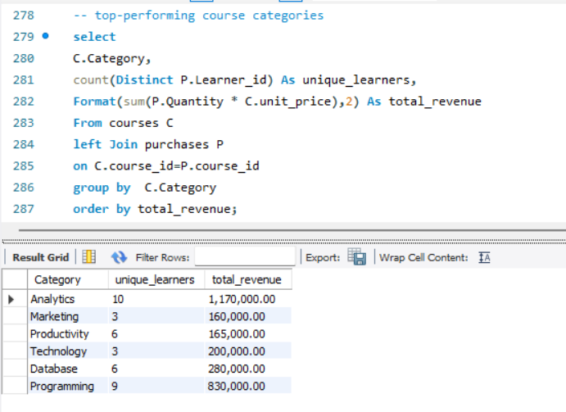

Top 3 courses by quantity sold:
Select
C.Course_name,
SUM(P.Quantity) As Total_Quantity
From courses C
left join purchases P
on C. course_id=P.course_id
group by C.Course_name
order by Total_Quantity DESC
limit 3;
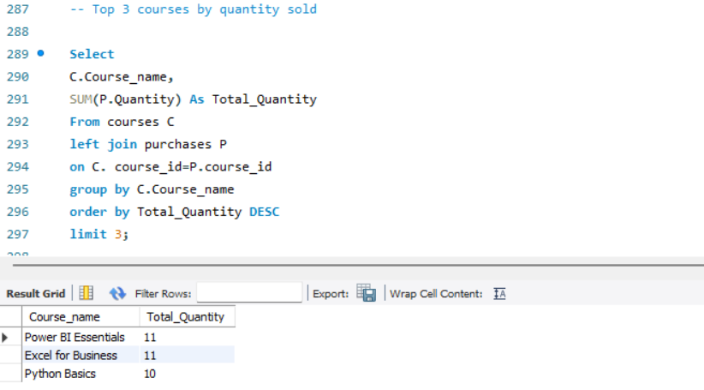
Top learners by spending :
select
L.Full_name as learner_name,
L.country,
Format(sum(C.unit_price * P.Quantity),2) As total_spent
From learners L left join
purchases P on L.learner_id=P.learner_id
Left join courses C
on P.course_id=C.course_id
Group by L.learner_id,L.country,learner_name
Order by total_spent;
