1. Write a C++ Program to add all the numbers from 1 to a given number.

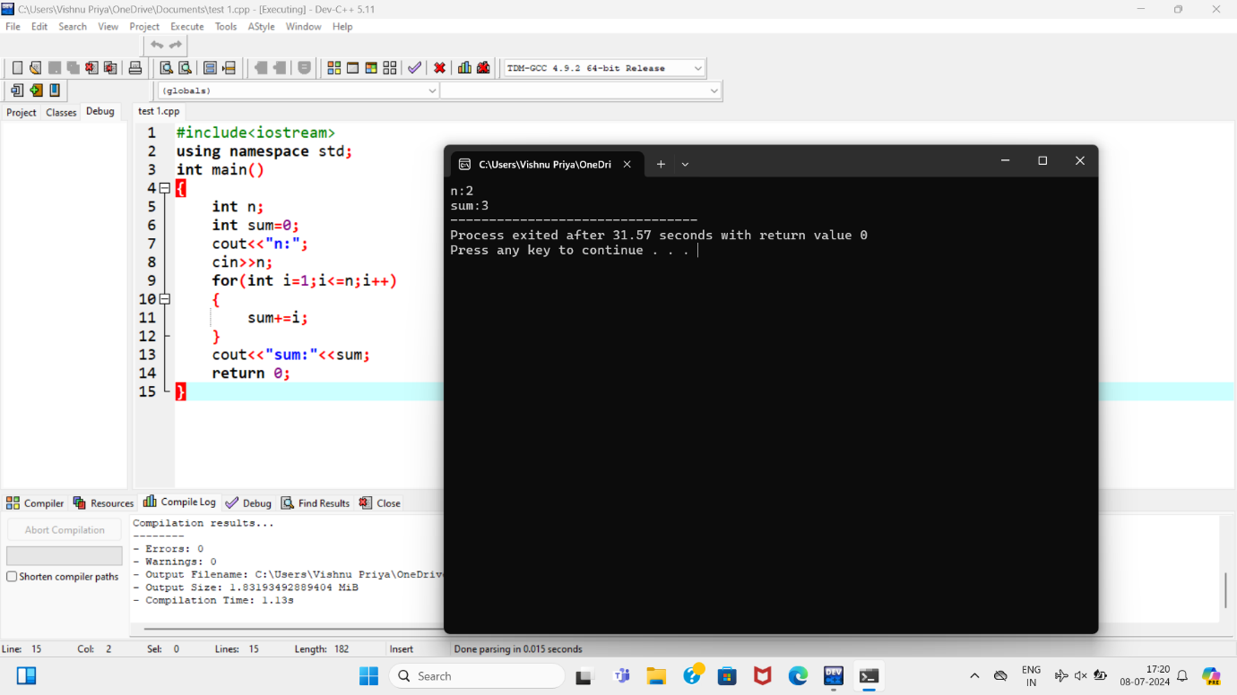

2.Write a C++ Program to check whether a given number is palindrome or not.

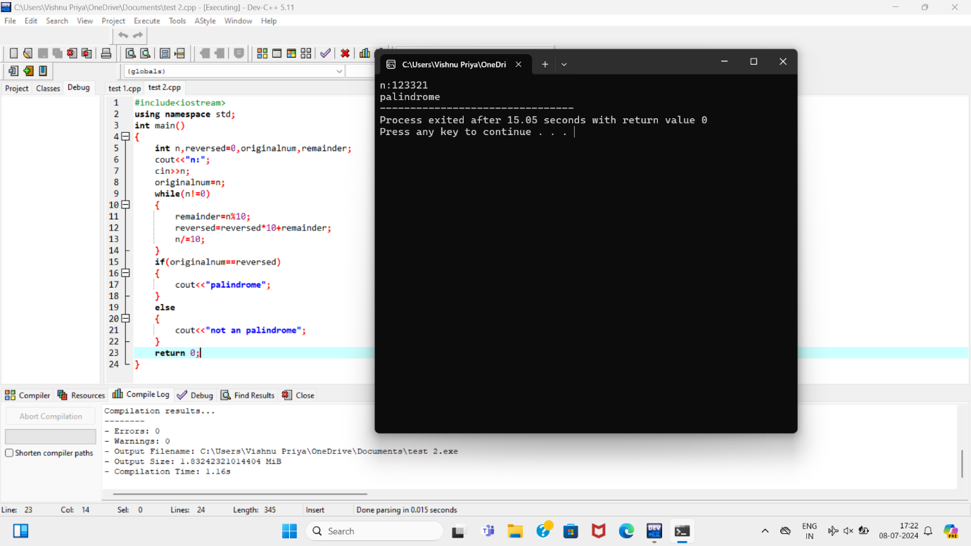

3.Write a program to find area of circle, rectangle and triangle using constructor overloading.

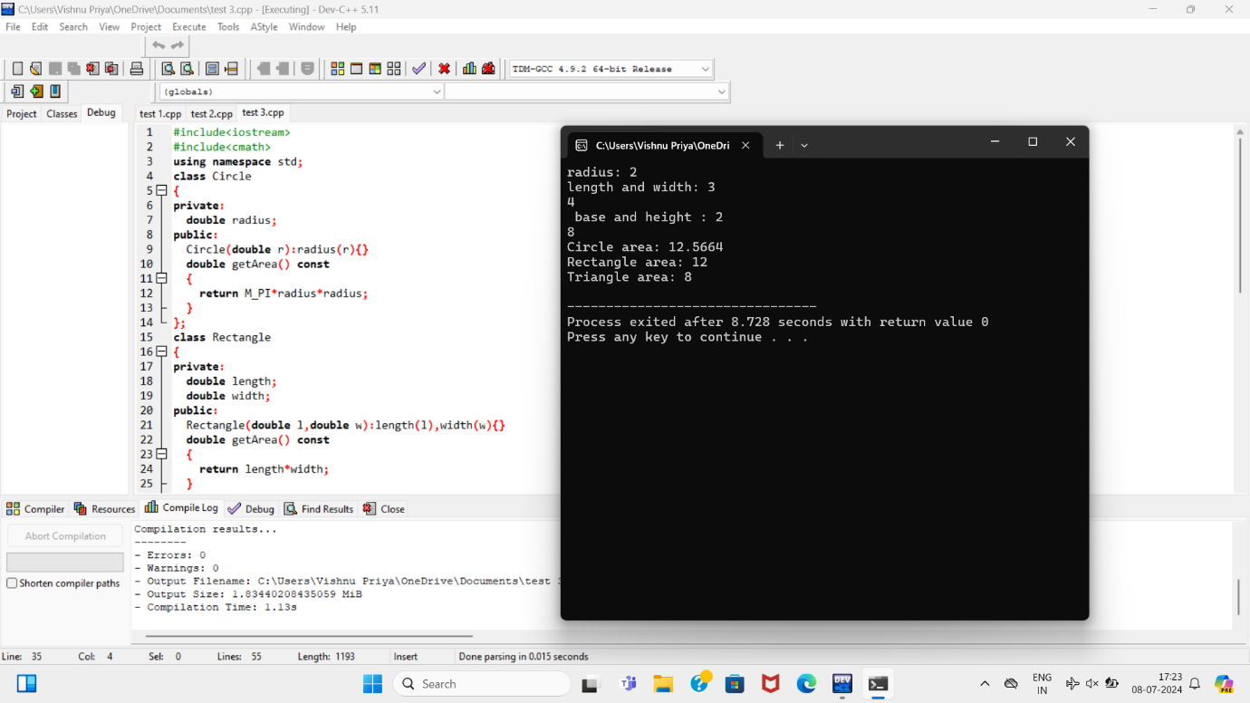

5.Write a C++ program to demonstrate the working of a copy constructor.

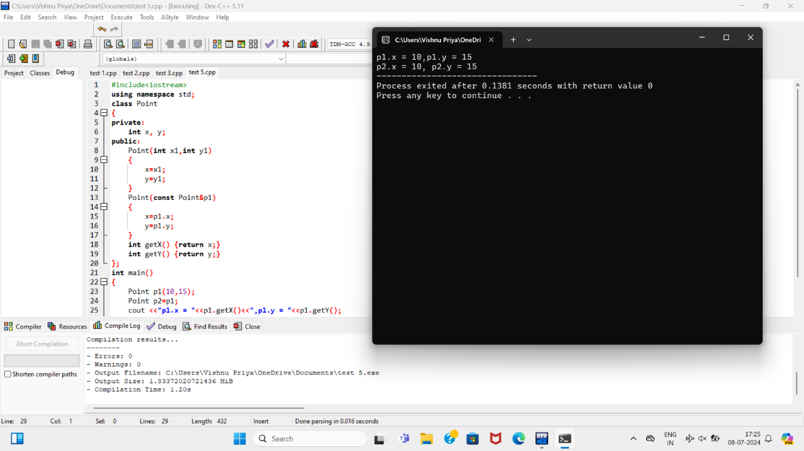

6. Write a program to print the area and perimeter of a triangle having sides of 3,4 and 5 units by creating a class named ‘Triangle’.

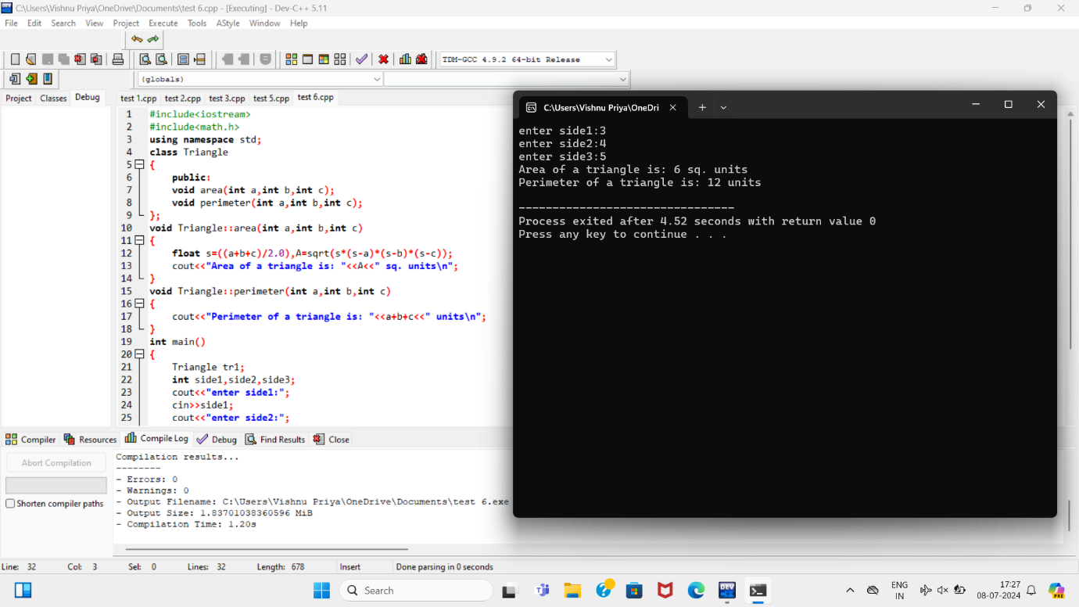

7. Create a class ‘Degree’ having a function ‘get degree’ that prints “I got a Degree”.

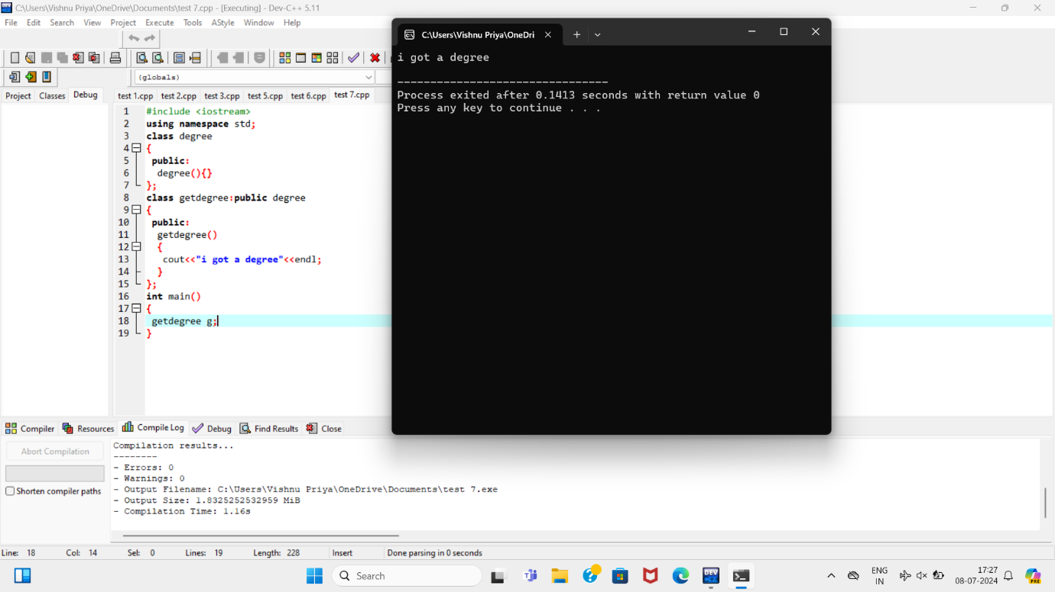

9. Write a program to find the sum of the series 1!/1+2!/2+3!/3+4!/4+5!/5.

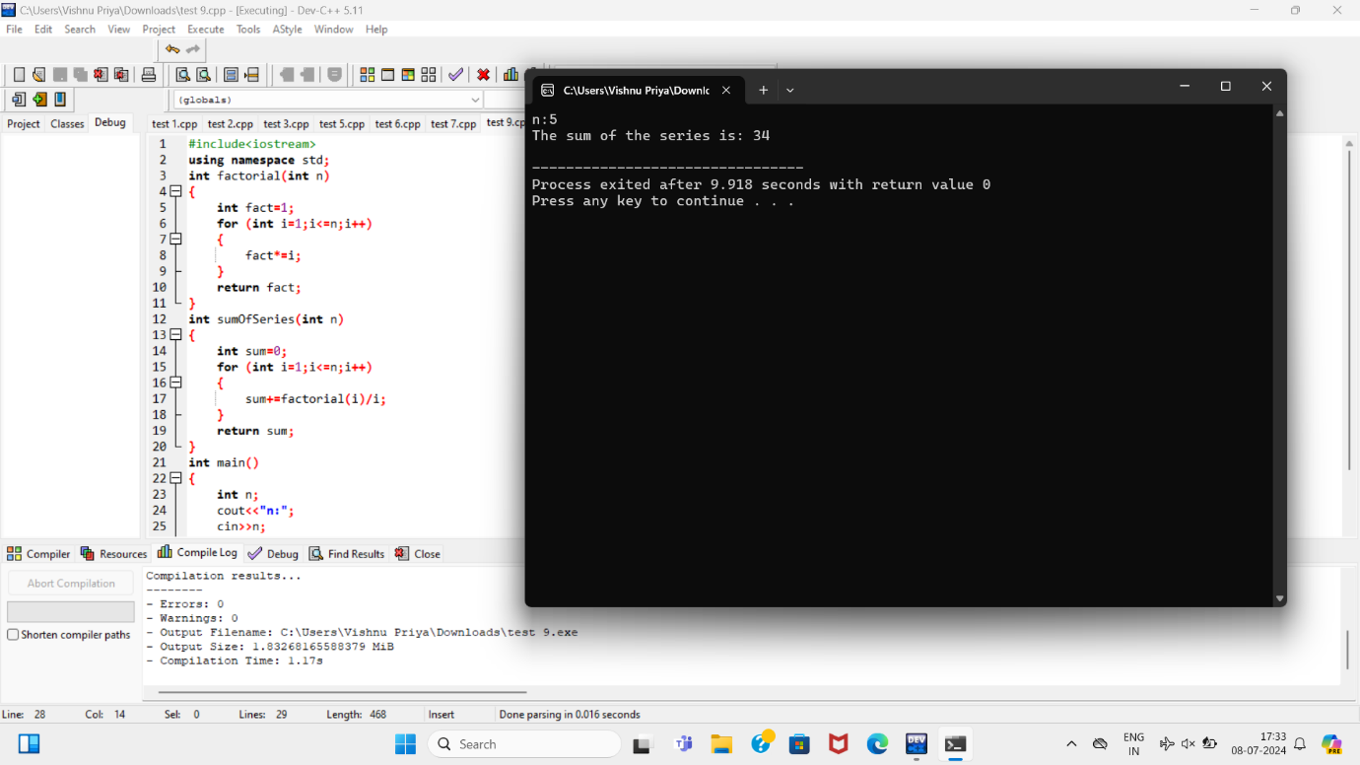

10. Write a program to order the array of elements in non-decreasing order.

