What is data governance?
Data governance is a comprehensive approach that comprises the principles, practices and tools to manage an organization’s data assets throughout their lifecycle. By aligning data-related requirements with business strategy, data governance provides superior data management, quality, visibility, security and compliance capabilities across the organization. Implementing an effective data governance strategy allows companies to make data easily available for data-driven decision-making while safeguarding their data from unauthorized access, and ensuring compliance with regulatory requirements.
Business benefits of data governance
- Increased operational efficiency and reduced costs
- Improved productivity and faster decision-making
- Enhanced collaboration and value realization
- Enhanced security and privacy
- Better compliance with regulations and standards
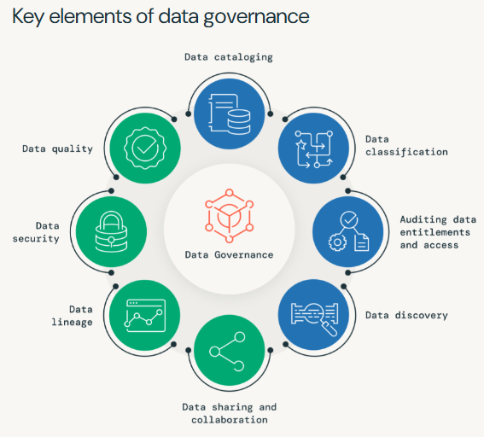
Data Cataloging:
Data cataloging is the process of creating a centralized repository of metadata for an organization’s data assets. It helps users easily discover, understand, and access data by providing details about its format, structure, location, and usage. A data catalog improves data governance, collaboration, analytics, and access control while reducing redundancy and supporting efficient data management.
Data Quality
Ensures data is accurate, complete, up-to-date, and compliant with quality standards, enabling reliable analytics and better decision-making.
Data Classification
Organizes data based on sensitivity, value, and importance, helping apply appropriate security measures and reduce risks.
Data Security
Protects sensitive data from unauthorized access through access controls and governance policies, ensuring compliance and maintaining trust.
Auditing Data Entitlements and Access
Tracks who can access data and monitors usage to detect misuse, improve security, and meet regulatory requirements.
Data Lineage
Provides a complete view of data flow and transformations across systems, improving data quality, troubleshooting, and audit readiness.

Data Discovery
Enables users to easily find and understand data assets, supporting analytics, AI/ML, collaboration, and preventing duplication.
Data Sharing and Collaboration
Facilitates secure data exchange among teams, partners, and customers while maintaining privacy, control, and enabling data-driven innovation.
What are the main steps of data governance?
The principal steps required include:
- Identifying all sources of data
- Preparing metadata for the data and organizing a metadata storage option
- Setting up mechanisms to track data lineage for data flow and usage
- Scanning for sensitive data in your data estate
- Creating a governance framework, with set policies and procedures for the various overseers
- Checking the framework’s compliance with relevant regulatory instruments
- Performing data quality checks by creating a rules library that is centrally managed and versioned. Update the rules library periodically with new rules.
- Regularly audit data entitlements and access to ensure compliance
- Identifying further risks, such as lack of data security or excess access to sensitive data sets
- Securing the go-ahead from the senior executive team and data governance committee
- Hiring or training essential staff members, such as data stewards
- Establishing a means of data distribution, so everyone in your organization can locate the centralized data catalog
- Having regular reviews with senior executives (inviting team member feedback)
- Constantly adapting the governance model, such as when new data sets are introduced.
Unity Catalog
Unity Catalog is Databricks' centralized, unified governance layer for all data and AI assets across your organization. It shifts security and metadata management from a fragmented, workspace-by-workspace level to a centralized account level, giving you a single source of truth for your Delta, Parquet, Iceberg, and JSON tables.
Key Capabilities
Unity Catalog simplifies how organizations secure, find, and monitor their data estate through several core features:
- Centralized Access Control: Manage permissions (grant, revoke) once at the account level. It supports standard table/schema access as well as attribute-based access control (ABAC) like dynamic row and column masking.
- 3-Level Namespace: Replaces the traditional Hive metastore with a strict 3-tier hierarchy: catalog.schema.table.
- Automated Data Lineage: Automatically tracks how data flows and transforms from raw sources to final dashboards across workspaces.
- Data Discovery & Classification: Provides a searchable Catalog Explorer UI where users can tag assets, add descriptions, and automatically detect sensitive PII.
- AI & Model Governance: Extends governance to Generative AI assets, allowing you to track and control AI models, LLM endpoints, and prompt tracking via AI Gateway.
- Open Source Accessibility: Unity Catalog has an open-source implementation governed by the Linux Foundation, making it extensible to non-Databricks compute engines.
Securable Objects Hierarchy
Every asset in Unity Catalog is modeled as a securable object. The hierarchy typically looks like this:
- Metastore: The top-level container that holds all metadata and data access permissions. (Usually deployed one per geographical region).
- Catalog: The primary organization unit (e.g., dev_catalog, prod_catalog).
- Schema (Database): The logical grouping of your datasets and AI models.
- Data Assets: The actual tables, views, volumes (unstructured files), and models.

Steps to Create a Unity Catalog Metastore and Enable a Databricks Workspace with Unity Catalog

1. Create a Metastore
- Sign in to the Databricks Account Console.
- Go to Data → Metastores.
- Click Create Metastore.
- Enter:
  - Metastore Name
  - Region (same as your workspace)
  - Storage Location (cloud object storage path)
- Click Create.

2. Assign the Metastore to a Workspace
- In the Metastores page, select the metastore you created.
- Go to Workspaces.
- Click Assign to Workspaces.
- Select the Databricks workspace(s) you want to enable.
- Save the changes.

3. Configure Storage Credentials (Optional but Recommended)
- Navigate to Catalog → External Data.
- Create a Storage Credential using IAM roles or service principals.
- Create an External Location and associate it with the storage credential.

4. Verify Unity Catalog Enablement
- Open the assigned Databricks workspace.
- Go to Catalog Explorer.
- Confirm that the metastore and catalogs are visible.
- Run:
SELECT CURRENT_METASTORE();
to verify the workspace is connected to the metastore.

5. Create a Catalog
Execute:
CREATE CATALOG main_catalog;

6. Create a Schema
CREATE SCHEMA main_catalog.sales_schema;

7. Create a Table
CREATE TABLE main_catalog.sales_schema.customers (
customer_id INT,
customer_name STRING
);

8. Grant Permissions
GRANT USE CATALOG ON CATALOG main_catalog TO `users`;
GRANT USE SCHEMA ON SCHEMA main_catalog.sales_schema TO `users`;
GRANT SELECT ON TABLE main_catalog.sales_schema.customers TO `users`;

3-Level Namespace in Unity Catalog
Unity Catalog uses a three-level namespace to organize and manage data assets in Databricks. This hierarchical structure follows the format
Catalog → Schema → Table/View, allowing organizations to logically group and secure their data. It provides centralized governance, making it easier to manage permissions, discover data, and collaborate across multiple workspaces.
1. Catalog
A catalog is the highest-level container in Unity Catalog. It is used to organize data assets based on departments, projects, or business domains. Catalogs provide isolation between different teams and support access control at a broad level. For example, an organization may create separate catalogs for sales, finance, and marketing data.
2. Schema
A schema (also called a database) is a collection of related tables, views, and functions within a catalog. Schemas help further organize data into logical groups. For instance, within a sales catalog, separate schemas can be created for customer information, orders, and inventory data.
3. Tables and Views
Tables are the actual storage objects that contain structured data, while views are virtual tables created from queries on one or more tables. Tables and views reside inside schemas and represent the lowest level of the namespace hierarchy. They provide the data that users query and analyze.

Creating Unity Catalog Objects

Step 1: Create a Catalog
CREATE CATALOG sales_catalog;

Step 2: Create a Schema
CREATE SCHEMA sales_catalog.customer_data;

Step 3: Create a Table
CREATE TABLE sales_catalog.customer_data.orders (
order_id INT,
customer_name STRING,
amount DOUBLE
);

Step 4: Insert Data
INSERT INTO sales_catalog.customer_data.orders
VALUES
(1, 'John', 500.0),
(2, 'Alice', 750.0);

Step 5: Query the Table
SELECT * FROM sales_catalog.customer_data.orders;

Hierarchy Diagram
Metastore
│
├── Catalog (sales_catalog)
│ │
│ ├── Schema (customer_data)
│ │ │
│ │ ├── Table (orders)
│ │ ├── View
│ │ └── Functions

Benefits of the Three-Level Namespace
- Centralized Governance: Provides a unified way to manage data assets across multiple workspaces.
- Fine-Grained Access Control: Permissions can be applied at the catalog, schema, table, or even column level.
- Improved Data Organization: Logical grouping of data simplifies administration and maintenance.
- Enhanced Collaboration: Teams can securely share and access data assets.
- Better Data Discovery: Users can easily locate and understand available data resources.

