What is Airflow?
Apache Airflow is an open-source workflow orchestration platform used to schedule, automate, and monitor data pipelines. It allows users to define workflows as Directed Acyclic Graphs (DAGs) using Python code, where tasks are executed in a specified order.
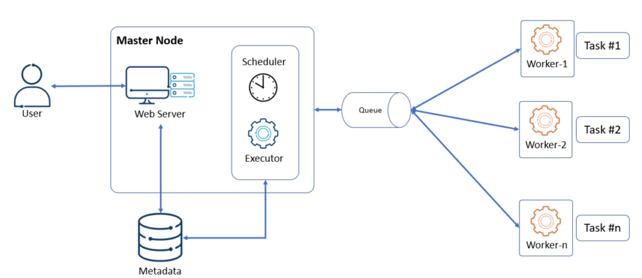
Core Concepts
Airflow structures your workflows using three main components:
- DAGs (Directed Acyclic Graphs): The core concept of Airflow. A DAG represents your workflow as a collection of tasks with directional dependencies. It ensures tasks run in the correct order without any infinite loops (cycles).
- Tasks: Individual units of work (e.g., fetching data from an API, running a database query, or sending an email).
- Operators & Hooks: Pre-built templates (like BashOperator or PythonOperator) that define exactly what a task does. Hooks allow you to interface with external APIs and databases.

Key Features
- Workflows as Code: DAGs are written in Python. This allows pipelines to be version-controlled, tested, and collaboratively developed alongside regular software.
- Robust UI: Airflow comes with a rich web-based user interface used to visualize pipeline dependencies, monitor progress in real-time, troubleshoot errors, and inspect logs.
- Automatic Retries: If a task fails, Airflow can automatically retry it based on declarative rules, and alert you if the pipeline completely breaks.
- Scalable Architecture: It uses a modular architecture with message queues (like Celery) and an array of workers to scale from a single local machine to massive distributed clusters

Common Use Cases
- ETL/ELT Processes: Automating the extraction, transformation, and loading of data from various business applications into central data warehouses.
- Machine Learning Automation: Scheduling pipelines that feed raw data, train ML models, and evaluate performance on a set cadence.
- Automated Reporting: Coordinating queries to generate business reports and distributing them to stakeholders.

2. Why Airflow instead of Azure Data Pipelines?

Feature | Apache Airflow | Azure Data Factory (ADF)
Nature | Open-source | Managed cloud service
Pipeline Definition | Python code | Drag-and-drop UI
Flexibility | Highly customizable | Limited to available activities
Deployment | Any environment | Azure ecosystem
Cost | Free (self-hosted) | Pay-as-you-use
Version Control | Easy with Git | Supported but less code-centric
Monitoring | Web UI | Azure Portal

Why choose Airflow?
- Supports complex workflows and dependencies.
- Pipelines are written in Python, making them easy to version control.
- Can run on-premises or any cloud platform.
- Large ecosystem and community support.
- Ideal for advanced ETL, ML, and data engineering workflows.

3. What is a DAG?
A DAG (Directed Acyclic Graph) is the fundamental concept in Airflow. It represents a workflow as a collection of tasks with dependencies.
- Directed: Tasks have a defined execution order.
- Acyclic: There are no loops or circular dependencies.
- Graph: Tasks are represented as nodes connected by edges.

Example:

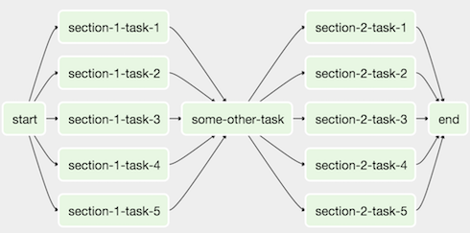
task1 → task2 → task3
Here:
- task1 runs first.
- After task1 succeeds, task2 starts.
- task3 runs only after task2 completes.

Sample Airflow Code:
task1 >> task2 >> task3

Key Concepts Within a DAG
- Tasks & Operators: A Task defines a unit of work (e.g., executing a script, running a query). Tasks are created by instantiating Operators (like PythonOperator or BashOperator).
- Dependencies: Defined using bitshift operators (>> or <<) to determine execution order. For example, task_A >> task_B means task_B runs only after task_A finishes.
- DAG Run: An individual instance of a DAG triggered in time, either automatically via a schedule or manually by a user.
In simple terms: A DAG defines what tasks should run, when they should run, and in what order.
How to Monitor and Run a DAG
- Save your script in the ~/airflow/dags directory.
- Launch your local Airflow stack using Docker or the standalone CLI command (airflow standalone).
- Open your browser and navigate to the Airflow Web UI at http://localhost:8080.
- Locate your dag_id to toggle it on, view its visual graph layout, or manually trigger execution.

Executing Killercoda steps
After understanding the basic concepts of Apache Airflow and DAGs, the next step is to gain hands-on experience by setting up an Airflow environment. For this purpose, KillerCoda provides an interactive Ubuntu playground where Airflow can be installed and configured without requiring local setup.

1. airflow standalone
Purpose: Initializes and starts Airflow in standalone mode.
Uses:
- Starts the scheduler and webserver automatically.
- Creates and initializes the metadata database.
- Generates default admin credentials.
- Suitable for learning, testing, and development.
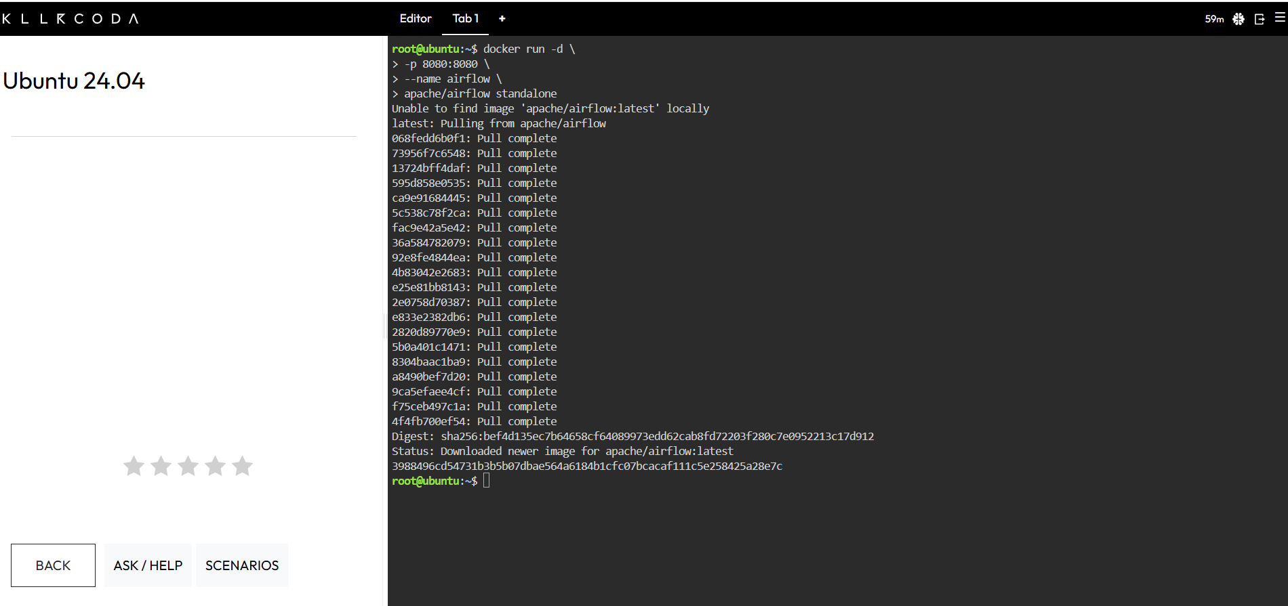

Once the environment is ready, a simple DAG named first_training_dag is created using Python. The DAG consists of multiple tasks defined using the PythonOperator. Task dependencies are established to ensure sequential execution of tasks.

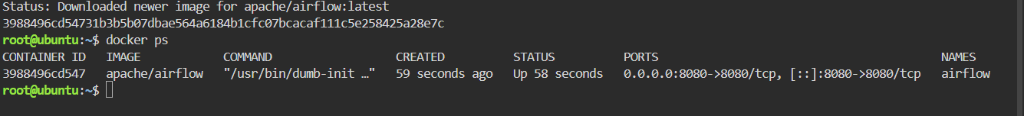

The Airflow environment is initialized using the airflow standalone command, which starts the web server, scheduler, and metadata database.
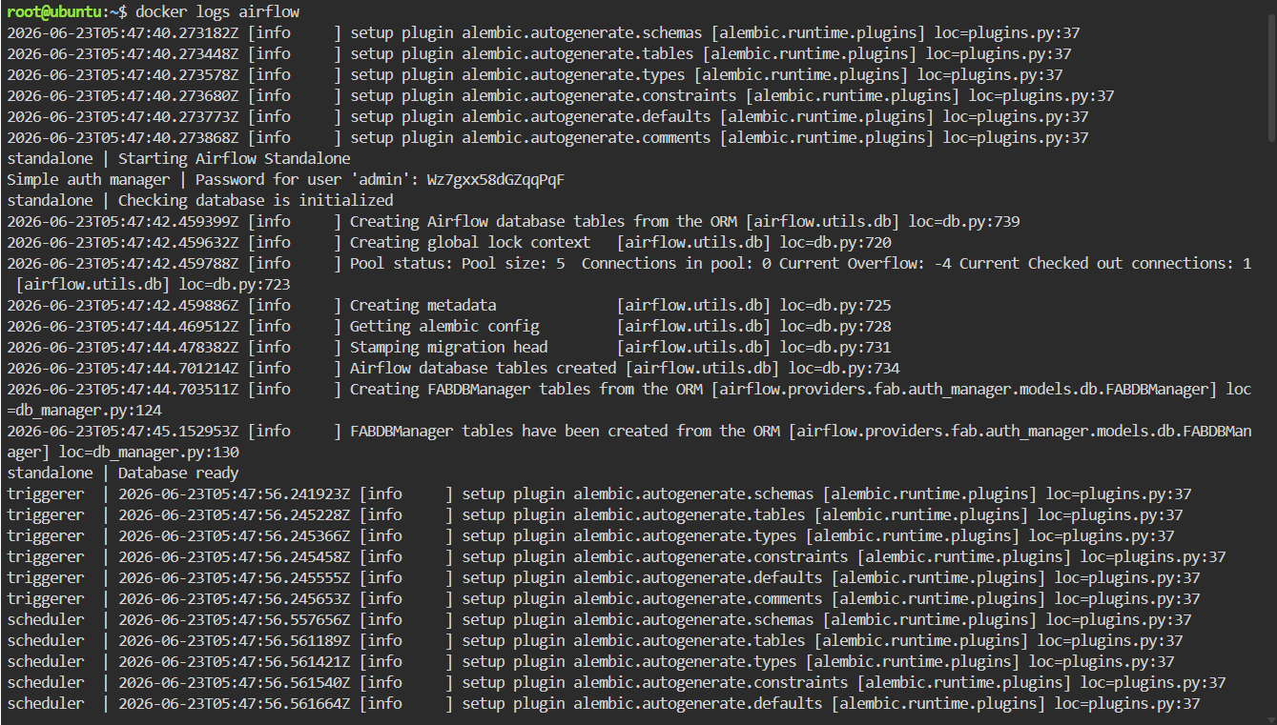

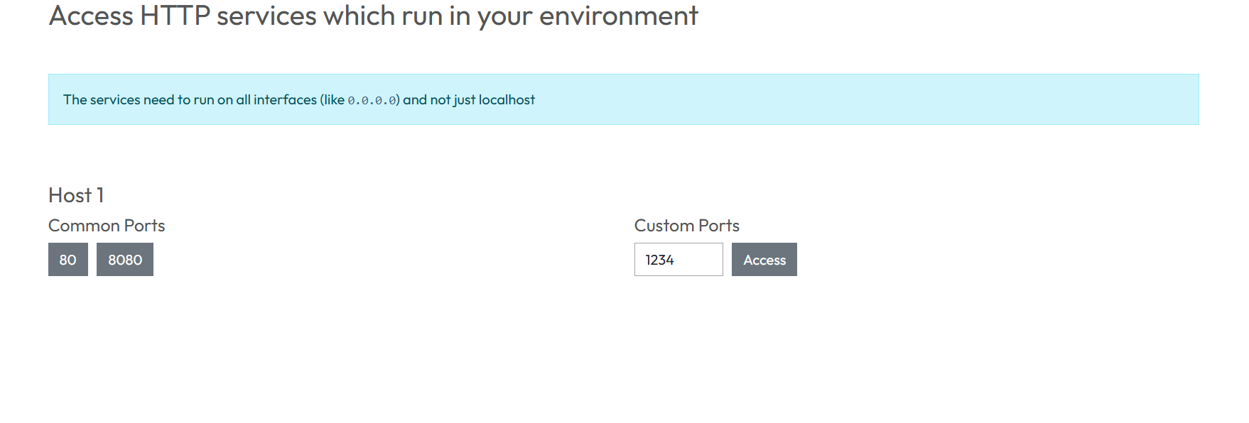
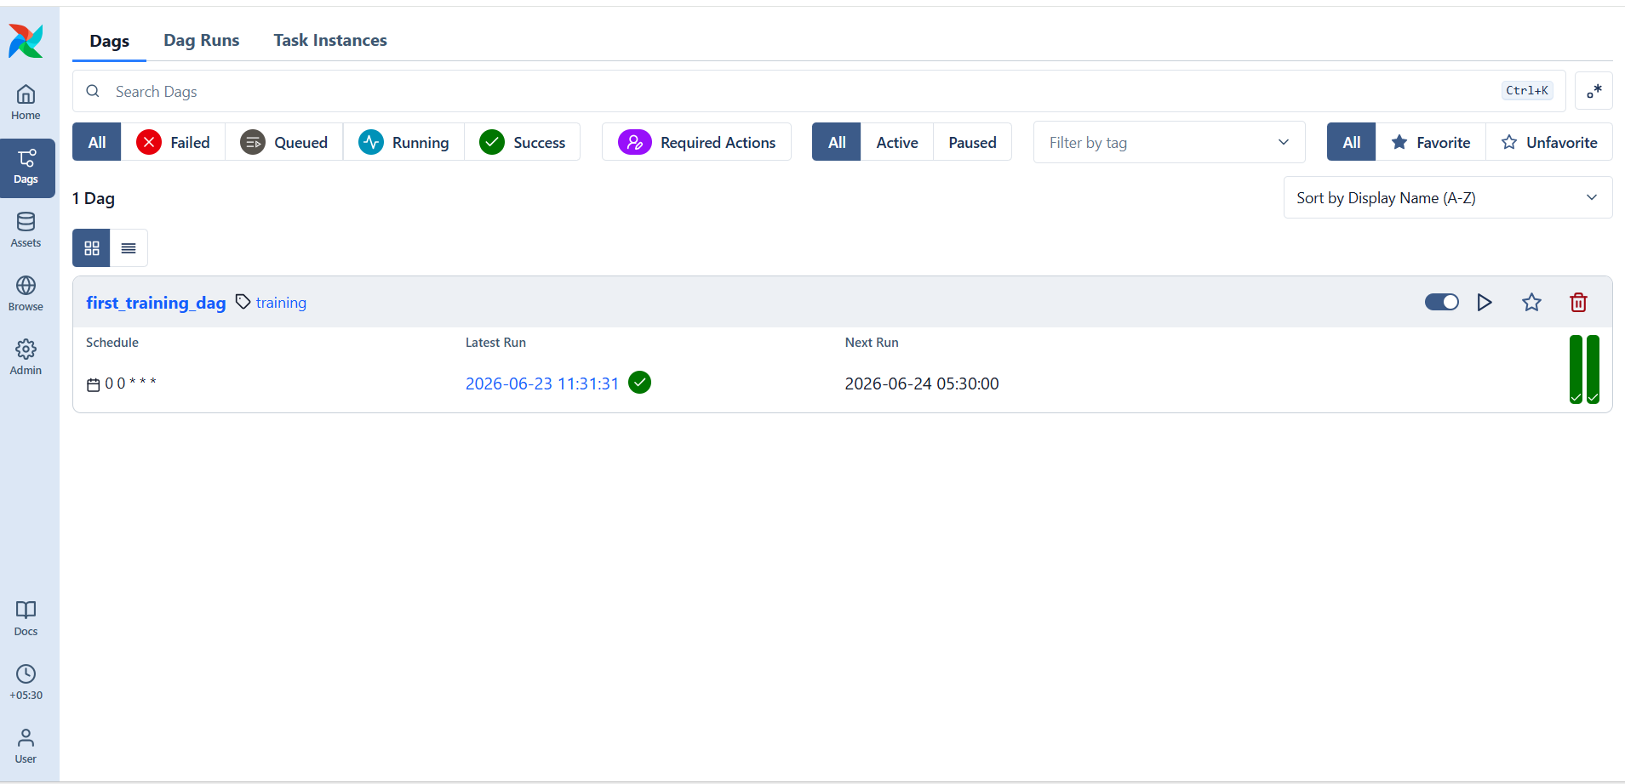
This allows users to interact with Airflow through its web interface and manage workflows efficiently.

Execute first DAG

Step 1: docker exec -it airflow bash
Purpose: Opens an interactive terminal inside the running Docker container named airflow.
- docker exec → Execute a command in a running container.
- -i → Keep the terminal interactive.
- -t → Allocate a terminal session.
- airflow → Name of the container.
- bash → Start a Bash shell inside the container.
After executing this command, your prompt changes from:
root@ubuntu:~$
to
airflow@3988496cd547:/opt/airflow$
which means you are now working inside the Airflow container.

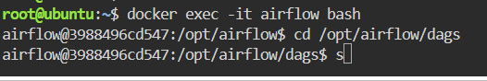

Step 2. cd /opt/airflow/dags
Purpose: Changes the current directory to the dags folder inside the container.
This folder is where Airflow looks for DAG definition files (*.py).
Step 3. Create a DAG File and Define the tasks and their dependencies in the file.
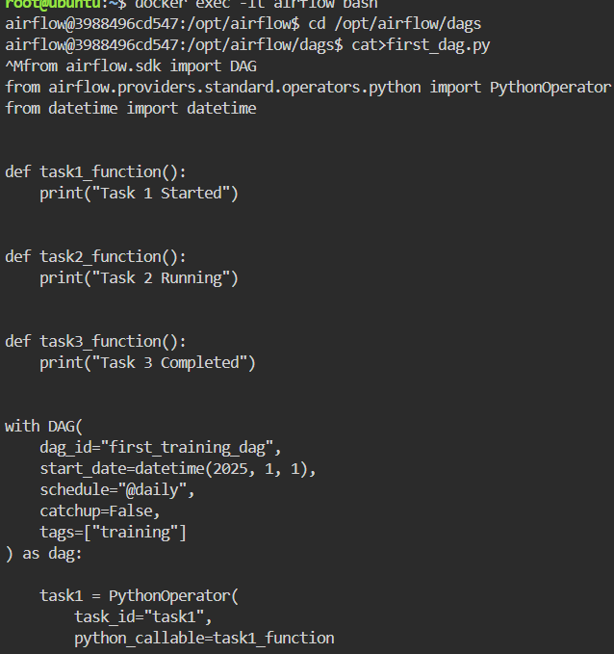
Step 4: Verify that the DAG is Loaded
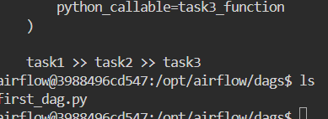

Step 5: Check for Import Errors
Purpose: Shows errors encountered while importing DAG files.
Uses:
- Helps debug syntax and import errors.
- Identifies problems preventing DAGs from appearing in the UI.
- Useful during DAG development and troubleshooting.

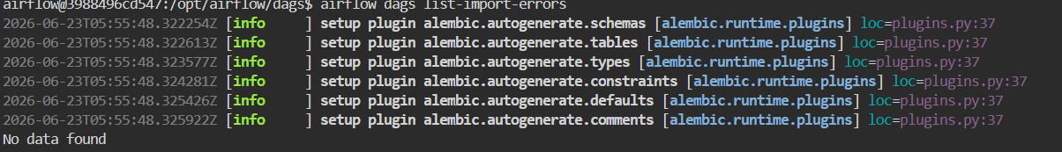

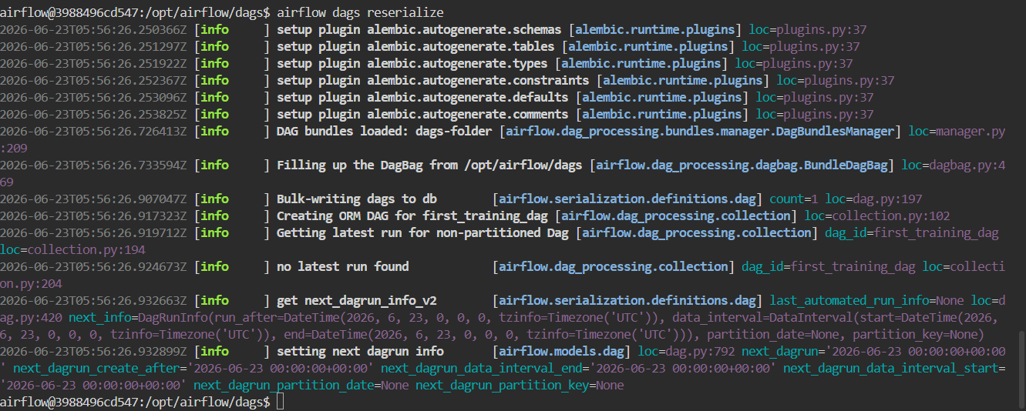

airflow dags list
Purpose: Displays all available DAGs in the Airflow environment.
Uses:
- Verifies whether a DAG has been loaded successfully.
- Lists active and paused DAGs.
- Helps identify if a DAG file is being recognized.
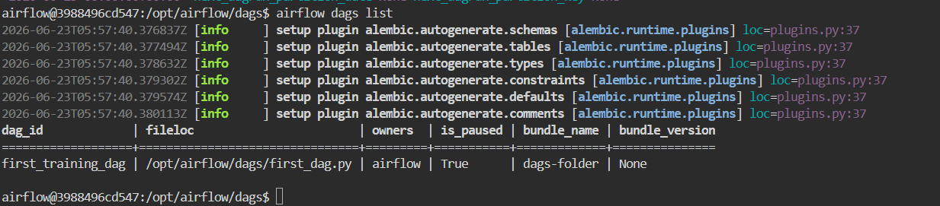

Step 6: Access the Airflow Dashboard
Open a web browser and navigate to:
http://localhost:8080
Log in using the username and password generated when airflow standalone was executed.

Step 7: Trigger the DAG
There are two ways to execute the DAG:

Using the Command Line
airflow dags trigger first_training_dag

Using the Web Interface
- Open the Airflow dashboard.
- Locate first_training_dag.
- Click the ▶ Play button to trigger the DAG.

Step 8: Monitor DAG Execution
Click on the DAG name and select:
- Grid View to monitor task status.
- Graph View to visualize task dependencies.
Task states are represented by colors:
- Green – Success
- Blue – Running
- Red – Failed

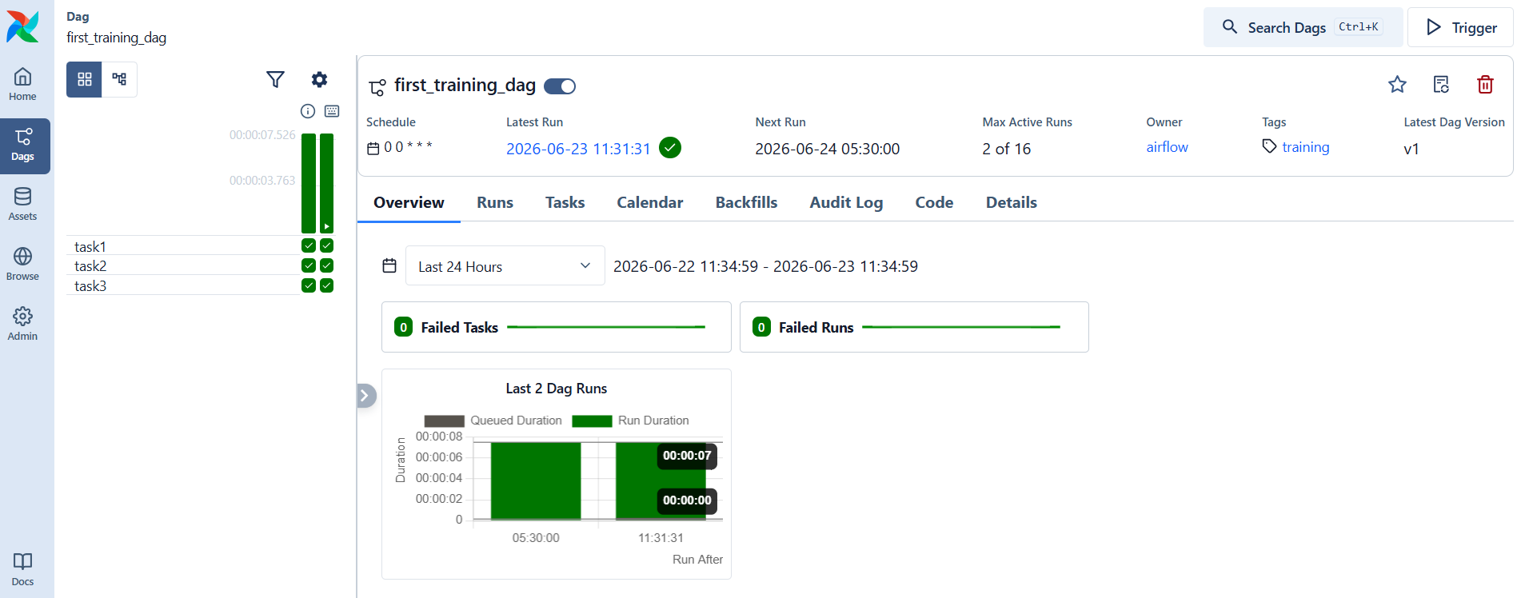

Airflow offers Grid and Graph views to visualize task execution. These views display the sequence of tasks and their current states, such as Running, Success, or Failed. This feature helps users monitor workflows and quickly identify any issues.
The successful execution of the DAG confirms that all tasks have completed without errors. The green indicators in the Airflow dashboard represent successful task completion, demonstrating the proper functioning of the workflow and task dependencies.

