RetailIQ – Full-Cycle E-Commerce Customer & Sales Analytics
A Project Report Submitted in
the partial fulfillment of the requirements for the award of the degree of

BACHELOR OF TECHNOLOGY
In

DEPARTMENT OF COMPUTER SCIENCE AND ENGINEERING
By
Vishnu Priya Kodali | 2420030630
Ivaturi Vennela | 2420030185
Lakshman Angara | 2420030067

Under the Esteemed Guidance of
Dr. N. SUNANDA
Associate Professor

Department of COMPUTER SCIENCE AND ENGINEERING

AY- 2026 - 2027

Semester: ODD SEMESTER




K L (Deemed to be) University
DEPARTMENT OF COMPUTER SCIENCE AND ENGINEERING

Declaration

The Project Report entitled “RetailIQ – Full-Cycle E-Commerce Customer & Sales Analytics” is a record of Bonafide work of Vishnu Priya Kodali – 2420030630, Ivaturi Vennela – 2420030185, Lakshman Angara – 2420030067 submitted in partial fulfillment for the award of B. Tech in Computer Science and Engineering to the K L University. The results embodied in this report have not been copied from any other departments/University/Institute.

Vishnu Priya Kodali - 2420030630
Ivaturi Vennela - 2420030185
Lakshman Angara - 2420030067
K L (Deemed to be) University
DEPARTMENT OF COMPUTER SCIENCE AND ENGINEERING

CERTIFICATE

This is certify that the mini project-based report entitled “RetailIQ – Full-Cycle E-Commerce Customer & Sales Analytics” is a Bonafide work done and submitted by Vishnu Priya Kodali – 2420030630, Ivaturi Vennela – 2420030185, Lakshman Angara – 2420030067 in partial fulfillment of the requirements for the award of the degree of BACHELOR OF TECHNOLOGY in Department of COMPUTER SCIENCE AND ENGINEERING, K L (Deemed to be University), during the academic year 2026-2027.

_____________________  Signature of the Guide  Dr. N. Sunanda  Associate Professor, CSE | _____________________  Course Coordinator  Dr. N. Sunanda  Department of CSE | _____________________  Head of the Department  Dr.P. Venkateswara Rao  Department of CSE

ACKNOWLEDGEMENT
The success in this project would not have been possible but for the timely help and guidance rendered by many people. Our wish to express my sincere thanks to all those who have assisted us in one way or the other for the completion of my project.

Our greatest appreciation to my Course Coordinator and my guide Dr. N. SUNANDA, Department of COMPUTER SCIENCE AND ENGINEERING, which cannot be expressed in words for his/her tremendous support, encouragement and guidance for this project.

We express our gratitude to Dr. P. Venkateshwar Rao, Head of the Department Of Computer Science and Engineering for providing us with adequate facilities, ways and means by which we are able to complete this project-based Lab.

We thank all the members of teaching and non-teaching staff members, and also who have assisted me directly or indirectly for successful completion of this project. Finally, I sincerely thank my parents, friends and classmates for their kind help and cooperation during my work.

Vishnu Priya Kodali - 2420030630
Ivaturi Vennela - 2420030185
Lakshman Angara - 2420030067

Abstract
The rapid growth of e-commerce has generated large volumes of customer and sales data, creating a need for effective methods to understand purchasing behaviour and improve business decisions. RetailIQ – Full-Cycle E-Commerce Customer and Sales Analytics is a data analytics and machine learning project developed to analyze customer behaviour, identify purchasing patterns, and segment customers based on their transaction history.
The project uses the Indian E-Commerce Customer Behavior and Purchase dataset obtained from Kaggle, consisting of 25,000 records and 29 attributes. Exploratory Data Analysis (EDA) is performed to examine sales trends, customer behaviour, purchase patterns, and cart abandonment. RFM (Recency, Frequency, and Monetary) analysis is then applied to generate customer-level features. K-Means clustering is used to segment 4,176 purchasing customers into five meaningful groups. Its performance is evaluated and compared with alternative clustering configurations, including Agglomerative Clustering, using Silhouette Score, Davies–Bouldin Index, and Calinski–Harabasz Score. The selected K-Means model with five clusters achieved a Davies–Bouldin Index of 0.9688.
An interactive dashboard is developed using Python and Streamlit to present analytical results, customer segments, visualizations, and business recommendations. RetailIQ provides a unified approach to e-commerce data analysis and helps businesses identify valuable customers, understand purchasing behaviour, and develop strategies for improving customer retention and sales performance.

Index
S. No. | Chapters | Topics | Page.no
 |  | Acknowledgement
 |  | Abstract
1 | Introduction | 1.1 Background  1.2 Problem Statement  1.3 Objectives  1.4 Scope  1.5 Importance and Applications | 1-10
2 | Literature Survey | 2.1 Review of Related Studies  2.2 Comparative Analysis  2.3 Research Gaps | 11-20
3 | System Requirements and Technology Stack | 3.1 Hardware Requirements  3.2 Software Requirements  3.3 Technologies, Libraries and Development Tools | 21-30
4 | Proposed Methodology and System Architecture | 4.1 Proposed System  4.2 Dataset Description  4.3 System Architecture  4.4 Data Preprocessing  4.5 EDA  4.6 Feature Engineering and Selection  4.7 Model Development and Evaluation | 31-35
5 | System Design and Implementation | 5.1 Overall Workflow  5.2 Module-wise Implementation  5.3 Machine Learning Pipeline  5.4 Stacking Ensemble Architecture  5.5 Streamlit Dashboard Implementation | 36-42
6 | Features and Functionalities | 6.1 Project Overview  6.2 EDA Visualizations  6.3 RetailQ  6.4 Model Evaluation  6.5 Dataset Insights | 43-55
7 | Results and Testing | 7.1 Experimental Setup  7.2 Evaluation Metrics  7.3 Model Performance Comparison  7.4 Prediction Results  7.5 Testing and Validation | 56-60
8 | Challenges and Limitations | 8.1 Challenges Faced  8.2 Solutions Applied  8.3 Current Limitations | 61-67
9 | Future Scope | 9.1 Dataset Expansion  9.2 Advanced ML Techniques  9.3 Real-Time Integration  9.4 Dashboard Enhancements | 68-73
10 | Conclusion | 10.1 Project Summary  10.2 Achievements  10.3 Skills Learned | 74-80
11 | References | Research papers
12 | Appendices | Dashboard screenshots  Important graphs  Code snippets

CHAPTER 1
Introduction
  - Background of the Project
The rapid growth of e-commerce has transformed the way businesses operate and interact with customers. Online shopping platforms generate large amounts of data through customer visits, product interactions, shopping cart activities, and purchase transactions. Analyzing this data helps businesses understand customer preferences, identify purchasing patterns, and make informed business decisions.
Customer behaviour analysis is important for identifying valuable customers, understanding purchasing frequency, and recognizing customers who may stop purchasing. RetailIQ – Full-Cycle E-Commerce Customer and Sales Analytics addresses these needs by applying Exploratory Data Analysis (EDA) to examine sales trends and customer behaviour, followed by RFM (Recency, Frequency, and Monetary) analysis to derive customer-level purchasing features. K-Means clustering is then used to group customers into meaningful segments.
The project also compares clustering techniques using performance evaluation metrics to assess the quality of customer segments. An interactive dashboard developed using Python and Streamlit presents the results through visualizations, customer insights, and business recommendations. RetailIQ aims to help e-commerce businesses understand customer behaviour, improve customer retention, identify valuable customer groups, and support data-driven decisions.
  - Problem Statement
E-commerce businesses generate large volumes of customer and sales data, making it challenging to understand purchasing behaviour, identify valuable customers, and recognize patterns in customer transactions. Traditional analysis methods may not effectively reveal meaningful customer groups or provide sufficient insights for business decision-making.
The problem addressed in this project is to develop a data analytics and machine learning-based system that analyzes e-commerce customer behaviour and sales patterns. The system aims to examine historical data, perform RFM analysis, apply customer segmentation using clustering algorithms, compare model performance, and present actionable insights through an interactive dashboard.

  - Objectives of the Project
The main objective of this project is to develop a data analytics and machine learning-based system that analyzes e-commerce customer behaviour and sales patterns. The project focuses on exploring customer data, identifying purchasing patterns, performing RFM-based customer segmentation using K-Means clustering, evaluating clustering performance, and providing an interactive dashboard for visualizing insights and supporting data-driven business decisions.
The specific objectives are:
- To analyze e-commerce customer behaviour and sales patterns using Exploratory Data Analysis (EDA).
- To perform RFM analysis and develop customer segments using K-Means clustering to identify distinct purchasing groups.
- To evaluate and compare clustering models using appropriate performance metrics.
- To develop an interactive Streamlit dashboard to visualize sales performance, customer segments, and actionable business recommendations.

  - Scope of the Project
The scope of RetailIQ is to analyze e-commerce customer behaviour and sales data to generate meaningful business insights. The project focuses on data preprocessing, exploratory data analysis, and RFM-based customer segmentation using K-Means clustering. It also includes comparing clustering techniques using performance evaluation metrics to identify a suitable segmentation approach.
The project covers the following areas:
- Data Preprocessing: Cleaning and preparing the e-commerce dataset for analysis.
- Exploratory Data Analysis: Examining sales trends, customer behaviour, and purchasing patterns.
- RFM Analysis: Calculating Recency, Frequency, and Monetary values for customers.
- Customer Segmentation: Grouping customers into five segments using K-Means clustering.
- Model Evaluation: Comparing clustering techniques using appropriate performance metrics.
- Dashboard Development: Presenting analytical results and visualizations through an interactive Streamlit dashboard.
- Business Recommendations: Providing insights to support customer retention, targeted marketing, and sales improvement.
The current implementation focuses on analyzing historical e-commerce customer and sales data using the available dataset. It does not include real-time customer activity tracking, live transaction data collection, integration with external e-commerce platforms, or deployment in a production business environment.
  - Importance and Applications
RetailIQ is important because it helps e-commerce businesses understand customer purchasing behaviour and sales patterns through data analysis and machine learning. By identifying different customer segments, businesses can make better decisions, improve customer retention, and plan targeted marketing strategies.
The major importance and applications of this project include:
- Customer Identification: Identifying high-value, frequent, recent, and inactive customers based on their purchasing behaviour.
- Customer Retention: Recognizing at-risk customers and planning suitable strategies to encourage repeat purchases.
- Targeted Marketing: Designing personalized offers and promotional campaigns for different customer segments.
- Sales Analysis: Understanding revenue patterns, purchase trends, and customer spending behaviour.
- Business Decision-Making: Using analytical insights and dashboard visualizations to support informed business decisions.
- Customer Relationship Management: Helping businesses understand customer value and improve long-term customer relationships.
The project can be useful for e-commerce companies, online retailers, digital marketing teams, and business analysts.

CHAPTER 2
LITERATURE SURVEY
2.1 Review of Related Studies
Several studies have explored customer segmentation and purchasing behaviour analysis using data mining and machine learning techniques. These studies provide a foundation for developing RetailIQ, which applies RFM analysis and clustering techniques to understand e-commerce customer behaviour.
Anitha and Patil [1] proposed an RFM-based customer segmentation approach using the K-Means algorithm. Their study analyzed customer purchasing history using Recency, Frequency, and Monetary values to identify potential customers and understand buying patterns. The study demonstrated how combining RFM analysis with clustering can support business intelligence and customer-related decision-making.
Gomes and Meisen [2] conducted a comprehensive review of customer segmentation methods used in e-commerce. They examined 105 publications and identified RFM analysis and manually selected features as common approaches for customer representation. Their findings also showed that K-Means was the most frequently used clustering technique in the reviewed studies, highlighting its importance in customer segmentation.
Salminen et al. [3] presented a systematic literature review of algorithmic customer segmentation. Their research examined 172 relevant articles and identified several clustering algorithms and evaluation measures. K-Means was found to be the most frequently used algorithm. The study also emphasized that the choice of clustering algorithm and evaluation method depends on the characteristics of the dataset and the segmentation objective.
Wu et al. [4] proposed an improved RFM model and K-Medoids clustering approach for e-commerce customer segmentation. They extended the traditional RFM model by including shopping cart and product-favourite information. The Calinski–Harabasz index was used to determine the number of clusters, while K-Means++ was incorporated to improve the selection of initial cluster centres. Their results demonstrated the usefulness of enhanced customer behaviour features for improving segmentation.
A study published in the 2023 IEEE International Conference on Electrical, Automation and Computer Engineering [5] investigated e-commerce user classification using the RFM model and K-Means algorithm. The researchers applied RFM features to transaction data to group customers according to their purchasing behaviour. The study highlighted the potential of customer segmentation for improving targeted marketing and understanding customer requirements.
Rousseeuw [6] introduced the Silhouette method to evaluate the quality of clustering results. It measures how closely a data point belongs to its assigned cluster compared with other clusters. This measure is useful for assessing both cluster cohesion and separation.
Davies and Bouldin [7] introduced the Davies–Bouldin index as a measure of cluster separation. It evaluates the similarity between clusters based on their dispersion and distance. A lower Davies–Bouldin index indicates better-separated clusters.
Caliński and Harabasz [8] proposed a statistical criterion for evaluating clustering results, now known as the Calinski–Harabasz index. It compares the separation between clusters with the variation within clusters. A higher value generally indicates better-defined clusters.
Based on these related studies, RFM analysis and clustering techniques are suitable approaches for identifying meaningful customer groups in e-commerce datasets. However, the effectiveness of segmentation depends on the dataset, selected features, clustering algorithm, and evaluation method. Therefore, RetailIQ applies RFM analysis to historical e-commerce purchasing data, uses K-Means to identify customer segments, and compares clustering performance using Silhouette, Davies–Bouldin, and Calinski–Harabasz metrics. The results are presented through an interactive Streamlit dashboard to support the interpretation of customer and sales patterns.
2.2 Comparative Analysis
The following table compares the related research studies, their approaches, identified limitations, and the research gap addressed by RetailIQ.
2.2 Comparative Analysis
The following table compares the related research studies, their approaches, identified limitations, and the research gap addressed by RetailIQ.
No. | Research Paper (Year) | Approach / Focus | Identified Limitation | Gap Addressed by Our Project
1 | Anitha and Patil (2022) [1] | RFM analysis with K-Means for customer purchase behaviour. | Focuses mainly on RFM-based customer segmentation. | Extends the analysis by comparing multiple clustering approaches and presenting results through an interactive dashboard.
2 | Gomes and Meisen (2023) [2] | Review of customer segmentation methods for personalized e-commerce targeting. | Provides a review of existing methods rather than implementing a complete analytics system. | Implements an end-to-end customer analytics workflow using a real e-commerce dataset.
3 | Salminen et al. (2023) [3] | Systematic review of algorithmic customer segmentation techniques. | Focuses on reviewing segmentation methods rather than developing a specific business analytics application. | Applies customer segmentation and presents interpretable results through a dashboard.
4 | Wu et al. (2022) [4] | Improved RFM model with K-Medoids for e-commerce customer segmentation. | Uses a different clustering approach and additional customer behaviour features. | Applies RFM-based K-Means segmentation and compares it with Agglomerative Clustering.
5 | RFM and K-Means-based e-commerce user classification (2023) [5] | Uses RFM features and K-Means to classify e-commerce users. | Primarily focuses on customer classification through clustering. | Adds comparative model evaluation and interactive visualization of customer segments.
6 | Rousseeuw (1987) [6] | Introduces the Silhouette method for evaluating clustering quality. | Provides a clustering evaluation measure rather than a complete customer segmentation application. | Uses the Silhouette Score along with other metrics to evaluate customer clusters.
7 | Davies and Bouldin (1979) [7] | Introduces the Davies–Bouldin Index for measuring cluster separation. | Focuses on evaluating cluster quality rather than customer behaviour analysis. | Uses the index to compare clustering models applied to e-commerce customer data.
8 | Caliński and Harabasz (1974) [8] | Introduces a statistical criterion for evaluating cluster structures. | Does not address e-commerce customer segmentation directly. | Applies the Calinski–Harabasz Score to evaluate the clustering results in RetailIQ.

2.3 Research Gaps
The review of existing studies highlights several areas that can be further explored in e-commerce customer analytics. Although previous research has applied RFM analysis and clustering techniques for customer segmentation, there is scope to combine these methods with comparative model evaluation and interactive visualization.
The major research gaps identified are:
1. Limited Integration of Analytical Techniques: Existing studies often focus on individual techniques. There is a need to integrate data preprocessing, exploratory data analysis, RFM analysis, and customer segmentation into a single workflow.
2. Limited Comparison of Clustering Algorithms: Many approaches focus on a particular clustering algorithm. Comparing K-Means with other clustering techniques can provide a better understanding of their performance on the same dataset.
3. Need for Comprehensive Model Evaluation: Evaluating clustering results using only one metric may not provide a complete assessment. Multiple evaluation metrics can help examine cluster quality from different perspectives.
4. Limited Interactive Visualization: Analytical results may be difficult for business users to interpret when presented only through static outputs. An interactive dashboard can make customer segments and sales insights easier to understand.
5. Need for Actionable Business Insights: Identifying customer groups alone may not be sufficient. The results should also help businesses recognize high-value and at-risk customers and plan suitable marketing and retention strategies.
How RetailIQ Addresses These Gaps
RetailIQ addresses these research gaps by integrating data preprocessing, exploratory data analysis, RFM-based customer segmentation, and clustering model comparison into one system. It evaluates K-Means and Agglomerative Clustering using Silhouette Score, Davies–Bouldin Index, and Calinski–Harabasz Score. The project also provides a Streamlit dashboard to visualize sales patterns, customer segments, and business recommendations.
This integrated approach aims to make e-commerce customer analysis more understandable and useful for data-driven business decision-making.

CHAPTER 3
SYSTEM REQUIREMENTS AND TECHNOLOGY STACK
3.1 Hardware Requirements
The following hardware requirements are sufficient for developing and running the RetailIQ project using Python, machine learning libraries, and Streamlit.
S.No. | Hardware Component | Minimum Requirement
1 | Processor | Intel Core i3 or equivalent
2 | RAM | 4 GB
3 | Storage | 10 GB of available disk space
4 | System Type | 64-bit computer
5 | Display | Standard monitor or laptop display
6 | Input Devices | Keyboard and mouse
7 | Network | Internet connection for downloading libraries and accessing documentation

3.2 Software Requirements
The following software and tools are used for the development and execution of the RetailIQ project.
S. No. | Software Component | Technology / Requirement
1 | Operating System | Windows 10 / Windows 11
2 | Programming Language | Python
3 | Development Environment | Anaconda / Jupyter Notebook
4 | Code Editor | Visual Studio Code
5 | Data Manipulation | Pandas, NumPy
6 | Data Visualization | Matplotlib, Seaborn
7 | Machine Learning | Scikit-learn
8 | Dashboard Development | Streamlit
9 | Data Storage | CSV file (Ecommerce.csv)
10 | Web Browser | Google Chrome or equivalent

Python Libraries:
- Pandas: Used for loading, cleaning, preprocessing, and analyzing the e-commerce dataset.
- NumPy: Used for numerical calculations and data operations.
- Matplotlib: Used to create graphs and visualizations for exploratory data analysis.
- Seaborn: Used to create statistical plots and visualize customer behaviour patterns.
- Scikit-learn: Used for implementing K-Means and Agglomerative Clustering, PCA, and clustering evaluation metrics.
- Streamlit: Used to develop the interactive dashboard for displaying analytical results, customer segments, and business insights.
3.3 Technologies, Libraries and Development Tools
The following technologies and tools were used in the development of the RetailIQ – Full-Cycle E-Commerce Customer & Sales Analytics system:
- Programming Language: Python
- Development Environment: Anaconda and Jupyter Notebook
- Code Editor: Visual Studio Code
- Data Processing: Pandas and NumPy
- Data Visualization: Matplotlib and Seaborn
- Machine Learning: Scikit-learn
- ML Algorithms: K-Means Clustering and Agglomerative Clustering.
- Dimensionality Reduction: Principal Component Analysis (PCA).
- Customer Segmentation: Recency, Frequency, and Monetary (RFM) Analysis.
- Model Evaluation: Silhouette Score, Davies–Bouldin Index, and Calinski–Harabasz Score.
- Dashboard Development: Streamlit
- Dataset Source: Kaggle – Indian E-Commerce Customer Behavior and Purchase Dataset.
CHAPTER 4
PROPOSED METHODOLOGY AND SYSTEM ARCHITECTURE

4.1 Proposed System
The proposed system, RetailIQ – Full-Cycle E-Commerce Customer & Sales Analytics, is designed to analyze e-commerce customer behaviour and sales patterns using data analytics and machine learning techniques.
The system uses the Indian E-Commerce Customer Behavior and Purchase dataset obtained from Kaggle. Initially, the dataset undergoes data preprocessing to handle missing values, verify data consistency, and prepare the data for analysis. Exploratory Data Analysis (EDA) is then performed to identify sales trends, purchasing patterns, and customer behaviour.
RFM analysis is applied to calculate Recency, Frequency, and Monetary values for each customer who has made at least one purchase. These values are used as input features for customer segmentation.
The proposed system applies K-Means and Agglomerative Clustering to group customers based on their purchasing behaviour. The clustering results are evaluated using Silhouette Score, Davies–Bouldin Index, and Calinski–Harabasz Score to compare model performance. K-Means with five clusters is selected for the final segmentation based on its overall evaluation results and the usefulness of the resulting customer groups.
Finally, an interactive dashboard is developed using Streamlit to display sales analysis, customer segments, evaluation results, visualizations, and business recommendations.

4.2 Dataset Description
The dataset used in the RetailIQ project is the Indian E-Commerce Customer Behavior and Purchase Dataset, obtained from Kaggle. It contains historical e-commerce customer and transaction-related information, which is used to analyze purchasing patterns, sales performance, and customer behaviour.
The dataset consists of 25,000 records and 29 attributes. It includes information related to customer details, browsing and shopping activities, cart interactions, purchase behaviour, and transaction values.
Dataset Details
- Dataset Name: Indian E-Commerce Customer Behavior and Purchase
- Source: Kaggle
- Total Records: 25,000
- Total Attributes: 29
- Unique Customers: 8,442
- File Format: CSV (Ecommerce.csv)
- Dataset Type: Structured Data
- Data Usage: Exploratory Data Analysis, RFM Analysis, Customer Segmentation, and Sales Analysis.
For RFM-based segmentation, the analysis considers 4,176 customers who have made at least one purchase.
Dataset Source: K. Bedmutha, “Indian E-Commerce Customer Behavior and Purchase Dataset,” Kaggle. [Online]. Available: https://www.kaggle.com/datasets/kundanbedmutha/indian-e-commerce-customer-behavior-and-purchase

4.3 System Architecture
The system architecture of RetailIQ – Full-Cycle E-Commerce Customer & Sales Analytics describes the sequence of processes involved in analysing e-commerce data and generating meaningful business insights. The system follows a structured workflow, starting from dataset input and ending with the presentation of results through an interactive dashboard.
The architecture consists of the following major components:
1. Data Input: The Ecommerce.csv dataset is loaded into the system. It contains 25,000 records and 29 attributes related to customer behaviour and e-commerce activities.
2. Data Preprocessing: The dataset is examined and prepared for analysis by handling missing values, checking data consistency, and preparing the required attributes.
3. Exploratory Data Analysis (EDA): Customer behaviour, sales performance, purchase patterns, and shopping cart activities are analysed using statistical summaries and visualizations.
4. RFM Analysis: Recency, Frequency, and Monetary values are calculated for customers with at least one purchase. These values are used to understand customer purchasing behaviour.
5. Customer Segmentation: K-Means clustering is applied to group customers into five meaningful segments. Agglomerative Clustering is also implemented for comparison.
6. Model Evaluation: The clustering results are evaluated using Silhouette Score, Davies–Bouldin Index, and Calinski–Harabasz Score to assess the quality of the generated clusters.
7. Dashboard and Visualization: The analytical results, customer segments, model evaluation metrics, and business recommendations are presented through an interactive dashboard developed using Streamlit.
8. Business Insights: The final output helps identify valuable and at-risk customers, understand purchasing patterns, and support targeted marketing and customer retention strategies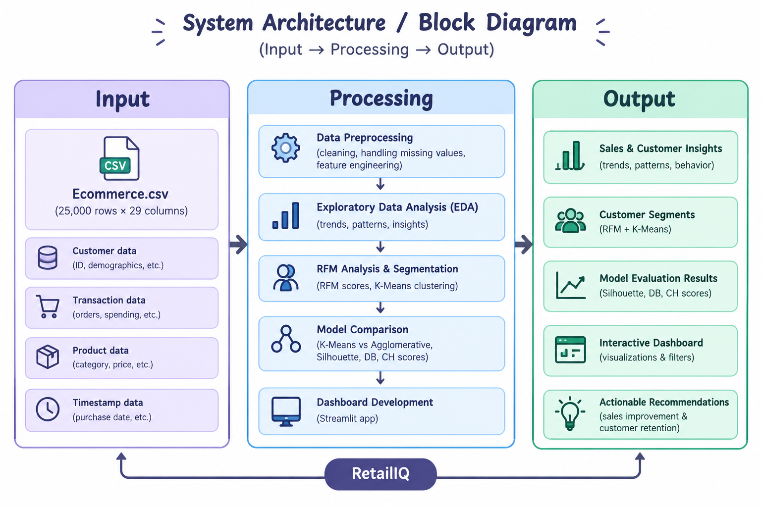

4.4 Data Preprocessing
Data preprocessing is an important step in the RetailIQ project, as it ensures that the dataset is clean, consistent, and suitable for further analysis and machine learning. The Ecommerce.csv dataset containing 25,000 records and 29 attributes was loaded and examined using Python libraries such as Pandas and NumPy.
The following preprocessing steps were performed:
1. Dataset Loading: The dataset was imported into the Jupyter Notebook using Pandas for further processing and analysis.
2. Dataset Inspection: The number of rows and columns, data types, column names, and sample records were examined to understand the dataset structure.
3. Missing Value Handling: Missing values were identified and handled wherever necessary to maintain data consistency and avoid issues during analysis.
4. Duplicate Record Checking: Duplicate records were checked to ensure that repeated entries did not affect the analysis. The dataset contained no duplicate rows.
5. Data Type Verification: The data types of the attributes were examined to ensure that numerical and categorical values were represented appropriately.
6. Data Consistency: Relevant columns were checked for consistency, and the required attributes were prepared for sales analysis and customer behaviour analysis.
7. Feature Preparation: The attributes required for Exploratory Data Analysis and RFM calculations were selected and prepared. Customer-level Recency, Frequency, and Monetary values were calculated using purchase-related records.
8. Preparation for Clustering: The RFM features were prepared for clustering. Feature scaling was applied before using the clustering algorithms to ensure that differences in feature ranges did not dominate the results.

4.5 Exploratory Data Analysis (EDA)
Exploratory Data Analysis (EDA) was performed to understand the e-commerce dataset, identify customer purchasing patterns, and examine sales performance. The analysis was carried out using Python libraries such as Pandas, NumPy, Matplotlib, and Seaborn.
The following aspects were explored:
1. Customer Analysis: Examined the number of unique customers and their behaviour across different shopping activities.
2. Purchase Analysis: Analysed purchase records to understand customer purchasing patterns and calculate the overall purchase rate.
3. Revenue Analysis: Examined the revenue generated from completed purchases to understand sales performance and customer spending behaviour.
4. Shopping Cart Analysis: Analysed cart additions and abandoned carts to understand customer activity and identify potential gaps in the purchase process.
5. Purchase Behaviour Analysis: Studied customer interactions and purchasing patterns to identify trends and behavioural differences.
6. Statistical Analysis: Used descriptive statistics and visualizations to understand the distribution and characteristics of relevant numerical attributes.
7. Data Visualization: Created charts and graphs using Matplotlib and Seaborn to present the findings in an understandable manner.
Key Findings from EDA:
- Total records analysed: 25,000.
- Unique customers: 8,442.
- Total completed purchases: 5,616.
- Purchase rate: 22.46%.
- Total revenue: 10,116,169.06.
- Total cart additions: 16,117.
- Abandoned carts: 10,501.
- Cart abandonment rate: 65.15%.
The EDA results provided an overall understanding of customer behaviour, sales performance, and shopping cart activities. These findings helped identify important patterns in the dataset and provided a foundation for the subsequent RFM analysis and customer segmentation process.

4.6 RFM Analysis
RFM (Recency, Frequency, and Monetary) analysis is a customer segmentation technique used to understand customer purchasing behaviour based on their transaction history. In the RetailIQ project, RFM analysis was performed to identify customer value and purchasing patterns before applying clustering algorithms.
The analysis was carried out using the following three measures:
1. Recency (R): Measures the number of days since a customer's most recent purchase. Customers with lower recency values have purchased more recently.
2. Frequency (F): Represents the total number of purchases made by a customer. A higher frequency indicates that the customer purchases more frequently.
3. Monetary (M): Represents the total amount spent by a customer on purchases. A higher monetary value indicates greater customer spending.
Steps Involved in RFM Analysis:
- Selected customers who had completed at least one purchase.
- Identified the purchase-related records required for calculating RFM values.
- Calculated Recency using the customer's most recent purchase date.
- Calculated Frequency by counting the purchases made by each customer.
- Calculated Monetary by summing the customer's purchase amounts.
- Combined the three measures to create an RFM dataset for customer segmentation.
RFM Analysis Summary:
- Total unique customers in the original dataset: 8,442.
- Customers considered for RFM analysis: 4,176.
- RFM attributes: Recency, Frequency, and Monetary.
The calculated RFM values provide a customer-level representation of purchasing behaviour. These features were then used as input for the K-Means and Agglomerative Clustering algorithms to identify distinct customer segments.

4.7 Customer Segmentation Using Clustering
Customer segmentation is the process of grouping customers based on similar purchasing behaviour. In RetailIQ, clustering algorithms are applied to the RFM features (Recency, Frequency, and Monetary) to identify different customer groups.
The following clustering algorithms were implemented:
1. K-Means Clustering
K-Means is an unsupervised machine learning algorithm that divides data points into a predefined number of clusters based on their similarity. In this project, K-Means was applied to the RFM values to group customers into five segments.
The main steps involved are:
- Selected the RFM features for clustering.
- Applied feature scaling to prepare the data.
- Determined suitable cluster configurations through experimentation.
- Applied the K-Means algorithm with five clusters.
- Analysed the characteristics of each cluster using RFM values.
- Assigned meaningful labels to the resulting customer segments.

2. Agglomerative Clustering
Agglomerative Clustering is a hierarchical clustering algorithm that starts by treating each data point as an individual cluster and gradually merges similar clusters. It was implemented with five clusters to compare its segmentation performance with K-Means.
Final Customer Segments
Based on the K-Means clustering results, customers were grouped into the following five segments:
- High-Spending At-Risk Customers: Customers with high spending but relatively longer periods since their last purchase.
- High-Value Frequent Customers: Customers who purchase frequently and contribute high monetary value.
- Inactive / At-Risk Customers: Customers who have not purchased recently and generally show low purchasing activity.
- Recent One-Time Customers: Customers who have made a purchase recently but have purchased only once.
- Repeat Customers: Customers who have made multiple purchases and show consistent purchasing activity.
The clustering process helps identify valuable customer groups and customers who may require retention strategies. The generated clusters are further evaluated using clustering performance metrics to compare the effectiveness of the implemented algorithms.

4.8 Model Evaluation
Model evaluation was performed to assess the quality of the customer segments generated by the clustering algorithms. Since K-Means and Agglomerative Clustering are unsupervised learning algorithms, their performance was evaluated using internal clustering metrics rather than classification accuracy.
The following evaluation metrics were used:
1. Silhouette Score: Measures how well each customer fits within its assigned cluster compared to other clusters. A higher score indicates better-defined clusters.
2. Davies–Bouldin Index: Measures the similarity between clusters based on their compactness and separation. A lower value indicates better clustering performance.
3. Calinski–Harabasz Score: Evaluates the ratio of between-cluster dispersion to within-cluster dispersion. A higher score indicates better-separated and more compact clusters.
Comparison of Clustering Models
The K-Means algorithm was evaluated with different cluster configurations, and its results were compared with Agglomerative Clustering.

Algorithm /Configuration | Silhouette Score | Davies–Bouldin Index | Calinski–Harabasz Score
K-Means (K=2) | 0.41910 | 1.0859 | 2540.665
K-Means (K=5) | 0.39920 | 0.9688 | 2622.5918
Agglomerative (K=5) | 0.34436 | 1.1261 | 2220.3403

Evaluation Result:
- K-Means with K=2 achieved the highest Silhouette Score.
- K-Means with K=5 achieved the lowest Davies–Bouldin Index and the highest Calinski–Harabasz Score among the compared configurations.
- Agglomerative Clustering with five clusters produced lower evaluation performance than K-Means with five clusters across the three metrics.
Based on the overall evaluation results and the need for more detailed, actionable customer groups, K-Means with five clusters was selected as the final segmentation model. Its Davies–Bouldin Index was 0.9688.
The evaluation helped identify a suitable clustering configuration for the RetailIQ project and supported the selection of the final customer segmentation model.

4.9 Dimensionality Reduction Using PCA
Principal Component Analysis (PCA) is a dimensionality reduction technique used to transform data with multiple features into a smaller set of components while retaining as much information as possible.
In the RetailIQ project, PCA was applied to the prepared RFM features to reduce them to two principal components. This helped represent the customer data in a two-dimensional space and visualize the distribution of customer segments.
Steps Involved:
- Selected the prepared RFM features for dimensionality reduction.
- Applied feature scaling before performing PCA.
- Implemented PCA with two principal components.
- Transformed the RFM data into a two-dimensional representation.
- Visualized the customer clusters using the two principal components.
Result:
The two principal components explained 85.32% of the total variance in the prepared RFM data.
PCA helped visualize the customer segments and understand their distribution in a two-dimensional space. It was used as a supporting analysis and visualization technique, while the final customer segmentation was performed using the original RFM features.

4.10 Dashboard Development
An interactive dashboard was developed using Python and Streamlit to present the results of the RetailIQ project. It provides a user-friendly interface to explore sales performance, customer segments, clustering evaluation results, and business recommendations.
The dashboard includes the following sections:
- Overview: Displays key sales and customer statistics.
- Customer Segmentation: Presents the five customer segments and their characteristics.
- Model Evaluation: Displays and compares the clustering evaluation metrics.
- Visualizations: Shows graphical representations of sales patterns and customer behaviour.
- Business Recommendations: Provides suggestions for customer retention and targeted marketing based on the analysis.

CHAPTER 5
SYSTEM DESIGN AND IMPLEMENTATION
5.1 Overall Workflow
The RetailIQ project follows a systematic workflow to analyse e-commerce customer behaviour and sales data, perform customer segmentation, and generate useful business insights.
The overall workflow consists of the following steps:
- Dataset Collection: Obtaining the Indian E-Commerce Customer Behavior and Purchase dataset from Kaggle in CSV format.
- Data Preprocessing: Loading, inspecting, and preparing the dataset for analysis.
- Exploratory Data Analysis: Analysing customer behaviour, purchase patterns, revenue, and shopping cart activities.
- RFM Analysis: Calculating Recency, Frequency, and Monetary values for customers with at least one purchase.
- Feature Scaling: Scaling the RFM features before applying clustering algorithms.
- Customer Segmentation: Applying K-Means and Agglomerative Clustering to group customers based on purchasing behaviour.
- Model Evaluation: Comparing clustering results using Silhouette Score, Davies–Bouldin Index, and Calinski–Harabasz Score.
- PCA Visualization: Reducing the RFM data to two principal components for visualizing customer clusters.
- Dashboard Development: Presenting analytical results, customer segments, evaluation metrics, and recommendations using Streamlit.
- Business Insights: Interpreting the results to identify valuable and at-risk customers and support business decision-making.
5.2 Module-wise Implementation
The RetailIQ project is implemented through a set of modules, where each module performs a specific task in the process of analysing e-commerce data and generating customer insights.
1. Dataset Loading Module
- Loads the Ecommerce.csv dataset using Pandas.
- Reads the customer and transaction-related attributes for further processing.
2. Data Preprocessing Module
- Inspects the dataset structure, data types, and missing values.
- Checks for duplicate records and data consistency.
- Prepares the required attributes for analysis.
3. Exploratory Data Analysis Module
- Analyses customer behaviour and purchasing patterns.
- Examines revenue, completed purchases, cart additions, and abandoned carts.
- Generates charts and visualizations using Matplotlib and Seaborn.
4. RFM Analysis Module
- Calculates Recency, Frequency, and Monetary values for each eligible customer.
- Creates customer-level RFM data for segmentation.
- Considers customers with at least one completed purchase.
5. Customer Segmentation Module
- Applies feature scaling to the RFM data.
- Implements K-Means clustering with five clusters.
- Implements Agglomerative Clustering for comparison.
- Assigns meaningful labels to the customer segments.
6. Model Evaluation Module
- Evaluates clustering performance using Silhouette Score, Davies–Bouldin Index, and Calinski–Harabasz Score.
- Compares the results of different clustering configurations.
- Selects K-Means with five clusters as the final segmentation model.
7. PCA Visualization Module
- Applies Principal Component Analysis to the prepared RFM features.
- Reduces the data to two principal components.
- Visualizes customer clusters in a two-dimensional space.
8. Dashboard Module
- Develops an interactive dashboard using Streamlit.
- Displays key statistics, customer segments, model evaluation results, and visualizations.
- Presents business recommendations based on the analytical findings.
These modules work together to complete the RetailIQ workflow, from dataset loading and analysis to customer segmentation and interactive result presentation.

5.3 Machine Learning Pipeline
The machine learning pipeline in RetailIQ describes the sequence of steps followed to prepare customer data, apply clustering algorithms, evaluate their performance, and generate customer segments.
The pipeline consists of the following stages:
1. Input Data: The prepared e-commerce dataset is used as the input for the machine learning process.
2. RFM Feature Extraction: Recency, Frequency, and Monetary values are calculated for customers who have completed at least one purchase.
3. Feature Scaling: The RFM features are scaled to bring them to a comparable range before clustering.
4. Clustering Algorithm Application: K-Means and Agglomerative Clustering algorithms are applied to group customers based on their purchasing behaviour.
5. Model Evaluation: The clustering results are evaluated using Silhouette Score, Davies–Bouldin Index, and Calinski–Harabasz Score.
6. Final Model Selection: K-Means with five clusters is selected based on its overall evaluation results and the usefulness of the resulting customer segments.
7. Customer Segment Generation: Customers are assigned to five segments: High-Spending At-Risk Customers, High-Value Frequent Customers, Inactive / At-Risk Customers, Recent One-Time Customers, and Repeat Customers.
8. PCA Visualization: PCA is used to reduce the RFM features to two dimensions for visualizing the generated clusters.
9. Result Presentation: The final segmentation results and evaluation metrics are displayed

5.5 Streamlit Dashboard Implementation
An interactive dashboard was developed using Python and Streamlit to present the results of the RetailIQ project. The dashboard provides a simple interface for exploring e-commerce sales performance, customer behaviour, segmentation results, and model evaluation.
The dashboard is organised into the following sections:
1. Overview
- Displays important dataset and business statistics.
- Presents key information such as total customers, completed purchases, revenue, and purchase rate.
- Provides an overall summary of e-commerce performance.
2. Customer Segmentation
- Displays the five customer segments generated using K-Means clustering.
- Presents segment-wise customer information and purchasing characteristics.
- Helps identify high-value, frequent, and at-risk customers.
3. Model Evaluation
- Displays the evaluation results of K-Means and Agglomerative Clustering.
- Presents Silhouette Score, Davies–Bouldin Index, and Calinski–Harabasz Score.
- Helps compare clustering performance.
4. Visualizations
- Presents graphical representations of customer behaviour and sales patterns.
- Displays customer segmentation and analytical findings in an understandable format.
5. Business Recommendations
- Provides suggestions based on the identified customer segments.
- Highlights possible customer retention and targeted marketing strategies.
- Supports data-driven business decisions.
The Streamlit dashboard brings the results of data analysis and machine learning together in one interface. It makes the findings easier to explore and understand without requiring users to examine the underlying Python code.

Codes:

# Check the number of rows and columns
print("Dataset shape:", df.shape)

# Check all column names
print("\nColumn names:")
print(df.columns.tolist())

# Check the data types and non-null counts
print("\nDataset information:")
df.info()

# Step 1D: Check duplicate records

print("Exact duplicate rows:", df.duplicated().sum())

# Check whether session IDs are repeated
print("Duplicate session IDs:", df["session_id"].duplicated().sum())

# Check the number of unique customers and sessions
print("Unique customers:", df["customer_id"].nunique())
print("Unique sessions:", df["session_id"].nunique())

# Step 1F: Investigate dates and purchase-related columns

# 1. Check the date range
print("Earliest visit date:", df["visit_date"].min())
print("Latest visit date:", df["visit_date"].max())

# 2. Compare purchase status with revenue
print("\nPurchase status vs revenue")
print(df.groupby("purchased")["revenue"].agg(["count", "mean", "min", "max"]))

# 3. Compare cart status, purchase status and abandonment
print("\nCart and purchase combinations")
print(pd.crosstab(df["added_to_cart"], df["purchased"]))

print("\nAbandonment vs purchase")
print(pd.crosstab(df["cart_abandoned"], df["purchased"]))

# 4. Check important numerical ranges
print("\nNon-positive prices:", (df["unit_price"] <= 0).sum())
print("Non-positive quantities:", (df["quantity"] <= 0).sum())
print("Negative revenue:", (df["revenue"] < 0).sum())
print("Discounts above 100%:", (df["discount_percent"] > 100).sum())
print("Negative time on site:", (df["time_on_site_sec"] < 0).sum())

CHAPTER 6
Features and Functionalities
6.1 Project Overview
RetailIQ – Full-Cycle E-Commerce Customer & Sales Analytics is a data analytics and machine learning-based project developed to analyse e-commerce customer behaviour and sales performance using the Indian E-Commerce Customer Behavior and Purchase dataset, which contains 25,000 records and 29 attributes. The project involves data preprocessing, Exploratory Data Analysis (EDA), RFM analysis, and customer segmentation using K-Means and Agglomerative Clustering algorithms. The clustering models are evaluated using Silhouette Score, Davies–Bouldin Index, and Calinski–Harabasz Score, based on which K-Means with five clusters is selected as the final segmentation model. PCA is used to visualize customer clusters in two dimensions, while an interactive Streamlit dashboard presents sales statistics, customer segments, evaluation results, visualizations, and business recommendations. The project aims to identify valuable and at-risk customers, understand purchasing patterns, and support data-driven business decisions.
The major features of the system include:
- Data Preprocessing: Cleaning and preparing the e-commerce dataset for accurate analysis.
- Sales Analysis: Analysing revenue, purchases, shopping cart activities, and customer behaviour.
- RFM Analysis: Calculating Recency, Frequency, and Monetary values to understand customer purchasing patterns.
- Customer Segmentation: Grouping customers into five meaningful segments using K-Means clustering.
- Clustering Comparison: Comparing K-Means and Agglomerative Clustering algorithms.
- Model Evaluation: Assessing clustering performance using Silhouette Score, Davies–Bouldin Index, and Calinski–Harabasz Score.
- PCA Visualization: Representing customer clusters in a two-dimensional space.
- Interactive Dashboard: Displaying analytical results, customer segments, and visualizations through Streamlit.
- Business Recommendations: Providing insights to support customer retention, targeted marketing, and business decision-making.
6.2 EDA Visualizations
Exploratory Data Analysis (EDA) visualizations were developed to understand the structure of the e-commerce dataset, identify customer purchasing patterns, and analyse overall sales performance. The visualizations were created using Matplotlib and Seaborn libraries in Python. Different types of charts were used to represent numerical information, compare customer activities, and identify patterns in the dataset.
The following visualizations were used in the EDA process:
1. Customer Distribution Analysis
Customer distribution was analysed to understand the number of unique customers and their participation in different e-commerce activities. This analysis helped examine how customers were distributed across the available customer-related attributes.
2. Purchase Behaviour Analysis
Purchase-related visualizations were used to examine completed purchases and customer purchasing behaviour. The dataset contained 5,616 completed purchases, representing a purchase rate of 22.46%. This helped understand the proportion of customer activities resulting in successful purchases.
3. Revenue Analysis
Revenue visualizations were used to examine the overall sales performance of the e-commerce business. The total revenue generated from completed purchases was 10,116,169.06. These visualizations helped understand revenue distribution and customer spending patterns.
4. Shopping Cart Analysis
Shopping cart activities were analysed to understand how customers interacted with products before completing purchases. The dataset recorded 16,117 cart additions, of which 10,501 resulted in abandoned carts. The cart abandonment rate was 65.15%. This analysis highlighted the difference between cart activity and completed purchases.
5. Customer Activity Analysis
Customer activity patterns were examined to understand interactions and purchasing-related behaviour. This helped identify differences in customer engagement and provided useful information for subsequent customer segmentation.
6. Numerical Attribute Distribution
Distribution plots and statistical visualizations were used to examine numerical attributes in the dataset. These visualizations helped understand the spread of values, identify variations, and observe the distribution of relevant features.
7. Correlation Analysis
Correlation analysis was used to examine relationships between relevant numerical attributes. A correlation heatmap helped visualize the strength and direction of relationships between selected variables and provided a better understanding of the dataset.
Importance of EDA Visualizations
The EDA visualizations helped in:
- Understanding customer behaviour and purchasing patterns.
- Examining revenue and overall sales performance.
- Identifying shopping cart abandonment patterns.
- Observing the distribution of numerical attributes.
- Understanding relationships between relevant variables.
- Identifying useful features for subsequent RFM analysis and customer segmentation.
Overall, EDA visualizations provided a clear understanding of the e-commerce dataset and helped identify important business patterns. The findings served as the foundation for RFM analysis and the development of customer segments using clustering algorithms.

6.3 Customer Segmentation Results
The customer segmentation results obtained using K-Means clustering are presented in this section. The model grouped customers into five segments based on their Recency, Frequency, and Monetary values. These segments help understand differences in customer purchasing behaviour, spending patterns, and engagement levels.
The five customer segments are:
- High-Spending At-Risk Customers
- High-Value Frequent Customers
- Inactive / At-Risk Customers
- Recent One-Time Customers
- Repeat Customers
The segmentation results provide useful insights into customer value and purchasing activity and help businesses identify customers who may benefit from targeted marketing and retention strategies.
6.4 Dataset Insights
The analysis of the Indian E-Commerce Customer Behavior and Purchase dataset provided several useful insights into customer behaviour, purchasing patterns, and sales performance. The dataset contains 25,000 records, 29 attributes, and 8,442 unique customers. The major insights obtained from the analysis are:
1. Customer Base: The dataset contains 8,442 unique customers, providing sufficient customer information for analysing purchasing behaviour and performing segmentation.
2. Purchase Behaviour: A total of 5,616 completed purchases were recorded, representing a purchase rate of 22.46%.
3. Revenue Generation: The total revenue generated from completed purchases was 10,116,169.06, providing an overview of the sales performance.
4. Shopping Cart Activity: A total of 16,117 cart additions were recorded, indicating considerable customer interaction with shopping carts.
5. Cart Abandonment: Out of the recorded cart additions, 10,501 resulted in abandoned carts, giving a cart abandonment rate of 65.15%. This highlights a potential area for improving purchase conversion.
6. Customer Segmentation: RFM analysis was performed on 4,176 customers who had completed at least one purchase. K-Means clustering grouped these customers into five distinct segments based on their purchasing behaviour.
7. High-Value Customers: The High-Value Frequent Customers segment contains customers with relatively high purchase frequency and monetary value, making it an important group for customer retention strategies.

CHAPTER 7

Results and Testing
7.1 Experimental Setup
The RetailIQ project was implemented using Python in the Anaconda environment, with Jupyter Notebook used for data analysis, preprocessing, visualization, and machine learning implementation. The Indian E-Commerce Customer Behavior and Purchase dataset was used for conducting experiments. Pandas and NumPy were used for data manipulation and numerical operations, while Matplotlib and Seaborn were used for data visualization. Scikit-learn was used to implement K-Means and Agglomerative Clustering, perform feature scaling and PCA, and evaluate clustering performance. RFM features (Recency, Frequency, and Monetary) were used as input for customer segmentation. Different clustering configurations were tested and evaluated using Silhouette Score, Davies–Bouldin Index, and Calinski–Harabasz Score. Based on the evaluation results, K-Means with five clusters was selected as the final segmentation model. Finally, Streamlit was used to develop an interactive dashboard to present the analytical results and customer insights.

7.2 Evaluation Metrics
The performance of the clustering algorithms implemented in RetailIQ was evaluated using three internal clustering evaluation metrics: Silhouette Score, Davies–Bouldin Index, and Calinski–Harabasz Score. These metrics were used to measure cluster quality, separation, and compactness. Since the project uses unsupervised learning algorithms, classification metrics such as accuracy, precision, recall, and F1-score are not applicable.
- Silhouette Score
The Silhouette Score measures how well each data point fits within its assigned cluster compared to other clusters. It ranges from -1 to +1.
- A value close to +1 indicates well-separated clusters.
- A value around 0 indicates overlapping clusters.
- A negative value indicates that some data points may be assigned to incorrect clusters.
- Higher values indicate better clustering quality.
2. Davies–Bouldin Index (DBI)
The Davies–Bouldin Index measures the similarity between clusters by considering their compactness and separation.
- Lower values indicate better clustering.
- A low score represents compact clusters with good separation.
- Higher values indicate greater similarity between clusters.
3. Calinski–Harabasz Score (CHI)
The Calinski–Harabasz Score evaluates clustering quality using the ratio of between-cluster dispersion to within-cluster dispersion.
- Higher values indicate better-defined clusters.
- It measures how well-separated the clusters are.
- A higher score generally indicates better clustering performance.
Evaluation Results
The following table presents the evaluation results obtained from the implemented clustering algorithms:
Clustering Model | Silhouette Score | Davies–Bouldin Index | Calinski–Harabasz Score
K-Means (K=2) | 0.41910 | 1.0859 | 2540.665
K-Means (K=5) | 0.39920 | 0.9688 | 2622.5918
Agglomerative (K=5) | 0.34436 | 1.1261 | 2220.3403
Overall Evaluation:
K-Means with five clusters achieved the lowest Davies–Bouldin Index and the highest Calinski–Harabasz Score among the compared models. Although K-Means with two clusters obtained a slightly higher Silhouette Score, the five-cluster configuration provided more detailed and actionable customer segments. Therefore, K-Means with five clusters was selected as the final model for RetailIQ.

7.3 Model Performance Comparison
The performance of K-Means and Agglomerative Clustering was compared using three evaluation metrics: Silhouette Score, Davies–Bouldin Index, and Calinski–Harabasz Score. Different clustering configurations were tested to identify a suitable model for customer segmentation.
Comparison of Clustering Models
Model | Silhouette Score | Davies–Bouldin Index | Calinski–Harabasz Score
K-Means (K=2) | 0.41910 | 1.0859 | 2540.665
K-Means (K=5) | 0.39920 | 0.9688 | 2622.5918
Agglomerative (K=5) | 0.34436 | 1.1261 | 2220.3403
Performance Analysis:
1. K-Means (K=2): Achieved the highest Silhouette Score of 0.41910, indicating better cluster separation according to this metric. However, it provides only two customer groups.
2. K-Means (K=5): Achieved a Silhouette Score of 0.39920, the lowest Davies–Bouldin Index of 0.9688, and the highest Calinski–Harabasz Score of 2622.5918. It provides five detailed customer segments.
3. Agglomerative Clustering (K=5): Achieved a Silhouette Score of 0.34436, a Davies–Bouldin Index of 1.1261, and a Calinski–Harabasz Score of 2220.3403. Its results were comparatively lower across all three metrics than K-Means with five clusters.
Final Model Selection:
Based on the overall evaluation, K-Means with five clusters was selected as the final model for RetailIQ. Although K-Means with two clusters achieved a slightly higher Silhouette Score, K-Means with five clusters performed better in terms of the Davies–Bouldin and Calinski–Harabasz metrics. Additionally, it provided more detailed and meaningful customer segments, making it more suitable for business analysis and targeted customer retention strategies.

7.4 Prediction Results
RetailIQ uses unsupervised machine learning algorithms for customer segmentation rather than supervised prediction. The K-Means clustering model with five clusters was selected as the final model based on the overall evaluation results.
The model assigned 4,176 customers to five different segments based on their Recency, Frequency, and Monetary values.
Customer Segmentation Results:
Customer Segment | Number of Customers
High-Spending At-Risk Customers | 476
High-Value Frequent Customers | 324
Inactive / At-Risk Customers | 1,248
Recent One-Time Customers | 1,369
Repeat Customers | 759
Total | 4,176
Result Analysis:
- High-Spending At-Risk Customers: Customers with high spending but relatively longer periods since their last purchase.
- High-Value Frequent Customers: Customers who purchase frequently and contribute high monetary value.
- Inactive / At-Risk Customers: Customers with low purchasing activity and longer periods since their last purchase.
- Recent One-Time Customers: Customers who have made a recent purchase but have not purchased again.
- Repeat Customers: Customers who have made multiple purchases.
The results demonstrate that the K-Means model successfully grouped customers into five segments based on their purchasing behaviour. These segments provide useful insights for identifying valuable customers, recognizing at-risk groups, and planning targeted marketing and customer retention strategies.

7.5 Testing and Validation
Testing and validation were performed to check the correctness, consistency, and reliability of the RetailIQ system at different stages of implementation. The following checks were carried out:
1. Dataset Validation: Verified the dataset dimensions, column names, data types, missing values, and duplicate records. The dataset contained 25,000 records and 29 attributes, with no duplicate rows.
2. Data Preprocessing Validation: Checked the prepared dataset to ensure that the required attributes were available and suitable for further analysis.
3. Revenue Validation: Verified the revenue calculations by comparing the calculated values with the expected revenue based on unit price, quantity, and discount amount for purchased records. No mismatches were found beyond the specified tolerance.
4. RFM Validation: Checked the Recency, Frequency, and Monetary calculations to ensure that customer-level purchasing information was correctly generated.
5. Clustering Validation: Verified that the K-Means and Agglomerative Clustering algorithms generated customer groups and that the resulting cluster assignments were available for analysis.
6. Model Evaluation Validation: Checked the clustering results using Silhouette Score, Davies–Bouldin Index, and Calinski–Harabasz Score to compare the implemented models.
7. PCA Validation: Verified the two-component PCA transformation and the explained variance, which was 85.32%.
8. Dashboard Validation: Checked the Streamlit dashboard to ensure that the analytical results, customer segments, evaluation metrics, and visualizations were displayed.
Overall, these testing and validation activities helped verify the correctness of the data analysis, customer segmentation, model evaluation, and dashboard implementation.

Output Screenshots

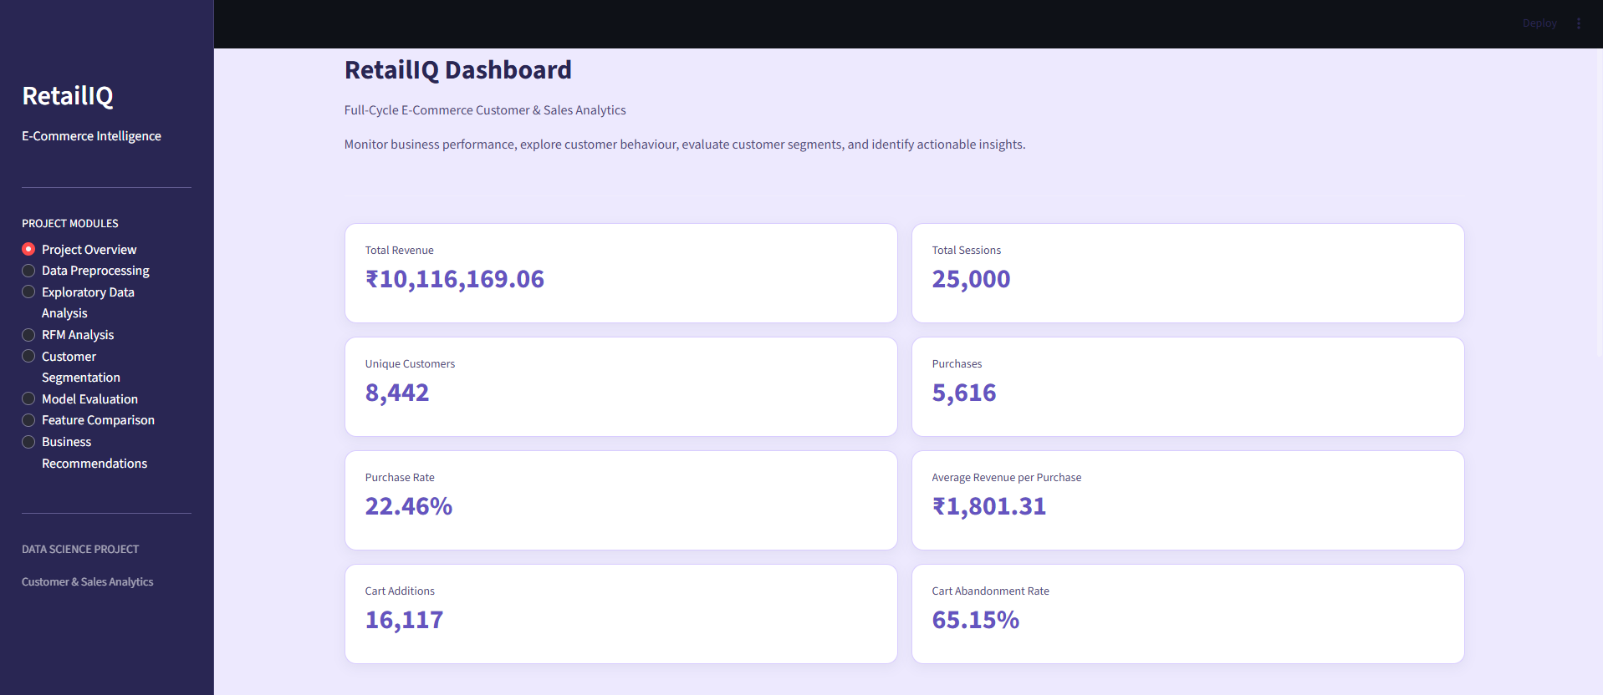

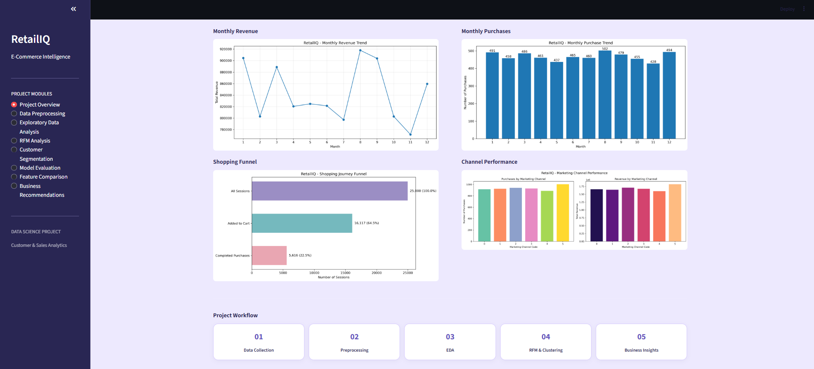

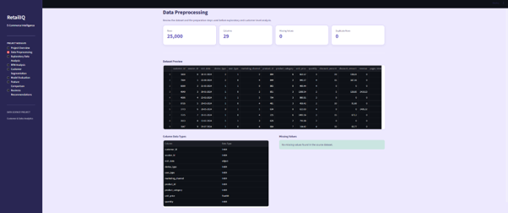

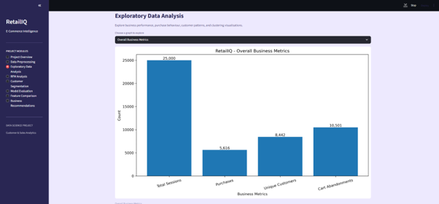

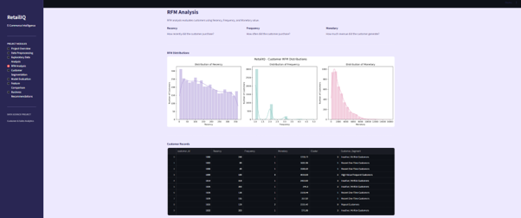

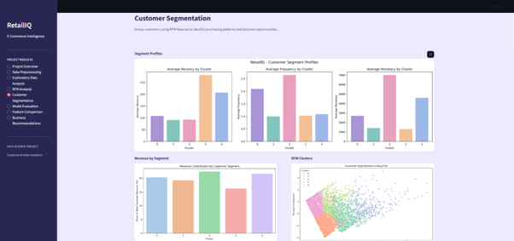

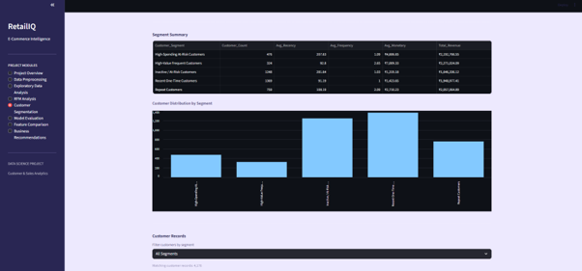

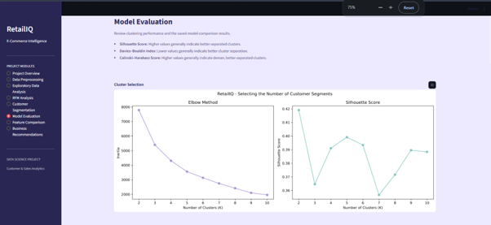

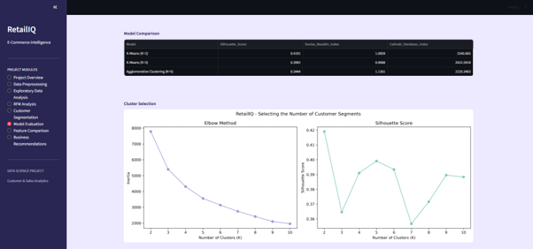

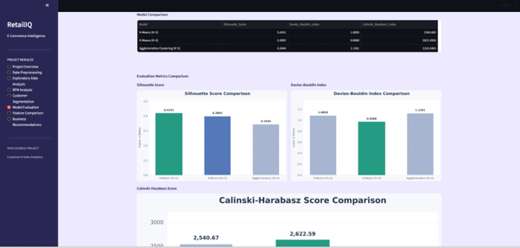
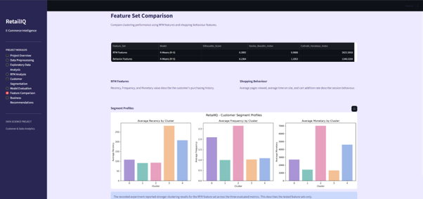

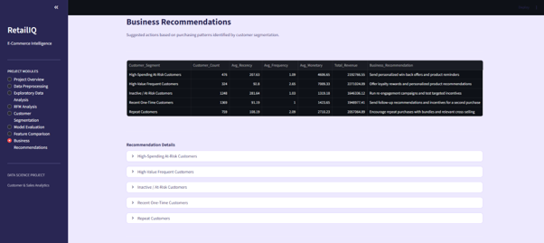

CHAPTER 8
Challenges and Limitations
8.1 Challenges Faced
During the development of RetailIQ – Full-Cycle E-Commerce Customer & Sales Analytics, several challenges were encountered while analysing the dataset, implementing clustering algorithms, and developing the dashboard.
1. Understanding the Dataset: Understanding the 29 attributes and identifying the relevant features required for customer behaviour and sales analysis was an initial challenge.
2. Data Preprocessing: Preparing the dataset and ensuring data consistency before performing statistical analysis and machine learning required careful examination.
3. RFM Feature Calculation: Calculating Recency, Frequency, and Monetary values correctly at the customer level required identifying relevant purchase records and applying appropriate calculations.
4. Feature Scaling: The RFM features had different numerical ranges. Scaling them appropriately was necessary to prevent features with larger values from dominating the clustering process.
5. Selecting the Optimal Number of Clusters: Determining a suitable number of clusters was challenging because different configurations produced different evaluation results and customer groupings.
6. Comparing Clustering Algorithms: Comparing K-Means and Agglomerative Clustering required analysing multiple evaluation metrics rather than relying on a single performance measure.
7. Interpreting Customer Segments: Understanding the characteristics of each generated cluster and assigning meaningful business-oriented labels required examining the average RFM values of the customer groups.
8. Dashboard Development: Presenting the analytical results, customer segments, evaluation metrics, and visualizations in an understandable and organized Streamlit interface required careful implementation.
8.2 Solutions Applied
To overcome the challenges encountered during the development of RetailIQ, several solutions and approaches were applied to ensure accurate analysis, effective customer segmentation, and proper system implementation.
1. Dataset Understanding: Examined the dataset structure, attribute descriptions, data types, and sample records to identify the relevant features for analysis.
2. Data Preprocessing: Used Pandas and NumPy to inspect missing values, verify data consistency, check duplicate records, and prepare the dataset for further processing.
3. RFM Calculation: Applied customer-level aggregation techniques to calculate Recency, Frequency, and Monetary values using completed purchase records.
4. Feature Scaling: Applied feature scaling to the RFM attributes before clustering to bring the features to a comparable scale.
5. Cluster Selection: Experimented with different cluster configurations and evaluated the results using Silhouette Score, Davies–Bouldin Index, and Calinski–Harabasz Score.
6. Model Comparison: Implemented both K-Means and Agglomerative Clustering and compared their results using multiple evaluation metrics.
7. Customer Segment Interpretation: Analysed the average RFM values of each cluster and assigned meaningful labels based on customer purchasing behaviour.
8. PCA Visualization: Applied PCA to reduce the RFM data to two components, explaining 85.32% of the total variance, to support two-dimensional cluster visualization.
9. Dashboard Development: Used Streamlit to organize the analytical results, customer segments, evaluation metrics, visualizations, and business recommendations into an interactive interface.
These solutions helped improve the overall implementation of RetailIQ and enabled the development of a structured system for e-commerce customer and sales analytics.
8.3 Current Limitations
Although RetailIQ provides useful insights into e-commerce customer behaviour and sales performance, the current implementation has certain limitations:
1. Historical Dataset: The system uses a static dataset and does not analyse real-time customer activities or live transactions.
2. Dataset Dependency: The accuracy and usefulness of the analysis depend on the quality, completeness, and availability of the input dataset.
3. Limited Customer Information: Customer segmentation is primarily based on Recency, Frequency, and Monetary values. Other factors influencing customer behaviour are not included in the final segmentation model.
4. Clustering Limitations: K-Means requires the number of clusters to be specified in advance and may be influenced by the distribution of data and outliers.
5. No Future Purchase Prediction: The system identifies customer segments based on historical purchasing behaviour but does not predict future purchases or customer churn.
6. Limited External Integration: The dashboard is not connected to external e-commerce platforms, databases, or live transaction systems.
7. Deployment Limitations: The current implementation is developed as an academic project and is not deployed as a production-level business application.

CHAPTER 9
Future Scope
9.1 Dataset Expansion
In future development, the RetailIQ system can be enhanced by expanding the existing dataset with additional customer records and transaction details. A larger and more diverse dataset would help analyse customer behaviour across different time periods, product categories, and purchasing patterns.
The following improvements can be considered:
1. Larger Dataset: Include more customer records and transaction data to improve the coverage of customer behaviour analysis.
2. Multiple Data Sources: Integrate data from different e-commerce platforms to analyse a wider range of customer activities.
3. Additional Customer Attributes: Include factors such as customer demographics, product preferences, and browsing history for more detailed analysis.
4. Time-Based Data: Collect transaction records over longer periods to identify seasonal trends and changes in purchasing behaviour.
5. Product-Level Information: Include detailed product categories, prices, and purchase histories to understand product preferences and sales patterns.
Expanding the dataset would provide more comprehensive information for customer segmentation, sales analysis, and business decision-making.
9.2 Advanced Machine Learning Techniques
In the future, RetailIQ can be enhanced by incorporating advanced machine learning techniques to improve customer analysis, segmentation, and business insights. These techniques can help identify complex customer behaviour patterns and provide more accurate predictions.
The following enhancements can be considered:
1. Advanced Clustering Algorithms: Implement DBSCAN, Gaussian Mixture Models, and other clustering techniques to identify customer groups with different behavioural patterns.
2. Customer Churn Prediction: Develop supervised machine learning models to identify customers who are likely to stop purchasing.
3. Purchase Prediction: Apply classification or regression algorithms to estimate future customer purchasing behaviour.
4. Recommendation Systems: Implement recommendation techniques to suggest relevant products based on customer preferences and previous purchases.
5. Deep Learning Techniques: Explore neural network-based approaches to identify complex patterns in large customer datasets.
6. Automated Model Selection: Experiment with automated methods to identify suitable clustering configurations and improve model evaluation.
These advanced techniques can extend the capabilities of RetailIQ beyond its current RFM-based customer segmentation approach and support more comprehensive e-commerce analytics.
9.3 Real-Time Integration
In the future, RetailIQ can be enhanced by integrating real-time data collection and processing capabilities to analyse customer activities and sales transactions as they occur. This would allow businesses to monitor current purchasing patterns and respond quickly to changes in customer behaviour.
The following enhancements can be considered:
1. Live Transaction Integration: Connect the system with e-commerce platforms to collect and analyse purchase transactions in real time.
2. Real-Time Customer Activity Tracking: Monitor customer activities such as product views, searches, cart additions, and purchases.
3. Live Sales Monitoring: Display updated sales information, revenue, and purchase statistics through the dashboard.
4. Dynamic Customer Segmentation: Update customer RFM values and customer segments whenever new transaction data becomes available.
5. Real-Time Notifications: Generate alerts for important events, such as increased cart abandonment or changes in customer purchasing activity.
6. Automated Dashboard Updates: Integrate live data sources to refresh dashboard visualizations and analytical results automatically.
Real-time integration would transform RetailIQ from a historical data analysis system into a more dynamic analytics platform, helping businesses monitor customer behaviour and make timely decisions.
9.4 Dashboard Enhancements
In the future, the RetailIQ dashboard can be enhanced with additional features to improve usability, visualization, and analytical capabilities. These improvements can make the dashboard more interactive and useful for business decision-making.
The following enhancements can be considered:
1. Advanced Visualizations: Include additional charts and graphs to provide deeper insights into customer behaviour, sales trends, and purchasing patterns.
2. Interactive Filters: Add filters based on customer segments, purchase frequency, revenue, and transaction periods to allow users to explore specific data.
3. Automated Report Generation: Introduce options to generate and download analytical reports in PDF and CSV formats.
4. Customer-Level Analysis: Provide detailed information about individual customer purchasing patterns, RFM values, and segment assignments.
5. Improved User Interface: Enhance the dashboard layout, navigation, and visual design to provide a better user experience.
6. Real-Time Dashboard Updates: Integrate live data sources to automatically refresh customer statistics, sales information, and visualizations.
7. Advanced Business Insights: Include additional analytical summaries and recommendations to help businesses identify opportunities for customer retention and sales improvement.
CHAPTER 10
Conclusion
10.1 Project Summary
RetailIQ – Full-Cycle E-Commerce Customer & Sales Analytics was developed to analyse e-commerce customer behaviour and sales performance using data analytics and machine learning techniques. The project uses the Indian E-Commerce Customer Behavior and Purchase dataset, which contains 25,000 records and 29 attributes. The main aim is to understand customer purchasing patterns, identify valuable customer groups, and generate meaningful business insights.
The project begins with data preprocessing and Exploratory Data Analysis (EDA) to examine customer activities, purchase patterns, revenue generation, and shopping cart behaviour. Various visualizations were created to understand the dataset and identify important trends. RFM analysis was then performed on 4,176 customers who had completed at least one purchase, using Recency, Frequency, and Monetary values to represent customer purchasing behaviour.
K-Means and Agglomerative Clustering algorithms were implemented to perform customer segmentation. Their performance was evaluated using Silhouette Score, Davies–Bouldin Index, and Calinski–Harabasz Score. Based on the overall evaluation results, K-Means with five clusters was selected as the final model, generating five meaningful customer segments. PCA was also applied to reduce the RFM data to two dimensions for visualization, explaining 85.32% of the total variance.
Finally, an interactive dashboard was developed using Streamlit to present sales statistics, customer segments, model evaluation results, visualizations, and business recommendations. Overall, RetailIQ demonstrates how data analytics and machine learning can transform historical e-commerce data into useful customer insights, helping businesses understand purchasing behaviour, identify at-risk customers, and support informed business decision-making
10.2 Achievements
The RetailIQ project successfully integrates data analytics, machine learning, and interactive visualization to analyse e-commerce customer behaviour and sales performance. The major achievements of the project include:
1. Successful Dataset Analysis: Analysed 25,000 records with 29 attributes and identified 8,442 unique customers.
2. Comprehensive EDA: Examined customer purchasing behaviour, revenue generation, purchase rates, and shopping cart activities to identify important business patterns.
3. RFM Analysis: Successfully calculated Recency, Frequency, and Monetary values for 4,176 customers who had completed at least one purchase.
4. Customer Segmentation: Implemented K-Means clustering and identified five meaningful customer segments based on purchasing behaviour.
5. Clustering Model Comparison: Compared K-Means and Agglomerative Clustering using three evaluation metrics: Silhouette Score, Davies–Bouldin Index, and Calinski–Harabasz Score.
6. Final Model Selection: Selected K-Means with five clusters based on its overall evaluation results and ability to provide detailed customer segments.
7. Dimensionality Reduction: Applied PCA to reduce the RFM data to two principal components, explaining 85.32% of the total variance.
8. Interactive Dashboard Development: Successfully developed a Streamlit dashboard to present analytical results, customer segments, visualizations, and business recommendations.
9. Business Insights: Identified high-value, frequent, recent, and at-risk customer groups, providing insights that can support targeted marketing and customer retention strategies.
Overall, the project achieved its main objectives by developing an integrated e-commerce analytics system that converts historical customer data into meaningful insights and supports data-driven business decisions.
10.3 Skills Learned
The development of RetailIQ provided practical experience in data analytics, machine learning, data visualization, and dashboard development. The major skills learned during the project include:
1. Python Programming: Improved understanding of Python programming and its application in data analysis and machine learning.
2. Data Preprocessing: Gained experience in loading, inspecting, cleaning, and preparing datasets using Pandas and NumPy.
3. Exploratory Data Analysis: Learned to analyse datasets, identify patterns, interpret statistical information, and generate meaningful visualizations.
4. Data Visualization: Developed skills in creating charts, graphs, and heatmaps using Matplotlib and Seaborn.
5. RFM Analysis: Gained practical knowledge of Recency, Frequency, and Monetary analysis for understanding customer purchasing behaviour.
6. Machine Learning: Gained hands-on experience in implementing unsupervised learning algorithms such as K-Means and Agglomerative Clustering.
7. Model Evaluation: Learned to evaluate and compare clustering algorithms using Silhouette Score, Davies–Bouldin Index, and Calinski–Harabasz Score.
8. Dimensionality Reduction: Understood the application of Principal Component Analysis (PCA) for reducing feature dimensions and visualizing customer clusters.
9. Dashboard Development: Gained experience in developing interactive dashboards using Streamlit to present analytical results.
10. Analytical and Problem-Solving Skills: Improved the ability to interpret data, identify challenges, compare alternative approaches, and derive meaningful business insights.
Overall, the project strengthened practical knowledge of the complete data analytics and machine learning workflow, from raw dataset processing to customer segmentation and interactive dashboard development.

CHAPTER 11
References
[1] P. Anitha and M. M. Patil, “RFM model for customer purchase behavior using K-Means algorithm,” Journal of King Saud University – Computer and Information Sciences, vol. 34, no. 5, pp. 1785–1792, 2022. doi: 10.1016/j.jksuci.2019.12.011.
[2] P. J. Rousseeuw, “Silhouettes: A graphical aid to the interpretation and validation of cluster analysis,” Journal of Computational and Applied Mathematics, vol. 20, pp. 53–65, 1987. doi: 10.1016/0377-0427(87)90125-7.
[3] D. L. Davies and D. W. Bouldin, “A cluster separation measure,” IEEE Transactions on Pattern Analysis and Machine Intelligence, vol. PAMI-1, no. 2, pp. 224–227, 1979. doi: 10.1109/TPAMI.1979.4766909.
[4] T. Caliński and J. Harabasz, “A dendrite method for cluster analysis,” Communications in Statistics, vol. 3, no. 1, pp. 1–27, 1974. doi: 10.1080/03610927408827101.
[5] J. A. Hartigan and M. A. Wong, “A K-means clustering algorithm,” Journal of the Royal Statistical Society: Series C (Applied Statistics), vol. 28, no. 1, pp. 100–108, 1979. doi: 10.2307/2346830.
[6] J. MacQueen, “Some methods for classification and analysis of multivariate observations,” in Proceedings of the Fifth Berkeley Symposium on Mathematical Statistics and Probability, vol. 1, 1967, pp. 281–297.
[7] M. Halkidi, Y. Batistakis, and M. Vazirgiannis, “On clustering validation techniques,” Journal of Intelligent Information Systems, vol. 17, pp. 107–145, 2001. doi: 10.1023/A:1012801612483.
[8] T. van Klompenburg, A. Kassahun, and C. Catal, “Crop yield prediction using machine learning: A systematic literature review,” Computers and Electronics in Agriculture, vol. 177, Art. no. 105709, 2020.
[9] C.-G. Wong, G.-K. Tong, and S.-C. Haw, “Exploring customer segmentation in e-commerce using RFM analysis with clustering techniques,” Journal of Telecommunications and the Digital Economy, vol. 12, no. 3, pp. 97–125, 2024. doi: 10.18080/jtde.v12n3.978.
[10] Z. Wu et al., “Research on segmenting e-commerce customer through an improved K-medoids clustering algorithm,” Computational Intelligence and Neuroscience, 2022.
[11] “RFMI-based customer segmentation with K-means,” in Proceedings of the 2024 IEEE International Conference on Big Data, 2024. doi: 10.1109/BigData62323.2024.10825251.
[12] “Customer segmentation based on Recency Frequency Monetary (RFM) and User Event Tracking (UET) using K-Means algorithm,” in Proceedings of the 2022 IEEE 8th Information Technology International Seminar (ITIS), 2022. doi: 10.1109/ITIS57155.2022.10009981.
[13] A. Serwah, K. W. Khaw, S. P. Y. Cheang, and A. Alnoor, “Customer analytics for online retailers using weighted K-means and RFM analysis,” Data Analytics and Applied Mathematics, vol. 4, no. 1. doi: 10.15282/daam.v4i1.9171.
[14] M. Wedel and W. A. Kamakura, Market Segmentation: Conceptual and Methodological Foundations, 2nd ed. Boston, MA, USA: Kluwer Academic Publishers, 2000.
[15] J. Han, M. Kamber, and J. Pei, Data Mining: Concepts and Techniques, 3rd ed. Waltham, MA, USA: Morgan Kaufmann, 2011.
[16] P.-N. Tan, M. Steinbach, A. Karpatne, and V. Kumar, Introduction to Data Mining, 2nd ed. Pearson, 2018.
[17] C. M. Bishop, Pattern Recognition and Machine Learning. New York, NY, USA: Springer, 2006.
[18] G. James, D. Witten, T. Hastie, R. Tibshirani, and J. Taylor, An Introduction to Statistical Learning: With Applications in Python. Cham, Switzerland: Springer, 2023.
[19] W. McKinney, Python for Data Analysis: Data Wrangling with pandas, NumPy, and Jupyter, 3rd ed. Sebastopol, CA, USA: O’Reilly Media, 2022.
[20] C. R. Harris et al., “Array programming with NumPy,” Nature, vol. 585, pp. 357–362, 2020. doi: 10.1038/s41586-020-2649-2.
[21] T. pandas development team, “pandas: Powerful Python data analysis toolkit.” [Online]. Available: https://pandas.pydata.org/docs/
[22] J. D. Hunter, “Matplotlib: A 2D graphics environment,” Computing in Science & Engineering, vol. 9, no. 3, pp. 90–95, 2007. doi: 10.1109/MCSE.2007.55.
[23] M. L. Waskom, “Seaborn: Statistical data visualization,” Journal of Open Source Software, vol. 6, no. 60, Art. no. 3021, 2021. doi: 10.21105/joss.03021.
[24] F. Pedregosa et al., “Scikit-learn: Machine learning in Python,” Journal of Machine Learning Research, vol. 12, pp. 2825–2830, 2011.
[25] Scikit-learn Developers, “Clustering.” Scikit-learn Documentation. [Online]. Available: https://scikit-learn.org/stable/modules/clustering.html
[26] Scikit-learn Developers, “Silhouette score.” Scikit-learn Documentation. [Online]. Available: https://scikit-learn.org/stable/modules/generated/sklearn.metrics.silhouette_score.html
[27] Streamlit, Inc., “Streamlit documentation.” [Online]. Available: https://docs.streamlit.io/
[28] Python Software Foundation, “Python 3 documentation.” [Online]. Available: https://docs.python.org/3/
[29] K. Bedmutha, “Indian E-Commerce Customer Behavior and Purchase Dataset,” Kaggle. [Online]. Available: https://www.kaggle.com/datasets/kundanbedmutha/indian-e-commerce-customer-behavior-and-purchase
[30] D. L. Olson and D. Delen, Advanced Data Mining Techniques. Berlin, Germany: Springer, 2008.

CHAPTER 12
Appendices
Appendices
The appendices provide supplementary information and supporting materials related to the implementation of the RetailIQ project. They include additional details that support the project documentation and help in understanding the development process.
Appendix A – Dataset Information
- Dataset Name: Indian E-Commerce Customer Behavior and Purchase Dataset
- Source: Kaggle
- File Name: Ecommerce.csv
- Number of Records: 25,000
- Number of Attributes: 29
Appendix B – Technologies and Libraries
The following technologies and Python libraries were used in the project:
- Python
- Pandas
- NumPy
- Matplotlib
- Seaborn
- Scikit-learn
- Streamlit
- Anaconda and Jupyter Notebook
Appendix C – Machine Learning Evaluation Results
Model | Silhouette Score | Davies–Bouldin Index | Calinski–Harabasz Score
K-Means (K=2) | 0.41910 | 1.0859 | 2540.665
K-Means (K=5) | 0.39920 | 0.9688 | 2622.5918
Agglomerative (K=5) | 0.34436 | 1.1261 | 2220.3403
Appendix D – Customer Segmentation Results
The final K-Means model with five clusters identified the following customer segments:
Customer Segment | Number of Customers
High-Spending At-Risk Customers | 476
High-Value Frequent Customers | 324
Inactive / At-Risk Customers | 1,248
Recent One-Time Customers | 1,369
Repeat Customers | 759
Total | 4,176
Appendix E – Additional Project Screenshots
This appendix can include screenshots of:
- Dataset inspection and preprocessing.
- Exploratory Data Analysis visualizations.
- RFM analysis results.
- K-Means and Agglomerative clustering outputs.
- Model evaluation comparison charts.
- PCA-based customer cluster visualization.
- RetailIQ Streamlit dashboard pages.

