# 

# Internship on WEB APPLICATION DEVELOPMENT

**An internship report submitted in partial fulfillment of the requirements for the award of degree of**

# BACHELOR OF TECHNOLOGY

**in**

# CSE-Artificial Intelligence & Machine Learning

**Submitted by:**

**P.Vishnu Varun**

**22MH1A4259**



# Department of CSE-AI&ML

**ADITYA COLLEGE OF ENGINEERING**

**Approved by AICTE, permanently affiliated to JNTUK & Accredited by NAAC**

**Recognized by UGC under the sections 2(f) and 12(B) of the UGC act 1956 Aditya Nagar, ADB Road – Surampalem 533437, E.G. Dist., A.P.,**

**2024 – 2024**

# ADITYA COLLEGE OF ENGINEERING

**Approved by AICTE, Permanently Affiliated to JNTUK & Accredited by NAAC Recognized by UGC under the sections 2(f) and 12(B) of the UGC act 1956 Aditya Nagar, ADB Road - Surampalem – 533437, E.G.Dist., A.P.,**

# Department of CSE-AI&ML



**CERTIFICATE**

This is to certify that **P.Vishnu Varun** Reg. No. **22MH1A4259** has completed Internship in **TECHNICAL** **HUB,** on **WEB APPLICATION DEVELOPMENT** as a part of partial fulfillment of the requirement for the Degree of **Bachelor of Technology** in the Department of **CSE-AI&ML** for the academic year 2024-2024.

**Internship Coordinator Head of the Department**  ______________ Dr. B. Kiran Kumar, M. Tech, Ph.D. Assistant Professor Associate Professor

Department of CSE-AIML&IOT HOD-Department of CSE-AIML&IOT

**External Examiner**

# DECLARATION

I **P.Vishnu Varun** a student of **Bachelor of Technology** Program, Reg. No. **22MH1A4259** of the Department of **CSE-AI&ML, Aditya College of Engineering** do hereby declare that I have completed the mandatory internship from **15-05-2024** to **08-07-2024** in **TECHNICAL HUB,** on **WEB APPLICATION DEVELOPMENT** under the Faculty Guideship of **MR._____**, Department of **AI&ML, Aditya College of Engineerin****g.**

**BY**

**P.Vishnu Varun**

**(22MH1A4259)**

# INTERNSHIP COMPLETION CERTIFICATES

**ACKNOWLEDGEMENT**

First, I would like to thank the Recruiting CEO of Technical Hub for giving me the opportunity to do an internship within your organizations. I would like to thank our internship mentors who have guided us a lot and encouraged us in every step of the internship project work. I also would like all the people that worked along with me in Technical Hub.

It is with immense pleasure that we would like to express our indebted gratitude to our internship coordinator **Mr. ____,** who has guided us a lot and encouraged us in every step of the intern project work, hisvaluable moral support and guidance throughout the Intern project helped us to a greater extent.

Our deepest thanks to **Dr. B. Kiran Kumar, Professor & Head of the Department** for inspiring us all this way and for arranging all the facilities and resources needed for our Intern.

We wish to thank **Dr. PULLELA SVVSR KUMAR, Professor** in CSE and Dean Academics for his moral

Support and suggestions during our internship work.

We owe our sincere gratitude to **Dr. A RAMESH, Principal** for providing a great support and for giving

the opportunity of doing the Internship.

We are thankful to our **College Management** for providing all the facilities in time to us for completing our internship.

Not to forget, **Faculty, Lab Technicians, non-teaching staff and our friends** who have directly or also

indirectly helped and supported us in completing our internship in time.

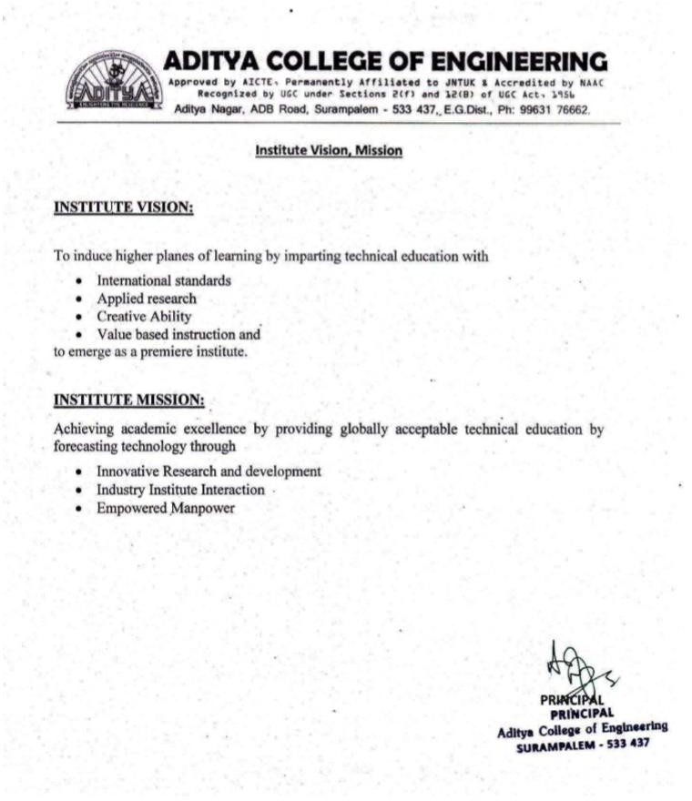

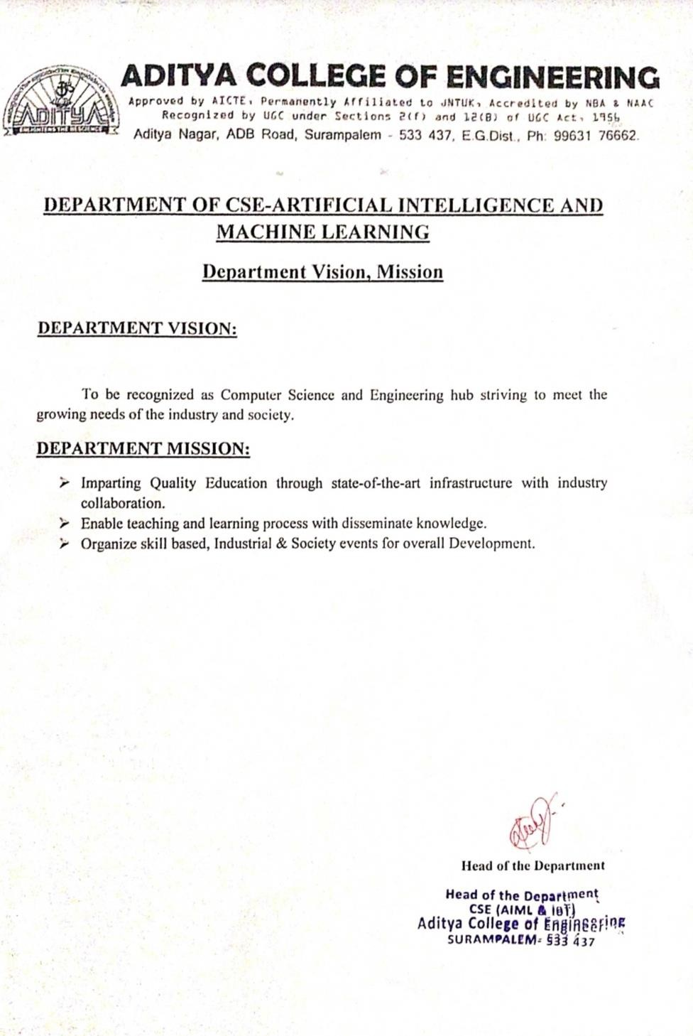

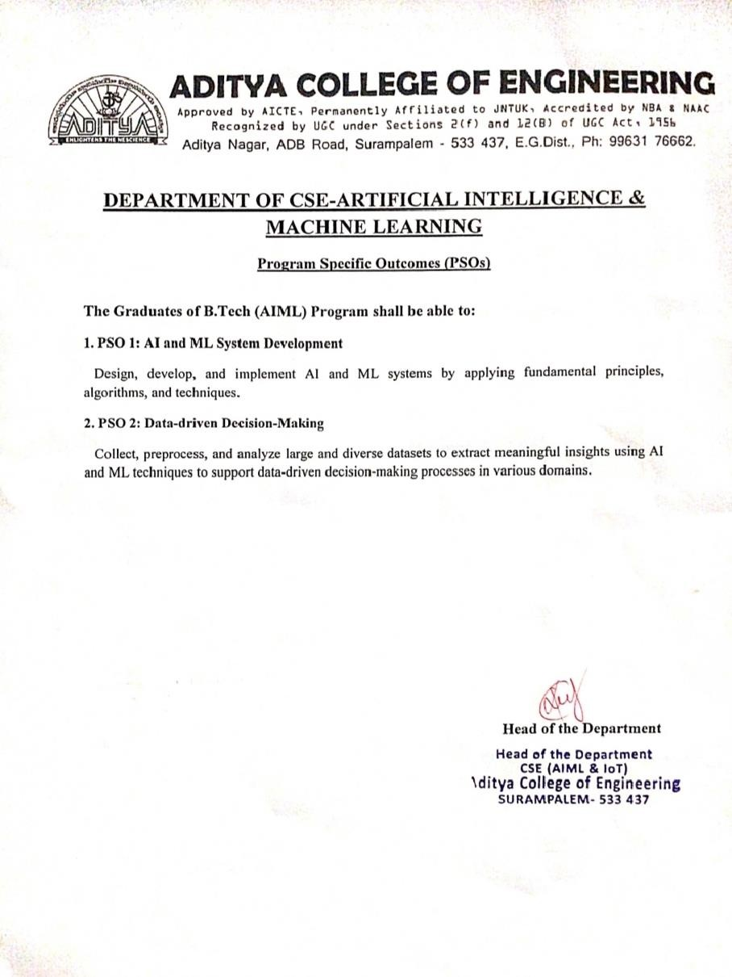

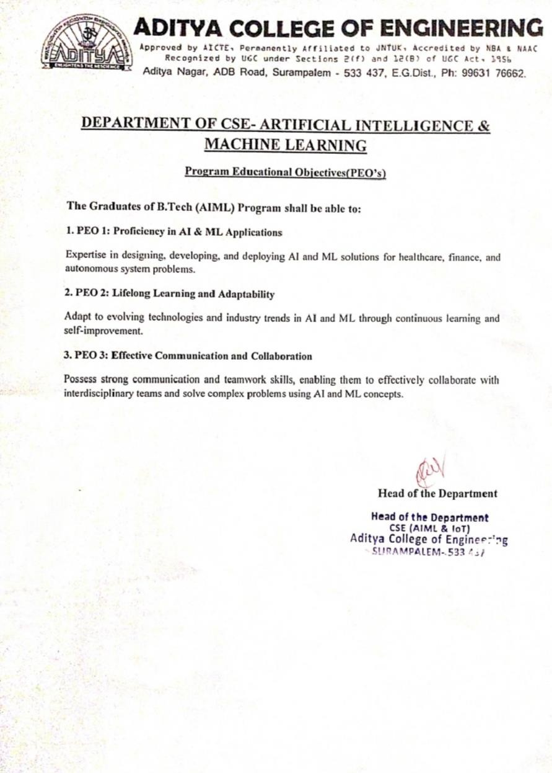

**ABSTRACT**

Web application development has revolutionized how individuals and organizations interact with technology, offering dynamic, interactive, and user-friendly interfaces accessible via web browsers. This abstract provides an overview of the key concepts, methodologies, and tools involved in web application development.

Web application development involves creating application software that resides on remote servers and is delivered to users devices over the Internet. Unlike traditional desktop applications, web applications are accessed through web browsers, making them platform-independent and easily accessible.

Web applications are built using a combination of front-end and back-end technologies. The front end, or client side, involves HTML, CSS, and JavaScript to create interactive and visually appealing user interfaces. Popular frameworks and libraries like React, Angular, and Vue.js enhance the development of complex user interfaces.

The back end, or server side, involves handling the application logic, database interactions, user authentication, and server configuration. Common back-end technologies include Node.js, Django, Ruby on Rails, and Laravel. Databases such as MySQL, PostgreSQL, and MongoDB store and manage application data.

Web application development is a dynamic and evolving field, continuously shaped by advancements in technology and changing user expectations. By leveraging modern frameworks, development practices, and addressing security and performance challenges, developers can create robust, scalable, and user-centric web applications that cater to diverse needs and drive innovation.

# INDEX

|  |  |  |
| --- | --- | --- |
| S. NO | TOPIC | PAGE NO |
| 1 | Introduction | 1 |
| 2 | Learning Objectives/Internship Objectives | 2 |
| 3 | Day To Day Overview of Internship Activities | 3-4 |
| 4 | Weekly Report | 5-6 |
| 5 | Executive Summary | 7 |
| 6 | Opportunities | 8 |
| 7 | Training | 9 |
| 8 | Challenges Faced | 10 |
| 9 | About Project | 11-17 |
| 10 | Student Self Evaluation sheet | 18 |
| 11 | Photos & Video Links | 19-53 |

1. **INTRODUCTION**

Web application development has become a cornerstone of modern technology, fundamentally transforming the way businesses operate and individuals interact with digital services. Unlike traditional desktop applications, which are installed on individual computers, web applications run on web servers and are accessed through web browsers. This unique characteristic offers several advantages, including cross-platform compatibility, ease of access, and simplified deployment.

Web application development involves creating software applications that reside on remote servers and deliver interactive and dynamic content to users over the Internet. These applications range from simple web pages to complex platforms providing services such as online banking, social networking, e-commerce, and cloud-based productivity tools.

The evolution of web application development has been rapid and profound. From the static HTML pages of the early 1990s to the highly interactive and responsive applications powered by advanced JavaScript frameworks today, web development technologies have continuously adapted to meet growing user demands. This evolution has enabled businesses to offer richer, more engaging user experiences, thus driving greater user engagement and satisfaction.

Web application development is typically divided into two main components: the front-end and the back-end.

Front-End Development: This aspect focuses on the user interface and user experience. It involves using

technologies like HTML, CSS, and JavaScript to build the visual and interactive elements of a web application. Modern frameworks such as React, Angular, and Vue.js have revolutionized front-end development by enabling developers to create complex and dynamic interfaces efficiently.

Back-End Development: The back-end is responsible for the server-side logic, database interactions, user authentication, and application functionality. Technologies such as Node.js, Django, Ruby on Rails, and Laravel are commonly used for back-end development. Databases like MySQL, PostgreSQL, and MongoDB manage and store application data, ensuring it is accessible and secure.

# LEARNING OBJECTIVES/INTERNSHIP OBJECTIVES

* Internships are generally thought of to be reserved for college students looking to gain experience in a particular field. However, a wide array of people can benefit from Training in Internship in order to receive real world experience and develop their skills.
* An objective for this position should emphasize the skills you already possess in the area and your interest in learning more
* Internships are utilized in a number of different career fields, including architecture, engineering, healthcare, economics, advertising and many more.
* Some internships are used to allow individuals to perform scientific research while others are specifically designed to allow people to gain first-hand experience working.
* Utilizing internships is a great way to build your resume and develop skills that can be emphasized in your resume for future jobs. When you are applying for a Training Internship, make sure to highlight any special skills or talents that can make you stand apart from the rest of the applicants so that you have an improved chance of landing the position.

# DAY TO DAY OVERVIEW OF INTERNSHIP ACTIVITIES

|  |  |  |
| --- | --- | --- |
| **DATE** | **TOPIC** | **HOURS** |
| 15-05-2024 | Attended Session | 3 hrs. |
| 23-05-2024 | Attended Session | 3 hrs. |
| 24-05-2024 | Attended Session | 3 hrs. |
| 25-05-2024 | Attended Session | 3 hrs. |
| 26-05-2024 | Attended Session | 3 hrs. |
| 29-05-2024 | Attended Session | 3 hrs. |
| 30-05-2024 | Attended Session | 3 hrs. |
| 31-05-2024 | Attended Session | 3 hrs. |
| 01-06-2024 | Attended Session | 3 hrs. |
| 02-06-2024 | Attended Session | 3 hrs. |

|  |  |  |
| --- | --- | --- |
| 05-06-2024 | Attended Session | 3 hrs. |
| 06-06-2024 | Attended Session | 3 hrs. |
| 07-06-2024 | Attended Session | 3 hrs. |
| 08-06-2024 | Attended Session | 3 hrs. |
| 09-06-2024 | Attended Session | 3 hrs. |
| 10-06-2024 | Attended Session | 3 hrs. |
| 12-06-2024 | Attended Session | 3 hrs. |
| 13-06-2024 | Attended Session | 3 hrs. |
| 14-06-2024 | Attended Session | 3 hrs. |
| 15-06-2024 | Attended Session | 3 hrs. |

|  |  |
| --- | --- |
| **Boot camp** | **Table of Content** |
| **Week-1** | **INTRODUCTION TO WEB APPLICATION**  **DEVELOPMENT**    **HTML (HYPER TEXT MARKUP LANGUAGE)**  **->** Basics of HTML tags and structure  **->** Creating a sample webpage    **CSS (CASCADING STYLE SHEETS)**  **->**Introduction to CSS and styling web content  **->**Selectors, properties and values  **->**Basic layout and Positioning    **Planning and Initial Setup**  **->** Defined project scope and objectives.  **->**Created a project timeline and task breakdown.  **->**Set up the development environment (installed code  editor, created project directory, etc.). |
| **Week-2** |   **Developing HTML Structure and CSS Styling**    **->**Designed the layout of the quiz app.  **->**Created the HTML structure including containers for  Questions and answers.  **->**Applied CSS to style the Portfolio, ensuring a user-  friendly design.  **->**Ensured responsive design for different screen sizes. |
| **Week-3** |   **Implementing JavaScript Logic**  **->**Defined functions in JavaScript.  **->** Implemented functions to handle menu navigation display and setting current year.  **->** Added event listeners for user interactions. |

**4. WEEKLY REPORT**

|  |  |
| --- | --- |
| **To Last Week** |   **Testing, Debugging, and Final Touches**  **->**Conducted thorough testing of the quiz app to identify and  fix bugs.  **->** Improved the user interface based on feedback.  **->**Added final touches like transitions and additional question  sets.  **->**Prepared documentation and user guide for the app. |

**5.EXECUTIVE SUMMARY**

This report is about my ___ weeks internship program with TECHNICAL HUB (Surampalem). In this comprehensive report, I have discussed about every major aspect of the company which I observed and perceived during my internship program.

During my internship program, I have learned and mainly worked on WEB APPLICATION DEVELOPMENT. All the details have been discussed in detail. All the policies and procedures of the company have been discussed in detail.

As per TECHNICAL HUB The purpose of the internship is to learn, by working in practical environment and to apply the knowledge acquired during the studies in real world scenario in order to tackle the problems using the knowledge and skill learned during the academic.

# OPPORTUNITIES

During these ___ Weeks of the internship, I was given the opportunity to perform following role:

* **Intern:** Coordinating with the team members and team leads on a regular basis to keep a track of the activities like the Offline sessions held and about the work to be done.
* I learned about making a quiz app using web application development it includes HTML, CSS, JS.
* For that I have referred YouTube videos, Geeks for Geeks related to gain the complete knowledge on making a Portfolio.
* Then I have gathered the requirements for making a Portfolio.
* They also provide us the opportunity to voluntarily interact in other projects as well.
* They have given different tasks to develop different parts of the application.
* Also, they have finally conducted test to certify with the completion of internship.

# TRAINING

During these 8 weeks of internship there are totally 18 Online sessions, 18 practical sessions

and total of 12 application development sessions are held. Duration of Online and Practical sessions is 1 and

half hrs. per each and each application development session of duration 3 hrs.

An internship in Web Application development is an invaluable experience that provides aspiring developers with a practical and hands-on understanding of building the user interface and experience

for websites and applications. Throughout the internship, interns have the opportunity to work on real-world projects, collaborate with seasoned professionals, and refine their technical skills. As the internship comes to a close, it's important to reflect on the experience and articulate the learnings and growth achieved during this period.

The internship provided an excellent platform for enhancing technical skills in HTML, CSS,

JavaScript, and various Web Application frameworks. Through daily tasks and projects, I gained proficiency

in creating responsive designs, optimizing performance, and integrating interactive components using industry- standard practices.

As the internship concludes, I am eager to continue my journey in Web Application development. I plan to leverage the skills and experiences gained during this period to pursue a full-time role in the field. I am excited to further develop my abilities, contribute to innovative projects, and collaborate with diverse teams in the ever-evolving tech industry.

# CHALLENGES FACED

* At the beginning of internship, I faced difficulty for understanding the applications and different tools. 
* I faced difficulty in installing the packages. 
* I faced difficulty in understanding the advanced topics on java script. 
* I faced difficulty in network issues. 
* I faced difficulty in getting the hang of the language’s syntax. 
* I faced difficulty while implementing updates. 
* I faced difficulty in connecting to various applications. 
* I faced difficulty while handling the errors in exception handling syntax. 

Even with these difficulties, I am able to complete the internship so that it will help me to secure a job in near

future.

# 9.ABOUT PROJECT

## **9.1** – Project Introduction:

* The Objective of this project is to develop my skill in WEB APPLICATION DEVELOPMENT, where I provide a comprehensive overview of my enriching experience as a WEB APPLICATION DEVELOPMENT Intern. Over the course of this internship, I had the privilege to work with Technical Hub a leading company, where I delved into the dynamic world of WEB APPLICATION DEVELOPMENT. This documentation encapsulates the invaluable insights, skills acquired, and achievements I gained during this internship journey.

## **9.2**– Project Requirements:

Hardware:

**Processor:** Intel – I3.

**RAM:** 2 GB.

**Hard Disk:** 256 GB. Software:

**OS:** Windows / MAC / Linux.

**VS code:** Version(16,17,20).

**IDE:** Notepad / vs code / Android studio

## **9.3**– Project Modules:

## User Interface (UI) Module - Develops and manages the front-end experience, ensuring the app is

## user-friendly and accessible.

## Quiz Management Module - Facilitates the creation, modification, and deletion of quizzes and their

## organizational structures.

## Scoring and Results Module - Calculates scores based on answers and manages feedback

## provided to users post-quiz.

**9.4- Project Implementation (Sample code):**

**PORTFOLIO WEBSITE USING WEB APPLICATION DEVELOPMENT**

**Index.html:**

<!DOCTYPE html>

<html lang="en">

<head>

<meta charset="UTF-8" />

<meta http-equiv="X-UA-Compatible" content="IE=edge" />

<meta name="viewport" content="width=device-width, initial-scale=1.0" />

<title>PVV09-Portfolio</title>

<script type="module" src="https://unpkg.com/ionicons@7.1.0/dist/ionicons/ionicons.esm.js"></script>

<script nomodule src="https://unpkg.com/ionicons@7.1.0/dist/ionicons/ionicons.js"></script>

<script defer src="script.js"></script>

<link rel="stylesheet" href="style.css" />

<link rel="stylesheet" href="query.css" />

</head>

<body>

<section class="hero">

<section class="header">

<div class="name">Vishnu</div>

<nav class="nav">

<div>

<a href="#" class="nav-link">Home</a>

<a href="#about" class="nav-link">About</a>

<a href="#resume" class="nav-link">Resume</a>

<a href="#skills" class="nav-link">Skills</a>

<a href="#projects" class="nav-link">Projects</a>

<a href="#contact" class="nav-link">Contact</a>

</div>

</nav>

<button class="mob-nav">

<ion-icon class="mob-icon" name="menu-outline"></ion-icon>

<ion-icon class="mob-icon" name="close-outline"></ion-icon>

</button>

</section>

<section class="home">

<section class="intro">

<span class="hlo">HELLO !</span>

<span class="im">I'm</span><span class="vishnu">Vishnu</span>

<p class="varun">Varun Punati</p>

<p class="job">A Web Developer</p>

<div>

<a href="#" class="hire">HIRE ME</a>

<a href="#" class="works">MY WORKS</a>

</div>

</section>

<section>

<div><img src="img/my_photo.png" alt="photo" /></div>

</section>

</section>

</section>

<section id="about" class="abt">

<div class="img2">

<div><img src="img/my_photo2.png" alt="about me" /></div>

</div>

<div class="abt-st">

<h2 class="prim-heading">About Me</h2>

<h3 class="sec-heading">About</h3>

<p> I'm a Web Developer, Who usually develops user friendly websites to the Clients.</p>

<div class="abt-cont">

<div class="lhs">

<li>Name:</li>

<li>Date of birth:</li>

<li>Address:</li>

<li>Pin code:</li>

<li>Email:</li>

<li>Phone:</li>

</div>

<div class="rhs">

<li>Vishnu Varun Punati</li>

<li>October 30,2004</li>

<li>Narasaraopet Palnadu AndhraPradesh</li>

<li>522601</li>

<li>punativishnuvarun@gmail.com</li>

<li>+91-9059407503</li>

</div>

</div>

<div class="abt-project">

<span>120</span>

<p>Projects completed</p>

</div>

<a class="cv" href="#" download="/img/My Resume.pdf">DOWNLOAD CV</a>

</div>

</section>

<section id="resume" class="sect-res">

<h2 class="res-1 prim-heading">Resume</h2>

<h3 class="res-2 sec-heading">Resume</h3>

<p class="abt-res">Here is my Resume.In this i included all my educational details as well as my professional details.</p>

<div class="res-main">

<div>

<h2>2019-2020</h2>

<br />

<h3>Secondary School Education</h3>

<br />

<h4>Bhashyam High School</h4>

<br />

<p> In Secondary School Education, I got 94%. I have comleted my 10th during the year 2019-2020

Bhashyam High School at Chilakaluripet.This is my first most certified exam.

</p>

</div>

<div>

<h2>2020-2022</h2>

<br />

<h3>Intermediate</h3>

<br />

<h4>Sri Chaitanya Jr College</h4>

<br />

<p>

In Intermediate, I got 79.3%.I I have comleted my Intermediate

during the year 2020-2022 in Sri Chaitanya Jr College at

Chilakaluripet.In 1st year i got 300 marks and In second year i got

493 marks.

</p>

</div>

<div>

<h2>2022-2026</h2>

<br />

<h3>Bachelor of Technology</h3>

<br />

<h4>Aditya College of Engineering</h4>

<br />

<p>

I am currently pursuing my Bachelors in Aditya College of

Engineering in the stream of Artificial Intelligence and Machine

Learing.Now my current percentage is 75%.

</p>

</div>

<div>

<h2>2023-2024</h2>

<br />

<h3>Internship in AI&ML</h3>

<br />

<h4>APSSDC</h4>

<br />

<p>

I have completed an Online Internship based on Artificial Intelligence & Machine Learning.I have completed the Internship during the period May 15, 2024 to June 26, 2024.

</p>

</div>

</div>

<a class="cv" href="#" download="/img/My Resume.pdf">download cv</a>

</section>

<section id="skills" class="my-skills">

<h4 class="prim-heading">My Skills</h4>

<h6 class="sec-heading">Skills</h6>

<p> Here is my skill progress among different programming languages and applications

</p>

<div class="Skills">

<div>

<label for="photoshop">Photoshop</label>

<progress id="photoshop" value="90" max="100"></progress>

</div>

<div>

<label for="HTML5">HTML5</label>

<progress id="HTML5" value="95" max="100"></progress>

</div>

<div>

<label for="CSS3">CSS3</label>

<progress id="CSS3" value="87" max="100"></progress>

</div>

<div>

<label for="Java">Java</label ><progress id="Java" value="71" max="100"></progress>

</div>

<div class="py">

<label for="Python">Python</label><progress id="Python" value="65" max="100"></progress>

</div>

</div>

</section>

<section id="projects" class="sect-project">

<h2 class="prim-heading">Our Projects</h2>

<h3 class="sec-heading">Projects</h3>

<p>Here are my projects that are build using HTMl, CSS and a little a Javascript</p>

</section>

<div class="projects">

<div class="proj-img"><img src="img/omnifood.png" alt="Omnifood " /></div>

<div class="proj">

<h4>Omnifood</h4>

<p>Omnifood is a premium food delivry service with the mission to bring affordable and healthy meals to as many people as possible. The smart 365-days-per-year food subscription that will make you eat healthy

again. Omnifood AI will create a 100% personalized weekly meal plan just for you.

</p>

</div>

<div class="proj">

<h4>CoTrawell</h4>

<p> CoTrawell is a type of paid service that is started by a group of travellers.The main aim of this project is to give travel experience to the people. In this the customers are travelled with a professional travller. Explore diverse destinations with our CoTrawell CO's. </p>

</div>

<div class="proj-img">

<img src="img/cotrawell.png" alt="Cotrawell" />

</div>

<div class="proj-img"><img src="img/icybliss.png" alt="IcybLiss" /></div>

<div class="proj">

<h4>IcyBliss</h4>

<p> IcyBliss is an online and offline icecream store.They emphasize using natural, premium ingredients and provide options catering to various dairy needs.The brand is likely committed to sustainability, using ecofriendly packaging and supporting ethical practises.

</p>

</div>

</div>

<section id="contact" class="sect-cont">

<h2 class="prim-heading">Contact Me</h2>

<h3 clas="sec-heading">Contact</h3>

<p class="cont-p"> I'm a Web Developer.if you have any web related issues or if you want ton work with

me or do you need any thing from me Contact me.

</p>

<div class="cont-dtl">

<div class="dtl-1">

<ion-icon name="navigate" class="cont-icon"></ion-icon>

<div class="cont-data">

<h4>Address</h4>

<p>Narasaraopet, Palnadu, AndhraPradesh, India</p>

</div>

</div>

<div class="dtl-2">

<ion-icon name="call" class="cont-icon"></ion-icon>

<div class="cont-data">

<h4>contact number</h4>

<span>+91 9059407503</span>

</div>

</div>

<div class="dtl-3">

<ion-icon name="mail" class="cont-icon"></ion-icon>

<div class="cont-data">

<h4>Email address</h4>

<span>punativishnuvarun@gmail.com</span>

</div>

</div>

<div class="dtl-4">

<ion-icon name="globe" class="cont-icon"></ion-icon>

<div class="cont-data">

<h4>website</h4>

<span>punativishnuvarun.com</span>

</div>

</div>

</div>

</section>

# STUDENT SELF EVALUATION SHEET

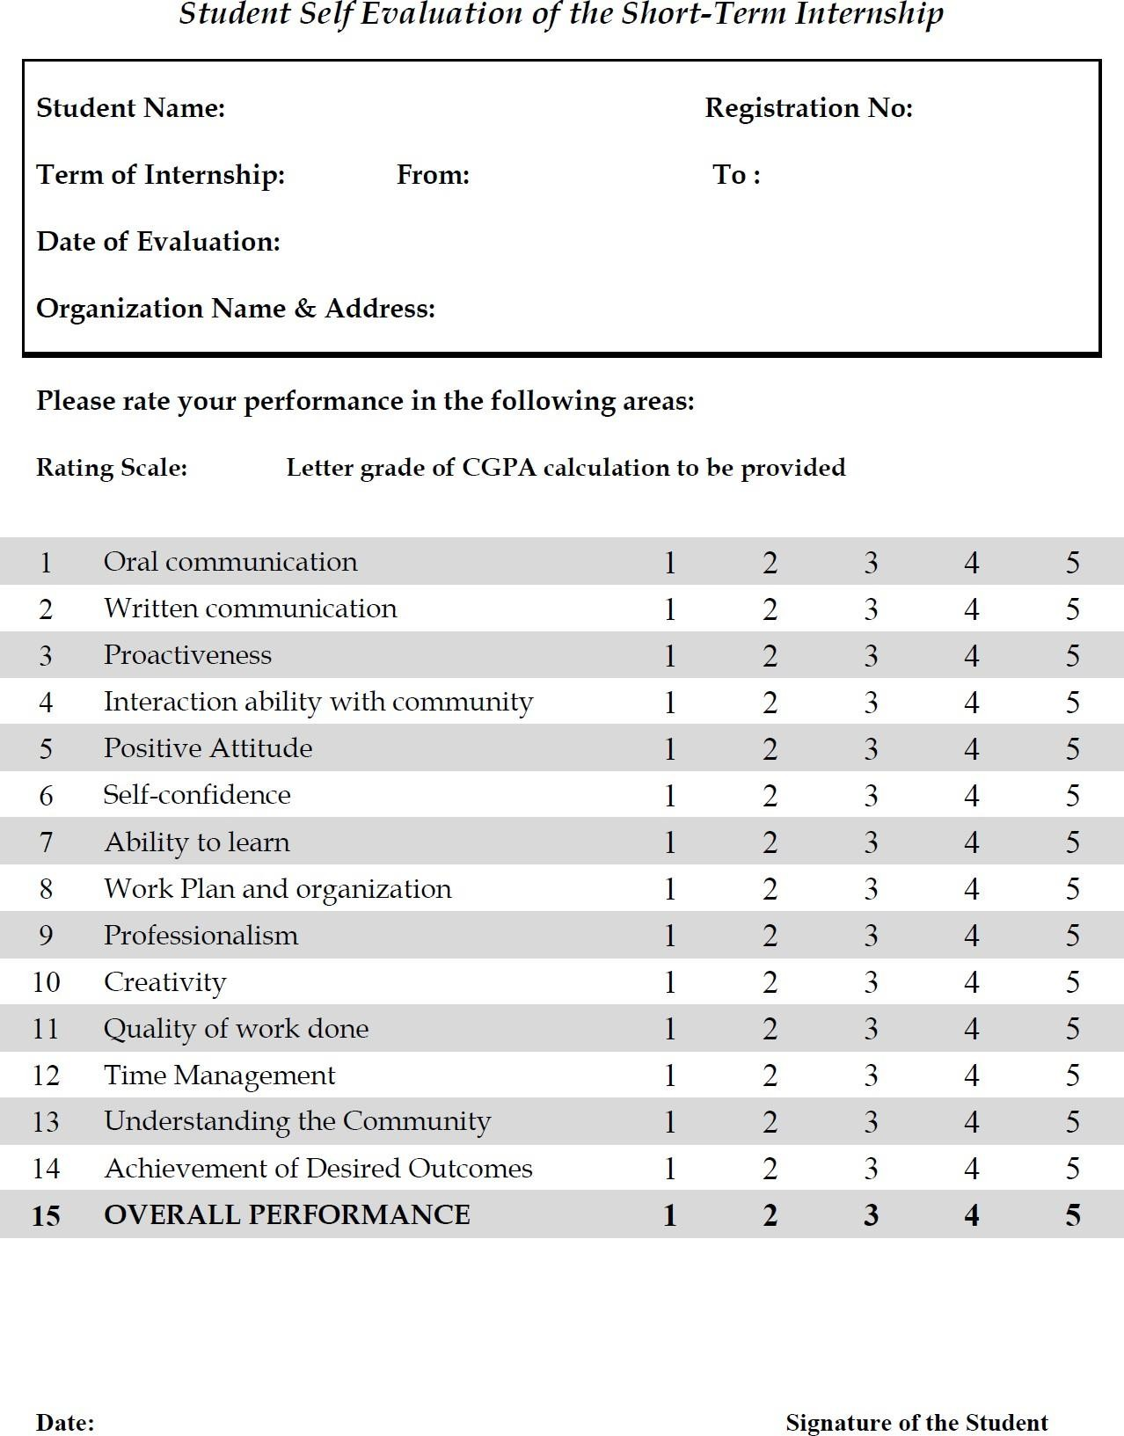

* 1. **PORTFOLIO**

**SOURCE CODE:**

<!DOCTYPE html>

<html lang="en">

  <head>

    <meta charset="UTF-8" />

    <meta http-equiv="X-UA-Compatible" content="IE=edge" />

    <meta name="viewport" content="width=device-width, initial-scale=1.0" />

    <title>PVV09-Portfolio</title>

    <script

      type="module"

      src="https://unpkg.com/ionicons@7.1.0/dist/ionicons/ionicons.esm.js"

    ></script>

    <script

      nomodule

      src="https://unpkg.com/ionicons@7.1.0/dist/ionicons/ionicons.js"

    ></script>

    <script defer src="script.js"></script>

    <link rel="stylesheet" href="style.css" />

    <link rel="stylesheet" href="query.css" />

  </head>

  <body>

    <section class="hero">

      <section class="header">

        <div class="name">Vishnu</div>

        <nav class="nav">

          <div>

            <a href="#" class="nav-link">Home</a>

            <a href="#about" class="nav-link">About</a>

            <a href="#resume" class="nav-link">Resume</a>

            <!-- <a href="#">Services</a> -->

            <a href="#skills" class="nav-link">Skills</a>

            <a href="#projects" class="nav-link">Projects</a>

            <!-- <a href="#">My Blog</a> -->

            <a href="#contact" class="nav-link">Contact</a>

          </div>

        </nav>

        <button class="mob-nav">

          <ion-icon class="mob-icon" name="menu-outline"></ion-icon>

          <ion-icon class="mob-icon" name="close-outline"></ion-icon>

        </button>

      </section>

      <section class="home">

        <section class="intro">

          <span class="hlo">HELLO !</span>

          <span class="im">I'm</span><span class="vishnu">Vishnu</span>

          <p class="varun">Varun Punati</p>

          <p class="job">A Web Developer</p>

          <div>

            <a href="#" class="hire">HIRE ME</a>

            <a href="#" class="works">MY WORKS</a>

          </div>

        </section>

        <section>

          <div><img src="img/my_photo.png" alt="photo" /></div>

        </section>

      </section>

    </section>

    <section id="about" class="abt">

      <div class="img2">

        <div><img src="img/my_photo2.png" alt="about me" /></div>

      </div>

      <div class="abt-st">

        <h2 class="prim-heading">About Me</h2>

        <h3 class="sec-heading">About</h3>

        <p>

          I'm a Web Developer, Who usually develops user friendly websites to

          the Clients.

        </p>

        <div class="abt-cont">

          <div class="lhs">

            <li>Name:</li>

            <li>Date of birth:</li>

            <li>Address:</li>

            <li>Pin code:</li>

            <li>Email:</li>

            <li>Phone:</li>

          </div>

          <div class="rhs">

            <li>Vishnu Varun Punati</li>

            <li>October 30,2004</li>

            <li>Narasaraopet Palnadu AndhraPradesh</li>

            <li>522601</li>

            <li>punativishnuvarun@gmail.com</li>

            <li>+91-9059407503</li>

          </div>

        </div>

        <div class="abt-project">

          <span>120</span>

          <p>Projects completed</p>

        </div>

        <a class="cv" href="#" download="/img/My Resume.pdf">DOWNLOAD CV</a>

      </div>

    </section>

    <section id="resume" class="sect-res">

      <h2 class="res-1 prim-heading">Resume</h2>

      <h3 class="res-2 sec-heading">Resume</h3>

      <p class="abt-res">

        Here is my Resume.In this i included all my educational details as well

        as my professional details.

      </p>

      <div class="res-main">

        <div>

          <h2>2019-2020</h2>

          <br />

          <h3>Secondary School Education</h3>

          <br />

          <h4>Bhashyam High School</h4>

          <br />

          <p>

            In Secondary School Education, I got 94%. I have comleted my 10th

            during the year 2019-2020 in Bhashyam High School at Chilakaluripet.

            This is my first most certified exam.

          </p>

        </div>

        <div>

          <h2>2020-2022</h2>

          <br />

          <h3>Intermediate</h3>

          <br />

          <h4>Sri Chaitanya Jr College</h4>

          <br />

          <p>

            In Intermediate, I got 79.3%.I I have comleted my Intermediate

            during the year 2020-2022 in Sri Chaitanya Jr College at

            Chilakaluripet.In 1st year i got 300 marks and In second year i got

            493 marks.

          </p>

        </div>

        <div>

          <h2>2022-2026</h2>

          <br />

          <h3>Bachelor of Technology</h3>

          <br />

          <h4>Aditya College of Engineering</h4>

          <br />

          <p>

            I am currently pursuing my Bachelors in Aditya College of

            Engineering in the stream of Artificial Intelligence and Machine

            Learing.Now my current percentage is 75%.

          </p>

        </div>

        <div>

          <h2>2023-2024</h2>

          <br />

          <h3>Internship in AI&ML</h3>

          <br />

          <h4>APSSDC</h4>

          <br />

          <p>

            I have completed an Online Internship based on Artificial

            Intelligence & Machine Learning.I have completed the Internship

            during the period May 15, 2024 to June 26, 2024.

          </p>

        </div>

      </div>

      <a class="cv" href="#" download="/img/My Resume.pdf">download cv</a>

    </section>

    <section id="skills" class="my-skills">

      <h4 class="prim-heading">My Skills</h4>

      <h6 class="sec-heading">Skills</h6>

      <p>

        Here is my skill progress among different programming languages and

        applications

      </p>

      <div class="Skills">

        <div>

          <label for="photoshop">Photoshop</label

          ><progress id="photoshop" value="90" max="100"></progress>

        </div>

        <div>

          <label for="HTML5">HTML5</label

          ><progress id="HTML5" value="95" max="100"></progress>

        </div>

        <div>

          <label for="CSS3">CSS3</label

          ><progress id="CSS3" value="87" max="100"></progress>

        </div>

        <div>

          <label for="Java">Java</label

          ><progress id="Java" value="71" max="100"></progress>

        </div>

        <div class="py">

          <label for="Python">Python</label

          ><progress id="Python" value="65" max="100"></progress>

        </div>

      </div>

    </section>

    <section id="projects" class="sect-project">

      <h2 class="prim-heading">Our Projects</h2>

      <h3 class="sec-heading">Projects</h3>

      <p>

        Here are my projects that are build using HTMl, CSS and a little a

        Javascript

      </p>

    </section>

    <div class="projects">

      <div class="proj-img"><img src="img/omnifood.png" alt="Omnifood " /></div>

      <div class="proj">

        <h4>Omnifood</h4>

        <p>

          Omnifood is a premium food delivry service with the mission to bring

          affordable and healthy meals to as many people as possible. The smart

          365-days-per-year food subscription that will make you eat healthy

          again.Omnifood AI will create a 100% personalized weekly meal plan

          just for you.

        </p>

      </div>

      <div class="proj">

        <h4>CoTrawell</h4>

        <p>

          CoTrawell is a type of paid service that is started by a group of

          travellers.The main aim of this project is to give travel experience

          to the people. In this the customers are travelled with a professional

          travller. Explore diverse destinations with our CoTrawell CO's.

        </p>

      </div>

      <div class="proj-img">

        <img src="img/cotrawell.png" alt="Cotrawell" />

      </div>

      <div class="proj-img"><img src="img/icybliss.png" alt="IcybLiss" /></div>

      <div class="proj">

        <h4>IcyBliss</h4>

        <p>

          IcyBliss is an online and offline icecream store.They emphasize using

          natural, premium ingredients and provide options catering to various

          dairy needs.The brand is likely committed to sustainability, using

          ecofriendly packaging and supporting ethical practises.

        </p>

      </div>

    </div>

    <section id="contact" class="sect-cont">

      <h2 class="prim-heading">Contact Me</h2>

      <h3 clas="sec-heading">Contact</h3>

      <p class="cont-p">

        I'm a Web Developer.if you have any web related issues or if you want

        ton work with me or do you need any thing from me Contact me.

      </p>

      <div class="cont-dtl">

        <div class="dtl-1">

          <ion-icon name="navigate" class="cont-icon"></ion-icon>

          <div class="cont-data">

            <h4>Address</h4>

            <p>Narasaraopet, Palnadu, AndhraPradesh, India</p>

          </div>

        </div>

        <div class="dtl-2">

          <ion-icon name="call" class="cont-icon"></ion-icon>

          <div class="cont-data">

            <h4>contact number</h4>

            <span>+91 9059407503</span>

          </div>

        </div>

        <div class="dtl-3">

          <ion-icon name="mail" class="cont-icon"></ion-icon>

          <div class="cont-data">

            <h4>Email address</h4>

            <span>punativishnuvarun@gmail.com</span>

          </div>

        </div>

        <div class="dtl-4">

          <ion-icon name="globe" class="cont-icon"></ion-icon>

          <div class="cont-data">

            <h4>website</h4>

            <span>punativishnuvarun.com</span>

          </div>

        </div>

      </div>

    </section>

    <section class="footer">

      <section class="footer-main">

        <div class="ft-1">

          <h4>About</h4>

          <p>

            Once again, This is Vishnu Varun Punati,who can develop responsive

            websites using HTML and CSS.Wanna work with me then Contact me.

          </p>

        </div>

        <div class="ft-2">

          <h4>Links</h4>

          <ul>

            <li>

              <a href="#">Home</a>

            </li>

            <li>

              <a href="#about">About</a>

            </li>

            <li>

              <a href="#">Services</a>

            </li>

            <li>

              <a href="#projects">Projects</a>

            </li>

            <li>

              <a href="#contact">Contact</a>

            </li>

          </ul>

        </div>

        <div class="ft-3">

          <h4>Services</h4>

          <ul>

            <li>

              <a href="#">Web Design</a>

            </li>

            <li>

              <a href="#">Web Development</a>

            </li>

            <li>

              <a href="#">Business Strategy</a>

            </li>

            <li>

              <a href="#">Data Analysis</a>

            </li>

            <li>

              <a href="#">Graphic Design</a>

            </li>

          </ul>

        </div>

        <div class="ft-4">

          <h4>Any Queries ?</h4>

          <ul>

            <li>

              <ion-icon name="location-outline" class="icon-ft"></ion-icon

              >Narasaraopet, Palnadu, AndhraPradesh, India

            </li>

            <br />

            <li>

              <ion-icon name="call-outline" class="icon-ft"></ion-icon>+91

              9059407503

            </li>

            <br />

            <li>

              <ion-icon name="send-outline" class="icon-ft"></ion-icon

              >punativishnuvarun@gmail.com

            </li>

          </ul>

        </div>

      </section>

      <aside>

        <p>

          Copyright &copy;

          <span class="year">2024</span>

          All rights reserved | This is owned by Vishnu Varun Punati

        </p>

      </aside>

    </section>

  </body>

</html>

**Styles**.**css:**

* {

  padding: 0;

  margin: 0;

  box-sizing: border-box;

}

html {

  font-size: 62.5%;

  scroll-behavior: smooth;

}

body {

  font-family: Poppins, Arial, sans-serif;

  background-color: black;

  color: white;

  padding: 0 14%;

}

/* ///////////////////////////// */

/* Hero Section */

/* //////////////////////////// */

.hero {

  height: 100vh;

}

.hero img {

  height: 60rem;

  position: absolute;

  right: 20%;

  top: -3%;

  transform: scale(1.8);

}

.header {

  display: flex;

  justify-content: space-between;

  position: relative;

}

.name {

  margin-top: 2.5rem;

  font-size: 2.8rem;

  font-weight: 900;

}

.nav {

  display: flex;

  align-items: center;

  font-size: 1.8rem;

  margin-top: 2.5rem;

  font-weight: 500;

}

.nav a {

  /* display: inlin; */

  text-decoration: none;

  color: white;

  margin-left: 4rem;

  padding-bottom: 0.5rem;

}

.nav a:nth-child(1) {

  color: #94d82d;

  border-bottom: 0.2rem solid #94d82d;

  border-radius: 0.3rem;

}

.home {

  display: flex;

}

.intro {

  padding-top: 18rem;

  /* position: absolute;

  top: 25%; */

}

.hlo {

  display: block;

  margin-bottom: 2rem;

  letter-spacing: 0.25rem;

  font-size: 1.4rem;

  color: #94d82d;

  font-weight: 700;

}

.im {

  font-size: 6rem;

  font-weight: 900;

}

.vishnu {

  display: inline-block;

  color: #94d82d;

  font-weight: 900;

  font-size: 6rem;

  margin-left: 1.6rem;

line-height: 1.1;

  margin-bottom: 1rem;

}

.varun {

  display: block;

  color: #94d82d;

  font-weight: 900;

  font-size: 6rem;

  margin-top: -1.8rem;

}

.job {

  /* position: relative; */

  font-size: 3.2rem;

  font-weight: 700;

  margin-top: 3.2rem;

  letter-spacing: 0.12rem;

  left: 0.2rem;

}

.hire {

  display: inline-block;

  text-decoration: none;

  color: #000;

  padding: 1.8rem 3rem;

  background-color: #94d82d;

  font-size: 1.2rem;

  font-weight: 600;

  letter-spacing: 0.15rem;

  border-radius: 2.5rem;

  margin-top: 3.2rem;

}

.works {

  display: inline-block;

  text-decoration: none;

  color: white;

  padding: 1.8rem 3rem;

  font-size: 1.2rem;

  font-weight: 600;

  letter-spacing: 0.15rem;

  border-radius: 2.5rem;

  margin-top: 3.2rem;

  border: 0.00001px solid#e6e6e6;

  margin-left: 0.5rem;

}

/* ///////////////////////////// */

/* About Section */

/* //////////////////////////// */

.abt {

  /* height: 100vh; */

  display: grid;

  grid-template-columns: 1fr 1fr;

  /* align-items: center;

  justify-content: center; */

}

.abt img {

  height: 60rem;

  transform: scale(1.6);

  margin-left: 14%;

}

.abt-st {

  margin-top: 5.2rem;

  /* justify-self: start; */

}

.abt-st h2 {

  font-size: 5rem;

  font-weight: 900;

  /* position: relative;

  left: 15%; */

}

.abt-st h3 {

  font-weight: 900;

  font-size: 10rem;

  color: #1a1a1a;

  /* opacity: 0.14; */

  z-index: -2;

  margin-top: -8%;

  margin-left: -1rem;

}

.abt-st p {

  font-size: 1.8rem;

  font-weight: 500;

  color: #899197;

  margin-top: -3rem;

  line-height: 1.5;

}

.abt-cont {

  margin-top: 3rem;

  display: flex;

  gap: 3rem;

}

.abt-cont li {

  list-style: none;

  font-size: 1.9rem;

}

.lhs li {

  font-weight: 700;

  margin-bottom: 1.8rem;

}

.rhs li {

  font-weight: 500;

  color: #899197;

  margin-bottom: 1.8rem;

}

.abt-project {

  margin-top: 5.2rem;

  font-size: 2.6rem;

  display: flex;

}

.abt-project span {

  display: inline-block;

  color: #94d82d;

  font-weight: 700;

  margin-top: 0.4rem;

  margin-right: 0.5rem;

}

.abt-project p {

  font-size: 2.6rem;

  color: #fff;

  font-weight: 400;

  margin-top: 0.07rem;

}

.cv {

  display: inline-block;

  text-decoration: none;

  color: #000;

  padding: 1.8rem 3rem;

  background-color: #94d82d;

  font-size: 1.2rem;

  font-weight: 600;

  letter-spacing: 0.25rem;

  border-radius: 2.5rem;

  margin-top: 3.2rem;

  text-transform: uppercase;

}

/* ///////////////////////////// */

/* Resume Section */

/* //////////////////////////// */

.res-1 {

  font-size: 5rem;

  font-weight: 900;

  padding-top: 14%;

  text-align: center;

}

.res-2 {

  font-size: 12rem;

  margin-top: -6%;

  text-align: center;

  font-weight: 900;

  opacity: 0.14;

  z-index: -2;

}

.abt-res {

  text-align: center;

  font-weight: 500;

  color: #ffffffb3;

  opacity: 0.8;

  font-size: 1.8rem;

  margin-top: -2.8%;

  /* padding-left: 20rem; */

  /* padding-right: 20rem; */

}

.res-main {

  display: grid;

  grid-template-columns: repeat(2, 1fr);

  grid-template-rows: repeat(2, 1fr);

  gap: 3rem;

  padding-top: 8rem;

}

.res-main h2 {

  font-size: 2.6rem;

  font-weight: 900;

  color: #94d82d;

}

.res-main h3 {

  font-size: 2.6rem;

  font-weight: 700;

  opacity: 1;

}

.res-main h4 {

  font-size: 1.2rem;

  font-weight: 200;

  letter-spacing: 0.3rem;

  color: #899197;

  text-transform: uppercase;

}

.res-main p {

  font-size: 1.8rem;

  font-weight: 300;

  color: #899197;

  line-height: 2;

  margin-top: 1.5rem;

}

.res-main div {

  background-color: #161719;

  padding: 4rem 2rem 4rem 2rem;

  border-radius: 0.5rem;

  z-index: 1;

  text-align: left;

}

.sect-res .cv {

  padding: 2.5rem 5rem;

  border-radius: 5rem;

  margin-top: 8rem;

}

.sect-res {

  text-align: center;

}

/* ///////////////////////////// */

/* SKills Section */

/* //////////////////////////// */

.my-skills {

  height: 100vh;

}

.my-skills h4 {

  padding-top: 14%;

  font-size: 5rem;

  font-weight: 900;

  text-align: center;

}

.my-skills h6 {

  margin-top: -5%;

  text-align: center;

  font-size: 12rem;

  font-weight: 900;

  opacity: 0.14;

  z-index: -2;

}

.my-skills p {

  text-align: center;

  font-weight: 500;

  color: #ffffffb3;

  opacity: 0.8;

  font-size: 1.8rem;

  margin-top: -4%;

}

.Skills {

  padding-top: 10rem;

  display: grid;

  grid-template-columns: repeat(2, 1fr);

  row-gap: 3.6rem;

  column-gap: 3.6rem;

}

/*

.py {

  grid-column-start: 1;

  grid-column-end: -1;

} */

label {

  display: inline-block;

  font-size: 2rem;

  font-weight: 600;

  margin-bottom: 1rem;

}

progress {

  accent-color: #94d82d;

  height: 3.5rem;

  width: 100%;

}

/* ///////////////////////////// */

/* Projects Section */

/* //////////////////////////// */

.sect-project h2 {

  font-size: 5rem;

  font-weight: 900;

  text-align: center;

}

.sect-project h3 {

  margin-top: -6%;

  text-align: center;

  font-size: 12rem;

  font-weight: 900;

  opacity: 0.14;

  z-index: -2;

}

.sect-project p {

  text-align: center;

  font-weight: 500;

  color: #ffffffb3;

  opacity: 0.8;

  font-size: 1.8rem;

  margin-top: -3%;

  padding: 0 auto;

}

.projects {

  display: grid;

  grid-template-columns: repeat(2, 1fr);

  padding-top: 8rem;

  gap: 4rem;

}

.proj-img {

  overflow: hidden;

  border-radius: 0.8rem;

  z-index: 2;

}

.projects img {

  height: 35rem;

  object-fit: contain;

  transition: all 0.5s;

}

.projects img:hover {

  transform: scale(1.1);

}

.proj {

  padding: 2rem;

}

.projects h4 {

  font-size: 3rem;

  font-weight: 900;

  color: #94d82d;

  margin-bottom: 2rem;

  text-align: center;

}

.projects p {

  font-size: 2rem;

  font-weight: 500;

  color: #899197;

  line-height: 2;

}

.sect-cont {

  height: 90vh;

}

.sect-cont h2 {

  padding-top: 14%;

  font-size: 5rem;

  font-weight: 900;

  text-align: center;

  /* margin-left: 20rem; */

}

.sect-cont h3 {

  margin-top: -6%;

  text-align: center;

  font-size: 12rem;

  font-weight: 900;

  opacity: 0.14;

  z-index: -2;

}

.sect-cont .cont-p {

  text-align: center;

  font-weight: 500;

  color: #ffffffb3;

  opacity: 0.8;

  font-size: 1.8rem;

  margin-top: -4%;

  padding-left: 25rem;

  padding-right: 25rem;

  line-height: 1.8;

}

.cont-dtl {

  margin-top: 14%;

  display: grid;

  grid-template-columns: 1fr 1fr 1fr 1fr;

  column-gap: 4rem;

  }

.cont-icon {

  display: block;

  height: 2.5rem;

  width: 2.5rem;

  color: #94d82d;

  background-color: #2b2f32;

  border-radius: 50%;

  padding: 3rem;

  transform: translate(50%, -50%);

}

.cont-dtl h4 {

  font-size: 1.7rem;

  text-transform: uppercase;

  font-weight: 500;

  /* text-align: center; */

}

.cont-dtl p {

  font-weight: 500;

  color: #ffffffb3;

  opacity: 0.8;

  font-size: 1.6rem;

  padding-top: 2rem;

  line-height: 1.8;

}

.cont-dtl span {

  display: inline-block;

  font-size: 1.6rem;

  padding-top: 2rem;

  line-height: 1.8;

}

.footer {

  height: 90vh;

}

.footer-main {

  display: grid;

  grid-template-columns: 1.5fr 1fr 1fr 1.5fr;

  column-gap: 2rem;

  padding-top: 14%;

}

.footer-main h4 {

  font-size: 2.8rem;

  color: #fff;

  margin-bottom: 4.6rem;

}

.footer-main:not(.footer h4) {

  color: #ffffffb3;

}

.footer-main p {

  font-size: 2rem;

  font-weight: 300;

  line-height: 2;

  opacity: 0.8;

}

.footer-main a {

  display: inline-block;

  font-size: 2rem;

  text-decoration: none;

  color: #ffffffb3;

  font-weight: lighter;

  line-height: 2.3;

  opacity: 0.8;

}

.ft-4 {

  font-size: 1.8rem;

  font-weight: 300;

  opacity: 0.8;

}

.ft-2 a,

.ft-3 a {

  margin-left: 1rem;

}

.footer-main li {

  list-style: none;

}

.icon-ft {

  display: inline-block;

  height: 2rem;

  width: 2rem;

  margin-right: 0.5rem;

}

.footer aside {

  display: flex;

  align-items: center;

  justify-content: center;

  padding-top: 14%;

  font-size: 1.8rem;

  color: #ffffffb3;

  opacity: 0.9;

}

.mob-nav {

  border: none;

  background: none;

  cursor: pointer;

  display: none;

}

.mob-icon {

  display: block;

  height: auto;

  width: 4.8rem;

  color: red;

}

.mob-icon[name="close-outline"] {

  display: none;

}

**Query.css:**

/* ///////////////////////////// */

/* BELOW  1344px */

/* ///////////////////////////// */

@media (max-width: 84em) {

  body {

    padding-left: 10%;

    padding-right: 10%;

  }

  header img {

    height: 90vh;

  }

}

@media (max-width: 71em) {

  html {

    font-size: 56.25%;

  }

  body {

    padding-left: 6%;

    padding-right: 6%;

  }

}

/* ///////////////////////////// */

/* BELOW 984px /////////////////////////////

/*  */

@media (max-width: 65em) {

  /* html {

    font-size: 50%;

  } */

  body {

    padding-left: 4%;

    padding-right: 4%;

  }

}

/*

  */

/*

  .mob-nav {

    margin-top: 2.5rem;

    display: block;

    /* margin-right: 4%; */

/*

  .hero img {

    height: 90%;

    transform: scale(1.2);

  } */

/* ************************ */

/* below 768px width  (for Mobiles)*/

@media (max-width: 48em) {

  html {

    font-size: 50%;

  }

  body {

    padding-left: 2%;

    padding-right: 2%;

  }

  /* ///////////////////// */

  .prim-heading {

    font-size: 4rem;

  }

  .sec-heading {

    font-size: 10rem;

    /* display: none; */

  }

  /* ///////////////////// */

  .hero {

    height: 100vh;

  }

  .home img {

    display: none;

    /* height: 90vh;

    z-index: -5;

    margin-top: -10%;

    transform: scale(1.3);

    margin-bottom: 4rem; */

  }

  .home {

    display: flex;

    align-items: center;

    text-align: center;

  }

  .intro {

    padding-top: 2%;

    text-align: center;

    margin: 20% auto;

  }

  /* ////////////////////// */

  .abt {

    height: auto;

    grid-template-columns: 1fr;

    align-items: center;

    justify-content: center;

    padding-left: 2rem;

    padding-right: 2rem;

  }

  .abt img {

    display: none;

  }

  .abt-st {

    margin-top: 5.2rem;

    /* justify-self: start; */

  }

  .abt-st h3 {

    margin-top: -8%;

  }

  .abt-st p {

    margin-top: -3.5rem;

  }

  .abt-cont {

    margin-top: 3rem;

    gap: 3rem;

  }

  .lhs li,

  .rhs li {

    margin-bottom: 1.8rem;

  }

  .abt-project {

    margin-top: 5.2rem;

    font-size: 2.6rem;

    display: flex;

  }

  .abt-project span {

    display: inline-block;

    color: #94d82d;

    font-weight: 700;

    margin-top: 0.4rem;

    margin-right: 0.5rem;

  }

  .abt-project p {

    font-size: 2.6rem;

    color: #fff;

    font-weight: 400;

    margin-top: 0.07rem;

  }

  .cv {

    display: inline-block;

    text-decoration: none;

    color: #000;

    padding: 1.8rem 3rem;

    background-color: #94d82d;

    font-size: 1.2rem;

    font-weight: 600;

    letter-spacing: 0.25rem;

    border-radius: 2.5rem;

    margin-top: 3.2rem;

    text-transform: uppercase;

  }

  /* //////////////////////////////// */

  .res-2 {

    margin-top: -8%;

    font-size: 10rem;

  }

  .abt-res {

    margin-top: -3%;

  }

  .res-main {

    grid-template-columns: 1fr;

    gap: 2rem;

    padding-top: 4rem;

  }

  .res-main p {

    line-height: 1.8;

    margin-top: 1.5rem;

  }

  .res-main div {

    background-color: #161719;

    padding: 4rem 2rem 4rem 2rem;

    border-radius: 0.5rem;

  }

  .sect-res .cv {

    padding: 1.5rem 3rem;

    border-radius: 3rem;

    margin-top: 5rem;

  }

  .sect-res {

    text-align: center;

  }

  /* /////////////////////// */

  .my-skills {

    height: auto;

  }

  .Skills {

    padding: 6rem 2rem;

    grid-template-columns: 1fr;

    gap: 2.2rem;

  }

  progress {

    height: 1.7rem;

  }

  /* ////////////////////// */

  .sect-project {

    padding-top: 5rem;

  }

  .sect-project h3 {

    margin-top: -6%;

    font-size: 10rem;

  }

  .sect-project p {

    margin-top: -3%;

  }

  .projects {

    grid-template-columns: 1fr;

    padding-top: 6rem;

    gap: 2rem;

  }

  .projects img {

    object-fit: contain;

    height: 38rem;

    width: 100%;

  }

  .projects h4 {

    margin-bottom: 1.5rem;

  }

  .projects p {

    line-height: 1.8;

  }

  .projects :nth-child(3) {

    grid-row: 4;

  }

  /* //////////////////////// */

  .sect-cont {

    height: auto;

  }

  .sect-cont h2 {

    padding-top: 10%;

  }

  .sect-cont h3 {

    margin-top: -7%;

    font-size: 10rem;

  }

  .sect-cont .cont-p {

    margin-top: -3%;

    padding: 0 8rem;

    line-height: 1.4;

  }

  .cont-dtl {

    margin-top: 10%;

    grid-template-columns: 1fr;

    row-gap: 6rem;

  }

  .dtl-1,

  .dtl-2,

  .dtl-3,

  .dtl-4 {

    text-align: center;

    width: 100%;

    margin-bottom: 4rem;

    display: flex;

    flex-direction: column;

    align-items: center;

  }

  .cont-icon {

    display: block;

    height: 2.5rem;

    width: 2.5rem;

    color: #94d82d;

    background-color: #2b2f32;

    border-radius: 50%;

    padding: 2rem;

    position: relative;

    right: 2.5rem;

  }

  .cont-dtl p {

    padding-top: 1.5rem;

    line-height: 1.6;

  }

  .cont-dtl span {

    line-height: 1.6;

  }

  /* ////////////////// */

  .footer {

    height: auto;

  }

  .footer-main {

    grid-template-columns: 1.5fr;

    row-gap: 4rem;

    padding-top: 8rem;

  }

  .footer-main h4 {

    margin-bottom: 2.3rem;

  }

  .footer-main p {

    line-height: 1.6;

  }

  .footer-main a {

    line-height: 2;

  }

  .footer aside {

    text-align: center;

    margin-bottom: 10%;

  }

  /* MOBILE NAV */

  /*

  .nav {

    display: none;

  } */

  .nav {

    background-color: red;

    position: absolute;

    top: 0;

    left: 0;

    width: 100%;

    height: 100vh;

    transform: translateY(-120%);

    /* display: flex; */

    align-items: center;

    justify-content: center;

    transition: all 0.5s ease-in;

    /* hide nav */

    opacity: 0;

    pointer-events: none;

    visibility: hidden;

  }

  .nav-open .nav {

    opacity: 1;

    pointer-events: auto;

    visibility: visible;

    transform: translateY(0);

  }

  .nav-open .mob-icon[name="close-outline"] {

    display: block;

  }

  .nav-open .mob-icon[name="menu-outline"] {

    display: none;

  }

  .nav div {

    display: flex;

    flex-direction: column;

    gap: 4.8rem;

  }

  .nav a {

    font-size: 3rem;

  }

  .nav a:nth-child(1) {

    color: #fff;

    border: none;

  }

  .mob-nav {

    /* margin-top: 4%; */

    display: block;

    z-index: 9999;

    /* height: 100%; */

    /* width: 100%; */

    /* margin-right: 4%; */

  }

  .mob-icon {

    margin-top: 2.5rem;

    height: 4.8rem;

    width: 4.8rem;

    color: #fff;

  }

  /* .header div {

    margin-left: 0;

    margin-right: 0;

    padding-left: 0;

    padding-right: 0;

  } */

}

**Scrit.js:**

// Mobile Navigation

const btnNavEl = document.querySelector(".mob-nav");

const headerEl = document.querySelector(".header");

btnNavEl.addEventListener("click", function () {

  headerEl.classList.toggle("nav-open");

});

const allLinks = document.querySelectorAll("a:link");

allLinks.forEach(function (*link*) {

  link.addEventListener("click", function (*e*) {

    e.preventDefault();

    if (link.classList.contains("nav-link"))

      headerEl.classList.toggle("nav-open");

  });

});

// setting current year

const yearEl = document.querySelector(".year");

const currentYear = new Date().getFullYear();

yearEl.textContent = currentYear;

**OUTPUT-1:**

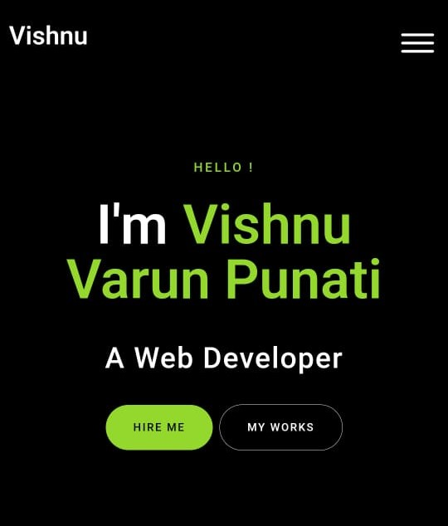

**OUTPUT-2:**

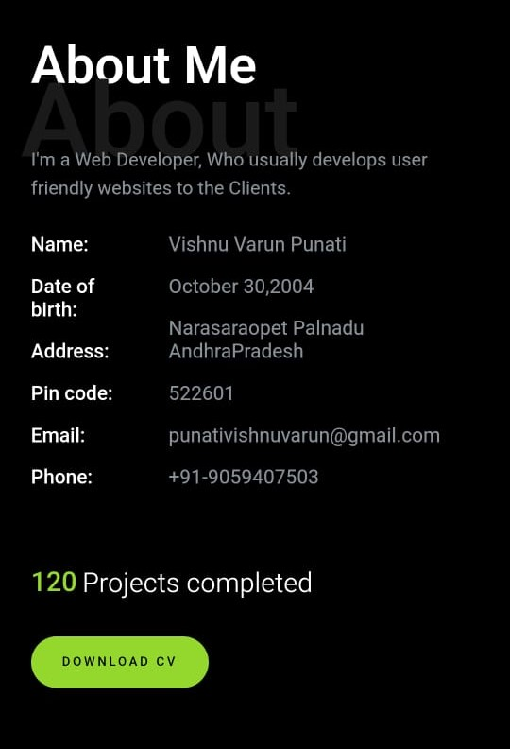

**OUTPUT-3:**

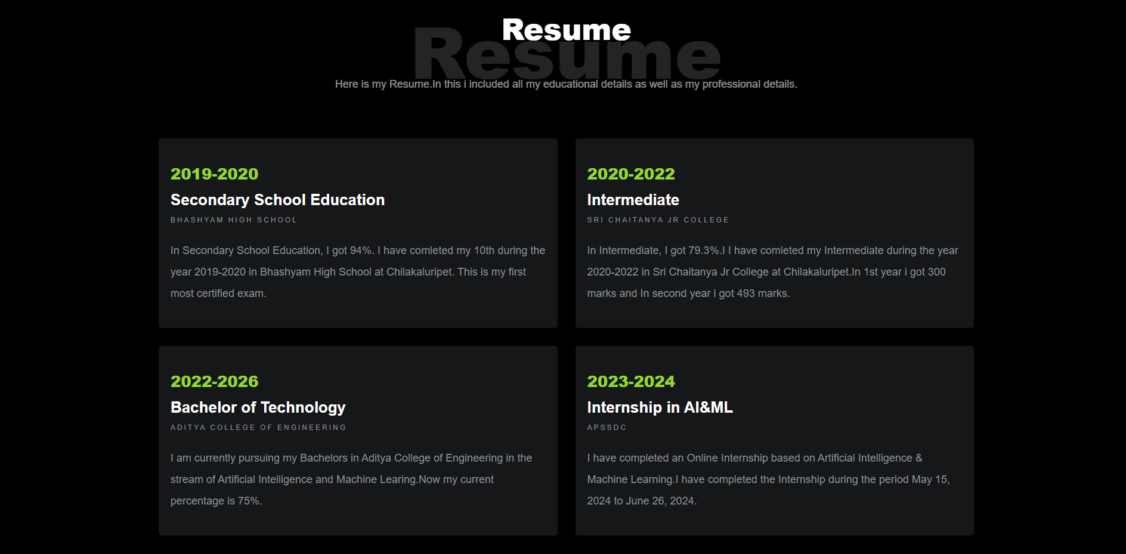

**OUTPUT-4:**

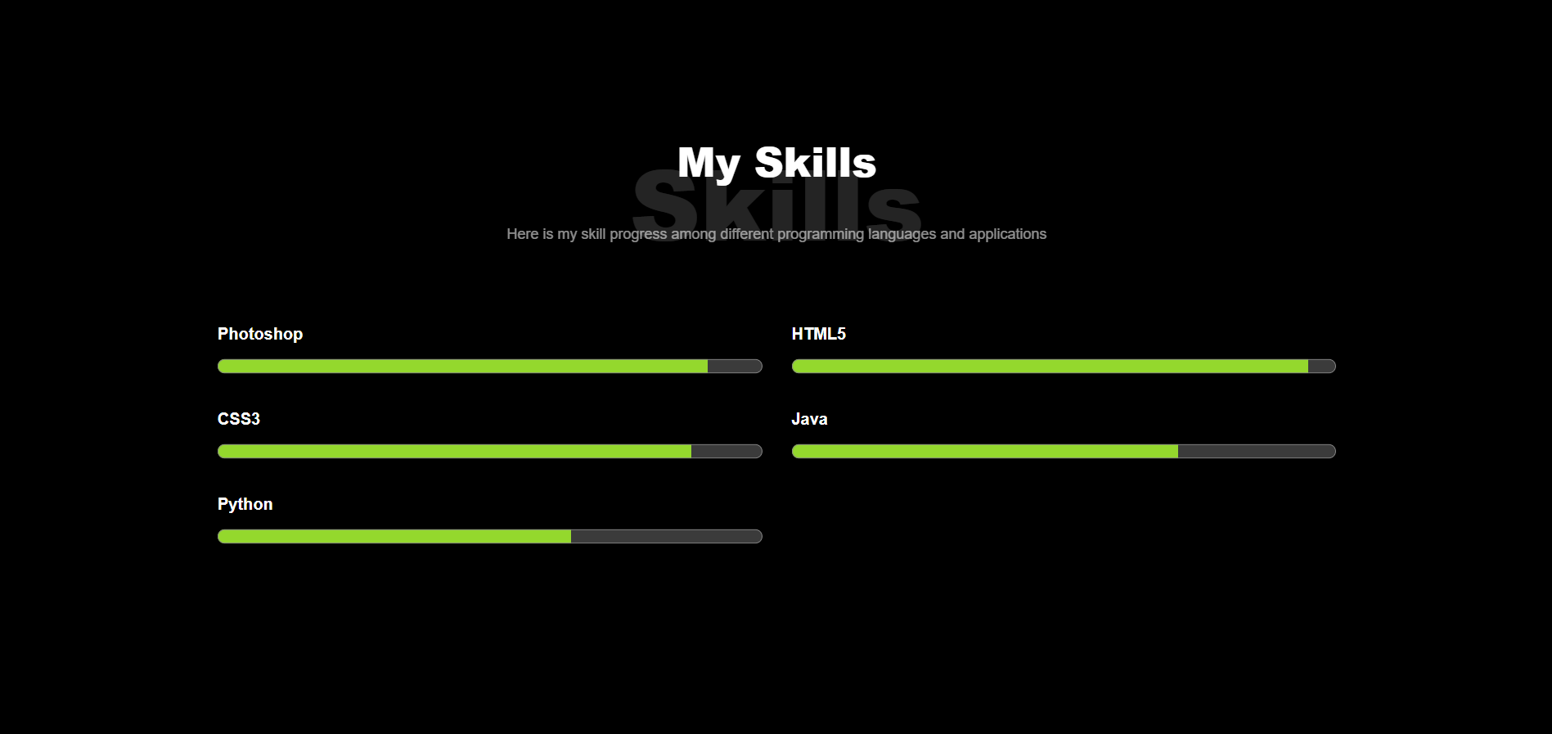

**OUTPUT-5:**

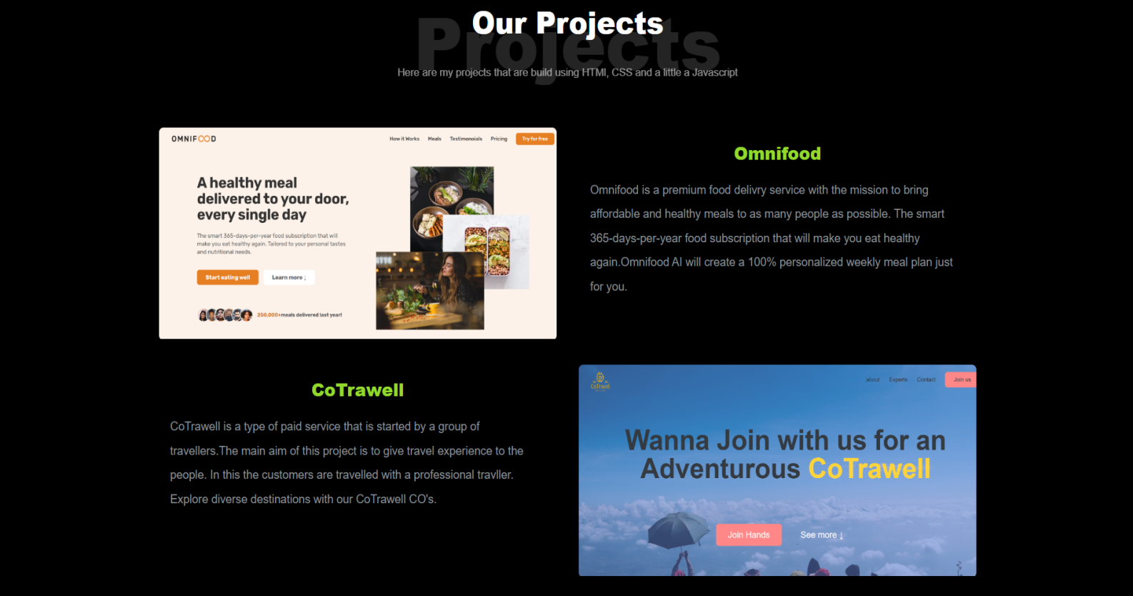

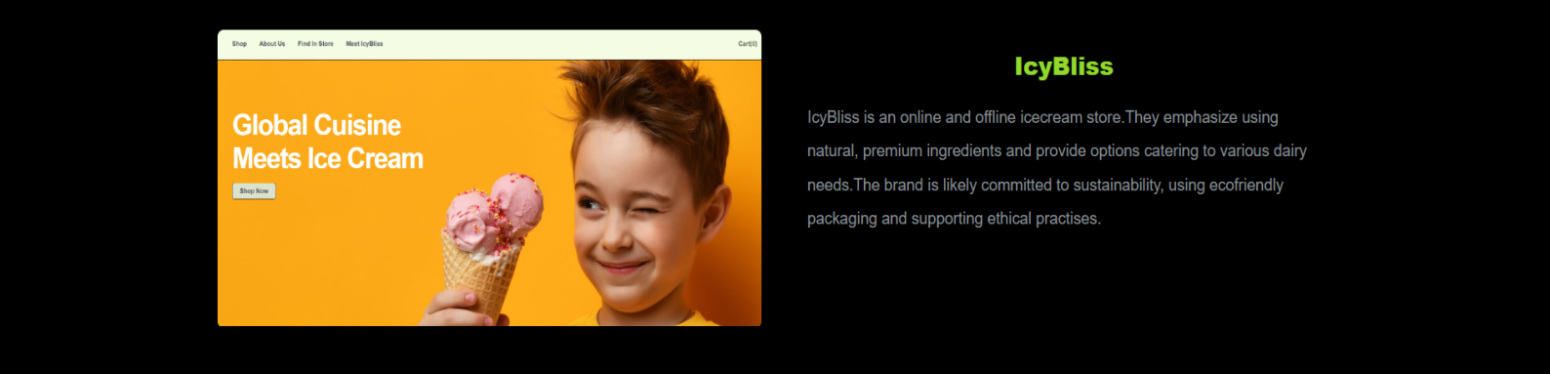

**OUTPUT-6:**

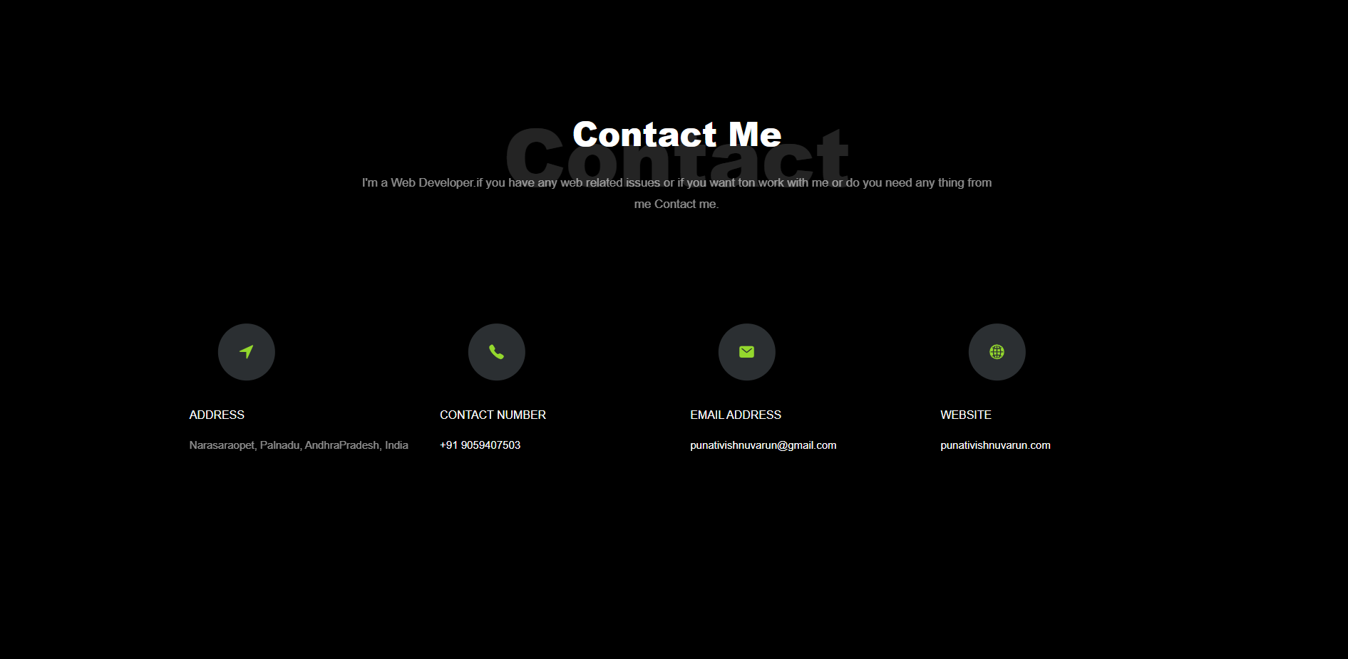

**OUTPUT-7:**

